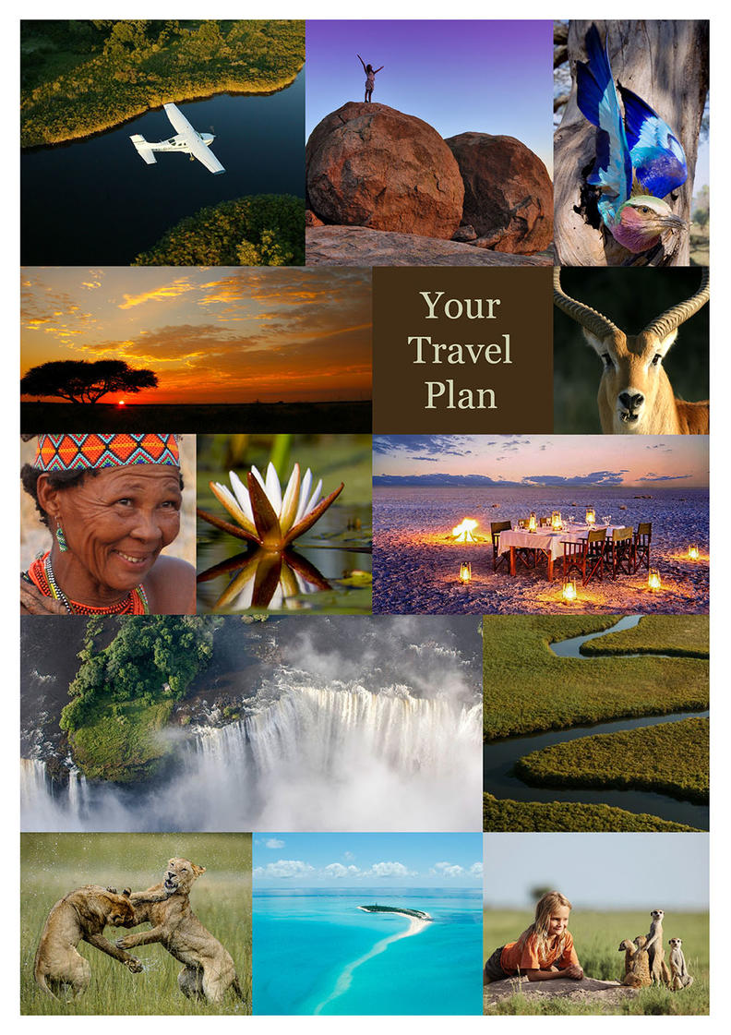
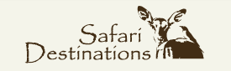

9N Best Kept Secrets
Mashatu Game Reserve - Okavango Delta - Victoria Falls, Zimbabwe
10 Days / 9 Nights
2 Persons

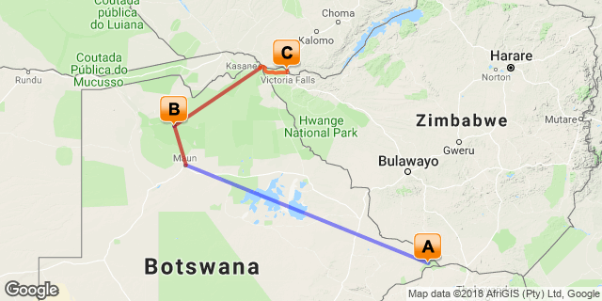

Click here to view your Digital Itinerary

Introduction

Start | Accommodation | Destination | Duration
Day 1 | Mashatu Lodge (Main Camp) | Mashatu Game Reserve | 3 Nights
Day 4 | Shinde | Okavango Delta | 3 Nights
Day 7 | Old Drift Lodge | Victoria Falls, Zimbabwe | 3 Nights

Transport

Flight Information
Date | Flight | Details | Class | Ref
Day 1 | Angel Gabriel | Lanseria - Limpopo Valley Airfield
Day 4 | Angel Gabriel | Limpopo Valley Airfield - Maun Airport
Day 4 | Mack Air | Maun Airport - Shinde Airstrip
Day 7 | Mack Air | Shinde Airstrip - Kasane Airport

Transfers
Date | Company | Details
Day 7 | Wild Horizons | Kasane Airport - The Old Drift Lodge
Day 10 | Old Drift Lodge | Old Drift Lodge - Victoria Falls Airport

Day 1-4
Mashatu Lodge (Main Camp), Mashatu Game Reserve

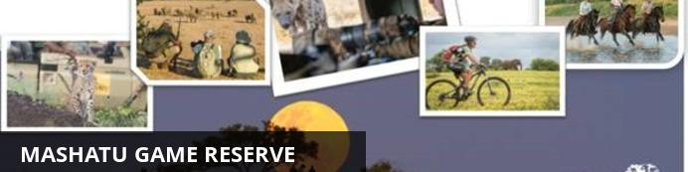
Mashatu Game Reserve in the south eastern extreme of Botswana offers a unique portfolio of adventure safari experiences on a reserve known as the Land of Giants, named after the largest herds of elephant on private land in Africa. In addition to the two camps (luxury all-suite and tented) and excellent daily sightings of all the African predators (lion, leopard, cheetah, hyena, jackal and African wildcat), Mashatu is unquestionably the adventure safari destination for energetic travelers and multi-generational families. With five diverse ways to experience Africa’s wildlife, Mashatu offers, to complement the vehicle safaris conducted by guides with an average of 15 years’ experience on Mashatu; activities including the world-class photographic experience including two underground elephant hides, mountain biking safaris, horse safaris and walking safaris. The single fastest growth is in the photographic experience where excellent ‘Tuli’ light has engendered interest in Mashatu from all over the world. All our adventure experiences cater for the safari-goer who yearns for a more active and intimate safari holiday.

Overnight: Mashatu Lodge (Main Camp) View iBrochure
Includes: meals, game drives and scheduled airfield and Pont Drift transfers.
Excludes: drinks, additional activities and applicable park fees, laundry and unscheduled transfers.
Activities included: day & night drives.
Activities at an additional cost: bushwalks, horseback safaris and cycling safaris (pre-booking required)
Mashatu camp lies in the eastern corner of Botswana, at the confluence of the Limpopo and Shashe rivers, in the Tuli enclave, in the Mashatu Game reserve. The name is derived from the magnificent Mashatu trees, which occur throughout this immense tract of privately owned land.
The camp offers fourteen tastefully and authentically decorated suites. Each suite has an expansive en-suite bathroom with shower, bath, his and hers basins, air-conditioning and a private lounge area overlooking the surrounding bush.
The main camp is elevated around a waterhole and offers excellent game viewing opportunities from within the camp itself. The dining area, stunning day lounge and bar provide diverse lookouts from which to enjoy and appreciate the view. Facilities within the camp include a swimming pool, an air-conditioned lounge and dining room and enclosed African boma. A well-appointed curio shop complements the facilities.
Activities in the rugged, unspoilt African landscape include game drives in the comfort of open 4-wheel drive vehicles, walking safaris, on mountain bicycles and horseback, guided by expert rangers and experienced trackers. In addition to the game experience, Mashatu offers a view of Africa, unchanged with time and has historic and archaeological sites, most notable are the Motloutse Ruins and the Pitsani Koppie sites. Apart from game drives, all other activities are at an additional cost and must be pre – booked.
Transfer Time: From Pont Drift border is 45 minutes
From Limpopo Valley Airfield is 40 minutes
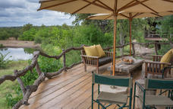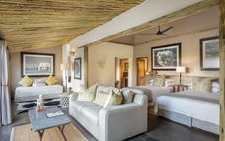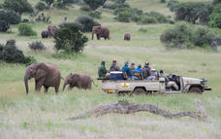

Day 4-7
Shinde, Okavango Delta

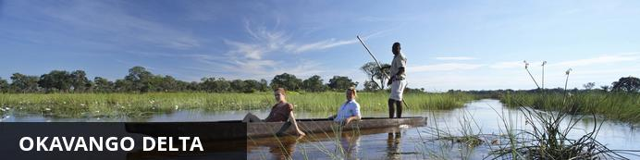
The Okavango Delta is where the wild things are: an immense, waterlogged oasis alive with elephants and birdlife, adrift in the middle of Kalahari sands. The real magic of the Delta lies in its water, trickling through from far away highlands, and spreading across the channels and floodplains.
During winter in the Kalahari, when the sun has baked the earth bare and turned the desert its driest, water fills the Okavango; transforming the floodplains into a Noah’s Ark of African wildlife.
As the water brings life to the delta, its local residents shape and recreate it. Termites slowly build mounds into islands, germinated with palm trees by passing elephants. Waterways open and close on the whim of wide-bottomed hippos, carving out channels where they crash through reeds, and leaving room behind them for exploration by mokoro.
The Okavango has many faces, which change throughout the year, prompted by that most unpredictable diva of all: the weather. Water levels rise and drop, expanding and shrinking islands, while animals move where the life is easiest and the grass greenest. In a few days, a sandy road driven by vehicle can become a waterway of unknowable depth, prompting a safari by boat instead.
Where and when you stay in the Okavango Delta will hugely influence what you do in the bush each day, the animals you’re most likely to see and finally, the safari experience you’ll have.
The delta’s watery heart is best discovered by mokoro through shallow channels and floodplains, as well as crossing the islands on foot. For less water and more of the big game, visit a camp on its drier edges (including Moremi Game Reserve and the Khwai Community Area), jump on a vehicle and seek out the animals hiding in the woodlands.

Overnight: Shinde View iBrochure
Includes: meals, drinks, activities, park fees , laundry & return airstrip transfers
Excludes: Premium imported wines, champagne & spirits
Activities: game drives, boating, mokoro (seasonal) and walking
Shinde is a magical hideaway in the wildlife abundant Shinde private concession, nestled within the shade of ancient jackal berries, water figs and knob thorns and built in a remote and exclusive setting on the edge of the permanent waters of the northern Okavango Delta. It is surrounded by clear waterways teeming with birdlife and game, and offering a wide variety of activities all year round.
The camp consists of eight large safari style tents on timber decking furnished in elegant African style, featuring open gauze windows and en-suite bathrooms with a separate toilet. The main lodge is known as the ‘tree house’ and is a multi-tiered structure with the dining room adjoined by stairs and ramps (for wheelchair-friendly access) to several lounging areas each offering different aspects across the delta. The boma area at the foot of the lodge provides a meeting point for guests for afternoon tea and a venue for stargazing in the evenings while enjoying a drink around the campfire. Shinde also features a curio shop and a swimming pool. Within the camp is the Shinde Enclave, a perfect choice for a family or small group. The enclave is a camp within a camp, and offers guests their own private deck, dining facilities and an exclusive host/guide.
Activities at Shinde include game drives in open 4x4 safari vehicles which offer some of the finest dry land game viewing in Botswana with regular sightings of lion and leopard, exploring the water ways in mokoro (traditional dugout canoes), guided nature walks, night drives, motor boating and sunset cruises. It is also possible to enjoy a longer outing, by motorboat to the Gadikwe lagoons in the Moremi game reserve to view breeding colonies of herons, egrets, pelicans and storks (August to December). For the fishing enthusiasts, Shinde provides basic fishing equipment for guests to take on the challenge of the fighting tiger fish or bream, pike and catfish during the fishing season.
Airstrip Transfer Time: 10 minutes
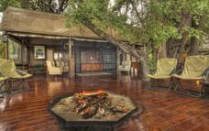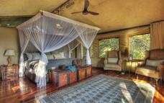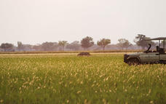

Day 7-10
Old Drift Lodge, Victoria Falls, Zimbabwe

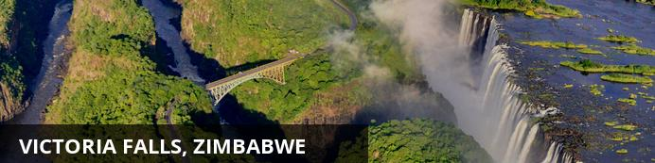
At Victoria Falls, the earth splits open and swallows one of Africa’s greatest rivers, the mighty Zambezi, creating the largest sheet of falling water on earth. As the water hits the narrow depths of the Batoka Gorge beneath, it blasts a cloud of mist skywards, lending the falls their local name ‘mosi-oa-tunya’ (the smoke that thunders). When the Zambezi is its fullest, the mist hangs a permanent raincloud above the falls, showering visitors on even the sunniest of days and visible for miles around.
Above the falls on the upper Zambezi, boats cruise the tranquil water at sunset while the distant spray catches the fading light downstream. Below the falls, the Batoka Gorge’s rocky walls funnel the lower Zambezi into a chain of world-class rapids, prime for white water rafting.
Aside from being a UNESCO world heritage site and a natural world wonder, Victoria Falls also forms a natural border between Zimbabwe and Zambia. The falls can be seen from both countries, and for the most part the same activities are offered on both sides, from helicopter scenic flights to village visits and souvenir shopping.
Whether your idea of getting away from it all is a relaxed high tea in colonial grandeur or a heart-stopping bungee jump off a bridge, Victoria Falls keeps both the faint of heart and the most insatiable of adrenalin junkies busy for days.
From Zambia, a side on view of the falls is on offer with views into the Batoka Gorge, as well as the possibility of perching yourself at the edge of the falls on the vertigo-inducing Livingstone Island.
From Zimbabwe, you’ll get a full-frontal view of three quarters of the falls’ 1.7km wide curtain of water from viewpoints and footpaths meandering through a rainforest kept hot and humid by the spray of the falls.

Overnight: Old Drift Lodge View iBrochure
Includes: meals, two game activities daily, local drinks, return Victoria Falls/Livingstone airport transfers, town shuttle & laundry
Excludes: premium drinks, additional activities, Falls Tour and Conservation park fees
Included Activities: morning and afternoon game drives and river safaris, bush walks, lunch at the Lookout Café including local drinks (on request), guided Tour of the Falls (excluding Entry Fee)
Old Drift Lodge nestles in the untouched, beautiful surrounds of the Zambezi National Park, only 4.5km upstream from Victoria Falls. An abundance of wildlife inhabits the park which can be explored by road, river or on foot. The region’s rich natural heritage is reflected in the lodge’s fourteen graceful tented rooms. All carefully styled rooms feature spacious, ensuite bedrooms with indoor/ outdoor showers, outdoor “bath with a view”, complimentary mini bar drinks in rooms, deck and private plunge pool. Four are ensuite family rooms.
With sweeping 360° views from the splendour of the Zambezi River through to a waterhole (and back to the river), the main lodge area boasts a breath-taking dining and bar setting. Game drives follow the river course whilst pontoon boat safaris offer unique views of wildlife along the banks as well as in the water. Large mammals including giraffe, eland, zebra, elephants and buffaloes roam the park, as do secretive predators. Guided bush walks afford fascinating ways to discover the smaller creatures, plants and numerous birds of the park. A guided Tour of the Falls and lunch at the Lookout Café bring guests incredibly close to the awe-inspiring Falls.
Airport Transfer Time: 40 minutes from Victoria Falls Airport
Zambezi National Park is a national park located upstream, just 5km from Victoria Falls on the Zambezi River in Zimbabwe and comprises 40km of Zambezi River frontage. It was split off from Victoria Falls National Park in 1979 and is 56,000 hectares (140,000 acres) in size. The park is bisected by a road to Kazungula, dividing it into a riverine side and a Chamabonda Vlei side. Most of the park is within the ecoregion of Zambezian and Mopane woodlands, while a small portion in the south is within the Zambezian Baikiaea woodlands.
The Zambezi National Park plays host to a wide variety of larger mammals including African elephant, lion, Cape buffalo and leopard. In addition to these charismatic members of the "big 5" there are herds of sable antelope, common eland, common zebra, Southern giraffe, greater kudu, waterbuck and impala. In addition, many species of smaller wildlife can be seen here.
Over 400 species of birds have been recorded within the Zambezi National Park. Pel's fishing owl, African skimmer, collared palm thrush, lanner falcon, goliath heron, African finfoot, rock pratincole and long-toed lapwing are considered to be among the speciality birds of the park. Aside from birds and land animals, there are 75 species of fish located in the park, including the famous tiger fish.
The easiest way to access the Zambezi National Park is via the Zambezi River Game Drive, which is extensive network of roads along the banks of the Zambezi and is accessed through the main gate. There is a 25-kilometre Chamabondo Game Drive that can take the visitor into the wilder the southern part of the Park, and which starts 5 kilometres south of Victoria Falls town; just off the main Victoria Falls to Bulawayo road.

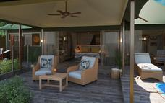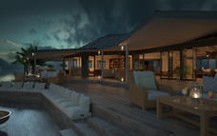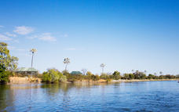

Day 10
End of Itinerary

Activities
Travel For Impact SD

Travel For Impact
Travel for Impact – Responsible Travel
By booking this itinerary USD$1 is contributed for every night of travel per person on the booking. The contribution goes to Travel for Impact (TFI) and ensures that your safari has a meaningful impact on the people who live locally.
TFI believes in changing lives through travel and provides the link between donors and beneficiaries. They assess NGO's (Non Government Organisations) at various levels, including their effectiveness and financial integrity. They provide a mentorship for the organisations in being sustainable and ultimately to grow the impact and reach of each organisation.
Thank you for contributing towards Responsible Tourism Botswana.
For more information you can visit www.travelforimpact.com
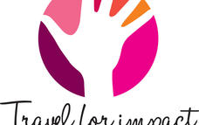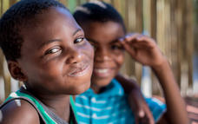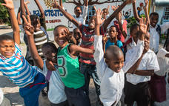

Travel Information
• Please take note of our Booking Terms & Conditions. It will be understood that these have been read and accepted by you on receipt of confirmation of the booking.
• For your safety and peace of mind, on confirmation of your booking, we strongly recommend that Travel Insurance is arranged to cover cancellation, curtailment, emergency evacuation, medical and repatriation expenses, damage/theft/loss of personal luggage, money and goods.
• Road and air transfers and activities are quoted on a seat basis (shared) unless otherwise requested or specified. Passengers may have various stops en-route to a destination. The transfer or charter company reserves the right to specify departure and arrival times. Private charters can be requested at an additional cost.
• Passengers weighing over 100kg should please advise us at the time of booking, as we may need to cost in an additional seat on internal flights for your safety and comfort.
• The costs are subject to change at any time due to fluctuations in fuel costs, taxes, levies, government regulations, rate of exchange and factors that are imposed upon us by our suppliers that are beyond or control.
• Please advise us of the ages of children (under 18) travelling, together with their date of birth, at the time of booking as not all lodges accept children and there may be restrictions or conditions which can affect pricing.
• We recommend that optional activities be booked in advance at time of confirmation to guarantee availability e.g. Elephant Back Safari in Victoria Falls
• Please allow a minimum 2-3 hours connection time in Johannesburg for international flights. It is important that you check that your flight tickets have been issued in your full names as per your passport.
• We require full payment for international and domestic scheduled flights at the time of confirmation e.g. Air Botswana JNB/MUB, Proflight LIV/LUS. We are not able to guarantee any flights before receipt of payment as seats are often held for a limited period before ticketing is required so this is a time sensitive issue. Air tickets are considered non refundable unless otherwise specified. Please confirm the details with your consultant at the time of booking.
Passports, Visas and Travel Documentation
Your passport must have at least 6 months validity before the expiry date and 6 empty pages (not including the endorsement pages). The onus is upon the guests to ensure that passports and visas are valid for the countries visited. Please note that certain visas can take up to 3 months to be processed so please consider this when booking.
If you are travelling with children through Southern Africa please be aware that you will be required to have certified copies of their unabridged birth certificates, and passports on hand. If you are not their legal parents, or if only one of you is travelling – you will need to have consent in the form of an affidavit giving you permission to travel with the child.
Inter-camp transfers
Due to the vast distances involved in travelling in the remote areas of Southern Africa - your itinerary may include road, boat and air transfers in small aircraft.
On shared air transfers, all the flight times between lodges are arranged a few days before the flights take place to avoid endless schedule changes. The lodge or camp where you are staying will be advised of your departure time the day before travel and will ensure that you are at the airstrip on time. Although every effort will be made to ensure that guests are transferred together in one vehicle / aircraft, this cannot be guaranteed, especially with larger groups. The aircraft used for inter-camp transfers vary in size from 3, 5, 7 and 12 seater aircraft. We recommend that guests susceptible to motion sickness take appropriate precautions due to flying conditions.
Weight & Luggage Restrictions
There are strict luggage restrictions in place on any itinerary, which includes light aircraft transfers for safety reasons. Luggage, including camera equipment and hand luggage, is restricted to 20 kg per person travelling on seat rates. Only soft bags will be accepted - no hard suitcases or bags with wheels can be transported, as they physically cannot fit into the aircraft.
The maximum dimensions of the soft bags that can be accommodated are as follows: 25cm/10 inches wide x 30cm/11 inches high and 62cm/24 inches long. Please keep in mind that the baggage compartments on the light aircraft are only 25cm high, so the pilots must have the ability to manipulate the bag into the compartment. Note that laundry can be done on a daily basis at most camps and lodges.
Should you arrive with excess baggage without prior warning, your baggage could be delayed, as we may have to fly the baggage into camp at a later stage at considerable extra cost to you. However, should you notify us in advance that your baggage will exceed the limit; we may be able to assist you with alternative arrangements e.g. storage or purchase of additional luggage allowance.
For bookings including flights within Zambia & Mozambique, please note luggage weight exceptions under destination information.
Lost Luggage
Lost luggage on international flights is a common problem facing travellers today. We suggest that you pack a small bag with your essentials, including any life sustaining medication, which can be carried with you as hand luggage. If travelling as a couple or family we suggest that you split your clothing between bags so that if one bag gets lost, you will have basic items on hand to see you through the first couple of days while we try and recover your lost baggage.
Please note that whilst we try our utmost to locate and re-unite you with your bags, that there may be charges involved in getting your bags to remote areas, which would be for your cost. Please remember to report the lost luggage to the airline as soon as you make the discovery - the airline will issue you with a Baggage Claim Form, which you will need in order for us to trace the bag.
Health and Dietary
Please note that you are travelling to a Malaria-risk area. Please consult your doctor for medical advice prior to travel.
Although usually safe to drink, we do not recommend that you drink the tap water. Filtered water is available at the camps and lodges.
The camps are isolated and generally have limited power supply and access to supplies. Please notify us in advance of any special dietary requirements, medical conditions and medical equipment you may need with you. Please carry critical medication in your hand luggage.
Yellow Fever Certificates - are only required if you have travelled to a Yellow Fever area as designated by the World Health Organisation. Please check with your Travel Clinic or doctor well in advance of your departure date.
General Travel Information
• There is no or limited electricity and cell phone coverage in the camps and lodges excluding major towns and cities. All camps do make provision for charging cameras and electronic devices.
• Please ensure that you do not pack any valuables, cameras, cash, laptops in your checked in luggage – these should be kept on your person at all times.
• Please notify us immediately of any changes to flight arrival and departure details as this affects onward transfer arrangements.
• Please note that most camps & lodges in Botswana do not have double beds. Twin beds are pushed together to make up a double room.
• Although every effort is made to adhere to schedules the company reserves the right and in fact is obliged to occasionally change routes and camps on safaris as dictated by changing conditions or unforeseen circumstances.
• By confirmation of the booking, you acknowledge that you have been made aware and accept that the tour carries inherent risks, and that you voluntarily assume all risks which are associated with the tour. You will be required to sign indemnities at the various camps, lodges and service providers, and abide by their operators code of conduct in order to ensure your safety.
• If you have any cause for complaint while travelling, you should immediately bring it to the attention of the camp manager and / or our Maun office that will attempt to resolve the situation immediately.
• Do not remove any animal artefacts, flora or fauna from any of the areas you visit, as there are strict international regulations on the export of such items.
Please refer to the Safari Information (https://dl.dropboxusercontent.com/u/44362671/safari-information.pdf) for further details on preparing for your safari.
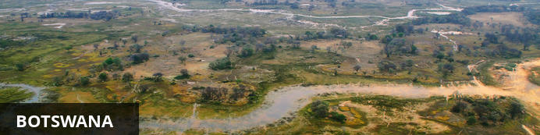
Visa
Some visitors need to apply for visas before arrival please check with your Embassy.
For more information on visas please visit the following address:
Botswana Government - Visa Requirements
BORDER CROSSINGS
Currency
The currency of Botswana is the Pula (BWP). US$ Dollar notes (2007 Series onwards), and Visa and MasterCard are accepted.
Internal Flights and Transfers
Due to the remote areas the camps and lodges are based in, transfers between camps may take place by boat, mekoro, game drive vehicle or light aircraft.
Flight times around Botswana | Approximate flying times
Flight duration times (as listed below), are to be used as an average guideline. They are based on actual flying time, and passengers may have various stops en-route to a destination affecting the total travel time. Your pilot will brief you of your flight route and duration during the safety briefing.
Maun - Delta: 15 to 30 minutes
Delta – Delta: 10 to 20 minutes
Delta - Linyanti: 30 to 40 minutes
Maun – Linyanti: 50 to 60 minutes
Linyanti - Kasane: 40 to 60 minutes
Maun/Delta - Kasane: 60 to 80 minutes
Maun - Makgadikgadi/Desert: 40 to 60 minutes
Departure Taxes
Departure taxes are included in ticket prices.
Weight & Luggage Restrictions
See Booking Information

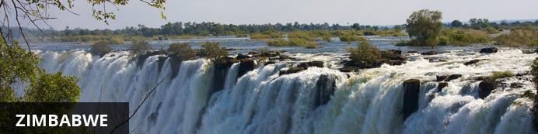
Currency
The currency of Zimbabwe is the American Dollar (US$). US$ Dollar notes (2007 Series onwards), and Visa and MasterCard are accepted. Always have enough US$ cash available in smaller denominations in the event where ATM's and Credit Card facilities are not operational.
Visa
Fees for Visitors to Zimbabwe who are eligible to receive their visa on entry
Europe and USA: US$ 30.00 for single entry/ US$ 45.00 for double entry.
UK & Ireland: US$ 55.00 for single entry/ US$ 70.00 for double entry.
Canada: US$ 75.00 for single entry/ double entry to be obtained from local embassy prior to travel
Some visitors need to apply for visas before arrival - please check with your Embassy, Zimbabwe Government Visa Requirements. ALWAYS have cash available in the correct US$ amount at ALL ports of entry.
Kaza Univisa – Zimbabwe and Zambia
Travellers planning to visit both Zimbabwe and Zambia should apply for a UniVisa (also known as KAZA visa). The visa can be obtained in advance, as well as at ports of entry, but cannot be guaranteed.
The UniVisa allows travellers 30 days travel within both Zambia and Zimbabwe, and is also valid for daytrips to Botswana. Travellers must remain within Zambia & Zimbabwe for the visa to stay valid. Visiting Botswana as a daytrip will not affect the visa’s validity, provided travellers return to Zambia or Zimbabwe the same day.
Internal Flights and Transfers
Due to the remote areas the camps and lodges are based in, transfers between camps may take place by boat, train, game drive vehicle or light aircraft.
Departure Taxes
International departure taxes are included in the scheduled flight rates. However light aircraft transfers from Victoria Falls Airport to Livingstone or Kasane require an International Departure tax of US$35 per person & AIDF Levy of US$15 = US$50 per person to be paid in cash.
Domestic departure taxes are payable in cash at the airport, for any flights departing internally from any registered, manned airport. These include Harare, Bulawayo, Kariba, Hwange and Victoria Falls Airport. The amount is US$10 departure tax + US$5 AIDF Levy = US$15 per person. We recommend small denominations for easier and quicker transactions as change is not always available. Traveller’s cheques and credit cards are NOT accepted.
Weight & Luggage Restrictions
See Booking Information

