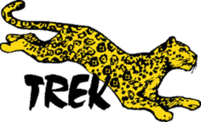

Tanzania Safari and Gorilla Trekking in Rwanda

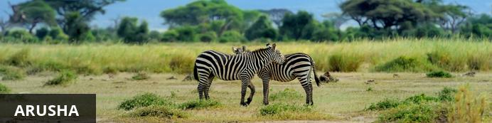
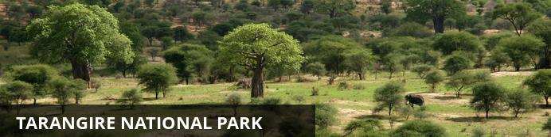
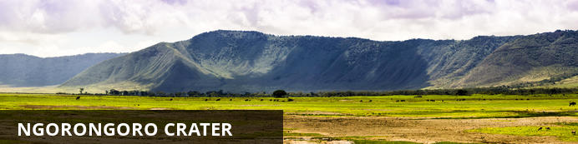
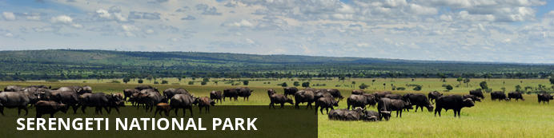
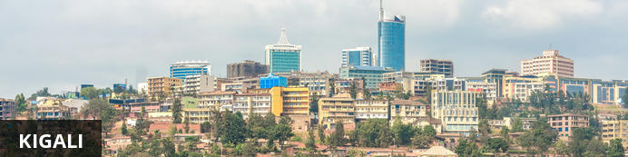
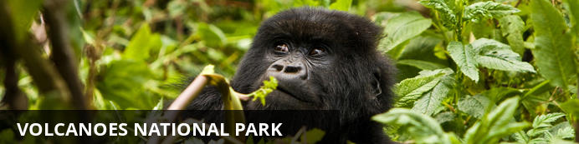

Tanzania Safari and Gorilla Trekking in Rwanda
Arusha - Tarangire National Park - Ngorongoro Crater - Serengeti National Park - Kigali - Volcanoes National Park
11 Days / 10 Nights
Date of Issue: 30 October 2017

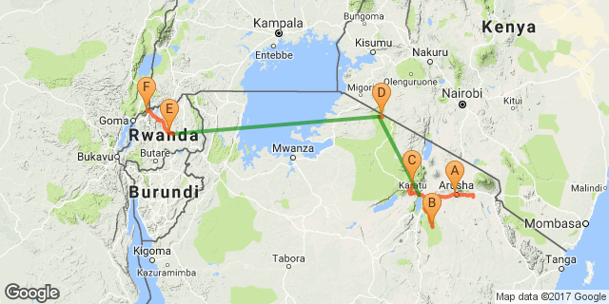

Overview

Accommodation | Destination | Nights | Basis
Elewana Arusha Coffee Lodge | Arusha | 1 | B&B
Oliver's Camp | Tarangire National Park | 2 | FI
Lemala Ngorongoro Tented Camp | Ngorongoro Crater | 2 | FI
Olakira Mobile Camp (Jun-Nov) | Serengeti National Park | 2 | FI
Kigali Serena Hotel | Kigali | 1 | B&B
Bisate Lodge | Volcanoes National Park | 2 | FI

Key
B&B: Bed and breakfast
FI: Fully inclusive

Price
2018
June travel - from US$ 12,500.00 per person sharing
Itinerary accommodations subject to change based on availability.

Included
Cost Includes – Rwanda
Meet and greet services
Assistance at the airport
English speaking guides throughout
Use of a Private vehicle for transfers
Guaranteed window seat on safari vehicle
All accommodation and meals as specified
All park fees and government taxes
One Gorilla viewing permit
Cost Includes – Tanzania
Meet and greet services
Depart by Private 4x4 vehicle with photo roof (maximum 6 clients per vehicle) for Tarangire and Ngorongoro sector
Shared 4x4 vehicle with photo roof (maximum 07 client per vehicle ) for Northern Serengeti
Services of an English-speaking driver-guide
Guaranteed window seat on safari vehicle
Game drives , crater tour and park fees
All accommodation and meals as specified
One bottle of mineral water per person per day during game drives for Tarangire and Ngorongoro
Flight Auric air Lake Manyara to Kogatende + Kogatende to Kigali inclusive taxes and surcharges

Excluded
International flights
Visas
Airport tax (International)
Guide or local escort gratuities
Drinks and dining rooms tips, porterage, personal travel and baggage insurance for Tanzania / Rwanda
Telephone bill, laundry and any items of a personal nature

Day 1: Elewana Arusha Coffee Lodge, Arusha

Day Itinerary
On arrival into Kilimanjaro International Airport and clearing customs and immigration, you will be met and transferred to Arusha Coffee Lodge for an overnight stay.

Consultant Notes
Passengers should bring only soft sided bags on safaris.
All the passengers must have Identification Card/Passport with them for internal flights.
Baggage on internal flights is strictly limited to 15kgs per person (including hand luggage).
Any excess baggage will be charged by the airline at check-in

Arusha
Arusha is the safari capital of Tanzania located at the foot of Mt. Meru, close to Mount Kilimanjaro, the Manyara, Tarangire and Ngorongoro National Parks. From there it’s only a short trip to the Serengeti. Just to the north, on the slopes of Mt. Meru is the Arusha National Park.
Built by the Germans as a centre of colonial administration because of the temperate climate, Arusha is a good spot to take a day or two off from your safari.

Overnight: Elewana Arusha Coffee Lodge
Located in the middle of a verdant coffee plantation, Arusha Coffee Lodge is a sanctuary of aromatic tranquility and a welcome retreat after a long international flight, or the dust and excitement of a thrilling bush safari.
Take residence in one of 30 luxury wooden chalets - 12 Plantation Suites and 18 Plantation Rooms - nestled amongst the surrounding gardens and sea of coffee trees.
Turning off the road, a tree-lined drive guides you to the warm and inviting main area with its quiet understated aura of luxury. Vibrant gardens, a spa, and a swimming pool await, and a restaurant, Bacchus, and café bistro, 3° South, boast menus to satisfy the most discerning of palates, successfully fusing international culinary prowess with locally-sourced ingredients.
Visitors are also welcome to enjoy convenient gift shopping at the Traders Walk Boutiques, located on site. Browse through a collection of five boutiques offering arts and crafts, jewellery, clothing, gourmet coffee and cakes and traditional Swahili food.

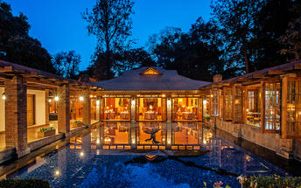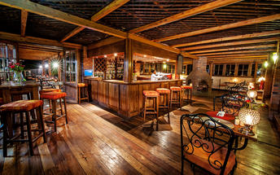

Included
Bed & Breakfast

Day 2: Oliver's Camp, Tarangire National Park

Day Itinerary
After breakfast, your guide will meet you and enjoy a scenic drive to Tarangire Park.
Enjoy game viewing en route arriving for lunch at Oliver's Camp.
Enjoy an afternoon game drive in Tarangire National Park.

Consultant Notes
As you have a private guide and vehicle, you may set your own pace.

Tarangire National Park
After the Serengeti, Tarangire has the greatest concentration of wildlife in Tanzania and in the dry season the Tarangire River is a magnet for thirsty wildlife. Large herds of elephants and migratory wildebeest, zebra, buffalo, impala, gazelle, hartebeest and eland gather and not surprisingly the predators follow. This is also the one place in Tanzania where dry-country antelope such as oryx and gerenuk are regularly spotted. Tarangire is also known for its spectacular baobab trees, and its breathtaking views of the Masaai Steppe and the mountains to the south.
Located just a few hours drive from the town of Arusha, Tarangire is a popular stop for safaris travelling through the northern circuit on their way to Ngorongoro and the Serengeti. The park extends into two game controlled areas and the wildlife are allowed to move freely throughout.

Two nights : Oliver's Camp
Discover Africa, just as it should be. Oliver’s Camp – in the remote southern reaches of Tarangire National Park – has just 10 beautifully appointed safari tents in a spectacular location close to the game-dense Silale Swamps and overlooking a flood plain of the Minyonyo Pools.
Oliver’s was inspired by the trailblazing camps that pioneered the early days of safari. It gives you direct access to the dense concentration of wildlife you will find year-round in this remote region, as well as the chance to enjoy walking safaris and fly camping. Oliver’s is intimate and personal, staffed by a world-class team that has worked together for many years to perfect a safari experience that guests consistently rank among their best.
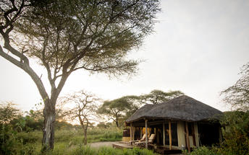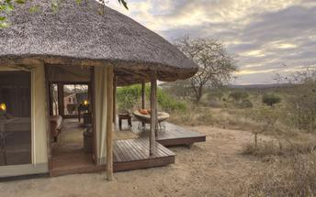

Included
Fully Inclusive
Drinks (Local Brands) Included

Excluded
Gratuities
Personal purchases

Day 3: Oliver's Camp, Tarangire National Park

Day Itinerary
Enjoy a full day of activities.
You may choose to participate in a shared bush walk and a night game drive in the Camp vehicle.
Your private guide will be at your disposal for the day.

Included
Fully Inclusive
Drinks (Local Brands) Included

Day 4: Lemala Ngorongoro Tented Camp, Ngorongoro Crater

Day Itinerary
After an early morning game drive, continue onward to your camp Lemala Ngorongoro for lunch.
Enjoy an afternoon of leisure in the camp or participate on a crater rim walk provided by the camp.

Ngorongoro Crater
The Ngorongoro Crater is game viewing gone crazy and it is not surprising that with is one of Tanzania’s major tourist drawcards. Within the crater rim a daily wildlife drama is played out as large herds of zebra and wildebeest graze nearby lions, leopards, elephants and black rhinos. Outside of the crater a similar drama continues in a more spread out manner with Masai herdsmen thrown into the mix.

Two nights: Lemala Ngorongoro Tented Camp
Lemala Ngorongoro is intimately set in a delightful ancient acacia forest close to the rim of the magnificent Ngorongoro Crater. As it is located next to the quiet Lemala crater access road on the eastern side, a key advantage of staying at Lemala Ngorongoro is the quick and easy drive down on to the crater floor in the morning; Lemala guests usually have an hour's head start over others descending via the far busier Seneto crater access road on the western rim. Game drives from camp may start as early as 6.15am and guests can be down among Ngorongoro’s abundant wildlife on the floor within 10-15 minutes - crucial for photographers who demand the best light conditions. Escorted walks are also available into the forest and along the crater rim with an armed ranger and Maasai guide.
Lemala Ngorongoro Tented Camp has 9 spacious tents that are positioned carefully to provide privacy and with minimal impact on the pristine forest environment. They accommodate two queen-size beds, and as it can get cool on the Ngorongoro Crater rim at night, little luxuries like warm winter-weight duvets, hot water bottles and gas heaters ensure a cosy night's sleep. The roomy en-suite bathrooms contain a dressing area, flush toilet and a large safari-style shower.
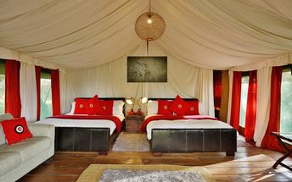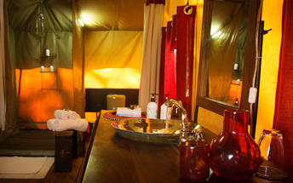

Included
Fully Inclusive
Drinks (Local Brands) Included

Excluded
Gratuities
Personal purchases

Day 5: Lemala Ngorongoro Tented Camp, Ngorongoro Crater

Day Itinerary
Depart camp early this morning for a full day private crater tour with a picnic lunch.
Return to camp in the late afternoon.
Enjoy drinks around the camp fire before dinner.

Included
Fully Inclusive
Drinks (Local Brands) Included

Day 6: Olakira Mobile Camp (Jun-Nov), Serengeti National Park

Day Itinerary
Transfer by camp vehicle this morning to Lake Manyara airstrip for a scheduled charter flight departure at 09:20 am to Kogatende airstrip in the Serengeti.
On arrival at 10:20 am, you will be met by your camp guide and transferred to Olakira Camp.

Serengeti National Park
The Serengeti together with Kenya’s Masai Mara Game Park form Africa’s most famous wildlife park. The image of acacia trees on an endless grass plain epitomises Africa for many, and then add a Masai warrior and some cattle to the picture and the conversation need go no further.
The annual wildebeest migration through the Serengeti and the Masai Mara is the largest mass movement of land mammals on the planet – with more than a million animals following the rains. But that is not where the game viewing ends; large prides of lions, elephants and giraffes in grasslands, gazelles and eland to mention but a few. Aside from traditional vehicle safaris, hot-air ballooning over the Serengeti plains has become almost essential and you can even do a horseback safari.

Two nights: Olakira Mobile Camp (Jun-Nov) View iBrochure
Immerse yourself in the Great Migration at Olakira Migration Camp. You will feel the earth vibrate during brave winter crossings of the mighty rivers in the north, or be moved beyond measure by the mass summer calving on the south’s grassy plains.
Olakira follows the massive herds of wildebeest to two spectacular locations in the north and south of the Serengeti National Park. Home from December to March is the southern Serengeti, where herds of wildebeest calve simultaneously and the plains throng with new life. As the dry days of winter arrive, Olakira relocates north to the confluence of the Mara and Bolongonja rivers for spectacular game viewing at the Mara River itself and around the Lamai Wedge.
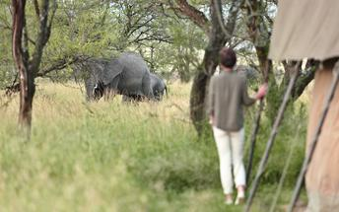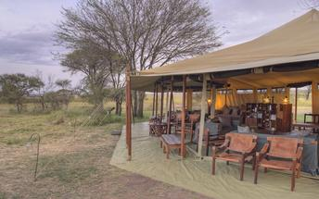

Included
Fully Inclusive
Drinks (Local Brands) Included

Excluded
Gratuities

Day 7: Olakira Mobile Camp (Jun-Nov), Serengeti National Park

Day Itinerary
Enjoy a day of game viewing activities on a shared basis with your camp guide.

Consultant Notes
This is a great location for the migration crossing which usually occurs from July to early November.

Included
Fully Inclusive
Drinks (Local Brands) Included

Day 8: Kigali Serena Hotel, Kigali

Day Itinerary
In the morning proceed for game drive and return to the camp for lunch followed by transfer to Kogatende airstrip for Coastal air scheduled flight departing at 15:10hrs and arriving Kigali airport at 17:25hrs.
Upon arrival into Kigali, transfer to Kigali Serena hotel.

Kigali
Rwanda’s capital and biggest city is built across an undulating series of lush hills surrounded by higher mountains, the largest of which is Mount Kigali, rising 1,850 metres above sea level. Kigali is the country’s financial, commercial and cultural hub, served by an international airport and featuring a wide range of accommodation options, restaurants and points of interest, including the Kigali Genocide Centre, an atmospheric market and numerous craft shops.

Overnight: Kigali Serena Hotel
Ideally located on one of Kigali's most charming boulevards, the five-star Kigali Serena Hotel is built around a polished granite atrium, which showcases the very best of Rwandese cultural art. Relaxed yet elegant, the hotel centres on the Executive Lounge and Bar, which opens onto a wide sundeck overlooking the newly refurbished swimming pool. Also overlooking the pool, the popular Milima Restaurant offers a wide range of all-day buffet choices, while the relaxed Sokoni Café offers inside and outside poolside seating. The capital's natural business hub, the hotel also boasts its own extensive conference centre, 500-seater auditorium and lavish ballroom.
The hotel features 148 rooms. Guests can choose from a selection of 60 Standard Rooms, 37 Superior Rooms, 19 Deluxe Rooms, 18 Junior Suites, 7 Prime Rooms, 6 Executive Suites and a luxury Presidential Suite. In-room facilities include 24 hour room service, air-conditioning, Wi-Fi, tea/coffee making facilities, mini fridge, hair dryer, private safe and a flat screen satellite TV.
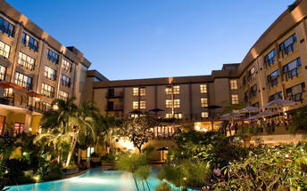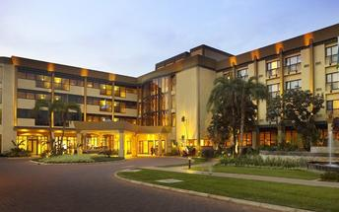

Included
Bed & Breakfast

Day 9: Bisate Lodge, Volcanoes National Park

Day Itinerary
After breakfast , leave Kigali Serena and transfer to Virunga Conservation area (approximately 2.5 hours drive).
If time permits, visit the markets, villages and local communities (at an extra cost payable locally ) or an optional visit to the little known by compellingly beautiful twin lakes Bulera and Ruhondo (payable directly).

Volcanoes National Park
Set high on the jungle-covered slopes of the volcanic Virunga Mountains, Parc National des Volcans is best known as a sanctuary for the region’s rare mountain gorillas. Highly regulated treks through the reserve allow visitors to spend an hour at a time with these incredible primates in their natural habitat.

Two nights: Bisate Lodge View iBrochure
Bisate Lodge is located in the natural amphitheatre of an eroded volcanic cone – the word bisate means ‘pieces’ in Kinyarwanda, describing how the cone was once whole but worn away by natural erosion. The area has dramatic views of the peaks of the volcanoes Bisoke and Karisimbi rearing up through the Afro-alpine forests of nearby Volcanoes National Park. Twelve guests will stay in sumptuous en-suite rooms that maximise comfort and views while retaining environmental principles and reflecting the culture of surrounding rural Rwanda.
Bisate is within easy driving distance of Park Headquarters, from where gorilla treks depart daily. Its vision of reforestation and rehabilitation mean that each guest will contribute to biodiversity conservation and local community engagement – making a far-reaching positive impact on an iconic endangered species: the mountain gorilla.
Aside from tracking one of the several habituated gorilla groups, activities can include visiting attractions such as Iby’wacu cultural village, the Twin Lakes of Buhondo and Burera, the lava tunnels of the Musanze Caves, Dian Fossey’s grave, and even seeing the endemic golden monkey. Walks on the extensive property offer birding and participation in the reforestation programme.
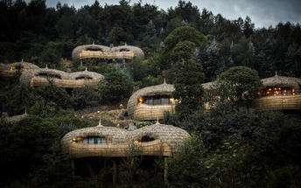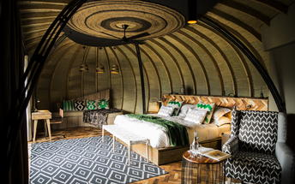

Alternate Accommodation: Virunga Lodge
The magnificent Virunga Lodge is the premier luxury gorilla lodge of Rwanda and one of Africa’s finest and most renowned lodges. The lodge is perched high on a ridge with stunning views of the Virunga Volcanoes and the Musanze valley to the west and Lake Bulera and Ruhondo to the east.
It offers the finest views in Africa, uniquely decorated rooms in the Rwandese style, fantastic food and exceptional and personalised service by our carefully trained staff. It is the first accommodation choice for the luxury traveller tracking the endangered mountain gorilla.
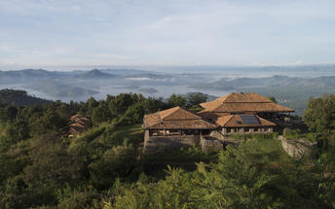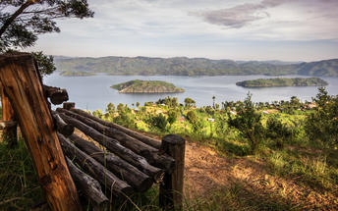

Alternate Accommodation: Sabyinyo Silverback Lodge
The lodge is only minutes away from the headquarters of the Parc National des Volcans from where clients trek on foot to see the magnificent Mountain Gorilla – perhaps one of the most dramatic, thrilling and poignant wildlife experiences possible. Accommodation at Sabyinyo Silverback Lodge comprises five double cottages, two suites and one family suite. All are stone buildings with Rwandese terracotta tile roofs, and feature large sitting areas, fireplaces, stylish en-suite bathrooms finished with Venetian plaster a dressing room and a sheltered veranda. Heat exchangers in the fireplaces provide a plentiful supply of hot water.
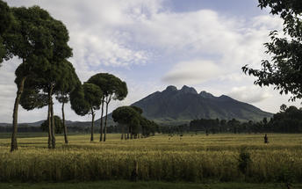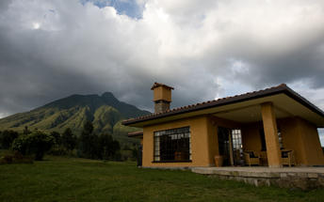

Alternate Accommodation: Mountain Gorilla View Lodge
The Mountain Gorilla View Lodge is perfectly situated for gorilla tracking in Rwanda. The 30 individual cottages have been built on 4 acres of land on the slopes of Mt Sabinyo. The stone and thatch cottages each have en-suite facilities, a small lounge with a fire place and a private veranda. The cottages are of a good size and are well positioned to give them privacy from each other. Being at altitude, it can get cold therefore each cottage has a fireplace in the room.
Located very close (about 15 minutes) from the main headquarters of Rwanda's Volcanoes National Park (Parc National de Volcans), this is a very handy base from which to explore the area and organise treks to see the Golden monkeys and, of course, the mountain gorillas. This is a great location with superb views of the volcanoes.
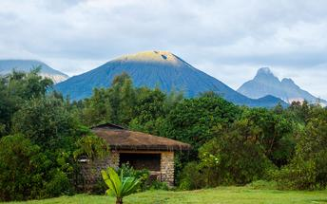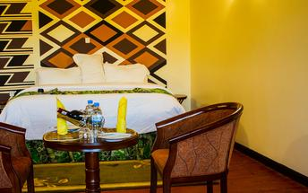

Included
Bed & Breakfast

Day 10: Bisate Lodge, Volcanoes National Park

Day Itinerary
After breakfast in morning transfer to the Volcanoes National Park offices. Briefing by the park's guides on how to behave in the forest and in the presence of mountain gorillas.
You then transfer over mildly bumpy roads to the trail head to start the trek. From the trail head, there is a 10-20 minute walk through fields (cultivated land) to edge of forest.
Here you enter the park for a gorilla trek which will take you until around midday depending on where you find them.
Once the gorillas are located all fatigue is forgotten, as the experience is often described as being the most profound natural history experience in the world.
It is important to take plenty of water.
Good cameras and plenty of fast speed film or memory cards are recommended.
It can rain at a few minutes’ notice, hence waterproof clothing is a good essential including zip lock bags for cameras and film.
After the trek, lunch will be at your hotel and spend rest of the day at leisure

Included
Bed & Breakfast

Day 11: Departure

Day Itinerary
After breakfast, transfer to Kigali airport for the onwards flight home.
BON VOYAGE AND THANK YOU FOR CHOOSING TREK EXPEDITIONS!

Transport

Flight Information
Date | Flight | Departure Airport | Time | Arrival Airport
 | Charter | Lake Manyara Airstrip |  | Kogatende Airstrip
 | Charter | Kogatende Airstrip |  | Kigali International Airport [KGL]

Transfers
Date | Pick Up | Drop Off |  | Vehicle
 | Kilimanjaro International Airport [JRO] | Elewana Arusha Coffee Lodge |  | Transfer
 | Elewana Arusha Coffee Lodge | Oliver's Camp |  | Transfer
 | Oliver's Camp | Lemala Ngorongoro Tented Camp |  | Transfer
 | Lemala Ngorongoro Tented Camp | Lake Manyara Airstrip |  | Transfer
 | Kogatende Airstrip | Olakira Mobile Camp (Jun-Nov) |  | Transfer
 | Olakira Mobile Camp (Jun-Nov) | Kogatende Airstrip |  | Transfer
 | Kigali International Airport [KGL] | Kigali Serena Hotel |  | Transfer
 | Kigali Serena Hotel | Bisate Lodge |  | Transfer
 | Bisate Lodge | Kigali International Airport [KGL] |  | Transfer

