Classic Luangwa

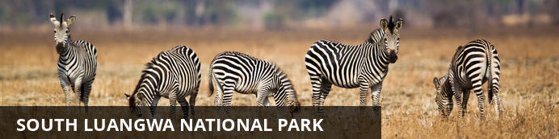

Classic Luangwa
South Luangwa National Park
11 Days / 10 Nights
Date of Issue: 02 March 2018

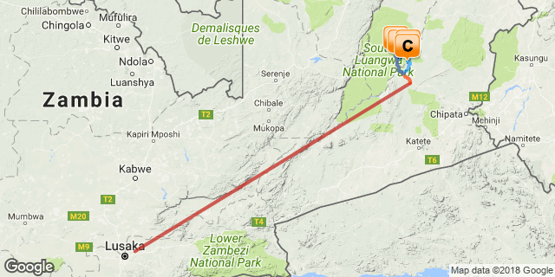

Click here to view your Digital Itinerary

Introduction
A walking or driving safari in the Luangwa Valley, Zambia
A 10-night itinerary staying in superb Bushcamps in the South Luangwa National Park, one of the greatest wildlife sanctuaries in the world – an unspoilt, wilderness and Zambia’s premier National Park. The Luangwa River and its associated ox-bow lagoons have the most intense concentrations of hippos and crocodiles in Africa, over 60 species of mammals and over 400 species of birdlife. This is a great value safari with an actual saving of 2 nights. It is an ideal holiday for those wanting to get away from the hustle and bustle of everyday life.

Accommodation | Destination | Nights | Basis | Room Type
Luwi by Norman Carr Safaris | South Luangwa National Park | 2 | FI
Nsolo by Norman Carr Safaris | South Luangwa National Park | 3 | FI
Kakuli by Norman Carr Safaris | South Luangwa National Park | 3 | FI
Mchenja by Norman Carr Safaris | South Luangwa National Park | 2 | FI

Key
B&B: Bed and breakfast
FI: Fully inclusive

Price

Included
Accommodation, all meals, park fees, standard bar drinks, house wine, walks and game drives, laundry and flights and road transfers as specified in the itinerary.

Excluded
International flights and visas, tips and other items of a personal nature.

Additional Information

Day 1: Luwi by Norman Carr Safaris, South Luangwa National Park

South Luangwa National Park
Bordering the Luangwa River, the northern and southern Luangwa National Parks contain some of the most breathtaking and untouched wilderness in Africa. As a result of this and the parks’ successful anti-poaching campaigns, the area has developed into a world-renowned wildlife haven. The South Luangwa National Park is renowned for its walking safari, which allows visitors to view elephant, hippo and even lion close-up under the supervision of professional and knowledgeable armed guides.

Day Itinerary
This morning you will fly from the Lusaka International Airport to the Mfuwe airport where your guide will collect you and drive you to your bushcamp. This drive will be part transfer through the village and park game drive of around 2 hours.

Consultant Notes
No Notes Available

Overnight: Luwi by Norman Carr Safaris
Luwi is a seasonal bush camp nestled under huge mahogany trees on the riverbed of the Luwi river. It is situated deep in the heart of the National Park and is one of the only Luangwa safari camps to be positioned well away from the permanent waters and rich vegetation of the main river. Due to its remote location there are not many roads in the area so activities are centred on walking safaris. This fact makes Luwi Bush Camp one of the most enthralling camps in Zambia. The wildlife in the area is prolific and to track it each day on foot is a memory that will last a lifetime. Accommodation is in five rooms that are made of grass and thatch. Each room is designed differently utilising trees and natural vegetation wherever possible. The design of these rooms lends the camp a rustic appeal and provides a truly African bush experience.
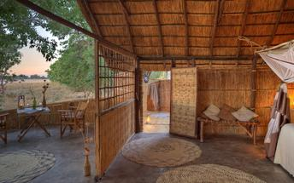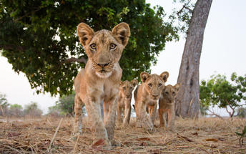

Activities

Optional

Recommended

Included
Fully Inclusive
Drinks (Local Brands) Included

Excluded
Excluded Not Available

Day 2: Luwi by Norman Carr Safaris, South Luangwa National Park

Day Itinerary
Luwi is an authentic and magical remote bushcamp, which makes the perfect camp for walking safaris. The wildlife in the area is prolific and memories of tracking game can last a lifetime. The Luwi area is famous for its lion and wild dogs, which makes for an excellent game viewing safari. Walks can be complimented by game drives to the source of the Luwi or to find the elusive Roan, reed buck, eland and hartebeest. When not on safari, there is a large hippo filled lagoon close by with a hide to watch the animals unnoticed high above the water.

Consultant Notes
No Notes Available

Activities

Optional

Recommended

Included
Fully Inclusive
Drinks (Local Brands) Included

Excluded
Excluded Not Available

Day 3: Nsolo by Norman Carr Safaris, South Luangwa National Park

South Luangwa National Park
See Above

Day Itinerary
No Notes Available

Consultant Notes
No Notes Available

Overnight: Nsolo by Norman Carr Safaris
Nsolo Bush Camp is a luxury safari camp consisting of four individually designed chalets each on raised wooden decks with high thatched roofs and private verandahs.
The rooms are very spacious with the stylish furnishings that one would expect from one of Zambia's luxury walking safari camps. The bathrooms have no roofs and are set under the shade of the trees above.
At Nsolo you don't usually have to search hard for your African safari experience. The wildlife frequents a waterhole in the dry river-bed in front of the camp and often your most exciting game-viewing is from the comfort of your own deck or from the central chitenje that houses the bar and small camp library.
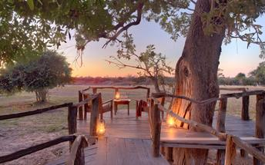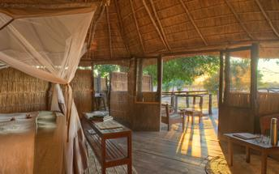

Activities

Optional

Recommended

Included
Fully Inclusive
Drinks (Local Brands) Included

Excluded
Excluded Not Available

Day 4: Nsolo by Norman Carr Safaris, South Luangwa National Park

Day Itinerary
Today you will transfer from Luwi Bushcamp to Nsolo Bushcamp either by foot or by vehicle arriving in camp in time for lunch. In the afternoon, along with the other guests, you will choose to either walk again or go on a game drive.

Consultant Notes
No Notes Available

Activities

Optional

Recommended

Included
Fully Inclusive
Drinks (Local Brands) Included

Excluded
Excluded Not Available

Day 5: Nsolo by Norman Carr Safaris, South Luangwa National Park

Day Itinerary
Nsolo is great for Lions as the area has many lion prides that overlap territories. The cats use the dry river bed as a thoroughfare. This is big game viewing on foot at its best. There is also the opportunity to participate in game drives for those wishing to combine walking and driving. Wild dogs have denned between Luwi and Nsolo for the last 6 years and chances of seeing these elusive creatures are high at certain times of the year.

Consultant Notes
No Notes Available

Activities

Optional

Recommended

Included
Fully Inclusive
Drinks (Local Brands) Included

Excluded
Excluded Not Available

Day 6: Kakuli by Norman Carr Safaris, South Luangwa National Park

South Luangwa National Park
See Above

Day Itinerary
No Notes Available

Consultant Notes
No Notes Available

Overnight: Kakuli by Norman Carr Safaris
Kakuli is a seasonal bush camp that offers some of the best game viewing and night drive safaris in Zambia.
There are four spacious, traditional safari tents under shady thatched roofs, each with an open-air bathroom and one family room which can host up to 5 guests. All of the tents overlook the river with stunning views up and down this hippo-packed stretch of the Luangwa. A lovely thatched chitenje acts as the centre of camp. It is on a wooden deck overlooking the grazing lawn that leads down to the two rivers and is a perfect spot in which to relax and watch the river and the wildlife meander by.
Safari activities from Kakuli will usually be a mixture of game drives and walking safaris.
As well as an exciting base for walking and game drives in the peak season, it is the only true bush camp open in Luangwa’s ‘Secret Season’ 20 Jan – 3 April for our Rivers and Rainbows safaris. At this time of the year the river is high and guests can experience both walking and boating safaris.
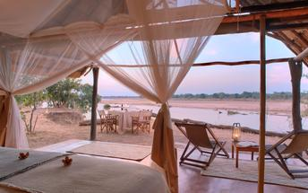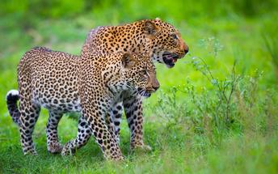

Activities

Optional

Recommended

Included
Fully Inclusive
Drinks (Local Brands) Included

Excluded
Excluded Not Available

Day 7: Kakuli by Norman Carr Safaris, South Luangwa National Park

Day Itinerary
Today, you will either walk or game drive to your next camp, which lies further down the Luwi River, arriving into camp before lunch. Kakuli is a perfect camp in which to relax and watch the wildlife meander by. This area of the park is renowned for offering clients some of the best game viewing opportunities in Zambia. Activities from Kakuli include game drives, walks and boating in the green season.

Consultant Notes
No Notes Available

Activities

Optional

Recommended

Included
Fully Inclusive
Drinks (Local Brands) Included

Excluded
Excluded Not Available

Day 8: Kakuli by Norman Carr Safaris, South Luangwa National Park

Day Itinerary
No Notes Available

Consultant Notes
No Notes Available

Activities

Optional

Recommended

Included
Fully Inclusive
Drinks (Local Brands) Included

Excluded
Excluded Not Available

Day 9: Mchenja by Norman Carr Safaris, South Luangwa National Park

South Luangwa National Park
See Above

Day Itinerary
You will transfer from Kakuli to Mchenja today arriving in camp in time for lunch. Your bags will be waiting in your room. After a siesta, you can either walk or take an afternoon game drive.

Consultant Notes
No Notes Available

Overnight: Mchenja by Norman Carr Safaris
Set in a grove of magnificent ebony trees Mchenja (meaning ebony) is a luxurious, elegant and stylish tented camp overlooking a huge sweeping bend in the Luangwa. Mchenja has been described as one of the most luxurious and romantic bush camps in Zambia. Five specially designed octagonal tents with roll-top baths and outdoor showers string along the Luangwa River affording spectacular views from all rooms. The beautiful central chitenje (lounge) is built around one of the old fallen Mchenja (ebony) trees and lunch is taken in the shady lounge but dinner is more often served on the river bank under the stars.
Elephants are known to drink from the plunge pool in the main area and lions and leopard are frequently seen wandering around the nearby ebony grove and permanent lagoon. Mchenja is situated in a superb game-viewing area where walking safaris, game drives and night drives are always productive and exciting.
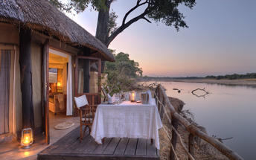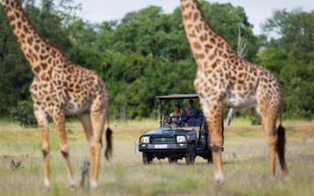

Activities

Optional

Recommended

Included
Fully Inclusive
Drinks (Local Brands) Included

Excluded
Excluded Not Available

Day 10: Mchenja by Norman Carr Safaris, South Luangwa National Park

Day Itinerary
Mchenja meaning Ebony occupies a stunning setting beneath a grove of ebony trees on the banks of the Luangwa River. Mchenja is a luxurious and elegant tented camp overlooking a sweeping bend in the Luangwa River. Elephants are known to drink from the pool and lions and leopard are frequently seen wandering around the nearby ebony grove. Mchenja is situated in a renowned game viewing area where walking safaris, game drives and night drives are always exciting.

Consultant Notes
No Notes Available

Activities

Optional

Recommended

Included
Fully Inclusive
Drinks (Local Brands) Included

Excluded
Excluded Not Available

Day 11: Departure

Day Itinerary
On your final morning, you will be driven to the airstrip to fly back to Mfuwe airport for your onward flight.

Consultant Notes
No Notes Available

Activities

Optional

Recommended

Included
Included Not Available

Excluded
Excluded Not Available

Transport

Flight Information
Date | Flight | Airline | Departure Airport | Time | Arrival Airport | Time | Class | Ref
 | Scheduled |  | Kenneth Kaunda International Airport [LUN] |  | Mfuwe Airport [MFU]
 | Scheduled |  | Mfuwe Airport [MFU] |  | Kenneth Kaunda International Airport [LUN]

Transfers
Date | Company | Pick Up | Drop Off | Time | Vehicle
 |  | Mfuwe Airport [MFU] | Luwi by Norman Carr Safaris |  | Transfer
 |  | Mchenja by Norman Carr Safaris | Mfuwe Airport [MFU] |  | Transfer

Urgent Contact Numbers
Company Name | Telephone | Email Address | Contact Person
Safari Adventures Worldwide | (303)447-1195 | charles@safariadventuresworldwide.com | Charles Williams

Contact Details & Reference Numbers
Service Provider | Ref. Number | Telephone | Address
Kakuli by Norman Carr Safaris |  | +260 21 6246025 | Kapani Lodge  PO Box 100  Mfuwe  Eastern Province  Zambia
Mchenja by Norman Carr Safaris |  | +260 21 6246025 | PO Box 100,  Mfuwe,  Zambia

Terms and Conditions

Safari Adventures Worldwide Terms and Conditions
Payment Terms
o Arrangements are booked and confirmed on receipt of a 30% Nonrefundable Deposit.
o There shall be no binding contract until the deposit has been paid in full.
o Failure to remit your deposit on time may result in an automatic release of the confirmed space and the possible inability to reinstate your reservation.
o When the Company acknowledges, in writing to you, receipt of the deposit shall be deemed to constitute acceptance and confirmation of the reservation.
o By paying a deposit you, the client, The Company and any applicable operating company are deemed to be under contract for the dates quoted and your safari.
o The balance is due no later than 60 days before commencement of your trip.
o If the balance due has not been received by this date, The Company shall be entitled, at its discretion, to treat your reservation as cancelled and consequently your deposit will be forfeited.
Cancellation Policy
o Any cancellation of reservation must be in writing and shall only be effective upon its acknowledged receipt by The Company.
o In the event of a cancellation you will forfeit the deposit in total.
o If you cancel your trip after the final balance has been paid, the Safari rate is forfeited in full.

