Summer weekend in Valencia
Valencia
4 Days / 3 Nights
0 Persons
Date of Issue: 07 December 2017
22 August 2018 - 25 August 2018

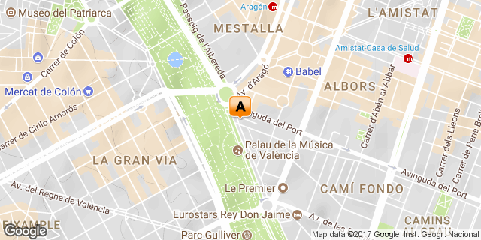

Click here to view your Digital Itinerary

Overview
For years, Spain's third-largest metropolis lingered in the shadow of the country's "Big Two" (Madrid and Barcelona). But thanks to some snazzy new cultural draws, and rejuvenated old quarters, Valencia has emerged as one of Europe's most talked-about city breaks. A blissful Mediterranean climate – balmy summers and extremely mild winters – makes Valencia an alluring year-round destination.

Accommodation | Destination | Arr. | Dep. | Nights | Basis | Room Type
SH Valencia Palace | Valencia | 22 Aug | 25 Aug | 3 | B&B

Key
B&B: Bed and breakfast

Price
Available on request.

Day 1: Wednesday, 22 August
SH Valencia Palace, Valencia

Day Itinerary
A walk in the old city center is very pleasant, and what is enjoyed the most is being able to walk on the narrow streets and observe the beautiful old buildings everywhere. There are abundant sights to see as you make your way through the city, but here are some of the highlights:
The North Station (Estació de Nord) is the main train station in Valencia, a beautiful modernist building with lot of details in its facade. These details are mostly dedicated to the agricultural activities around Valencia, related to their most famous product, the delicious Valencian orange. Just around the bend, you cannot miss the City Hall, which is an impressive building, presiding the main square of the city.
The Central Market of Valencia occupies a beautiful building, and you will have a great time just getting lost amongst the stands selling fruit, vegetables and meat. Just next to the market you can find the most spectacular building of the old neighborhood, the Lonja, one of the most impressive examples of Gothic civil architecture. It was built during the golden century, and well represents the commercial prosperity of the city in that era.
The extraordinary Cathedral in the Plaza de la Virgen square is also a majestic piece of Gothic art and on the border between the old medieval town and the new town of Valencia stood the medieval wall of the city. Today, only the towers remain from this wall, the Torres de Serrano and Torres de Quart, both of them are impressive and you can enjoy a nice view from the top.
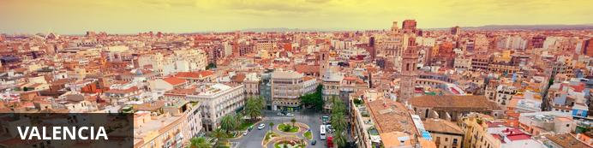
Resting on Spain’s southeast coast, where the Turia River meets the Mediterranean Sea, the charming port city of Valencia is the capital of the Old Kingdom of Valencia province. The city is renowned for its impressive cultural and architectural complex known as the ‘City of Arts and Sciences’ comprised of a number of futuristic structures including a planetarium, an oceanarium, and an interactive museum. The cobbled alleys of the historic old town are lined with numerous attractions including the the bustling marketplace of the grand Plaza del Mercado and the Gothic Valencia Cathedral, home to what many consider to be the authentic Holy Grail. With its thriving nightlife and restaurant scene, quality museums, exquisite Blue Flag beaches, and a characterful historic quarter, it is little surprise that Valencia is developing into a hugely popular tourism centre.

Overnight: SH Valencia Palace
The SH Valencia Palace is located in the heart of the cultural centre of the city of Valencia, a well known area for its modernism and constant innovation. It is located between the prestigious Palau de la Música and the “City of the Arts and Sciences” scientific museum. The hotel features 239 rooms equipped with plasma TVs, minibars, safes big enough for laptops, air conditioning, bathrobes and slippers, and Rituals bathroom amenities. Hotel facilities include 24 hour room service, express laundry service, a pillow menu, wellness centre, and swimming pool.
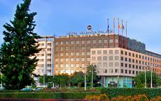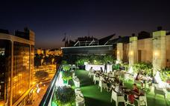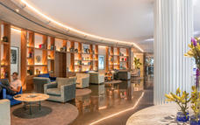

Alternate: Caro Hotel
Caro Hotel is located in the Seu-Xerea neighbourhood, in the heart of the city of Valencia. The hotel features 26 comfortable and inviting rooms, each appointed with free Wi-Fi internet service, safety deposit box, a pillow menu, writing desk, mini-bar, air conditioning, telephone and free tea service. Hotel amenities available to guests include an on-site restaurant, and a splash pool.
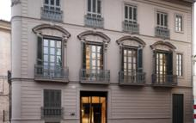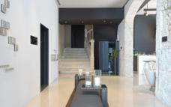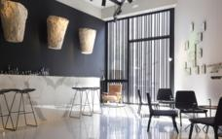

Recommended
Valencia City Hall
The Silk Exchange
Plaza de la Virgen
Valencia Cathedral
Serranos Towers
Quart Towers

Valencia City Hall
Valencia City Hall is located in Valencia's city centre. The building has a modern design and features a marble staircase, a clock tower, municipal archives, administrative offices, and a museum. The hall is open Monday to Friday from 10h00 until 13h30.

The Silk Exchange
The Silk Exchange is an exquisite example of European Gothic civil architecture, built in the 15th century under master mason Pere Compte. The building is located in Valencia, and is made up of a tower, Orange-tree Patio, Sea Consulate Room, and the Room of Columns. The site is open daily for visitors to explore, and on Sundays hosts an exhibition of coins and stamps.

Plaza de la Virgen
Plaza de la Virgen is located in Valencia's historic centre. The plaza features a vibrant atmosphere and plenty of cafes, restaurants and bars. Visitors to the area will see la Fuente del Turia, the cathedral, the Miguelete, and the entrance to the Barrio del Carmen. The plaza comes alive during the festival of Las Fallas, where locals create a huge wooden structure of the Virgin Mary and adorn it with flowers.

Valencia Cathedral
The Valencia Cathedral is the mother Church of the Christian community in Valencia. The cathedral is dedicated to worship, and welcomes believers and men of good will. Witness to the passing of the centuries, its history is master of humanity and its images, archives and the architecture are signs of the cultural and religious vitality of the Valencian Christian people from the 4th century onwards. Valencia Cathedral is not a museum, though there are many interesting archives to view and contemplate.
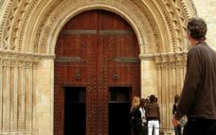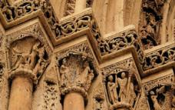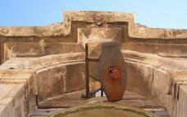

Serranos Towers
The Serranos Towers were built at the end of the 14th century as part of Valencia's fortification. The gothic towers were constructed by Pere Balaguer and initially housed prison cells. Visitors to the Serranos Towers can see picturesque views of the river Turia and the city from the terraces. The historic attraction is open daily and entry is free on Sundays.

Quart Towers
Quart Towers is a historical landmark located in Valencia, Spain. The towers are remains of the old city walls and served a defensive function in the 19th century, when Napoleon entered Valencia through their gates.

Included
Bed & Breakfast

Day 2: Thursday, 23 August
SH Valencia Palace, Valencia

Day Itinerary
Today you will be off to two of Valencia's main attractions!
The first is the Bioparc, which is a new-generation zoo, quite different from those we had seen before. In the Bioparc, different ecosystems of Africa has been recreated, like the Savannah, Madagascar or the Jungle, and the animals seem to be almost free. Instead of cages there are natural borders, like artificial rivers or lakes that separate the animals from each other. This kind of zoo permits an immersion of the visitors to the natural living space of the animals. It’s especially great for families, since in the zoo they propose loads of special activities, mostly for kids.
The City of Arts and Sciences is one of the most iconic places to visit in Valencia, in just a few years since its opening at the end of the last century, it has become one of the main symbols of the city. In this modern complex designed by the Spanish architect Calatrava, you can find the Museum of Sciences, the Palace of Arts, the Planetarium/IMAX (Hemisfèric) and the biggest aquarium in Europe (Oceanogràfic).
n the Museum of Sciences, you will find an infinite selection of interactive activities to understand different aspects of Science in an entertaining way. In the Hemisfèric you can enjoy fantastic 3D documentaries about Nature or Science, and probably the most impressive part of the museum complex is the Oceanogràfic. Your visit to Valencia can’t be complete without spending a few hours in this fantastic aquarium. It’s like finding yourself in the middle of an underwater documentary. The aquarium is divided into different sections according to the different habitats of marine species, such as the Mediterranean, tropical seas or the Red Sea amongst others.
The most spectacular part is the 35 meter long tunnel, where big sharks basically swim over your head. Just sitting there and observing these enormous sea animals was one of our favorite things to do in Valencia without any doubt!

Activities
Bioparc Valencia
City of Arts and Sciences
Hemisferic
Oceanografic

Optional
Prince Felipe Science Museum
Palace of the Arts Queen Sofia

Bioparc Valencia
Bioparc Valencia is an innovative project that offers visitors the chance to venture into wild animal enclosures where social groups of species coexist with other species, as it is in nature. Bioparc Valencia is an animal park that has been designed under the concept of zoo-immersion. The incorporation of multi-species enclosures makes it possible for visitors to enjoy a unique experience only usually found in the wild. Visitors will see a variety of animals including giraffes, leopards, porcupines, meerkats, African lion, dwarf mongoose, pygmy mice, warthogs, and more.
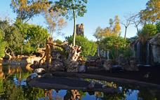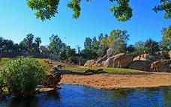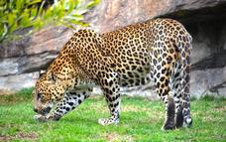

City of Arts and Sciences
City of Arts and Sciences is an entertainment-based scientific and cultural complex in Valencia, Spain. Visitors to the complex can experience interactive exhibitions, take part in workshops, enjoy 900 square metres of screen in the only IMAX dome in Spain, get to know the planet's main marine ecosystems in the Oceanogràfic, and much more.
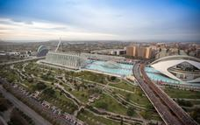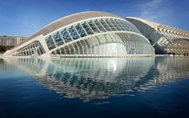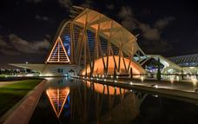

Hemisferic
The Hemisferic was inaugurated in 1998 and was the first building in the City of Arts and Sciences to open its doors to the public. It is a spectacular construction designed by Santiago Calatrava, with an ovoid roof over 100 metres long that contains in its interior the large sphere that constitutes the projection room. Hemisferic is a remarkable and spectacular building that represents a huge human eye, the eye of wisdom. This symbolises the observation of the world that visitors discover by means of surprising audiovisual projections.

Oceanografic
Oceanografic of Valencia is the biggest aquarium in Europe. Situated inside the architectural complex of the City of the Arts and Sciences, the aquarium reproduces faithfully the most important marine ecosystems. Habitats available for visitors to see include the Antarctic, Red Sea, Oceans, Dolphinarium, Artic, Mediterranean, Temperate and Tropical, Islands, Wetlands, Crocodilary, and the Butterfly Room. Activities at the Oceanografic include sleeping with the sharks, diving with the sharks, Trainer For a Day programme, visiting the other side of the aquarium, and more.
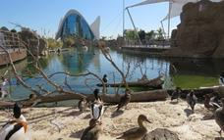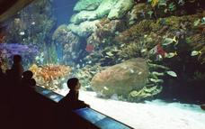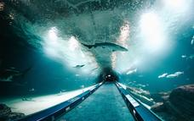

Prince Felipe Science Museum
Prince Felipe Science Museum is a 21st-century science museum that allows visitors to learn everything to do with life, science, and technology, in a didactic, interactive, and entertaining way. The museum's main objective is stimulating curiosity and critical thinking and at the same time surprising and amusing the public by its contents from the world of science, technology, and the environment.
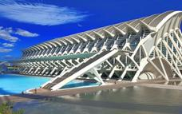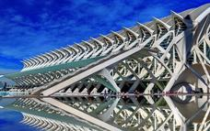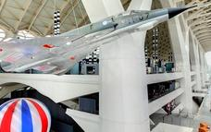

Palace of the Arts Queen Sofia
Palace of the Arts Queen Sofia is an opera house located in Valencia, Spain. The opera house hosts symphonic concerts, opera galas, and vocal recitals. The building measures 75 metres in height, features 17 stories and is the world's tallest opera house. Palace of the Arts Queen Sofia comprises of The Sala Principal, The Auditorium, Aula Magistral, and the Martí i Soler Theatre.

Included
Bed & Breakfast

Day 3: Friday, 24 August
SH Valencia Palace, Valencia

Day Itinerary
The activity for the third day is related to the dish Valencia is famous about, the PAELLA!
Although it might seem odd that eating a paella in a restaurant can be a full-day activity, but you will discover that eating a paella in the Barraca de Toni Montoliu is much more than just tasting the famous Valencian rice dish.

Activities
The Barraca by Toni Montoliu

Optional
Casa Montana

The Barraca by Toni Montoliu
The Barraca by Toni Montoliu is a restaurant located in Meliana, Spain, that serves Mediterranean cuisine. The restaurant takes reservations, is wheel-chair accessible, has outdoor seating, serves alcohol, and has parking available. La Barraca de Toni Montoliu offers traditional dishes made with 100% Valencian products. The star of the menu is the rabbit and chicken paella, made with orange firewood.
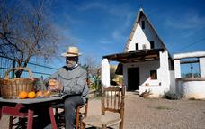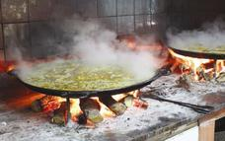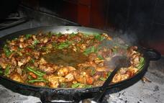

Casa Montana
Casa Montana was established in 1836 in Valencia, Spain. The tapas bar and restaurant serves Mediterranean and European cuisine, and offers wines, set menus, and allergy free options. Casa Montana has a warm and cosy atmosphere, and is the perfect venue for romantic dinners, friendly catch ups and after work drinks.
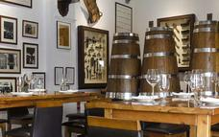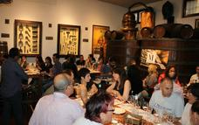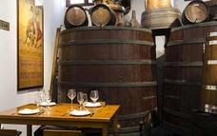

Included
Bed & Breakfast

Day 4: Saturday, 25 August
Departure

Transport

Contact Details & Reference Numbers
Service Provider | Ref. Number | Telephone | Address

Travel Information
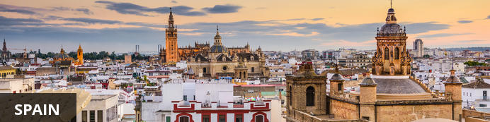
Spain typically conjures up images of matadors, sangria, flamenco dancers and paella. While Spain offers all of these traditional cliches in abundance, the country's real attraction is to be found in its passionate, laid back people and its unbeatable natural beauty. Even along the well beaten tourist tracks, there are authentic Spanish experiences to be had, traditional local dishes to sample and idyllic villages of timeless charm to be explored. Like the country’s famous tapas, Spain itself is a veritable smorgasbord of thriving cities, bizarre festivals, panoramic views and breathtaking beaches - rendering it a beautiful and beguiling country unlike any other.

Banking and Currency
Currency
Spain uses the European monetary unit, the euro (€). Euro bills come in denominations of 5, 10, 20, 50, 100, 200, and 500; coins are worth 1 cent of a euro, 2 cents, 5 cents, 10 cents, 20 cents, 50 cents, 1 euro, and 2 euros. Local merchants may refuse to accept €200 and €500 bills due to the prevalence of counterfeit bills.
Banking
Travellers will find that managing money in Spain is easy but expensive. Banking facilities are generally modern and function quite efficiently, but bank charges and commissions on international transfers are hefty when compared to most other countries in the European Union (EU).
Spain has one of the highest bank branches per capita on the European continent and most offer online banking with fast, easy transfers; Solbank and Bancaja cater specifically to British citizens.
Banks in Spain open from Monday to Friday 8.30am to 2pm and, in the winter, on Saturday mornings from 9am to 1pm or Thursday afternoons, from 5pm to 7pm.
ATMs (cajeros automáticos) are widely available and normally accept foreign cards. These machines provide the best exchange rates, but transaction charges do apply.
Alternatively, currency exchange offices (cambio) can be found at most airports and in most tourist areas. The exchange rates they tend to offer are less attractive than those provided by banks.
Debit and credit cards are widely accepted in Spain, although transaction charges will apply if someone is using an international debit or credit card.

Travel, Transport and Getting Around
Most of Spain is well covered by public transport. The rail network reaches all the provincial capitals and the main towns along the inter-city lines, and there’s an expanding high-speed network that has slashed journey times on major cross-country routes from Madrid. Inter-city bus services are often more frequent and cheaper than the regular trains, and will usually take you closer to your destination, as some train stations are a few kilometres from the town or village they serve. Driving a car, meanwhile, will give you the freedom to head away from the major tourist routes and take in some of the spectacular scenery at your own pace.
One important point to remember is that all public transport, and the bus service especially, is drastically reduced on Sundays and public holidays, don’t even consider travelling to out-of-the-way places on these days. The words to look out for on timetables are diario (daily), laborables (workdays, including Sat), and domingos y festivos (Sun and public hols).

Food, Drink and Cuisine Advice
Standards of hygiene in relation to food health and safety in Spain are generally high in hotels, restaurants, pubs and nightspots.
Food is more than a form of sustenance in Spain, it is literally a way of life. Friendships are formed, families unite, and the working week can be set around every day's very important meals. The country's distinctive cuisine brings together unique regional dishes, special ingredients and long standing influences from Moorish and Arab settlers.
Tourists travelling to Spain are often given a useful piece of advice - the Spanish eat late. Don't expect many restaurants to be open before 9pm. Book a restaurant table for between 11pm and midnight and you'll see the place hopping. Dinner is often light after a large lunch..
Breakfast in Spain is a pretty simple and traditionally European affair. The continental meal can include fresh rolls, bread and jam with coffee, hot chocolate or tea.
Tapas are probably the concept of Spanish cuisine most admired and imitated around the world, inspiring thousands of bars and restaurants. The idea is simple, straightforward, and a visit to a tapas bar is possibly the best way to sample a wide variety of Spanish food. Tapas can constitute something as simple as a piece of toasted bread, rubbed with garlic and dipped in olive oil, or a dish of olives. Slices of ham or salami, cheese, pieces of Spanish tortilla and marinated anchovies are popular. Dishes like meatballs in tomato sauce, garlic mushrooms, shrimp or cooked chorizo in wine are all offered to tickle the tastebuds at tapas bars around the country. So is paella, the saffron infused rice dish with meat, seafood and vegetables which is a Spanish institution.
Tap water is generally safe to drink in Spain. If you are in any doubt, ask ¿Es potable el agua (de grifo)? (Is the (tap) water drinkable?). Do not drink water from rivers or lakes as it may contain bacteria or viruses that can cause diarrhoea or vomiting.

Climate and Weather
Spain's climate varies from temperate in the north to dry and hot in the south. As it is a big country with varying terrain and altitudes, climate can be extremely distinctive from one corner to another. Overall, the coastal regions in the South and Eastern parts of Spain are excellent to visit all year round thanks to the Mediterranean climate (mild temperatures and long days). Northern Spain generally experiences colder temperatures than the South, while Central Spain stays hot and dry due to its location on a plateau.
The best time to visit depends on the region and type of travel experience you’re seeking. For a beach vacation, the best months for guaranteed sunshine are June to August. Naturally, these are also the busiest months for tourism along the coast and on the Spanish islands, so be prepared for high prices and crowds. If you’re looking to escape the crowds, head inland to cities like Seville, Madrid and Granada where temperatures are sizzling but streets are empty.
The shoulder season for travel in Spain is usually late spring and autumn: from April to end of May and October to November. These are when tourist destinations are least crowded and weather is still pleasant. January to February is the best time to ski, as snow is ample and the sun is shining. Especially in the Sierra Nevada, the sun can be quite overwhelming even in the snow – come prepared with snow goggles and sunscreen.

Clothing and Dress Recommendations
Spain is a modern country, but with many traditions of dress. Traditional/region dresses are usually worn at fiestas, but not by everyone. Try and attend a fiesta or two to see just how diverse the traditional clothing was.
Away from the beach men can wear shorts and T shirts, with flip flops, if they want to. The same would also be ideal for women too. Men and women should not wear swimming clothes at any restaurant, unless it is at a beach side restaurant. A tip to women who want to go topless on the beach. The law permits topless attire at every beach. Some beaches are designated nudist beaches.
Spain does get all of the seasons of the year, meaning spring, summer, autumn/fall, and winter, so pack with layers in mind. Buildings can be hot and stuffy whilst the outside temperatures are low. Remember that some, but not all, places of worship have enforced dress rules. For chilly days or nights, and for going out to restaurants, jersey/cardigan or lightweight jackets would be ideal attire. Bring some sort of waterproof clothing, especially during spring, autumn/fall, and winter periods. It should be noted that at a few hotels restaurants and clubs, if you are dressed inappropriately, will not let you in.

Electricity and Plug Standards
Electricity supply is 220 volts throughout Spain with 2 pin wall sockets. For any European countries that utilise 240 volts your electrical appliance should function adequately.
If you intend to use the UK electrical plugs then you will need an electricity plug adapter that will convert the standard 3 pin socket into a two pin socket. In the US where the electricity supply is 110 volts a transformer would be required to step down the voltage to 110 volts. Damage to the electrical appliance can occur if you attempt to use a 110 volt rated electrical appliance with a 220 volt supply.

