Photography Fixed Departure Safari

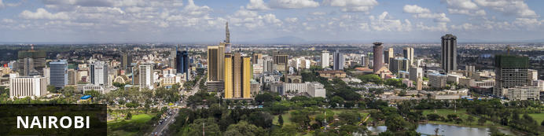
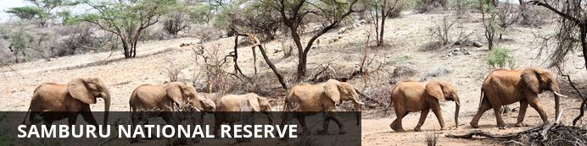
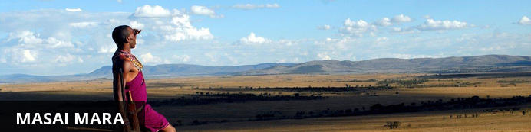

Photography Fixed Departure Safari
Nairobi - Samburu National Reserve - Masai Mara
8 Days / 7 Nights
Reference: TWLETG1210
Date of Issue: 01 March 2019

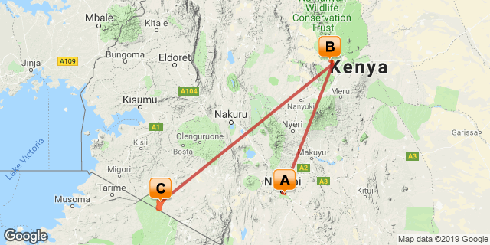

Click here to view your Digital Itinerary

Introduction
This safari is designed with the serious photographer in mind. Everything from the number of people on the trip to the extra weight limits has been designed for photography. Highlighted by two of the best and most diverse parks and reserves that Kenya has to offer, and is lead by our own Safari Gold Guide and photographer, who knows the parks, wildlife, flora and fauna intimately. This safari features:
- Maximum 6 photographers on safari
- All safari transportation via 4x4 safari vehicles
- 3 photographers per vehicle, each with his/her own row of seats
- Weight limit of 30kg per person to allow for camera equipment on internal flights
- Bean bags provided in the vehicles
- Fly internally to the parks for a hassle-free, comfortable safari
- Meet every evening to go over the day's photos, and work with our photographer to learn more and improve your skills

Accommodation | Destination | Basis | Duration
Ole Sereni Hotel | Nairobi | B&B | 1 Night
Samburu Intrepids Tented Camp | Samburu National Reserve | FB+ | 3 Nights
Entim Camp | Masai Mara | FB+ | 3 Nights

Key
B&B: Bed and Breakfast
FB+: Dinner, Bed, Breakfast, Lunch and Activities Daily

Price
Fixed Departure Dates
June 17th 2019
- USD 8,400 Per Person Sharing
- Single Room Supplement - USD 440
October 15th 2019
- USD 9,365 Per Person Sharing
- Single Room Supplement - USD 560
December 6th 2019
- USD 8,725 Per Person Sharing
- Single Room Supplement - USD 560

Included
- Arrival and departure airport transfers
- Accommodation and meals as specified in the itinerary above
- Park entrance fees and game drives as applicable in a camps 4x4 private vehicle
- Three photographers per vehicle
- Transfers in city transfer vehicles
- 01 litre mineral water per person per day in the vehicle while on safari
- Services of experienced English speaking driver guides
- Services of an English speaking professional photographer & safari gold guide
- Scheduled flights & transfers - Wilson - Samburu - Masai Mara - Wilson
- Conference facilities every night for photography conference and reviews

Excluded
- Meals not specified in the itinerary above
- Beverages
- International flights
- Balloon safaris - USD 450 per person
- Masai Village Visit - USD 30 per person
- Bird & Nature walks where not mentioned
- Tips/gratuities
- Entry visas and fees
- Medical and travel insurance (clients must have their own)
- Any other items of a personal nature not mentioned above.

Day 1: Ole Sereni Hotel, Nairobi

Nairobi
Situated in along the Nairobi River in beautiful Kenya, the capital of Nairobi is East Africa's most cosmopolitan city. It serves as an excellent starting point for African safari trips around Kenya. Nairobi is Africa’s 4th largest city and is a vibrant and exciting place, and although it has developed a reputation which keeps tourist visits brief, there are some fascinating attractions: its cafe culture, unbridled nightlife, the National Museum, the Karen Blixen Museum and most notably just 20 minutes from the city centre wild lions and buffalo roam in the world’s only urban game reserve. Make sure you pay a visit to the elephant orphanage operated by the David Sheldrick Wildlife Trust.

Day Itinerary
Upon arrival at Jomo Kenyatta International Airport, you will be met and assisted by our representatives. After brief introductions you will be transferred to your hotel. The rest of your day is at leisure.

Overnight: Ole Sereni Hotel
Located just off Mombasa road Ole-Sereni is the only hotel bordering a National Game Park. The title of the hotel is taken from the Maasai name for the area meaning 'place of tranquillity'. Ole-Sereni captures the essence of Nairobi, which is the only city in the world that boasts a natural game park within its precincts. The hotel offers its guests views of animals in their natural surroundings at the waterhole in the park from the restaurants, bar, swimming pool and other parts of the hotel.
As 'The City Hotel by the Game Park' Ole-Sereni combines the best features of a modern City Hotel and a traditional wildlife lodge where guests can enjoy nature's tranquillity from a very close range. Ole-Sereni is strategically positioned close to the Airport and the city centre, offering world-class facilities and personalized services to business as well as leisure travellers. The hotel also enjoys proximity to the central business district, international organizations, financial institutions, government offices and the industrial areas of Nairobi.
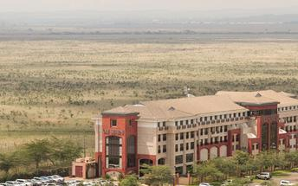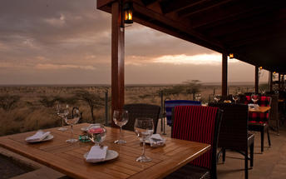

Basis
Bed & Breakfast

Included
- Airport Transfers

Excluded
- Dinner
- Drinks
- Extra activities not mentioned

Day 2-4: Samburu Intrepids Tented Camp, Samburu National Reserve

Samburu National Reserve
Resting on the banks of the Ewaso Ng'iro River and neighbouring the Buffalo Springs National Park, Samburu National Reserve is remote, hot and arid. The reserve spans over 165 square kilometres of spectacularly scenic landscape featuring rugged hills, undulating plains and riverine forests. The park is home to abundant wildlife including a variety of rare species such as the reticulated giraffe, the long necked gerenuk, Somali ostrich, Grevy's Zebra and Beisa Oryx. Samburu was one of the homes of 'Elsa the Lioness', star of the best selling book and award-winning movie 'Born Free'. Visitors can enjoy viewing over 900 elephants, a variety of predators, and over 450 bird species.

Day Itinerary
After breakfast, you will be transferred to the Wilson Airport for your flight to Samburu.
On arrival, you will be met and assisted by our driver guides. After brief introduction, you will be transferred to your camp.
You will have game tracking, drives, photography activities for the rest of your stay.

Consultant Notes
Samburu Game Reserve (40,800 acres/16,500 hectares) lies to the North of lush mountain woodland and rugged ranges that average only 14” (350mm) of rain a year. Through it flows the Ewaso Nyiro River, which is rimmed with towering river acacias and palms. Crocodiles can be seen swimming in the river along with the hippo. The river and several springs attract much wildlife, especially in dry periods. Mammals restricted to the Masai arid zone are found here, such as Gravy’s zebra, the reticulated giraffe, the beisa Oryx, Guenther’s dik-dik and the gerenuk. Also present are lesser kudus, elephants, grant’s gazelles, lions, cheetahs, leopards and 350 bird species, including the blue-flushed Somali ostrich and the bristle-crowned starling.
Samburu Intrepids is renowned as a pioneer of luxury camping in one of the world's last true wilderness areas. It is situated on the banks of the Ewaso Nyiro River in Samburuland.

Overnight: Samburu Intrepids Tented Camp
Dry, rugged and stunning, Samburu’s landscape is at once stark and sensual, with its iconic loaf shaped Lolokowe Mountain and hills spreading in every horizon. Its life lung is the Usao Nyiro River coursing through its craggy terrain full of stone, thorn bush and the forked doum palms. In this arid zone where water is scarce and the land baked by the eternal sun, herds of elephants and the big cats roam the plains with the Samburu special - the Reticulated giraffe, Grevy’s zebra, Beisa oryx, Somali ostrich and the long necked antelope, the gerenuk easily seen despite its harsh climes.
Located 345 kilometres north of Nairobi, the journey to the camp involves a 50-minute flight to the Samburu airstrip followed by a 20-minute drive through the reserve.
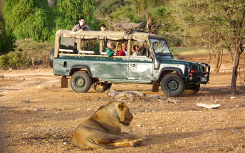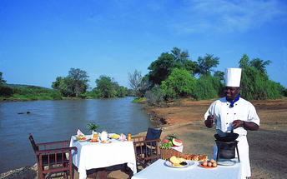

Basis
Full Board and Activities

Included
- Airport and airstrip transfers
- Scheduled Flight "Nairobi - Samburu" with extra luggage allowance
- Exclusive and unlimited 6am - 6.30pm use of 4x4 safari vehicles on game drives
- 2L water per person during game drives
- 3 photographers per vehicle
- Professional photographer and safari gold guide

Excluded
- Drinks
- Extra activities not mentioned

Day 5-7: Entim Camp, Masai Mara

Masai Mara
The Masai Mara together with Tanzania’s Serengeti form Africa’s most famous wildlife park, the Masai Mara National Reserve. The image of acacia trees dotting endless grass plains epitomises Africa for many, then add a Maasai warrior and some cattle to the picture and the conversation need go no further. The undeniable highlight of the Masai Mara National Reserve is undoubtedly the annual wildebeest migration traversing the vast plains of the Serengeti and the Masai Mara. It is known as the largest mass movement of land mammals on the planet – with more than a million animals following the rains. Large prides of lions, elephants, giraffes, gazelles and eland can also be spotted in the reserve. Aside from horse riding safaris and traditional vehicle safaris, hot-air ballooning over the Mara plains has become almost essential.

Day Itinerary
After breakfast, you will be transferred to the Samburu Airstrip for your flight to Masai Mara.
On arrival, you will be met and assisted by our driver guides. After brief introduction, you will be transferred to your camp.
You will have game tracking, drives, photography activities for the rest of your stay.

Consultant Notes
Day spent game-viewing in the reserve in a camps private 4x4 vehicle. With over 450 species of birds and animal species, Explore the plains and rolling hills for a chance to spot the elephant, black-manned lion, leopard, buffalo, cheetah, and with diverse species of hoofed animals. Lunch, dinner and overnight at your camp.
Masai Mara offers an absolutely unique variety of animals. The reason is that this hilly region is both humid and fertile, and is crossed by the Mara and Talek rivers, full of crocodiles and hippos. The abundance of water and excellent availability of food are the reasons why the Masai Mara, which in fact is a continuation of the Tanzanian Serengeti National Park, has the greatest population of wild animals in the whole of Africa. There is a particularly dramatic “spectacle” from July to October, the annual migration of huge herds of Gnus and zebras. Predators such as Hyenas, Jackals, Leopards and Lions of course, closely follow these herds. Gigantic herds of over 200 buffaloes can also be observed. Plenty of food is available for elephants, giraffes, and the many species of antelopes.
Optional extra activities:
Balloon Safaris
Masai Village Visit

Overnight: Entim Camp
Entim was designed with a purpose in mind; to be in the best possible location to view the wildebeest migration in the Maasai Mara game reserve. For a few months of the year the migration is on our doorstep on the Mara river.
While many other visitors to the Mara will be staying in camps in the surrounding areas and conservancies, at Entim you don't have to drive for hours to get to the wildlife action because you are right there in the middle of it. Nor do you have to be hurried out of the Reserve before gates close at 6.30 pm: at Entim you can continue to witness the wild's most important and dramatic events, which often take place at dusk and dawn. There’s actually no obligation to go out on game drives because you can sit in camp and watch the animals passing by right in front of you.
Entim meaning “forest” in Maasai is discreetly tucked on the edge of the riverine woodlands. From the shaded seclusion of this attractively-designed camp, guests can relax in luxury and admire unforgettable views over the Mara River and across expansive plains, with the distant backdrops of undulating escarpments and volcanically-sculpted hills. From the veranda of each tent it is even possible to witness the breathtaking sight of thousands of Wildebeest crossing the river during their annual migration through this vast wilderness area. We have kept the camp eco-friendly and small, with only ten, tastefully but differently furnished, well-equipped tents. Our decor aims to enhance the surrounding environment.
OUR TENTS:
All 10 guest tents overlook the Mara River and are well-placed, en-suite with flush-toilets and hot showers. There is a cosy lounge area with a small library, separate bar and dining area, which is open-fronted allowing guests the unmatched experience of eating meals while watching the animals move to and from the river to drink and forage for their food. The camp has been designed to give guests the feel that it is part of the landscape. The experience at Entim is not your average hotel or lodge experience: it's about being right in the hub of one of the most famous wildlife reserves in the world and part of a quintessential Kenya Safari Experience.
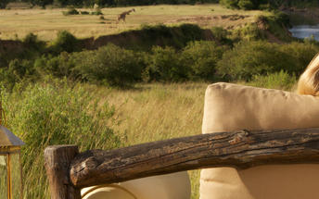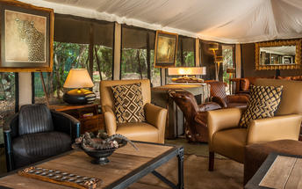

Basis
Full Board and Activities

Included
- Airport and airstrip transfers
- Scheduled Flight "Samburu - Masai Mara" with extra luggage allowance
- Exclusive and unlimited 6am - 6.30pm use of 4x4 safari vehicles on game drives
- 2L water per person during game drives
- 3 photographers per vehicle
- Photography guide

Excluded
- Drinks
- Extra activities not mentioned

Day 8: End of Itinerary

Day Itinerary
On checkout after breakfast, you will be transferred to the airstrip for your flight to Nairobi.
On arrival in Nairobi, you will be met by our guides who will assist you with luggage and city activities. Later you will be transferred to the international airport for your onward flight.

Basis
Bed & Breakfast

Included
- Airport transfers
- Use of vehicle in the city

Excluded
- Extra activities in the city
- Drinks
- Extra activities not mentioned

Transport

Flight Information
Date | Flight | Airline | Departure Airport | Time | Arrival Airport | Time | Class | Ref
 | Scheduled |  | Wilson Airport [WIL] |  | Samburu Airstrip
 | Scheduled |  | Samburu Airstrip |  | Ol Kiombo Airstrip
 | Scheduled |  | Ol Kiombo Airstrip |  | Wilson Airport [WIL]

Transfers
Date | Company | Pick Up | Drop Off | Time | Vehicle
 |  | Jomo Kenyatta International Airport [NBO] | Ole Sereni Hotel |  | Transfer
 |  | Ole Sereni Hotel | Wilson Airport [WIL] |  | Transfer
 |  | Samburu Airstrip | Samburu Intrepids Tented Camp |  | Transfer
 |  | Samburu Intrepids Tented Camp | Samburu Airstrip |  | Transfer
 |  | Ol Kiombo Airstrip | Entim Camp |  | Private Guided Trip
 |  | Entim Camp | Ol Kiombo Airstrip |  | Transfer
 |  | Wilson Airport [WIL] | Jomo Kenyatta International Airport [NBO] |  | Transfer

Urgent Contact Numbers
Company Name | Telephone | Email Address | Contact Person
Travel Wild East Africa | +254743794777 | kevin@travel-wild.com | Kevin Njoroge

Service Provider Directory
Service Provider | Ref. Number | Telephone | Address
Entim Camp |  | +254 733 258120 | Maasai Mara On The Mara River

Travel Information
An outline of our travel guide on http://www.travel-wild.com/travel-information
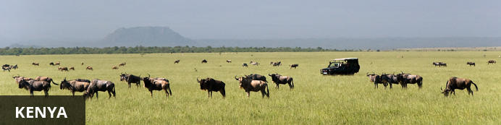
Resting in the magnificent Great Rift Valley and presided over by the majestic Mount Kilimanjaro, Kenya is characterised by hauntingly beautiful natural landscapes of forested hills, patchwork farms, wooded savanna and vast forests brimming with an extraordinary abundance of wildlife. The nation’s diverse range of traditional African cultures is influenced by over 70 unique ethnic groups from the Maasai, Samburu, Kikuyu, and Turkana tribes to the Arabs and Indians that settled on the coast. Add to this: an exquisite tropical coastline fringed with breathtaking golden sand beaches; gorgeous coral gardens providing excellent snorkeling and diving opportunities; and a slew of lively beach resorts, and it is easy to see why so many visitors flock here from around the world to experience a truly unique African adventure in one of the world’s most pristine safari destinations.

Banking and Currency
Currency
The currency in Kenya is the Kenyan Shilling (KES; symbol KSh). 1 Kenyan Shilling = 100 cents. Notes are in denominations of KSh1,000, 500, 200, 100 and 50. Coins are in denominations of KSh20, 10 and 5.
Foreign currency can be exchanged at the major banks, bureaux de change or authorised hotels. The banks at Jomo Kenyatta International Airport and Moi International Airport have 24-hour exchange services. The easiest currencies to exchange are US Dollars, Pounds Sterling and Euros.
There are no restrictions on the import or export of local or foreign currency. However, amounts exceeding US$5,000 or equivalent must be declared.
Banking
Banking hours: Monday-Friday 09h00-16h00, Saturday 09h00-12h00. Banks in Mombasa and the coastal areas typically open and close half an hour earlier.
Credits Cards are widely accepted in all major hotels and more upmarket establishments, with the most recognized being Master Card and Visa. American Express and Diners Club cards are occasionally accepted. However, you will need some cash handy because smaller shops will only accept cash.
Almost every bank now has an ATM, and they are increasingly being installed at petrol stations in cities and large towns.
Travellers cheques are no longer accepted in Kenya.

Travel, Transport and Getting Around
Nairobi has two airports for domestic and regional flights: Jomo Kenyatta International Airport and Wilson Airport (www.kaa.go.ke). Kenya has over 150 domestic airports and airstrips and there are daily flights to the most popular destinations. In addition to the scheduled airlines, several private charter companies operate out of Wilson Airport.
Kenya Airways (www.kenya-airways.com), Air Kenya (www.airkenya.com), Fly 540 (www.fly540.com), Mombasa Air Safari (www.mombasaairsafari.com) and Safarilink (www.flysafarilink.com) serve the most popular safari destinations, plus many others such as Lake Victoria.
On smaller, domestic planes the baggage allowance is restricted to 10-15 kg (22-33 lbs). Arrangements can be made to leave excess luggage with hotels or airlines.
Main roads between the major cities and towns are generally in good condition, and easily navigable in a normal saloon car. Most highways in the south are paved, but that’s not the case in the north.Vehicles are driven on the left side of the road.
While major roads are generally in a good condition, most minor gravel roads have deep potholes which deteriorate further in the rainy season. Dirt roads, including those in the parks and reserves, are extremely rough, and some are only passable with a 4-wheel drive.
You can hire self-drive and chauffeur-driven cars from travel agents and international hire companies. Drivers must be at least 23 years of age. Budget (www.budget.com) and Europcar (www.europcar.com) have outlets at Jomo Kenyatta International Airport in Nairobi. Budget also has a desk at Moi International Airport in Mombasa, while Europcar has an office in town. Car hire can be expensive and rates vary significantly.
A driving licence from a home country (and a translation if this is not in English) or an International Driving Permit is required. Third-party insurance is mandatory when hiring a car and it’s recommended to take out the additional collision damage waiver. A valid credit card is also needed.
Matatus (shared minibus taxis) hop from town to town, starting and finishing at bus stations. Fares are paid to the conductor. Private taxis can also be hired for long-distance journeys.
It is not possible to rent motorbikes or mopeds but some of the beach resorts hire out bicycles.
Numerous private bus companies operate in Kenya. Most vehicles are old and tend to depart when full, which means there are no set timetables. Petty theft on the vehicles and at bus stations can be a problem. Nevertheless, buses are cheap and link all long-distance destinations. Plus, seatbelts are now mandatory, so buses are relatively safe.
Nairobi and Mombasa have efficient local bus systems and there are also frequent matatus, but reckless driving and petty theft makes them a dodgy option for tourists. Three-wheeled auto rickshaws are popular in town centres and carry up to three passengers.
The newer fleets of taxis (usually painted white with a yellow band) are reliable and have meters. The older yellow taxis do not have meters, so fares should be agreed in advance. In Nairobi, there is a fleet of London-style black cabs. A 10% tip is expected. Cabs cannot be hailed in the street, but can be found parked in taxi ranks.

Food, Drink and Cuisine Advice
Bottled water is advisable for the first few weeks of your stay. When buying bottled water, check the seal of the bottle is intact. Never drink tap water unless it has been boiled, filtered or chemically disinfected (such as with iodine tablets). Never drink from streams, rivers and lakes. It’s also best to avoid drinking from pumps and wells – some do bring pure water to the surface, but the presence of animals can still contaminate supplies. Avoid ice and washed salads and fruit except in upmarket hotels and restaurants. Milk is pasteurised and dairy products are safe for consumption. Food prepared by unlicensed vendors should be avoided at all times.
Nairobi has some of the finest eating establishments in Africa. Many different cuisines and types of restaurants are available, from fast food to fancy. Many five-star hotels have excellent restaurants. Restaurants are called "hotels" and there are many in Nairobi. The local cuisine is also worth trying out, particullarly Pilau-a chicken and rice dish, cabbage and rice; and the staple food in Kenya-Ugali, made from maze flour.
Many restaurants can be found downtown and in the areas of Westlands and Hurlingham but these areas are filled with tourists and places like Ayani, Olympic, Kibera, and other places have more authentic food. Among the many cuisines available are Indian, Brazilian, Chinese, Thai, Japanese, German and French restaurants. Fast food restaurants, mostly by South African chains (Steers, Nandos), are common in the larger urban areas.

Climate and Weather
Kenya lies on the equator and has a pleasant tropical climate, but there are large regional climatic variations influenced by several factors, including altitude. Temperatures drop by about 6°C for every 1000m you climb (or 3.5°F per 1000ft). Kenya’s daytime temperatures average between 20°C/68°F and 28°C/82°F, but it is warmer on the coast. The coast is hot and humid all year round, but the heat is pleasant and tempered by the monsoon winds. Kenya is too close to the equator to experience a real winter and summer. There is, however, both a dry and wet season. The wet season is from November to May and the Dry season is from June to December.

Clothing and Dress Recommendations
Comfortable, casual clothing that is lightweight is the best bet while on safari. It can be quite cool in the early mornings, so you'll want to dress warmly in layers, until the sun has a chance to warm up the air. "Kenya Convertibles", khaki pants with zip-off legs, are perfect for cool early morning game drives that turn warm before you're back in camp. Walking shorts, long pants, cotton shirts and tees are just right. A cotton bush jacket or wind-breaker will be useful along with a warm sweater or fleece jacket for the cool nights. And, a hat that ties on is a must. There is not a good deal of long walking or hiking on most safaris, so a comfortable pair of walking shoes or tennis shoes and a pair of sandals should be adequate. You will need thorn-proof soles.
In Kenya's major cities the dress code is conservative but not overly formal – jeans and decent tops for women are fine. Swimsuits are acceptable on the beach but you’ll need to cover up in public places.

Electricity and Plug Standards
Electric Power is 220V - 240V running at 50Hz. The Plug type used in Kenya is the 3 large flat prong (UK). If your appliances are compatible with 220V-240V electrical output, an adapter is all that you will need, if not a voltage converter will be necessary.

Terms and Conditions

Itinerary Terms and Conditions
- Luggage limit of maximum 30 kilograms per person during this travel. Have soft bags. Hard cases should be avoided as they cannot fit in safari vehicles/aircraft
- Passports should be valid at least 06 months beyond the period of stay
- It is the duty of the client to check passport requirements for travel
- Check-in at hotels is 1100hrs and check-out is 1000hrs
- Missed or delayed flights can lead to changes in itinerary and will be at the client’s expense should the case arise
- All prices given are subject to availability
- Payment by credit card is subject to a 4% surcharge
NB: USD rates are commission-able to bonafide tour operators & travel agents. Travel Wild terms and conditions apply.

Travel Wild East Africa Terms and Conditions
Our terms and conditions are as outlined on http://www.travel-wild.com/terms-conditions

