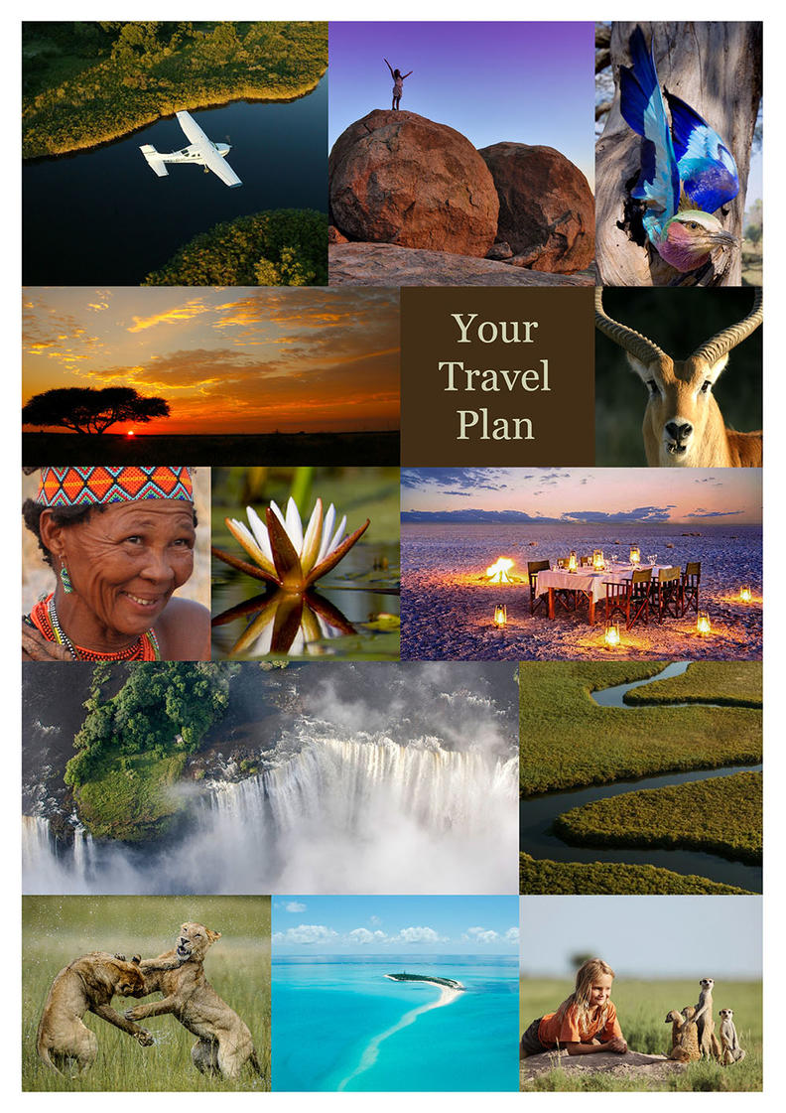

9N Botswana Self Dr_On The Dirt_Std
Victoria Falls, Zimbabwe - Chobe River Front - Savuti - Chobe National Park - Khwai Community Area - Maun
10 Days / 9 Nights
2 Persons

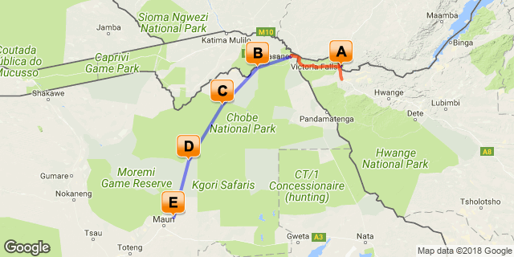

Click here to view your Digital Itinerary

Introduction

Start | Accommodation | Destination | Duration
Day 1 | Ilala Lodge | Victoria Falls, Zimbabwe | 2 Nights
Day 3 | Chobe Elephant Camp | Chobe River Front | 2 Nights
Day 5 | Ghoha Hills Savuti Lodge | Savuti - Chobe National Park | 2 Nights
Day 7 | Sango Safari Camp - Fully Inclusive | Khwai Community Area | 2 Nights
Day 9 | Thamalakane River Lodge | Maun | 1 Night

Transport

Transfers
Date | Company | Details
Day 1 | Wild Horizons | Victoria Falls Airport - Ilala Lodge
Day 3 | Wild Horizons | Ilala Lodge - Kasane Airport

Day 1-3
Ilala Lodge, Victoria Falls, Zimbabwe

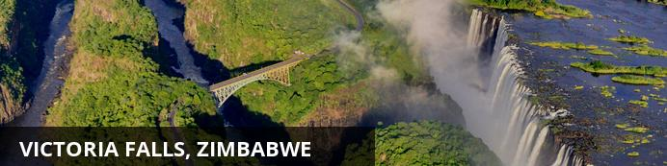
At Victoria Falls, the earth splits open and swallows one of Africa’s greatest rivers, the mighty Zambezi, creating the largest sheet of falling water on earth. As the water hits the narrow depths of the Batoka Gorge beneath, it blasts a cloud of mist skywards, lending the falls their local name ‘mosi-oa-tunya’ (the smoke that thunders). When the Zambezi is its fullest, the mist hangs a permanent raincloud above the falls, showering visitors on even the sunniest of days and visible for miles around.
Above the falls on the upper Zambezi, boats cruise the tranquil water at sunset while the distant spray catches the fading light downstream. Below the falls, the Batoka Gorge’s rocky walls funnel the lower Zambezi into a chain of world-class rapids, prime for white water rafting.
Aside from being a UNESCO world heritage site and a natural world wonder, Victoria Falls also forms a natural border between Zimbabwe and Zambia. The falls can be seen from both countries, and for the most part the same activities are offered on both sides, from helicopter scenic flights to village visits and souvenir shopping.
Whether your idea of getting away from it all is a relaxed high tea in colonial grandeur or a heart-stopping bungee jump off a bridge, Victoria Falls keeps both the faint of heart and the most insatiable of adrenalin junkies busy for days.
From Zambia, a side on view of the falls is on offer with views into the Batoka Gorge, as well as the possibility of perching yourself at the edge of the falls on the vertigo-inducing Livingstone Island.
From Zimbabwe, you’ll get a full-frontal view of three quarters of the falls’ 1.7km wide curtain of water from viewpoints and footpaths meandering through a rainforest kept hot and humid by the spray of the falls.

Overnight: Ilala Lodge View iBrochure
Includes: bed & breakfast (please see detailed itinerary for additional meals and activities booked)
Ilala Lodge is situated close to the Victoria Falls, Zimbabwe as well as to the town centre. Wild animals are often seen grazing the hotel lawns as the National Park borders the front of the property.
In the central wing, the Lodge offers 34 rooms: 30 standard twins, 2 standard doubles and 2 standard suites. All rooms have an ensuite bathroom with separate shower, wireless internet, in-room safe, tea/coffee self service, air-conditioning, overhead fans and satellite television. The rooms are spacious with railway sleeper teak furnishings and patio doors leading onto either an open lawn or a balcony facing the Victoria Falls.
The new extension wing offers 8 deluxe twin rooms, 12 deluxe double rooms and 2 executive suites. All rooms have a private balcony, mini bar fridges, international plugs/ adaptors, wireless internet, in-room safe, tea/ coffee self service, air conditioning, overhead fans and satellite television.
Conveniently located, the central and extension wing rooms provide easy access to the restaurants, pool and adventure booking centre.
There is an à la carte restaurant which serves breakfast, lunch and dinner and offers a comprehensive wine list and cocktails. Dining outside under the African night sky amidst the sound of the mighty waterfall makes for a very romantic evening.
Airport Transfer Time: 30 minutes
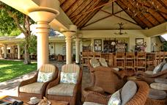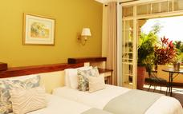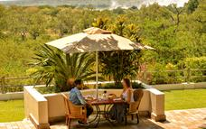

Day 3-5
Chobe Elephant Camp, Chobe River Front

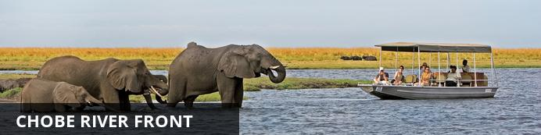
The Chobe Riverfront is an elephant mecca; home to the largest density of African elephants in the world. Travel here during winter and you’ll fast run out of fingers and toes while you count them drinking at the riverbanks and socialising out on the floodplains.
Thanks to its ease of access from Victoria Falls, the Chobe Riverfront is the busiest part of Botswana (though still a much quieter affair than most South or East African safaris). What Chobe lacks in solitude during the busier months, it more than makes up for with quality game viewing.
Chobe will leave you feeling tiny as giant elephant bulls stroll up next to your vehicle or snorkel alongside your boat. It will make you feel lost as hundreds of hippos and buffaloes crowd you out on the floodplains. It will put your heart in your throat as prides of lions stalk antelopes by the water’s edge, and it will leave you alone with your thoughts while the classic red sunsets melt over the river to a soundtrack of whistling fish eagles.
Chobe is not just a great introduction to Botswana. It also makes a rewarding repeat journey once you’ve ticked off the big stuff. It’s a place to search for the rare sable antelope, to spot that gem from the birders’ bucket list and to explore the remoter corners.
Where you stay in Chobe makes a huge difference to your safari experience. The most affordable options are at bigger hotels in a town setting where you’ll share your game drives with a few more vehicles. On the more exclusive end, stay in a wilder area in or around the park, listen to the sounds of the bush at night and get a head start on accessing the park for activities.

Overnight: Chobe Elephant Camp
Includes: meals, local drinks, activities, laundry and park fees.
Excludes: premium drinks
Activities: game drives, boating and canoe excursions (stays of 2 nights or longer) and cultural village visit
Located high on the edge of a rocky ridge overlooking the famous Chobe River is Chobe Elephant Camp. This uniquely designed lodge has been built to take advantage of the incredible views overlooking the sweeping floodplains while offering a comfortable refuge from the harsh African conditions.
The lodge has been entirely constructed from sandbags, the thick sand-filled walls create a natural insulating barrier between the inhabitants and the harsh African climate and enhance the old farm-style feel of the camp. It houses ten rooms, one family room and can sleep 24 guests at a time.
With a variety of activities that include viewing the region’s spectacular wildlife from open safari vehicles, by boat on the Chobe River or experiencing life in the village, a visit to Chobe Elephant Camp offers a wide range of experiences to our guests. Tranquil canoe excursions ranging from 1.5 to 2.5 hours duration offer guests the opportunity to paddle their own canoes – safely following their canoe guide – to discover the wonders of the Chobe River floodplain system in quiet harmony with these remarkable surroundings.(Depends on water levels)
Chobe / Ngoma Gate
This property is located near the Ngoma Gate for entry to the Chobe Riverfront. Very few lodges are located at this end of the park and few people utilize this entry point, creating a more remote and exclusive experience than at the properties around Kasane. Although outside the park, this option is located in a bush setting where wildlife frequently passes through.
Airport transfer time: 50 minutes
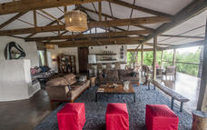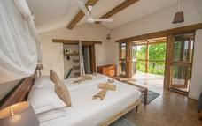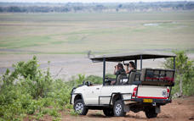

Day 5-7
Ghoha Hills Savuti Lodge, Savuti - Chobe National Park

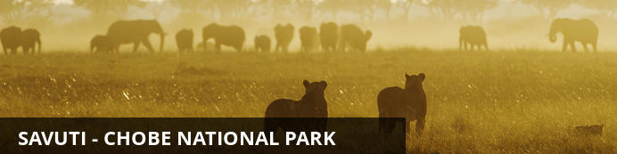
When it comes to Botswana, Savute breaks all the rules: both for animal behaviour and for habitats. Here, lions hunt elephants, leopards take to fishing, the grasslands are vast and open and rocky hills punctuate the flat terrain.
Savute has proved itself somewhat of an enigma over the decades. During years of abundance its marsh fills with water, fed by the Savute Channel. The water weaves its way here from Angola via a chain of rivers and lagoons, spilling out into the marsh and drawing huge herds of elephants, wildebeest, zebras and buffalos.
In drier years, the channel shrinks into small pools and can evaporate completely, leaving the marsh dry and sending wildlife to the waterholes for water, where the tension between plains game and predators heats up over a parched and dusty landscape.
Wherever the plains game goes in Savute, the predators follow close-by, learning tricks of survival to adapt to the marsh’s ever changing nature. Whether the water flows here or not is anyone’s guess. The channel and marsh have a life of their own, independent both of the seasons and the annual rainfall.
Savute doesn’t just offer a safari; it’s also a feast for the eyes. Whitewashed skeletal trees set against green grass and huge blue skies, blinding red sunsets that spill purple and orange across the bush, and endless horizons that fade into a hazy mirage with the heat.
As Savute is part of Chobe National Park, a safari here is limited to game drives only. With the diversity of habitats, wildlife and landscapes that the marsh has to offer however, you’ll still find yourself wishing you had more time to see it all.

Overnight: Ghoha Hills Savuti Lodge View iBrochure
Includes: meals, local drinks, activities, park fees, laundry & return airstrip transfers
Excludes: premium drinks
Activities: day game drives
Ghoha Hills Savuti Lodge is perched high on the Ghoha Hills, overlooking the vast expanse of Savute within the Chobe National Park. The lodge is situated 20km from the Savute Channel (approx 45mins from airstrip) and with the elevated position, offers breathtaking views, unique in Botswana. The Lodge has been designed to take full advantage of the views whether dining in the guest areas, taking a swim or sitting on the balcony of the chalets.
Ghoha Hills offers 9 canvas chalets and 2 family units with en-suite facilities and private viewing decks. The guest area is a large split level thatch building with semi-enclosed sides, shaded by large trees, incorporating several private lounges & dining areas, bar and curio shop on a lower level is the fire-pit and a pool built into the rock.
Activities offered at the lodge are birding, stargazing and game drives to the nearby pans. Guests must also enjoy the full Savute experience of the marsh and the Savute Channel with a picnic lunch. There is a private hide a few kilometres from the lodge, which provides guests with a close-up & personal experience of wildlife throughout the day and the most amazing sunsets.
Airport Transfer Time: 45 minutes
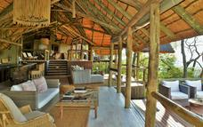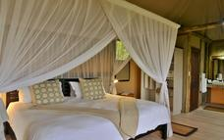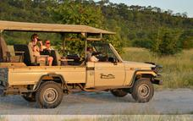

Day 7-9
Sango Safari Camp - Fully Inclusive, Khwai Community Area

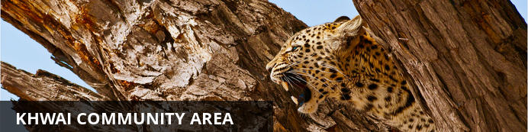
Looking at a map of Botswana, you’d miss Khwai completely if you didn’t know it was there. Wedged between the big-ticket attractions of Chobe National Park to the east and Moremi Game Reserve to the south, Khwai exists as a significant big game destination of its own.
Lying on the eastern fringes of the Okavango Delta with a rich wildlife population and no borders drawn around it on the map, Khwai is often overlooked in favour of its more famous neighbours, though in the winter months it can hold its own for the quality of big game viewing.
During your time here, you’ll spend most days exploring the narrow Khwai River, which forms the natural boundary to the Moremi Game Reserve on the south. The Khwai River is a beacon for wildlife and plays host to leopards stalking lechwe in the long grass, lions swimming from the banks to save their cubs’ during territorial disputes and crocodiles competing with wild dogs for a midday meal of impala.
As Khwai lies outside the parks, it offers the freedom and flexibility normally only possible with the heavier price tag of a private concession. Go off-road for a closer look at sightings, night drive in search of nocturnal species, and, with a little advance planning, head out on game walks to track wildlife on foot.
Khwai is also home to a village community where people live side by side with the resident wildlife. Some camps will offer village visits for a dose of cultural insight to go with your safari. For those not visiting the water camps of the delta, many camps in Khwai offer the chance to get out on a mokoro (traditional canoe), although excursions are less traditional in nature, skirting the riverbanks, rather than open delta floodplains.

Overnight: Sango Safari Camp - Fully Inclusive
Includes: meals, local drinks, activities, park fees, laundry & return airstrip transfers
Excludes: premium imported wines, champagnes & spirits
Activities: day & night game drives and mokoro (seasonal). Walking on request.
Sango Safari Camp is nestled in the shade of the trees overlooking the Khwai River. Situated on the outskirts of the traditional village of Khwai and on the border of Moremi Game Reserve, the camp offers guests the perfect base from which to explore the wildlife and culture of this unique habitat.
This intimate safari camp is named for the Sango Family, some of the original inhabitants of the Khwai area. Guests will have the chance to learn first hand about the unique lifestyle and experiences that come from living and growing up in one of the most wildlife-rich areas of Botswana.
Accommodating 12 guests in 6 en-suite meru tents, Sango Safari Camp is designed in the style of the classic tented safari camp of days gone by. Hand crafted furnishings and classic styling successfully blend the rustic with the luxurious to recreate the atmosphere of the luxury mobile safari camp. Each guest tent has its own private outdoor shower with solar heated geysers for piping hot water. The main area comprises a dining and lounge area where guests can relax and enjoy meals, as well as a viewing deck and plunge pool for whiling away the hours during siesta.
With the Khwai River forming a natural border between the world famous Moremi Game Reserve and Khwai Concession, animals can travel freely through this vast unfenced wilderness. Situated on the river overlooking the Moremi and with access to both these magnificent wildlife areas, Sango Safari Camp is focused on delivering an exceptional wildlife experience to our guests. The camp’s location allows guests to take advantage of a host of wildlife activities which include open vehicle game drives both in the Moremi and in the Khwai concession area, guided bush walks, night drives and mokoro trips.
With a combination of permanent water, seasonal floodplains, open grasslands, riverine forests, and dry woodlands this incredibly rich habitat supports a diversity and abundance of mammals and birds rarely matched in northern Botswana. Sango Safari Camp invites you to share in this bounty.
Airstrip Transfer Time: 30 minutes
GPS Coordinates:
Lat: 19 1634 S 19 09’ 48.2”
Long: 23 7628 E 23 45’ 46.0”
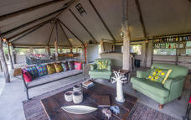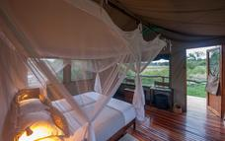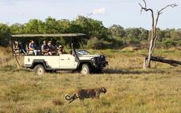

Day 9
Thamalakane River Lodge, Maun

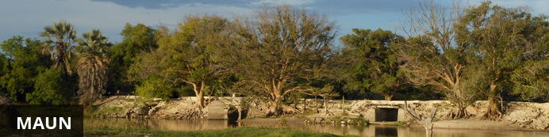
Situated along the banks of the Thamalakane River, in the North-West District of Botswana, Maun, a term that derives its name from the San language, meaning "the place of reeds," serves as the administrative town center of Ngamiland. Maun is notoriously known as a "Frontier" town, and is referred to as the 'gateway' to the Okavango Delta and Moremi Game Reserve as most tourists enter these destinations through this buzzing town.
Although classified as one of the fastest growing towns in Botswana, and boasting one of the busiest airports in Southern Africa, Maun still retains much of its old/traditional (village-like) character, which encompasses the old judicial court of chiefs who are still active. Reed and mud hut infrastructures are seen in and around town as well as donkeys/carts and livestock. However, numerous hotels, lodges, bed and breakfasts, shopping malls, post offices, a museum and a big hospital are available too. Maun also serves as the headquarters for the safari industry, tour operators and air charter companies that offer trips into the Okavango Delta and National Parks such as Moremi Game Reserve, Khwai, Savute, Makgadikgadi, Chobe, Nxai Pan to name a few, as well as monumental historical sites like the Tsodilo Hills. Opportunities to visit nearby cultural villages can also be arranged from this central point.

Activities
Travel For Impact SD

Overnight: Thamalakane River Lodge
Includes: bed & breakfast
Excludes: all other meals not specified, drinks and activities
Activities: boat cruises and various activities in and around Maun & Moremi can be arranged on request.
Thamalakane River Lodge is situated on the Thamalakane River, 19km from Maun, on the road to Moremi Game Reserve. The lodge is built in stone and thatch and is nestled under tall trees on the banks of the river. Thamalakane River Lodge offers an escape from Maun in tranquil surroundings, yet with the convenience of proximity to town.
The lodge offers a variety of accommodation in en-suite stone chalets, which are positioned in the shade of the riverine forest. All chalets have mosquito nets, tea and coffee making facilities as well as a veranda overlooking the river.
During your stay you can enjoy drinks and meals at the open bar/restaurant while enjoying spectacular sunsets over the river. The grounds provide a haven for extensive birdlife and there is a swimming pool and grassed leisure area for your enjoyment.
Thamalakane Lodge is accessible by 2 wheel drive vehicles and offers the discerning traveller a wonderful stopping point or base from which to begin a safari into the Okavango Delta.
Airport Transfer Time: 30 minutes
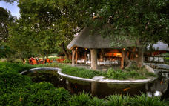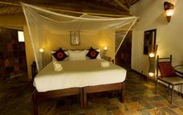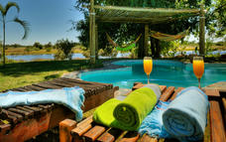

Day 10
End of Itinerary

Activities
Travel For Impact SD

Travel Information
• Please take note of our Booking Terms & Conditions. It will be understood that these have been read and accepted by you on receipt of confirmation of the booking.
• For your safety and peace of mind, on confirmation of your booking, we strongly recommend that Travel Insurance is arranged to cover cancellation, curtailment, emergency evacuation, medical and repatriation expenses, damage/theft/loss of personal luggage, money and goods.
• Road and air transfers and activities are quoted on a seat basis (shared) unless otherwise requested or specified. Passengers may have various stops en-route to a destination. The transfer or charter company reserves the right to specify departure and arrival times. Private charters can be requested at an additional cost.
• Passengers weighing over 100kg should please advise us at the time of booking, as we may need to cost in an additional seat on internal flights for your safety and comfort.
• The costs are subject to change at any time due to fluctuations in fuel costs, taxes, levies, government regulations, rate of exchange and factors that are imposed upon us by our suppliers that are beyond or control.
• Please advise us of the ages of children (under 18) travelling, together with their date of birth, at the time of booking as not all lodges accept children and there may be restrictions or conditions which can affect pricing.
• We recommend that optional activities be booked in advance at time of confirmation to guarantee availability e.g. Elephant Back Safari in Victoria Falls
• Please allow a minimum 2-3 hours connection time in Johannesburg for international flights. It is important that you check that your flight tickets have been issued in your full names as per your passport.
• We require full payment for international and domestic scheduled flights at the time of confirmation e.g. Air Botswana JNB/MUB, Proflight LIV/LUS. We are not able to guarantee any flights before receipt of payment as seats are often held for a limited period before ticketing is required so this is a time sensitive issue. Air tickets are considered non refundable unless otherwise specified. Please confirm the details with your consultant at the time of booking.
Passports, Visas and Travel Documentation
Your passport must have at least 6 months validity before the expiry date and 6 empty pages (not including the endorsement pages). The onus is upon the guests to ensure that passports and visas are valid for the countries visited. Please note that certain visas can take up to 3 months to be processed so please consider this when booking.
If you are travelling with children through Southern Africa please be aware that you will be required to have certified copies of their unabridged birth certificates, and passports on hand. If you are not their legal parents, or if only one of you is travelling – you will need to have consent in the form of an affidavit giving you permission to travel with the child.
Inter-camp transfers
Due to the vast distances involved in travelling in the remote areas of Southern Africa - your itinerary may include road, boat and air transfers in small aircraft.
On shared air transfers, all the flight times between lodges are arranged a few days before the flights take place to avoid endless schedule changes. The lodge or camp where you are staying will be advised of your departure time the day before travel and will ensure that you are at the airstrip on time. Although every effort will be made to ensure that guests are transferred together in one vehicle / aircraft, this cannot be guaranteed, especially with larger groups. The aircraft used for inter-camp transfers vary in size from 3, 5, 7 and 12 seater aircraft. We recommend that guests susceptible to motion sickness take appropriate precautions due to flying conditions.
Weight & Luggage Restrictions
There are strict luggage restrictions in place on any itinerary, which includes light aircraft transfers for safety reasons. Luggage, including camera equipment and hand luggage, is restricted to 20 kg per person travelling on seat rates. Only soft bags will be accepted - no hard suitcases or bags with wheels can be transported, as they physically cannot fit into the aircraft.
The maximum dimensions of the soft bags that can be accommodated are as follows: 25cm/10 inches wide x 30cm/11 inches high and 62cm/24 inches long. Please keep in mind that the baggage compartments on the light aircraft are only 25cm high, so the pilots must have the ability to manipulate the bag into the compartment. Note that laundry can be done on a daily basis at most camps and lodges.
Should you arrive with excess baggage without prior warning, your baggage could be delayed, as we may have to fly the baggage into camp at a later stage at considerable extra cost to you. However, should you notify us in advance that your baggage will exceed the limit; we may be able to assist you with alternative arrangements e.g. storage or purchase of additional luggage allowance.
For bookings including flights within Zambia & Mozambique, please note luggage weight exceptions under destination information.
Lost Luggage
Lost luggage on international flights is a common problem facing travellers today. We suggest that you pack a small bag with your essentials, including any life sustaining medication, which can be carried with you as hand luggage. If travelling as a couple or family we suggest that you split your clothing between bags so that if one bag gets lost, you will have basic items on hand to see you through the first couple of days while we try and recover your lost baggage.
Please note that whilst we try our utmost to locate and re-unite you with your bags, that there may be charges involved in getting your bags to remote areas, which would be for your cost. Please remember to report the lost luggage to the airline as soon as you make the discovery - the airline will issue you with a Baggage Claim Form, which you will need in order for us to trace the bag.
Health and Dietary
Please note that you are travelling to a Malaria-risk area. Please consult your doctor for medical advice prior to travel.
Although usually safe to drink, we do not recommend that you drink the tap water. Filtered water is available at the camps and lodges.
The camps are isolated and generally have limited power supply and access to supplies. Please notify us in advance of any special dietary requirements, medical conditions and medical equipment you may need with you. Please carry critical medication in your hand luggage.
Yellow Fever Certificates - are only required if you have travelled to a Yellow Fever area as designated by the World Health Organisation. Please check with your Travel Clinic or doctor well in advance of your departure date.
General Travel Information
• There is no or limited electricity and cell phone coverage in the camps and lodges excluding major towns and cities. All camps do make provision for charging cameras and electronic devices.
• Please ensure that you do not pack any valuables, cameras, cash, laptops in your checked in luggage – these should be kept on your person at all times.
• Please notify us immediately of any changes to flight arrival and departure details as this affects onward transfer arrangements.
• Please note that most camps & lodges in Botswana do not have double beds. Twin beds are pushed together to make up a double room.
• Although every effort is made to adhere to schedules the company reserves the right and in fact is obliged to occasionally change routes and camps on safaris as dictated by changing conditions or unforeseen circumstances.
• By confirmation of the booking, you acknowledge that you have been made aware and accept that the tour carries inherent risks, and that you voluntarily assume all risks which are associated with the tour. You will be required to sign indemnities at the various camps, lodges and service providers, and abide by their operators code of conduct in order to ensure your safety.
• If you have any cause for complaint while travelling, you should immediately bring it to the attention of the camp manager and / or our Maun office that will attempt to resolve the situation immediately.
• Do not remove any animal artefacts, flora or fauna from any of the areas you visit, as there are strict international regulations on the export of such items.
Please refer to the Safari Information (https://www.dropbox.com/s/3e5s2s55z8yhray/safari-information.pdf?dl=0) for further details on preparing for your safari.
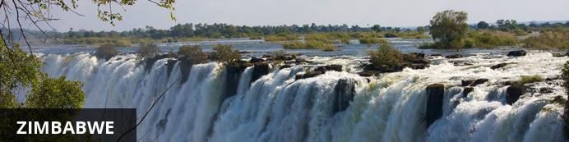
Currency
The currency of Zimbabwe is the American Dollar (US$). US$ Dollar notes (2007 Series onwards), and Visa and MasterCard are accepted. Always have enough US$ cash available in smaller denominations in the event where ATM's and Credit Card facilities are not operational.
Visa
Fees for Visitors to Zimbabwe who are eligible to receive their visa on entry
Europe and USA: U$D 30.00 for single entry/ U$D 45.00 for double entry.
UK & Ireland: U$D 55.00 for single entry/ U$D 70.00 for double entry.
Canada: U$D 75.00 for single entry/ double entry to be obtained from local embassy prior to travel
Some visitors need to apply for visas before arrival - please check with your Embassy, Zimbabwe Government Visa Requirements. ALWAYS have cash available in the correct USD amount at ALL ports of entry.
Kaza Univisa – Zimbabwe and Zambia
Travellers planning to visit both Zimbabwe and Zambia should apply for a UniVisa (also known as KAZA visa). The visa can be obtained in advance, as well as at ports of entry, but cannot be guaranteed.
The UniVisa allows travellers 30 days travel within both Zambia and Zimbabwe, and is also valid for daytrips to Botswana. Travellers must remain within Zambia & Zimbabwe for the visa to stay valid. Visiting Botswana as a daytrip will not affect the visa’s validity, provided travellers return to Zambia or Zimbabwe the same day.
Internal Flights and Transfers
Due to the remote areas the camps and lodges are based in, transfers between camps may take place by boat, train, game drive vehicle or light aircraft.
Departure Taxes
International departure taxes are included in the scheduled flight rates. However light aircraft transfers from Victoria Falls Airport to Livingstone or Kasane require an International Departure tax of US$35 per person & AIDF Levy of $15 = $50 per person to be paid in cash.
Domestic departure taxes are payable in cash at the airport, for any flights departing internally from any registered, manned airport. These include Harare, Bulawayo, Kariba, Hwange and Victoria Falls Airport. The amount is US$10 departure tax + US$5 AIDF Levy = US$15 per person. We recommend small denominations for easier and quicker transactions as change is not always available. Traveller’s cheques and credit cards are NOT accepted.
Weight & Luggage Restrictions
See Booking Information

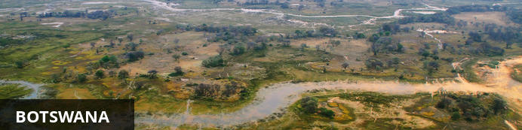
Visa
Some visitors need to apply for visas before arrival please check with your Embassy.
For more information on visas please visit the following address:
Botswana Government - Visa Requirements
BORDER CROSSINGS
Currency
The currency of Botswana is the Pula (BWP). US$ Dollar notes (2007 Series onwards), and Visa and MasterCard are accepted.
Internal Flights and Transfers
Due to the remote areas the camps and lodges are based in, transfers between camps may take place by boat, mekoro, game drive vehicle or light aircraft.
Flight times around Botswana | Approximate flying times
Flight duration times (as listed below), are to be used as an average guideline. They are based on actual flying time, and passengers may have various stops en-route to a destination affecting the total travel time. Your pilot will brief you of your flight route and duration during the safety briefing.
Maun - Delta: 15 to 30 minutes
Delta – Delta: 10 to 20 minutes
Delta - Linyanti: 30 to 40 minutes
Maun – Linyanti: 50 to 60 minutes
Linyanti - Kasane: 40 to 60 minutes
Maun/Delta - Kasane: 60 to 80 minutes
Maun - Makgadikgadi/Desert: 40 to 60 minutes
Departure Taxes
Departure taxes are included in ticket prices.
Weight & Luggage Restrictions
See Booking Information

