Spacing
Lowveld - Durban - Bloemfontein - Port Elizabeth - Paarl - Cape Town - South Africa
14 Dage / 13 Nætter
2 Personer
Udstedelsesdato: 12 June 2018
18 June 2018 - 01 July 2018

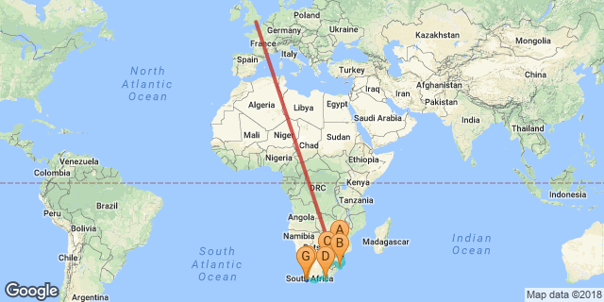

Klik her for at se din digitale rejseplan

Introduction
DANISH introduction

Indkvartering | Type | Destination | Start | Slut | Basis | Varighed
Rovos Rail |  |  | 18 Jun | 26 Jun | B, B&F | 8 Nætter
→ Nelspruit | stop | Lowveld | 18 Jun | 20 Jun |  | 2 Nætter
→ Durban | stop | Durban | 20 Jun | 22 Jun |  | 2 Nætter
→ Bloemfontein | stop | Bloemfontein | 22 Jun | 23 Jun |  | 1 Nat
→ Port Elizabeth | stop | Port Elizabeth | 23 Jun | 24 Jun |  | 1 Nat
→ Paarl | stop | Paarl | 24 Jun | 25 Jun |  | 1 Nat
Cape Grace |  | Cape Town | 26 Jun | 29 Jun | Helpension | 3 Nætter
Constantia Sun |  | South Africa | 29 Jun | 1 Jul | Alt inklusive | 2 Nætter

Nøgle
B&B overnatning og morgenmad
B, B&F, overnatning, morgenmad og frokost
Helpension+: overnatning, morgenmad, frokost
AI: Alt inklusive

Pris
- USD 985
- GBP 765
- EUR 965

- ZAR 13000

Inkluderet
PRICE INCLUDES
- Daily breakfast served at the camp’s dining room “Mads Lange”.

- Welcome duffel bag containing a few luxurious camp essentials upon arrival.
- Return luxurious airport transfers with our Camp Navigators for stays of 2 nights or more.
- One time return car transfers to/from Ubud till 6pm, as per the camp’s schedule.
- Complimentary soft drinks, a select variety of local alcoholic beverages and snacks from your in-retreat refreshment trunk, replenished once a day.
- Exclusive access to the camp’s living room and library “The Officers Tent” with refreshments throughout the day and the daily sunset cocktail and canapé ritual.
- Daily laundry service of up to 4 pieces per person, excluding dry cleaning.
- Daily seasonal fruit and infused spring water in tented retreat.
- Complimentary smart phone inclusive data and International* & local telephone calls for use during your stay. (*pre-assigned geographical areas).
- Complimentary high speed WIFI.
- 24-hour access to “The Armory”, our tented gymnasium – exclusively for Capella Ubud, Bali’s guests and usage of “The Cistern”, the 30-metre outdoor rainforest pool.
- Use of mountain bikes.
- Low and high impact camping excursions with our Camp Rangers, offered from the camp’s weekly schedule of activities.
- Exclusive range of organic bathroom amenities and a soap menu.
- Daily camp turndown ritual.
- Complimentary in-retreat coffee (Illy espresso machine) and tea making facilities. (kettle)

Udelukket
PRICE EXCLUDES
- Daily breakfast served at the camp’s dining room “Mads Lange”.

- Welcome duffel bag containing a few luxurious camp essentials upon arrival.
- Return luxurious airport transfers with our Camp Navigators for stays of 2 nights or more.
- One time return car transfers to/from Ubud till 6pm, as per the camp’s schedule.
- Complimentary soft drinks, a select variety of local alcoholic beverages and snacks from your in-retreat refreshment trunk, replenished once a day.
- Exclusive access to the camp’s living room and library “The Officers Tent” with refreshments throughout the day and the daily sunset cocktail and canapé ritual.
- Daily laundry service of up to 4 pieces per person, excluding dry cleaning.
- Daily seasonal fruit and infused spring water in tented retreat.
- Complimentary smart phone inclusive data and International* & local telephone calls for use during your stay. (*pre-assigned geographical areas).
- Complimentary high speed WIFI.
- 24-hour access to “The Armory”, our tented gymnasium – exclusively for Capella Ubud, Bali’s guests and usage of “The Cistern”, the 30-metre outdoor rainforest pool.
- Use of mountain bikes.
- Low and high impact camping excursions with our Camp Rangers, offered from the camp’s weekly schedule of activities.
- Exclusive range of organic bathroom amenities and a soap menu.
- Daily camp turndown ritual.
- Complimentary in-retreat coffee (Illy espresso machine) and tea making facilities. (kettle)

Dag 1: Rovos Rail, Lowveld (Mon, 18 June)

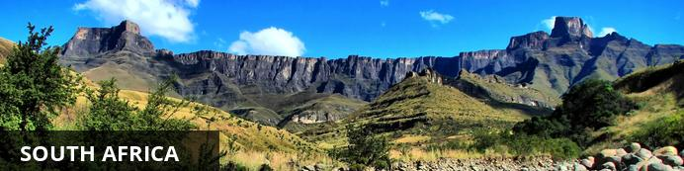
DANISH -
This vast country is undoubtedly one of the most culturally and geographically diverse places on earth. Fondly known by locals as the 'Rainbow Nation', South Africa has 11 official languages and its multicultural inhabitants are influenced by a fascinating mix of African, Asian and European cultures. Spend your days: discovering the gourmet restaurants, impressive art and nightlife scenes and fine beaches of Cape Town; enjoying a typical local braai (barbecue) in the Soweto township; browsing the bustling Indian markets in Durban; or sampling some of the world’s finest wines at the myriad wine estates dotted around the picturesque Cape Winelands. Due to its rich and turbulent history there are plenty of historical attractions to explore including the Zululand battlefields of KwaZulu-Natal, the Apartheid Museum in Johannesburg and Robben Island, just off the coast of Cape Town. Above all else, South Africa’s attraction lies in its remarkably untamed wilderness with its astonishing range of wildlife roaming freely across massive unfenced game reserves such as the world famous Kruger National Park. With all of this variety on offer, it is little wonder that South Africa has fast become Africa’s most popular tourist destination.

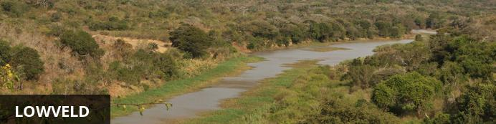
Sandwiched between Mozambique and the Mpumalanga area of the Drakensberg, the Lowveld is renowned for it subtropical climate, abundant wildlife, and ancient history. This area encompasses a number of spectacular game reserves including the world-famous Kruger National Park, vast farmlands, and the popular Panorama Route. This area serves as an excellent base from which to explore the Kruger. Visitors can explore the old gold rush town of Barberton, enjoy the city lights of Nelspruit and stay at a variety of comfortable country lodges.

Dags rejseplan
DANISH - Day Itinierary

Overnatning: Rovos Rail Se iBrochure
Rovos Rail has earned an international reputation for its truly world class travel experiences. Exceptional train safaris combine some of Africa’s most magnificent scenery with travel aboard an authentically refurbished Edwardian-style train, accommodating up to 72 guests in the most spacious train suites in the world, each with their own en-suite bathroom and subtle modern conveniences. The eight scheduled journeys begin or end at Rovos Rail Station, the headquarters and private station of this independent railway company, which is situated in Pretoria.
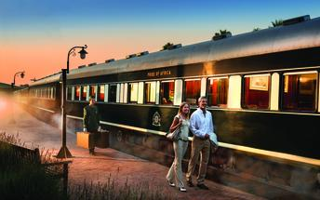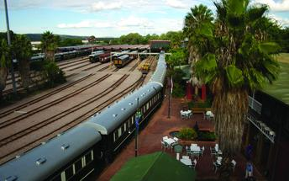

Stop
Nelspruit

Modtagelse
Danish M&G
John Smith +27 21 123 4567
Danish meet and greet text

Nelspruit
Once a simple farming town, Nelspruit (also called Mbombela) is now the flourishing capital of Mpumalanga. Its popularity is largely due to its proximity to the Kruger National Park and Mozambique. Nelspruit is located in the hot lowveld valley of Crocodile River, featuring lush and colourful vegetation.

Basis
Overnatning, morgenmad & frokost
Drikkevarer inkluderet (sodavand)

Dag 2: Rovos Rail, Lowveld (Tue, 19 June)

Stop
Nelspruit

Nelspruit
Once a simple farming town, Nelspruit (also called Mbombela) is now the flourishing capital of Mpumalanga. Its popularity is largely due to its proximity to the Kruger National Park and Mozambique. Nelspruit is located in the hot lowveld valley of Crocodile River, featuring lush and colourful vegetation.

Basis
Overnatning, morgenmad & frokost
Drikkevarer inkluderet (sodavand)

Dag 3: Rovos Rail, Durban (Wed, 20 June)

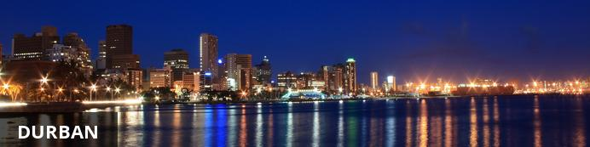
With its beautiful beaches, lively wining and dining scene, and rich cultural heritage, Durban is South Africa’s third largest city and KwaZulu Natal’s tourist hub. The swimming and surfing is rated the best of any major city across the world and because of the sub-tropical climate the water is warm all year round. Known as the Golden Mile, this stretch of beaches and amusement parks is Durban’s major attraction with the recently developed UShaka Marine World at the southern end providing a world-class aquarium and other entertainments. Visitors can look forward to an array of wonderful activities including: strolling along the beachfront promenade, visiting the Durban Botanical Gardens and exploring the many Asian/Indian markets.

Stop
Nelspruit
Durban

Nelspruit
Once a simple farming town, Nelspruit (also called Mbombela) is now the flourishing capital of Mpumalanga. Its popularity is largely due to its proximity to the Kruger National Park and Mozambique. Nelspruit is located in the hot lowveld valley of Crocodile River, featuring lush and colourful vegetation.

Durban
With its beautiful beaches, lively wining and dining scene, and rich cultural heritage, Durban is South Africa’s third largest city and KwaZulu Natal’s tourist hub. The swimming and surfing is rated the best of any major city across the world and because of the sub-tropical climate the water is warm all year round. Known as the Golden Mile, this stretch of beaches and amusement parks is Durban’s major attraction with the recently developed UShaka Marine World at the southern end providing a world-class aquarium and other entertainments. Visitors can look forward to an array of wonderful activities including: strolling along the beachfront promenade, visiting the Durban Botanical Gardens and exploring the many Asian/Indian markets.
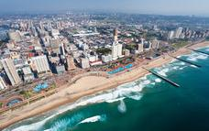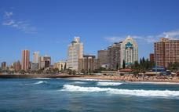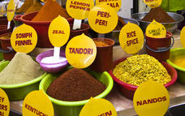

Basis
Overnatning, morgenmad & frokost
Drikkevarer inkluderet (sodavand)

Dag 4: Rovos Rail, Durban (Thu, 21 June)

Stop
Durban

Durban
With its beautiful beaches, lively wining and dining scene, and rich cultural heritage, Durban is South Africa’s third largest city and KwaZulu Natal’s tourist hub. The swimming and surfing is rated the best of any major city across the world and because of the sub-tropical climate the water is warm all year round. Known as the Golden Mile, this stretch of beaches and amusement parks is Durban’s major attraction with the recently developed UShaka Marine World at the southern end providing a world-class aquarium and other entertainments. Visitors can look forward to an array of wonderful activities including: strolling along the beachfront promenade, visiting the Durban Botanical Gardens and exploring the many Asian/Indian markets.

Basis
Overnatning, morgenmad & frokost
Drikkevarer inkluderet (sodavand)

Dag 5: Rovos Rail, Bloemfontein (Fri, 22 June)

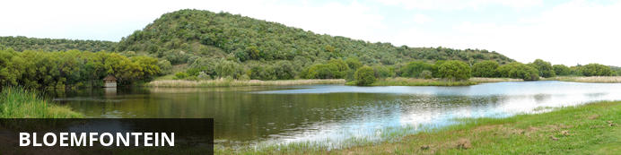
Serving as the commercial and cultural centre of the Free State, as well as South Africa’s judicial capital, Bloemfontein is affectionately known among locals as the ‘City of Roses’. The name Bloemfontein translates to ‘Flower Fountain', so this is no surprise. This compact city is surrounded by sprawling suburbs and provides an excellent stopover for visitors en route to Cape Town from Johannesburg. This friendly, peaceful and clean environment lies at the heart of South Africa where the country’s main road, rail and air links meet. Visitors can soak up city views from the towering Naval Hill, explore numerous art galleries and museums, and stroll through the city’s beautiful botanical garden. Don’t miss the opportunity to visit the nearby cheetah sanctuary for a once in a lifetime cheetah experience.

Stop
Durban
Bloemfontein

Durban
With its beautiful beaches, lively wining and dining scene, and rich cultural heritage, Durban is South Africa’s third largest city and KwaZulu Natal’s tourist hub. The swimming and surfing is rated the best of any major city across the world and because of the sub-tropical climate the water is warm all year round. Known as the Golden Mile, this stretch of beaches and amusement parks is Durban’s major attraction with the recently developed UShaka Marine World at the southern end providing a world-class aquarium and other entertainments. Visitors can look forward to an array of wonderful activities including: strolling along the beachfront promenade, visiting the Durban Botanical Gardens and exploring the many Asian/Indian markets.

Bloemfontein
Serving as the commercial and cultural centre of the Free State, as well as South Africa’s judicial capital, Bloemfontein is affectionately known among locals as the ‘City of Roses’. The name Bloemfontein translates to ‘Flower Fountain', so this is no surprise. This compact city is surrounded by sprawling suburbs and provides an excellent stopover for visitors en route to Cape Town from Johannesburg. This friendly, peaceful and clean environment lies at the heart of South Africa where the country’s main road, rail and air links meet. Visitors can soak up city views from the towering Naval Hill, explore numerous art galleries and museums, and stroll through the city’s beautiful botanical garden. Don’t miss the opportunity to visit the nearby cheetah sanctuary for a once in a lifetime cheetah experience.
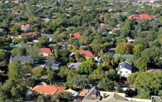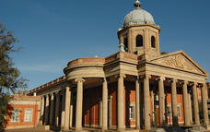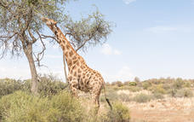

Basis
Overnatning, morgenmad & frokost
Drikkevarer inkluderet (sodavand)

Dag 6: Rovos Rail, Port Elizabeth (Sat, 23 June)

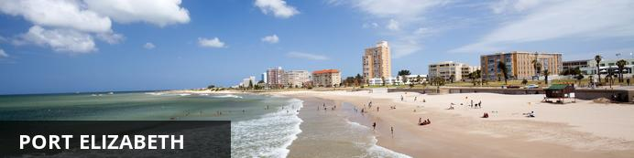
Set on Algoa Bay in South Africa’s Eastern Cape Province, Port Elizabeth also referred to as PE, is known as the Friendly City as well as the Windy City and hopefully, if you stay here you will get a chance to experience the former and not the latter. Port Elizabeth was established to home British settlers who were brought out on a government-sponsored programme to provide a buffer between the Cape Dutch and the Xhosa conflict. The little port grew from there and today it is the gateway to the beautiful Garden Route and serves as an excellent base to explore the Eastern Cape’s magnificent game reserves and pristine beaches. Visitors can explore the Addo Elephant National Park, inhabited by hundreds of elephants; and other wildlife, climb the area’s largest dune at Maitland’s Beach and jump on a boat tour to spot rare seabirds and whales.

Stop
Bloemfontein
Port Elizabeth

Bloemfontein
Serving as the commercial and cultural centre of the Free State, as well as South Africa’s judicial capital, Bloemfontein is affectionately known among locals as the ‘City of Roses’. The name Bloemfontein translates to ‘Flower Fountain', so this is no surprise. This compact city is surrounded by sprawling suburbs and provides an excellent stopover for visitors en route to Cape Town from Johannesburg. This friendly, peaceful and clean environment lies at the heart of South Africa where the country’s main road, rail and air links meet. Visitors can soak up city views from the towering Naval Hill, explore numerous art galleries and museums, and stroll through the city’s beautiful botanical garden. Don’t miss the opportunity to visit the nearby cheetah sanctuary for a once in a lifetime cheetah experience.

Port Elizabeth
Set on Algoa Bay in South Africa’s Eastern Cape Province, Port Elizabeth also referred to as PE, is known as the Friendly City as well as the Windy City and hopefully, if you stay here you will get a chance to experience the former and not the latter. Port Elizabeth was established to home British settlers who were brought out on a government-sponsored programme to provide a buffer between the Cape Dutch and the Xhosa conflict. The little port grew from there and today it is the gateway to the beautiful Garden Route and serves as an excellent base to explore the Eastern Cape’s magnificent game reserves and pristine beaches. Visitors can explore the Addo Elephant National Park, inhabited by hundreds of elephants; and other wildlife, climb the area’s largest dune at Maitland’s Beach and jump on a boat tour to spot rare seabirds and whales.
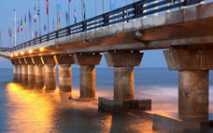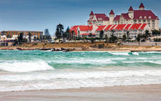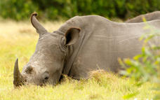

Basis
Overnatning, morgenmad & frokost
Drikkevarer inkluderet (sodavand)

Dag 7: Rovos Rail, Paarl (Sun, 24 June)

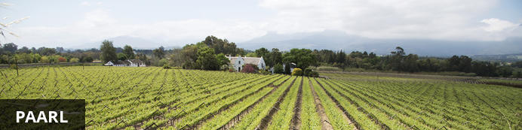
Situated in the heart of the Cape Winelands, Paarl boasts an array of cultural and historical attractions and is surrounded by some spectacular nature reserves. Paarl was named after the huge granite dome of rock, which overlooks the town founded in 1690. The famous 11-kilometre-long Main Street features the Strooidak Church, Die Oude Pastorie Museum and the Patriot Building. The beautiful homestead of Labories in Main Street was bought by KWV. The KWV cellar complex is the largest in the world, covering an area of 22 hectares. The magnificent Cathedral Cellar, with its barrel-vaulted roof and large carved red wine vats is spectacular and depicts the history of the Cape’s wine industry. Visitors can enjoy a wide selection of activities including: wine tasting, scenic fynbos hikes, cycling, sampling local cuisine and much more.

Stop
Port Elizabeth
Paarl

Port Elizabeth
Set on Algoa Bay in South Africa’s Eastern Cape Province, Port Elizabeth also referred to as PE, is known as the Friendly City as well as the Windy City and hopefully, if you stay here you will get a chance to experience the former and not the latter. Port Elizabeth was established to home British settlers who were brought out on a government-sponsored programme to provide a buffer between the Cape Dutch and the Xhosa conflict. The little port grew from there and today it is the gateway to the beautiful Garden Route and serves as an excellent base to explore the Eastern Cape’s magnificent game reserves and pristine beaches. Visitors can explore the Addo Elephant National Park, inhabited by hundreds of elephants; and other wildlife, climb the area’s largest dune at Maitland’s Beach and jump on a boat tour to spot rare seabirds and whales.

Paarl
Situated in the heart of the Cape Winelands, Paarl boasts an array of cultural and historical attractions and is surrounded by some spectacular nature reserves. Paarl was named after the huge granite dome of rock, which overlooks the town founded in 1690. The famous 11-kilometre-long Main Street features the Strooidak Church, Die Oude Pastorie Museum and the Patriot Building. The beautiful homestead of Labories in Main Street was bought by KWV. The KWV cellar complex is the largest in the world, covering an area of 22 hectares. The magnificent Cathedral Cellar, with its barrel-vaulted roof and large carved red wine vats is spectacular and depicts the history of the Cape’s wine industry. Visitors can enjoy a wide selection of activities including: wine tasting, scenic fynbos hikes, cycling, sampling local cuisine and much more.
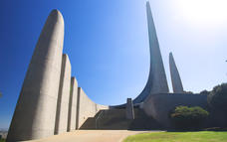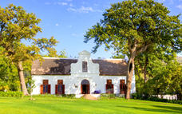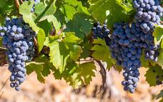

Basis
Overnatning, morgenmad & frokost
Drikkevarer inkluderet (sodavand)

Dag 8: Rovos Rail (Mon, 25 June)

Stop
Paarl

Paarl
Situated in the heart of the Cape Winelands, Paarl boasts an array of cultural and historical attractions and is surrounded by some spectacular nature reserves. Paarl was named after the huge granite dome of rock, which overlooks the town founded in 1690. The famous 11-kilometre-long Main Street features the Strooidak Church, Die Oude Pastorie Museum and the Patriot Building. The beautiful homestead of Labories in Main Street was bought by KWV. The KWV cellar complex is the largest in the world, covering an area of 22 hectares. The magnificent Cathedral Cellar, with its barrel-vaulted roof and large carved red wine vats is spectacular and depicts the history of the Cape’s wine industry. Visitors can enjoy a wide selection of activities including: wine tasting, scenic fynbos hikes, cycling, sampling local cuisine and much more.

Basis
Overnatning, morgenmad & frokost
Drikkevarer inkluderet (sodavand)

Dag 9-12: Cape Grace, Cape Town (Tue, 26 June to Fri, 29 June)

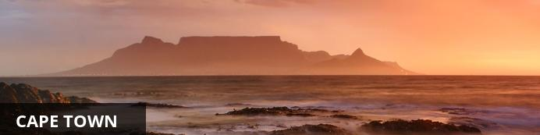
Resting at the confluence of the Indian and Atlantic Ocean, sandwiched between the slopes of the iconic Table Mountain and the glistening sapphire waters of Table Bay, the exceptionally scenic city of Cape Town is in a class of its own. Some cities boast rich culture, vibrant nightlife, a cosmopolitan atmosphere and extraordinary architecture, while others boast breathtaking landscapes and extraordinary natural wonders. Cape Town is lucky enough to be blessed with all of these attractions and so much more. With its bustling harbour, world-class beaches, top-notch vineyards, and its mountainous surroundings brimming with diverse flora and fauna, Cape Town consistently captivates the hearts of all who visit.

Dags rejseplan
Dutch DAY ITINERARY
- Daily breakfast served at the camp’s dining room “Mads Lange”.

- Welcome duffel bag containing a few luxurious camp essentials upon arrival.
- Return luxurious airport transfers with our Camp Navigators for stays of 2 nights or more.
- One time return car transfers to/from Ubud till 6pm, as per the camp’s schedule.
- Complimentary soft drinks, a select variety of local alcoholic beverages and snacks from your in-retreat refreshment trunk, replenished once a day.
- Exclusive access to the camp’s living room and library “The Officers Tent” with refreshments throughout the day and the daily sunset cocktail and canapé ritual.
- Daily laundry service of up to 4 pieces per person, excluding dry cleaning.
- Daily seasonal fruit and infused spring water in tented retreat.
- Complimentary smart phone inclusive data and International* & local telephone calls for use during your stay. (*pre-assigned geographical areas).
- Complimentary high speed WIFI.
- 24-hour access to “The Armory”, our tented gymnasium – exclusively for Capella Ubud, Bali’s guests and usage of “The Cistern”, the 30-metre outdoor rainforest pool.
- Use of mountain bikes.
- Low and high impact camping excursions with our Camp Rangers, offered from the camp’s weekly schedule of activities.
- Exclusive range of organic bathroom amenities and a soap menu.
- Daily camp turndown ritual.
- Complimentary in-retreat coffee (Illy espresso machine) and tea making facilities. (kettle)

Konsulent noter
Dutch EXPERT TIPS
- Daily breakfast served at the camp’s dining room “Mads Lange”.

- Welcome duffel bag containing a few luxurious camp essentials upon arrival.
- Return luxurious airport transfers with our Camp Navigators for stays of 2 nights or more.
- One time return car transfers to/from Ubud till 6pm, as per the camp’s schedule.
- Complimentary soft drinks, a select variety of local alcoholic beverages and snacks from your in-retreat refreshment trunk, replenished once a day.
- Exclusive access to the camp’s living room and library “The Officers Tent” with refreshments throughout the day and the daily sunset cocktail and canapé ritual.
- Daily laundry service of up to 4 pieces per person, excluding dry cleaning.
- Daily seasonal fruit and infused spring water in tented retreat.
- Complimentary smart phone inclusive data and International* & local telephone calls for use during your stay. (*pre-assigned geographical areas).
- Complimentary high speed WIFI.
- 24-hour access to “The Armory”, our tented gymnasium – exclusively for Capella Ubud, Bali’s guests and usage of “The Cistern”, the 30-metre outdoor rainforest pool.
- Use of mountain bikes.
- Low and high impact camping excursions with our Camp Rangers, offered from the camp’s weekly schedule of activities.
- Exclusive range of organic bathroom amenities and a soap menu.
- Daily camp turndown ritual.
- Complimentary in-retreat coffee (Illy espresso machine) and tea making facilities. (kettle)

Overnatning: Cape Grace Se iBrochure
DANISH-
Welcome to Cape Grace. Situated on a private quay between Cape Town’s bustling V&A Waterfront and the tranquil yacht marina, there is no better position from where to soak in the natural beauty of our Mother City and the very essence of Cape Town living at its best. Our elegant and warm atmosphere, evident in every fine detail, begins at the welcoming reception lounge and extends to our spacious harbour and mountain-facing rooms. Stories of the Cape’s colourful past present themselves in our exquisite furniture, rare fabrics, intriguing artefacts and original antiques. Local paintings and sculptures lend a contemporary flair to our décor and feel, while fresh displays of Proteas that hint at the wonder of our natural botanical kingdom enrich each room. We invite you to share in tailor-made experiences that include our sumptuous tasting menus, rare whisky pairings, luxurious spa treatments, and indulgent Afternoon Teas – all thoughtfully created to enhance your journey in the Cape and with us.
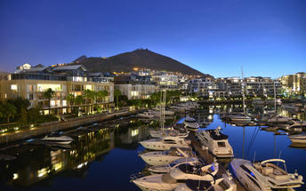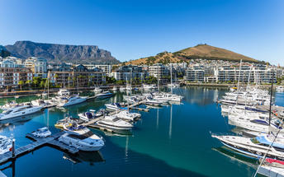

Aktiviteter
Birdmen Paragliding
Half Day Cape Malay Home Hosted Dinner Experience

Birdmen Paragliding
Have you ever wanted to experience the absolute freedom of flight?
Want an adrenaline rush? See the Cape from a different view?
Spoil your partner? Do something you have never done before?
Why not try a Tandem Paragliding flight with Birdmen Paragliding.
Experience It
The average tandem flight lasts for about 15 - 25 minutes. All flights are weather dependent and the sites that are generally flown are Lion's Head, Signal Hill, Sir Lowry's Pass, Hermanus and Franschhoek.
During the flight you can relax and enjoy the view from a bird’s-eye perspective. You can take photos while in the air and your pilot is also equipped with a camera to take photos (optional). Pure simplicity and freedom is the true beauty of paragliding. Within minutes you and the glider can be ready and in the air. It is a truly awesome and unique experience!
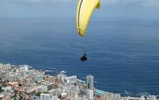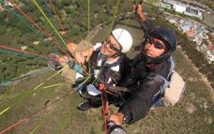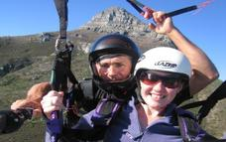

Half Day Cape Malay Home Hosted Dinner Experience
Enjoy a unique interaction and experience the cultural diversity of the Cape Malay community, descendants of the original Malay slaves. We start in front of the Bo-Kaap Museum in the heart of the Cape Malay Quarter where you learn more about their history and the preservation of their traditions in Africa. Your host will then guide you on an entertaining walking tour giving you insights into the historical and architectural landscape that adds so much colour and character to Cape Town’s City Bowl. The highlight of this experience is enjoying an authentic home-cooked dinner at the gracious home of your host family.
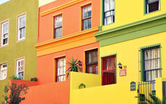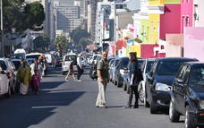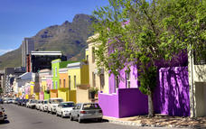

Basis
Helpension
Alle drikkevarer inkluderet

Inkluderet
Dutch INCLUDED
- Daily breakfast served at the camp’s dining room “Mads Lange”.
- Welcome duffel bag containing a few luxurious camp essentials upon arrival.

- Return luxurious airport transfers with our Camp Navigators for stays of 2 nights or more.
- One time return car transfers to/from Ubud till 6pm, as per the camp’s schedule.
- Complimentary soft drinks, a select variety of local alcoholic beverages and snacks from your in-retreat refreshment trunk, replenished once a day.
- Exclusive access to the camp’s living room and library “The Officers Tent” with refreshments throughout the day and the daily sunset cocktail and canapé ritual.
- Daily laundry service of up to 4 pieces per person, excluding dry cleaning.
- Daily seasonal fruit and infused spring water in tented retreat.
- Complimentary smart phone inclusive data and International* & local telephone calls for use during your stay. (*pre-assigned geographical areas).
- Complimentary high speed WIFI.
- 24-hour access to “The Armory”, our tented gymnasium – exclusively for Capella Ubud, Bali’s guests and usage of “The Cistern”, the 30-metre outdoor rainforest pool.
- Use of mountain bikes.
- Low and high impact camping excursions with our Camp Rangers, offered from the camp’s weekly schedule of activities.
- Exclusive range of organic bathroom amenities and a soap menu.
- Daily camp turndown ritual.
- Complimentary in-retreat coffee (Illy espresso machine) and tea making facilities. (kettle)

Udelukket
EXCLUDED
- Daily breakfast served at the camp’s dining room “Mads Lange”.
- Welcome duffel bag containing a few luxurious camp essentials upon arrival.

- Return luxurious airport transfers with our Camp Navigators for stays of 2 nights or more.
- One time return car transfers to/from Ubud till 6pm, as per the camp’s schedule.
- Complimentary soft drinks, a select variety of local alcoholic beverages and snacks from your in-retreat refreshment trunk, replenished once a day.
- Exclusive access to the camp’s living room and library “The Officers Tent” with refreshments throughout the day and the daily sunset cocktail and canapé ritual.
- Daily laundry service of up to 4 pieces per person, excluding dry cleaning.
- Daily seasonal fruit and infused spring water in tented retreat.
- Complimentary smart phone inclusive data and International* & local telephone calls for use during your stay. (*pre-assigned geographical areas).
- Complimentary high speed WIFI.
- 24-hour access to “The Armory”, our tented gymnasium – exclusively for Capella Ubud, Bali’s guests and usage of “The Cistern”, the 30-metre outdoor rainforest pool.
- Use of mountain bikes.
- Low and high impact camping excursions with our Camp Rangers, offered from the camp’s weekly schedule of activities.
- Exclusive range of organic bathroom amenities and a soap menu.
- Daily camp turndown ritual.
- Complimentary in-retreat coffee (Illy espresso machine) and tea making facilities. (kettle)

Dag 12-14: Constantia Sun, South Africa (Fri, 29 June to Sun, 1 July)

Overnatning: Constantia Sun
Constantia Sun, a newly built self-catering guest house, nestled on the hill, high in the peaceful mountains of Constantia with fantastic view over the valley and to the False Bay nearest to the City of Cape Town. We have not doubt, you will enjoy your stay with us. Enjoy tranquillity, privacy, security and superb accommodation in our splendid house and magnificent garden.
Overlooking forests, vineyards, mountains and sea, Constantia Sun is the ideal retreat for those who wish to get away from it all, yet is only 25 minutes from the Cape Town city centre and 30 minutes from Cape Town International Airport. An up-market suburb of Cape Town, Constantia is set in beautiful surroundings with plentiful sporting, shopping and restaurant amenities - and is within easy access of all the wonderful tourism venues of Cape Town and the Cape Winelands.
An ideal venue for golfers, located 10 minutes to two championship golf courses and 20 minutes to a further five major golf courses. Didn't bring your golf clubs? Constantia Sun has one set of golf clubs available for complimentary use by guests...
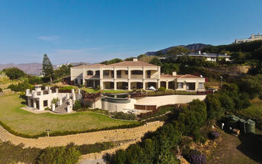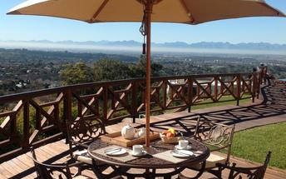

Basis
Alt inklusiv
Drikkevarer inkluderet (undtagen spiritus)

Dag 14: Slutningen af ​​Rejseplanen (Sun, 1 July)

Basis
Bed & Breakfast

Transport

Fly information
Dato | Fly | Flyselskab | Afrejse lufthavn | Tid | Ankomst lufthavn | Tid | Klasse | Ref
18 Jun | BA786 (Planlagt) | BA | Heathrow Terminal 4 | 20:00 | OR Tambo International Airport [JNB] | 06:00 | Business | BAgyu765swvbdhd;BAgyu765swvbyuy

Tur information
Dato | Tog | Bureau | Afrejse perron | Tid | Ankomst platform | Tid | Klasse | Ref
18 Jun | 89 (Tog) | Rovos | Rovos Rail Station | 13:00 | Cape Town Station | 15:00  (26 Jun) | A | RR678;RR679

Akut kontakt numre
Firma navn | Telefon | Email adresse | Kontakt person
Wetu | +27 (0)21 674 5390 | ursula@wetu.com | Ursula

Oversigt over serviceudbydere
Service udbyder | Ref.nummer | Telefon | Adresse
BA | BAgyu765swvbdhd;BAgyu765swvbyuy
Cape Grace |  | +27 21 410 7100 | West Quay Road  V&A Waterfront  Cape Town
Constantia Sun |  | 021 794 4657 | Constantia Sun  36a Price Drive  Constantia  Cape Town  Western Cape  7806  South Africa
Rovos | RR678;RR679
Rovos Rail |  | +27 12 315 8242 | Rovos Rail Station  1 Transnet Avenue  Capital Park  Pretoria  0001

Rejseinformation
This is where Travel Guidance displays

Vilkår og betingelser

Rejseplan vilkår og betingelser
T&C
Daily breakfast served at the camp’s dining room “Mads Lange”.
Welcome duffel bag containing a few luxurious camp essentials upon arrival.
Return luxurious airport transfers with our Camp Navigators for stays of 2 nights or more.
One time return car transfers to/from Ubud till 6pm, as per the camp’s schedule.
Complimentary soft drinks, a select variety of local alcoholic beverages and snacks from your in-retreat refreshment trunk, replenished once a day.
Exclusive access to the camp’s living room and library “The Officers Tent” with refreshments throughout the day and the daily sunset cocktail and canapé ritual.
Daily laundry service of up to 4 pieces per person, excluding dry cleaning.
Daily seasonal fruit and infused spring water in tented retreat.
Complimentary smart phone inclusive data and International* & local telephone calls for use during your stay. (*pre-assigned geographical areas).
Complimentary high speed WIFI.
24-hour access to “The Armory”, our tented gymnasium – exclusively for Capella Ubud, Bali’s guests and usage of “The Cistern”, the 30-metre outdoor rainforest pool.
Use of mountain bikes.
Low and high impact camping excursions with our Camp Rangers, offered from the camp’s weekly schedule of activities.
Exclusive range of organic bathroom amenities and a soap menu.
Daily camp turndown ritual.
Complimentary in-retreat coffee (Illy espresso machine) and tea making facilities. (kettle)

Wetu Vilkår og betingelser
This is where you would put your standard terms and conditions. This is a sample account for Wetu so we do not have any T & Cs

