Dear ****CLIENT NAMES****,

On behalf of Koen & Sophie at Puur Reizen, welcome to Namibia and I hope that you have a fantastic holiday and Namibian adventure!

In this file, I will give you as much information as possible but please do not hesitate to contact me for any more information. Here are some points I would like to note before I go into the day-to-day breakdowns:

***NOTE:*** *Should you have any flight delays or arrival time changes, please make an effort to contact us ahead of time and advise on the new times or changes. Our staff drive out to the international airport which is about a 45 minute drive from the city, and if there are any delays longer than 1 hour we would like to be notified so we can make the needed arrangements. Please feel free to contact Carlo (see number below) or your consultant via sms/text message or WhatsApp to let us know.*

1) On your arrival at Windhoek International Airport, you will be met by a representative of Puur Reizen who will transfer you into Windhoek, *******to the Depot offices*****OR ACCOMMODATOIN*****, where we will do the vehicle handover and go through the rental agreement with you. Please note that the meeting point for Puur Reizen clients is at The Arrivals Terminal. Our representative will be waiting for you with a welcome sign and your name on the board.

**\*\*\*\*CAR RENTAL COMPANY\*\*\*\*** – ****CONTACT DETAILS******

2) Our representative will do a ‘meet & greet’ with you after you have completed the rental procedures. He or she will hand you your travel pack for the duration of your tour, as well as go through your route and offer some tips for along the way. Please feel free to ask him/her any questions or clarify anything if you have any uncertainties.

**Carlo or Maxie** – Puur Reizen transfer / fleet manager / meet & greet controller+264 81 129 8530.

3) Please take note that no meals are included for the nights that you are camping. All additional meals will be for your own arrangement and account. It is important to plan your meals for camping nights accordingly, and stock up on supplies as you go along. Refer to your day-to-day itinerary for more information for where and when to buy supplies. Kindly do also take note of the meal basis for the nights that you are Lodging. For the nights in Windhoek and Swakopmund, only breakfast is included. All other meals will be for your own account.

4) The Red Line, also referred to as the veterinary cordon fence (VCF) is a pest-exclusion fence, which separates northern Namibia from the central and southern regions. In Namibia and Botswana, vet fence restrictions allow you to move meat from south to north and from east to west. However, you cannot move meat from north to south, and from west to east, past the vet lines. Northern regions are classified as foot-and-mouth infected zones (see map below).

Movement of raw meat and animal products, including unpasteurized milk, is allowed entry but not exit from a classified infected zone. When entering National Parks, you will be able to take meat, dairy and food products into the park, but you will not be able to take them out of the park again. At some of these fences, you may be asked to drive your vehicle through a dip filled with a disinfecting solution and you, and your passengers may have to exit the vehicle and walk on a mat impregnated with the solution to disinfect your shoes (the ones you are wearing plus extras).

In Namibia you are not allowed to take meat/ fresh produce from:

- Katima Mulilo to Rundu

- Rundu to Grootfontein

- Palmwag south into Damaraland

- From the vet fence, west between Tsumkwe and the main Rundu/Grootfontein road

- Etosha south. You can however take meat into Etosha coming from the south.

Due to vet fences in Botswana, you are not allowed to take meat from Maun to Nxai Pan, Makgadigadi, Nata or Ghanzi. You can, however, take meat from Maun to Tsodillo Hills, Moremi, Chobe and Savuti.

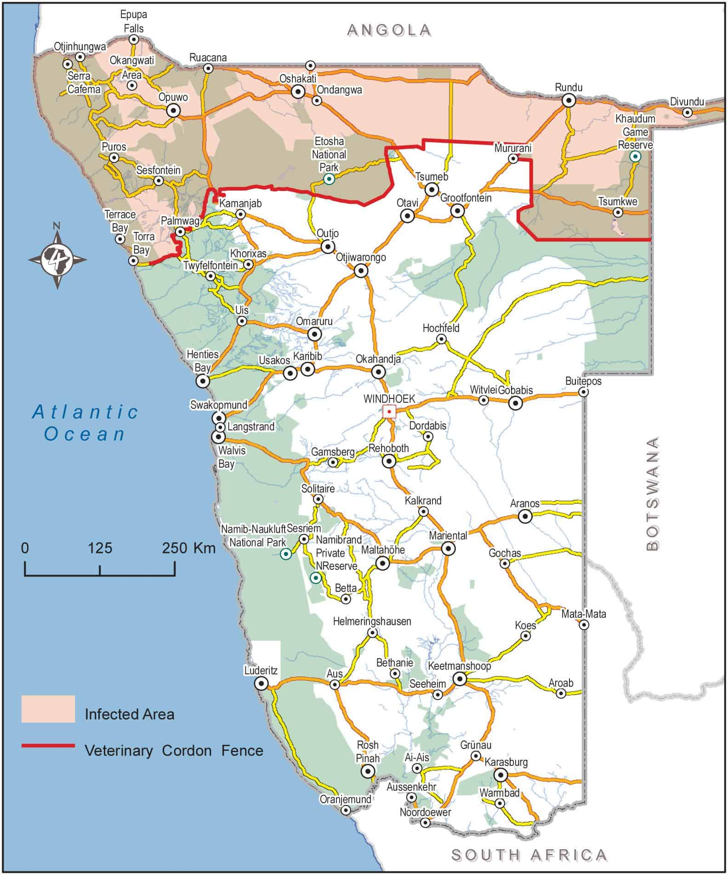

5) Please make sure that you have enough water with you as there are routes with no shops along the way. I would also suggest that you have “snacks” with you for “emergency”. You can also take food along for lunches on the road for a picnic along the way.

6) All National Parks restrict the use of plastic bags in the parks. Therefore, no plastic shopping bags will be allowed into the parks on entry.

7) In Windhoek and Swakopmund, it is recommended to make reservations for dinners, especially in high season when the popular restaurants get fully booked. Discuss this with your meet & greet agent or let me know, and I can make a recommendation and booking for you.

8) If you’d like us to assist with booking activities in Swakopmund, you can visit our very own activity centre at our office in town. Come meet with us, browse your options, discuss them with a travel expert and enjoy a cup of coffee whilst you’re at it. Find us on the 2nd Floor, Pandion Building on Same Nujoma Avenue (the main road through the centre of town). We’d love to meet you.

9) In Namibia, we locals make a habit of refueling often or whenever there is a fueling station available. It has happened that one thinks that you have enough fuel, only to find that the next station does not have any fuel available!

10) PLEASE NO off-road driving. Keep to the roads mentioned on the itinerary. The reason is not only for your safety and well-being, but the terrain in our part of Africa is very sensitive and tracks left in the bush take many, many years to recover. Apart from this, in national parks/reserves, concession areas and private land, it is against the law to drive off-road.

11) At all times when driving a motor vehicle during the day on a trunk road, main road and district road, you need to switch on your head lamps on dipped beam or daytime running lights. This is according to Namibian Law.

12) You will be supplied with a GPS for your self-drive safari. We have added lodge and hotel locations in the ‘favorites’ section of the GPS. Please note that updates are done constantly by the relative providers, and that these are not always 100% accurate. You will also receive a map of your route and driving directions, so combining the use of the GPS and your map along with the directions, I am sure you will easily find your destination.

13) Please adhere to speed limits at all times. This is for your own safety and to abide by Namibian law.

14) Take note of the standard check-in and check-out times at the lodges, and plan your travelling days accordingly. Check-in is usually from 14:00pm. Check-out is usually around 10:00/11:00am. Should you arrive early or depart late, you will need to arrange this with reception accordingly or arrange to leave your luggage at reception, if necessary.

15) Should you have an early arrival or late departure with time to spare before check-in for flights or accommodation, you are welcome to make use of our day room facilities in Windhoek. You can speak to myself or Carlo to arrange accordingly.

16) Please make sure you have a local contact number while in the country. Where possible, please ensure that our office receives this contact number in case we need to get hold of you for any reason whilst on tour.

17) You will find all the necessary contact numbers you may need on your provided vouchers, as well as in your travel diary. Please feel free to contact our office at any time and do not hesitate to contact me if you have any problems or if I can assist you with anything further during your time in Namibia.

I hope that you will have an amazing holiday! Travel safe and as you will meet many friendly people, feel free to ask for help and advice along the way.

Best regards,

****CONSULTANT NAME*****

**Travel Expert ****CONSULTANT CONTACT NUMBER\*\*\*\*\***

**Important Telephone numbers to note:**

After hours number +264 81 784 4315

****CAR RENTAL NAME & CONTACT NUMBER******

Carlo Basson, Meet & Greet +264 81 129 8530