Rental Agreement: 4x4 Safari Cruiser

**Pro-Forma Invoice #:** …….…………………..………….…………………..…………..…….…

**Date:** …….…………………..………….…………………..…………..…..………………………

**Tour Name/Number:** …………………..………….…………………..………….………………

**Guest Name:** …………………..………….……………….…………………..………….………

**Arrival Date:** ………….……………….…………… **Place:** ………….……………….………..

**Departure Date:** ……….……………….…………. **Place:** ………….……………….…….…..

**Number of Days**: ………….……………….………..……….………………………….………..

This serves to confirm that I (herein after known as “the renter”),

…………………………………………………………………………………………………………………….…. agree to the company Terms and Conditions of the Tour/Safari as well as that of the vehicle included in this tour and safari package.

**Signed at** ……………………..………….……………. **on this** …….. **day of**…………………..….. **20** ….…

**Name of The Renter**…………………………….…………………………………………………………………

**The Renter Signature**………………………….………………………………………………………….………

**Name of Company Representative**………………………….………………………………………….………

**Representative Signature**………………………….………………………………………………….……….…

Driver/s & Vehicle Details:

|  |  |  |  |
| --- | --- | --- | --- |
| Name |  | Driving License # |  |
| Address 1 |  | Address 2 |  |
| Passport # |  | Nationality |  |
| Extra driver |  | Driving License # |  |

|  |  |  |  |
| --- | --- | --- | --- |
| Vehicle Reg # |  | Vehicle Name |  |
| Start place |  | End place |  |
| Date & Time Start |  | Date/Time Return |  |
| Total Days |  | Vehicle Cover  Excess |  |

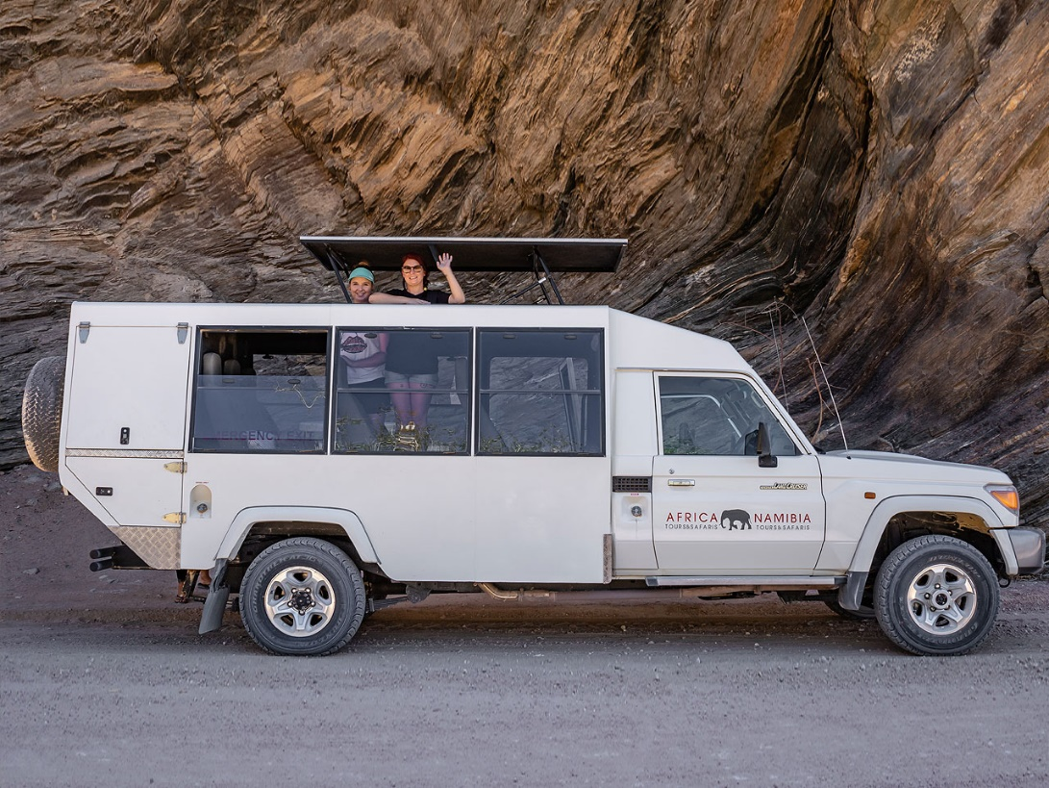4x4 Safari Vehicle

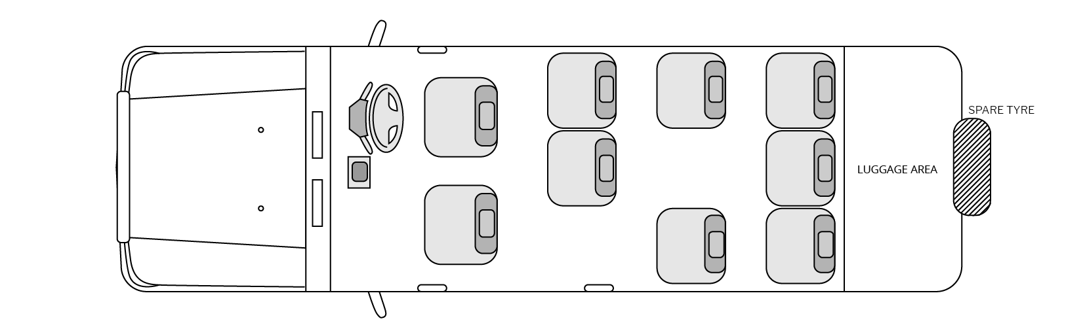

Specifications:

Engine size 4.5 litre Diesel Passenger seats 8 (6 window seats at back)

Forward gears 5 (Manual) 4-Wheel-Drive yes

Low range yes Power steering yes

Electric windows yes (front only) Air conditioning yes (front only)

Radio/CD player yes Air bags yes (front only)

ABS yes Fuel tank size double tanks

Pop-up roof yes Fire extinguisher yes

Medical Kit yes

Vehicle Terms & Conditions

**Car hire includes the following:**

* Rates inclusive of VAT (15%)
* Unlimited kilometres
* Collision and Theft Cover depending on excess option taken
* Standard vehicle accessories
* Daily rates are calculated per 24 hour period as per tour/safari itinerary
* GPS
* 2nd spare tyre
* Tyre & Windscreen insurance subject to area driven … see below

**The rental excludes:**

* Exclude excess deposit and non-waverable excess
* Exclude personal or passenger insurance
* Rates exclude trailers, camping equipment, additional charges as well as excess deposits
* Delivery and collection fees not included ... quoted separately
* Excludes non-standard accessories and equipment
* In the event of Breach of Contract (see below) breakdown, road-side assistance, replacement rental and recovery charges not included
* Damages/loss excluded from the insurance (see insurance)
* Damage / loss claims, fines and administration fee
* Tyre and windscreen insurance is not included in any areas west of Sesfontein in the Kaokoland area.

**Drivers**

* A valid and unendorsed license must be produced by all drivers
* The minimum age for authorised drivers is 23 years

**Excess & Security Deposit**

The full excess amount as decided by the client per vehicle, will be the liability of the Renter. Authorisation is given below by giving the relevant credit card details and providing signature on collection of the vehicle. This will be held on record as assurance. Charges will only be charged to the client once the vehicle has been returned and after any further charges that may occur when the vehicle is returned has been recovered: minor damages and repairs, vehicle returned without a full tank of fuel, speeding fines, under-body damage. (Client will be notified if charges are to be put through). Should none of these apply, there will be no charges to the credit card.

**Termination of Rental**

* Clients are requested to allow at least 30 minutes returning the vehicle and settling any possible final charges.
* Keys are to be handed to NTS personnel only.
* NTS will not be liable for any losses incurred by the client due to flights missed. It is the client’s responsibility to allow ample time to return to the point of departure and allow for any possible delays along the way.

**Insurance Cover**

The following is not covered by the cover option:

* Personal Property
* Personal injury / death
* Sandstorm and water damage
* Under-carriage damage
* Own negligence

*We strongly recommend that all clients have travel insurance for medical expenses, baggage loss, cancellation/curtailment, default and personal injury or death due to an accident. This is not included in the rental agreement.*

**Factors that will negate all cover Insurance Cover**

* Gross or criminal negligence
* Speeding on gravel and tarmac roads. Maximum of 80kph on gravel roads (recommend 70kph). It is highly recommended to engage the 4-wheel-drive system when driving on any gravel road as this offers greater control and stability.
* Vehicle accident where no other vehicle is involved
* Unauthorised drivers – copy of license not provided pre-rental
* Failing to obtain authorisation to extend the rental
* Not reporting an accident or loss to the Namibia Police immediately
* Not reporting an accident or loss to Namibia Tours and Safaris immediately
* Not adhering to traffic, road and driving rules and regulations
* Driving under the influence of alcohol or any illegal substance
* Unsuitable or reckless driving
* Road conditions not suitable for the type of vehicle rented
* Unauthorised country border crossings
* Not being able to produce keys in case of theft
* Not reporting exact details of last known location of vehicle prior to theft
* Any off-road or dune driving nor any un-proclaimed roads
* Any driving in unauthorised areas such as west of the Sesfontein area – unless this area is included in the itinerary of the particular tour/safari.
* Own negligence

**Breakdown & Roadside Assistance**

Assistance will be provided in the event of a breakdown or any roadside emergency by our representatives authorised to do so. Where a vehicle can’t be repaired, a replacement vehicle will be delivered. Recovery of the vehicle and/or roadside mechanical assistance will necessitate extra charges and be billed to the client, except where such a vehicle failure is not caused by the client. Where a vehicle cannot continue under this agreement due to negligence, accident or fault on behalf of the Renter this agreement will become null and void. A new contract will take effect to the replacement vehicle with all conditions, rates, excesses and other implications ditto to this agreement.

* If a vehicle cannot continue for any reason where the Renter is not negligent or any breach of contract, the vehicle will be repaired or replaced without extra costs.
* If a vehicle cannot continue for any reason due to Renter negligence or any breach of contract, the contract will become nil and void and payments/monies forfeited. If a replacement vehicle is supplied, this will be done on a new contract and full rental payment will be required.

Please note that in this African sub-region, roads and areas can be quite remote and assistance can take from a few hours to a day or two.

**General**

* Vehicles must be returned in the same condition as received, including all accessories, equipment and fuel at roughly the same level as on rental. If less, a calculated amount will be charged;
* Vehicles included in this package is subject to the terms and conditions of the rental agreement, laws of Namibia and our insurance policies;
* We reserve the right to substitute vehicles with a similar vehicle;
* As this falls within a package, keeping a vehicle beyond the return date, must be arranged 48-hours in advance,
* Traffic fines are for your own account and will be charged to your credit card if you do not settle fines before leaving Namibia;
* Off-Road driving through bushes, riverbeds etc. as well as dune driving is strictly prohibited, and the client will be held responsible for all damages caused.