Meno a Kwena Safari

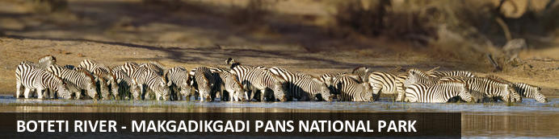

Bouic & Bracoud

Meno a Kwena Safari
Boteti River - Makgadikgadi Pans National Park
4 Days / 3 Nights
4 guests
Reference: CTNS144819
Date of Issue: 13 March 2023
20 March 2023 - 23 March 2023

Introduction

Accommodation | Destination | Basis | Room Type | Duration
Meno a Kwena Tented Camp | Boteti River - Makgadikgadi Pans National Park | FI | 1 x Double Room, 1 x Twin Room | 3 Nights

Key
B&B: Bed and Breakfast
FI: Fully Inclusive - Bed, All Meals, Fees and Activities

Day 1: Meno a Kwena Tented Camp, Boteti River - Makgadikgadi Pans National Park (Mon, 20 March)

Boteti River - Makgadikgadi Pans National Park
North-eastern Botswana’s Boteti River, within the Makgadikgadi Pans National Park, lies on the grounds of an ancient lake, within a region where some of the first ‘homo sapiens’ (humans) lived. This area is an essential part of the massive annual migration - visitors can look forward to seeing enormous herds of oryx, wildebeests, impalas, zebras, and springbok as well as elephants and hippopotamuses along the riverbank. The river also provides prime bird-watching opportunities, with large flocks of flamingos and numerous other species calling it home. Besides the usual nature reserve activities, try taking a small chartered plane for the best views of the herds; go quad biking across salt flats and sleep there under the stars, or take a cultural tour to see ancient tribal sites.

Day Itinerary
On arrival at Maun Airport, you will collect your car rental and self-drive to Meno a Kwena
FLIGHT: Cape Town / Maun 4Z314 10:55 / 13:35

Overnight: Meno a Kwena Tented Camp
Meno a Kwena is an understated rustic lodge perched on a clifftop overlooking the Boteti River and offering a diverse range of activities. The Lodge exudes old world, classic safari style. Each of the 10 tents has an enviable view of the Boteti River allowing guests to watch Southern Africa’s largest zebra and wildebeest migration concentrates at the river during the dry season. Meals are cooked over the camp fire and down time spent in the pool or loungers.
Guests can immerse themselves in the silence and solitude of the Makgadikgadi salt pans with our sleep out (dry season only), watch the bustle of river-seeking herds from land or water, or oversee phenomenal wildlife sightings within the Park. The iconic local bushmen tribe bestow their knowledge of flora and fauna in a fascinating cultural exchange during walks from camp. With its easy access from Maun, this is a perfect camp for those on a self-drive itinerary, travelling with children or as part of a group.
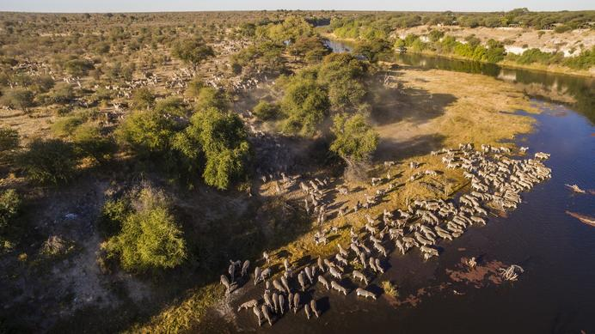

Further Information: www.menoakwena.com

Basis
Fully Inclusive - Bed, All Meals, Fees and Activities
All Drinks Included

Day 2: Meno a Kwena Tented Camp, Boteti River - Makgadikgadi Pans National Park (Tue, 21 March)

Basis
Fully Inclusive - Bed, All Meals, Fees and Activities
All Drinks Included

Day 3: Meno a Kwena Tented Camp, Boteti River - Makgadikgadi Pans National Park (Wed, 22 March)

Day Itinerary
The camp manager will re confirm your departure time for the next day

Basis
Fully Inclusive - Bed, All Meals, Fees and Activities
All Drinks Included

Day 4: End of Itinerary (Thu, 23 March)

Day Itinerary
On check out of the Lodge, you will self-drive to Audi Tented Lodge

Basis
Bed and Breakfast

Travel Information
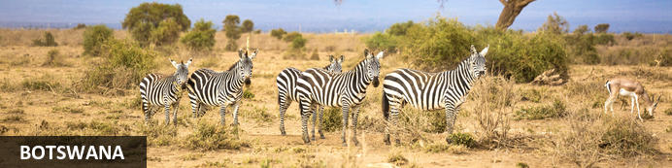
Situated in the southern reaches of Africa, Botswana is renowned for its pristine wilderness areas characterised by deep lagoons, wetlands, lush palms, rugged hills and desert plains. The country’s primary tourist drawcard is undoubtedly the vast red expanse of the Kalahari Desert and its remarkably beautiful Okavango Delta, the largest inland delta in the world. These natural wonders provide a tranquil haven for an abundance of African wildlife to thrive. Other highlights include the impressive Makgadikgadi Salt Pans, where visitors are privy to massive zebra migrations during the flood season; the Savuti plains, which host a significant pride of lions; and the Tsodilo Hills, where 4500 rock paintings form a unique record of human settlement over many millennia.

Banking and Currency
Currency
Botswana's currency is Pula (which means 'rain' in Setswana). It is divided into 100 thebe (which means 'shield' in Setswana). Travellers' cheques and foreign currency may be changed at banks, bureaux de change and authorised hotels.
The US dollar, Euros, British Pound and the South African Rand are the most easily convertible currencies (and accepted by some estabishments - but, generally, then an inflated rate of exchange will be applied).
Banking
Seven main commercial banks, as well as a number of foreign exchange bureaux, operate in Botswana. Operating hours are Monday to Friday 08h30 to 15h30 and Saturday 08h30 to 10h45.
Full banking services are available in major towns, although ATMs are sprouting up all over the country. Most credit cards are accepted at hotels and restaurants. Cultural sites and community art and craft outlets usually only accept cash.

Travel, Transport and Getting Around
Public transport in Botswana is geared towards the needs of the local populace and is confined to main roads between major population centres. Although cheap and reliable, it is of little use to the traveller as most of Botswana’s tourist attractions lie off the beaten track.
Driving off the main roads in Botswana is only recommended to expects in 4x4 vehicles, that are equipped correctly. Most lodges offer transfers or they can be arranged. If, however, you will be driving in Botswana: your home driving licence will be accepted (with an official English translation if necessary; driving is on the left side of the road; and the national speed limit is on tarred roads is 120km/h and 60km/h in towns and villages.

Be sure to watch out for wild animals on the roads!
There are major airports in Maun, Kasane and Gaborone, while smaller charter flights are used to get to the other top attractions and camps.

Food, Drink and Cuisine Advice
Safari lodges and camps serve international-style cuisine, generally of an extremely high standard, along with local beer and imported wine and spirits. Good restaurants and bars can be found in main towns, often within hotels. Beef and goat are very popular meats. Elsewhere, food is more basic: millet and sorghum porridge are the local staples.
Tap water is considered safe to drink, although outside main cities and towns, visitors are advised to check first and sterilise water if in any doubt. Bottled water is available in most tourist centres. Filtered water is available at most camps and shops offer bottled water - it is advised to be well stocked of bottled water if you are travelling off the beaten track. Milk is pasteurised, and dairy products, local meat, poultry, seafood, fruit and vegetables are generally safe.
A discretionary five-to-ten-percent tip is typical for restaurant bills. In many places, a service charge is automatically added. It is customary to tip the game guide and lodge staff while on safari.

Climate and Weather
Botswana's climatic pattern is typical of southern Africa, although its rainfall is less than countries further east. The rains in Botswana come mostly between December and March, when average minimum temperatures are in the low 20°s. Some days will be bright and sunny, some will have afternoon thunderstorms, and some will just be grey.
As with Namibia, April and May in Botswana are generally lovely, with the sky clear and the landscape green. Night temperatures start to drop during these months, especially in the Kalahari. Note that places in and around the Okavango tend to have less extreme, more moderate temperatures than the drier areas of the Kalahari.
From June to August the night-time temperatures in drier areas can be close to freezing, but it warms up rapidly during the day, when the sky is usually clear and blue. It's now very much 'peak season' for most safari areas: the land is dry in most areas so the animals congregate around the few available water sources.
This continues into September and October, when temperatures climb again, drying the landscapes and concentrating the game even more. This is the best time for big game safaris – although October can feel very hot, with maximum temperatures sometimes approaching 40°C.
November is difficult to predict, as it can sometimes be a continuation of October's heat, whilst sometimes it's cooled by the first rains; it's always an interesting month.

Clothing and Dress Recommendations
In summer, lightweight, light-coloured cottons are preferable. Avoid synthetic materials and black clothing, as they increase perspiration and discomfort. In winter, wear trousers, long-sleeved shirts / blouses and jerseys. From May – August, night temperatures can fall below zero degrees Celsius, so warm jerseys and jackets are vital, especially on morning and evening game drives. Garments of neutral colours that blend with the bush and forest are advisable for safaris and game viewing. Bring a lightweight jacket and/or jersey for unexpected temperature changes or rain. Closed, comfortable walking shoes or gym shoes are a must in all seasons. Special attention should be given to protection from the sun. Bring a sunhat, good quality sunscreen, sun lotion and polarised sunglasses. Wide brimmed sun hats are essential.

Internet Availability
Some hotels, lodges and guest houses offer internet access or Wi-Fi (free or paid), and there are internet cafe's in Gaborone and Maun. Internet access in more remote rural areas is often hard to come by.

Electricity and Plug Standards
Electrical sockets (outlets) in Botswana are the 'Type M' South African SABS1661 ('Large' 15 amp BS-546) sockets. This is actually an old British standard. The 'Type M' South African plug and socket is not to be confused with the 'Type D' Indian plug and socket. In pictures, they look very similar, but the South African type is much larger than the Indian type, and they are physically incompatible. If your appliance's plug doesn't match the shape of these sockets, you will need a travel plug adapter in order to plug in. Travel plug adapters simply change the shape of your appliance's plug to match whatever type of socket you need to plug into.
Electrical sockets (outlets) in Botswana usually supply electricity at between 220- and 240-volts AC. If you're plugging in an appliance that was built for 220-240 volt electrical input, or an appliance that is compatible with multiple voltages, then an adapter is all you need.
But travel plug adapters do not change the voltage, so the electricity coming through the adapter will still be the same 220-240 volts the socket is supplying. If you need to use appliances that are not compatible with 220-240 volt electrical input, you will need a voltage converter.

