TB-176 Day Tour images

Summary

Click here to view your Virtual Day Tour
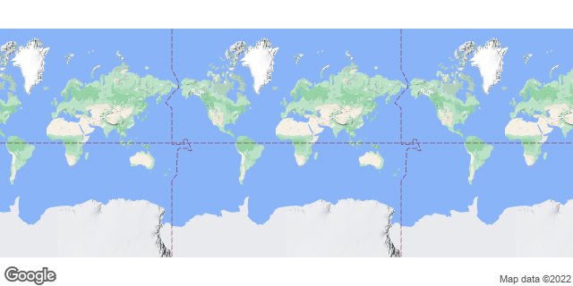

Activities
- Elephant's Eye, Hwange

Elephant's Eye, Hwange
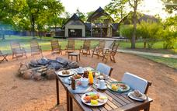
The best Zimbabwe has to offer: Elephant's Eye, Hwange offers an unforgettable experience with the African wilderness.
The camp comprises of 8 tented chalets. Every chalet has a double or twin beds surrounded by mosquito netting, an en-suite bathroom with a bath and basin, a glam outside shower and wrap-around veranda. The Elephant's Eye, Hwange lodge can host a maximum of 16 people at any given time and all meals and most drinks are included.
Activities at Elephant's Eye include game viewing, a fully operational spa, guided educational walks, bird watching, night game drives with trained field guides; swimming or enjoying sundowners while relaxing near the pool are also pleasurable activities. Elephant's Eye has a waterhole which offers unlimited opportunities to view game at close range.

