Peace Day Tour

Summary

Click here to view your Virtual Day Tour
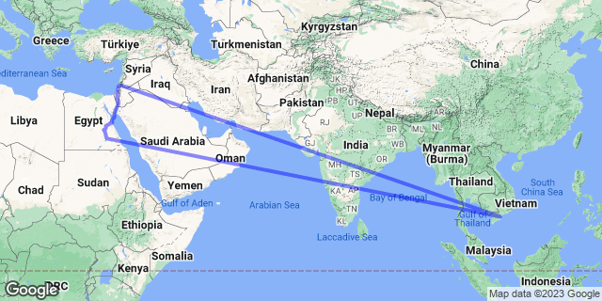

Price
R1

Activities
- Wine Tours by Bike

Optional
- Sea of Galilee Boat Ride

Recommended
- Felucca Ride Aswan

Information

Description

Wine Tours by Bike
The thing that makes our bike tours so popular is that not only do we offer visitors a free pickup and drop off service from their accommodation in Blenheim or Renwick (so that they don’t need risk drinking and driving), but they will also get the complete freedom to choose how they are going to spend their time on the bikes, rather than us pre-planning it for them.
Our tours are self-guided - so instead of going around together as one big group, where there is often a sense of pressure to keep up with others, their day is designed to be very much their own so they can go at their own pace, decide how far they are happy to bike, which restaurant they fancy stopping at for lunch, and which cellar doors they think best caters to their individual tastes.
We are here to offer advice and provide them with up to date information on the cellar doors, and if emergency help is needed at any time whilst they are on the bikes, we are but a phone call away.
3 Self-guided Tours Daily - Start times and pickup times are found on our website

Sea of Galilee Boat Ride
Visitors to Galilee have the opportunity to go on a boat trip on the Sea of Galilee where it is said that Jesus walked on the water, calmed the storm, and blessed his disciples with miraculous catches of fish.
Trips are offered by a variety of operators and most are offered in boats similar to those used by the fishermen of the time to create a more authentic experience.
A variety of options are available - leisure trips for regular tourists, religious trips for Christian pilgrims, educational trips, special occasion trips, and sunset-, sunrise-, and moonlight trips.

Felucca Ride Aswan
Enjoy a Felucca Ride in Aswan. Visitors will sail the Nile for an hour around Elephantine Island and visit El Nabatat Island and the Botanical Gardens, known for its range of plants imported from all over the world. The island was owned by Lord Kitchener and is also known as Kitchener's Island. From there, guests will be transferred back to their ship in Aswan.

Price Includes
Nothing

Price Excludes
Everything

Additional Information

Group Size

Languages Spoken

Departure Points

Departure Times

Duration

