CLASSIC MAKING TRUCKS THROUGH THE RIFT VALLEY

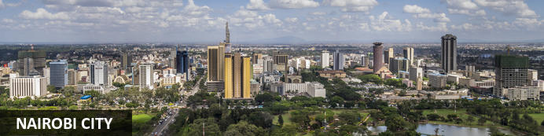
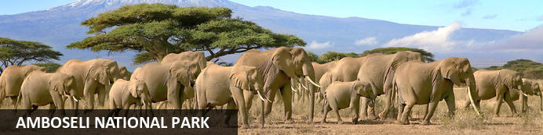
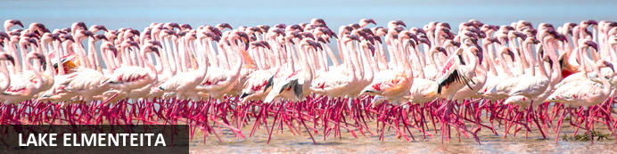
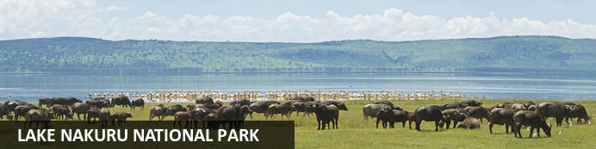
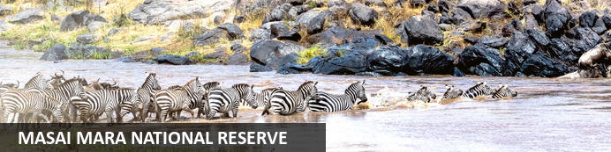

CLASSIC MAKING TRUCKS THROUGH THE RIFT VALLEY
Nairobi City - Amboseli National Park - Lake Elmenteita - Lake Nakuru National Park - Masai Mara National Reserve
8 Days / 7 Nights
Reference: CSKE003
Date of Issue: October 13, 2022

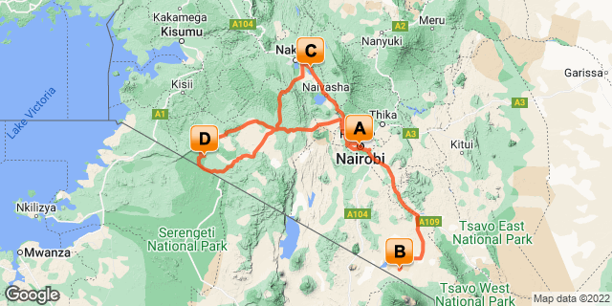

Click here to view your Digital Itinerary

Introduction

Start | Accommodation | Destination | Basis | Duration
Day 1 | Nairobi Serena Hotel | Nairobi City | B&B | 1 Night
Day 2 | Amboseli Serena Safari Lodge | Amboseli National Park | FB | 2 Nights
Day 4 | Lake Elmenteita Serena Camp | Lake Elmenteita | FB | 2 Nights
Day 6 | Mara Serena Safari Lodge | Masai Mara National Reserve | FB | 2 Nights

Key
B&B: Bed and Breakfast
FB: Full Board - Dinner, Bed, Breakfast and Lunch

Price
*From US$ 2382.00 Per Person Sharing
*Terms and Conditions Apply

Included
- Accommodation as stipulated in the itinerary.
- Transportation in a chauffeur driven 4x4 Safari Landcruiser with a pop up roof for game viewing & photography.
- Services of a professional driver-guide
- All game viewing drives
- All parks entrance fees as indicated in the itinerary.
- All Government taxes and levies.
- Complimentary 500 ml mineral water per person per game drive in the safari vehicle.
- All meet and greet services.
- All arrival and departure transfers.
- 24 hours stand-by contact number.
- Meals as indicated in the itinerary.
- Two-way long range high frequency radio communication in each vehicle.
- On safari accessories in each vehicle: - First-aid kit, wildlife books, a pair of binoculars, cool box and fire extinguisher.

Excluded
- All items of personal nature e.g. telephone call bills, fax/email bills etc.
- Tipping
- Alcoholic and non-alcoholic drinks,
- International flight and departure taxes.
- Laundry services.
- Any other item(s) not included in our itinerary.
- Visa fees

Day 1: Nairobi Serena Hotel, Nairobi City

Nairobi City
Nairobi is Africa’s 4th largest city and is a vibrant and exciting place and although it has developed a reputation which keeps tourist visits brief there are some fascinating attractions: its café culture, unbridled nightlife, the National Museum, the Karen Blixen Museum and most notably just 20 minutes from the city centre wild lions and buffalo roam in the world’s only urban game reserve.

Day Itinerary
Upon arrival at Jomo Kenyatta International Airport in Nairobi, you will be met a representative from Classic Safaris who will assist with the transfer to Nairobi Serena Hotel for overnight stay.

Overnight: Nairobi Serena Hotel
The Nairobi Serena Hotel is nestled among lush gardens at the edge of Nairobi’s Central Park. The elegant guest rooms include satellite TV, minibars, coffee and tea making stations, free daily newspapers, and free Wi-Fi. With three on-site restaurants, a coffee bar and a pool bar serving drinks, guests are spoilt for choice when it comes to dining. Guests can enjoy leisurely strolls through the large grounds, have a splash in the heated pool, or enjoy relaxing massages and treatments at the Maisha Spa and Health Club.
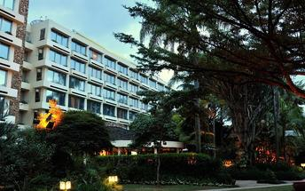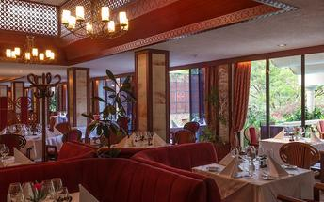

Basis
Bed and Breakfast

Day 2-4: Amboseli Serena Safari Lodge, Amboseli National Park

Amboseli National Park
Located in the southern reaches of Kenya, the Amboseli National Park is renowned for its excellent variety of wildlife such as Maasai giraffe, elephant, lion and cheetah and not surprisingly it is one of Kenya's most popular parks. The landscape of Amboseli is dominated by the majestic snowcap of Mount Kilimanjaro, as well as open plains, acacia woodland, swamps and the massif of Ol Doinyo Orok. The birding is excellent, especially closer to the lakes and swamps. The park is famous for being the best place in Africa to get close to large herds of elephants among other wildlife species. Other attractions include opportunities to meet the Maasai people and soak up spectacular views of Mount Kilimanjaro, the highest free-standing mountain in the world.

Day Itinerary
This morning drive to Amboseli National Park located at the foot of Africa's highest mountain, Mount Kilimanjaro. The snow-capped peak of Mount Kilimanjaro rises above a saucer of clouds and dominates every aspect of Amboseli. This park covers only 150 square miles but despite its small size and its fragile ecosystem it supports a wide range of mammals (well over 50 of the larger species) and birds (over 400 species). Lunch will be at your lodge followed by an afternoon game viewing drive. Later as the sun sets, you will be transferred back to your lodge for dinner and overnight. stay for 2 nights.

Overnight: Amboseli Serena Safari Lodge
Amboseli Serena Safari Lodge is located near Mount Kilimanjaro in the heart of Kenya’s Amboseli National Park. The lodge offers 92 rooms which feature complimentary Wi-Fi, 24-hour room service and a private balcony. Hotel facilities include a swimming pool and sundeck, a gift shop, spacious interior bar with terrace, a campfire bar and bush BBQ area. Guests can also enjoy guided walks, bird-watching walks, dinner in the bush and Maasai dance performances in dedicated exterior bush BBQ area.
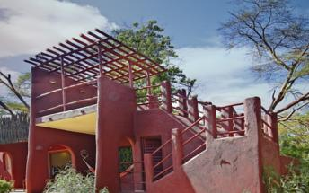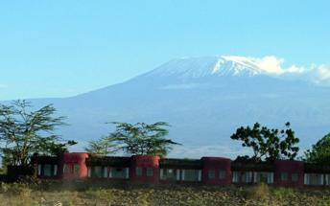

Basis
Full Board - Dinner, Bed, Breakfast and Lunch

Day 4: Lake Elmenteita Serena Camp, Lake Elmenteita

Lake Elmenteita
Elmenteita, meaning ‘place of dust’, is a photogenic, little soda lake situated in Kenya’s Great Rift Valley. Famously attracting many visiting flamingos as well as many other birds, it has been named as a World Heritage Site for its prolific birdlife. This is where Kenya’s most famous settler Lord Delamere lived and he was responsible for much of Kenya’s early agricultural experimentation in this fertile area; it is still inhabited by some of his descendants. The shores are often filled with wildlife and the surrounding forests are perfect for long walks and bird watching. Visitors can look forward to visiting the idyllic Kekopey hot springs, game viewing along the lake’s edge, and numerous other activities. Look out for eland, kudu, zebra, gazelle, and warthog families.

Day Itinerary
Following breakfast, depart for Elementaita stopping en route at Nairobi for lunch. Continue to Elementaita and arrive in the late afternoon. Spend the rest of the day at leisure. Dinner and overnight stay.

Overnight: Lake Elmenteita Serena Camp
Lake Elmenteita Serena Camp is located in Kenya's Soysambu Conservancy and features spectacular views of the surrounding volcanoes. Accommodation is available in deluxe tents and flamingo suites which feature a balcony and modern amenities, including free Wi-Fi, satellite TV, mini-fridges, and mosquito nets.
Guests may enjoy a meal in the central dining room or outdoors in the bush while watching the sunset. The camp features a beautiful outdoor swimming pool where guests can relax and enjoy the African sun. A massage service is available on-site and offers a variety of luxurious treatments.
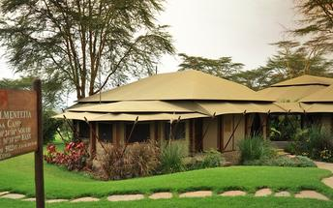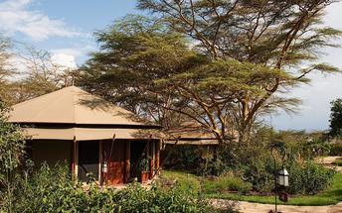

Basis
Full Board - Dinner, Bed, Breakfast and Lunch

Day 5: Lake Elmenteita Serena Camp, Lake Elmenteita

Day Itinerary
Today you will have a full day game viewing drives at Lake Nakuru National Park, a shallow alkaline lake that is world-renowned for its huge concentration of flamingos; at times, hundreds of thousands of these birds give the lake a pink shimmering glow. You will have an afternoon game viewing drive before later being transferred to Elementaita Serena Camp for dinner and overnight stay.

Activities
Lake Nakuru National Park

Lake Nakuru National Park
Located in the Great Rift Valley surrounded by yellow acacia woodlands and bushy shrublands, the Lake Nakuru National Park was created to protect the Lake and its large flocks of Lesser Flamingo, which are drawn to the algae that flourish in the saline waters of this soda lake. The national park is inhabited by over 50 mammal species including hippo, black and white rhino, Rothschild giraffe, buffalo and eland. Known as a bird watcher’s paradise, the park is home to over 450 bird species. Visitors can look forward to hiking through the scenic landscape, picnicking next to this magnificent lake, and spotting an array of wildlife on a game drive. Don’t miss the opportunity to visit the beautiful Makalia Waterfall.

Basis
Full Board - Dinner, Bed, Breakfast and Lunch

Day 6: Mara Serena Safari Lodge, Masai Mara National Reserve

Masai Mara National Reserve
One of Kenya’s undisputed natural highlights is the Masai Mara National Reserve, which sprawls across more than 1500 square kilometres of the country’s southwest. The park protects a phenomenal array of game, including elephant, lion, leopard and buffalo, as well as crocodile and hippopotamus in the Mara River. The birdlife is no less impressive, with over 450 resident bird species. However, the true highlight here is the Great Migration, recognised as one of the Seven New Wonders of the World. To survive the dry months of July to September, some 1.7 million wildebeest, migrate from the parched plains of the Serengeti National Park in Tanzania. Along with much smaller numbers of antelope, buffalo and zebra, they move to the more forgiving grasslands of the Masai Mara. In their wake come predators such as lion, hyena and cheetah, for whom these giant herds are an easy source of prey.

Day Itinerary
This morning depart for Maasai Mara. Arrive and Embark on a game viewing drive on arrival as you are transferred to your camp for check in followed by lunch. In the afternoon, you will have a game viewing drive before returning later to your lodge for dinner and overnight stay.

Overnight: Mara Serena Safari Lodge
Secreted deep within the Masai Mara National Reserve, the Mara Serena Safari Lodge is the ultimate safari destination. Set high on a bush-cloaked hill, embraced by arcing vistas and washed by a sea of richly rolling grasslands, it stands centre-stage to one of Africa’s most dramatic wildlife arenas and has a ringside seat for the greatest wildlife show on Earth, the legendary migration of the wildebeest. Drawing its inspiration from the traditional Maasai cultural motif of a cluster of domed, mud-colored huts encircled by a “Boma” of brushwood, the Mara Serena offers a rare blend of raw African splendor and sumptuous sophistication. The essentially ethnic décor also draws on a vibrant colour-palette of sun-burst colors, embellished by a unique selection of Maasai art to create the look and feel of a traditional bush encampment. The lodge features individual rooms, each with their own balcony and view of eternity, a sky-blue swimming pool and a spectacular restaurant, overlooking a water hole where a fantasia of creatures collect to drink.
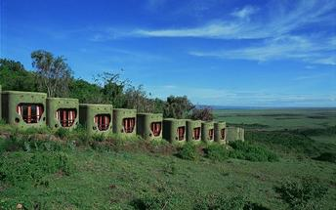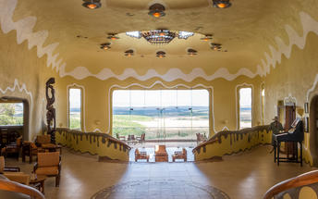

Basis
Full Board - Dinner, Bed, Breakfast and Lunch

Day 7: Mara Serena Safari Lodge, Masai Mara National Reserve

Day Itinerary
Take another sunup game drive after muffins and coffee. Keep in mind, each game drive is distinct, and since the camps are small, the drives can be tailored to the group's preferences. Your driver and guide can always stop for an hour or so if you come across a lioness on a hunt.
Return to lodge for a late brunch; then keep a look out for game, read or just kick back. After lunch and a siesta, set off on your late afternoon game drive. At the end of the drive, you'll stop for a drink and watch night fall over the Masai Mara.

Basis
Full Board - Dinner, Bed, Breakfast and Lunch

Day 8: End of Itinerary

Day Itinerary
After breakfast at the lodge, bid farewell to the Masai Mara as you set on your journey back to Nairobi.
Drive back down the Great Rift Valley to Nairobi, passing the dormant volcano, Mount Longonot, and
lakes Elementaita and Naivasha on the way. Keep an eye out for herds of giraffe and gazelle and head up
the escarpment. You will arrive in Kenya's bustling capital city Nairobi in the early afternoon where you
will be transferred to the Jomo Kenyatta International airport for your departure flight back home.

Transport

Transfers
Date | Company | Pick Up | Drop Off | Time | Vehicle
 | Classic Safaris | Jomo Kenyatta International Airport [NBO] | Nairobi Serena Hotel |  | Safari Minivan (Transfer)
 | Classic Safaris Ltd | Nairobi Serena Hotel | Amboseli Serena Lodge |  | Safari Minivan (Fully Guided Trip)
 |  | Amboseli Serena Safari Lodge | Lake Elmenteita Serena Camp |  | Fully Guided Trip
 |  | Lake Elmenteita Serena Camp | Mara Serena Safari Lodge |  | Fully Guided Trip
 | Classic Safaris Ltd | Mara Serena Safari Lodge | Jomo Kenyatta International Airport [NBO] |  | Safari Minivan (Fully Guided Trip)

Urgent Contact Numbers
Company Name | Telephone | Email Address | Contact Person
CLASSIC SAFARIS LTD | +254 716 269009/255 | sylvia@classicsafaris.co.ke | Sylvia

Service Provider Directory
Service Provider | Ref. Number | Telephone | Address
Amboseli Serena Safari Lodge |  | +254 | Amboseli National Park  Kenya
Lake Elmenteita Serena Camp |  | +254 732 123333 | Lake Elmenteita Serena Camp  Soysambu Conservancy  Lake Elmenteita, Kenya
Nairobi Serena Hotel |  |  | Kenyatta Avenue  Nairobi,  Kenya

Travel Information
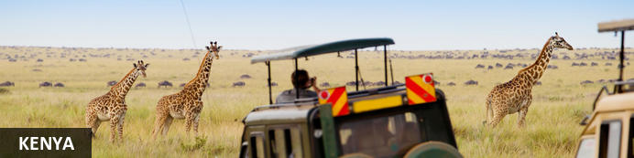
Resting in the magnificent Great Rift Valley and presided over by the majestic Mount Kilimanjaro, Kenya is characterised by hauntingly beautiful natural landscapes of forested hills, patchwork farms, wooded savanna and vast forests brimming with an extraordinary abundance of wildlife. The nation’s diverse range of traditional African cultures is influenced by over 70 unique ethnic groups from the Maasai, Samburu, Kikuyu, and Turkana tribes to the Arabs and Indians that settled on the coast. Add to this: an exquisite tropical coastline fringed with breathtaking golden sand beaches; gorgeous coral gardens providing excellent snorkeling and diving opportunities; and a slew of lively beach resorts, and it is easy to see why so many visitors flock here from around the world to experience a truly unique African adventure in one of the world’s most pristine safari destinations.

Entry Requirements
KENYA: VISA REQUIREMENTS
A visa is required for entry into Kenya for most people (see below for exceptions). An ordinary visa (also known as a tourist visa) is used by tourists. This visa is issued at any Kenyan embassy, or can be issued on arrival at an entry point to citizens of any country listed in Category 2 in the Visas section of the Immigration website (link below). It grants tourists / visitors the authorization to enter the country through designated entry points on the border, through airports, and harbour stations.
Please note that the possession of a Kenyan visa is not the final authority to enter Kenya. The immigration officer at the port of entry may deny entry if the visitor is unable to fulfil the immigration requirements and if the entry and presence of such a person in Kenya would be contrary to the national interests of Kenya, even if such a person is in possession of a valid visa for Kenya.
Visa Descriptions:
1. Single Entry - Allows you to enter into Kenya once (see also note below)
2. Transit - Allows a short stop over (up to 3 days) in Kenya (see also note below).
3. Multiple Entry - Allows entry multiple times into Kenya.
Note: No visa is required for direct transit (not leaving the secure area of the airport, aka staying 'airside', within the airport terminal) between two flights. If you are in transit but leave the secure area of the airport, for example for an overnight stay between flights, for a period of less than 24 hours then a transit visa is required.
Note: A single entry visa will allow re-entry to Kenya from any of the following East African countries: Uganda, Tanzania, Burundi, and Rwanda.
Visa Requirements
Obtained in advance: By E-Visa or through a Kenyan Foreign Embassy.
1. A complete visa application form. A copy of the form is available on the web -http://evisa.go.ke/evisa.html or at any Kenyan embassy.
2. Valid passport (at least 6 months before expiration). There must be at least two facing blank visa pages available, one for the Kenya visa sticker and one facing for the stamps.
3. 1 passport size photograph recently taken.
4. Travel Itinerary
5. Hotel booking
6. A return ticket
7. Visa fee (see below).
Obtained on Arrival:
1. A complete visa application form. A copy of the form is available on the web, at any Kenyan embassy, or at any entry point into Kenya.
2. Valid passport (at least 6 months before expiration). There must be at least two facing blank visa pages available, one for the Kenya visa sticker and one facing for the stamps.
3. Travel Itinerary
4. Hotel booking
5. A return ticket
6. Visa fee (see below).
Note: No photographs are required for a visa on arrival as you are photographed and finger printed at the Immigration desk.
Visa Fees:
1. Single entry visa - US$50.00 or £30 or €40
2. Multiple entry visa - US$110.00 or £60
3. Transit visa - US$20.00 or £10
Note: See below under 'additional information' for information about the cost of a 'referency fee', if required.
Non-tourists:
If you are not a tourist, for example a business traveler, contact any Kenyan embassy for additional information.
Additional Information:
No visa is required for nationals of the following countries:
Barbados, Maldives, St. Lucia, Belize, Malta, Swaziland, Botswana, Mauritius, Seychelles, Brunei Darussalam, Namibia, The Gambia, Burundi, Nauru, Tanzania, Cyprus, Papua New Guinea, The Bahamas, Dominica, Rwanda, Tonga, Fiji Island, Trinidad and Tobago, Ghana, Samoa, Tuvalu, Grenada, St. Kitts and Navis, Uganda, Jamaica, Sierra Leona, Vanuatu, Kiribati, Singapore, Zambia, Lesotho, Solomon Islands, Zimbabwe, Malawi, South Africa (for less than 30 days stay), St. Vincent and the Grenadines, Malaysia (for less than 30 days stay), Ethiopia, Eritrea, San Marino
Holders of U.S Refugee Travel Documents issued by the Department of Homeland Security (Greencard Holders/Permanent Residents) and nationals (passport holders) of the countries listed below shall have their visa applications referred to the Director of Immigration Services, Nairobi for approval. The processing varies from case to case. In addition, when a visa application is referred to the Director of Immigration Services Nairobi, a non-refundable reference fee of US $5 shall be collected at the time of application. This fee will be in addition to any other visa fee and will not be refunded if a visa is issued or is not issued.
Afghanistan, Senegal, Azerbaijan, Kosovo, Eritrea, Somalia, Armenia, Lebanon, Syria, Libya, Cameroon, Mali, Palestine, Iraq, Democratic People’s Republic of North Korea, Tajikistan
For more information on the visa application process and visa categories based on nationalities, please visit www.immigration.go.ke or http://evisa.go.ke/evisa.html

Banking and Currency
MONEY:
The currency in Kenya is the Kenyan Shilling (KES; symbol KSh). 1 Kenyan Shilling = 100 cents. Notes are in denominations of KSh1,000, 500, 200, 100 and 50. Coins are in denominations of KSh20, 10, 5 and 1.
The local currency is the Kenyan shilling, and the Tanzanian shilling respectively.
1 US dollar = 100 Kenyan shillings; (this changes based on the currency flactuation)
Please respect the local currency and note that it is a criminal offence in both countries to damage or tear the local currency.
Money may be changed easily at airports, hotels, banks and forex bureau. Please avoid changing money in the street with money vendors, as they are operating illegally.
It is unnecessary to carry excessive amounts of money (on safari, all meals are included, except for the drinks) and credit cards are widely accepted for payment of meals outside the meal plan, hotel extras, shopping etc
The equivalent of USD 100 per person is a guideline for exchange, as you may use your credit cards such as VISA or MASTERCARD for any additional costs, in most of the places you will visit.
Traveller´s Cheques are also a safe and simple method of payment; however you may have some problems with regard to their acceptance whilst on safari.
If at the end of the safari, you have any left over local currency, this may be changed back into dollars, at the airport.
There are no restrictions on the import or export of local or foreign currency. However, amounts exceeding US$5,000 or equivalent must be declared.
Banking
Banking hours: Monday-Friday 09h00-16h00, Saturday 09h00-12h00. Banks in Mombasa and the coastal areas typically open and close half an hour earlier.
Credits Cards are widely accepted in all major hotels and more upmarket establishments, with the most recognized being Master Card and Visa. American Express and Diners Club cards are occasionally accepted. However, you will need some cash handy because smaller shops will only accept cash.
Almost every bank now has an ATM, and they are increasingly being installed at, malls, shopping centres and petrol stations in cities and large towns.
Travellers cheques are no longer accepted in Kenya.

Travel, Transport and Getting Around
Nairobi has two airports for domestic and international flights: Jomo Kenyatta International Airport and Wilson Airport (www.kaa.go.ke).
Mombasa has one airport for both domestic and international flights - Mombasa International Airport
Kenya has over 150 domestic airports and airstrips and there are daily flights to the most popular destinations. In addition to the scheduled airlines, several private charter companies operate out of Wilson Airport.
Kenya Airways (www.kenya-airways.com), Air Kenya (www.airkenya.com), Fly 540 (www.fly540.com), Mombasa Air Safari (www.mombasaairsafari.com) and Safarilink (www.flysafarilink.com) serve the most popular safari destinations, plus many others such as Lake Victoria.
On smaller, domestic planes the baggage allowance is restricted to maximum 15 kg (22-33 lbs). Arrangements can be made to leave excess luggage with your Kenya tour operator, hotels or airlines
Main roads between the major cities and towns are generally in good condition, and easily navigatable in a normal saloon car. Most highways are paved.Vehicles are driven on the left side of the road.
While major roads are generally in a good condition, most minor gravel roads deteriorate in the rainy season. Dirt roads, including those in the parks and reserves, are rough, and some are only passable with a 4-wheel drive.
You can hire chauffeur-driven cars from your travel agents and international hire companies. Self-drive although highly discouraged for new drivers in Kenya is an option. Drivers must be at least 23 years of age. Car hire can be expensive and rates vary significantly.
A driving licence from a home country (and a translation if this is not in English) or an International Driving Permit is required. Third-party insurance is mandatory when hiring a car and it’s recommended to take out the additional collision damage waiver. A valid credit card is also needed.
Matatus (shared minibus taxis) hop from town to town, starting and finishing at bus stations. Fares are paid to the conductor. Private taxis can also be hired for long-distance journeys.
It is not possible to rent motorbikes or mopeds but some of the beach resorts hire out bicycles.
Numerous private bus companies operate in Kenya. Most vehicles tend to depart when full, which means there are no set timetables. Petty theft on the vehicles and at bus stations can be a problem. Nevertheless, buses are cheap and link all long-distance destinations. Plus, seatbelts are now mandatory, so buses are relatively safe.
Nairobi and Mombasa have efficient local bus systems and there are also frequent matatus, but reckless driving and petty theft makes them a dodgy option for tourists. Three-wheeled auto rickshaws are popular in the coastal towns and carry up to three passengers.
Online taxis service Uber is now in Kenya, available both in Nairobi and Mombasa and other online taxis options are coming up in Nairobi, these service are reliable and have meters. The older yellow taxis do not have meters, so fares should be agreed in advance. Cabs cannot be hailed in the street, but can be found parked in taxi ranks.

Health and Medical Information
HEALTH:
A certificate of vaccination against Yellow Fever is required. Malaria is endemic to Kenya and Tanzania, so please remember to take anti-malaria tablets. In case of any medical emergency, your hotel will have a doctor on call, or will have the medicine you may require, including the parks on safari.
All the same, please take the following precautions:
Dress in warm clothing in the evenings and at night; use repellants against mosquitoes and use insecticide sprays in rooms before sleeping (or before going for dinner). This area is right at the Equator, and the hot sun can cause sunburn very quickly- including on cloudy days.
Sun creams, lip balm, hats and sunglasses are recommended.
Although tap water in the big towns is potable, we advise you to drink mineral water always. In the hotels/ lodges during the safaris, there is always a jar/bottle/thermos of filtered water in the rooms, which is convenient for using for cleaning your teeth.
The mineral water in the hotels/ lodges has quite an elevated price. You may buy some bottled water at the local supermarkets at a more reasonable price.

Safety Notices
As it is the case in most regions of the world, security is a topic that should be kept in mind. Nairobi and Mombasa are generally safe during the day, as long as narrow alleys or isolated streets are avoided. We advise you not to walk in the streets in the dark. If youwishtotravelbynight,alwayscallforataxi.
Don’t carry a lot of money with you when you go out; only the amount you think you will spend. While walking in the streets, don’t wear jewellery or valuables that bring attention to you.
Please leave all valuables (jewellery, travel documents, cameras etc) in the safes or safety deposit boxes of the hotel you are staying at.
Please don’t leave anything of value lying around your hotel room.

Food, Drink and Cuisine Advice
FOOD:
During the safari, all your meals will be taken in the hotels.
In Nairobi and Arusha; generally only breakfast is included in your hotel accommodation; Lunch and dinner billed separately.
The food is of an excellent quality and you may eat all the types of fruits and vegetables without worry. The meal plan is usually as follows:
Full breakfast, between 0700 hrs and 0930 hrs;
Buffet lunch, served from about 1230 hrs;
Tea and coffee, served from 1600 hrs to 1800 hrs;
Dinner served from 1930hrs to 2130hrs, at the table. Generally, we choose the second course and dessert. Most of the hotels have both local and imported beers and wines, liquors, fruit juices and refreshments available. Drinksarenotincluded (unlessotherwisestated).
If you require a special diet or are vegetarian, please make sure you communicate this to the reception at the time of your arrival at the hotel.
Nairobi has some of the finest eating establishments in Africa. Many different cuisines and types of restaurants are available, from fast food to fancy. Many five-star hotels have excellent restaurants. Restaurants are many in Nairobi. The local cuisine is also worth trying out, particullarly Pilau-a chicken and rice dish, cabbage and rice; and the staple food in Kenya-Ugali, made from maze flour.
Many restaurants can be found downtown and in most areas of the urban centres however if you're looking for a real authentic experience away from most tourists, places like Ayani, Olympic, Kibera, and other places have the more authentic food. Among the many cuisines available are Indian, Brazilian, Chinese, Thai, Japanese, German and French restaurants. Fast food restaurants are common in malls which are in every area of Nairobi .

Climate and Weather
Kenya lies on the equator and has a pleasant tropical climate, but there are large regional climatic variations influenced by several factors, including altitude. Temperatures drop by about 6°C for every 1000m you climb (or 3.5°F per 1000ft). Kenya’s daytime temperatures average between 20°C/68°F and 28°C/82°F, but it is warmer on the coast. The coast is hot and humid all year round, but the heat is pleasant and tempered by the monsoon winds. Kenya is too close to the equator to experience a real winter and summer. There is, however, both a dry and wet season. The wet seasons are from March to June and from October to Mid December. The rest of the time it is dry although significantly cold (atleast for the Kenyan person) during the months of July and August.

Clothing and Dress Recommendations
Comfortable, casual clothing that is lightweight is the best bet while on safari. It can be quite cool in the early mornings, so you'll want to dress warmly in layers, until the sun has a chance to warm up the air. "Kenya Convertibles", khaki pants with zip-off legs, are perfect for cool early morning game drives that turn warm before you're back in camp. Walking shorts, long pants, cotton shirts and tees are just right. A cotton bush jacket or wind-breaker will be useful along with a warm sweater or fleece jacket for the cool nights, long-sleeves and trousers for the nights for protection against insects, and a light raincoat in case it rains. And, a hat that ties on is a must. There is not a good deal of long walking or hiking on most safaris, so a comfortable pair of walking shoes or tennis shoes and a pair of sandals should be adequate. You will need thorn-proof soles.
In Kenya's major cities the dress code is conservative but not overly formal – jeans and decent tops for women are fine. Swimsuits are acceptable on the beach but you’ll need to cover up in public places.

Internet Availability
Wi-Fi is readily available in major cities and hotels, as well as in luxury game lodges.

Electricity and Plug Standards
ELECTRICITY:
Most hotels use generators which function only in the morning, and at night. We use 240 volts and plugs with three spokes (UK). An adapter is all that you will need and are mostly available at the hotel receptions if you forget to carry one. A small deposit is required as security when you borrow the transformer, which is refundable.

General Guidance
IT IS CONVENIENT TO TRAVEL LIGHT:
The safari vehicles do not have a lot of luggage capacity and for this reason, we recommend soft, light luggage. In any hotel with a stay of 2 days or more, laundry service is available.
WE RECOMMEND YOU CARRY:
Binoculars (INDISPENSABLE).
Many more rolls of film than what you thought enough! up to 100 Photos per day during the safari. (It
doesn’t weigh much, and could be slightly more expensive here).
A torch.
Insect repellant.
Lip balms and sun creams.
Coloured biro pens, pencils, pictures, small books, balloons, etc. to give out as presents in case you visit a local village (they are more appropriate than sweets, and are more appreciated).
Disposable lighters, caps, scarves, T-shirts, etc. as “barter material” in souvenir shops (although in actuality, no “barter” without some money changing hands, exists!).
Waist pouches for carrying money, passports and small valuables are very practical.
DON’T CARRY:
Your gold Communion medal, diamonds, Grandmother’s pearls, gold watches, $200 sunglasses, etc.
In other words, carry things that will not be sorely missed in case of loss.
TIPPING:
Most people, when visiting a foreign country, like to be given some guideline regarding tipping. Yet, this is truly voluntary and extremely personal matter. A tip is an indication of appreciation on the part of the guest for the services given and ISONLYGIVENWHENTHESERVICEWASUPTOYOUREXPECTATIONS, and is paid after all the services have been completed, and is NEVEROBLIGATORY. A guideline for each traveler follows below:-
Restaurants: These guidelines are for lunches and dinners you may enjoy on your own, which are not included in your itinerary. If the menu says 10% service charge included, you do not need to tip. Otherwise, between 5 and 10 % of the total bill is considered usual and customary.
Hotels’Camps’& Lodges’staff: 2 – 5 dollars per person per day.
SafaridriverandGuide: Ever since the early days of safari-ing, driver-guide and naturalist/tour guide in Africa have had their expert bush skills acknowledged in form of tips. We recommend 5 – 10 dollars per person per day, but this is entirely at your own discretion.
ArrivalTransfer: 5 dollars per person per day.
COMMUNICATIONS:
Communication is as sophisticated here as it is in Europe or the States, but it is however more expensive. It is possible to make international calls from most of the hotels, but the price is between USD 7- 10 per minute, for a minimum of 3 minutes. It is mostly automatically billed.
The Nairobi hotels, mainly, will also offer email services.
However in the era of smart phones and what's app, as long you can internet - which is now available in most camps and lodges, communication is cheap and easy.
MobilePhones: The mobile network coverage in Kenya is no longer limited. Right now there is network almost in all the safari circuit areas. Just incase your cell phone provider has roaming contract with some of the few providers in Kenya (Which is mostly the case); most of the places have network coverage including in the parks and all the cities.
SHOPPING:
Numerous shops and stalls selling a variety of souvenirs can be found in the towns and en route during the safaris. You can buy both traditional and modern jewellery, wood carvings, sculptures, soapstone figures, baskets and bags, safari attire, articles made from banana fibre, khangas and kikois
(khangas are the colourful wraps worn by women especially at the coast and in the countryside, while kikois are the wraps worn by men at the coast), precious stones like Tanzanite (violet/blue), semi precious stones such as green Tsavorite, Tiger Eye and Malachite etc
It is important to bargain in most of the shops for a better price.
We also have some small “markets” such as the Maasai Market in Nairobi, where you can not only enjoy the hectic atmosphere but also find all types of arts and cratfs for sale. This market is open air, operating at shopping malls on each day of the week (please ask your guide for a recommendation while in Nairobi).
Most hotels also have gift shops that sell souvenirs, T-shirts etc
In case you happen to purchase items of African craft while on safari and you decide you want the purchased items to be send to your home country, please make sure you clarify and confirm that the entire shipping costs are included in your invoice just to avoid any inconveniences upon delivery. Mostly, the shipping charges are normally done at the destination airport so as to be able to go through customs inspections and formalities. Kindly note that we take our clients to shopping areas that are highly recommendable for shopping, however Classic Safaris will not be held responsible for any damages caused during the shipping period of the said items. At the same time, the company shall not be held responsible for the non-sending of the purchased items to the agreed destination and will not accept any responsibility for shipment or customs charges.
SHOPPING HOURS:
Shopping hours are from 0830hrs to 1230hrs and 1400hrs to 1700hrs. Mondays to Fridays and from 0830hrs to 1300hrs on Saturdays. The bigger supermarkets do not shut over lunchtime, and stay open until 2000hrs during the week and 1800hrs on weekends. There some supermarkets in Nairobi those are now open 24 hours.
WILDLIFE, NATIONAL PARKS:
Please refrain from disturbing or feeding the animals in the parks. It is dangerous to try to touch them- they ARE wild. Please stay in the vehicle during game drives in the park.
It is prohibited to sit on top of the vehicles, even while they are stationary.
REGISTRATION AND HOTEL CHECK OUTS:
On arrival, you will fill in a registration card at the reception in order to obtain the room key. Roomoccupancyisonlyguaranteedafter1100hrs,andoncheckoutmustbedoneby1000hrsor1800hrs,ifyouhavecontractedadayroom.
Extras bills will be paid at the reception. When this is cleared and the room key has been handed in, you will receive a luggage ticket which allows your luggage to leave the hotel, as it indicates all bills and outstanding matters have been cleared.

Terms and Conditions

CLASSIC SAFARIS LTD Terms and Conditions
CLASSIC SAFARIS LTD TERMS & CONDITIONS AGREEMENT
Classic Safaris Ltd Inclusions & Exclusions
Inclusions:
Accommodation in carefully selected properties in all East African countries as per the itineraries.
Transport in 4 X 4 Land cruisers or comfortable safari minibus, driven by a naturalist driver/guide.Multi lingual driver guides can also be provided.
Two ½ size bottles of mineral water each day for each guest while on safari.
All meals while on safari as per the itineraries.
All park entry fees as per itineraries.
All transfers as indicated in the itineraries.
Exclusions:
International flights
Things of personal nature and any other service not included in the itinerary
Passport and visa fees and service charges for obtaining visas.
Personal and baggage insurance.
Cost for anything not specifically mentioned in the listing above.
Laundry, beer and non luxurious spirits
How to Book:
Send a non-refundable deposit of 30% of the total tour cost. On receipt of your deposit, subject to availability terms, we will reserve a place on your selected safari.
Final Payment
Final payment is due one month prior to departure. Costs of gratuities to driver guides, lodge/hotel staff, as well as any excursion not related to the safari, and other items of personal nature are not included.
Cancellation & No Show
Reservations/Bookings that are cancelled, reduced in length of stay or reduced in numbers of participants (hereinafter collectively called CANCELLATION) are subject to cancellation and No Show fees. The scale of charges, expressed as a percentage of the tour prices, is as follows:
More than 8 week notice: - Deposit refunded less 5% handling fee
8 weeks – 4 week notice: - 50%
Less than 3 week notice: - 60%
Less than 2 week notice:- 90%
Less than 1 week notice:- 100%
Should you fail to join a tour or join it after departure or leave prior to its completion, no tour fare refund can be made. (Please note that if the reason for the cancellation falls within the terms of any holiday insurance policy, which you hold, then the insurance company, subject to the terms of your insurance will normally refund any such charges to you).
Accommodation Substitution:
Should the case arise whereby accommodation is not available at the quoted hotels/Lodges/Tented camps alternative accommodation will be provided at hotels/lodges/tented camps of similar caliber.
Refund:
Whilst the company uses its best endeavors to ensure that all anticipated accommodation is available as planned, there shall be no claim of any nature whatsoever against the company for a refund either in whole or part, if any accommodation or excursion is unavailable, or the passenger was unable to use this service.
Diet:
Guests with special dietary requirements are advised to warn us well in advance before your departure.
Luggage:
Please keep your luggage light – soft duffel bags are preferable. Luggage is limited to 15kg per person on internal local flights.
Passport and visas:
The onus is upon the client to ensure that passport and visas are valid for the countries listed. The company, its staff and its agents cannot be held liable for any visas etc. not held by the clients.
Photography:
The company reserves the right without further notice to make use of any photography or film taken on safari by our staff for general purposes without payment or permission.
Check-in and Check-out times:
Rooms are available for check in at 1200 Noon on the scheduled arrival date. Rooms should be vacated by 1000Hrs on the scheduled departure date. Special consideration may be extended on departure time subject to anticipated arrivals.
Changes to Schedule:
Although every effort is made to adhere to schedules it should be borne in mind that the Company reserves the right, and in fact is obliged, to occasionally change routes and accommodations on safaris as dictated by changing conditions. Such conditions may be brought by force majeure” or statutory directive, seasonal rainfall on bush tracks, airfields and game areas, or game migrations from region to another or reservation problems, etc. However, the company shall make all reasonable efforts in resolving the situation not limited to offering alternative
Airline Clause:
Flight fares, taxes and schedules are subject to change without prior notification by the airlines. The company will not be held liable for these changes and delays. The airlines cannot be held liable for
act, omission or event during the time the passengers are not on board their plane or conveyance. The passengers’ tickets in use by the airline or by other carriers concerned when issued, shall constitute a sole contract between the airline and the purchaser of these tickets and or passengers. Please note that the company subcontracts the flying services to independent charter operations, and they are responsible for the flying. The same will apply to train services.
Guide Substitution:
If one of our guides is unable to take a safari due to illness or other reasons, we reserve the right to substitute with another guide.
Prices:
We will do our outmost to keep the prices as quoted or published. Should fluctuation in statutory taxes, exchange rates, etc. force increases on us; we reserve the right to surcharge without notice, up to maximum of 10% of the tour rate.
Participant Incompatibilit:
The company may, at its discretion and without liability of its cost to itself, at any time cancel or terminate the passengers booking and in particular without limiting the generality of the forgoing, it shall be entitled to do in the event of illness or illegal or incompatible behaviour of the passenger, who shall in such circumstances not be entitled to any refund.
Publicity Materials:
The company reserves the right to use any photograph or film taken during the safari by any appointed representative of The Company, for the use in The Company’s advertising or publicity material, without obtaining further consent from the client prior to the departure of the client’s appointed safari
Fitness:
The client acknowledges that the safari can sometimes be demanding and it’s his/her responsibility to ensure that he/she is sufficiently fit and able to embark on the tour.
Authority of the Safari Leader:
Clients will accept the authority and decisions of the safari leader appointed by the Company. The final decision on the itinerary, accommodation and conduct on the safari will be taken by the safari leader appointed by the Company.
Liability:
The company is insured against legal liabilities arising from any injuries which might be received by passengers in its vehicles. The Company’s liability to passengers carried in its vehicles is governed by the laws of Kenya and no other Country, and all claims subject to the jurisdiction of the courts of Kenya.
The Company reserves the right to employ sub-contractors to carry out all or part of the Services agreed to be supplied and in the event of the exercise of such right the terms of clause relating to The Company is subject to the booking conditions and cancellation provisions of the Travel organizer or the airline concerned.
Neither the Company, nor any person acting for, through or on behalf of The Company shall be liable for any loss or damage whatsoever and without restricting the generality of errors or omission
contained in the brochure or other literature, late or non-confirmations or acceptance of bookings, loss or damage caused by delays, sickness or death whether occasioned by the negligence or not.
In addition, The Company shall have the right at any time at its discretion to cancel any tour or the reminder thereof or make alteration on route, accommodation, price or other details and in the event of any tour being rendered impossible, illegal or inadvisable by the weather, avalanches, strike, war, government or interference or any other cause whatsoever. The extra expense incurred as a result thereof shall be the responsibility of the passenger.
Please be aware that these safaris may take you into close contact with wild animals. Attacks by wild animals are rare, but no safari into the African Wilderness can guarantee that this will not occur. Neither the company, nor its employees, nor its agents can be held responsible for any injury or incident on the safari.
Governing Law:
All terms and conditions of this agreement shall be governed by and construed in accordance to the laws of Kenya, and any litigation necessary to resolve disputes between the parties shall be field in the courts located in Kenya where such a dispute cannot be solved through arbitration.

