CLASSIC HIGHLIGHTS OF KENYA & TANZANIA

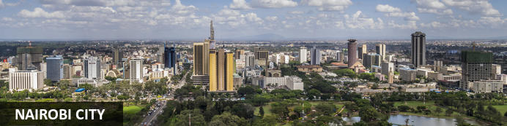
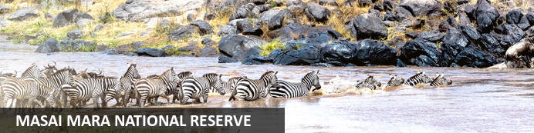
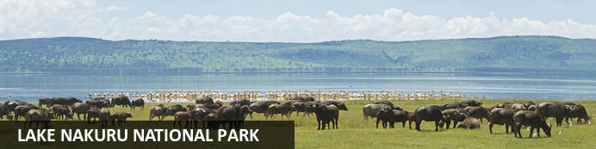
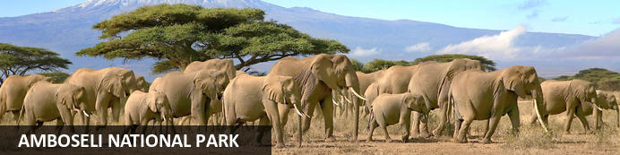
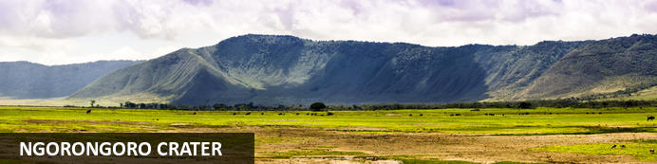
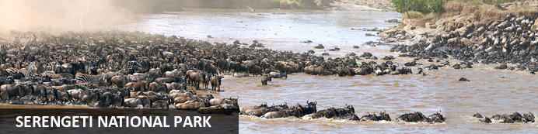
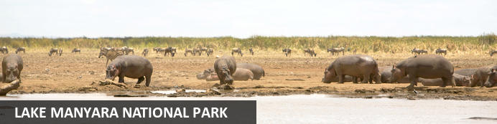

CLASSIC HIGHLIGHTS OF KE & TZ
Nairobi City - Masai Mara National Reserve - Lake Nakuru National Park - Amboseli National Park - Ngorongoro Crater - Serengeti National Park - Lake Manyara National Park
12 Days / 11 Nights
Reference: CSKETZ001
Date of Issue: October 13, 2022

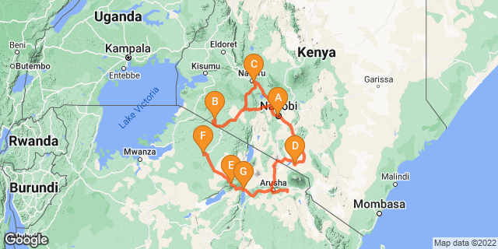

Click here to view your Digital Itinerary

Introduction

Start | Accommodation | Destination | Basis | Duration
Day 1 | Nairobi Serena Hotel | Nairobi City | B&B | 1 Night
Day 2 | Mara Serena Safari Lodge | Masai Mara National Reserve | FB | 2 Nights
Day 4 | Sarova Lion Hill Game Lodge | Lake Nakuru National Park | FB | 1 Night
Day 5 | Amboseli Serena Safari Lodge | Amboseli National Park | FB | 2 Nights
Day 7 | Ngorongoro Serena Safari Lodge | Ngorongoro Crater | FB | 2 Nights
Day 9 | Serengeti Serena Safari Lodge | Serengeti National Park | FB | 2 Nights
Day 11 | Lake Manyara Serena Safari Lodge | Lake Manyara National Park | FB | 1 Night

Key
B&B: Bed and Breakfast
FB: Full Board - Dinner, Bed, Breakfast and Lunch

Price
*From US$ 4386.00 Per Person Sharing
*Terms and Conditions to Apply.

Included
- Accommodation & Meals as stipulated in the itinerary.
- Transportation on safari will be in a 4 x 4 land cruiser with a pop up roof for easy game viewing & photography.
- Services of a professional driver-guide
- All transfers
- All park fees
- All Government taxes and levies.
- 24 hours stand-by contact number.
- Guaranteed window seat.
- Two-way long range high frequency radio communication in each vehicle.
- On safari accessories in each vehicle: First-aid kit, wildlife books, cools box and fire extinguisher.

Excluded
- All items of personal nature e.g. telephone call bills, fax/email bills etc.
- Gratuities and Tips to Hotels / Camps staff and Driver/Guide(s).
- International flight/s and departure taxes and other taxes.
- Laundry services.
- Visa fees. Visas are available on arrival at all Entry point/s
- Easter Supplements

Day 1: Nairobi Serena Hotel, Nairobi City

Nairobi City
Nairobi is Africa’s 4th largest city and is a vibrant and exciting place and although it has developed a reputation which keeps tourist visits brief there are some fascinating attractions: its café culture, unbridled nightlife, the National Museum, the Karen Blixen Museum and most notably just 20 minutes from the city centre wild lions and buffalo roam in the world’s only urban game reserve.

Day Itinerary
Jambo! Upon arrival at Jomo Kenyatta International Airport in Nairobi, you will be met by Classic Safaris representative who will assist with the transfer to Nairobi Serena Hotel.
Overnight: Nairobi Serena Hotel
Meal Plan: Bed and Breakfast

Overnight: Nairobi Serena Hotel
The Nairobi Serena Hotel is nestled among lush gardens at the edge of Nairobi’s Central Park. The elegant guest rooms include satellite TV, minibars, coffee and tea making stations, free daily newspapers, and free Wi-Fi. With three on-site restaurants, a coffee bar and a pool bar serving drinks, guests are spoilt for choice when it comes to dining. Guests can enjoy leisurely strolls through the large grounds, have a splash in the heated pool, or enjoy relaxing massages and treatments at the Maisha Spa and Health Club.
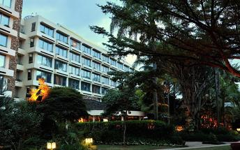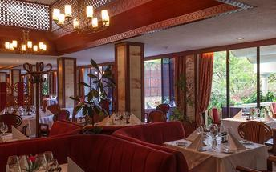

Basis
Bed and Breakfast

Day 2: Mara Serena Safari Lodge, Masai Mara National Reserve

Masai Mara National Reserve
One of Kenya’s undisputed natural highlights is the Masai Mara National Reserve, which sprawls across more than 1500 square kilometres of the country’s southwest. The park protects a phenomenal array of game, including elephant, lion, leopard and buffalo, as well as crocodile and hippopotamus in the Mara River. The birdlife is no less impressive, with over 450 resident bird species. However, the true highlight here is the Great Migration, recognised as one of the Seven New Wonders of the World. To survive the dry months of July to September, some 1.7 million wildebeest, migrate from the parched plains of the Serengeti National Park in Tanzania. Along with much smaller numbers of antelope, buffalo and zebra, they move to the more forgiving grasslands of the Masai Mara. In their wake come predators such as lion, hyena and cheetah, for whom these giant herds are an easy source of prey.

Day Itinerary
Your comfortable drive now takes you to the Maasai Mara, Kenya’s most famous wildlife reserve and the setting for much of the film Out of Africa. It is classic savannah grasslands, where animals are plentiful and the vistas spectacular. Here Maasai tend their cattle in concert with free roaming wildlife – all sharing the same land with minimal conflicts. You will have two days of wildlife-viewing opportunities in the Maasai Mara Reserve, also known as the “Jewel of Africa,” inhabited by many of Africa's most popular wild animals, including lion, cheetah, elephant, leopard, black rhino and hippo. There are over 500 resident species of birds in the park including ostrich, larks and sunbirds as well as the lovely Lilac-breasted Roller.

The area is famous for rolling grassland and for the Mara River, which runs through the reserve from north to south. The reserve covers an area of 700 square miles and forms part of the Serengeti ecosystem, hosting the world famous spectacle of the annual migration of up to two million wildebeest, thousands of zebra and an escort of carnivores as they follow the rains and succulent new grass. A costly trek as many of the lame, laggard and sick will fall prey to ravenous packs of predators and many more will die crossing the swirling flood waters of the Mara River.
Optional activities (at additional cost) include a balloon safari for an exhilarating experience over the savannah as the early sun rises and the animals are more active. Or, you can visit a Maasai Village to see how this nomadic tribe has existed through the millennia in harmony with nature.
Overnight: Mara Serena Safari Lodge
Meal Plan: Full Board

Overnight: Mara Serena Safari Lodge
Secreted deep within the Masai Mara National Reserve, the Mara Serena Safari Lodge is the ultimate safari destination. Set high on a bush-cloaked hill, embraced by arcing vistas and washed by a sea of richly rolling grasslands, it stands centre-stage to one of Africa’s most dramatic wildlife arenas and has a ringside seat for the greatest wildlife show on Earth, the legendary migration of the wildebeest. Drawing its inspiration from the traditional Maasai cultural motif of a cluster of domed, mud-colored huts encircled by a “Boma” of brushwood, the Mara Serena offers a rare blend of raw African splendor and sumptuous sophistication. The essentially ethnic décor also draws on a vibrant colour-palette of sun-burst colors, embellished by a unique selection of Maasai art to create the look and feel of a traditional bush encampment. The lodge features individual rooms, each with their own balcony and view of eternity, a sky-blue swimming pool and a spectacular restaurant, overlooking a water hole where a fantasia of creatures collect to drink.
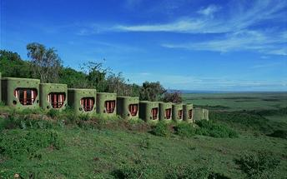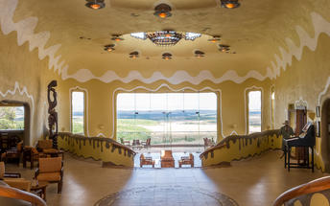

Basis
Full Board - Dinner, Bed, Breakfast and Lunch

Day 3: Mara Serena Safari Lodge, Masai Mara National Reserve

Day Itinerary
Morning and afyternoon game drives. All meals and overnight stay at the lodge
Overnight: Mara Serena Safari Lodge
Meal Plan: Full Board

Basis
Full Board - Dinner, Bed, Breakfast and Lunch

Day 4: Sarova Lion Hill Game Lodge, Lake Nakuru National Park

Lake Nakuru National Park
Located in the Great Rift Valley surrounded by yellow acacia woodlands and bushy shrublands, the Lake Nakuru National Park was created to protect the Lake and its large flocks of Lesser Flamingo, which are drawn to the algae that flourish in the saline waters of this soda lake. The national park is inhabited by over 50 mammal species including hippo, black and white rhino, Rothschild giraffe, buffalo and eland. Known as a bird watcher’s paradise, the park is home to over 450 bird species. Visitors can look forward to hiking through the scenic landscape, picnicking next to this magnificent lake, and spotting an array of wildlife on a game drive. Don’t miss the opportunity to visit the beautiful Makalia Waterfall.

Day Itinerary
After breakfast drive south to Lake Nakuru which is the most famous of the Great Rift Valley lakes and home to a shifting population of over one million flamingos. Arrive in time for lunch at the Sarova Lion Hill Lodge, which enjoys sweeping views across the lake. Spend the afternoon on safari in Kenya's first and largest rhino sanctuary where sightings of both black and white rhino are almost guaranteed and where you have a higher than average chance of spotting a leopard. Other wildlife includes; lion, hippo, the rare Rothschild's giraffe, Colobus monkey, numerous plains game and 450 species of birds.
Overnight: Sarova Lion Hill Lodge
Meal Plan: Full Board

Overnight: Sarova Lion Hill Game Lodge
Sarova Lion Hill Game Lodge is nestled along the Lion Hill overlooking the spectacular flamingo pink rimmed Lake Nakuru. Its location affords panoramic views of the lake and the picturesque Lake Nakuru National Park. A short two-hour drive from Nairobi, Sarova Lion Hill Game Lodge is a favourite with residents and visitors to Kenya.
Sarova Lion Hill Game Lodge is cleverly laid out in such a way that most rooms and sitting areas afford stunning views of the lake and the park. The Lodge incorporates natural landscaping with tall acacia trees, winding walkways and greens dotted with bird feeds. The Lodge is a natural haven for bird life and attracts over 50 species of birds amongst the 400 species that inhabit the Park.
Lake Nakuru National Park was created in 1968 to protect the huge flocks of over of the lesser flamingo that breed and nest at the edge of Lake Nakuru, giving it the characteristic pink rim. Lake Nakuru National Park, located at an altitude of 4,000-5,767 feet above sea level, covers 188 square kilometres of land of great ecological diversity - from lake water, woodland, bush grassland, to rocky ridges. The park is home to not just the lesser flamingo but over 400 species of birds and one of the few places to see the endangered white rhino. Other wildlife at the park includes lions, leopards, zebra, gazelles, eland, giraffe and the hyrax.
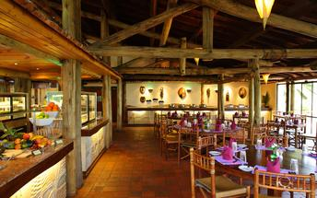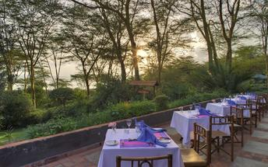

Basis
Full Board - Dinner, Bed, Breakfast and Lunch

Day 5: Amboseli Serena Safari Lodge, Amboseli National Park

Amboseli National Park
Located in the southern reaches of Kenya, the Amboseli National Park is renowned for its excellent variety of wildlife such as Maasai giraffe, elephant, lion and cheetah and not surprisingly it is one of Kenya's most popular parks. The landscape of Amboseli is dominated by the majestic snowcap of Mount Kilimanjaro, as well as open plains, acacia woodland, swamps and the massif of Ol Doinyo Orok. The birding is excellent, especially closer to the lakes and swamps. The park is famous for being the best place in Africa to get close to large herds of elephants among other wildlife species. Other attractions include opportunities to meet the Maasai people and soak up spectacular views of Mount Kilimanjaro, the highest free-standing mountain in the world.

Day Itinerary
Depart to Amboseli National Park, located at the foot of Africa's highest mountain, Mount Kilimanjaro. The snow-capped peak of Mount Kilimanjaro rises above a saucer of clouds and dominates every aspect of Amboseli. This park covers only 150 square miles but despite its small size and its fragile ecosystem it supports a wide range of mammals (well over 50 of the larger species) and birds (over 400 species). Afternoon game viewing drive. Later as the sun sets, you will be transferred back to your lodge for dinner and overnight.
Overnight: Amboseli Serena Safari Lodge
Meal Plan: Full Board

Overnight: Amboseli Serena Safari Lodge
Amboseli Serena Safari Lodge is situated in the Amboseli National Park, Kenya. The lodge's rooms are equipped with ceiling fans, telephones, mosquito nets, and Wi-Fi. The lodge features a restaurant, a palm-shaded outdoor swimming pool and sundeck, and a bush barbeque area. For activities, guests can go on a day or night game drive to see the "Big Five", guided nature walks, or join in on a cooking and Swahili lesson.
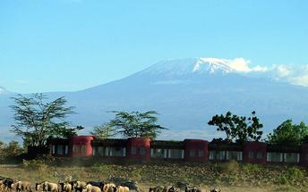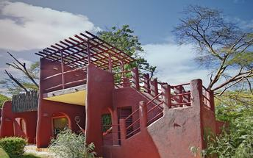

Basis
Full Board - Dinner, Bed, Breakfast and Lunch

Day 6: Amboseli Serena Safari Lodge, Amboseli National Park

Day Itinerary
This morning, enjoy a game drive. Amboseli is best known for views of spectacular Mount Kilimanjaro, the highest mountain in Africa at some 19,341 feet. The park affords you the best opportunity to get close to the mighty elephant. You might also spot Cape buffalo, zebra, wild dog, and others. During the heat of the day, relax at your lodge. You will have a game viewing drive in the afternoon. All meals and overnight at the lodge.
Overnight: Amboseli Serena Safari Lodge
Meal Plan: Full Board

Basis
Full Board - Dinner, Bed, Breakfast and Lunch

Day 7: Ngorongoro Serena Safari Lodge, Ngorongoro Crater

Ngorongoro Crater
Located in Northern Tanzania, the Ngorongoro Crater is best known for its natural beauty and abundance of diverse wildlife; which makes it one of Africa’s most popular safari destinations. Surrounded by Tanzania’s highlands, this UNESCO-listed crater is said to be the world’s largest intact volcanic caldera. Visitors can look forward to spotting the world-renowned Big Five and a host of other wildlife species including large herds of zebra and wildebeest. It is famed as one of Tanzania’s best tourist attractions offering visitors an array of wonderful activities including excellent bird watching, trekking, wildlife viewing, mountain biking and visiting a local Maasai village. Don’t miss the opportunity to jump on an excursion to the magnificent Olduvai Gorge.

Day Itinerary
After breakfast, drive towards Namanga to clear with customs. Continue to Arusha town arriving for lunch at Kibo Palace Hotel. After lunch in Arusha, drive to the famous Ngorongoro Crater Conservation Area (NCCA), which features rolling plains, lakes, craters, mountains and dormant volcanoes. Journey up
the side of the vast Ngorongoro Crater, a World Heritage Site, which is one of the largest volcanic craters in the world (almost 20 kilometers wide, 610-760 metres deep and covering a total area of 264 sq km) and arrive at the Ngorongoro Serena Lodge in time for one of the finest views in the world.
Overnight: Ngorongoro Serena Safari Lodge
Meal Plan: Full Board

Overnight: Ngorongoro Serena Safari Lodge
Perched on the jagged rim of the crater, wreathed in morning mist, camouflaged in river-stone and cloaked in indigenous creepers, the Ngorongoro Serena Safari Lodge is a triumph of ecological and architectural fusion. Sensitively constructed so as to take nothing from its environment whilst affording endless vistas over the heat-shimmering reaches of the crater below, the clustered boulder-built buildings of the Lodge hug the crater rim, linked by rope-lashed timber walkways that skirt the buttressed roots of ancient, liana-hung trees.
The interior, radiating out from the primeval log fire glowing at the heart of the Lodge, blends the concentrated hush of a game-viewing hide with the ochre, rust and charcoal images of a prehistoric cavern. Lit by flaming wall-lanterns, clad in gigantic volcanic boulders and decorated by the iron spears, bright-beaded robes and intricately carven artefacts of the Maasai, the Lodge is a unique blend of world-class luxury, timeless volcanic splendour and ethnic style. As for the views, from lilac-streaked sunrise, to indigo star-studded night, the immeasurably ancient Ngorongoro Crater delivers a theatre of vistas, most unchanged since the dawn of time.
Strung around the crater rim, each with its own rock-enclosed balcony, the rooms feature brass lamps, embossed leather headboards, wildwood mirrors, Maasai carvings and flamboyant prehistoric wall motifs depicting fleeing giraffes, stylised gazelle and plunging buffalo. Each room draws on a cave-grey, indigo-blue and jasper-red colour-scheme, is fully air-conditioned and enjoys uninterrupted views over the Crater's unmatched splendour.
At the end of an action-packed day, guests can also follow a gentle nature trail that loops around the Lodge through moss-hung glades and plunging ravines, take a guided walk to the Crater's rim, relax with a herbal massage, or watch as the burning sun sinks behind the mountains from a unique vantage point on the craggy heights of the Crater's rim.
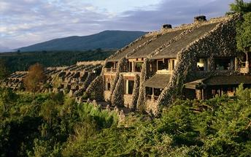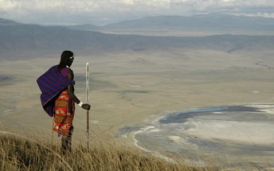

Basis
Full Board - Dinner, Bed, Breakfast and Lunch

Day 8: Ngorongoro Serena Safari Lodge, Ngorongoro Crater

Day Itinerary
After breakfast, descend into the ‘8th Wonder of the World’, a unique biosphere that has remained virtually unchanged since the dawn of time. Enclosed within its towering walls are grasslands, swamps, forests, saltpans, a fresh water lake and a glorious variety of birdlife. Here too are all the members of the ‘Big Five’ (lion, elephant, rhino, leopard and buffalo) as well as a large cast of plains game and one of Africa’s densest populations of predators. Enjoy a picnic lunch on the crater floor before climbing back up to the lodge in time for relaxation before dinner.
Overnight: Ngorongoro Serena Safari Lodge
Meal Plan: Full Board

Basis
Full Board - Dinner, Bed, Breakfast and Lunch

Day 9: Serengeti Serena Safari Lodge, Serengeti National Park

Serengeti National Park
The Serengeti, together with Kenya’s Masai Mara Game Park, constitute Africa's most famous wildlife park, spread over the enthralling landscapes of northern Tanzania. This is a precious ecosystem, supporting the annual wildebeest migration through the Serengeti and the Masai Mara. The largest mass movement of land mammals on the planet involves more than a million animals following the rains, including more than 1.5 million white-bearded wildebeest and 250 000 zebras. Prides of lions, as well as groups of elephants, giraffes, gazelles, and eland, roam among the photogenic vast grass plains between weird-and-wonderful-looking acacia trees. Aside from traditional vehicle safaris, hot-air ballooning over the Serengeti plains and horse riding safaris are on offer.

Day Itinerary
After breakfast, leave the NCCA and cross into neighbouring Serengeti National Park. Arrive in time for lunch. Afternoon game drive.
Overnight: Serengeti Serena Safari Lodge
Meal Plan: Full Board

Overnight: Serengeti Serena Safari Lodge
Serengeti Serena Safari Lodge is situated high a tree clad ridge, commanding panoramic views across the Serengeti. The lodge is a fusion of traditional African architecture and modern style. Centrally located adjacent to the Western Corridor and Grumeti River, the lodge has been designed to blend completely into the living landscape. A series of traditional domed rondavels are widely spaced throughout the grounds, which are cooled by groves of acacia trees and watered by sparkling streams. On the very edge of the ridge is a pool, which looks out over the endless plains. The lodge has been styled to offer a showcase of cultural performance, heritage and traditional art, illustrated by the lavish Makonde carvings which decorate the rooms and the stunning domed dining room.
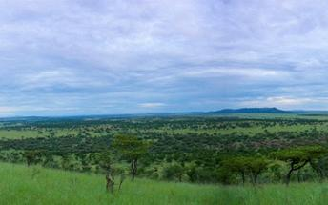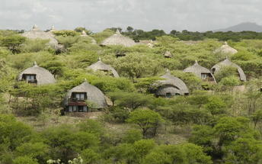

Basis
Full Board - Dinner, Bed, Breakfast and Lunch

Day 10: Serengeti Serena Safari Lodge, Serengeti National Park

Day Itinerary
After breakfast, enjoy a full day’s game driving (meals taken in true safari style ‘in the bush’) in the vast and sensational Serengeti, which covers 14,763 sq km of endlessly rolling savannah. Venue for ‘the greatest wildlife show on Earth’, the annual migration of over one million wildebeest, the park is
also renowned for its lions, cheetahs, zebras, giraffes and plains game. Overnight at the lodge.
Overnight: Serengeti Serena Safari Lodge
Meal Plan: Full Board

Basis
Full Board - Dinner, Bed, Breakfast and Lunch

Day 11: Lake Manyara Serena Safari Lodge, Lake Manyara National Park

Lake Manyara National Park
Situated in Tanzania’s central-northern region with the Lake Manyara to its east and the Manyara Escarpment to its west, the Lake Manyara National Park offers breathtaking views and a large variety of habitats supporting an array of wildlife. This small park is home to surprising biodiversity and features a magnificent landscape of acacia woodlands, forests, baobab strewn cliffs, algae-streaked hot springs, swamps and the lake itself. The park supports over 400 species of bird and the largest concentration of baboons anywhere in the world. Other species to spot include giraffes, zebras, wildebeest, impala, waterbuck, warthog, the Cape clawless otter, and the Egyptian mongoose. Don’t miss the opportunity to see thousands of flamingos on the lake, the renowned tree-climbing lions, and large families of elephants strolling through the forest.

Day Itinerary
After breakfast, drive to beautiful Lake Manyara, a shallow alkaline lake that shimmers in a cleft in the Great Rift Valley. Arrive in time for lunch at the Lake Manyara Serena Safari Lodge, which stands on the edge of the escarpment, overlooking the lake. A small but uniquely diverse national
park, Manyara is home to the world-famous tree-climbing lions, thousands of flamingoes and nearly 500 species of birds. Return to the lodge in time for a swim in the stunning horizon pool and dinner in the elegant central dining room.
Overnight: Lake Manyara Serena Safari Lodge
Meal Plan: Full Board

Overnight: Lake Manyara Serena Safari Lodge
Standing high on the bluff of a dramatic ochre and terracotta streaked cliff above the flamingo-frosted expanse of Lake Manyara’s gleaming alkaline waters, the Lodge commands panoramic views across the volcano-studded floor of the Great Rift Valley. Designed to reflect the brilliance of Lake Manyara’s unique birdlife, the Lodge draws on an inspirational architectural motif that melds swooping avian curves with the gentle concentric patterns of traditional Maasai ‘Bomas’ (encampments) whilst the vibrantly coloured frescoes lining the walls are designed to depict the colourful intricacy of bird migratory patterns. The ambiance of the Lodge is a fusion of lakeside tranquility, towering volcanic splendour and adventure-packed sporting activity.
As to wildlife, the park offers abundant sightings of; monkey, jackal, mongoose, hyena, hyrax, zebra, hippo, warthog, buffalo, Masai giraffe, duiker, waterbuck and impala. Significant numbers of elephant are also resident in the Park whilst sightings of black rhino and leopard are not uncommon. Manyara is also especially noted for its wealth of bird life, being visited by many thousands of sugar-pink Lesser Flamingos, significant numbers of Greater Flamingos and a host of other woodland, plains and water birds
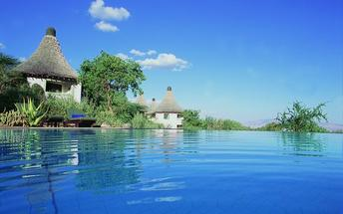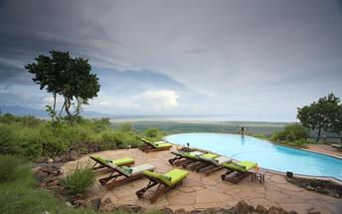

Basis
Full Board - Dinner, Bed, Breakfast and Lunch

Day 12: End of Itinerary

Day Itinerary
Drive to Arusha town for lunch at Arusha Coffee Lodge. After lunch, you will be transferred to Kilimanjaro airport for your International flight back home.

Basis
Full Board - Dinner, Bed, Breakfast and Lunch

Transport

Transfers
Date | Company | Pick Up | Drop Off | Time | Vehicle
 |  | Nairobi Serena Hotel | Nairobi Serena Hotel |  | Transfer
 |  | Nairobi Serena Hotel | Mara Serena Safari Lodge |  | Transfer
 |  | Mara Serena Safari Lodge | Sarova Lion Hill Game Lodge |  | Transfer
 |  | Sarova Lion Hill Game Lodge | Amboseli Serena Safari Lodge |  | Transfer
 |  | Amboseli Serena Safari Lodge | Ngorongoro Serena Safari Lodge |  | Transfer
 |  | Ngorongoro Serena Safari Lodge | Serengeti Serena Safari Lodge |  | Transfer
 |  | Serengeti Serena Safari Lodge | Lake Manyara Serena Safari Lodge |  | Transfer
 |  | Lake Manyara Serena Safari Lodge | Kilimanjaro International Airport [JRO] |  | Transfer

Urgent Contact Numbers
Company Name | Telephone | Email Address | Contact Person
CLASSIC SAFARIS LTD | +254 716 269009/255 | sylvia@classicsafaris.co.ke | Sylvia

Service Provider Directory
Service Provider | Ref. Number | Telephone | Address
Amboseli Serena Safari Lodge |  | +254 727 622500 | Amboseli National Park  Kenya  Africa
Lake Manyara Serena Safari Lodge |  | +255 27 253 9162
Nairobi Serena Hotel |  |  | Kenyatta Avenue  Nairobi,  Kenya
Sarova Lion Hill Game Lodge |  | +254 728 606584 | P.O. BOX 72493 00200 NAIROBI KENYA
Serengeti Serena Safari Lodge |  | +255 27 254 5555

Travel Information
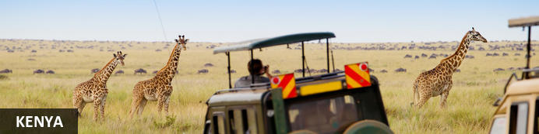
Resting in the magnificent Great Rift Valley and presided over by the majestic Mount Kilimanjaro, Kenya is characterised by hauntingly beautiful natural landscapes of forested hills, patchwork farms, wooded savanna and vast forests brimming with an extraordinary abundance of wildlife. The nation’s diverse range of traditional African cultures is influenced by over 70 unique ethnic groups from the Maasai, Samburu, Kikuyu, and Turkana tribes to the Arabs and Indians that settled on the coast. Add to this: an exquisite tropical coastline fringed with breathtaking golden sand beaches; gorgeous coral gardens providing excellent snorkeling and diving opportunities; and a slew of lively beach resorts, and it is easy to see why so many visitors flock here from around the world to experience a truly unique African adventure in one of the world’s most pristine safari destinations.

Entry Requirements
KENYA: VISA REQUIREMENTS
A visa is required for entry into Kenya for most people (see below for exceptions). An ordinary visa (also known as a tourist visa) is used by tourists. This visa is issued at any Kenyan embassy, or can be issued on arrival at an entry point to citizens of any country listed in Category 2 in the Visas section of the Immigration website (link below). It grants tourists / visitors the authorization to enter the country through designated entry points on the border, through airports, and harbour stations.
Please note that the possession of a Kenyan visa is not the final authority to enter Kenya. The immigration officer at the port of entry may deny entry if the visitor is unable to fulfil the immigration requirements and if the entry and presence of such a person in Kenya would be contrary to the national interests of Kenya, even if such a person is in possession of a valid visa for Kenya.
Visa Descriptions:
1. Single Entry - Allows you to enter into Kenya once (see also note below)
2. Transit - Allows a short stop over (up to 3 days) in Kenya (see also note below).
3. Multiple Entry - Allows entry multiple times into Kenya.
Note: No visa is required for direct transit (not leaving the secure area of the airport, aka staying 'airside', within the airport terminal) between two flights. If you are in transit but leave the secure area of the airport, for example for an overnight stay between flights, for a period of less than 24 hours then a transit visa is required.
Note: A single entry visa will allow re-entry to Kenya from any of the following East African countries: Uganda, Tanzania, Burundi, and Rwanda.
Visa Requirements
Obtained in advance: By E-Visa or through a Kenyan Foreign Embassy.
1. A complete visa application form. A copy of the form is available on the web -http://evisa.go.ke/evisa.html or at any Kenyan embassy.
2. Valid passport (at least 6 months before expiration). There must be at least two facing blank visa pages available, one for the Kenya visa sticker and one facing for the stamps.
3. 1 passport size photograph recently taken.
4. Travel Itinerary
5. Hotel booking
6. A return ticket
7. Visa fee (see below).
Obtained on Arrival:
1. A complete visa application form. A copy of the form is available on the web, at any Kenyan embassy, or at any entry point into Kenya.
2. Valid passport (at least 6 months before expiration). There must be at least two facing blank visa pages available, one for the Kenya visa sticker and one facing for the stamps.
3. Travel Itinerary
4. Hotel booking
5. A return ticket
6. Visa fee (see below).
Note: No photographs are required for a visa on arrival as you are photographed and finger printed at the Immigration desk.
Visa Fees:
1. Single entry visa - US$50.00 or £30 or €40
2. Multiple entry visa - US$110.00 or £60
3. Transit visa - US$20.00 or £10
Note: See below under 'additional information' for information about the cost of a 'referency fee', if required.
Non-tourists:
If you are not a tourist, for example a business traveler, contact any Kenyan embassy for additional information.
Additional Information:
No visa is required for nationals of the following countries:
Barbados, Maldives, St. Lucia, Belize, Malta, Swaziland, Botswana, Mauritius, Seychelles, Brunei Darussalam, Namibia, The Gambia, Burundi, Nauru, Tanzania, Cyprus, Papua New Guinea, The Bahamas, Dominica, Rwanda, Tonga, Fiji Island, Trinidad and Tobago, Ghana, Samoa, Tuvalu, Grenada, St. Kitts and Navis, Uganda, Jamaica, Sierra Leona, Vanuatu, Kiribati, Singapore, Zambia, Lesotho, Solomon Islands, Zimbabwe, Malawi, South Africa (for less than 30 days stay), St. Vincent and the Grenadines, Malaysia (for less than 30 days stay), Ethiopia, Eritrea, San Marino
Holders of U.S Refugee Travel Documents issued by the Department of Homeland Security (Greencard Holders/Permanent Residents) and nationals (passport holders) of the countries listed below shall have their visa applications referred to the Director of Immigration Services, Nairobi for approval. The processing varies from case to case. In addition, when a visa application is referred to the Director of Immigration Services Nairobi, a non-refundable reference fee of US $5 shall be collected at the time of application. This fee will be in addition to any other visa fee and will not be refunded if a visa is issued or is not issued.
Afghanistan, Senegal, Azerbaijan, Kosovo, Eritrea, Somalia, Armenia, Lebanon, Syria, Libya, Cameroon, Mali, Palestine, Iraq, Democratic People’s Republic of North Korea, Tajikistan
For more information on the visa application process and visa categories based on nationalities, please visit www.immigration.go.ke or http://evisa.go.ke/evisa.html

Banking and Currency
MONEY:
The currency in Kenya is the Kenyan Shilling (KES; symbol KSh). 1 Kenyan Shilling = 100 cents. Notes are in denominations of KSh1,000, 500, 200, 100 and 50. Coins are in denominations of KSh20, 10, 5 and 1.
The local currency is the Kenyan shilling, and the Tanzanian shilling respectively.
1 US dollar = 100 Kenyan shillings; (this changes based on the currency flactuation)
Please respect the local currency and note that it is a criminal offence in both countries to damage or tear the local currency.
Money may be changed easily at airports, hotels, banks and forex bureau. Please avoid changing money in the street with money vendors, as they are operating illegally.
It is unnecessary to carry excessive amounts of money (on safari, all meals are included, except for the drinks) and credit cards are widely accepted for payment of meals outside the meal plan, hotel extras, shopping etc
The equivalent of USD 100 per person is a guideline for exchange, as you may use your credit cards such as VISA or MASTERCARD for any additional costs, in most of the places you will visit.
Traveller´s Cheques are also a safe and simple method of payment; however you may have some problems with regard to their acceptance whilst on safari.
If at the end of the safari, you have any left over local currency, this may be changed back into dollars, at the airport.
There are no restrictions on the import or export of local or foreign currency. However, amounts exceeding US$5,000 or equivalent must be declared.
Banking
Banking hours: Monday-Friday 09h00-16h00, Saturday 09h00-12h00. Banks in Mombasa and the coastal areas typically open and close half an hour earlier.
Credits Cards are widely accepted in all major hotels and more upmarket establishments, with the most recognized being Master Card and Visa. American Express and Diners Club cards are occasionally accepted. However, you will need some cash handy because smaller shops will only accept cash.
Almost every bank now has an ATM, and they are increasingly being installed at, malls, shopping centres and petrol stations in cities and large towns.
Travellers cheques are no longer accepted in Kenya.

Travel, Transport and Getting Around
Nairobi has two airports for domestic and international flights: Jomo Kenyatta International Airport and Wilson Airport (www.kaa.go.ke).
Mombasa has one airport for both domestic and international flights - Mombasa International Airport
Kenya has over 150 domestic airports and airstrips and there are daily flights to the most popular destinations. In addition to the scheduled airlines, several private charter companies operate out of Wilson Airport.
Kenya Airways (www.kenya-airways.com), Air Kenya (www.airkenya.com), Fly 540 (www.fly540.com), Mombasa Air Safari (www.mombasaairsafari.com) and Safarilink (www.flysafarilink.com) serve the most popular safari destinations, plus many others such as Lake Victoria.
On smaller, domestic planes the baggage allowance is restricted to maximum 15 kg (22-33 lbs). Arrangements can be made to leave excess luggage with your Kenya tour operator, hotels or airlines
Main roads between the major cities and towns are generally in good condition, and easily navigatable in a normal saloon car. Most highways are paved.Vehicles are driven on the left side of the road.
While major roads are generally in a good condition, most minor gravel roads deteriorate in the rainy season. Dirt roads, including those in the parks and reserves, are rough, and some are only passable with a 4-wheel drive.
You can hire chauffeur-driven cars from your travel agents and international hire companies. Self-drive although highly discouraged for new drivers in Kenya is an option. Drivers must be at least 23 years of age. Car hire can be expensive and rates vary significantly.
A driving licence from a home country (and a translation if this is not in English) or an International Driving Permit is required. Third-party insurance is mandatory when hiring a car and it’s recommended to take out the additional collision damage waiver. A valid credit card is also needed.
Matatus (shared minibus taxis) hop from town to town, starting and finishing at bus stations. Fares are paid to the conductor. Private taxis can also be hired for long-distance journeys.
It is not possible to rent motorbikes or mopeds but some of the beach resorts hire out bicycles.
Numerous private bus companies operate in Kenya. Most vehicles tend to depart when full, which means there are no set timetables. Petty theft on the vehicles and at bus stations can be a problem. Nevertheless, buses are cheap and link all long-distance destinations. Plus, seatbelts are now mandatory, so buses are relatively safe.
Nairobi and Mombasa have efficient local bus systems and there are also frequent matatus, but reckless driving and petty theft makes them a dodgy option for tourists. Three-wheeled auto rickshaws are popular in the coastal towns and carry up to three passengers.
Online taxis service Uber is now in Kenya, available both in Nairobi and Mombasa and other online taxis options are coming up in Nairobi, these service are reliable and have meters. The older yellow taxis do not have meters, so fares should be agreed in advance. Cabs cannot be hailed in the street, but can be found parked in taxi ranks.

Health and Medical Information
HEALTH:
A certificate of vaccination against Yellow Fever is required. Malaria is endemic to Kenya and Tanzania, so please remember to take anti-malaria tablets. In case of any medical emergency, your hotel will have a doctor on call, or will have the medicine you may require, including the parks on safari.
All the same, please take the following precautions:
Dress in warm clothing in the evenings and at night; use repellants against mosquitoes and use insecticide sprays in rooms before sleeping (or before going for dinner). This area is right at the Equator, and the hot sun can cause sunburn very quickly- including on cloudy days.
Sun creams, lip balm, hats and sunglasses are recommended.
Although tap water in the big towns is potable, we advise you to drink mineral water always. In the hotels/ lodges during the safaris, there is always a jar/bottle/thermos of filtered water in the rooms, which is convenient for using for cleaning your teeth.
The mineral water in the hotels/ lodges has quite an elevated price. You may buy some bottled water at the local supermarkets at a more reasonable price.

Safety Notices
As it is the case in most regions of the world, security is a topic that should be kept in mind. Nairobi and Mombasa are generally safe during the day, as long as narrow alleys or isolated streets are avoided. We advise you not to walk in the streets in the dark. If youwishtotravelbynight,alwayscallforataxi.
Don’t carry a lot of money with you when you go out; only the amount you think you will spend. While walking in the streets, don’t wear jewellery or valuables that bring attention to you.
Please leave all valuables (jewellery, travel documents, cameras etc) in the safes or safety deposit boxes of the hotel you are staying at.
Please don’t leave anything of value lying around your hotel room.

Food, Drink and Cuisine Advice
FOOD:
During the safari, all your meals will be taken in the hotels.
In Nairobi and Arusha; generally only breakfast is included in your hotel accommodation; Lunch and dinner billed separately.
The food is of an excellent quality and you may eat all the types of fruits and vegetables without worry. The meal plan is usually as follows:
Full breakfast, between 0700 hrs and 0930 hrs;
Buffet lunch, served from about 1230 hrs;
Tea and coffee, served from 1600 hrs to 1800 hrs;
Dinner served from 1930hrs to 2130hrs, at the table. Generally, we choose the second course and dessert. Most of the hotels have both local and imported beers and wines, liquors, fruit juices and refreshments available. Drinksarenotincluded (unlessotherwisestated).
If you require a special diet or are vegetarian, please make sure you communicate this to the reception at the time of your arrival at the hotel.
Nairobi has some of the finest eating establishments in Africa. Many different cuisines and types of restaurants are available, from fast food to fancy. Many five-star hotels have excellent restaurants. Restaurants are many in Nairobi. The local cuisine is also worth trying out, particullarly Pilau-a chicken and rice dish, cabbage and rice; and the staple food in Kenya-Ugali, made from maze flour.
Many restaurants can be found downtown and in most areas of the urban centres however if you're looking for a real authentic experience away from most tourists, places like Ayani, Olympic, Kibera, and other places have the more authentic food. Among the many cuisines available are Indian, Brazilian, Chinese, Thai, Japanese, German and French restaurants. Fast food restaurants are common in malls which are in every area of Nairobi .

Climate and Weather
Kenya lies on the equator and has a pleasant tropical climate, but there are large regional climatic variations influenced by several factors, including altitude. Temperatures drop by about 6°C for every 1000m you climb (or 3.5°F per 1000ft). Kenya’s daytime temperatures average between 20°C/68°F and 28°C/82°F, but it is warmer on the coast. The coast is hot and humid all year round, but the heat is pleasant and tempered by the monsoon winds. Kenya is too close to the equator to experience a real winter and summer. There is, however, both a dry and wet season. The wet seasons are from March to June and from October to Mid December. The rest of the time it is dry although significantly cold (atleast for the Kenyan person) during the months of July and August.

Clothing and Dress Recommendations
Comfortable, casual clothing that is lightweight is the best bet while on safari. It can be quite cool in the early mornings, so you'll want to dress warmly in layers, until the sun has a chance to warm up the air. "Kenya Convertibles", khaki pants with zip-off legs, are perfect for cool early morning game drives that turn warm before you're back in camp. Walking shorts, long pants, cotton shirts and tees are just right. A cotton bush jacket or wind-breaker will be useful along with a warm sweater or fleece jacket for the cool nights, long-sleeves and trousers for the nights for protection against insects, and a light raincoat in case it rains. And, a hat that ties on is a must. There is not a good deal of long walking or hiking on most safaris, so a comfortable pair of walking shoes or tennis shoes and a pair of sandals should be adequate. You will need thorn-proof soles.
In Kenya's major cities the dress code is conservative but not overly formal – jeans and decent tops for women are fine. Swimsuits are acceptable on the beach but you’ll need to cover up in public places.

Internet Availability
Wi-Fi is readily available in major cities and hotels, as well as in luxury game lodges.

Electricity and Plug Standards
ELECTRICITY:
Most hotels use generators which function only in the morning, and at night. We use 240 volts and plugs with three spokes (UK). An adapter is all that you will need and are mostly available at the hotel receptions if you forget to carry one. A small deposit is required as security when you borrow the transformer, which is refundable.

General Guidance
IT IS CONVENIENT TO TRAVEL LIGHT:
The safari vehicles do not have a lot of luggage capacity and for this reason, we recommend soft, light luggage. In any hotel with a stay of 2 days or more, laundry service is available.
WE RECOMMEND YOU CARRY:
Binoculars (INDISPENSABLE).
Many more rolls of film than what you thought enough! up to 100 Photos per day during the safari. (It
doesn’t weigh much, and could be slightly more expensive here).
A torch.
Insect repellant.
Lip balms and sun creams.
Coloured biro pens, pencils, pictures, small books, balloons, etc. to give out as presents in case you visit a local village (they are more appropriate than sweets, and are more appreciated).
Disposable lighters, caps, scarves, T-shirts, etc. as “barter material” in souvenir shops (although in actuality, no “barter” without some money changing hands, exists!).
Waist pouches for carrying money, passports and small valuables are very practical.
DON’T CARRY:
Your gold Communion medal, diamonds, Grandmother’s pearls, gold watches, $200 sunglasses, etc.
In other words, carry things that will not be sorely missed in case of loss.
TIPPING:
Most people, when visiting a foreign country, like to be given some guideline regarding tipping. Yet, this is truly voluntary and extremely personal matter. A tip is an indication of appreciation on the part of the guest for the services given and ISONLYGIVENWHENTHESERVICEWASUPTOYOUREXPECTATIONS, and is paid after all the services have been completed, and is NEVEROBLIGATORY. A guideline for each traveler follows below:-
Restaurants: These guidelines are for lunches and dinners you may enjoy on your own, which are not included in your itinerary. If the menu says 10% service charge included, you do not need to tip. Otherwise, between 5 and 10 % of the total bill is considered usual and customary.
Hotels’Camps’& Lodges’staff: 2 – 5 dollars per person per day.
SafaridriverandGuide: Ever since the early days of safari-ing, driver-guide and naturalist/tour guide in Africa have had their expert bush skills acknowledged in form of tips. We recommend 5 – 10 dollars per person per day, but this is entirely at your own discretion.
ArrivalTransfer: 5 dollars per person per day.
COMMUNICATIONS:
Communication is as sophisticated here as it is in Europe or the States, but it is however more expensive. It is possible to make international calls from most of the hotels, but the price is between USD 7- 10 per minute, for a minimum of 3 minutes. It is mostly automatically billed.
The Nairobi hotels, mainly, will also offer email services.
However in the era of smart phones and what's app, as long you can internet - which is now available in most camps and lodges, communication is cheap and easy.
MobilePhones: The mobile network coverage in Kenya is no longer limited. Right now there is network almost in all the safari circuit areas. Just incase your cell phone provider has roaming contract with some of the few providers in Kenya (Which is mostly the case); most of the places have network coverage including in the parks and all the cities.
SHOPPING:
Numerous shops and stalls selling a variety of souvenirs can be found in the towns and en route during the safaris. You can buy both traditional and modern jewellery, wood carvings, sculptures, soapstone figures, baskets and bags, safari attire, articles made from banana fibre, khangas and kikois
(khangas are the colourful wraps worn by women especially at the coast and in the countryside, while kikois are the wraps worn by men at the coast), precious stones like Tanzanite (violet/blue), semi precious stones such as green Tsavorite, Tiger Eye and Malachite etc
It is important to bargain in most of the shops for a better price.
We also have some small “markets” such as the Maasai Market in Nairobi, where you can not only enjoy the hectic atmosphere but also find all types of arts and cratfs for sale. This market is open air, operating at shopping malls on each day of the week (please ask your guide for a recommendation while in Nairobi).
Most hotels also have gift shops that sell souvenirs, T-shirts etc
In case you happen to purchase items of African craft while on safari and you decide you want the purchased items to be send to your home country, please make sure you clarify and confirm that the entire shipping costs are included in your invoice just to avoid any inconveniences upon delivery. Mostly, the shipping charges are normally done at the destination airport so as to be able to go through customs inspections and formalities. Kindly note that we take our clients to shopping areas that are highly recommendable for shopping, however Classic Safaris will not be held responsible for any damages caused during the shipping period of the said items. At the same time, the company shall not be held responsible for the non-sending of the purchased items to the agreed destination and will not accept any responsibility for shipment or customs charges.
SHOPPING HOURS:
Shopping hours are from 0830hrs to 1230hrs and 1400hrs to 1700hrs. Mondays to Fridays and from 0830hrs to 1300hrs on Saturdays. The bigger supermarkets do not shut over lunchtime, and stay open until 2000hrs during the week and 1800hrs on weekends. There some supermarkets in Nairobi those are now open 24 hours.
WILDLIFE, NATIONAL PARKS:
Please refrain from disturbing or feeding the animals in the parks. It is dangerous to try to touch them- they ARE wild. Please stay in the vehicle during game drives in the park.
It is prohibited to sit on top of the vehicles, even while they are stationary.
REGISTRATION AND HOTEL CHECK OUTS:
On arrival, you will fill in a registration card at the reception in order to obtain the room key. Roomoccupancyisonlyguaranteedafter1100hrs,andoncheckoutmustbedoneby1000hrsor1800hrs,ifyouhavecontractedadayroom.
Extras bills will be paid at the reception. When this is cleared and the room key has been handed in, you will receive a luggage ticket which allows your luggage to leave the hotel, as it indicates all bills and outstanding matters have been cleared.

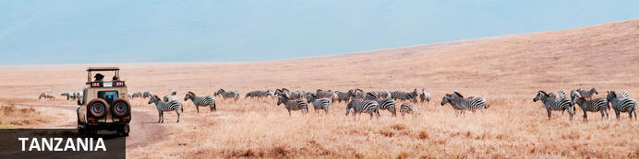
The name Tanzania conjures up images of wildebeest stampeding across vast savannah, rain forests teeming with monkeys and birdlife, and great plains brimming with legions of game. All of these natural wonders and more are on offer in this exceptionally diverse African nation. Visitors typically visit Tanzania to partake in at least one of the four well known Tanzanian tourist experiences: a relaxing seaside vacation on the picturesque island paradise of Zanzibar, an underwater tour of some of the world’s most renowned dive sites around the gorgeous Spice Islands, a safari adventure in some of Africa’s most impressive game reserves, or a hiking excursion around Mount Kilimanjaro National Park. Whichever of these incredible holidays you choose, you will undoubtedly be welcomed by some fabulously friendly and peaceful inhabitants who, despite being divided into 120 different ethnic groups and cultures, live in harmony with one another and provide some of the most wonderfully exotic local cuisine you could imagine. With all of this diversity on offer, the most difficult part of your Tanzanian holiday experience is likely to be deciding where to go!

Entry Requirements
ENTRY REQUIREMENTS AND VISA INFORMATION
Countries eligible for Visas and Fee rates
Visa Issuing Centers
Countries which require Referral Visa before coming to Tanzania
ENTRY REQUIREMENTS:
Any foreigner seeking to enter the United Republic of Tanzania is subject to the following entry requirements:
a passport or Travel Document which is valid for not less than six months issued by a State or an International Organization recognized by the Government of the United Republic of Tanzania and
that, he is a holder of or his name is endorsed upon a Residence Permit or a Pass issued in accordance with the provisions of the Immigration Act No. 7 of 1995; or
A valid Visa (for nationals whose country require visa) which is obtained at any Tanzania Mission abroad or on arrival at any designated entry points. Click here to see Official Entry Points
Note:
Upon complying with the entry requirements, a bonafide visitor is issued with a Visitor's Pass on arrival at the entry point into the United Republic of Tanzania for a validity not exceeding three months in first instance (and not exceeding six months for citizens of East African Community), provided that he is in possession of sufficient funds for subsistence while in the United Republic of Tanzania and a Return ticket or onward to ticket to his country of origin, domicile or destination as the case may be.
VISA INFORMATION
Purpose of Visa
A Visa is a permission granted to a foreigner other than a prohibited Immigrant (please click here to see the list of countries whose nationals require visa) to enter and remain in the United Republic of Tanzania for the purpose of visit, leisure, holiday, business, health treatment, studies, or any other activity which is not illegal under the Laws of the United Republic of Tanzania.
Note:
It should be noted that the possession of Visa is not a final authority to enter the United Republic of Tanzania. The Immigration Officer at the entry point may refuse such a person permission to enter if he is satisfied that he is unable to fulfill immigration entry requirements and that the presence of such person/visitor in the United Republic of Tanzania would be contrary to the national interests.
CATEGORIES OF VISAS
There are five categories of Visas which may be granted to foreigners other than prohibited immigrants who seek to enter the United Republic of Tanzania as follows:
Ordinary Visa
Transit Visa
Multiple Entry Visa
Gratis Visa
Referral Visa
ORDINARY VISA
This is a Visa granted to foreigners other than prohibited immigrants seeking to enter the United Republic of Tanzania upon application for the purpose of visit, leisure, holiday, business, health treatment, studies, or any other activity legally recognized by the Laws of the United Republic of Tanzania for validity not exceeding three months for a single entry only.
TRANSIT VISA
This is a Visa granted to foreigners other than prohibited immigrants intending to pass through the United Republic of Tanzania to other destinations for a period not exceeding fourteen days provided that such persons should have onward tickets, sufficient fund for subsistence while in the United Republic of Tanzania and an entry Visa to the country of destination (where applicable) or any other proof to satisfy that such person will be allowed entry to that other country.
MULTIPLE ENTRY VISAS
This is a Visa granted to persons who are nationals of countries which require Visa for United Republic of Tanzania and who by nature of their businesses or circumstances require making frequent visits to the United Republic of Tanzania. Multiple Visas may be issued for a period of three, six or twelve months to permit the holder to enter and re-enter subject to the validity of the visa, provided that a single stay of the holder should not exceed three months.
GRATIS VISA
This is a Visa granted to holders of Diplomatic or Official/Service Passports when travelling on official missions to the United Republic of Tanzania and it is granted free of charge. In some cases Gratis Visa may be granted to holders of Ordinary Passports where an exemption has been given by the Issuing Authority.
Note:
Holders of Diplomatic and Service/Official passports when travelling on private visits into the United Republic of Tanzania are required to apply for visa like holders of ordinary passport.
REFERRAL VISA
This is a Visa granted to nationals of Countries which require a special clearance and approval from the Principal Commissioner of Immigration Services or the Commissioner of Immigration Services (Zanzibar) prior to the issuance of Visa. (Click here to see the List of Countries which requires Referral Visa).
Note:
Possession of a Visa for United Republic of Tanzania does not provide automatic right of entry for the holder into the Country. Accordingly, an Immigration Officer at the Entry Point may refuse any person regardless whether he holds a Visa or not, if he is satisfied that such a person is unable to fulfill the immigration requirements and/or that such person's/visitor's presence in the United Republic of Tanzania would be contrary to national interests.
REQUIREMENTS FOR VISA
An application of Visa for United Republic of Tanzania should be accompanied with:
application form duly filled in;
security Bond duly filled in(for Multiple Visa);
five passport size photographs (if required);
copy of the Applicant's valid Passport;
copy of the valid Passport or any other identity of the person to be visited (applicant's host if required);
documents of the Company or Business to be visited; (for Multiple Visa)
any other evidence to prove that the applicant is bound to travel frequently into the United Republic of Tanzania(for Multiple Visa)
VISA ISSUING CENTRES:
A Visa may be obtained at any United Republic of Tanzania Missions abroad or Consulates (click here to see the List of Tanzania Missions abroad) and also on arrival at all designated Entry Points. In case of Referral and Multiple Visas applicants are required to submit their applications to the office of the Principal Commissioner of Immigration Services Dar es Salaam or at the office of the Commissioner of Immigration Services Zanzibar. Click here to see Visa Issuing Centers.
VISA FEES:
Standard fee rate for Ordinary Visa is US $ 50, for Multiple Entry Visa is US $ 100 and for Transit visa is US $ 30. However a different fee may be set in accordance with the rules guiding Visa issuance or on the basis of reciprocity. Click here for more details on Visa eligibility and fee rates.
Note:
Visa fees are payable at Issuing Centers and an Exchequer Receipt should be provided for the payment made.

Banking and Currency
MONEY:
The local currency is the Kenyan shilling, and the Tanzanian shilling respectively.
1 US dollar = 2180 Tanzanian shillings (or as per current currency flactuation).
Please respect the local currency and note that it is a criminal offence in both countries to damage or tear the local currency.
Money may be changed easily at airports, hotels, banks and forex bureau. Please avoid changing money in the street with money vendors, as they are operating illegally.
It is unnecessary to carry excessive amounts of money (on safari, all meals are included, except for the drinks) and credit cards are widely accepted for payment of meals outside the meal plan, hotel extras, shopping etc
The equivalent of USD 100 per person is a guideline for exchange, as you may use your credit cards such as VISA or MASTERCARD for any additional costs, in most of the places you will visit.
Traveller´s Cheques are also a safe and simple method of payment; however you may have some problems with regard to their acceptance whilst on safari.
If at the end of the safari, you have any left over local currency, this may be changed back into dollars, at the airport.

Travel, Transport and Getting Around
If you are visiting a number of parks and reserves in Tanzania, you can either drive or fly between them. Roads in most of the wilderness areas are in poor condition and unmarked, and self-driving is not recommended. Operators will supply you with a driver who doubles as an informal guide; alternatively, you can arrange to fly to your destination and utilize a car and driver supplied by the lodgings. Elsewhere in Tanzania, towns and cities are linked by a steady stream of buses and dala-dalas (minibuses), and in the cities, there is public transport in the way of buses, dala-dalas, taxis, and, in some places, bicycles or tuk-tuks.
Precision Air run regular services, mostly via Dar es Salaam, Kilimanjaro or Zanzibar, to all main towns and other destinations in East Africa and beyond. All national parks and some of the top-end luxury lodges have airstrips and Coastal Air and Regional Air operates between these and the main airports on the mainland and the islands of Zanzibar, Pemba and Mafia. ZanAir has frequent connections between Zanzibar, Pemba and the mainland.
Driving is on the left hand side of the road

Health and Medical Information
HEALTH:
A certificate of vaccination against Yellow Fever is required. Malaria is endemic to Kenya and Tanzania, so please remember to take anti-malaria tablets. In case of any medical emergency, your hotel will have a doctor on call, or will have the medicine you may require, including the parks on safari.
All the same, please take the following precautions:
Dress in warm clothing in the evenings and at night; use repellants against mosquitoes and use insecticide sprays in rooms before sleeping (or before going for dinner). This area is right at the Equator, and the hot sun can cause sunburn very quickly- including on cloudy days.
Sun creams, lip balm, hats and sunglasses are recommended.
Although tap water in the big towns is potable, we advise you to drink mineral water always. In the hotels/ lodges during the safaris, there is always a jar/bottle/thermos of filtered water in the rooms, which is convenient for using for cleaning your teeth.
The mineral water in the hotels/ lodges has quite an elevated price. You may buy some bottled water at the local supermarkets at a more reasonable price.

Safety Notices
SECURITY:
As it is the case in most regions of the world, security is a topic that should be kept in mind. Nairobi and Mombasa are generally safe during the day, as long as narrow alleys or isolated streets are avoided. We advise you not to walk in the streets in the dark. If youwishtotravelbynight,alwayscallforataxi.
Don’t carry a lot of money with you when you go out; only the amount you think you will spend. While walking in the streets, don’t wear jewellery or valuables that bring attention to you.
Please leave all valuables (jewellery, travel documents, cameras etc) in the safes or safety deposit boxes of the hotel you are staying at.
Please don’t leave anything of value lying around your hotel room.

Food, Drink and Cuisine Advice
Most camps, lodges or hotels cater specifically to tourists and serve Western-style food, ranging in standard, but generally are excellent. Game lodges tend to offer a daily set menu with a limited selection, so it is advisable to have your tour operator specify in advance if you are a vegetarian or have other specific dietary requirements. First-time visitors to Africa might take note that most game lodges in and around the national parks have isolated locations, and driving within the parks is neither permitted nor advisable after dark, so that there is no realistic alternative to eating at your lodge.
Tap water in Tanzania is generally not safe to drink, and most travellers try to stick to mineral water. Filtered and bottled water can be difficult to find you are travelling outside of main town and so it is advisable to stock up. Most camps, lodges and hotels have bottled water readily available.

Climate and Weather
CLIMATE:
The average temperature oscillates between 25º C during the day and 10º C during the night in the interior and between 30º C and 15º C at the coast with a high level of humidity seemingly intensifying the heat.
Some of the areas that you may visit, stands at high latitiudes, for example the Ngorongoro Crater in Tanzania stand at around 2000 metres above sea level, and the nights are chillyand humid.
The rainy seasons are between April and June, and November to the middle of December. The coldest months are July and August, while the hottest are January and February.

Clothing and Dress Recommendations
It never gets really cold in Tanzania so lightweight clothing, preferably cotton or linen, is recommended. While on a game viewing safari, avoid brightly coloured clothing, stick to whites, beiges, khakis and browns. There may be long days sitting in safari vehicles, so it is advisable to wear light comfortable clothing such as short sleeved shirts and cotton/linen trousers or shorts. Denim will become too hot and extremely uncomfortable. Walking shoes and socks will be required.
The evenings will be chilly, so long sleeved shirts and trousers should be worn. A sweater may be needed. These will also prevent you being bitten by insects. A hat should be worn at all times outside. The sun may sometimes not feel hot, but it can still easily burn, especially if it is cloudy and overcast.
If on a safari or visiting Zanzibar or any coastal town don't forget to take a swimsuit. Zanzibar or any other coastal town is invariably warm. Ladies are recommended to take cotton skirts, blouses and dresses. Sandals are a must for this environment! On the beaches and within the confines of hotels, normal swimwear is acceptable but nudity is not.
As over a third of the population in Tanzania is Muslim, it is therefore not etiquette for ladies to walk around in public displaying their legs and shoulders. Remember to dress modestly as short shorts, miniskirts, vests and tank tops will be frowned upon.

Internet Availability
Tanzania has good Internet Service Providers with email and internet services offered by many hotels and lodges (free / paid). In most towns there are plenty of private business centres and cyber cafes offering email and internet access, although the speeds might be somewhat slower than what you are used to.

Electricity and Plug Standards
ELECTRICITY:
Most hotels use generators which function only in the morning, and at night. We use 240 volts and plugs with three spokes (UK). An adapter is all that you will need and are mostly available at the hotel receptions if you forget to carry one. A small deposit is required as security when you borrow the transformer, which is refundable.

General Guidance
IT IS CONVENIENT TO TRAVEL LIGHT:
The safari vehicles do not have a lot of luggage capacity and for this reason, we recommend soft, light luggage. In any hotel with a stay of 2 days or more, laundry service is available.
WE RECOMMEND YOU CARRY:
Binoculars (INDISPENSABLE).
Many more rolls of film than what you thought enough! up to 100 Photos per day during the safari. (It
doesn’t weigh much, and could be slightly more expensive here).
A torch.
Insect repellant.
Lip balms and sun creams.
Coloured biro pens, pencils, pictures, small books, balloons, etc. to give out as presents in case you visit a local village (they are more appropriate than sweets, and are more appreciated).
Disposable lighters, caps, scarves, T-shirts, etc. as “barter material” in souvenir shops (although in actuality, no “barter” without some money changing hands, exists!).
Waist pouches for carrying money, passports and small valuables are very practical.
DON’T CARRY:
Your gold Communion medal, diamonds, Grandmother’s pearls, gold watches, $200 sunglasses, etc.
In other words, carry things that will not be sorely missed in case of loss.
TIPPING:
Most people, when visiting a foreign country, like to be given some guideline regarding tipping. Yet, this is truly voluntary and extremely personal matter. A tip is an indication of appreciation on the part of the guest for the services given and ISONLYGIVENWHENTHESERVICEWASUPTOYOUREXPECTATIONS, and is paid after all the services have been completed, and is NEVEROBLIGATORY. A guideline for each traveler follows below:-
Restaurants: These guidelines are for lunches and dinners you may enjoy on your own, which are not included in your itinerary. If the menu says 10% service charge included, you do not need to tip. Otherwise, between 5 and 10 % of the total bill is considered usual and customary.
Hotels’Camps’& Lodges’staff: 2 – 5 dollars per person per day.
SafaridriverandGuide: Ever since the early days of safari-ing, driver-guide and naturalist/tour guide in Africa have had their expert bush skills acknowledged in form of tips. We recommend 5 – 10 dollars per person per day, but this is entirely at your own discretion.
ArrivalTransfer: 5 dollars per person per day.
COMMUNICATIONS:
Communication is as sophisticated here as it is in Europe or the States, but it is however more expensive. It is possible to make international calls from most of the hotels, but the price is between USD 7- 10 per minute, for a minimum of 3 minutes. It is mostly automatically billed.
However in the era of smart phones and what's app, as long you have internet - which is now available in most camps and lodges, communication is cheap and easy.
MobilePhones: The mobile network coverage in Tanzania is no longer limited. Right now there is network almost in all the safari circuit areas. Just incase your cell phone provider has roaming contract with some of the few providers in Tanzania (Which mostly is the case); most of the places have network coverage including in the parks and all the cities.
SHOPPING:
Numerous shops and stalls selling a variety of souvenirs can be found in the towns and en route during the safaris. You can buy both traditional and modern jewellery, wood carvings, sculptures, soapstone figures, baskets and bags, safari attire, articles made from banana fibre, khangas and kikois
(khangas are the colourful wraps worn by women especially at the coast and in the countryside, while kikois are the wraps worn by men at the coast), precious stones like Tanzanite (violet/blue), semi precious stones such as green Tsavorite, Tiger Eye and Malachite etc
It is important to bargain in most of the shops for a better price.
We also have some small “markets”, where you can not only enjoy the hectic atmosphere but also find all types of arts and cratfs for sale. This market is open air, operating at designated areas and are through out the week (please ask your guide for a recommendation).
Most hotels also have gift shops that sell souvenirs, T-shirts etc
In case you happen to purchase items of African craft while on safari and you decide you want the purchased items to be send to your home country, please make sure you clarify and confirm that the entire shipping costs are included in your invoice just to avoid any inconveniences upon delivery. Mostly, the shipping charges are normally done at the destination airport so as to be able to go through customs inspections and formalities. Kindly note that we take our clients to shopping areas that are highly recommendable for shopping, however Classic Safaris will not be held responsible for any damages caused during the shipping period of the said items. At the same time, the company shall not be held responsible for the non-sending of the purchased items to the agreed destination and will not accept any responsibility for shipment or customs charges.
SHOPPING HOURS:
Shopping hours are from 0830hrs to 1230hrs and 1400hrs to 1700hrs. Mondays to Fridays and from 0830hrs to 1300hrs on Saturdays. The bigger supermarkets do not shut over lunchtime.
WILDLIFE, NATIONAL PARKS:
Please refrain from disturbing or feeding the animals in the parks. It is dangerous to try to touch them- they ARE wild. Please stay in the vehicle during game drives in the park.
It is prohibited to sit on top of the vehicles, even while they are stationary.
REGISTRATION AND HOTEL CHECK OUTS:
On arrival, you will fill in a registration card at the reception in order to obtain the room key. Roomoccupancyisonlyguaranteedafter1100hrs,andoncheckoutmustbedoneby1000hrsor1800hrs,ifyouhavecontractedadayroom.
Extras bills will be paid at the reception. When this is cleared and the room key has been handed in, you will receive a luggage ticket which allows your luggage to leave the hotel, as it indicates all bills and outstanding matters have been cleared.

Terms and Conditions

CLASSIC SAFARIS LTD Terms and Conditions
CLASSIC SAFARIS LTD TERMS & CONDITIONS AGREEMENT
Classic Safaris Ltd Inclusions & Exclusions
Inclusions:
Accommodation in carefully selected properties in all East African countries as per the itineraries.
Transport in 4 X 4 Land cruisers or comfortable safari minibus, driven by a naturalist driver/guide.Multi lingual driver guides can also be provided.
Two ½ size bottles of mineral water each day for each guest while on safari.
All meals while on safari as per the itineraries.
All park entry fees as per itineraries.
All transfers as indicated in the itineraries.
Exclusions:
International flights
Things of personal nature and any other service not included in the itinerary
Passport and visa fees and service charges for obtaining visas.
Personal and baggage insurance.
Cost for anything not specifically mentioned in the listing above.
Laundry, beer and non luxurious spirits
How to Book:
Send a non-refundable deposit of 30% of the total tour cost. On receipt of your deposit, subject to availability terms, we will reserve a place on your selected safari.
Final Payment
Final payment is due one month prior to departure. Costs of gratuities to driver guides, lodge/hotel staff, as well as any excursion not related to the safari, and other items of personal nature are not included.
Cancellation & No Show
Reservations/Bookings that are cancelled, reduced in length of stay or reduced in numbers of participants (hereinafter collectively called CANCELLATION) are subject to cancellation and No Show fees. The scale of charges, expressed as a percentage of the tour prices, is as follows:
More than 8 week notice: - Deposit refunded less 5% handling fee
8 weeks – 4 week notice: - 50%
Less than 3 week notice: - 60%
Less than 2 week notice:- 90%
Less than 1 week notice:- 100%
Should you fail to join a tour or join it after departure or leave prior to its completion, no tour fare refund can be made. (Please note that if the reason for the cancellation falls within the terms of any holiday insurance policy, which you hold, then the insurance company, subject to the terms of your insurance will normally refund any such charges to you).
Accommodation Substitution:
Should the case arise whereby accommodation is not available at the quoted hotels/Lodges/Tented camps alternative accommodation will be provided at hotels/lodges/tented camps of similar caliber.
Refund:
Whilst the company uses its best endeavors to ensure that all anticipated accommodation is available as planned, there shall be no claim of any nature whatsoever against the company for a refund either in whole or part, if any accommodation or excursion is unavailable, or the passenger was unable to use this service.
Diet:
Guests with special dietary requirements are advised to warn us well in advance before your departure.
Luggage:
Please keep your luggage light – soft duffel bags are preferable. Luggage is limited to 15kg per person on internal local flights.
Passport and visas:
The onus is upon the client to ensure that passport and visas are valid for the countries listed. The company, its staff and its agents cannot be held liable for any visas etc. not held by the clients.
Photography:
The company reserves the right without further notice to make use of any photography or film taken on safari by our staff for general purposes without payment or permission.
Check-in and Check-out times:
Rooms are available for check in at 1200 Noon on the scheduled arrival date. Rooms should be vacated by 1000Hrs on the scheduled departure date. Special consideration may be extended on departure time subject to anticipated arrivals.
Changes to Schedule:
Although every effort is made to adhere to schedules it should be borne in mind that the Company reserves the right, and in fact is obliged, to occasionally change routes and accommodations on safaris as dictated by changing conditions. Such conditions may be brought by force majeure” or statutory directive, seasonal rainfall on bush tracks, airfields and game areas, or game migrations from region to another or reservation problems, etc. However, the company shall make all reasonable efforts in resolving the situation not limited to offering alternative
Airline Clause:
Flight fares, taxes and schedules are subject to change without prior notification by the airlines. The company will not be held liable for these changes and delays. The airlines cannot be held liable for
act, omission or event during the time the passengers are not on board their plane or conveyance. The passengers’ tickets in use by the airline or by other carriers concerned when issued, shall constitute a sole contract between the airline and the purchaser of these tickets and or passengers. Please note that the company subcontracts the flying services to independent charter operations, and they are responsible for the flying. The same will apply to train services.
Guide Substitution:
If one of our guides is unable to take a safari due to illness or other reasons, we reserve the right to substitute with another guide.
Prices:
We will do our outmost to keep the prices as quoted or published. Should fluctuation in statutory taxes, exchange rates, etc. force increases on us; we reserve the right to surcharge without notice, up to maximum of 10% of the tour rate.
Participant Incompatibilit:
The company may, at its discretion and without liability of its cost to itself, at any time cancel or terminate the passengers booking and in particular without limiting the generality of the forgoing, it shall be entitled to do in the event of illness or illegal or incompatible behaviour of the passenger, who shall in such circumstances not be entitled to any refund.
Publicity Materials:
The company reserves the right to use any photograph or film taken during the safari by any appointed representative of The Company, for the use in The Company’s advertising or publicity material, without obtaining further consent from the client prior to the departure of the client’s appointed safari
Fitness:
The client acknowledges that the safari can sometimes be demanding and it’s his/her responsibility to ensure that he/she is sufficiently fit and able to embark on the tour.
Authority of the Safari Leader:
Clients will accept the authority and decisions of the safari leader appointed by the Company. The final decision on the itinerary, accommodation and conduct on the safari will be taken by the safari leader appointed by the Company.
Liability:
The company is insured against legal liabilities arising from any injuries which might be received by passengers in its vehicles. The Company’s liability to passengers carried in its vehicles is governed by the laws of Kenya and no other Country, and all claims subject to the jurisdiction of the courts of Kenya.
The Company reserves the right to employ sub-contractors to carry out all or part of the Services agreed to be supplied and in the event of the exercise of such right the terms of clause relating to The Company is subject to the booking conditions and cancellation provisions of the Travel organizer or the airline concerned.
Neither the Company, nor any person acting for, through or on behalf of The Company shall be liable for any loss or damage whatsoever and without restricting the generality of errors or omission
contained in the brochure or other literature, late or non-confirmations or acceptance of bookings, loss or damage caused by delays, sickness or death whether occasioned by the negligence or not.
In addition, The Company shall have the right at any time at its discretion to cancel any tour or the reminder thereof or make alteration on route, accommodation, price or other details and in the event of any tour being rendered impossible, illegal or inadvisable by the weather, avalanches, strike, war, government or interference or any other cause whatsoever. The extra expense incurred as a result thereof shall be the responsibility of the passenger.
Please be aware that these safaris may take you into close contact with wild animals. Attacks by wild animals are rare, but no safari into the African Wilderness can guarantee that this will not occur. Neither the company, nor its employees, nor its agents can be held responsible for any injury or incident on the safari.
Governing Law:
All terms and conditions of this agreement shall be governed by and construed in accordance to the laws of Kenya, and any litigation necessary to resolve disputes between the parties shall be field in the courts located in Kenya where such a dispute cannot be solved through arbitration.

