CLASSIC TANZANIA HORIZONS SAFARI

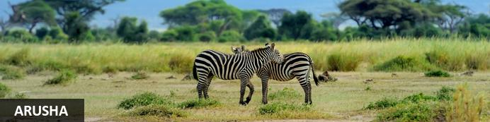
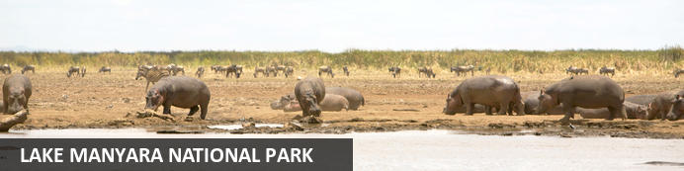
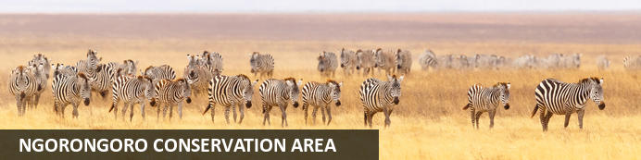
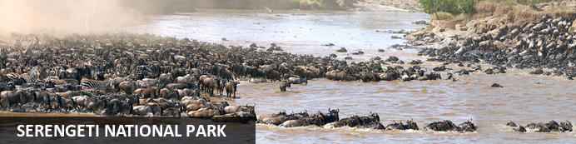
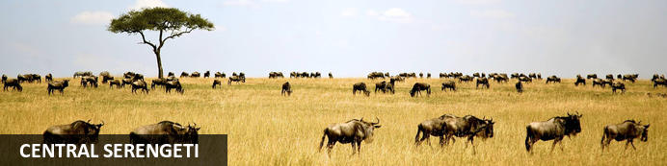

CLASSIC TANZANIA HORIZONS SAFARI
Arusha - Lake Manyara National Park - Ngorongoro Conservation Area - Serengeti National Park - Central Serengeti
7 Days / 6 Nights
Reference: CSTZ005
Date of Issue: October 13, 2022

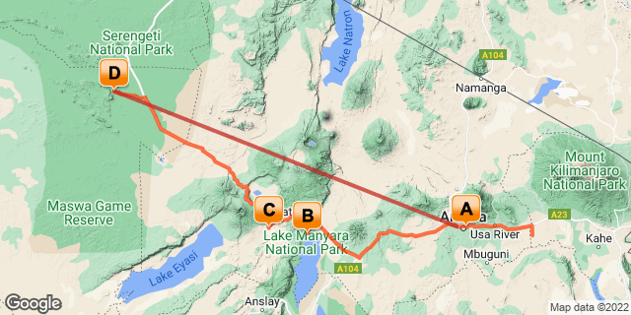

Click here to view your Digital Itinerary

Introduction

Start | Accommodation | Destination | Basis | Duration
Day 1 | Kibo Palace Hotel | Arusha | B&B | 1 Night
Day 2 | Lake Manyara Kilimamoja Lodge | Lake Manyara National Park | FB | 1 Night
Day 3 | Ngorongoro Oldeani Mountain Lodge | Ngorongoro Conservation Area | FB | 1 Night
Day 4 | Ole Serai Luxury Camp Moru Kopjes | Serengeti National Park | FB | 3 Nights

Key
B&B: Bed and Breakfast
FB: Full Board - Dinner, Bed, Breakfast and Lunch

Price
*From US$ 3637.00Per Person Sharing
*Terms and Conditions Apply.

Included
​​​
- Accommodation as stipulated in the itinerary.
- Transportation in a chauffeur driven 4x4.
- Services of a professional English speaking driver-guide
- All game viewing drives.
- Flying Doctor’s fee.
- All park entrance fees as indicated in the itinerary.
- One way flight Serengeti – Arusha on a light Aircraft, 15 Kg baggage allowance.
- All Government taxes and levies.
- Complimentary 500 ml mineral water per person per game drive in the safari vehicle.
- All meet and greet services.
- All arrival and departure transfers.
- 24 hours stand-by contact number.
- Meals as indicated in the itinerary.
- Two-way long range high frequency radio communication in each vehicle.
- On safari accessories in each vehicle: - First-aid kit, wildlife books, a pair of binoculars, cool box and fire extinguisher.

Excluded
- All items of personal nature e.g. telephone call bills, fax/email bills etc.
- Tipping / Gratuities
- Extra Meals Not Included above
- International flight and departure taxes.
- Laundry services.
- Visa Fees
- Travel Insurance
- Any other item(s) not included in our itinerary.

Day 1: Kibo Palace Hotel, Arusha

Arusha
Resting at the foot of Mount Meru, the sprawling city of Arusha is known as the safari capital of northern Tanzania. It serves as an excellent base from which to explore the remarkably scenic surrounding area which includes majestic Mount Kilimanjaro, as well as the Manyara, Tarangire and Ngorongoro National Parks. Arusha is a good spot to take a day or two off from the safari circuit as it features a temperate climate and lush surrounds. Visitors can look forward to exploring the wildlife-abundant Serengeti National Park; the magnificent Arusha National Park; and taking on the challenge of climbing Mount Meru, Africa’s fifth highest mountain.

Day Itinerary
Jambo! Upon arrival at Kilimanjaro International Airport, you will be met by Classic Safaris Representative who will greet you and assist with the transfer to Kibo Palace for Overnight stay.
Overnight Stay: Kibo Palace Hotel
Meal Plan: Bed & Breakfast

Overnight: Kibo Palace Hotel
When Kibo Palace Hotel opened its doors in 2006, it brought a breath of fresh air and set the pace in hotel standards offering fine cuisine and highest level of professionalism in Arusha. Since then, it has been recognized in various forums. The hotel has hosted important events and continues to accommodate international, regional and local dignitaries, politicians and renowned businessmen and women as well as those coming to visit our beautiful parks. We are very proud of our hotel both for it’s beautiful architectural design, ambiance and the service we provide to match.
The Kibo Palace Hotel enjoys a prime location close to The Arusha International Conferencing Centre, The United Nations and the East African Community Headquarters. Arusha is the gateway to the famous Ngorongoro Crater, Mt. Kilimanjaro, Serengeti National Park, Tarangire, Arusha and Lake Manyara National Parks.
The hotel has 77well appointed luxury rooms and suites with all modern amenities. The Chef and his team serve delectable cuisine and mouth watering desserts that are a favourite for many at our Kilimanjaro Restaurant and Poolside. The hotel’s banqueting services are the perfect choice for any Event Manager as they are hassle free.
Other Services
- Forex Bureau and business centre that is open from 07.00 a.m. to 10.00 p.m.
- 24 hour room service at a nominal fee
- Laundry and Dry Cleaning facilities at nominal fee
- Complimentary Wi-Fi
- Jewellery Shop
- Airport pick up and drop off services
- Outside Catering
- Conference and Event Management
- Day trips and Safaris to our game parks
Hotel Activities
Wednesday
Happy Hour from 06.00 p.m. to 08.00 p.m.
Enjoy soothing music at the Pool Side and Tropical Garden
Thursday
Corporate Networking Night from 06.30 p.m. to 09.00 p.m. Every First Thursday of the month with a guest speaker. Great networking opportunity and entertainment.
Friday
African Buffet Dinner at our Kilimanjaro Restaurant from 07.00 p.m.
Live Band at the Pool Side
Saturday
Relax with soothing Ballards at the pool side and tropical garden
Sunday
Swahili Brunch from 06.30 a.m. to 11.00 a.m.
Buffet lunch with complimentary swimming for kids
Live entertainment at the pool side
Share your experience of your stay with us on Trip Advisor and interact with us on Facebook and Twitter.
Our Sales and Marketing Team (Charity, Patricia or Faraja) will be happy to assist you should you require more information on our services on sm@kibopalacehotel.com or sales@kibopalacehotel.com and www.kibopalacehotel.com
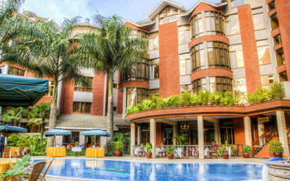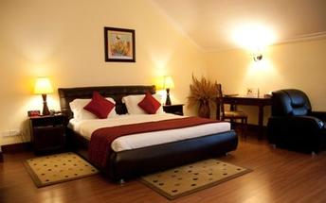

Basis
Bed and Breakfast

Included
Bed & Breakfast

Day 2: Lake Manyara Kilimamoja Lodge, Lake Manyara National Park

Lake Manyara National Park
Situated in Tanzania’s central-northern region with the Lake Manyara to its east and the Manyara Escarpment to its west, the Lake Manyara National Park offers breathtaking views and a large variety of habitats supporting an array of wildlife. This small park is home to surprising biodiversity and features a magnificent landscape of acacia woodlands, forests, baobab strewn cliffs, algae-streaked hot springs, swamps and the lake itself. The park supports over 400 species of bird and the largest concentration of baboons anywhere in the world. Other species to spot include giraffes, zebras, wildebeest, impala, waterbuck, warthog, the Cape clawless otter, and the Egyptian mongoose. Don’t miss the opportunity to see thousands of flamingos on the lake, the renowned tree-climbing lions, and large families of elephants strolling through the forest.

Day Itinerary
After Breakfast, depart to the beautiful Lake Manyara a shallow alkaline lake that shimmers in a cleft in the Great Rift Valley. You will arrive for lunch at your lodge followed by an afternoon game drive. Animals found here includes elephant, buffalo, hippo, lion, leopard, occasional cheetah and giraffe. Lions here have opted to rest up during the heat of midday in trees, giving Manyara lions somehow different behavior.
Later as the sun sets, you will be transferred back to your lodge
Dinner and overnight stay Lake Manyara Kilimamoja Lodge.
Meal Plan: Full Board

Overnight: Lake Manyara Kilimamoja Lodge View iBrochure
Lake Manyara Kilimamoja Lodge is nestled on the rim of the Great African Rift Valley with stunning views of Lake Manyara, Mount Meru and on a clear day, Mount Kilimanjaro.
The lodge is situated in lush green gardens and local vegetation with over 130 species of bird. It offers an ideal place in which to base a northern safari experience. The Ngorongoro Crater, Oldeani, Lake Eyasi, Lake Manyara and the Ngorongoro Highlands are just a short drive away from the lodge. Sitting around the outside fireplace watching the sun setting over the Great Rift Valley and listening to the humming of the birds in the background is a fitting way to end the day, and preparing for a sumptuous dinner feast.
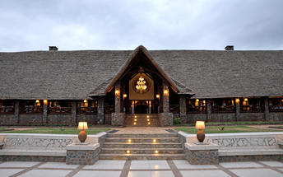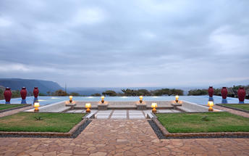

Basis
Full Board - Dinner, Bed, Breakfast and Lunch

Day 3: Ngorongoro Oldeani Mountain Lodge, Ngorongoro Conservation Area

Ngorongoro Conservation Area
Situated in the Crater Highlands in Northern Tanzania, the Ngorongoro Conservation Area is best known for its archaeological and geological significance, rich wildlife, and beautiful scenery. The conservation area encompasses the famous Crater, the renowned Olduvai Gorge and vast plains of grasslands, forests and mountains extending to the Serengeti. This 8000-square-kilometre protected area is recognised for its natural beauty and has been placed on the UNESCO World Heritage List. Visitors flock here to soak up the spectacular views of the Ngorongoro Crater, voted as one of the Seven Natural Wonders of Africa, it is famed for its natural beauty and abundant wildlife. Popular activities include: mountain biking, hiking, game drives, bush walks, and visiting a local Maasai village.

Day Itinerary
Early this morning, Descend into the 8th Wonder of the World, a unique biosphere that has remained virtually unchanged since the dawn of time. Enclosed within its towering walss are grasslands, forests, saltpans, a fresh water lake and a glorious variety of birdlife. Here too are all the members of the 'Big Five' (Lion, Rhino, elephant, Leopard and Buffalo) as well as a large cast of plains game and one of Africa's densest populations of predators. Enjoy a picnic lunch on the crater floor before climbing back up to the lodge in time for relaxation before dinner.
Dinner and overnight stay at Ngorongoro Oldeani Mountain Lodge
Meal Plan: Full Board

Overnight: Ngorongoro Oldeani Mountain Lodge View iBrochure
O'ldeani Ngorongoro Mountain Lodge is a colonial lodge situated on a picturesque hill with spectacular views of Oldeani Mountain and the Ngorongoro Crater Rim. The lodge is elevated, featuring spectacular views that extend all the way to Lake Eyasi and Lake Manyara.
The property is set on 40 acres of lush green gardens and local vegetation, with over 130 species of birds. The lodge is accessed over a pond and one's first impression is the grand central hallway with wooden trusses looking out over the fireplace, infinity pool and out to Mount O'ldeani, which is part of the caldera of the Ngorongoro crater, only 12 km away.
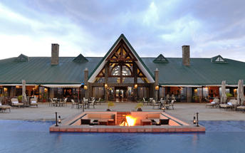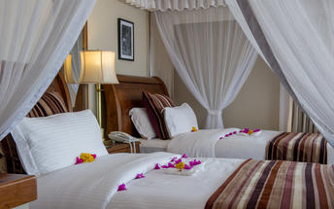

Basis
Full Board - Dinner, Bed, Breakfast and Lunch

Day 4-7: Ole Serai Luxury Camp Moru Kopjes, Serengeti National Park

Serengeti National Park
The Serengeti, together with Kenya’s Masai Mara Game Park, constitute Africa's most famous wildlife park, spread over the enthralling landscapes of northern Tanzania. This is a precious ecosystem, supporting the annual wildebeest migration through the Serengeti and the Masai Mara. The largest mass movement of land mammals on the planet involves more than a million animals following the rains, including more than 1.5 million white-bearded wildebeest and 250 000 zebras. Prides of lions, as well as groups of elephants, giraffes, gazelles, and eland, roam among the photogenic vast grass plains between weird-and-wonderful-looking acacia trees. Aside from traditional vehicle safaris, hot-air ballooning over the Serengeti plains and horse riding safaris are on offer.

Day Itinerary
Drive to Serengeti National Park. You will have 3 days of game drives in this Park. Serengeti National Park is a World Heritage Site teeming with wildlife: over 2 million ungulates, 4000 lions, 1000 leopard, 550 cheetahs and some 500 bird species inhabit an area close to 15,000 square kilometers in size. Join us on a safari and explore the endless Serengeti plains dotted with trees and kopjes from which majestic lions control their kingdom; gaze upon the Great Migration in awe or find an elusive leopard in a riverine forest. Or perhaps see everything from a bird’s-eye view and soar over the plains at sunrise during a hot air balloon safari.
All meals and Overnight Stay at Ole Serai Luxury Camp - Moru Kopjes
Meal Plan: Full Board.

Overnight: Ole Serai Luxury Camp Moru Kopjes View iBrochure
This Luxury Camp is ideally located within Central Seronera area of the famous Serengeti National Park in Tanzania around the vicinity of the famous Moru Kopjes and Lake Magadi.
The Camp site is perched between the Rongai Hills & Nyaroboro Hills, a few metres away from the banks of the Mbalageti / Seronera River having an abundant variety of resident wildlife (including all the Big 5) as well as a Hippo Pool located only a few metres away from the camp.
Due to the Campsite’s ideal location, the great spectacle of the world-famous Annual Migration can be witnessed almost as close as to the camp’s doorsteps – since the site lies along one of the main migratory corridors/routes which the wildebeest use during their Great Migration going to and fro the North and South of the Serengeti.
The Rooms and the Guest areas have been specifically designed to offer the Guests an optimum 180-degree view while on their bed or while enjoying their meal or drinks and to bring them as close to the nature as possible from the covered verandas. These stunning views embrace
the sparsely spaced Acacia Tortillas Trees with the abundance of animals in the vicinity making the experience awe-inspiring.
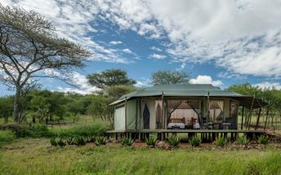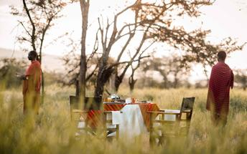

Optional
WALKING SAFARIS
APERITIFS AND COCKTAILS AT THE BONFIRE
SWAHILI LESSON
STAR GAZING
STORY TELLING AROUND THE FIRE PLACE
CULTURAL ACTIVITIES
SPECIAL ARRANGEMENT FOR THE HONEY MOONERS
BUSH DINNER
BUSH LUNCH
BUSH BREAKFAST

WALKING SAFARIS
The walking safaris starts from the boma towards Rongai river which is about 150 meters from the lodge, this walking safaris is called short walk of about 1 to 2 hours. During the walking safaris you will be introduced about the nature of plants and animals that are dominating around this area including Acacia tortillas, birds, hippos and hippo pool and the root of migration which is exactly in front of the lodge and destination for the lion’s birth.
The safari will be led by our professional guide with armed ranger along the River towards the plain areas to learn more on Acacia trees, whistling thorn and umbrella trees which are dominating in Rongai, this walking safari will be accompanied by a lot of wild animal sounds around the river including Thompson, water buck and a nice melody of birds and jackals.
The walking safaris normally start at 7.00Am to 9.00Am or 4.00pm to 6.00pm. These hours are recommended mostly because the animals surrounding these areas are very visible and not arrogant during this time due to avoid devastation of water and sun
After one or two hours walking safaris you will be well come by a chilled complimentary glass of amarula in our boma

APERITIFS AND COCKTAILS AT THE BONFIRE
Our Serengeti bar tender will provide varieties of the local cocktails including Serengeti blues, Serengeti sunset at the fire place with a finger bite snacks

SWAHILI LESSON
The Swahili phrase, HAKUNA MATATA, meaning (No Trouble) was made famous by lion king Disney movie. Learn Swahili words with our resident teachers who will give you a one on one lesson every evening at the fire place

STAR GAZING
On a clear night standing under the sky is like having a blankets star surrounds
These are the same stars that guide the Masai Nomads to greener areas for their livestock. However, the best viewing of constellation can be seen from the boma. Grab a night cap and join us outside under the African sky.

STORY TELLING AROUND THE FIRE PLACE
Play and traditional stories told around the fire place

CULTURAL ACTIVITIES
This is taught by a traditional Massai and cover the lifestyle of the locals including fire making lessons traditional dancing and singing as well historical background on livestock

SPECIAL ARRANGEMENT FOR THE HONEY MOONERS
Hide away table for dinner under the umbrella tree with candle lit, special natural flowers on the table and bed with a chilled bottle of sparkling wine, including masai fire lights

BUSH DINNER
Located around the hippo pool under the umbrella tree facing at the Hippos with traditional Massai fire lighting, mostly BBQ Dinner recommended

BUSH LUNCH
Delicious bbq bush lunch located at (MAWE MEUPE) 15km from the lodge, and the area is well covered by the white stones and umbrella trees as well as long range of an endless plains of Serengeti.

BUSH BREAKFAST
Located around the hippo pool under the umbrella tree facing at the Hippos instrumented along with birds’ melody

Basis
Full Board - Dinner, Bed, Breakfast and Lunch

Day 7: End of Itinerary

Day Itinerary
Bid farewell to the Serengeti as you are transferred to the airstrip for your morning flight to Arusha. You will be met and transferred to Arusha Coffee Lodge where a day room has been resreved for you until 1800hrs. Later you will be escorted to the airport for your departure flight back home.

Basis
Full Board - Dinner, Bed, Breakfast and Lunch

Transport

Flight Information
Date | Flight | Airline | Departure Airport | Time | Arrival Airport | Time | Class | Ref
 | Scheduled |  | Ole Serai Luxury Camp Moru Kopjes |  | Elewana Arusha Coffee Lodge

Transfers
Date | Company | Pick Up | Drop Off | Time | Vehicle
 |  | Kilimanjaro International Airport [JRO] | Kibo Palace Hotel |  | Transfer
 |  | Kibo Palace Hotel | Lake Manyara Kilimamoja Lodge |  | Transfer
 |  | Lake Manyara Kilimamoja Lodge | Ngorongoro Oldeani Mountain Lodge |  | Transfer
 |  | Ngorongoro Oldeani Mountain Lodge | Ole Serai Luxury Camp Moru Kopjes |  | Transfer

Urgent Contact Numbers
Company Name | Telephone | Email Address | Contact Person
CLASSIC SAFARIS LTD | +254 716 269009/255 | sylvia@classicsafaris.co.ke | Sylvia

Service Provider Directory
Service Provider | Ref. Number | Telephone | Address
Elewana Arusha Coffee Lodge |  | +255 784 250 630 | Sopa Plaza, 99 Serengeti Road,  P. O. Box 12814, Arusha, Tanzania
Kibo Palace Hotel |  | +255 27 297 0163 | Old Moshi Road,  Arusha  Tanzania
Lake Manyara Kilimamoja Lodge |  | +255 688 058 365 | Lake Manyara Kilimamoja Village, Manyara
Ngorongoro Oldeani Mountain Lodge |  | +255 688 058 365 | Njia Panda, Changarawe, Karatu, Tanzania
Ole Serai Luxury Camp Moru Kopjes |  | +255 688 058 365 | Seronera, Central Serengeti National Park

Travel Information
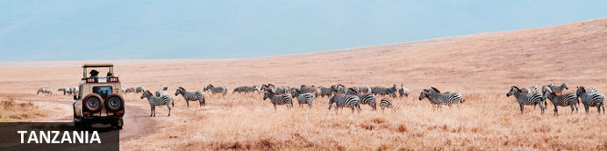
The name Tanzania conjures up images of wildebeest stampeding across vast savannah, rain forests teeming with monkeys and birdlife, and great plains brimming with legions of game. All of these natural wonders and more are on offer in this exceptionally diverse African nation. Visitors typically visit Tanzania to partake in at least one of the four well known Tanzanian tourist experiences: a relaxing seaside vacation on the picturesque island paradise of Zanzibar, an underwater tour of some of the world’s most renowned dive sites around the gorgeous Spice Islands, a safari adventure in some of Africa’s most impressive game reserves, or a hiking excursion around Mount Kilimanjaro National Park. Whichever of these incredible holidays you choose, you will undoubtedly be welcomed by some fabulously friendly and peaceful inhabitants who, despite being divided into 120 different ethnic groups and cultures, live in harmony with one another and provide some of the most wonderfully exotic local cuisine you could imagine. With all of this diversity on offer, the most difficult part of your Tanzanian holiday experience is likely to be deciding where to go!

Entry Requirements
ENTRY REQUIREMENTS AND VISA INFORMATION
Countries eligible for Visas and Fee rates
Visa Issuing Centers
Countries which require Referral Visa before coming to Tanzania
ENTRY REQUIREMENTS:
Any foreigner seeking to enter the United Republic of Tanzania is subject to the following entry requirements:
a passport or Travel Document which is valid for not less than six months issued by a State or an International Organization recognized by the Government of the United Republic of Tanzania and
that, he is a holder of or his name is endorsed upon a Residence Permit or a Pass issued in accordance with the provisions of the Immigration Act No. 7 of 1995; or
A valid Visa (for nationals whose country require visa) which is obtained at any Tanzania Mission abroad or on arrival at any designated entry points. Click here to see Official Entry Points
Note:
Upon complying with the entry requirements, a bonafide visitor is issued with a Visitor's Pass on arrival at the entry point into the United Republic of Tanzania for a validity not exceeding three months in first instance (and not exceeding six months for citizens of East African Community), provided that he is in possession of sufficient funds for subsistence while in the United Republic of Tanzania and a Return ticket or onward to ticket to his country of origin, domicile or destination as the case may be.
VISA INFORMATION
Purpose of Visa
A Visa is a permission granted to a foreigner other than a prohibited Immigrant (please click here to see the list of countries whose nationals require visa) to enter and remain in the United Republic of Tanzania for the purpose of visit, leisure, holiday, business, health treatment, studies, or any other activity which is not illegal under the Laws of the United Republic of Tanzania.
Note:
It should be noted that the possession of Visa is not a final authority to enter the United Republic of Tanzania. The Immigration Officer at the entry point may refuse such a person permission to enter if he is satisfied that he is unable to fulfill immigration entry requirements and that the presence of such person/visitor in the United Republic of Tanzania would be contrary to the national interests.
CATEGORIES OF VISAS
There are five categories of Visas which may be granted to foreigners other than prohibited immigrants who seek to enter the United Republic of Tanzania as follows:
Ordinary Visa
Transit Visa
Multiple Entry Visa
Gratis Visa
Referral Visa
ORDINARY VISA
This is a Visa granted to foreigners other than prohibited immigrants seeking to enter the United Republic of Tanzania upon application for the purpose of visit, leisure, holiday, business, health treatment, studies, or any other activity legally recognized by the Laws of the United Republic of Tanzania for validity not exceeding three months for a single entry only.
TRANSIT VISA
This is a Visa granted to foreigners other than prohibited immigrants intending to pass through the United Republic of Tanzania to other destinations for a period not exceeding fourteen days provided that such persons should have onward tickets, sufficient fund for subsistence while in the United Republic of Tanzania and an entry Visa to the country of destination (where applicable) or any other proof to satisfy that such person will be allowed entry to that other country.
MULTIPLE ENTRY VISAS
This is a Visa granted to persons who are nationals of countries which require Visa for United Republic of Tanzania and who by nature of their businesses or circumstances require making frequent visits to the United Republic of Tanzania. Multiple Visas may be issued for a period of three, six or twelve months to permit the holder to enter and re-enter subject to the validity of the visa, provided that a single stay of the holder should not exceed three months.
GRATIS VISA
This is a Visa granted to holders of Diplomatic or Official/Service Passports when travelling on official missions to the United Republic of Tanzania and it is granted free of charge. In some cases Gratis Visa may be granted to holders of Ordinary Passports where an exemption has been given by the Issuing Authority.
Note:
Holders of Diplomatic and Service/Official passports when travelling on private visits into the United Republic of Tanzania are required to apply for visa like holders of ordinary passport.
REFERRAL VISA
This is a Visa granted to nationals of Countries which require a special clearance and approval from the Principal Commissioner of Immigration Services or the Commissioner of Immigration Services (Zanzibar) prior to the issuance of Visa. (Click here to see the List of Countries which requires Referral Visa).
Note:
Possession of a Visa for United Republic of Tanzania does not provide automatic right of entry for the holder into the Country. Accordingly, an Immigration Officer at the Entry Point may refuse any person regardless whether he holds a Visa or not, if he is satisfied that such a person is unable to fulfill the immigration requirements and/or that such person's/visitor's presence in the United Republic of Tanzania would be contrary to national interests.
REQUIREMENTS FOR VISA
An application of Visa for United Republic of Tanzania should be accompanied with:
application form duly filled in;
security Bond duly filled in(for Multiple Visa);
five passport size photographs (if required);
copy of the Applicant's valid Passport;
copy of the valid Passport or any other identity of the person to be visited (applicant's host if required);
documents of the Company or Business to be visited; (for Multiple Visa)
any other evidence to prove that the applicant is bound to travel frequently into the United Republic of Tanzania(for Multiple Visa)
VISA ISSUING CENTRES:
A Visa may be obtained at any United Republic of Tanzania Missions abroad or Consulates (click here to see the List of Tanzania Missions abroad) and also on arrival at all designated Entry Points. In case of Referral and Multiple Visas applicants are required to submit their applications to the office of the Principal Commissioner of Immigration Services Dar es Salaam or at the office of the Commissioner of Immigration Services Zanzibar. Click here to see Visa Issuing Centers.
VISA FEES:
Standard fee rate for Ordinary Visa is US $ 50, for Multiple Entry Visa is US $ 100 and for Transit visa is US $ 30. However a different fee may be set in accordance with the rules guiding Visa issuance or on the basis of reciprocity. Click here for more details on Visa eligibility and fee rates.
Note:
Visa fees are payable at Issuing Centers and an Exchequer Receipt should be provided for the payment made.

Banking and Currency
MONEY:
The local currency is the Kenyan shilling, and the Tanzanian shilling respectively.
1 US dollar = 2180 Tanzanian shillings (or as per current currency flactuation).
Please respect the local currency and note that it is a criminal offence in both countries to damage or tear the local currency.
Money may be changed easily at airports, hotels, banks and forex bureau. Please avoid changing money in the street with money vendors, as they are operating illegally.
It is unnecessary to carry excessive amounts of money (on safari, all meals are included, except for the drinks) and credit cards are widely accepted for payment of meals outside the meal plan, hotel extras, shopping etc
The equivalent of USD 100 per person is a guideline for exchange, as you may use your credit cards such as VISA or MASTERCARD for any additional costs, in most of the places you will visit.
Traveller´s Cheques are also a safe and simple method of payment; however you may have some problems with regard to their acceptance whilst on safari.
If at the end of the safari, you have any left over local currency, this may be changed back into dollars, at the airport.

Travel, Transport and Getting Around
If you are visiting a number of parks and reserves in Tanzania, you can either drive or fly between them. Roads in most of the wilderness areas are in poor condition and unmarked, and self-driving is not recommended. Operators will supply you with a driver who doubles as an informal guide; alternatively, you can arrange to fly to your destination and utilize a car and driver supplied by the lodgings. Elsewhere in Tanzania, towns and cities are linked by a steady stream of buses and dala-dalas (minibuses), and in the cities, there is public transport in the way of buses, dala-dalas, taxis, and, in some places, bicycles or tuk-tuks.
Precision Air run regular services, mostly via Dar es Salaam, Kilimanjaro or Zanzibar, to all main towns and other destinations in East Africa and beyond. All national parks and some of the top-end luxury lodges have airstrips and Coastal Air and Regional Air operates between these and the main airports on the mainland and the islands of Zanzibar, Pemba and Mafia. ZanAir has frequent connections between Zanzibar, Pemba and the mainland.
Driving is on the left hand side of the road

Health and Medical Information
HEALTH:
A certificate of vaccination against Yellow Fever is required. Malaria is endemic to Kenya and Tanzania, so please remember to take anti-malaria tablets. In case of any medical emergency, your hotel will have a doctor on call, or will have the medicine you may require, including the parks on safari.
All the same, please take the following precautions:
Dress in warm clothing in the evenings and at night; use repellants against mosquitoes and use insecticide sprays in rooms before sleeping (or before going for dinner). This area is right at the Equator, and the hot sun can cause sunburn very quickly- including on cloudy days.
Sun creams, lip balm, hats and sunglasses are recommended.
Although tap water in the big towns is potable, we advise you to drink mineral water always. In the hotels/ lodges during the safaris, there is always a jar/bottle/thermos of filtered water in the rooms, which is convenient for using for cleaning your teeth.
The mineral water in the hotels/ lodges has quite an elevated price. You may buy some bottled water at the local supermarkets at a more reasonable price.

Safety Notices
SECURITY:
As it is the case in most regions of the world, security is a topic that should be kept in mind. Nairobi and Mombasa are generally safe during the day, as long as narrow alleys or isolated streets are avoided. We advise you not to walk in the streets in the dark. If youwishtotravelbynight,alwayscallforataxi.
Don’t carry a lot of money with you when you go out; only the amount you think you will spend. While walking in the streets, don’t wear jewellery or valuables that bring attention to you.
Please leave all valuables (jewellery, travel documents, cameras etc) in the safes or safety deposit boxes of the hotel you are staying at.
Please don’t leave anything of value lying around your hotel room.

Food, Drink and Cuisine Advice
Most camps, lodges or hotels cater specifically to tourists and serve Western-style food, ranging in standard, but generally are excellent. Game lodges tend to offer a daily set menu with a limited selection, so it is advisable to have your tour operator specify in advance if you are a vegetarian or have other specific dietary requirements. First-time visitors to Africa might take note that most game lodges in and around the national parks have isolated locations, and driving within the parks is neither permitted nor advisable after dark, so that there is no realistic alternative to eating at your lodge.
Tap water in Tanzania is generally not safe to drink, and most travellers try to stick to mineral water. Filtered and bottled water can be difficult to find you are travelling outside of main town and so it is advisable to stock up. Most camps, lodges and hotels have bottled water readily available.

Climate and Weather
CLIMATE:
The average temperature oscillates between 25º C during the day and 10º C during the night in the interior and between 30º C and 15º C at the coast with a high level of humidity seemingly intensifying the heat.
Some of the areas that you may visit, stands at high latitiudes, for example the Ngorongoro Crater in Tanzania stand at around 2000 metres above sea level, and the nights are chillyand humid.
The rainy seasons are between April and June, and November to the middle of December. The coldest months are July and August, while the hottest are January and February.

Clothing and Dress Recommendations
It never gets really cold in Tanzania so lightweight clothing, preferably cotton or linen, is recommended. While on a game viewing safari, avoid brightly coloured clothing, stick to whites, beiges, khakis and browns. There may be long days sitting in safari vehicles, so it is advisable to wear light comfortable clothing such as short sleeved shirts and cotton/linen trousers or shorts. Denim will become too hot and extremely uncomfortable. Walking shoes and socks will be required.
The evenings will be chilly, so long sleeved shirts and trousers should be worn. A sweater may be needed. These will also prevent you being bitten by insects. A hat should be worn at all times outside. The sun may sometimes not feel hot, but it can still easily burn, especially if it is cloudy and overcast.
If on a safari or visiting Zanzibar or any coastal town don't forget to take a swimsuit. Zanzibar or any other coastal town is invariably warm. Ladies are recommended to take cotton skirts, blouses and dresses. Sandals are a must for this environment! On the beaches and within the confines of hotels, normal swimwear is acceptable but nudity is not.
As over a third of the population in Tanzania is Muslim, it is therefore not etiquette for ladies to walk around in public displaying their legs and shoulders. Remember to dress modestly as short shorts, miniskirts, vests and tank tops will be frowned upon.

Internet Availability
Tanzania has good Internet Service Providers with email and internet services offered by many hotels and lodges (free / paid). In most towns there are plenty of private business centres and cyber cafes offering email and internet access, although the speeds might be somewhat slower than what you are used to.

Electricity and Plug Standards
ELECTRICITY:
Most hotels use generators which function only in the morning, and at night. We use 240 volts and plugs with three spokes (UK). An adapter is all that you will need and are mostly available at the hotel receptions if you forget to carry one. A small deposit is required as security when you borrow the transformer, which is refundable.

General Guidance
IT IS CONVENIENT TO TRAVEL LIGHT:
The safari vehicles do not have a lot of luggage capacity and for this reason, we recommend soft, light luggage. In any hotel with a stay of 2 days or more, laundry service is available.
WE RECOMMEND YOU CARRY:
Binoculars (INDISPENSABLE).
Many more rolls of film than what you thought enough! up to 100 Photos per day during the safari. (It
doesn’t weigh much, and could be slightly more expensive here).
A torch.
Insect repellant.
Lip balms and sun creams.
Coloured biro pens, pencils, pictures, small books, balloons, etc. to give out as presents in case you visit a local village (they are more appropriate than sweets, and are more appreciated).
Disposable lighters, caps, scarves, T-shirts, etc. as “barter material” in souvenir shops (although in actuality, no “barter” without some money changing hands, exists!).
Waist pouches for carrying money, passports and small valuables are very practical.
DON’T CARRY:
Your gold Communion medal, diamonds, Grandmother’s pearls, gold watches, $200 sunglasses, etc.
In other words, carry things that will not be sorely missed in case of loss.
TIPPING:
Most people, when visiting a foreign country, like to be given some guideline regarding tipping. Yet, this is truly voluntary and extremely personal matter. A tip is an indication of appreciation on the part of the guest for the services given and ISONLYGIVENWHENTHESERVICEWASUPTOYOUREXPECTATIONS, and is paid after all the services have been completed, and is NEVEROBLIGATORY. A guideline for each traveler follows below:-
Restaurants: These guidelines are for lunches and dinners you may enjoy on your own, which are not included in your itinerary. If the menu says 10% service charge included, you do not need to tip. Otherwise, between 5 and 10 % of the total bill is considered usual and customary.
Hotels’Camps’& Lodges’staff: 2 – 5 dollars per person per day.
SafaridriverandGuide: Ever since the early days of safari-ing, driver-guide and naturalist/tour guide in Africa have had their expert bush skills acknowledged in form of tips. We recommend 5 – 10 dollars per person per day, but this is entirely at your own discretion.
ArrivalTransfer: 5 dollars per person per day.
COMMUNICATIONS:
Communication is as sophisticated here as it is in Europe or the States, but it is however more expensive. It is possible to make international calls from most of the hotels, but the price is between USD 7- 10 per minute, for a minimum of 3 minutes. It is mostly automatically billed.
However in the era of smart phones and what's app, as long you have internet - which is now available in most camps and lodges, communication is cheap and easy.
MobilePhones: The mobile network coverage in Tanzania is no longer limited. Right now there is network almost in all the safari circuit areas. Just incase your cell phone provider has roaming contract with some of the few providers in Tanzania (Which mostly is the case); most of the places have network coverage including in the parks and all the cities.
SHOPPING:
Numerous shops and stalls selling a variety of souvenirs can be found in the towns and en route during the safaris. You can buy both traditional and modern jewellery, wood carvings, sculptures, soapstone figures, baskets and bags, safari attire, articles made from banana fibre, khangas and kikois
(khangas are the colourful wraps worn by women especially at the coast and in the countryside, while kikois are the wraps worn by men at the coast), precious stones like Tanzanite (violet/blue), semi precious stones such as green Tsavorite, Tiger Eye and Malachite etc
It is important to bargain in most of the shops for a better price.
We also have some small “markets”, where you can not only enjoy the hectic atmosphere but also find all types of arts and cratfs for sale. This market is open air, operating at designated areas and are through out the week (please ask your guide for a recommendation).
Most hotels also have gift shops that sell souvenirs, T-shirts etc
In case you happen to purchase items of African craft while on safari and you decide you want the purchased items to be send to your home country, please make sure you clarify and confirm that the entire shipping costs are included in your invoice just to avoid any inconveniences upon delivery. Mostly, the shipping charges are normally done at the destination airport so as to be able to go through customs inspections and formalities. Kindly note that we take our clients to shopping areas that are highly recommendable for shopping, however Classic Safaris will not be held responsible for any damages caused during the shipping period of the said items. At the same time, the company shall not be held responsible for the non-sending of the purchased items to the agreed destination and will not accept any responsibility for shipment or customs charges.
SHOPPING HOURS:
Shopping hours are from 0830hrs to 1230hrs and 1400hrs to 1700hrs. Mondays to Fridays and from 0830hrs to 1300hrs on Saturdays. The bigger supermarkets do not shut over lunchtime.
WILDLIFE, NATIONAL PARKS:
Please refrain from disturbing or feeding the animals in the parks. It is dangerous to try to touch them- they ARE wild. Please stay in the vehicle during game drives in the park.
It is prohibited to sit on top of the vehicles, even while they are stationary.
REGISTRATION AND HOTEL CHECK OUTS:
On arrival, you will fill in a registration card at the reception in order to obtain the room key. Roomoccupancyisonlyguaranteedafter1100hrs,andoncheckoutmustbedoneby1000hrsor1800hrs,ifyouhavecontractedadayroom.
Extras bills will be paid at the reception. When this is cleared and the room key has been handed in, you will receive a luggage ticket which allows your luggage to leave the hotel, as it indicates all bills and outstanding matters have been cleared.

Terms and Conditions

CLASSIC SAFARIS LTD Terms and Conditions
CLASSIC SAFARIS LTD TERMS & CONDITIONS AGREEMENT
Classic Safaris Ltd Inclusions & Exclusions
Inclusions:
Accommodation in carefully selected properties in all East African countries as per the itineraries.
Transport in 4 X 4 Land cruisers or comfortable safari minibus, driven by a naturalist driver/guide.Multi lingual driver guides can also be provided.
Two ½ size bottles of mineral water each day for each guest while on safari.
All meals while on safari as per the itineraries.
All park entry fees as per itineraries.
All transfers as indicated in the itineraries.
Exclusions:
International flights
Things of personal nature and any other service not included in the itinerary
Passport and visa fees and service charges for obtaining visas.
Personal and baggage insurance.
Cost for anything not specifically mentioned in the listing above.
Laundry, beer and non luxurious spirits
How to Book:
Send a non-refundable deposit of 30% of the total tour cost. On receipt of your deposit, subject to availability terms, we will reserve a place on your selected safari.
Final Payment
Final payment is due one month prior to departure. Costs of gratuities to driver guides, lodge/hotel staff, as well as any excursion not related to the safari, and other items of personal nature are not included.
Cancellation & No Show
Reservations/Bookings that are cancelled, reduced in length of stay or reduced in numbers of participants (hereinafter collectively called CANCELLATION) are subject to cancellation and No Show fees. The scale of charges, expressed as a percentage of the tour prices, is as follows:
More than 8 week notice: - Deposit refunded less 5% handling fee
8 weeks – 4 week notice: - 50%
Less than 3 week notice: - 60%
Less than 2 week notice:- 90%
Less than 1 week notice:- 100%
Should you fail to join a tour or join it after departure or leave prior to its completion, no tour fare refund can be made. (Please note that if the reason for the cancellation falls within the terms of any holiday insurance policy, which you hold, then the insurance company, subject to the terms of your insurance will normally refund any such charges to you).
Accommodation Substitution:
Should the case arise whereby accommodation is not available at the quoted hotels/Lodges/Tented camps alternative accommodation will be provided at hotels/lodges/tented camps of similar caliber.
Refund:
Whilst the company uses its best endeavors to ensure that all anticipated accommodation is available as planned, there shall be no claim of any nature whatsoever against the company for a refund either in whole or part, if any accommodation or excursion is unavailable, or the passenger was unable to use this service.
Diet:
Guests with special dietary requirements are advised to warn us well in advance before your departure.
Luggage:
Please keep your luggage light – soft duffel bags are preferable. Luggage is limited to 15kg per person on internal local flights.
Passport and visas:
The onus is upon the client to ensure that passport and visas are valid for the countries listed. The company, its staff and its agents cannot be held liable for any visas etc. not held by the clients.
Photography:
The company reserves the right without further notice to make use of any photography or film taken on safari by our staff for general purposes without payment or permission.
Check-in and Check-out times:
Rooms are available for check in at 1200 Noon on the scheduled arrival date. Rooms should be vacated by 1000Hrs on the scheduled departure date. Special consideration may be extended on departure time subject to anticipated arrivals.
Changes to Schedule:
Although every effort is made to adhere to schedules it should be borne in mind that the Company reserves the right, and in fact is obliged, to occasionally change routes and accommodations on safaris as dictated by changing conditions. Such conditions may be brought by force majeure” or statutory directive, seasonal rainfall on bush tracks, airfields and game areas, or game migrations from region to another or reservation problems, etc. However, the company shall make all reasonable efforts in resolving the situation not limited to offering alternative
Airline Clause:
Flight fares, taxes and schedules are subject to change without prior notification by the airlines. The company will not be held liable for these changes and delays. The airlines cannot be held liable for
act, omission or event during the time the passengers are not on board their plane or conveyance. The passengers’ tickets in use by the airline or by other carriers concerned when issued, shall constitute a sole contract between the airline and the purchaser of these tickets and or passengers. Please note that the company subcontracts the flying services to independent charter operations, and they are responsible for the flying. The same will apply to train services.
Guide Substitution:
If one of our guides is unable to take a safari due to illness or other reasons, we reserve the right to substitute with another guide.
Prices:
We will do our outmost to keep the prices as quoted or published. Should fluctuation in statutory taxes, exchange rates, etc. force increases on us; we reserve the right to surcharge without notice, up to maximum of 10% of the tour rate.
Participant Incompatibilit:
The company may, at its discretion and without liability of its cost to itself, at any time cancel or terminate the passengers booking and in particular without limiting the generality of the forgoing, it shall be entitled to do in the event of illness or illegal or incompatible behaviour of the passenger, who shall in such circumstances not be entitled to any refund.
Publicity Materials:
The company reserves the right to use any photograph or film taken during the safari by any appointed representative of The Company, for the use in The Company’s advertising or publicity material, without obtaining further consent from the client prior to the departure of the client’s appointed safari
Fitness:
The client acknowledges that the safari can sometimes be demanding and it’s his/her responsibility to ensure that he/she is sufficiently fit and able to embark on the tour.
Authority of the Safari Leader:
Clients will accept the authority and decisions of the safari leader appointed by the Company. The final decision on the itinerary, accommodation and conduct on the safari will be taken by the safari leader appointed by the Company.
Liability:
The company is insured against legal liabilities arising from any injuries which might be received by passengers in its vehicles. The Company’s liability to passengers carried in its vehicles is governed by the laws of Kenya and no other Country, and all claims subject to the jurisdiction of the courts of Kenya.
The Company reserves the right to employ sub-contractors to carry out all or part of the Services agreed to be supplied and in the event of the exercise of such right the terms of clause relating to The Company is subject to the booking conditions and cancellation provisions of the Travel organizer or the airline concerned.
Neither the Company, nor any person acting for, through or on behalf of The Company shall be liable for any loss or damage whatsoever and without restricting the generality of errors or omission
contained in the brochure or other literature, late or non-confirmations or acceptance of bookings, loss or damage caused by delays, sickness or death whether occasioned by the negligence or not.
In addition, The Company shall have the right at any time at its discretion to cancel any tour or the reminder thereof or make alteration on route, accommodation, price or other details and in the event of any tour being rendered impossible, illegal or inadvisable by the weather, avalanches, strike, war, government or interference or any other cause whatsoever. The extra expense incurred as a result thereof shall be the responsibility of the passenger.
Please be aware that these safaris may take you into close contact with wild animals. Attacks by wild animals are rare, but no safari into the African Wilderness can guarantee that this will not occur. Neither the company, nor its employees, nor its agents can be held responsible for any injury or incident on the safari.
Governing Law:
All terms and conditions of this agreement shall be governed by and construed in accordance to the laws of Kenya, and any litigation necessary to resolve disputes between the parties shall be field in the courts located in Kenya where such a dispute cannot be solved through arbitration.

