The Best of Sri Lanka

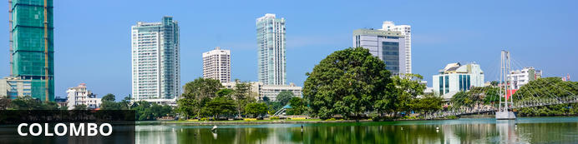
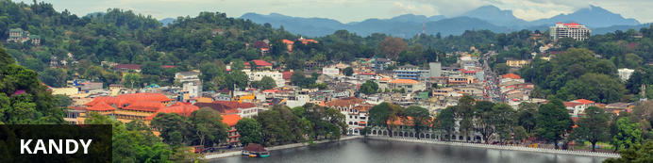
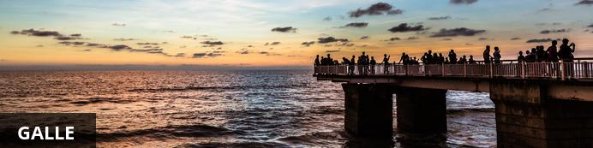

Belchers

The Best of Sri Lanka
Colombo - Kandy - Galle
10 Days / 9 Nights
2 Persons
Date of Issue: 10 April 2018
14 June 2019 - 23 June 2019

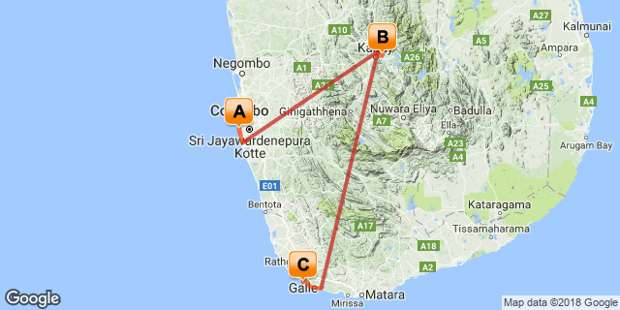

Click here to view your Digital Itinerary

Introduction
This 10 day vacation in Sri Lanka will leave you wanting more. Start your holiday off with 3 nights in Colombo, staying at Casa Colombo where you will explore the city and the night life, should you desire it. Your next destination will be Kandy, where you will spend 3 nights at The Kandy House with a range of activities to keep you busy. Yuor final stop will be in Galle, at the Galle Fort Hotel with a fully inclusive stay. These final days will be spent at your leisure.
PLEASE NOTE THAT THIS IS JUST A SAMPLE ITINERARY TO SHOW YOU WHAT IS POSSIBLE WITH WETU

Accommodation | Destination | Nights | Basis | Room Type
Casa Colombo | Colombo | 3 | B&B
The Kandy House | Kandy | 3
Galle Fort Hotel | Galle | 3 | FB

Key
B&B: Bed and breakfast
FB: Dinner, bed, breakfast and lunch

Price
Price starting at $1234

Included
Services of professional English-speaking guides and staff
Comprehensive trip preparation
3 nights at Casa Colombo
3 nights at The Kandy House
3 nights at Galle Fort Hotel
Softdrinks at all accommodations

Excluded
Items of personal nature
Beverages at accommodations excluded unless otherwise stated
Travel insurance
Gratuities
Excess baggage fees
Airport departure taxes
Passport and visa fees
International airfare (available upon request)

Additional Information

Day 1: Casa Colombo, Colombo (Fri, 14 June)

Colombo
Sri Lanka’s seaside metropolis offers a laid back atmosphere coupled with a mixture of crumbling colonial buildings and glinting skyscrapers. Stroll to Pettah, Colombo’s main market and be dazzled by the variety of gems, the brightly coloured fruit and vegetable stalls and the plethora of ayurvedic medicines on offer. Sample some of the city’s fine fare, from curries to crabs, in any one of the beachfront bistros or inner city dining rooms. Nature lovers should head to Galle Face Green, a grassy promenade along the Indian Ocean for a stroll or take a scenic train ride to Mount Lavinia beach.

Day Itinerary
Your fist stop in Sri Lanka will be at Ratmalana Airport in Colombo where you will be collected ans transfered to your accommodation, Casa Colombo. Your first day in Colombo will include a visit to Colombo Harbour to see the boats, after which you will be taken back to your hotel for the remainder of the evening. You are welcome to explore the city or the night life but tomorrow will be full of activities.

Consultant Notes
No Notes Available

Overnight: Casa Colombo View iBrochure
Casa Colombo is a 12 suite Retro-chic boutique hotel in Colombo that blends a contemporary designer style with the charms of a magnificent 200 year old Moorish mansion.
Built by one of the wealthiest Indian trading families at the time, the mansion is adorned with acres of Italian and Indian mosaic floors, carved arches, moulded ceilings and Moorish styled balconies, and are one of the few remaining treasures of its era. A significant part of creating this amazing boutique hotel in Colombo involved restoring the building back to its former grandeur.
Located in Bambalapitiya in Colombo 4, it is in the heart of Colombo’s business district, however as it’s neatly cosseted away from the busy Galle Road by its own cul de sac, it is a gated and very private hotel, which is known and recognised as one of the finest boutique hotels for your holidays in Sri Lanka.
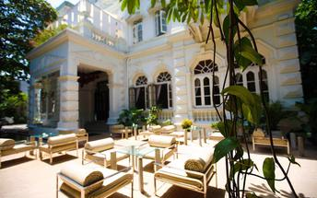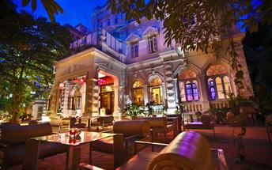

Activities
Colombo Harbour

Optional

Recommended

Colombo Harbour
No Description Available

Included
Bed & Breakfast

Excluded
Excluded Not Available

Day 2: Casa Colombo, Colombo (Sat, 15 June)

Day Itinerary
After breakfast today, you will be collected at reception at 11am and taken around the city with a day full of activities. The first stop of the day will be at Kelaniya Temple, where you will have a guided tour. The next stop for the day will be at St. Lucia's Cathedral for a short while before stopping off for lunch somewhere in town. After lunch you will head towards Slave Island for your final activity for the day before heading back to the hotel.

Consultant Notes
No Notes Available

Activities
Kelaniya Temple
St. Lucia's Cathedral
Slave Island

Optional

Recommended

Kelaniya Temple
No Description Available

St. Lucia's Cathedral
No Description Available

Slave Island
No Description Available

Included
Breakfast
Transfers
Cover charges

Excluded
Lunch
Evening activities
Souvenirs

Day 3: Casa Colombo, Colombo (Sun, 16 June)

Day Itinerary
On your third day in Colombo, you will have a day of leisure. There is still a wide variety of sights and attractions to see around the city and there is a guide available upon request. For the golfers, you can visit Royal Colombo Golf Club, otherwise if shopping is what you would like to do, Colombo Racecourse Mall is also available.

Consultant Notes
No Notes Available

Activities
Royal Colombo Golf Club

Optional

Recommended

Royal Colombo Golf Club
No Description Available

Included
Bed & Breakfast

Excluded
Excluded Not Available

Day 4: The Kandy House, Kandy (Mon, 17 June)

Kandy
The second major city in Sri Lanka (the other being Colombo) lies in the midst of the Kandy Plateau, an area of tropical tea plantations. A prominent feature is Kandy Lake, to the north of which lies the golden-roofed Temple of The Tooth, a UNESCO World Heritage Site and important place for Buddhist worship, as it is said to house a tooth relic of Buddha. Other fascinating places include the Ceylon Tea Museum, the Buddhist Publication Society, the Ayurvedic centre in the Amaya Hills nearby, the Kandyan Art Association and Cultural Centre, where crafts people can be seen at work, and the Kandy Muslim Hotel, which offers the finest spiced curries served with naan or rotis.

Day Itinerary
After your final breakfast in Colombo you will be collected at reception and taken to Ratmalana Airport for your flight to Polgolla Reservoir Airport where you will be picked up and transfered to The Kandy House for your next 3 nights. The flight to Kandy will be short and lunch will be served at The Kandy House upon arrival. The evening can be spent at your leisure.

Consultant Notes
No Notes Available

Overnight: The Kandy House View iBrochure
The Kandy House is a nine-room, 200-year-old manor house which was built by the last Chief Minister of the Kandyan Kingdom in 1804. It was fully restored and opened in 2005 as an upmarket boutique hotel, situated 20 minutes from Kandy. With only 9 bedrooms, the aim is to give guests an experience of staying more in a private house than a conventional hotel. In the gardens, a stunning infinity pool has been landscaped into the hillside overlooking the rice paddy fields. Delicious European fusion and Sri Lankan cuisine is on offer.
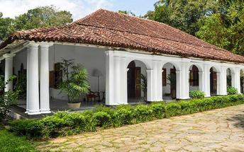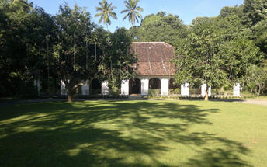

Activities

Optional

Recommended

Included
Bed, Breakfast & Lunch

Excluded
Excluded Not Available

Day 5-6: The Kandy House, Kandy (Tue, 18 June to Wed, 19 June)

Day Itinerary
Over the next 2 days in Kandy, you will be free to explore the city at your own pace. If you would like a guide for your stay here there is 1 available on request. There is an array of activities around the city for you to choose from. Your breakfast and lunch will be included during your stay, however your dinner will need to be arranged by you. With the wide variety of restaurants available, you will not have a problem finding a place suitable to your taste. We would highly recommend that you visit Ceylon Tea Museum and Sri Dalada Maligawa Temple of the Sacred Tooth Relic during your stay here.

Consultant Notes
No Notes Available

Activities

Optional

Recommended
Sri Dalada Maligawa Temple of the Sacred Tooth Relic
Ceylon Tea Trails

Sri Dalada Maligawa Temple of the Sacred Tooth Relic
Sri Dalada Maligawa or the Temple of the Sacred Tooth Relic is a Buddhist temple in the city of Kandy, Sri Lanka. It is located in the royal palace complex of the former Kingdom of Kandy, which houses the relic of the tooth of Buddha. Since ancient times, the relic has played an important role in local politics because it is believed that whoever holds the relic holds the governance of the country. Kandy was the last capital of the Sri Lankan kings and is a UNESCO world heritage site partly due to the temple.

Ceylon Tea Trails
Ceylon Tea Trails, Sri Lanka's first Relais & Chateaux resort, comprises four luxurious colonial era tea planters' bungalows, connected by walking trails through stunningly beautiful Ceylon tea gardens. Each of the four bungalows is different. Summerville with an air of a country cottage, Castlereagh with an eclectic style of its own, the high colonial Tientsin, one of the first planter's residences to be built in Ceylon and the more modern Norwood; abounding with 50's character, 21 exquisite rooms and suites in all. Built between 1888 and 1950, the bungalows offer a taste of gracious living thanks to butler service and period furnishings, accompanied by gourmet meals.
Follow the Tea Trail from one unique bungalow to the next, staying a night or two at each or just laze in one. Trek, bike or picnic at spectacular locations each day in cool comfort. Book a room or the entire bungalow and relish a luxury holiday in the heart of Sri Lanka's breathtaking Ceylon tea country.

Included
Bed & Breakfast

Excluded
Excluded Not Available

Day 7-9: Galle Fort Hotel , Galle (Thu, 20 June to Sat, 22 June)

Galle
Pronounced ‘gawl’ in English, Galle is the best example of a walled city built by the Portuguese in South Asia in the 16th Century. It was extensively fortified by the Dutch in the 17th century. When you enter the old city gates of this World Heritage Site you can’t help but notice the grand colonial houses and boutique shops and of course the beautiful beaches on the fringes of town. Attracting many luxury travellers from around the world, the town is also a favourite with cricket fans who rate the Galle International Stadium to be one of the most picturesque cricket grounds in the world.

Day Itinerary
After breakfast at The Kandy House, you will head towards Polgolla Reservoir Airport for a flight to Koggala Airport in Galle. Upon arrival in Galle you will be collected at the airport and taken to your final destination, Galle Fort Hotel where you will spend the next 3 nights. Galle has many beaches for you to visit along with alot of sight attractions in order to keep you busy. Exploring the city will be left up to you, however a guide is available upon request.

Consultant Notes
No Notes Available

Overnight: Galle Fort Hotel
Galle Fort Hotel, the ultimate boutique hotel from which to explore Galle. Accommodation at the Galle Fort Hotel comprises of an expansive range of rooms and suites for comfort and preference. For a true Sri Lanka experience, the hotel management organizes personalized excursions and tours of the town's most beautiful and iconic destinations.
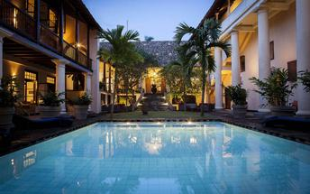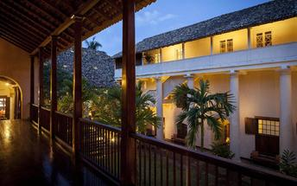

Activities

Optional

Recommended
Bonavista Beach
Unawatuna Beach

Bonavista Beach
No Description Available

Unawatuna Beach
No Description Available

Included
Full Board

Excluded
Excluded Not Available

Day 10: End of Itinerary (Sun, 23 June)

Day Itinerary
Your final breakfast in Galle will be served at 10am, after which you will be collected and transfered to Koggla Airport for a flight to Ratmalana Airport, before your final flight home.

Consultant Notes
No Notes Available

Activities

Optional

Recommended

Included
Included Not Available

Excluded
Excluded Not Available

Transport

Flight Information
Date | Flight | Airline | Departure Airport | Time | Arrival Airport | Time | Class | Ref
17 Jun | Scheduled |  | Ratmalana Airport [RML] | 11:00 | Polgolla Reservoir Airport [KDZ] | 12:00
20 Jun | Scheduled |  | Polgolla Reservoir Airport [KDZ] | 11:00 | Koggala Airport [KCT] | 12:00
23 Jun | Scheduled |  | Koggala Airport [KCT] | 11:30 | Ratmalana Airport [RML] | 12:15

Transfers
Date | Company | Pick Up | Drop Off | Time | Vehicle
14 Jun |  | Ratmalana Airport [RML] | Casa Colombo |  | Transfer
17 Jun |  | Casa Colombo | Ratmalana Airport [RML] |  | Transfer
17 Jun |  | Polgolla Reservoir Airport [KDZ] | The Kandy House |  | Transfer
20 Jun |  | The Kandy House | Polgolla Reservoir Airport [KDZ] |  | Transfer
20 Jun |  | Koggala Airport [KCT] | Galle Fort Hotel |  | Transfer
23 Jun |  | Galle Fort Hotel | Koggala Airport [KCT] |  | Transfer

Urgent Contact Numbers
Company Name | Telephone | Email Address | Contact Person
ABC Travel | +27216745390 | travel@abctravels.com | New User

Service Provider Directory
Service Provider | Ref. Number | Telephone | Address
Casa Colombo |  | +94 11 4 520130 | 231, Galle Road,  Colombo 4,  Sri Lanka
Galle Fort Hotel |  | +94 91 2 232870 | 28, Church Street, Fort, Galle, Sri Lanka
The Kandy House |  | +94 81 4 921394 | THE KANDY HOUSE  Amunugama Walauwa  Gunnepana  Kandy  Sri Lanka

Terms and Conditions

ABC Travel Terms and Conditions
Here is where you would insert your standard Terms and Conditions.
A Terms and Conditions agreement includes the terms, the rules and the guidelines of acceptable behavior, plus other useful sections, to which users must agree in order to use or access your product, website and mobile app.
Lorem ipsum dolor sit amet, consectetur adipiscing elit. Nunc ultricies libero eget ante vehicula, eu egestas sem commodo. Quisque feugiat nunc eget pretium placerat. Nam eleifend ullamcorper ipsum, sed condimentum dui venenatis quis. Mauris vel eros in libero iaculis auctor in vitae purus. Maecenas dui ipsum, tincidunt vitae sapien id, efficitur pulvinar nibh. Nulla eget urna ut velit viverra tincidunt. In justo quam, blandit euismod viverra nec, sodales vitae justo. Aenean leo enim, elementum eu venenatis vitae, convallis sit amet odio. Duis vitae ligula arcu. Donec non dolor in justo facilisis tempus in bibendum ipsum.

