

# Phuket, Phi Phi Islands and Krabi

*Phuket - Koh Phi Phi - Krabi*  
*10 Days / 9 Nights*  
*4 Persons*  
*Date of Issue: 22 November 2016*  
**21 October 2016 - 30 October 2016**

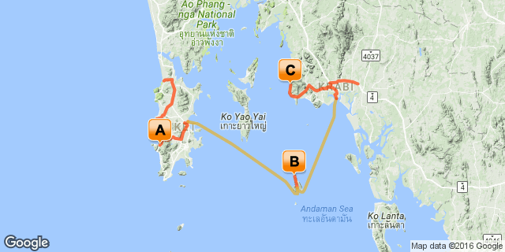

# [Click here to view your Digital Itinerary](http://wetu.com/Itinerary/Landing/b7917b6d-52fe-444e-ae55-5f4ef1b04038)

## Overview

9 Nights, Phuket, Phi Phi Islands and Krabi

|  |  |  |  |  |  |  |
| --- | --- | --- | --- | --- | --- | --- |
| **Accommodation** | **Destination** | **Arr.** | **Dep.** | **Nights** | **Basis** | **Room Type** |
| Patong Merlin Hotel | Phuket | 21 Oct | 24 Oct | 3 | B&B | 2x Double Room |
| Zeavola Resort & Spa | Koh Phi Phi | 24 Oct | 27 Oct | 3 | B&B | 2x Double Room |
| Amari Vogue Krabi | Krabi | 27 Oct | 30 Oct | 3 | B&B | 2x Double Room |

**Key**  
RO: Room only  
SC: Self Catering  
HB: Half Board  
B&B: Bed and breakfast  
B, B&L: Bed, breakfast and lunch  
D, B&B: Dinner, bed and breakfast  
FB: Dinner, bed, breakfast and lunch  
FB+: Dinner, bed, breakfast, lunch and activities daily  
FI: Fully inclusive

## Price

From R 24 940 pps

## Included

Return flights from Johannesburg  
Airport taxes  
Internal transfers  
3 Nights at Patong Merlin (Phuket)  
3 Nights at Zeavola Resort ( Phi Phi island)  
3 Nights Amari Vogue (Krabi)  
Breakfast

## Day 1-4: Friday, 21 October to Monday, 24 October Patong Merlin Hotel, Patong

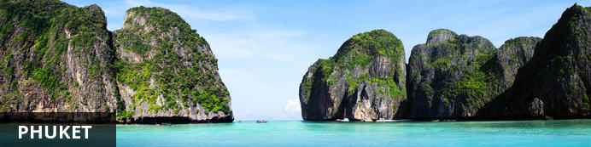

One of Thailand’s most famous and popular island destinations, Phuket draws scores of tourists each year to its sand-fringed shores, inviting them to bask in the tropical sun, swim and snorkel in its azure bays, and revel in the endless leisure and adventure activities on offer. Phuket’s refurbished old town is one of its trendiest areas, where the diverse cultural and architectural influences of the past have been fused and immortalised – vivid red and gold Chinese temples stand side by side with Indian roti restaurants and antiquated colonial buildings. Patong is the hub of Phuket nightlife, with scores of bars and pulsing nightclubs lining the streets, while more relaxed beachside bars and restaurants are dotted along the coast. Those who prefer nature and serenity should head to the secluded beaches of the north, or to Promthep Cape, a rugged promontory that forms Phuket’s southernmost point, providing dramatic scenery and breathtaking sunset views.

### Notes

Phuket lies in the Andaman Sea on Thailand's Indian Ocean coast located 867 kilometres south of Bangkok. Phuket is blessed with magnificent coves and bays, palm-filled, white beaches, small surrounding islands, hospitable people and great seafood. The most famous beaches are Patong, Kata, Karon, Kamala and Nai Harn Beach. Phuket islands are ideal for sailing, diving, snorkelling, golfing and all kinds of sports and entertainment you could wish for.

### Overnight: Patong Merlin Hotel

The Patong Merlin Hotel is an international holiday resort in the heart of Patong Beach, Phuket's exotic area. Nestled among acres of swaying coconut palms and flowering gardens, the Merlin weaves it’s way around four beautiful aquamarine sculptured swimming pools in a labyrinth of curved walkways and meandering paths. With easy access to the sparkling sandy beach and the quaint street markets, as well as an enchanted ambiance and attentive services, the hotel ensures a memorable and pleasant stay.

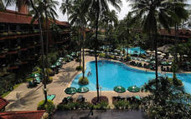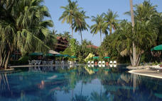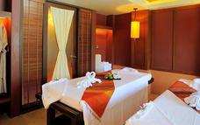

### Recommended

Phuket Introduction Tour  
Phuket Fantasea with Dinner  
Phuket Thai Cookery School

#### Phuket Introduction Tour

This tour will take you around Phuket Island. It is a good chance for you to learn about and to familiarise with this island and its people.

#### Phuket Thai Cookery School

With 7 different courses, Phuket Thai Cookery School offers comprehensive Thai Cooking courses, which starts with an introduction to Thai ingredients, a visit of local market, to actual cooking, with a wide selection of mouth-watering Thai dishes.

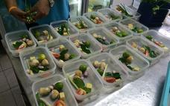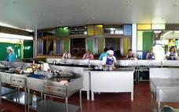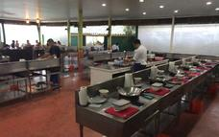

### Transfers

|  |  |  |  |  |
| --- | --- | --- | --- | --- |
| **Date** | **Pick Up** | **Drop Off** | **Time** | **Vehicle** |
| 21 Oct | Phuket International Airport [HKT] | Patong Merlin Hotel |  | Transfer |

### Included

Bed & Breakfast

## Day 4-7: Monday, 24 October to Thursday, 27 October Zeavola Resort & Spa, Koh Phi Phi

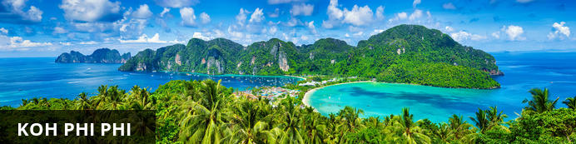

Set right in the middle of the magnificent Phang Nga Bay, Ko Phi Phi is a small archipelago in Southern Thailand’s Krabi Province, known for its spectacular natural beauty and its exceptionally lively nightlife. Phi Phi Don is the main island of the group and is home to an impressive array of restaurants, dive centers, bars, cafes and shops. The surrounding uninhabited islands are part of a protected national park, and can only be visited on a guided tour. With its limestone cliffs, crystal clear turquoise waters, pristine white sand beaches and miles of lush forest, Ko Phi Phi is widely considered to be Thailand’s most idyllic tropical island. Visitors can enjoy a range of activities including rock climbing, swimming, snorkelling, scuba diving or simply relaxing on a beach lounger with a cocktail in the one hand and a good book in the other.

### Notes

The Phi Phi islands are some of the loveliest in Southeast Asia. Just a 45-minute speedboat trip or a 90-minute ferryboat ride from either Phuket or Krabi, these picture postcard islands offer the ultimate tropical getaway. Featuring classic tropical beaches, stunning rock formations and vivid turquoise waters teeming with colourful marine life, it is paradise perfected.

### Overnight: Zeavola Resort & Spa

Zeavola Resort & Spa is a sustainable Phi Phi Island luxury resort located on the tranquil white sand Laem Tong Beach, with an air of rustic romance. The barefoot luxury experience at the Phi Phi Island hotel allows guests to unplug and reconnect amidst spectacular tropical beauty.  
Guests can step back in time and immerse in the simplicity of rural village life in adorable teak wood suites, close to nature. Fill the days with exciting journeys of exploration and adventure on the Andaman Sea, pampering spa treatments, cooking classes and indulge in authentic, delicious cuisine.

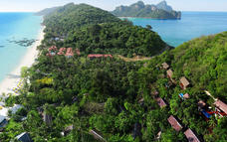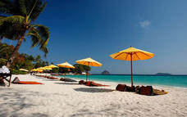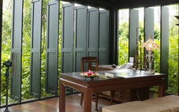

### Recommended

James Bond by Speedboat  
Phi Phi Island by Speed Boat

#### James Bond by Speedboat

Phang Nga Bay is famous for its limestone “Sea Mountains”, a magic + “out - of – time” place used in the making of 2 James Bond Movies. Phang Nga Bay is one of the most unique places in the world.

#### Phi Phi Island by Speed Boat

The Phi Phi Islands are a 'Hot Spot' of Southern Thailand They were made famous by the movie “The Beach”. The Maya Bay crystal clear water are stunning. This is a great site for snorkelling addicts.

### Transfers

|  |  |  |  |  |
| --- | --- | --- | --- | --- |
| **Date** | **Pick Up** | **Drop Off** | **Time** | **Vehicle** |
| 24 Oct | Patong Merlin Hotel | Royal Phuket Marina |  | Transfer |
| 24 Oct | Ao Tonsai Pier | Zeavola Resort & Spa |  | Transfer |

### Voyage Information

|  |  |  |  |  |  |  |  |
| --- | --- | --- | --- | --- | --- | --- | --- |
| **Date** | **Boat** | **Departure Port** | **Time** | **Arrival Port** | **Time** | **Class** | **Ref** |
| 24 Oct | Cruise | Royal Phuket Marina |  | Ao Tonsai Pier |  |  |  |

### Included

Bed & Breakfast

## Day 7-10: Thursday, 27 October to Sunday, 30 October Amari Vogue Krabi, Krabi

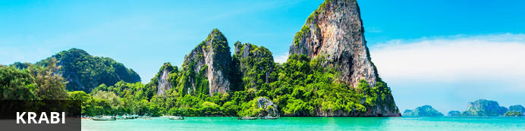

Krabi is one of Thailand’s most scenic destinations, renowned for the towering limestone monolithsthat shoot from its turquoise bays, its lush jungle vegetation, and the wide array of adventure andrecreational activities available. Go hiking along verdant rainforest trails or rock-climbing on sheerocean cliffs on the Railay peninsula; feast on fresh seafood from beachfront restaurants in Tonsai;enjoy the nightlife in Ao Nang; or simply kick back and soak up the sunshine and sea air at any ofthese world-class destinations. Krabi is also the kick-off point for excursions to Koh Phi Phi, famous asone of the locations for the famous US blockbuster, 'The Beach'.

### Notes

Krabi white sandy beaches, coral reefs rich in marine life; the area is the very definition of paradise. A wide array of leisure activities are available for the whole family from Island-hopping, snorkelling, rock climbing, sea kayaking, jungle trekking and scuba diving, are only some of the most popular excursions that can be enjoyed while on holiday in Krabi.

### Overnight: Amari Vogue Krabi

Situated on the sandy white shores of Tub Kaek Beach beside the tranquil blue of the Andaman Sea, Amari Vogue Resort is an intimate resort with elegant Lanna inspired architecture in a beautiful garden setting. The hotel boasts comfortable accommodation suitable for holidays from romantic weekend getaways to family vacations, including indulgent spa suites and ocean villas for an exceptional holiday experience.  
Guests can slow down the pace of life and be swept away by the tropical magic of Krabi. Dine on impeccably prepared seafood and pastas at the beachfront Bellini Italian Restaurant. Toast the stars from the balcony of a comfortable suite, and be pampered with a full body massage at the renowned Breeze Spa.

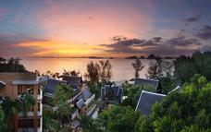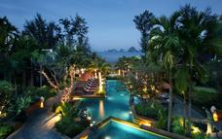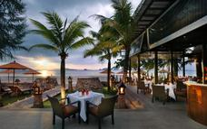

### Recommended

Krabi Rainforest Discovery  
Krabi 4 Islands by Speedboat  
Ban Bor Thor Kayaking Tour

#### Krabi Rainforest Discovery

60 km south of Krabi town lays the National Park with its Hot Water spring and an extraordinary year-round crystal clear Emerald Pool. Also visit the Tiger Cave Temple.

#### Krabi 4 Islands by Speedboat

Ideal for beautiful beaches, crystal clear water and snorkelling – all in just a half day! Poda island, Tup island, Chicken island and the world-famous Phra Nang Cave Beach.

#### Ban Bor Thor Kayaking Tour

Paddling their way through the wild mangroves and beautiful limestone caves decorated with bizarre cave paintings.

### Transfers

|  |  |  |  |  |
| --- | --- | --- | --- | --- |
| **Date** | **Pick Up** | **Drop Off** | **Time** | **Vehicle** |
| 27 Oct | Zeavola Resort & Spa | Ao Tonsai Pier |  | Transfer |
| 27 Oct | Krabi Ferry Terminal | Amari Vogue Krabi |  | Transfer |

### Voyage Information

|  |  |  |  |  |  |  |  |
| --- | --- | --- | --- | --- | --- | --- | --- |
| **Date** | **Boat** | **Departure Port** | **Time** | **Arrival Port** | **Time** | **Class** | **Ref** |
| 27 Oct | Cruise | Ao Tonsai Pier |  | Krabi Ferry Terminal |  |  |  |

### Included

Bed & Breakfast

## Day 10: Sunday, 30 October Departure

### Day Itinerary

Departure day

### Transfers

|  |  |  |  |  |
| --- | --- | --- | --- | --- |
| **Date** | **Pick Up** | **Drop Off** | **Time** | **Vehicle** |
| 30 Oct | Amari Vogue Krabi | Krabi International Airport [KBV] |  | Transfer |

### Urgent Contact Numbers

|  |  |  |  |
| --- | --- | --- | --- |
| **Company Name** | **Telephone** | **Email Address** | **Contact Person** |
| Perfect Destinations | +27 (0)21 250 0752 | shona.pittaway@perfectdestinations.co.za | Shona |

### Contact Details & Reference Numbers

|  |  |  |  |
| --- | --- | --- | --- |
| **Service Provider** | **Ref. Number** | **Telephone** | **Address** |
| Amari Vogue Krabi |  | +66 75 607 777 | Tubkaak Beach, Krabi 81180 |
| Patong Merlin Hotel |  | +66 76 349 888 |  |
| Zeavola Resort & Spa |  | +66 75 627 000 | 11 Moo 8 Laem Tong,  Koh Phi Phi,  Ao Nang,  Krabi  81000,  Thailand |

## Travel Information

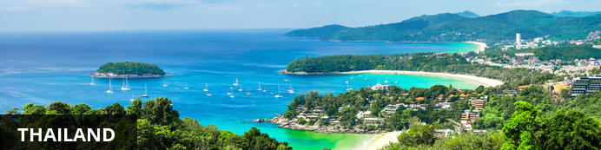

Fondly known as “the land of smiles”, Thailand is commonly associated with gorgeous golden sand, palm-lined beaches, warm aquamarine waters, glorious temples and verdant jungle-clad mountains. With sixteen million foreigners flying into the country each year, Thailand is the primary travel hub of Southeast Asia, offering a diverse range attractions and activities to suit all tastes and budgets. Whether exploring the teeming metropolis of Bangkok, relaxing on the tropical beaches of the southern islands, scuba diving in the underwater wonderland off the coast of Koh Tao, jungle trekking in the North, or discovering the ancient cities of Chiang Mai, Thailand is filled with attractions to satisfy any interest.

#### Banking and Currency

**Currency**

Baht (THB; symbol ฿) = 100 satang. Notes are in denominations of ฿1,000, 500, 100, 50, 20 and 10. Coins are in denominations of ฿10, 5, 2 and 1, and 50, 25, 10, 5 and 1 satang.

The import and export of local currency is limited to ฿50,000. The import and export of foreign currency is unlimited, but amounts over US$20,000 must be declared.

Foreign currencies can be exchanged at banks (which have the best rates), hotels (which charge high commissions) and bureaux de changes can be found in larger towns (generally open 0800-2000). Outside large towns and tourist areas, high value notes may be difficult to exchange, so visitors are advised to carry small change.

**Banking**

Banking hours: Mon-Fri 0830-1530.

American Express, MasterCard and Visa credit cards are widely accepted. ATMs are found in all major cities and almost all provincial banks.

Travellers cheques are accepted by almost all banks and large hotels and shops. To avoid additional exchange rate charges, travellers are advised to take traveller's cheques in US Dollars, Euros or Pounds Sterling.

#### Travel, Transport and Getting Around

Thai Airways International (TG) (www.thaiairways.com) runs services to all major towns, a total of 12 domestic destinations including Phuket and Chiang Mai. Bangkok Airways (PG) (www.bangkokair.com) flies several additional routes including Ko Samui. Discounts are available during off-peak seasons and during special promotional periods. Orient Thai Airlines, formerly known as One-Two-Go Airlines (www.flyorientthai.com) and Nok Air (www.nokair.co.th) also offer domestic flights.

Roads in Thailand range from multi-lane freeways around Bangkok to tiny lanes known as sois. Popular routes in the provinces are often four lanes.There is a reasonable road network comprising many highways, which are designated by numbers, and 52,000km (32,300 miles) of national and provincial roads. All major roads are paved.

Car hire services are available in all main towns and cities from both international and local companies. The minimum age for driving in Thailand is 18 years and the wearing of seat belts is compulsory. The speed limit is 50kph (31mph) to 60kph (35mph) in towns and cities and 90 to 120kph (52 to 74mph) on expressways and country roads. A national licence and International Driving Permit (IDP) are required. IDPs are valid for three months, after which a Thai driving licence is required. Cars are driven on the left side of the road in Thailand.

Taxis are easy to find and cheap to use in Bangkok. In other cities, such as Chiang Mai, local transport such as tuk tuks are much cheaper and more common.

Bike hire is available at most tourist locations throughout the country but, due to the erratic nature of driving standards and the heavy traffic, caution must be observed. It is however an excellent form of transport for those wishing to travel the quieter areas of the country.

There are many intercity bus services, which range from uncomfortable and crowded buses to luxury, air conditioned coaches. Prices are quite cheap but the appalling traffic in some areas of Thailand makes travelling by bus quite slow.

Conventional bus services in Bangkok are operated by the Bangkok Mass Transit Authority, but there are also extensive private minibus operations. Premium fares are charged for air-conditioned (cream and blue buses) and express buses. The ordinary buses are cream and red or white and blue and charge a flat rate regardless of distance travelled. Fares are generally low and are collected by conductors.

In Bangkok, taxis displaying the TAXI-METER sign are metered. Samlors or tuk-tuks are three-wheeled taxis without a meter; the fare must be negotiated before the journey commences. These are cheaper than taxis but are only suitable for short distances.

There are express, rapid and ordinary motorboat services operated by the Chao Phraya Express Boat on the Chao Phraya River between Nonthaburi pier to the north of Bangkok to Rajburana pier in southern Bangkok. The express boats, marked with yellow, blue or green and yellow flags, are more expensive than the rapid orange-flag-flying boats. The ordinary flagless boats are the cheapest.

The Skytrain (BTS), an elevated mass transit system in Bangkok, runs from 0600-2400. The Metro runs from Hualamphong to Bang Sue. Trains leave every five to nine minutes between 0600 and 2400.

Chiang Mai public transport is limited to red songtaew (minibuses), tuk-tuks, rickshaws and distinctive yellow metered taxis mainly operating from the airport. There is now a limited bus service in operation.

The excellent railway network extends over 4,600km (2,860 miles), linking all major towns with the exception of Phuket. It is run by State Railways of Thailand (tel: 1690; www.railway.co.th; online booking: www.thairailticket.com). There are four main routes to the northern, eastern, southern and northeastern regions, and also a western line serving Thon Buri, River Kwai Bridge and Nam Tok.

There are several daily services on each route, with air-conditioned sleeping and restaurant cars on the principal trains. The journeys are leisurely and comfortable, and travelling by train is certainly one of the best ways to get around the country. The Southern Line Express stops at Surat Thani for those who wish to continue by bus and ferry to the islands off the east coast. Most railway timetables are published in English.

Ferry services operate between the mainland and several islands including Surat Thani to Ko Samui, Phuket to Phi Phi, Pattaya to Ko Samet and Trat to Ko Chang, and can be booked in person at the dock. Strong competition on all of the major routes ensures that fares are kept low. Reduced services operate during the monsoon season from May through to October along the east coast and Andaman coast, and from November until January on the Gulf coast. The more remote spots become inaccessible during these periods.

#### Food, Drink and Cuisine Advice

Use only bottled or boiled water for drinking, brushing teeth or making ice. Unpasteurised milk should also be boiled, although pasteurised or homogenised milk is available. Tinned or powdered milk is safe as long as it is reconstituted with sterile water. Beware of dairy products that may have been made with unboiled milk. Stick to meat and fish that have been well cooked, preferably served hot, but not reheated. Avoid raw vegetables and unpeeled fruit.

Thai food is traditionally fairly hot and spicy, but most tourist restaurants tend to tone down the heat for the more fragile Western palate. Most Thai food is prepared with fresh ingredients such as lemon grass and coriander and rice is commonly eaten with most meals. Popular fruits are papaya, jackfruit, mangosteens, rambutans, pomelos (similar to grapefruits) and, above all, durians, which farangs (foreigners) either love or hate. The thorny fruits have a rather malodorous scent which has even resulted in many hotels banning them from their premises.

Excellent food can be found at the stalls of the many street vendors around the country as well as top-notch eateries. There are also many Asian and European restaurants throughout the major cities and smaller towns.

#### Climate and Weather

The weather in Thailand is generally very hot and humid, particularly between March and May. The monsoon season runs from June to October, when the climate is still hot and humid with torrential rains. The best time for travelling is November to February (cool season), although the southern islands are best from June to September.

#### Clothing and Dress Recommendations

Lightweight cotton or linen clothing and lightweight rainwear are advised year round. A bathing suit, sunscreen, sunhat and beach wear are essential. A good pair of walking shoes is recommended.

#### Electricity and Plug Standards

Electricity in Thailand is 220 Volts, alternating at 50 cycles per second. If you travel to Thailand with a device that does not accept 220 Volts at 50 Hertz, you will need a voltage converter. Outlets in Thailand generally accept 2 types of plug: type A and Type C. Plug adapters are available in Thailand but it is advisable to buy one before you leave home to avoid the hassle of trying to find one when you arrive.

## Terms and Conditions

This is where you would put your standard terms and conditions. This is a sample account for Wetu so we do not have any T & Cs