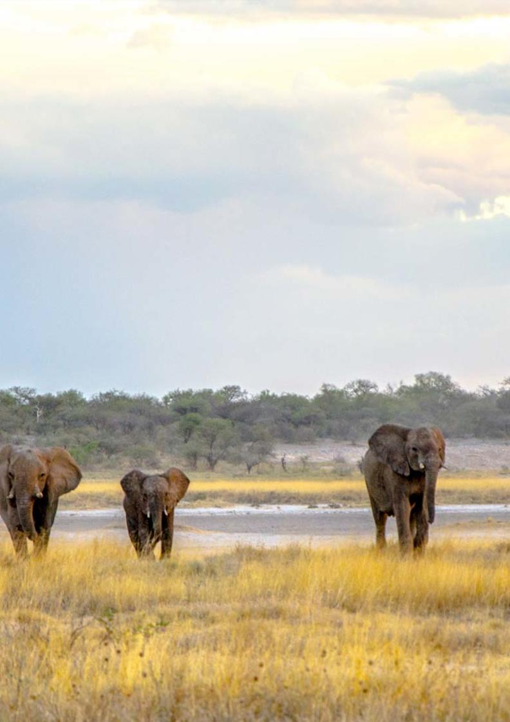

11-Day Namibia Photographic Highlights Private Guided Safari - Luxury - NETT

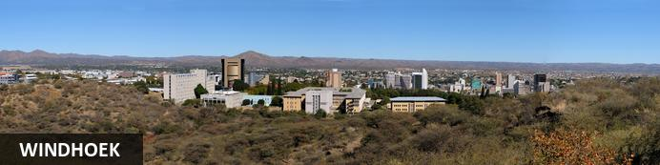
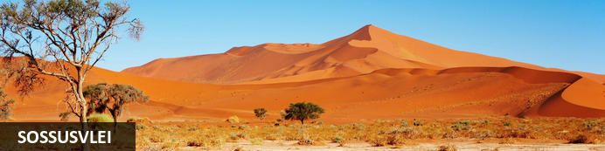
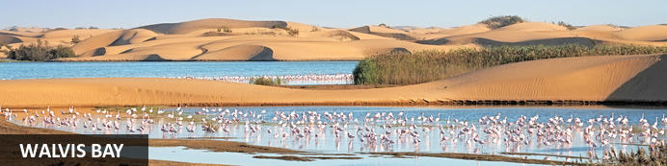
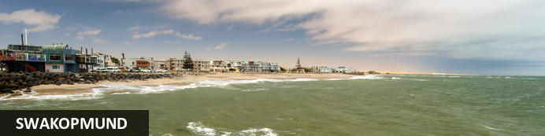
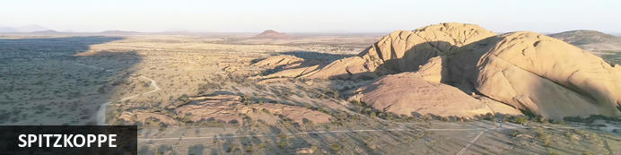
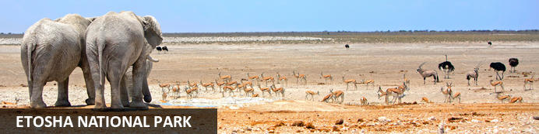
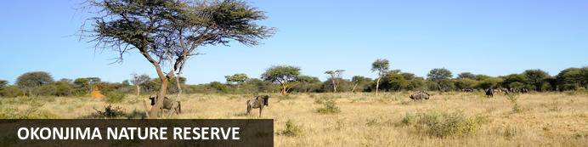

11-Day Namibia Photographic Highlights Private Guided Safari - Luxury - NETT
Windhoek - Sossusvlei - Walvis Bay - Swakopmund - Spitzkoppe - Etosha National Park - Okonjima Nature Reserve
11 Days / 10 Nights
Date of Issue: 13 March 2023

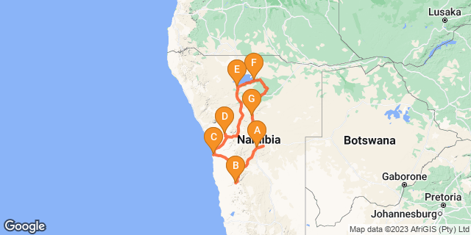

Click here to view your Digital Itinerary

Introduction
This 11-day Namibia Highlights Photographic Safari offers the best photo opportunities - the subjects are varied, interesting and rewarding including spectacular landscapes, fascinating macros, sensual abstracts, full-frontal wildlife, cultural detail and much more. Capture the ancient sand dunes of Sossusvlei, the lagoon and birdlife in Walvis Bay, the landscape at Spitzkoppe Mountain and incredible wildlife in Etosha plus a visit to the AfriCat Foundation.

Add a few nights to make this lovely itinerary even better:
- Venture further south to include the Quiver Tree Forest, Fish River Canyon and Kolmanskop Ghost Town near Luderitz.
- Damaraland to search for the desert adapted elephants and other wildlife in this harsh environment
- Opuwo for a hint of culture and authentic Himba villages
- Tsumkwe for an authentic Bushman experience
More wildlife - add the Caprivi strip, the Chobe National Park and the Okavango Delta in Botswana

Accommodation | Destination | Basis | Duration
The Weinberg Windhoek | Windhoek | B&B | 1 Night
Sossus Dune Lodge | Sossusvlei | B&B | 2 Nights
Flamingo Villas Boutique Hotel | Walvis Bay | B&B | 2 Nights
Spitzkoppen Lodge | Spitzkoppe | D,B&B | 1 Night
Okaukuejo Resort | Etosha National Park | B&B | 2 Nights
Namutoni Resort | Etosha National Park | B&B | 1 Night
Okonjima Luxury Bush Camp | Okonjima Nature Reserve | FI | 1 Night

Key
B&B: Bed and Breakfast
D,B&B: Dinner, Bed and Breakfast
FI: Fully Inclusive - Bed, All Meals, Fees and Activities

Price
NETT STO COSTS
1st January – 30th June 2023 – Low Season
2 guests - ZAR 85 720 per person sharing
4 guests - ZAR 59 900 per person sharing
6 guests - ZAR 51 970 per person sharing
Single supplement - ZAR 13 580
1st July – 31st December 2023 – High Season
2 guests - ZAR 99 520 per person sharing
4 guests - ZAR 71 020 per person sharing
6 guests - ZAR 62 275 per person sharing
Single supplement - ZAR 17 335

Included
- Accommodation as indicated - can change depending on availability and request at time of booking
- Meals as indicated
- Car hire for 2 & 4 pax - for 6 pax the vehicle is slightly larger
- All vehicle costs including fuel
- All park entry fees
- Guide and guide costs
- Water in the vehicle at all times
- Activities as shown in the itinerary … all activities that can be done with NTS guide and vehicle are included
- Tour file with detailed itinerary, map with route descriptions, vouchers etc.
- 24 hour personal and friendly support
- Fast and efficient response to service providers

Excluded
- Items of a personal nature
- Optional extra activities
- International flights
- Holiday or personal insurance
- Staff gratuities
- Visas and visa applications

Day 1: The Weinberg Windhoek, Windhoek

Windhoek
Surrounded by the stubble-covered Auas Mountains and the endless Khomas Hochland, Windhoek lies in a long valley fed by ancient hot springs in the central highlands. Namibia’s capital and bustling city. More often than not, the start or end place of your Namibia safari.
In Windhoek there are many interesting historical buildings, museums, galleries and craft shops. The city has several good restaurants and modern shops and services making it an excellent base camp from which to launch your Namibian adventure.

Day Itinerary
- You will be met by your guide on arrival in Windhoek and handed your travel documents
- City tour of Windhoek with your guide (if time permits)
- The remainder of the day can be spent relaxing at your own leisure
- For dinner tonight, you can head into town for a bite to eat at one of Windhoek's well-known restaurants

Overnight: The Weinberg Windhoek View iBrochure
If you can imagine yourself in a fine countryside manor house overlooking orchards and then at the same time imagine you are in an urban chic, modern hotel, then you could see yourself at The Weinberg Windhoek for sure. Cape Town meets Stellenbosch in central residential Windhoek.
Previously named, Am Weinberg Boutique Hotel, this elegant 41-room hotel is built around a heritage building. It offers contemporary amenities with a touch of class and sophistication without being presumptuous. While not quite five star, they've perfected the balance between lavish and homely, unpretentious, yet certainly gives you a feeling of being in the presence of the elite.
From colours, textures and materials used, the well thought out décor makes you feel right at home, if the home is that of your wealthy, but down to earth aunt and uncle perhaps. Nothing is out of place and be assured every fine detail has been thought out to ensure a top class stay.
Colonial meets modern, fine country living and 21st century all in one, in harmony. Add great service, multiple dining options, roof–top terrace and world class spa and you find yourself in one of the best up and coming places to stay in Windhoek, without actually feeling as though you are in the capital city at all.
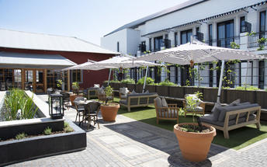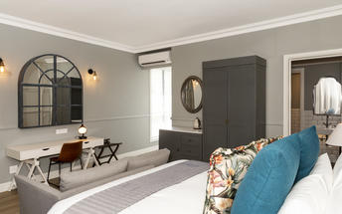

Meet and Greet
NTS Car Hire- Toyota Hilux Safari Private Guided
Toyota Hilux Safari Travelling as a small group of friends or as a family and need a bit more space than you get with an SUV? Is your focus on photography and you want to get the best shots? This is how you travel in true safari style.

Basis
Bed and Breakfast

Day 2-4: Sossus Dune Lodge, Sossusvlei

Sossusvlei
Star dunes with up to five crests rise 300m into the air and rank among the biggest in the world; the dune valleys are marked by vast clay pans where the Tsauchab River gave up its fight to reach the sea more than 60,000 years ago.
Besides the dunes and pans of Sossusvlei and Sesriem Canyon, a sideshow of activities and sights has developed around the region and there are plenty of game lodges that provide additional desert-adapted activities.Plants and birds are the dominant life form in this dessicated realm and they support a tiny world of mammals, reptiles and insects that, in the absence of coastal fog, seldom wander far from the rivercourse and its pans.

Day Itinerary
Windhoek - Sossusvlei 350km - approximately 5 to 6 hours
- After breakfast, you can still pop into town for anything you might need and then depart heading south from Windhoek to your lodge for the next 2 nights
- The route will take you either via the beautiful Spreetshoogte or Remhoogte Pass, both showcasing the natural beauty of Namibia
- Stay at Sossus Dune Lodge inside the park to be able to take photographs before sunrise and after sunset
- Wake up early for breakfast (Day 3) and then head south to Sossusvlei for some amazing pictures as the sun rises
- Spend the morning in the beautiful Sossusvlei area, exploring the highlights: Sossusvlei, Dead Vlei, Dune 45, Big Daddy, Elim Dune and the Sesriem Canyon
- Return to the lodge for lunch and then head back into the park to snap some photos at sunset
- Optional extra activities: Guided Sossusvlei excursion; Hot air balloon safari; Nature drives

Overnight: Sossus Dune Lodge
Sossus Dune Lodge sits in an enviable location as it is the first of only two lodges built inside the restricted Sossusvlei area.
Built against low lying mountains, Sossus Dune Lodge offers views across the plains to the dunes. It has a total of 25 chalets (including 2 honeymoon suites): 13 are on the left of the main area, with views of dunes; and the remaining 12 chalets, on the right of the main area, have mountain/canyon views.
All the chalets are very well linked by wooden walkways a few metres from the ground and each chalets is furnished in leather, dark wood and suede and has a large en-suite bathroom. The staggered chalets, looking like huts, ensure you can sit on your balcony in total privacy.
Situated within the park, guests benefit from being able to reach Sossusvlei before sunrise, and stay until after sunset. The lodge is also within walking distance of the Sesriem Canyon.
It's these privileges that sell this property. Although the lodge covers the basics, one should be prepared to sacrifice on standard for the added advantages of being the first or the last into the park.
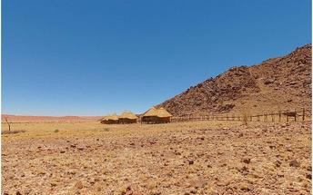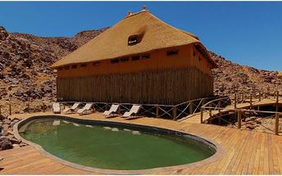

Basis
Bed and Breakfast

Day 4-6: Flamingo Villas Boutique Hotel, Walvis Bay

Walvis Bay
Walvis Bay is an industrial port which lies along the Atlantic Ocean, off Namibia's Skeleton Coast. The large bay and surrounding sand dunes help make Walvis Bay a tourist mecca with loads of activities on offer to explore it.
- Explore the Skeleton Coast where the dunes meet the sea at Sandwich Harbour‍
- Go on a dolphin boat cruise in the harbour. Enjoy champagne and oysters
- Kayak among the seals at Pelican Point
- Visit and climb the mighty Dune 7‍
- Visit the RAMSAR wetland birding site and the Walvis Bay Lagoon. Thousands of flamingos from October to April‍
- Explore the neighbouring town of Swakopmund. Activities abound and dining delights

Swakopmund
Surrounded by the ancient Namib desert and the inhospitable - but bounteous - Atlantic Ocean, Swakopmund is alive with activity and has a lot on offer for the adventure-seeker: quad-biking, sand-boarding, horse-riding, skydiving and more.
Swakopmund has many interesting German-influenced buildings from the early 1900s in a variety of styles and, for its size, Swakopmund has an astonishing array of restaurants that serve mainly seafood, steak and many German staples.

Day Itinerary
Sossusvlei - Walvis Bay 350km - approximately 5 to 6 hours
- Depart after breakfast and head north to Solitaire, then west crossing the Tropic of Capricorn, through the Gaub and Kuiseb Canyons via the Namib Gravel Plains to the coast
- Either direct to Walvis Bay or (recommended) detour via Ganab to the Welwitschia Plains, Moon Landscape and Swakopmund
- The Namibian coastline is generally known as The Skeleton Coast due to the barren areas, ship wrecks and, in days gone by, whale skeletons left on the beach
- 1 full day is set aside for this lovely area where Walvis Bay offers a wide range of activities such as: Dolphin cruise; Sandwich Harbour excursion (a real Skeleton Coast experience); Dune quad biking; Sand boarding; Sea kayaking; Lots more…
- Spend time at the lagoon photographing the sea birds, pelicans and flamingos
- Lunches and dinners can be enjoyed at any of the many great cafés or restaurants overlooking the sea

Overnight: Flamingo Villas Boutique Hotel View iBrochure
Built from the ground up across from the Walvis Bay lagoon esplanade, Flamingo Villa Boutique Hotel opened for business in September of 2016 to instant acclaim.
Looking more like a Bauhaus block of seaside apartments than a cheery seaside hotel, the rather imposing exterior belies an explosion of colour and life going on inside. Flamingoes and their pink underbellies feature in motif form throughout the hotel and with good reason - look across the bay and you'll see hundreds of thousands of them, greater and lesser, doing their groovy shuffle or hunched down against the biting cold wind that skims off the polar sea current.
The rooms - standard, luxury and suites - are all enormous with high quality finishes and furnishings. Decor is reigned in for a more neutral, relaxing pose and the floor-to-ceiling windows frame the bird-filled lagoon and setting sun rather well.
Room amenities satisfy all but the most critical of boutique hotel definitions including air con, satellite TV, mini bar, coffee station, WiFi, gadget-sized personal safe, universal plug points and high quality toiletries, towels, robes and linen. If you're staying in a suite, you'll also receive a bouquet of flowers and a complimentary bottle of sparkling wine too.
Fulfilling the grand promises made by the plush finishes and modern amenities, the service at Flamingo Villa is top-notch: warm smiles attach themselves to an attentive attitude giving one the distinct impression the staff here genuinely care about your comfort and happiness. At every turn, the place positively oozes professionalism but nowhere is this more evident than the restaurant.
Open to the public for a more convivial atmosphere, the small but varied a la carte menu gives Namibia's excellent local produce a worldly makeover. Seafood of course is the order of the day with some wonderful venison additions. The wine list is well-thought out pitting South Africa's noble vintages against the new kids on the block.
Between Walvis Bay and Swakopmund you've got a menu of activities to suit every appetite and taste. Birding is a big attraction at Walvis Bay, the lagoon, salt pans and dune fields being highly regarded hotspots. The lagoon supports flamingoes, pelicans and hundreds of waders; seals, dolphins, mola mola, whales and some might game fish thrive on the nutrient-rich waters welling up from the Antarctic Benguela current.
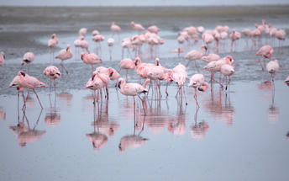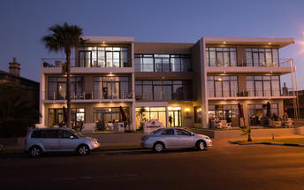

Basis
Bed and Breakfast

Day 6: Spitzkoppen Lodge, Spitzkoppe

Spitzkoppe
Situated in Namibia’s desolate, awe-inspiring Namib Desert, between Usakos and Swakopmund and about two hours’ drive from Swakopmund, the Spitzkoppe are a group of bald granite peaks forming one of Namibia’s most recognizable and dramatic landmarks. These enormous towering domes are a mecca for hikers and mountaineers, from beginners interested in guided historic walks to professional climbers seeking an adrenaline boost. Numerous ancient rock paintings can be visited as part of a guided walking tour. The extreme, barren landscapes and striking rock formations create an excellent setting for photography.

Day Itinerary
Walvis Bay - Spitzkoppe 330km - approximately 5 to 6 hours
- Head north along the Skeleton Coast, via Henties Bay to visit the Cape Cross seal colony. Along the way, stop at the Lichen Fields as well as the ship wreck between the colourful small town of Wlotskasbaken and Henties Bay
- Backtrack to Henties Bay and head inland through wide open plains to Spitzkoppe
- Spend some time taking pictures of the incredible Spitzkoppe Mountain and landscape of the area including the Rock Arch and surrounds
- A chance to see some Bushman paintings
- Enjoy the view at sunset… one of the most beautiful sunsets in Africa!

Overnight: Spitzkoppen Lodge View iBrochure
No joke, you’ll feel like you’re in a modern art installation. On another planet. A remote desert one. This place is cool. Stylish, contemporary, minimalist it’s literally embedded into the rocks of Spitzkoppe.
Set in open desert, this place mixes old and new. 15 private chalets sit between massive 150 million year old granite boulders. Everything’s been created to blend into the environment - including the pool which is landscaped into the rocks. The deck is split level and there’s a fire pit too. The sun sets in front of you, behind the Brandberg mountains, and there’s a 360 degree view to the boulders which are lit at night. It’s a long drive - 4 and a half hours from Windhoek and 3 from Swakopmund but it is closer than Mars. Which is a bonus.
The chalets are spaced out so you’ll see them but it’s up to you if you want to be sociable and wander back to the main lodge and pool.
Each chalet has a private bathroom and you’ll have your own deck. It’s all raised on stilts and connected by long, elevated walkways across the sand. You might want to hire a bike or make use of the golf cart shuttle to get back to base.
There’s a bit of grandeur with the zebra skin floor rugs and the decor is all icy blue drapes and white bed linen. Uber stylish. Your roof’s a tent so it might get flappy at night but grab your earplugs and just watch the stars unspoilt by light pollution.
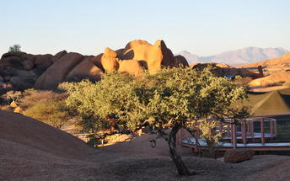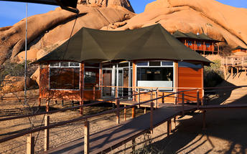

Basis
Dinner, Bed and Breakfast

Day 7-9: Okaukuejo Resort, Etosha National Park

Etosha National Park
Famous for its wildlife, Etosha Park supports 114 species of mammal and over 340 species of bird. At the heart of the park is a 4,800 square kilometre salt pan surrounded by sparse shrubs and grassy plains, the perfect haven for animals.
As vegetation in most areas is sparse, the animals have learnt to drink during the day when predators are inactive and it is the safest time to be out in the open. It is not uncommon to see up to 7 different species of game at any waterhole.Like everything in Namibia, the pan is ancient - 2 million years or so - and was formed when a great continental upheaval diverted the Kunene River towards the sea, leaving a massive inland lake that soon dried up. Usually a shimmering white horizon, the pan fills with water after a good rainy season and becomes a vast knee-deep lake.

Day Itinerary
Spitzkoppe - Etosha (south) 440km - approximately 5 to 6 hours
- After breakfast, head via Usakos and Karibib before turning north via Omaruru to Outjo and further on to the southern entrance of Etosha, the Anderson Gate
- If time permits, enter Etosha for an afternoon game drive. Depending on how often you stop today, you should arrive at your lodge in time for lunch (optional extra)
- On entering the park, the first stop is Okaukuejo where you pay your entry fees (included) and I suggest you pop in at the local shop to purchase some drinks and snacks and most importantly, a map of Etosha which will show you all the waterholes along the way. This is where you will spend the next 2 nights.
- 1 full day is set aside to enjoy game drives in the park or to enjoy the waterhole at the lodge inside the park… a great place to sit with your camera ready for sightings, even at night
- Etosha is one of Africa's great game parks. With 114 species of mammal and 340 species of birds you are sure to see a great variety of wildlife on your safari

Overnight: Okaukuejo Resort
Okaukuejo is one of only six lodges inside Etosha National Park. They are all in front of floodlit waterholes, the one at Okaukuejo being regarded as the best of the lot.
Okaukuejo (pronounced oka-KOO-yo) is a simple lodge with bungalows, a bar, a buffet restaurant, and a generous swimming pool. They have useful facilities like a filling station, a shop, and camping; it also houses the administrative and research offices of Etosha National Park.
One of only six lodges inside the park - all owned by the parastatal Namibia Wildlife Resorts - Okaukuejo has a floodlit waterhole that is famous for producing some spectacular wildlife action. Elephants, black rhino and lion frequent the permanent water source and they often do it at the same time.
You'll opt to stay here for the benefit of being inside the park, the accommodation and amenities are basic with the service and food fairly decent. Mind you if you're spending all your time enjoying the waterhole, then you'll happily overlook the rest.
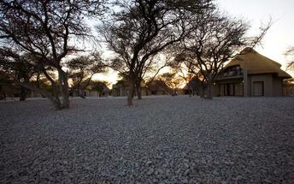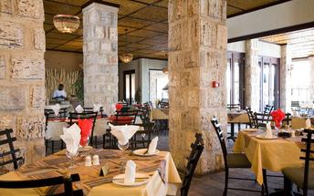

Basis
Bed and Breakfast

Day 9: Namutoni Resort, Etosha National Park

Etosha National Park
As previously described

Day Itinerary
Etosha (south) - Etosha (east) a full days game drive through the park
- From one side to the other side of the park is a full day game drive as you head slowly east stopping at numerous waterholes along the way
- Take a slow drive in the morning and then enjoy a packed lunch (optional extra) overlooking one of the waterholes before continuing on through the park for the afternoon to the eastern side

Overnight: Namutoni Resort
Namutoni is one of six safari lodges inside Etosha National Park. Overlooking a floodlit waterhole and Fisher's Pan, the game viewing comes first and the accommodation tries its best to catch up.
Namutoni is one of the few possible options to stay inside Etosha National Park and all of these lodges are owned and managed by the parastatal Namibia Wildlife Resorts.
Located on the eastern edge of the vast Etosha Pan and south of Fisher's Pan, Namutoni is a basic, no-frills lodge that overlooks a floodlit waterhole. The German fort around which it is built makes for a bizarre first encounter and the morning and evening bugle calls add to the surreality.
Accommodation is in bungalows of varying size or self-catering camping. The rooms are all air-conditioned and have en suite bathrooms. The large and popular pool is shaded by some grand Makalani palm trees and the lodge has a buffet restaurant and a well-stocked bar.

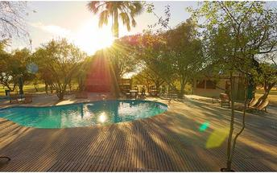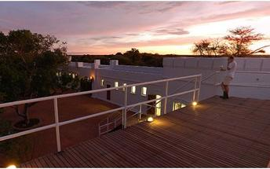

Basis
Bed and Breakfast

Day 10: Okonjima Luxury Bush Camp, Okonjima Nature Reserve

Okonjima Nature Reserve
This 22,000-hectare private nature reserve is surrounded by the the Omboroko Mountains and the home of The AfriCat Foundation. AfriCat works to assist with the long term conservation and rehabilitation of carnivores like cheetah, leopard, brown hyena and that African icon, lion. Since 1993, over 1,000 predators have been saved with 86% released. Here you can see cheetah, wild dog and hyena in their natural home - leopards are radio tracked so you could get lucky and spot them too. 250 bird species think it’s an ideal spot and there’s a hide for watching nocturnal animals.

Day Itinerary
Etosha (east) - Okonjima 315km - approximately 4 to 5 hours
- Head south via Otavi and Otjiwarongo to Okonjima, which is home to the AfriCat Foundation. Aim to arrive here by 14h00 latest in order to enjoy the afternoon tea/coffee and cakes before heading off on your afternoon excursion
- After dinner, an optional visit to the night hide to view some nocturnal animals

Overnight: Okonjima Luxury Bush Camp View iBrochure
Okonjima Luxury Bush Camp is the luxury option at Okonjima - a family-owned portfolio of lodges on a private reserve between Etosha and Windhoek.
Bright versions of earthy tones and an open-plan design give the place a relaxed and informal atmosphere. The eight chalets and junior suite are spaced well apart from each other and are built like an African hut - with some essential modifications. The front half of the chalets roll up to reveal nothing but the African bush; each has an en suite bathroom, mini-bar, telephone, ceiling fan and a safe. You'll also have your own private open-air sala for ultimate relaxation.
The living area, or lapa if you want to get into the swing of things, is an enormous open-sided thatch construction that looks out over a waterhole and the wilderness. Inside its earthen-coloured walls is the dining area, a large lounge with a raised fireplace, and a sunken bar area; next to it is the swimming pool.
Okonjima Bush Camp is the luxury option and the Main Camp is the original lodge that offers home-grown comfort; Okonjima Villa and Okonjima Bush Suite are the pinnacle of luxury and seclusion.
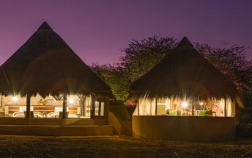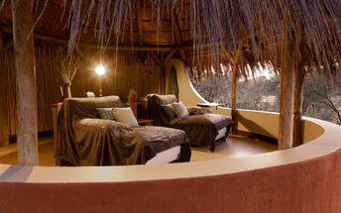

Basis
Fully Inclusive - Bed, All Meals, Fees and Activities

Day 11: End of Itinerary

Day Itinerary
Okonjima - Windhoek 225km - approximately 3 to 4 hours
- Early morning rise for a quick snack before joining the morning activity, which will be to visit the AfriCat Foundation or for a drive in the animal enclosure, which is more a game reserve
- Back to the lodge for a hearty Namibian breakfast before departure
- Head back to Windhoek today, where your guide will drop you at the airport in time for your departure flight (Keep in mind that you need to be at the airport 2 hours prior and the airport is still a 45 minute to 1 hour drive from town)
- End of services

Basis
Bed and Breakfast

Transport

Transfers
Date | Company | Pick Up | Drop Off | Time | Vehicle
 |  | Hosea Kutako International Airport [WDH] | The Weinberg Windhoek |  | Fully Guided Trip
 |  | The Weinberg Windhoek | Sossus Dune Lodge |  | Fully Guided Trip
 |  | Sossus Dune Lodge | Flamingo Villas Boutique Hotel |  | Fully Guided Trip
 |  | Flamingo Villas Boutique Hotel | Spitzkoppen Lodge |  | Fully Guided Trip
 |  | Spitzkoppen Lodge | Okaukuejo Resort |  | Fully Guided Trip
 |  | Okaukuejo Resort | Namutoni Resort |  | Fully Guided Trip
 |  | Namutoni Resort | Okonjima Luxury Bush Camp |  | Fully Guided Trip
 |  | Okonjima Luxury Bush Camp | Hosea Kutako International Airport [WDH] |  | Fully Guided Trip

Urgent Contact Numbers
Company Name | Telephone | Email Address | Contact Person
Namibia Tours & Safaris | +264 64 40 6038 | tanya@namibia-tours-safaris.com | Tanya Coetzee
Namibia Tours & Safaris - Emergency Contact | +264 81 784 4315

Service Provider Directory
Service Provider | Ref. Number | Telephone | Address
Flamingo Villas Boutique Hotel |  | +264 64 20 5631 | 30 Kuvambo Nujoma Drive, Meersig, Walvis Bay, Namibia.
Okaukuejo Resort |  | +264 81 180 0016 | Okaukuejo, Namibia
Okonjima Luxury Bush Camp |  | +264 67 31 4000 | Okonjima LodgeOtjiwarongo, Namibia9000
Spitzkoppen Lodge |  | +264 64 46 4144 | Spitzkoppen Lodge,Spitzkoppe Road D1918Spitzkoppe9000
The Weinberg Windhoek |  | +264 61 42 7200 | 13 Jan Jonker StreetWindhoek9000

Terms and Conditions

Namibia Tours & Safaris Terms and Conditions
Contract
1.1 The contract will become effective as from the date the invoice is completed and the deposit, referred to in Clause 2.1, is received by Africa Tours & Safaris CC (hereinafter known as the Company).
1.2 The contract is subject to the Namibian Law.
1.3 Any person making a reservation as per Clause 8.4 accepts the terms and conditions of this agreement set out hereunder.
How to Book
2.1 A 20% deposit of the full amount due is required to confirm any reservation and is to be done by the agent or client (see Clause 8.1) in writing or by e-mail.
2.2 The Company must receive the balance of the contract price no later than 42 days (6 weeks) prior to departure.
2.3 If the Company does not receive the full contract price 42 days (6 weeks) before the departure date, the Company may cancel the reservation and retain whatever deposit or other funds it has already received from the client or his agent.
How to Pay
3 The payment options will be provided upon confirmation of a booking.
Our Cancellation Policy
4.1 Any cancellation of a confirmed booking must be done in writing (email) to the Company whereupon cancellation charges as per Clause 4.2 will apply.
4.2 The following cancellation fees (as a percentage of the fully quoted price) are applicable to any cancelled travel:
Notice from date of travel: Cancellation fee:
42 days or more 20% (deposit forfeited)
29 – 41 days 50%
15 – 28 days 75%
0 – 14 days 100%
Please note: the notice period is calculated from the date of cancellation to the start date of the tour/safari booking.
4.3 No refund will be made by the Company if, for any reason, inclusions or parts of the tour cannot be carried out / or utilised. These would include all facets such as meals, game drives, accommodation etc. This would also apply to any client who has booked a tour but fails to undertake the tour for any reason.
Our Changes Policy
5 If a booking is changed to an earlier date than originally reserved, the Company will endeavour to change it. If the booking is for a later date, charges as per Clause 4.2 could apply.
As things go, we've all had to adapt to changes during the Coronavirus pandemic and so too have we therefore amended our terms and conditions for travel during such times. Check out the Updated COVID Terms and Conditions here.
Price Changes
6.1 The Company reserves the right to increase the price of any tour prior to departure due to factors beyond the control of the Company, such as, without being limited to, and increase in fuel prices, new Government legislation, accommodation price increases, fluctuations in exchange rates, etc.
6.2 If the Company announces an in increase in the tour price in terms of this Clause, such addition amount must be paid to the Company before the departure of such tour or else the Company shall have the right to cancel the tour and the charges in Clause 4.2 will apply.
Changes to Itineraries
7 The Company shall at any time have the right, in its entire discretion, to alter the terms of the booking in relation to the route, timetable, itinerary and accommodation. The Company shall, however, make every effort to offer the client an alternative tour of a comparable standard.
Should the alternative be of a lesser standard, the client will be refunded the difference, but should there be an increase, the client shall have the right to either reject the alternative and obtain a refund of the relevant portion of the original contract sum, or to accept the alternative and pay the increased cost. In the event of the client rejecting the alternative tour and claiming a refund, such rejection will be treated as a cancellation and the refund will be calculated according to Clause 4.2 hereof. The client shall have no claim against the Company for any damages arising out of the alternative booking.
Responsibility and Liability
8.1 Neither the Company nor any person acting for through and on behalf of the Company shall be liable for any loss or damage whatsoever arising from any cause whatsoever and without restricting the generality of the aforegoing shall particularly not be responsible for the loss or damage arising from any errors or omissions contained in its brochure or other literature, late or non-confirmation or acceptance or bookings, loss or damage caused by delays, sickness, injury or death, whether occasioned by negligence or not.
8.2 The Company shall have the right at any time at is sole discretion, to cancel or the remainder thereof or to make an alteration in the route, accommodation price or other details. This would include any event of any tour being rendered impossible, illegal or inadvisable by weather, avalanches, strike, war, government or other interference or due to any other cause whatsoever. The extra expenses incurred as a result thereof shall be the responsibility of the client.
8.3 The Company may at its discretion and without liability or cost to itself at any time cancel, or terminate, a client's booking and in particular, without limiting the generality of the aforegoing, it shall be entitled to do so in the event of illness or the illegal or incompatible behaviour of any client undertaking the tour, who shall in such circumstances not be entitled to any refund.
8.4 Any person making a reservation with the Company (refer to Clause 1.1) warrants that her or she has the necessary authority to enter into this contract on behalf of the person or persons included in such a booking. The person making the reservation shall be liable for the total amount due to the Company.
Client's Obligations
9.1 It is the onus and responsibility of the client to obtain the necessary comprehensive insurance before departure for any possible cancellations, medical expenses, protection or personal property and money.
9.2 The onus is upon the client to ensure that passports and visas are valid for the duration of the safari. The Company cannot be held liable for any necessary visas or other travel documents not held by clients. In the event of a client not having the necessary documentation to enter any area or country the Company shall reserve the right to leave the client a the point of entry of such area or country. In such an event, the Company will not be held responsible to the client for further travel arrangements.
9.3 The onus is upon the client to ensure that the SARS-CoV-2 PCR tests are done prior to commencement of the safari and valid on arrival in accordance to the requirements of the country of intended travel and for the airline with which the client will travel. The same applies for any necessary testing for departure. The costs of any such COVID testing will be for the clients own account. While The Company can assist with arrangements for testing in-country, The Company will not be held responsible to the client for such arrangements and with regards to return time of test results.
9.4 Should the client need to undergo mandatory quarantine once in-country with regards to the SARS-CoV-2 virus, either on arrival as called for by the authorities or due to testing positive once in-country, this will be at the clients own expense.
Health and Personal Safety
10.1 The client shall be reasonably fit to undertake the tour.
10.2 Anti-malaria precautions should be commenced prior to tour departure. A medical doctor should be consulted for advice.
10.3 Tours offered by the Company cover a wide spectrum of the African wilds and neither the Company, its employees or agents can be held responsible for any injury or other related incidents whilst on the tour / safari.
10.4 The Company cannot be held responsible for any client who falls ill or contracts the SARS-CoV-2 virus while in-country. The client accepts that travel is at own risk.
Baggage
11.1 Clients are limited to one soft sports type bag per person with a maximum weight of 20 kilograms. This includes photographic equipment and hand luggage.
11.2 Due to the rugged terrain, the Company cannot be held responsible for damage or loss of any personal items including bags, contents of bags or photographic and related equipment. Due to extremely dusty conditions, please ensure all bags are dust proof.
Airline and Car Hire Clause
12.1 The Company will act as the agent of the client when booking the client with a car hire company, an airline or air charter service. The client therefore contracts with the car hire company, airline or charter service and not with the Company.
12.2 Charter flights are normally operated by smaller type aircraft such as Cessna 210. Luggage is strictly limited to 10-15 kgs (depending on terms of particular airline used) per person in soft hold all type bags. Due to the desert heat, it is not safe to overload aircraft thus this limit needs to be strictly controlled.
Travelling or thinking of travelling during the COVID-19 pandemic? Take a look at our COVID Terms and Conditions for more information on how this will work and differ from our standard terms and conditions as listed above.

