Star Tours – San Pedro de Atacama

We offer a general star tours each clear night, apart from a 6 days period around the full moon. They allow people without any prior knowledge of the sky to understand how to look at it, and observe as well through powerful telescopes, and discover a new world, our universe ! And from one of the best place on Earth to see the sky, the Atacama desert.
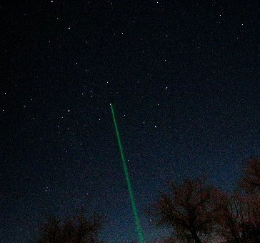
We try during the first part of the tour to explain the naked eye sky. What do we see when we look at the stars, what is a constellation, how to learn them, how to read a sky map and recognize the main stars. We use a green laser pointer to show you unambiguously the various constellations.
When the moon is visible, it is possible to take images of it through the telescopes provided you have a digital camera.
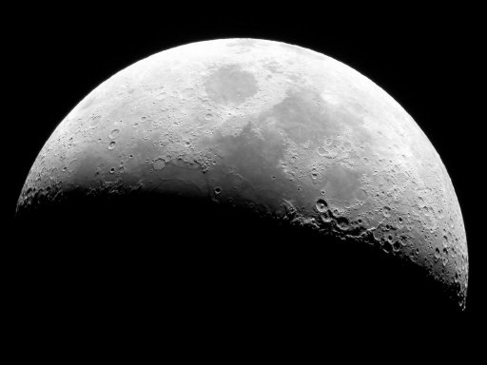
While you can find a lot of astronomical photographs on the web, there is nothing like the experience of visual observing. Everybody has seen images of Saturn, but the first time you really see the planet with your own eyes through a telescope becomes a moment to remember.
We have the largest park of telescopes of any public observatory in south America (between 20 and 72cm diameter), correctly aligned to always provide the best possible view, in order to let you discover some of the incredible views the sky has to offer. These telescopes are correctly maintained, and we use only high quality eyepieces to provide clear, sharp wide angle views. Our 72cm telescope is currently the largest touristic telescope in South America (waiting for our 1m15 telescope which will be really another story). We have also 60cm, 45cm and other smaller telescopes. What is hard to see in a 30cm telescope becomes quite visible, some stars show very vivid colors, and some nebulae start to be visible in color (normally, at night, we see in black and white).
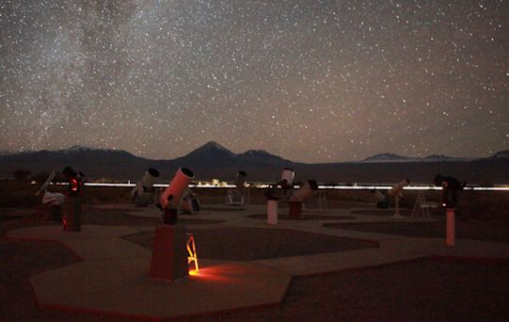
We are in the desert and the nights are cold. It is very important to be warmly dressed in order to enjoy the tour without getting cold.

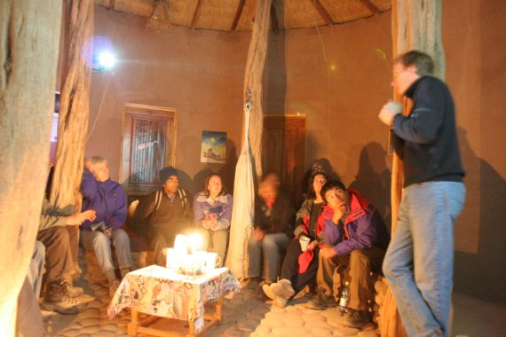
Our tours are ending around a warm drink to talk a little bit before returning to San Pedro. The tours last two hours and a half.
As seem quite obvious, we can not do the tour when the sky is covered by clouds. If the satellite map show obviously that the tour will be canceled, we do cancel it. We can then either move your reservation to a following night, or we reimburse your tour. Of course, being astronomer and not astrologer, we can not predict the future, and let alone the weather.We are close to the Andes, and during the altiplanic winter for example, weather can change rapidly. During the year we normally have one or two cloudy nights per months, except in January February where we can have anywhere from one week (which was the case in 2010) to three weeks covered by clouds (which was the case in 2011). These are all statistics, and unfortunately during the year, there are nights were we believe we should cancel the tour, and half an hour later the weather clears, or some other times where we don't cancel and during the tour, clouds come in. This is part of this type of weather dependent activity. Normally the weather is 100% clear (from August 2010 to January 22nd 2011, we closed 5 nights because of clouds).
In order to offer a quality tour, the number of guests is limited to 24 per tour.
https://www.spaceobs.com/en

