

# GLAMOUR

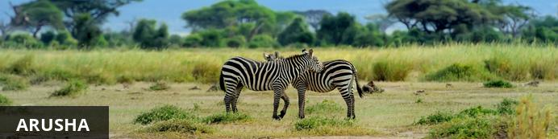

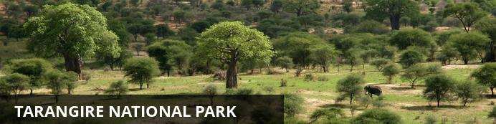

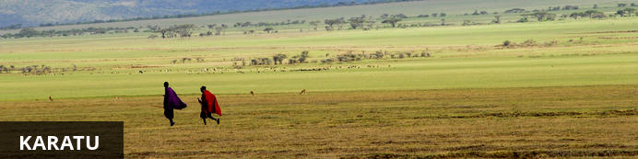

# GLAMOUR

*Arusha - Tarangire National Park - Karatu*  
*5 Giorni / 4 Notti*  
  
*Referenze: COD. 1691 - E.T.S. NORTHERN CUIRCUIT*  
*Data di Rilascio: 8 agosto 2018*

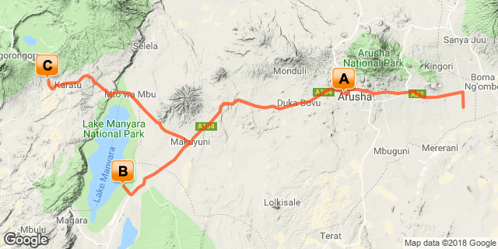

# [Clicca qui per vedere il tuo Itinerario Digitale](https://wetu.com/Itinerary/Landing/F9CA7390-C607-4EC2-9CC9-B253747E1971)

## Introduzione

**ESCLUSIVA IDEE PER VIAGGIARE**

Una fantastica esperienza alla scoperta di due dei più importanti parchi della Tanzania: dal Tarangire National Park, terra popolata da elefanti, al celebre cratere Ngorongoro.  
  
**ITINERARIO:  ARUSHA – TARANGIRE NATIONAL PARK – LAKE MANYARA NATIONAL PARK – NGORONGORO CRATER**  
  
**Giudizio Idee per Viaggiare**  
L'essenza di un terra meravigliosa ed emozionante, racchiusa in pochi giorni, soggiornando in strutture selezionate,  in posizioni davvero suggestive. Ideale per coloro che desiderano proseguire il viaggio aggiungendo un soggiorno mare a Zanzibar.

|  |  |  |  |  |
| --- | --- | --- | --- | --- |
| **Inizio** | **Sistemazioni** | **Destinazione** | **Trattamento** | **Durata** |
| Giorno 1 | [Elewana Arusha Coffee Lodge](https://wetu.com/iBrochure/21916_8715_13675) | Arusha | MP | **1 Notti** |
| Giorno 2 | [Maramboi Tented Camp](https://wetu.com/iBrochure/21916_8715_15402) | Tarangire National Park | FB+ | **1 Notti** |
| Giorno 3 | [Ngorongoro Farm House](https://wetu.com/iBrochure/21916_8715_15348) | Karatu | FB+ | **2 Notti** |

**Pasti**  
MP: Mezza Pensione  
B&B: Letto e Colazione  
FB+: Cena, Letto, Colazione, Pranzo e Attività Quotidiano

## Incluso

**LA QUOTA COMPRENDE**  
Trasferimenti come da programma  
 I pernottamenti nei campi tendati o nei lodges menzionati nel programma di viaggio con sistemazione in camere e tende doppie in categoria Standard  
4 colazioni – 3 pranzi al sacco – 4 cene  
Trasporto in auto fuoristrada 4x4 con autista/guida di lingua inglese parlante italiano.  
Massimo 6 partecipanti per veicolo  
I safari fotografici come da itinerario  
Tasse di ingresso ai parchi come da itinerario  
Assicurazione Flying Doctors  
1 bottiglia di acqua minerale per persona al giorno durante i safari

## Escluso

**LA QUOTA NON COMPRENDE**    
Volo internazionale e tasse aeroportuali  
Visto d'ingresso in Tanzania e tasse di uscita ove richiesto.  
Assicurazione di viaggio  
Eventuali tasse d’imbarco, di sicurezza e tasse doganali terrestri pagabili solamente Tasse locali da pagare in loco  
Acqua e bevande in generale  
Mance e facchinaggio  
Spese di carattere personale  
Eventuali spese per la consegna di bagagli in ritardo  
Tutto quanto non indicato nella sezione “la quota comprende"

## Giorno 1: Elewana Arusha Coffee Lodge, Arusha

### Itinerario del Giorno

**KILIMANJARO AIPORT - ARUSHA**  
Arrivo all’aeroporto di Kilimanjaro, disbrigo delle formalità doganali ed incontro con il rappresentante locale. Proseguimento per Arusha. Cena e pernottamento presso l’albergo.

### Tanzania

The name Tanzania conjures up images of wildebeest stampeding across vast savannah, rain forests teeming with monkeys and birdlife, and great plains brimming with legions of game. All of these natural wonders and more are on offer in this exceptionally diverse African nation. Visitors typically visit Tanzania to partake in at least one of the four well known Tanzanian tourist experiences: a relaxing seaside vacation on the picturesque island paradise of Zanzibar, an underwater tour of some of the world’s most renowned dive sites around the gorgeous Spice Islands, a safari adventure in some of Africa’s most impressive game reserves, or a hiking excursion around Mount Kilimanjaro National Park. Whichever of these incredible holidays you choose, you will undoubtedly be welcomed by some fabulously friendly and peaceful inhabitants who, despite being divided into 120 different ethnic groups and cultures, live in harmony with one another and provide some of the most wonderfully exotic local cuisine you could imagine. With all of this diversity on offer, the most difficult part of your Tanzanian holiday experience is likely to be deciding where to go!

#### Valuta e Banche

**Currency**

In Tanzania, the unit of currency is the Tanzanian Shilling, which is divided into 100 Cents. Notes are issued in denominations of 500, 1000, 2000, 5000, and 10000 Shillings. Coins are issued in denominations of 50, 100 and 200 Shillings.

**Banking**

Banks are open from 9:00am to 3:00pm Monday to Friday. Many banks are equipped with 24 hour ATM machines.

Credit cards and travellers checks are not widely accepted in Tanzania. Where they are accepted can high service fees and poor exchange rates be expected. Major foreign currencies - particularly US $ - are accepted in Tanzania and are convertible at banks and bureau de changes in the main towns and tourist areas. If bringing cash in US $, please make sure bank notes are in good condition, with no cuts or damage and are not older than 2004. Most banks offer higher exchange rates for US $ 100 / US $ 50 bank notes compared to US $ 20 / US $ 10 or US $ 5 bank notes.

#### Trasporti e Come Muoversi

If you are visiting a number of parks and reserves in Tanzania, you can either drive or fly between them. Roads in most of the wilderness areas are in poor condition and unmarked, and self-driving is not recommended. Operators will supply you with a driver who doubles as an informal guide; alternatively, you can arrange to fly to your destination and utilize a car and driver supplied by the lodgings. Elsewhere in Tanzania, towns and cities are linked by a steady stream of buses and *dala-dalas* (minibuses), and in the cities, there is public transport in the way of buses, *dala-dalas*, taxis, and, in some places, bicycles or *tuk-tuks*.

Precision Air run regular services, mostly via Dar es Salaam, Kilimanjaro or Zanzibar, to all main towns and other destinations in East Africa and beyond. All national parks and some of the top-end luxury lodges have airstrips and Coastal Air operates between these and the main airports on the mainland and the islands of Zanzibar, Pemba and Mafia. ZanAir has frequent connections between Zanzibar, Pemba and the mainland.

Driving is on the left hand side of the road

#### Cibo e Bevande

Most camps, lodges or hotels cater specifically to tourists and serve Western-style food, ranging in standard, but generally are excellent. Game lodges tend to offer a daily set menu with a limited selection, so it is advisable to have your tour operator specify in advance if you are a vegetarian or have other specific dietary requirements. First-time visitors to Africa might take note that most game lodges in and around the national parks have isolated locations, and driving within the parks is neither permitted nor advisable after dark, so that there is no realistic alternative to eating at your lodge.

Tap water in Tanzania is generally not safe to drink, and most travellers try to stick to mineral water. Filtered and bottled water can be difficult to find you are travelling outside of main town and so it is advisable to stock up. Most camps, lodges and hotels have bottled water readily available.

#### Clima

Just south of the equator, Tanzania is huge and its sheer size means that the climate varies considerably within it. However, generally the main rainy season, or the 'long rains', lasts during about **March**, **April** and **May**. Afternoon tropical downpours are the norm – which are heavier and more predictable beside the coast and on the islands. The humidity is high and daily temperatures reach the low-mid 30°s.  
  
The long dry season lasts throughout **June**, **July**, **August**, **September** and **October** is when rainfall is unusual, even on the islands. Temperatures vary hugely with altitude and location, but it's usually a fine, clear sky and sunny weather – it's a great time to visit Tanzania. During **November** and **December** there's another rainy season: the 'short rains'. These are much lighter than the main rains and less reliable.  
  
If it has rained during the short rains, then it normally dries up for a few months, **January** and **February**, which is Tanzania's 'short dry season', before starting to rain again in earnest in **March**.

#### Abbigliamento Consigliato

It never gets really cold in Tanzania so lightweight clothing, preferably cotton or linen, is recommended. While on a game viewing safari, avoid brightly coloured clothing, stick to whites, beiges, khakis and browns. There may be long days sitting in safari vehicles, so it is advisable to wear light comfortable clothing such as short sleeved shirts and cotton/linen trousers or shorts. Denim will become too hot and extremely uncomfortable. Walking shoes and socks will be required.

The evenings will be chilly, so long sleeved shirts and trousers should be worn. A sweater may be needed. These will also prevent you being bitten by insects. A hat should be worn at all times outside. The sun may sometimes not feel hot, but it can still easily burn, especially if it is cloudy and overcast.

If visiting Zanzibar or any coastal town don't forget to take a swimsuit, as it is invariably warm. Ladies are recommended to take cotton skirts, blouses and dresses. Sandals are a must for this environment! On the beaches and within the confines of hotels, normal swimwear is acceptable but nudity is not.

As over a third of the population in Tanzania is Muslim, it is therefore not etiquette for ladies to walk around in public displaying their legs and shoulders. Remember to dress modestly as short shorts, miniskirts, vests and tank tops will be frowned upon.

#### Elettricità e Prese di Corrente

The electricity supply in Tanzania is 220/240 volts at 50Hz. Plugs are 3 point square (UK Type).  Adapters are available at major airports.

### Arusha

Resting at the foot of Mount Meru, the sprawling city of Arusha is known as the safari capital of northern Tanzania. It serves as an excellent base from which to explore the remarkably scenic surrounding area which includes majestic Mount Kilimanjaro, as well as the Manyara, Tarangire and Ngorongoro National Parks. Arusha is a good spot to take a day or two off from the safari circuit as it features a temperate climate and lush surrounds. Visitors can look forward to exploring the wildlife-abundant Serengeti National Park; the magnificent Arusha National Park; and taking on the challenge of climbing Mount Meru, Africa’s fifth highest mountain.

### Pernottamento: Elewana Arusha Coffee Lodge [Entra nel iBrochure](https://wetu.com/iBrochure/21916_8715_13675)

Located in the middle of a verdant coffee plantation, Arusha Coffee Lodge is a sanctuary of aromatic tranquility and a welcome retreat after a long international flight, or the dust and excitement of a thrilling bush safari.  
  
Take residence in one of 30 luxury wooden chalets - 12 Plantation Suites and 18 Plantation Rooms - nestled amongst the surrounding gardens and sea of coffee trees.  
  
Turning off the road, a tree-lined drive guides you to the warm and inviting main area with its quiet understated aura of luxury. Vibrant gardens, a spa, and a swimming pool await, and a restaurant, Bacchus, and café bistro, 3° South, boast menus to satisfy the most discerning of palates, successfully fusing international culinary prowess with locally-sourced ingredients.  
  
Visitors are also welcome to enjoy convenient gift shopping at the Traders Walk Boutiques, located on site. Browse through a collection of five boutiques offering arts and crafts, jewellery, clothing, gourmet coffee and cakes and traditional Swahili food.

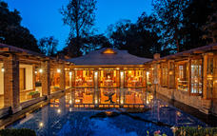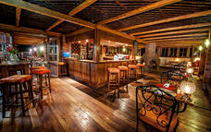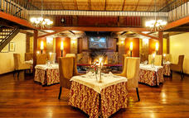

### Trattamento

Mezza Pensione

## Giorno 2: Maramboi Tented Camp, Tarangire National Park

### Itinerario del Giorno

**ARUSHA - PARCO NAZIONALE DI TARANGIRE**   
Dopo la prima colazione, partenza per il Tarangire e sosta per il pranzo con lunch-box. Il parco terra di baobab ed elefanti, offre meravigliosi e selvaggi paesaggi. Non è difficile incontrare giraffe, zebre, gazzelle o struzzi. Il parco prende il nome dall’omonimo fiume che lo attraversa. Il paesaggio è più rigoglioso rispetto al Serengeti e attorno al fiume si trovano anche paludi e boschi. All'interno di questo parco si trova la maggior concentrazione di baobab di tutta la Tanzania, numerosi elefanti e moltissimi mammiferi quali giraffe, zebre, gnu, etc..  
Nel pomeriggio safari nel parco. Arrivo presso il camp prenotato. Cena e pernottamento.

### Tarangire National Park

After the Serengeti, Tarangire has the greatest concentration of wildlife in Tanzania and in the dry season the Tarangire River is a magnet for thirsty wildlife. Large herds of elephants and migratory wildebeest, zebra, buffalo, impala, gazelle, hartebeest and eland gather and not surprisingly the predators follow. This is also the one place in Tanzania where dry-country antelope such as oryx and gerenuk are regularly spotted. Tarangire is also known for its spectacular baobab trees, and its breathtaking views of the Masaai Steppe and the mountains to the south.  
Located just a few hours drive from the town of Arusha, Tarangire is a popular stop for safaris travelling through the northern circuit on their way to Ngorongoro and the Serengeti. The park extends into two game controlled areas and the wildlife are allowed to move freely throughout.

### Pernottamento: Maramboi Tented Camp [Entra nel iBrochure](https://wetu.com/iBrochure/21916_8715_15402)

This is a unique opportunity to experience and explore the Tarangire and Manyara ecosystem.   
  
Maramboi Tented Camp offers permanent camp facilities and endless vistas of rolling golden grasslands and palm lined desert between Tarangire and Manyara Lake. A visit to the area is essential for anyone interested in evolution and the origins of Mankind and an explanation of the Rift Valley and Africa’s big picture. It is a complete semi desert experience focusing on safari walks and game drives.  
  
40 spacious tents built on ample wooden decks, among them there are 26 standard rooms, 10 suites and 2 units with 2 rooms interconnected, ideal for families with children. They all have en suite facilities and private veranda with 24 hours 220V electric lighting.

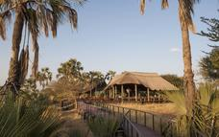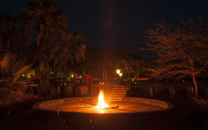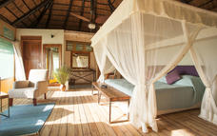

### Trattamento

Pensione Completa ed Attività

## Giorno 3: Ngorongoro Farm House, Karatu

### Itinerario del Giorno

**TARANGIRE/LAKE MANYARA N.P./CRATERE DI NGORONGORO**   
Prima colazione, partenza in direzione del Lake Manyara Nationaal Park con sosta per pranzo al sacco.  All’ arrivo fotosafari nel parco. Il parco  ospita diversi ecosistemi che creano l'habitat ideale per gli animali selvatici e uccelli. Offre inoltre  un’importante varietà di paesaggi che vanno dal lago alla pianura, dalla savana alle foreste sempre verdi. In questo luogo è possibile ammirare i leoni arboricoli, così denominati grazie alla loro abitudine, quando fa caldo e umido, di arrampicarsi sui rami più bassi degli alberi. Al termine del fotosafari, si riparte alla volta di Ngorongoro. Arrivo in serata. Cena e pernottamento.

### Karatu

Travellers heading for the Serengeti and Ngorongoro Crater will inevitably pass through the town of Karatu in the green hills of Tanzania’s northern highlands. Presided over by the towering Ol Deani Volcano, this small, colourful town serves as a popular overnight stop for visitors exploring the area’s many game parks. The town offers a variety of activities including browsing the bustling marketplace, sampling beer at a local brewery, visiting a traditional Iraqw homestead, or taking a guided walk through the Ngorongoro Forest in search of waterfalls and elephants caves. Whether you are looking for cultural tours, hiking and biking opportunities, a chance to enjoy an authentic rural Tanzania experience, or simply a break between safari game drives, this underrated town has plenty to offer.

### Pernottamento: Ngorongoro Farm House [Entra nel iBrochure](https://wetu.com/iBrochure/21916_8715_15348)

Ngorongoro Farmhouse Lodge is situated beneath the majestic Oldeani Volcano, and boasts easy access to both the untamed wilderness of Ngorongoro Conservation Area, as well as the simple pleasure of a ramble through 500 acres of farmland.  
  
Ngorongoro Farm House was inaugurated on February 20th 2003, and is offering 52 room cottages, 49 standard rooms and 3 suite rooms, all with ample space inside, built on the style of an old colonial farm and rustically decorated with local materials and full of details of good taste, with the purpose of offering our clients an imaginary journey to the life of the days gone.

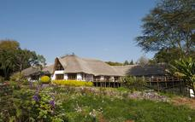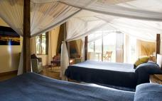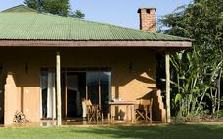

### Trattamento

Pensione Completa ed Attività

## Giorno 4: Ngorongoro Farm House, Karatu

### Itinerario del Giorno

**CRATERE DI NGORONGORO**  
Prima colazione e partenza alla volta della Ngorongoro Conservation Area dichiarata dall’UNESCO patrimonio dell’umanità nel 1981. L’area è costituita da un ampio altopiano situato all’interno della caldera di un antico vulcano spento. Posizionato a 2.200 metri sopra il livello del mare, il cratere Ngorongoro ospita nella sua immensa area un'incredibile concentrazione di animali selvatici tra cui: branchi di zebre e gnu, ma anche elefanti, leoni, bufali, iene e ghepardi. All'interno della Ngorongoro Conservation Area, i Masai possono vivere liberamente insieme ai loro animali domestici ed hanno diritto di pascolo in tutta la zona. Pranzo previsto con lunch box. Arrivo, cena e pernottamento presso il lodge.

### Trattamento

Pensione Completa ed Attività

## Giorno 5: Fine dell'itinerario

### Itinerario del Giorno

**CRATERE DI NGORONGORO - KILIMANJARO AIPORT**  
Prima colazione e partenza per l’aeroporto internazionale del Kilimanjaro. Fine dei servizi. Suggeriamo di proseguire il viaggio con una estensione mare a Zanzibar.

### Trattamento

Letto & Colazione

# Trasporti

## Trasferimenti

|  |  |  |  |  |  |
| --- | --- | --- | --- | --- | --- |
| **Data** | **Compagnia** | **Presa** | **Rilascio** | **Ora** | **Veicolo** |
|  |  | Kilimanjaro International Airport [JRO] | Elewana Arusha Coffee Lodge |  | Trasferimenti |
|  |  | Elewana Arusha Coffee Lodge | Maramboi Tented Camp |  | Trasferimenti |
|  |  | Maramboi Tented Camp | Ngorongoro Farm House |  | Trasferimenti |
|  |  | Ngorongoro Farm House | Kilimanjaro International Airport [JRO] |  | Trasferimenti |

### Numeri di Emergenza

|  |  |  |  |
| --- | --- | --- | --- |
| **Compagnia** | **Telefono** | **Indirizzo E-mail** | **Informazioni di Contatto** |
| Idee Per Viaggiare | +390652098550 | maria@ideeperviaggiare.it | Maria Comito |

### Elenco Fornitori dei Servizi

|  |  |  |  |
| --- | --- | --- | --- |
| **Servizi Forniti** | **Num. di Riferimento** | **Telefono** | **Indirizzi** |
| Elewana Arusha Coffee Lodge |  | +255 27 250 0630 |  |
| Maramboi Tented Camp |  | +255 759 565 016 | Minjingu  Tarangire - Tanzania |
| Ngorongoro Farm House |  | +255 784 202 827 | Karatu - Tanzania |

## Termini e Condizioni

### Termini e Condizioni dell'itinerario

1) Al momento della prenotazione preghiamo di verificare che il nome comunicato corrisponda esattamente a quello indicato sul passaporto.  
Eventuali spese di riemissione a causa di nomi comunicati errati saranno a carico del cliente.  La copia del passaporto dovrà esserci inviata via e-mail  
2) Allo scopo di evitare  spiacevoli imprevisti preghiamo i cittadini con passaporto straniero di comunicarlo in fase di preventivo per verificare eventuali visti d’ingresso richiesti.  
3) Data la condizione delle strade non asfaltate non è possibile determinare con precisione il chilometraggio percorso quotidianamente e le ore  impiegate negli spostamenti giornalieri.  
4) È vivamente consigliato limitare al minimo il proprio bagaglio (max 15 kg), utilizzando preferibilmente borse/sacche morbide.