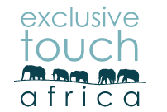

TRAVEL INFORMATION & REQUIREMENTS FOR YOUR JOURNEY WITH EXCLUSIVE TOUCH AFRICA

Scheduled Commercial Flights
Scheduled commercial airlines in Africa generally carry a weight restriction of 20 kg (44 lb) per economy class traveller, and 30 kg (66 lb) for business class. Please ensure that you comply with the applicable restrictions – further details regarding number of luggage pieces and exact dimensions for a particular carrier can be obtained from your ticketing agent or the airline website.
Please note when combining scheduled airline flights and air transfers (as specified below), then the smaller restriction of the two will apply unless alternative arrangements have been made for the storage or separate transfer of excess luggage.
It is very important that you do not put anything of high value (personal or financial) or vital medication in your checked-in baggage, as luggage can be tampered with and valuables removed. This includes, but is not limited to, jewellery, cameras, video equipment, reading glasses, sunglasses, laptops, or other computer/electronic equipment, medication (especially chronic medication), etc. Please also lock your luggage with a suitable lock to deter opportunistic theft.
In the event of your luggage being delayed or going missing, we would like to recommend that you pack a change of underwear, a clean T-shirt or similar, plus essential toiletries and medication into your carry-on/hand luggage to minimise the inconvenience experienced by this loss or delay.

Light Aircraft Transfers

Wilderness Air is Wilderness Safaris’ flying wing and generally operates the following aircraft in Botswana, Namibia, South Africa, Zambia and Zimbabwe:
- Cessna Caravan 208s – carrying 10 to 13 guests, depending on the routing and airstrips utilised – with 20 kg (44 lb) luggage.
- Cessna 206s and 210s – carrying 4 guests with 20 kg (44 lb) luggage.

Note that weight allowances on non-Wilderness Air aircraft may vary. Should guests be flying a combination of
Wilderness Air and non-Wilderness Air flights, guests are to please ensure that they adhere to Wilderness Air luggage restrictions. When guests are collected by Wilderness Air from a camp after flying in with a non-Wilderness Air flight and their bags do not conform to Wilderness Air luggage specifications, guests’ bags will be left behind and flown at a later stage (this cost will be for the guests’ expense). Please contact us for further details.

Safety is the number one priority for Wilderness Air. Adhering to aviation regulations, whilst taking the following into account, means that there have to be strict measures in place to ensure weight allowances are not exceeded and that these parameters are adhered to by all our partners world-wide. Physical limitations of the aircraft we use take into consideration:

. Size and type of aircraft
. Size of the luggage pod and seats

The strict weight restrictions in place on any itinerary which includes light aircraft transfers are for the following
reasons:

- The aircraft are designed with a maximum bodyweight and luggage weight allowance.
- Most of our airfields are at a fairly high elevation and located in the warm to hot tropics. Therefore the permissible aircraft carrying capacity is reduced.
- The aircraft have physical space restrictions. Please refer to the images below for an indication on the cargo hold compartment limitations.

Cessna 206 and Cessna 208 Luggage Pods and suitable size and type of luggage. (Below)

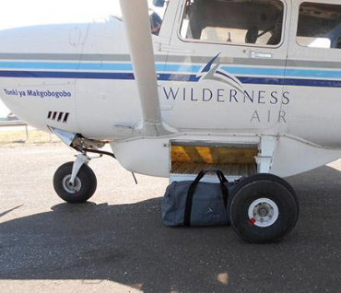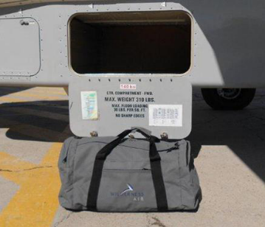

(Below) Unsuitable size and type of luggage.

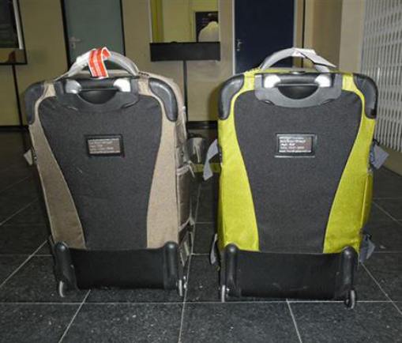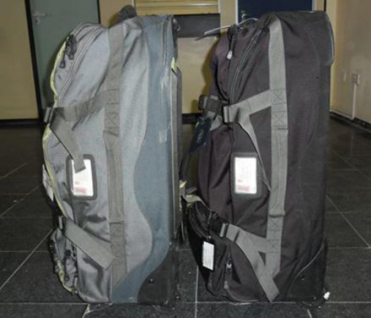

These important luggage and weight guidelines below must please be noted for all air transfers with Wilderness Air:

- Luggage, including camera equipment and hand luggage, is restricted to 20 kg (44 lb) per person travelling on seat rates, in Botswana, Namibia, South Africa, Zambia and Zimbabwe.
- Only soft bags will be accepted – no protruding wheels, frames or rigid structures can be transported as flexibility of the bag is limited and restricts physical loading into the aircraft. If the bag has an under carriage frame with wheels and a handle that folds back down into the frame, this is fine.
- The maximum dimensions of the soft bags which can be accommodated are as follows: 25 cm (10 inches) wide x 30 cm (12 inches) high and 62 cm (24 inches) long.
- Please keep in mind that the baggage compartments on the light aircraft are only 25 cm high (10 inches), so the pilots must have the ability to manipulate the bag into the compartment.
- A collapsible wheeled luggage frame/trolley (separate to the bag) is allowed, as long as basic dimensions are similar to that of the bag.

These limits are applicable to guests travelling on a seat rate basis so may differ if guests have booked a private charter option, in which case the parameters may vary depending on the type of aircraft and the number of passengers booked.

Whilst these weight and size allowances appear minimal, please bear in mind the following:

- Most safari camps/lodges and hotels provide basic toilet amenities.
- Laundry can be done on a daily basis (many camps provide this service free of charge, however, some camps and hotels do charge a nominal fee).
- More formal attire is usually required only when staying in the more prestigious city hotel establishments or on any of the luxury trains. On a wildlife safari, casual clothing is the order of the day. Please refer to our suggested packing list as a guideline.

Passengers travelling on light aircraft:

- Aviation authorities allow for us to estimate passenger weights to be an average of 85 kg (187 lb) for a Male and 75 kg (165 lb) for a Female. Wilderness Air, within legal limits, has pushed this up to 100 kg (220 lb) body weight per passenger and 20 kg (44 lb) luggage per passenger, inclusive of hand luggage. This is to accommodate our clients in a reasonable manner without jeopardising safety and comfort.
- Utilising the higher of the two weights, i.e. 85 kg (187 lb), the purchase of additional weight allowance (based on a percentage of a seat rate) allows for a total of 170 kg (374 lb) = 2 x 85 kg (187 lb). Our allowance of 100 kg (220 lb) per person in body weight means that the balance of weight allowance still available on the second seat provides for a maximum of 70 kg (154 lb) excess weight.
- We need to be informed in advance if guests weigh more than 100 kg (220 lb), as additional weight allowance on the aircraft must be purchased for safety and comfort. The cost for this is calculated on request according to specific region and routing.
- Each and every aircraft has a legal take-off and landing weight. This includes fuel, luggage and per seat passenger weight. We are unable to combine passenger weights as this may affect the weight and balance of an aircraft due to unknown variables of the group of passengers on the day. Any deviations from these weight regulations could affect the take-off and landing capabilities of the aircraft.
- Charter companies used, operate relatively small aircraft in wilderness areas where a number of factors influence the weight limitations of the aircraft: the length and condition of the runway, temperature and weather conditions, accessibility to fuel in these areas, as well as the distances flown.

Packing Suggestions
Please find herewith a list of suggested items which should be used as a guideline whilst planning your trip. Please bear in mind that as mentioned above, there are luggage restrictions of between 15 kg (33 lb) and 20 kg (44 lb) (in a soft bag with no wheels, frames or rigid structures) on some light aircraft transfers and 20 kg (44 lb) on most scheduled airline flights.

Clothing
The weather in southern Africa is generally pleasant throughout the year – warm to hot days, and cool to warm nights – with summer (September to April) being the hotter months. During our winter months however (May to August), it can get really cold at night and in the early morning, particularly when on safari, so we would like to suggest that you pack accordingly.

In central and east Africa, the temperature variation is generally less – in the summer months it can be quite hot and/or humid and the winters usually do not get as cold.

- . Sun hat/bush hat.
- . Headscarf/bandana – particularly for dusty dry regions.
- . Golf-shirts and/or T-shirts – preferably with a sleeve to protect your shoulders from the sun.
- . Long-sleeved cotton shirts.
- . Shorts and/or skirts – really short skirts are not practical for getting in and out of game drive vehicles.
- . Long trousers/slacks.
- . Track suit.
- . Pyjamas – lightweight for summer and warm/thermal for winter.
- . Underwear – on game drives the roads can be bumpy and uneven so a suitable bra may be required.
- . Socks – thermal options are recommended for the winter months.
- . Good closed walking shoes (running/tennis shoes are fine).
- . Sandals – preferably low heeled or flat if you are going on safari.
- . Swimming costume.
- . Lightweight jersey or fleece in summer.
- . Light rain gear or jacket for summer months.
- . Warm jersey or fleece plus anorak or parka in winter.
- . Additionally, a scarf, gloves and beanies/woollen hats for the cold winter months.
- . More formal attire for your stay at prestigious city hotels or on one of the luxury trains.

Equipment/Other

- . Good quality sunglasses, UV protected, preferably polarised. Tinted fashion glasses are not good in strong light.
- . If you wear contact lenses, we recommend that you bring along a pair of glasses in case you get irritation from the dust.
- . Torch.
- . Southern African bird guide if you are a keen birder, e.g., Newman’s or Sasol.
- . Personal toiletries (basic amenities are supplied by most establishments).
- . Malaria tablets (if applicable).
- . Antihistamine tablets if you suffer from any allergies.
- . Anti nausea tablets if you suffer from motion sickness.
- . Moisturising cream and suntan lotion – SPF 30 or higher recommended.
- . Insect repellent for body application, e.g. Tabard, Rid, Jungle Juice, etc.
- . Basic medical kit (aspirins, plasters, Imodium, antiseptic cream and antihistamine cream, etc.)
- . Tissues/Wet Wipes.
- . Visas, tickets, passports, money, credit cards, insurance details, etc.
- . Camera equipment including spare batteries, chargers, film, flash cards, memory sticks, etc.
- . Waterproof/dustproof bag or cover for your camera.
- . We highly recommend that you bring your own pair of binoculars for viewing both wildlife and birds. The recommended
- general purpose binocular specifications are 8x40 or 10x42.

NOTE 1: Bright colours and white are not advisable whilst on safari. Camouflage clothing is not recommended for travel in African countries (camouflage or military-inspired clothing is prohibited when travelling in Zimbabwe).

NOTE 2: There may be a restriction on luggage limits on your safari – please ensure that you have the details from your agent according to your itinerary and ask your agent ahead of time if you would like details on the feasibility and costs of taking excess luggage with you on any of these restricted luggage safaris.

