KRUGER AND THE KINGDOMS

When you combine the Kruger National Park, an icon of the wildlife world and the Kingdoms of eSwatini and Zululand, you have a mighty experience designed to take your travel desires to new heights.

It all begins in Johannesburg, where you will begin the first leg, a trip into Mpumalanga to marvel at the scenery along the Panorama Route. It’s then on to the Kruger National Park, where the Big Five roam, wild and free. Sightings are of an extraordinary caliber and an open vehicle game drive with a passionate guide is going to both thrill and excite.

You will then travel to eSwatini, an independent kingdom within the borders of South Africa, known for its colorful and vibrant culture. The people of eSwatini are the main attraction, where you will learn all about their traditions and customs. In Zululand, a cruise on Lake St Lucia awaits, where hippo and crocodiles abound. The journey ends in Durban.

DATE | ROUTING
DAY 1 - Sunday | JOHANNESBURG
DAY 2 - Monday | JOHANNESBURG – MPUMALANGA
DAY 3 - Tuesday | MPUMALANGA
DAY 4 - Wednesday | MPUMALANGA
DAY 5 - Thursday | MPUMALANGA – eSWATINI (SWAZILAND)
DAY 6 - Friday | eSWATINI (SWAZILAND) – ZULULAND
DAY 7 - Saturday | ZULULAND – DURBAN (UMHLANGA)
 | END OF TOUR

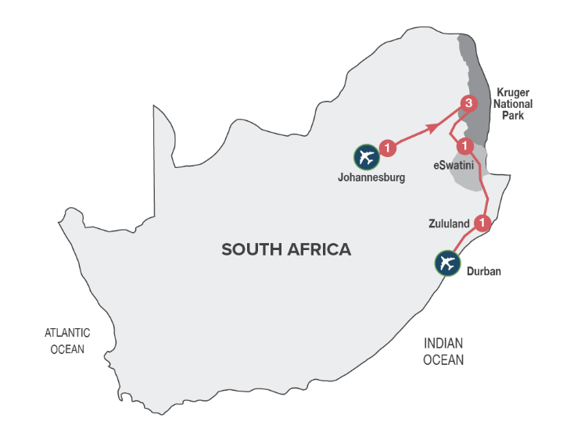
Small Group Tour
Minimum 2 guests / Maximum 10 guests

DURATION
7 days/6 nights

ROUTING
JOHANNESBURG – DURBAN (UMHLANGA)

INCLUDES
- 11 Meals: 6 breakfasts, 1 lunch, 4 dinners including gratuities
- 6 Nights’ accommodation including porterage
- Transportation including toll fees in air-conditioned vehicles
- Services of a professional English-speaking tour guide
- Entrance fees as specified in the itinerary
- Bottled water in eco-friendly packaging
TOUR HIGHLIGHTS
- Traverse the famous Long Tom Pass en route from Johannesburg to Mpumalanga
- Visit the spectacularly scenic Three Rondavels, Bourke’s Luck Potholes and God’s Window
- Experience an open vehicle game safari in the Kruger National Park including an introduction to the KNP anti-poaching Dog Unit
- Meet the friendly people of eSwatini (Swaziland) and experience their culture through singing and dancing
- Boat game cruise on Lake St Lucia
- Meals included in this trip support sustainable food production with at least 30% of the food on the menu being sourced locally (within 50-80km) of where it’s prepared
- Enjoy a variety of carefully chosen optional MAKE TRAVEL MATTER® Experiences that positively impact our travellers and the communities we visit

SELECTED DEPARTURE DATES
 | Jan24 | Feb24 | Mar24 | Apr24 | May24 | Jun24 | Jul24 | Aug24 | Sep24 | Oct24 | Nov24 | Dec24
English | 7;14;21;28 | 4;11;18;25 | 3;10;17;24;31 | 7;14;21;28 | 5;12;19;26 | 2;9;16;23;30 | 7;14;21;28 | 4;11;18;25 | 1;8;15;22;29 | 6;13;20;27 | 3;10;17;24 | 1;8

VISA REQUIREMENTS
This tour travels through eSwatini (Swaziland). Please check visa requirements, as certain nationalities may require visas to travel through eSwatini (Swaziland).

RACK RATES valid 01/01/24-30/04/24
R 27 650.00 per person sharing twin/double accommodation
R 33 320.00 per single person

RACK RATES valid 01/05/24-31/07/24
R 26 530.00 per person sharing twin/double accommodation
R 32 170.00 per single person

RACK RATES valid 01/08/24-31/12/24
R 27 900.00 per person sharing twin/double accommodation
R 33 725.00 per single person

Accommodation included:
4* Protea Hotel Balalaika or similar x 1 night
3* Hazyview Sun or similar x 3 nights
5* The Royal Villas or similar x 1 night
3* Anew Hotel Hluhluwe or similar x 1 night

Transportation:
Transportation is in air-conditioned touring vehicles appropriate to the requirements of the tour
- 2 guests will travel in a sedan vehicle
- 3-10 guests will travel in a 13-seater vehicle

DAY 1 – SUNDAY JOHANNESBURG
On arrival in Johannesburg at OR Tambo International Airport, you’ll be met by your representative and transferred to your hotel. Johannesburg is the largest and most populous city in South Africa. It is also the source of a large-scale gold and diamond trade due to its location on the mineral-rich Witwatersrand range of hills. The remainder of the day is at leisure and unescorted. Why not enjoy an optional (own account) sightseeing tour of Soweto, learning more about the struggle for freedom in South Africa, or simply relax at your hotel? At 19h00 we will meet at reception for a briefing on the tour and a chance to meet fellow travellers.
Distance travelled today: 35 kms

DAY 2 – MONDAY JOHANNESBURG - MPUMALANGA
Depart Johannesburg after breakfast and head for Pretoria, South Africa’s capital city, for a short orientation tour, before continuing to the Mpumalanga Province, known as “Paradise Country”. Dropping several hundred feet into the lush subtropical region of the Lowveld, we travel via the historic towns of Dullstroom and Lydenburg. After traversing the famous Long Tom Pass, we travel via Sabie and arrive late afternoon into Hazyview, the safari hub of the Kruger National Park. [Breakfast & Dinner]
Distance travelled today: 425 kms

DAY 3 – TUESDAY MPUMALANGA
After an early morning breakfast, we’ll drive along the spectacular ‘Panorama Route’, offering views of amazing scenery including the 26-kilometre long Blyde River Canyon (home to the Three Rondavels), Bourke’s Luck Potholes and historic God’s Window, a breath-taking view (weather permitting) of the edge of the escarpment taking in the Kruger National Park. We arrive back in Hazyview in the late afternoon where the remainder of the day is at leisure to relax. [Breakfast & Dinner]
Distance travelled today: 320 kms

DAY 4 – WEDNESDAY MPUMALANGA
The day begins with early morning coffee or tea, followed by a thrilling open vehicle game safari (with English speaking game ranger) through the Kruger National Park with pre-packed breakfast. Kruger is one of the world’s greatest national parks, home to a stunning array of wildlife. Search for the ‘Big Five’ (rhino, buffalo, lion, leopard, and elephant) as well as prolific birdlife and numerous other game species. The game safari includes an introduction to the Anti-Poaching Dog Unit (Project Watchdog), that was established because of the increase in rhino poaching worldwide. Learn about the dogs that are trained to track poachers in the field, detect firearms, ammunition and wildlife products that enter and exit through the Kruger National Park gates. A portion of the trip price of this MAKE TRAVEL MATTER® Experience goes towards ensuring that these dogs receive the best possible care in support of the vital work they do. The experience directly advances UN Global Goal 15: Life on Land. The afternoon is at leisure at your hotel. An afternoon open vehicle game drive is available as an extension to the morning game drive (optional and for own account). [Breakfast & Dinner]
Distance travelled today: 120 kms

DAY 5 – THURSDAY MPUMALANGA – eSWATINI (SWAZILAND)
This morning we travel to eSwatini (Swaziland), an independent Kingdom within the borders of South Africa, known for its lovely scenery, crafts and colourful indigenous culture. An interactive cultural experience inclusive of lunch, introduces us to the charming people of eSwatini (Swaziland) and their traditions. We travel via the capital city, Mbabane, to the beautiful Ezulwini Valley for overnight in eSwatini (Swaziland) and a sumptuous dinner at your hotel. [Breakfast, Lunch & Dinner]
Distance travelled today: 310 kms

DAY 6 – FRIDAY eSWATINI (SWAZILAND) - ZULULAND
After breakfast we will continue south through eSwatini (Swaziland), before re-entering South Africa. Travel into Zululand, passing traditional round huts and endless vistas. There is an option to enjoy an afternoon open vehicle safari (optional and for own account with an English-speaking game ranger) in the Hluhluwe-Umfolozi Game Reserve, which contains an immense diversity of fauna and flora and is particularly famous for its conservation of black and white rhino.
Overnight in Hluhluwe-Umfolozi region. [Breakfast]
Distance travelled today: 360 kms

DAY 7 – SATURDAY ZULULAND – DURBAN (UMHLANGA)
This morning we will join a cruise on Lake St Lucia (depending on favourable weather conditions) before departing for Durban. Our journey takes us past traditional Zulu Kraals, Eucalyptus plantations and sugar cane fields. We arrive in Durban in the early afternoon where the tour ends on arrival. [Breakfast]
Distance travelled today: 275 kms

OPTIONAL EXCURSIONS
Enhance your journey with optional excursions, available for pre-booking, subject to a minimum of 2 adults travelling:

Rack Rates valid 01/01/24 – 31/12/24:

DAY 1 – SUNDAY – JOHANNESBURG – AFTERNOON SOWETO TOUR – R 1 080.00 per person
Soweto is unlike any suburb you’ve ever seen or been to, yet the history of struggle encapsulated here is a cornerstone of the South African story.

DAY 4 – WEDNESDAY – KRUGER NATIONAL PARK – AFTERNOON OPEN VEHICLE GAME SAFARI – R 990.00 per person
For the wildlife enthusiasts a second open vehicle safari, as an extension to the morning safari, in one of the world’s most renowned game reserves.

DAY 6 – FRIDAY – HLUHLUWE-IMFOLOZI PARK – AFTERNOON OPEN VEHICLE GAME SAFARI – R 1 065.00 per person
Enjoy an afternoon, 3-hour open vehicle game safari into the Hluhluwe-Imfolozi Park, Africa’s oldest game reserve and world renowned for its highly successful white rhino conservation programme.

