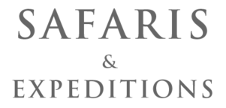

7 Nights Private Family Safari

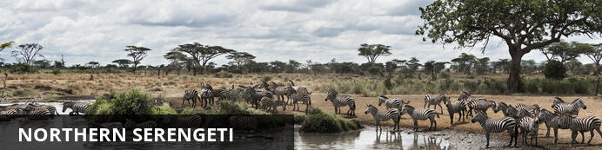
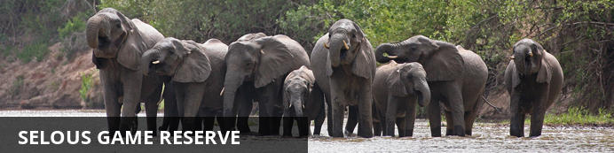

7 Nights Private Family Safari
Northern Serengeti - Selous Game Reserve
8 Days / 7 Nights
Group Size: 4/10 (Min/Max)
Reference: Nomad - Serengeti / Selous
Date of Issue: February 26, 2018

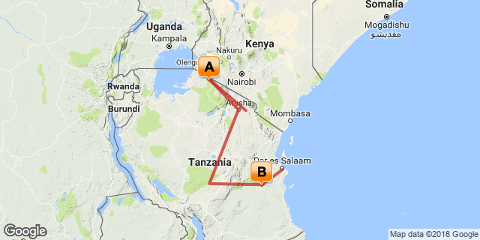

Click here to view your Digital Itinerary

Introduction
A 7-night family safari combining Northern Serengeti with the Selous Game Reserve staying in Private and Exclusive-Use accommodation throughout with freedom to plan your day and partake in those activities that suit the family
This itinerary is best suited to the dry season (July to November)
On an all inclusive Private Basis with own 4x4 safari vehicle and guide throughout.
In both camps you will be the only guests at the facility - the ideal home away from home combined with exciting safari experiences.

Accommodation | Destination | Nights | Basis | Room Type
Mkombe's House Lamai | Northern Serengeti | 3 | FB+
Kiba Point Selous | Selous Game Reserve | 4 | FB+

Key
FB+: Dinner, bed, breakfast, lunch and activities daily

Price
2018 Rates (Per adult sharing):
US$ 10,414 - (1 July - 30 September / 22 - 31 December)
US$ 8,274 - (1 - 31 October)
US$ 5,664 - (5 January - 15 March / 1- 30 June / 1 November - 21 December)
Reduced child rates apply for the following age ranges:
Age 20 - 16 (discounts at Mkombe's House / Kiba Point)
Age 12 - 15 (as above plus reduced park fees)
Age 5 - 11 (as above plus reduced flights)
Under 5 - not permitted

Included
Flights and transfers shown in the itinerary, park fees (except where mentioned as an extra), all meals, house drinks, laundry and activities (private 4x4 game drives and short walks for those 12 and over).

Excluded
International flights, visa fees for Tanzania ($50 or $100 per person), insurance, gratuities, transfers, activities and accommodation before and after the outlined itinerary.

Day 1-3: Mkombe's House Lamai, Northern Serengeti

Day Itinerary
Arrival - self booked flight into JRO
Coastal Schedule Flight Kilimanjaro to Kogatende (10h50/13h00)
Transfer by Mkombe's House Lamai to Lodge
Mkombe's House Lamai for 3nts - private GP - exclusive use of camp - arrive for lunch

Consultant Notes
Walks only for those aged 12 and over.

Tanzania
The name Tanzania conjures up images of wildebeest stampeding across vast savannah, rain forests teeming with monkeys and birdlife, and great plains brimming with legions of game. All of these natural wonders and more are on offer in this exceptionally diverse African nation. Visitors typically visit Tanzania to partake in at least one of the four well known Tanzanian tourist experiences: a relaxing seaside vacation on the picturesque island paradise of Zanzibar, an underwater tour of some of the world’s most renowned dive sites around the gorgeous Spice Islands, a safari adventure in some of Africa’s most impressive game reserves, or a hiking excursion around Mount Kilimanjaro National Park. Whichever of these incredible holidays you choose, you will undoubtedly be welcomed by some fabulously friendly and peaceful inhabitants who, despite being divided into 120 different ethnic groups and cultures, live in harmony with one another and provide some of the most wonderfully exotic local cuisine you could imagine. With all of this diversity on offer, the most difficult part of your Tanzanian holiday experience is likely to be deciding where to go!

Northern Serengeti
The Serengeti is one of the most famous wildlife areas in the world and home to the annual wildebeest migration. The Serengeti National Park itself covers 14,750 km2 of grassland plains, open savannah, riverine forests and woodlands. It lies in the north of Tanzania, bordered by Kenya and the Masai Mara National Reserve in the north, the Ngorongoro Crater Area to the southeast, the Maswa Game Reserve to the south west and the Loliondo Game Controlled Area area to the east. Together, all these areas form the larger Serengeti ecosystem which almost all see the wildebeest herds at some point during their annual circuit.
The northern Serengeti area of lush, rolling grassland and tree-lined watercourses is the most northerly point of the migration journey, together with Kenya's Masai Mara. During the dry season from July to October, the herds mass on both banks of the Mara River, frequently crossing - and braving the crocs - in response to local weather patterns that only they seem to understand.
Unlike the southern plains of the Serengeti that dry out, forcing all but the hardiest of species to leave, this area remains lush and green. There's a collective sigh of relief from the resident game when the one and a half million migrating wildebeest - and the madness that follows them - leave town for a few months. And the resident game in the area is spectacular. Plains game in the form of zebra, topi, gazelles, impala, buffalo and giraffe all frequent the area throughout the year. Lion are rarely far away and leopard, ever present, but always elusive, stalk the rocky kopjes and river lines.

Overnight: Mkombe's House Lamai View iBrochure
This self-contained private house for ten, totally designed around families and groups of friends, is charm itself, and set plum in the middle of one of Serengeti’s richest mammal habitats. Solitary under huge skies and amidst the great grassland plains, it grants complete freedom from other people and schedules. It’s also excitement-central: a lively base for expertly guided forays into the bush: scouting buffalo, elephants, lion, crocodiles – and the famous wildebeest river crossings.
The House is fully self-contained with two en-suite double/twin rooms, each with a nearby secure and en-suite children’s room. The House can sleep a total of 4 adults and 6 children comfortably and there is no minimum age. There are cots, high chairs and car-seats provided for the little ones.Each day, meals are planned with the in-house chef, allowing for lots of flexibility and plenty of choice from a menu loaded with fresh produce, home-baking and delicious flavours. The House incorporates a private dining room and lounge in addition to outside chill-out areas, a plunge pool and larger swimming pool and magnificent views across the Northern Serengeti.
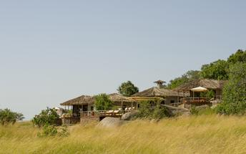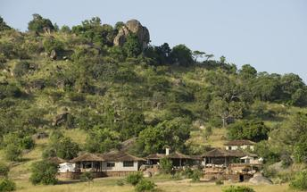

Included
Includes - all meals, house drinks, laundry and shared activities (4x4 game drives and short walks)

Excluded
Excludes - non-house drinks

Day 4-7: Kiba Point Selous, Selous Game Reserve

Day Itinerary
Transfer by Mkombe's House Lamai to Kogatende airstrip
Coastal Schedule Flight Kogatende to Selous/Kiba (09h25/17h05) via Arusha and Ruaha. Transfer by Kiba Point to Lodge
Kiba Point for 4nts - Private GP - Exclusive use of camp

Consultant Notes
Walks only for those aged 12 and over.

Selous Game Reserve
The remote and little-visited Selous Game Reserve covers more than 5% of Tanzania’s total area and is the largest of its kind in Africa. At an unbelievable 55,000 sq km it is almost twice the size of Belgium and four times larger than the famous Serengeti in the North. The landscape here has remained almost as it was before tourism began and the massive park has only a few accommodation options. The Great Rufiji River and its tributaries are the lifeblood of the reserve, creating a network of forests and woodlands around the lagoons, sandbanks and lakes with tall palm trees adding to the scenic splendour. Boating, walking safaris and fly camping are all available in the Selous.
By air, the Northern Selous is defined by the Rufii River. A mile wide in places, its courses are deeply carved in the soft sandy soil and visible for miles as you approach by light aircraft. Any tracks here are beaten not by the small number of visitors that come to stay, but by the feet of generations of hippos and elephant whose influence has shaped the landscape, at least as much as the river.
And the scenery changes quickly, in a matter of a few miles miombo woodland - home to hartebeest, zebra and herds of buffalo - gives way to wide grassy valleys, strangely reminiscent of English park land; thick stands of doum palms reveal glittering lakes burgeoning with life of all kinds.
And sand rivers, literally rivers of dry sand bleached white and littered with the sculptural forms of dead leadwood trees, are one of the most alluring aspects of this area. They are also a magnet to game, drawn to the fresh water that flows beneath the surface.
This area is home to all the major mammal species - lion, leopard, elephant, buffalo and even the very illusive black rhino.

Overnight: Kiba Point Selous View iBrochure
Kiba point is a totally exclusive little retreat in the heart of one of the most game-rich areas the Selous. It's set back off the river, with only 4 large and open-fronted rooms. Bathrooms are bush deluxe, with flush toilets, indoor and outdoor showers and hot and cold water as and when you want. Each room has its own plunge pool set into the edge of the deck, and there is also a large pool at the main thatched mess, where you can also sink into comfortable sofas and chairs for an afternoon of general laziness.
Kiba Point has its own small team of guides and staff, all of whom can help you plan your activities. Head out every day either on foot, by boat or by vehicle - as you want and when you want - that's the beauty of your own private camp.
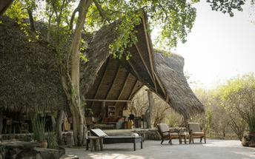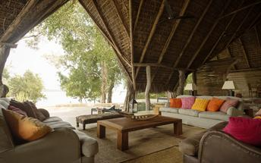

Included
Includes - all meals, house drinks, laundry and shared activities (4x4 game drives and short walks)

Excluded
Excludes - non-house drinks

Day 8: Departure

Day Itinerary
Transfer by Kiba Point to Kiba Airstrip
Coastal Schedule Flight Selous/Kiba to Dar (09h15/10h05)
Transfer in DAR between terminals
Departure - self booked flight from Dar (International flights TBC)

Transport

Flight Information
Date | Flight | Airline | Departure Airport | Time | Arrival Airport | Time | Class | Ref
 | Scheduled | Coastal Aviation | Kilimanjaro International Airport [JRO] | 10:15 | Kogatende Airstrip | 13:00
 | Scheduled | Coastal Aviation | Kogatende Airstrip | 9:25 | Arusha Airport [ARK] | 11:45
 | Scheduled | Coastal Aviation | Arusha Airport [ARK] | 12:45 | Msembe Airstrip | 14:20
 | Scheduled | Coastal Aviation | Msembe Airstrip | 14:30 | Kiba Airstrip | 14:40
 | Scheduled | Coastal Aviation | Kiba Airstrip | 9:15 | Julius Nyerere International Airport [DAR] | 10:05

Transfers
Date | Company | Pick Up | Drop Off | Time | Vehicle
 |  | Kogatende Airstrip | Mkombe's House Lamai
 |  | Mkombe's House Lamai | Kogatende Airstrip
 |  | Kiba Airstrip | Kiba Point Selous
 |  | Kiba Point Selous | Kiba Airstrip

Travel Information
We strongly recommend you review the current travel advice to be found at www.gov.uk/foreign-travel-advice and https://travel.state.gov/content/passports/en/alertswarnings.html before booking and ensure you remain up to date with this advice before traveling.

Terms and Conditions

Safaris and Expeditions Terms and Conditions
TERMS AND CONDITIONS
Reservations & Payment
Trips are booked and confirmed when Safaris & Expeditions, hereafter referred to as the Company, is in receipt of a 30% deposit of the total package cost. The Company must receive the full balance of payments no later than 61 days prior to the start of the trip.
Cancellations & Refunds
Cancellation of a reservation must be in writing and shall be effective upon its acknowledged receipt by the Company. In the event of the cancellation or postponement of a confirmed safari, you will become liable for a percentage of the full safari cost, as set out below.
Cancellation:
- 61 days or more before the start of the safari: 30% of total safari cost
- 60 to 31 days before the start of the safari: 50% of total safari cost
- 30 days or less before the start of the safari: 100% of total safari cost
- If you are a "no-show," the Company shall be entitled to treat your reservation as cancelled without notice and the total safari cost will be charged and forfeited
No refunds are given for:
- Circumstances beyond the Company's control resulting in alternative arrangements of an equivalent quality necessary to ensure the safety and / or further participation and enjoyment of your trip
- If you do not appear for any accommodations, service, sightseeing or trip segment without notifying the Company
- If you leave your trip after it has begun, or miss any scheduled sightseeing, activities or accommodations
The Company acts as a booking agent for other independent contractors providing accommodation, transportation, insurance and other services. Each of these companies is an independent corporation with its own management and is not subject to the control of the Company. Transportation, accommodation and other services provided by the independent contractors are offered subject to the terms and conditions contained in the tickets, exchange orders or vouchers issued by them and/or their suppliers. Because the Company does not have the right to control the operations of the independent operators and their suppliers, the Company CANNOT BE LIABLE FOR ANY PERSONAL INJURY OR PROPERTY DAMAGE which may arise out of these services.
The Company reserves the right to cancel any itinerary or any part of it, to make such alterations in the itinerary as it deems necessary or desirable, to refuse to accept or to retain as a member of any trip any person at any time, and to pass on to trip members any expenditure occasioned by delays or events beyond its control. In case of any appreciable variation in its cost, the Company reserves the right to adjust its rates.
Risks
There are certain inherent risks involved in participating in the type of trips sold by the Company. You accept these at your own risk. It is your responsibility to take all appropriate medical advice prior to departure as to whether you are fit enough to undertake the trip booked.
Insurance
The Company recommends that you obtain insurance covering accidental death and disability, loss of personal effects, emergency medical evacuation, major medical and trip cancellation.
Surcharges
Although the Company hopes that it will not need to levy surcharges, it reserves the right to do so on the invoice amount if this becomes necessary. The Company will endeavor to notify you in writing as soon as it is aware of any likely surcharge. Any refund made by the Company shall be at its sole and absolute discretion. Surcharges may result from, but not limited to, unexpected increases in Park, Conservation or other Government fees and increases in taxes including VAT that were not in force at the time of billing. In the case of such increases occurring, the company will do all in its power to minimize such increases.
Terms & Conditions
These terms and conditions govern the relationship between the Company and you, to the total exclusion of any other terms and conditions. No alteration to the terms and conditions may be made by any of the Company employees, authorized representatives or agents, unless in writing by an authorized officer of the Company. An authorized officer of the Company shall make all decisions and matters subject to the Company's discretion.
Carriage by Land, Sea & Air
Carriage by Land, Sea and Air is subject to the terms and conditions of the carrier with whom you travel and to international conventions, some of which may limit liability. Land, Sea and Air travel are also subject to operational decisions of carriers and air and sea ports which may result in cancellations, delays or diversions, over which the Company has no control and for which the Company accepts no liability whatsoever.
Consent
The payment of a deposit or any other partial payment for a reservation constitutes consent to all provisions of the conditions and general information enclosed herewith. The terms under which you agree to take these trips cannot be changed or amended except in writing signed by an authorized officer of the Company.

