SOUTH AFRICA ODYSSEY

The South Africa Odyssey is an exceptional, long wandering journey through South Africa. From city life to adventure, wildlife to culture, breath-taking scenery to sun-soaked coasts, South Africa is a premier travel destination.

Our Odyssey begins in Johannesburg and travels through Mpumalanga, with visits along the Panorama Route as well as the Kruger National Park, a safari extravaganza. Once you have encountered the wildlife of the country, you will then travel to the Kingdom of eSwatini, where a vibrant cultural journey inspires. Zululand is where ancient kings once hunted, where the Big Five now roam, conserved, and protected. The last leg of the odyssey is a Garden Route journey ending with a few days spent in the city of Cape Town.

DATE | ROUTING
DAY 1 – Sunday | JOHANNESBURG
DAY 2 – Monday | JOHANNESBURG – MPUMALANGA
DAY 3 – Tuesday | MPUMALANGA
DAY 4 – Wednesday | MPUMALANGA
DAY 5 – Thursday | MPUMALANGA – eSWATINI (SWAZILAND)
DAY 6 – Friday | eSWATINI (SWAZILAND) – ZULULAND
DAY 7 – Saturday | ZULULAND – DURBAN (UMHLANGA)
DAY 8 – Sunday | DURBAN (UMHLANGA) – GQEBERHA (PORT ELIZABETH) - KNYSNA
DAY 9 – Monday | KNYSNA – TSITSIKAMMA - KNYSNA
DAY 10 – Tuesday | KNYSNA – OUDTSHOORN
DAY 11 – Wednesday | OUDTSHOORN – CAPE TOWN
DAY 12 – Thursday | CAPE TOWN
DAY 13 – Friday | CAPE TOWN
DAY 14 – Saturday | CAPE TOWN
 | END OF TOUR

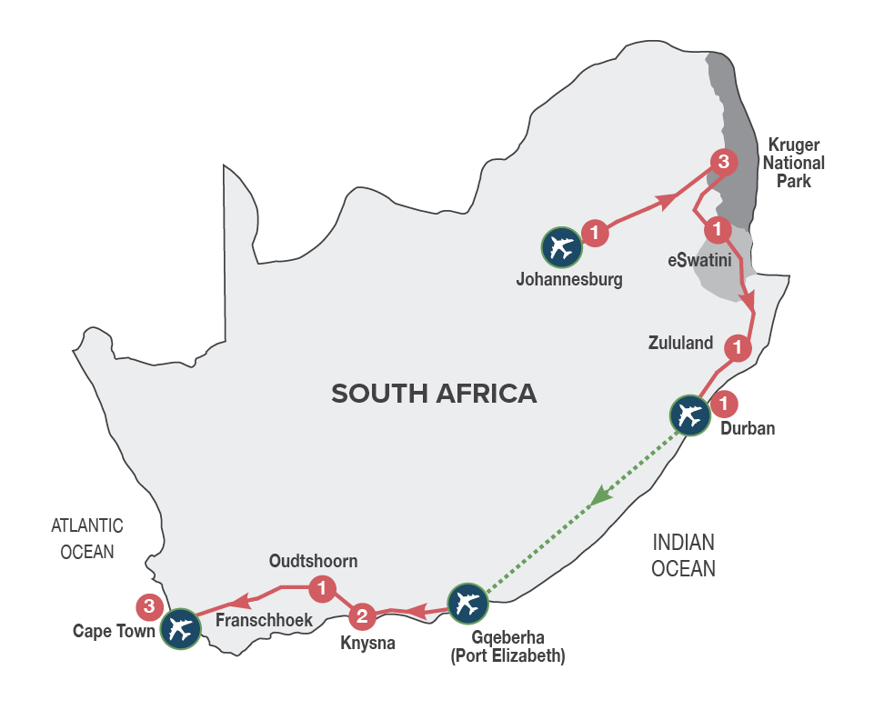
Small Group Tour
Minimum 2 guests / Maximum 10 guests

DURATION

14 Days/13 Nights

ROUTING
JOHANNESBURG - CAPE TOWN

INCLUDES
- 22 Meals: 13 breakfasts, 3 lunches, 6 dinners including gratuities
- 13 Nights’ accommodation including porterage
- Transportation including toll fees in air-conditioned vehicles
- Services of a professional English-speaking tour guide
- Entrance fees as specified in the itinerary
- Bottled water in eco-friendly packaging
TOUR HIGHLIGHTS
- Traverse the famous Long Tom Pass en route from Johannesburg to Mpumalanga
- Visit the spectacularly scenic Three Rondavels, Bourke’s Luck Potholes and God’s Window
- Experience an open vehicle game safari in the Kruger National Park including an introduction to the KNP anti-poaching Dog Unit
- Meet the friendly people of eSwatini (Swaziland) and experience their culture through singing and dancing
- Boat game cruise on Lake St Lucia
- Visit Tsitsikamma National Park and the scenic Storms River Mouth
- Enjoy a delicious dinner at a delightful lagoon side restaurant in Knysna
- Immersive journey into the mythical Knysna Forests, discovering the legends build around woodcutters, elephants, steam trains and gold miners
- Visit the ‘Dolphin Point’ lookout in Wilderness, with spectacular views of Wilderness beach and beyond
- Guided tour of the Cango Caves and a guided tour of a working ostrich farm in Oudtshoorn
- Visit a rural farm school in the Barrydale area with the opportunity to interact with the children. This visit supports our Barrydale Farm School Development Fund that encourages local education of underprivileged children in rural communities. School will be closed 01 – 16 Jan; 21 Mar - 02 April; 15 Jun.– 08 Jul; 21 – 30 Sep; 11 - 31 December 2024
- Explore the small towns along the well-known Route 62 between Oudtshoorn and Cape Town
- Authentic African dinner experience with a 14-dish taste safari paired with entertainment
- Three overnights in Cape Town, spectacularly set at the foot of Table Mountain
- Full Day Cape Peninsula Tour including the Cape of Good Hope, ‘the fairest cape in the whole circumference of the earth’
- Meals included in this trip support sustainable food production with at least 30% of the food on the menu being sourced locally (within 50-80km) of where it’s prepared
- Enjoy a variety of carefully chosen optional MAKE TRAVEL MATTER® Experiences that positively impact our travellers and the communities we visit.

EXCLUDES
FLIGHT: DURBAN (UMHLANGA) – GQEBERHA (PORT ELIZABETH) (DUR/PLZ) and departure tax on Day 8.
Recommended flight – FA421 departing Durban at 14h05, arriving Gqeberha (Port Elizabeth) 15h35.

SELECTED DEPARTURE DATES
Jan24 | Feb24 | Mar24 | Apr24 | May24 | Jun24 | Jul24 | Aug24 | Sep24 | Oct24 | Nov24 | Dec24
7;14;21;28 | 4;11;18;25 | 3;10;17;24;31 | 7;14;21;28 | 5;12;19;26 | 2;9;16;23;30 | 7;14;21;28 | 4;11;18;25 | 1;8;15;22;29 | 6;13;20;27 | 3;10;17;24 | 1;8

VISA REQUIREMENTS
This tour travels through eSwatini (Swaziland). Please check visa requirements, as certain nationalities may require visas to travel through eSwatini (Swaziland).

There is an opportunity to maximise your experience of the Cape Winelands, with an optional overnight stay (unescorted and at a supplementary cost) in the picturesque village of Franschhoek on Day 11, rejoining the main tour on Day 12.

FRANSCHHOEK WINELANDS OPTION
RACK RATES are valid 01/01/24-31/12/24 as a supplement to the tour price:
Accommodation based on 4* Protea Hotel Franschhoek or similar (this option is subject to availability at the time of booking)
R 3 220.00 per person sharing twin/double accommodation
R 3 415.00 per single person

RACK RATES valid 01/01/24-30/04/24
R 56 265.00 per person sharing twin/double accommodation
R 67 920.00 per single person
Rates exclude cost of Durban (Umhlanga) – Gqeberha (Port Elizabeth) flight on Day 8

RACK RATES valid 01/05/24-31/07/24
R 53 175.00 per person sharing twin/double accommodation
R 63 385.00 per single person
Rates exclude cost of Durban (Umhlanga) – Gqeberha (Port Elizabeth) flight on Day 8

RACK RATES valid 01/08/24-31/12/24
R 57 530.00 per person sharing twin/double accommodation
R 69 820.00 per single person
Rates exclude cost of Durban (Umhlanga) – Gqeberha (Port Elizabeth) flight on Day 8

Accommodation included:
4* Protea Hotel Balalaika or similar x 1 night
3* Hazyview Sun Hotel or similar x 3 nights
5* The Royal Villas or similar x 1 night
3* Anew Hotel Hluhluwe or similar x 1 night
4* Protea Hotel Umhlanga or similar x 1 night
4* Rex Hotel or similar x 2 nights
4* Hlangana Lodge or similar x 1 night
4* President Hotel or similar x 3 nights

Transportation:
Transportation is in air-conditioned touring vehicles appropriate to the requirements of the tour
- 2 guests will travel in a sedan vehicle
- 3-10 guests will travel in a 13-seater vehicle

DAY 1 – SUNDAY JOHANNESBURG
On arrival in Johannesburg at OR Tambo International Airport, you’ll be met by your representative and transferred to your hotel. Johannesburg is the largest and most populous city in South Africa. It is also the source of a large-scale gold and diamond trade due to its location on the mineral-rich Witwatersrand range of hills. The remainder of the day is at leisure and unescorted. Why not enjoy an optional (own account) sightseeing tour of Soweto, learning more about the struggle for freedom in South Africa, or simply relax at your hotel? At 19h00 we will meet at reception for a briefing on the tour and a chance to meet fellow travellers.
Distance travelled today: 35 kms

DAY 2 – MONDAY JOHANNESBURG - MPUMALANGA
Depart Johannesburg after breakfast and head for Pretoria, South Africa’s capital city, for a short orientation tour, before continuing to the Mpumalanga Province, known as “Paradise Country”. Dropping several hundred feet into the lush subtropical region of the Lowveld, we travel via the historic towns of Dullstroom and Lydenburg. After traversing the famous Long Tom Pass, we travel via Sabie and arrive late afternoon into Hazyview, the safari hub of the Kruger National Park. [Breakfast & Dinner]
Distance travelled today: 425 kms

DAY 3 – TUESDAY MPUMALANGA
After an early morning breakfast, we’ll drive along the spectacular ‘Panorama Route’, offering views of amazing scenery including the 26-kilometre long Blyde River Canyon (home to the Three Rondavels), Bourke’s Luck Potholes and historic God’s Window, a breath-taking view (weather permitting) of the edge of the escarpment taking in the Kruger National Park. We arrive back in Hazyview in the late afternoon where the remainder of the day is at leisure to relax. [Breakfast & Dinner]
Distance travelled today: 320 kms

DAY 4 – WEDNESDAY MPUMALANGA
The day begins with early morning coffee or tea, followed by a thrilling open vehicle game safari (with English speaking game ranger) through the Kruger National Park with pre-packed breakfast. Kruger is one of the world’s greatest national parks, home to a stunning array of wildlife. Search for the ‘Big Five’ (rhino, buffalo, lion, leopard, and elephant) as well as prolific birdlife and numerous other game species. The game safari includes an introduction to the Anti-Poaching Dog Unit (Project Watchdog), that was established because of the increase in rhino poaching worldwide. Learn about the dogs that are trained to track poachers in the field, detect firearms, ammunition and wildlife products that enter and exit through the Kruger National Park gates. A portion of the trip price of this MAKE TRAVEL MATTER® Experience goes towards ensuring that these dogs receive the best possible care in support of the vital work they do. The experience directly advances UN Global Goal 15: Life on Land. The afternoon is at leisure at your hotel. An afternoon open vehicle game drive is available as an extension to the morning game drive (optional and for own account). [Breakfast & Dinner]
Distance travelled today: 120 kms

DAY 5 – THURSDAY MPUMALANGA – eSWATINI (SWAZILAND)
This morning we travel to eSwatini (Swaziland), an independent Kingdom within the borders of South Africa, known for its lovely scenery, crafts and colourful indigenous culture. An interactive cultural experience inclusive of lunch, introduces us to the charming people of eSwatini (Swaziland) and their traditions. We travel via the capital city, Mbabane, to the beautiful Ezulwini Valley for overnight in eSwatini (Swaziland) and a sumptuous dinner at your hotel. [Breakfast, Lunch & Dinner]
Distance travelled today: 310 kms

DAY 6 – FRIDAY eSWATINI (SWAZILAND) - ZULULAND
After breakfast we will continue south through eSwatini (Swaziland), before re-entering South Africa. Travel into Zululand, passing traditional round huts and endless vistas. There is an option to enjoy an afternoon open vehicle game safari (optional and for own account with an English-speaking game ranger) in the Hluhluwe-iMfolozi Game Reserve, which contains an immense diversity of fauna and flora and is particularly famous for its conservation of black and white rhino.
Overnight in Hluhluwe-iMfolozi region. [Breakfast]
Distance travelled today: 360 kms

DAY 7 – SATURDAY ZULULAND – DURBAN (UMHLANGA)
This morning we will join a cruise on Lake St Lucia (depending on favourable weather conditions) before departing for Durban. Our journey takes us past traditional Zulu Kraals, Eucalyptus plantations and sugar cane fields. We arrive early afternoon and the remainder of the afternoon is at leisure and unescorted to enjoy the golden beaches of the Indian Ocean. Overnight in Durban (Umhlanga). [Breakfast]
Distance travelled today: 275 kms

DAY 8 – SUNDAY DURBAN (UMHLANGA) - KNYSNA
After breakfast, transfer to Durban (Umhlanga) airport for the short southward flight to Gqeberha (Port Elizabeth), where we will be met by our representative and once everyone has arrived, we head westwards along the Garden Route, which follows the Indian Ocean coastline, and is bordered inland by soaring mountain ranges and indigenous forests. You’ll arrive at your hotel in Knysna, known as the oyster box of South Africa, nestling on the banks of a beautiful lagoon, in the heart of the Garden Route. Overnight in Knysna. [Breakfast]
Distance travelled today: 360 kms

DAY 9 – MONDAY KNYSNA – TSITSIKAMMA - KNYSNA
After breakfast, visit the spectacular Tsitsikamma National Park, Storms River Mouth (weather permitting) and the magical Knysna Forests, the stamping ground of the elusive Knysna elephants. Discover the stories of the woodcutters who worked the forests, the elephants that were hunted to extinction and the discovery of gold. Our expedition into the forest starts with a visit to the Dalene Matthee Big Tree Memorial. The enormous Yellowwood tree of over 880 years was named after Matthee, best known author of four books on the Knysna Forest. Enjoy a delicious lunch en route of traditional cuisine and local treats. Overnight in Knysna with dinner at Drydock Restaurant, renowned for dishes with glorious aromas and flavours, using the finest local ingredients and freshly picked herbs from the region. [Breakfast, Lunch & Dinner]
Distance travelled today: 300 kms

DAY 10 – TUESDAY KNYSNA - OUDTSHOORN
Travel through the Outeniqua Pass to Oudtshoorn, known as the “ostrich capital” and the centre of the world’s Ostrich farming industry. Along the way, visit ‘Dolphin Point’, an extraordinary viewpoint in Wilderness. In Oudtshoorn, we’ll visit an Ostrich Farm for a fun filled interactive tour and light lunch that includes local specialities such as Ostrich Steak, before taking a tour of the spectacular limestone caverns of the Cango Caves, one of the world’s great natural wonders, sculpted by nature through the ages. We will arrive at our hotel in the late afternoon, in time to check in and relax before dinner (for own account). Overnight in Oudtshoorn. [Breakfast & Lunch]
Distance travelled today: 210 kms

DAY 11 – WEDNESDAY OUDTSHOORN – CAPE TOWN
There is an option (for own account and subject to availability) to enjoy an early morning Meerkat Safari. Witness these incredible wild habituated creatures emerging out of their burrows, in time to soak up the sun before they head about their daily activities (weather permitting). A portion of the monies paid by guests for this MAKE TRAVEL MATTER® Experience go towards the Buffelsdrift Foundation, that focusses on Wildlife conservation in the Klein Karoo region, habitat conservation and the local community. The experience directly advances UN Global Goal 15: Life on Land. After this thrilling experience, head back for a delicious breakfast. After breakfast, the journey continues through the ‘Little Karoo’ to Barrydale, where you will have the opportunity to visit a local farm school, to interact with the children and teachers, spending time with them in the classroom, learning more about this rural community. A portion of the trip monies go towards our Barrydale Farm School Development Fund, that supports local education of underprivileged children in rural communities. (The school visit is subject to the school being open). Continue to Cape Town, spectacularly set at the foot of Table Mountain. Overnight in Cape Town [Breakfast]
Distance travelled today: 468 kms

DAY 12 – THURSDAY CAPE TOWN (UNESCORTED)
Enjoy a full day at leisure. Perhaps join a sightseeing tour of Cape Town and Table Mountain (own account) or join us for a Marine Big Five Safari (own account), where you may see great white sharks, whales, Cape fur seals and a variety of seabirds on a 2-hour boat cruise with marine biologists on hand to explain more about these amazing animals that visit our shores. Although a small city, Cape Town is packed with sightseeing attractions, excellent bars, cafés, and restaurants as well as colourful craft markets. Enjoy a fun filled evening with interactive entertainment and delectable food at Gold Restaurant. Overnight in Cape Town. [Breakfast & Dinner]
Distance travelled today: 10 kms

DAY 13 – FRIDAY CAPE TOWN
Enjoy a full day tour of the Cape Peninsula, offering some of the most spectacular coastal scenery in the world. Drive through Sea Point, the seaside village of Hout Bay (where you can enjoy an optional and for own account seal island boat cruise) and then on to Cape Point where (by tradition) it is said that the Atlantic and Indian Oceans meet. We'll return to Cape Town by way of Simon's Town, where we visit the Penguin colony at Boulders Beach (entrance fee for own account) and Fish Hoek fishing village. Overnight in Cape Town. [Breakfast]
Distance travelled today: 200 kms

DAY 14 – SATURDAY CAPE TOWN
Enjoy some last-minute shopping (unescorted) or sightseeing (own account). The Robben Island Tour (for own account & time permitting), which departs from the Victoria & Alfred Waterfront, offers a fascinating excursion, or perhaps just wander through the variety of shops and boutiques catering for all tastes and budgets. Later you will be transferred to the airport, harbour, or railway station for your onward journey. [Breakfast]

FRANSCHHOEK WINELANDS OPTION

If you’ve always dreamed of experiencing an overnight in the scenic Cape Winelands, then this option is for you. You will have the opportunity to maximise your experience of picturesque vineyards, breath-taking scenery, warm hospitality, and fine wines, thereafter, re-joining the tour with minimum disruption.

DAY 11 – WEDNESDAY OUDTSHOORN - FRANSCHHOEK
Travel to Franschhoek, a picturesque village surrounded by spectacular vineyards, where French Huguenots settled more than 300 years ago, bringing with them their age-old French wine and food culture. Overnight in Franschhoek. [Breakfast]

DAY 12 – THURSDAY FRANSCHHOEK – CAPE TOWN
After a leisurely breakfast, meet your tour guide and set out to the picturesque Winelands of Paarl and Stellenbosch, surrounded by awe inspiring scenery. With extraordinary wine estates and fascinating historical landmarks to explore, your knowledgeable guide will create a memorable Winelands experience. Enjoy two wine tastings and a cellar tour before continuing to Cape Town, where you’ll re-join the main tour. [Breakfast & Dinner]

OPTIONAL EXCURSIONS
Enhance your journey with optional excursions, available for pre-booking, subject to a minimum of 2 adults travelling:

** MAKE TRAVEL MATTER® Experiences seek to encourage the greatest community benefit from travel and tourism, while also educating guests about The UN Global Sustainable Development Goals and the local community actions being taken to advance them.

Rack Rates valid 01/01/24 – 31/12/24:

DAY 1 – SUNDAY – JOHANNESBURG – AFTERNOON SOWETO TOUR – R 1 080.00 per person
Soweto is unlike any suburb you’ve ever seen or been to, yet the history of struggle encapsulated here is a cornerstone of the South African story.

DAY 4 – WEDNESDAY – KRUGER NATIONAL PARK – AFTERNOON OPEN VEHICLE GAME SAFARI – R 990.00 per person
For the wildlife enthusiasts a second open vehicle safari, as an extension to the morning safari, in one of the world’s most renowned game reserves.

DAY 6 – FRIDAY – HLUHLUWE-IMFOLOZI PARK – AFTERNOON OPEN VEHICLE GAME SAFARI – R 1 065.00 per person
Enjoy an afternoon, 3-hour open vehicle game safari into the Hluhluwe-Imfolozi Park, Africa’s oldest game reserve and world renowned for its highly successful white rhino conservation programme.

** DAY 11 – WEDNESDAY - OUDTSHOORN – MAKE TRAVEL MATTER® Experience - EARLY MORNING MEERKAT SAFARI –

R 850.00 per person
There is an option to enjoy an early morning Meerkat Safari. Witness these incredible wild habituated creatures emerging out of their burrows, in time to soak up the sun before they head about their daily activities (weather permitting & subject to availability at the time of booking). A portion of the monies paid by guests for this MAKE TRAVEL MATTER® Experience go towards the Buffelsdrift Foundation, that focusses on Wildlife conservation in the Klein Karoo region, habitat conservation and the local community. The experience directly advances UN Global Goal 15: Life on Land.

DAY 12 – THURSDAY – CAPE TOWN – MORNING TABLE MOUNTAIN & CAPE TOWN CITY TOUR - R 745.00 per person, excluding the cost of the Table Mountain cable way ticket.
Travel by cable car to the top of Table Mountain (weather permitting), then descend to further explore the city.

** DAY 12 – THURSDAY – CAPE TOWN – MAKE TRAVEL MATTER® Experience - MARINE BIG FIVE SAFARI EXPERIENCE –

R 3 500.00 per person
Join us for a marine safari where you may see great white sharks, whales, Cape fur seals and a variety of seabirds. On a 2-hour cruise from Gansbaai, Marine Biologists will be on hand to explain more about the amazing animals that visit our shores. A portion of the monies paid by guests for this MAKE TRAVEL MATTER® Experience go towards the Dyer Island Conservation Trust that delivers conservation and research programmes to protect the biodiversity of the marine eco-system surrounding Dyer Island. The experience directly advances UN Global Goal 14: Life below Water.

