GARDEN ROUTE, SAFARI & WINELANDS

South Africa is well known for its attractions that entice, and the Garden Route, a safari experience and the Cape Winelands are some of the most sought after. The Garden Route, Safari & Winelands package combines the best elements for a journey beyond expectation.

This round trip begins in Cape Town and travels through Barrydale, Oudtshoorn and Knysna, where you will experience local life at a farm school, before enjoying the ‘ostrich feather capital’ Oudtshoorn and Knysna, a verdant paradise. Your safari will be reveled in at a private game reserve that is malaria-free and features the Big Five. The journey concludes with a trip to Hermanus, a whale-watching mecca (in season) and ending in Franschhoek, South Africa’s French corner, where wine and art create the ambience of a distinguished experience.

DATE | ROUTING
DAY 1 - Thursday | CAPE TOWN – OUDTSHOORN
DAY 2 - Friday | OUDTSHOORN – KNYSNA
DAY 3 - Saturday | KNYSNA – PLETTENBERG BAY - KNYSNA
DAY 4 - Sunday | KNYSNA - ALBERTINIA
DAY 5 - Monday | ALBERTINIA – HERMANUS
DAY 6 - Tuesday | HERMANUS – CAPE TOWN
 | END OF TOUR

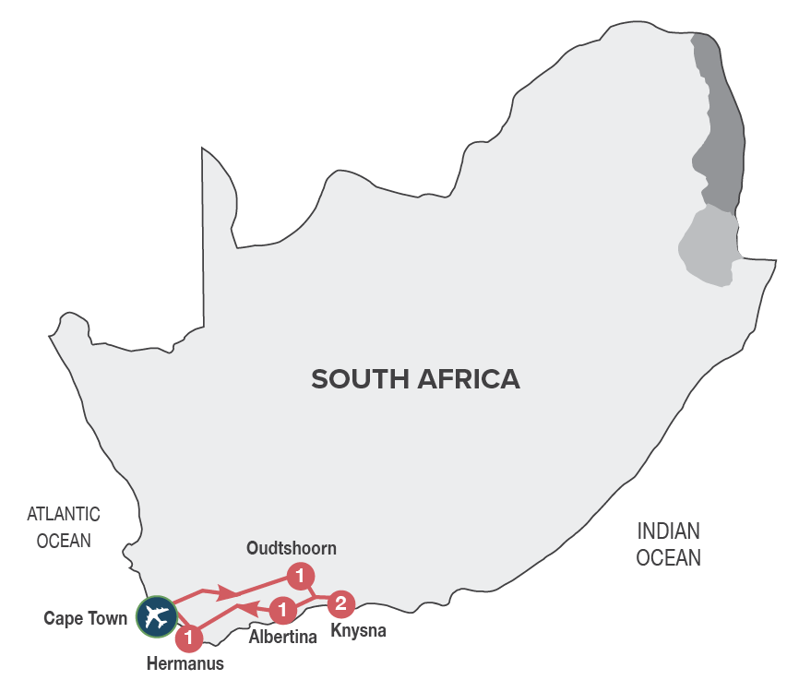
Small Group Tour
Minimum 2 guests / Maximum 10 guests

DURATION
6 days/5 nights

ROUTING
CAPE TOWN - KNYSNA - CAPE TOWN

INCLUDES
- 10 Meals: 5 breakfasts, 2 lunches, 3 dinners including gratuities
- 5 Nights’ accommodation including porterage
- Transportation including toll fees in air-conditioned vehicles
- Services of a professional English-speaking tour guide
- Entrance fees as specified in the itinerary
- Bottled water in eco-friendly packaging

TOUR HIGHLIGHTS
- Explore the small towns long the famous Route 62 between Cape Town and Oudtshoorn
- Enjoy tea & scones at the Montagu Country Hotel, the only original Art Deco Hotel in South Africa
- Visit a rural farm school in the Barrydale area with the opportunity to interact with the children. This visit supports our Barrydale Farm School Development Fund that encourages local education of underprivileged children in rural communities. School will be closed 01 – 16 Jan; 21 Mar - 02 April; 15 Jun.– 08 Jul; 21 – 30 Sep; 11 - 31 December 2024
- Sample top quality Port style wines in Calitzdorp, a town well known for its fortified wines
- Guided tour of the Cango Caves and a guided tour of a working ostrich farm in Oudtshoorn
- Visit the ‘Map of Africa’ viewpoint in Wilderness, a unique sight that is quite literally a Map of Africa
- Visit Tsitsikamma National Park and scenic Storms River Mouth
- Enjoy a leisurely walk or swim at Victoria Bay, one or the smallest and most beautiful bays along the Garden Route
- Open vehicle game safaris in a malaria-free Big Five private game reserve
- Visit to Hermanus, famous for shore-based whale watching during the whale season (August – November)
- Visit to Franschhoek, a picturesque village in the Cape Winelands
- Drive past the Victor Verster prison where Nelson Mandela was released from in 1990
- Meals included in this trip support sustainable food production with at least 30% of the food on the menu being sourced locally (within 50-80km) of where it’s prepared
- Enjoy carefully chosen optional MAKE TRAVEL MATTER® Experiences that positively impact our travellers and the communities we visit

SELECTED DEPARTURE DATES
 | Jan24 | Feb24 | Mar24 | Apr24 | May24 | Jun24 | Jul24 | Aug24 | Sep24 | Oct24 | Nov24 | Dec24
English | 4;18 | 1;15 | 7;21 | 11;25 | 9 | 6 | 4;25 | 8;22 | 5;19 | 3;17 | 7;21 | 5

RACK RATES valid 01/01/24-30/04/24 & 01/09/24-31/12/24
R 23 100.00 per person
R 27 225.00 per single person

RACK RATES valid 01/05/24-31/08/24
R 22 730.00 per person
R 26 690.00 per single person

Accommodation included:
4* La Plume Guest House or similar x 1 night
4* Rex Hotel or similar x 2 nights
4* Garden Route Game Lodge or similar x 1 night
4* Misty Waves Hotel or similar x 1 night

Transportation:
Transportation is in air-conditioned touring vehicles appropriate to the requirements of the tour
- 2 guests will travel in a sedan vehicle
- 3-10 guests will travel in a 13-seater vehicle

DAY 1 – THURSDAY CAPE TOWN - OUDTSHOORN
This morning you will be met at your hotel by your representative and depart for the ‘Little Karoo’, travelling via Montagu, a picturesque spa town. Enjoy tea and scones at the only original Art Deco Hotel in South Africa. Stop off in the town of Barrydale, where we will have the opportunity to visit a local farm school, interact with the children and teachers, spending time with them in the classroom, learning more about this rural community. A portion of the trip monies go towards our Barrydale Farm School Development Fund, that support local education of underprivileged children in rural communities. (The school visit is subject to the school being open). Sample top quality port style wines in Calitzdorp, before continuing to Oudtshoorn, the ‘ostrich feather capital’ and centre of the world’s Ostrich farming industry. Overnight in Oudtshoorn. Enjoy dinner at an Ostrich Farm, dining on local specialities. [Dinner]
Distance travelled today: 418 kms

DAY 2 – FRIDAY OUDTSHOORN - KNYSNA
After breakfast take a tour of the spectacular limestone caverns of the Cango Caves, one of the world’s great natural wonders, sculpted by nature through the ages. Return to Oudtshoorn for a fun filled interactive tour and light lunch at an Ostrich Farm, including local specialities such as Ostrich Steak. Our journey continues over the scenic Outeniqua Pass to George, the administrative hub of the Garden Route area and then onto Knysna, known as the oyster box of South Africa, nestling on the banks of a beautiful lagoon in the heart of the Garden Route. Along the way, visit the ‘Map of Africa’, an extraordinary viewpoint in Wilderness. Overnight in Knysna. [Breakfast & Lunch]
Distance travelled today: 204 kms

DAY 3 – SATURDAY KNYSNA – PLETTENBERG BAY - KNYSNA
After a leisurely breakfast, drive through the Tsitsikamma Forests. Explore this breathtaking stretch of the Garden Route, where mountains, indigenous forests, deep gorges, and lush vegetation hug the rugged coastline of cliffs and sandy beaches. Visit the spectacular Tsitsikamma National Park and Storms River Mouth (weather permitting). In the afternoon you’ll return to Knysna, with a stop in Plettenberg Bay, originally christened "Bahia Formosa" (beautiful bay) by early Portuguese explorers.
There is an option (for own account and subject to availability) to visit Monkeyland Primate Sanctuary, where you will be able to see a variety of primates, roaming free in the forest. A portion of the trip price of this MAKE TRAVEL MATTER® Experience, goes towards ensuring that these already endangered species can survive and reproduce for a future reintroduction into the wild. The experience directly advances UN Global Goal 15: Life on Land. There is also an option.
(for own account and subject to availability) to visit the Birds of Eden Sanctuary, the biggest single free flight aviary in the world. A portion of the trip price of this MAKE TRAVEL MATTER® Experience goes towards protecting genetically pure species of various Taxa in a semi-wild state and to hold the seeds of these Taxa for future reintroduction into the wild. The experience directly advances UN Global Goal 15: Life on Land. Lunch will be enjoyed en route.
Overnight in Knysna. [Breakfast & Lunch]
Distance travelled today: 200 kms

DAY 4 – SUNDAY KNYSNA - ALBERTINIA
After a leisurely breakfast, travel via George and Mossel Bay to Albertinia, a town set against the backdrop of the majestic Langeberg Mountain Range. En route, enjoy a leisurely walk or swim at Victoria Bay, one of the smallest and most beautiful bays along the Garden Route. Join an afternoon open vehicle game drive, at a malaria free private game reserve, that is home to an abundance of animal and birdlife, including the Big Five. Enjoy a relaxed dinner of safari cuisine, discussing the day’s game viewing. Overnight in the region of Albertinia. [Breakfast & Dinner]
Distance travelled today: 150 kms

DAY 5 – MONDAY ALBERTINIA - HERMANUS
Our safari adventure continues with an early morning open vehicle game drive. Our expert guide will endeavour to spoil us with sightings of the ‘Big Five’, general game and prolific bird life. Leaving the bush behind, our journey will take us to the picturesque Cape Dutch town of Swellendam. This charming town was founded in 1745 and is famous for its youngberries, eclectic architecture, and National Parks, as well as outdoor activities. Our journey further continues to the seaside resort of Hermanus, known as the heart of the whale route, offering the best land-based whale watching (August to November) in the world. Dinner at the Heritage Restaurant, one of the oldest fisherman’s cottages in Hermanus, where delectable dishes are created using seasonal, local produce. Overnight in Hermanus. [Breakfast & Dinner]
Distance travelled today: 370 kms

DAY 6 – TUESDAY HERMANUS - CAPE TOWN
After a leisurely breakfast depart Hermanus and travel to Franschhoek, a picturesque village surrounded by spectacular vineyards, where French Huguenots settled more than 300 years ago, bringing with them their age-old French wine and food culture. Our guide will take us on a tour through Franschhoek village, sharing with us the fascinating history of the French Huguenots, then drive past the Victor Verster prison, where Nelson Mandela was released from in 1990. Finally, onto Cape Town, the oldest city in South Africa, spectacularly set at the foot of Table Mountain where the tour ends on arrival. [Breakfast]
Distance travelled today: 180 kms

OPTIONAL EXCURSIONS
Enhance your journey with an optional excursion, available for pre-booking, subject to a minimum of 2 adults travelling:

Rack Rates valid 01/01/24 – 31/12/24:

** This MAKE TRAVEL MATTER® Experience seeks to encourage the greatest community benefit from travel and tourism, while also educating guests about The UN Global Sustainable Development Goals and the local community actions being taken to advance them.

** DAY 3 – SATURDAY – PLETTENBERG BAY – MAKE TRAVEL MATTER® Experience – MONKEYLAND PRIMATE SANCTUARY – R 450.00 per person
There is an option to visit Monkeyland Primate Sanctuary, where you will be able to see a variety of primates, roaming free in the forest. This award-winning sanctuary is well known for its efforts to rehabilitate and free previously caged primates. A portion of the trip price of this MAKE TRAVEL MATTER® Experience, goes towards ensuring that these already endangered species can survive and reproduce for a future reintroduction into the wild. The experience directly advances UN Global Goal 15: Life on Land.

** DAY 3 – SATURDAY – PLETTENBERG BAY – MAKE TRAVEL MATTER® Experience – BIRDS OF EDEN SANCTUARY – R 450.00 per person
There is an option to visit the Birds of Eden Sanctuary, the biggest single free flight aviary in the world. The sanctuary was developed to create a safe environment in which to release a large collection of free-flight African birds. A portion of the trip price of this MAKE TRAVEL MATTER® Experience goes towards protecting genetically pure species of various Taxa in a semi-wild state and to hold the seeds of these Taxa for future reintroduction into the wild. The experience directly advances UN Global Goal 15: Life on Land.

MONKEYLAND PRIMATE SANCTUARY / – BIRDS OF EDEN SANCTUARY COMBO Ticket – R 730.00 per person

