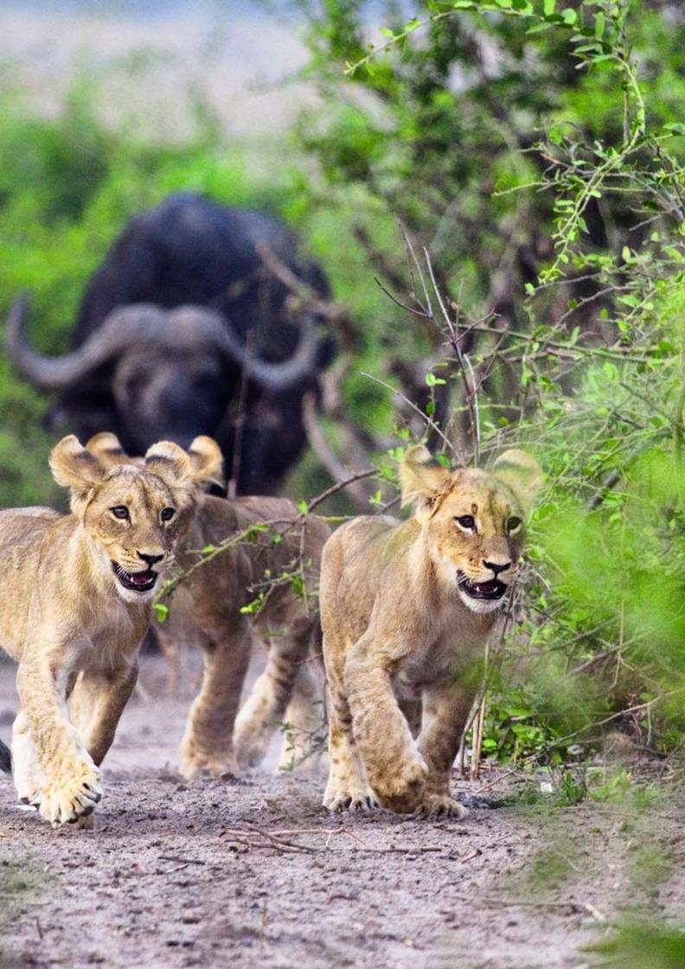


19-Day Namibia & Botswana Roundabout Self-drive Safari - Standard - RACK

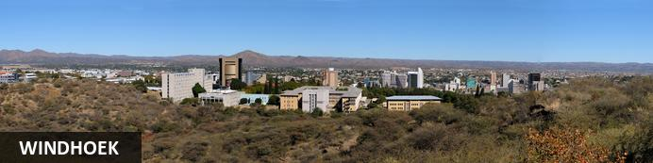
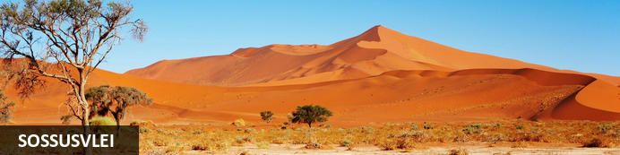
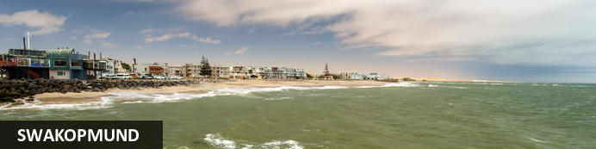
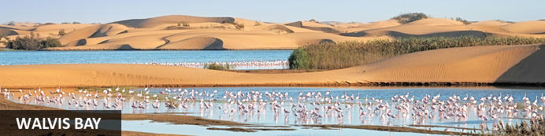
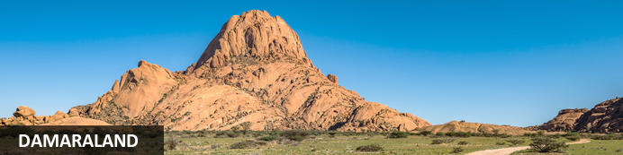
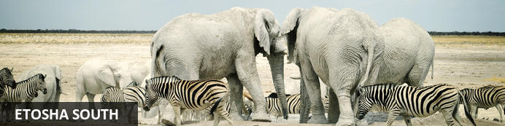
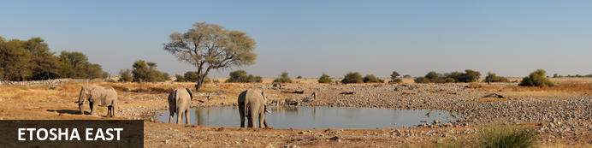
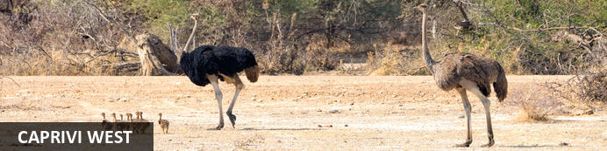
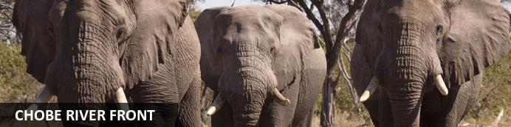
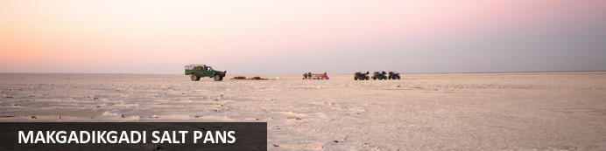
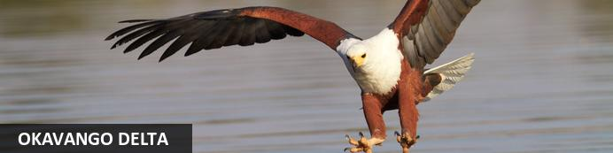
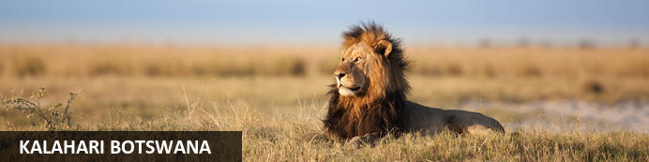

19-Day Namibia & Botswana Roundabout Self-drive Safari - Standard - RACK
Windhoek - Sossusvlei - Swakopmund - Walvis Bay - Damaraland - Etosha South - Etosha East - Caprivi West - Chobe River Front - Makgadikgadi Salt Pans - Okavango Delta - Kalahari Botswana
19 Days / 18 Nights
Date of Issue: 05 August 2022

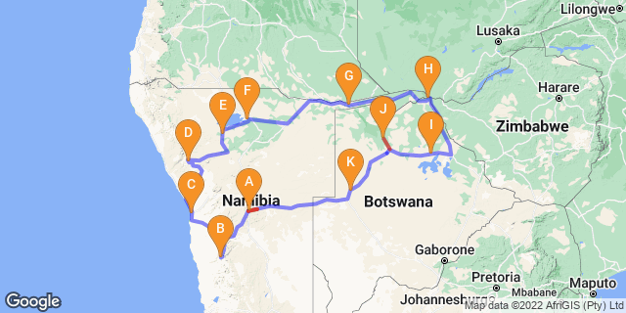

Click here to view your Digital Itinerary

Introduction
Showcasing diverse landscapes and incredible game viewing, this 19-day Namibia & Botswana Roundabout self-drive safari combines the best of Namibia with the best of Botswana as well as a visit to Victoria Falls.
Between the ancient desert, the wildlife of Damaraland and Etosha, the bounteous wetlands of the Caprivi, Chobe and the Okavango Delta and of course the wonder of Victoria Falls, it will be hard to pick a favourite. The tour starts and ends in Windhoek but you can start and end it in Chobe National Park or Victoria Falls.

Accommodation | Destination | Basis | Duration
The Elegant Guesthouse | Windhoek | B&B | 1 Night
Desert Quiver Camp | Sossusvlei | D,B&B | 2 Nights
Swakopmund Luxury Suites | Swakopmund | B&B | 2 Nights
Twyfelfontein Adventure Camp | Damaraland | D,B&B | 1 Night
Etosha Village | Etosha South | D,B&B | 1 Night
Onguma Bush Camp | Etosha East | D,B&B | 2 Nights
Shametu River Lodge | Caprivi West | D,B&B | 2 Nights
Chobe Safari Lodge | Chobe River Front | HB+ | 3 Nights
Planet Baobab | Makgadikgadi Salt Pans | B&B | 1 Night
Moremi Crossing | Okavango Delta | FI | 2 Nights
Thakadu Bush Camp | Kalahari Botswana | D,B&B | 1 Night

Key
B&B: Bed and Breakfast
D,B&B: Dinner, Bed and Breakfast
HB+: Half Board Plus - Dinner, Bed, Breakfast and Activities
FI: Fully Inclusive - Bed, All Meals, Fees and Activities

Price
1st January – 30th June 2023 – Low Season
Nam Section
2 guests - ZAR 40 015 per person sharing
4 guests - ZAR 31 020 per person sharing
Single supplement - ZAR 8 050
Bots/Zim Section
2 guests - USD 3 095per person sharing
4 guests - USD 3 095 per person sharing
Single supplement - USD 1 010
1st July – 31st December 2023 – High Season
Nam Section
2 guests - ZAR 42 950 per person sharing
4 guests - ZAR 32 955 per person sharing
Single supplement - ZAR 8 425
Bots/Zim Section
2 guests - USD 3 330 per person sharing
4 guests - USD 3 330 per person sharing
Single supplement - USD 1 105

Included
- Accommodation as indicated – can change depending on availability and request at time of booking
- Meals as indicated
- Meet and greet upon arrival
- Car hire- 4X4 Toyota Fortuner – Standard cover ZAR 50 000
- Airport transfers on arrival and for departure
- Charter flights as indicated – on a set seat rate basis
- Activities as indicated
- Tour file with detailed itinerary, map with route descriptions, vouchers etc.
- 24 hour personal and friendly support
- Fast and efficient response to service providers

Excluded
- Items of a personal nature
- Optional extra activities
- International flights
- Holiday or personal insurance
- Staff gratuities
- Park entry fees
- Fuel for vehicle rental
- Visas and visa applications

Day 1: The Elegant Guesthouse, Windhoek

Windhoek
Surrounded by the stubble-covered Auas Mountains and the endless Khomas Hochland, Windhoek lies in a long valley fed by ancient hot springs in the central highlands. Namibia’s capital and bustling city. More often than not, the start or end place of your Namibia safari.
In Windhoek there are many interesting historical buildings, museums, galleries and craft shops. The city has several good restaurants and modern shops and services making it an excellent base camp from which to launch your Namibian adventure.

Day Itinerary
- You will be met by the car rental company representative on arrival and transferred to their offices in Windhoek to complete all rental procedures
- You will then meet with our representative to hand over your travel documents
- The remainder of the day can be spent relaxing at your own leisure
- For dinner tonight, you can head into town for a bite to eat at one of Windhoek’s well known restaurants

Overnight: The Elegant Guesthouse View iBrochure
With easy access from Windhoek International and situated in Klein Windhoek - the Namibian capital's prototype leafy suburb - The Elegant Guesthouse makes for a comfortable overnight stop.
The Elegant, as she is known in these parts, is in a quiet neighbourhood, very secure and close to the shops, restaurants and attractions of northern Windhoek. Getting there from the airport requires two turns, getting to the rest of the country from here requires just three turns.
Modern design and fittings give The Elegant Guesthouse a sophisticated air. Once a small six-roomer, the Elegant has been upgraded and is ever more sophisticated now, offering 17 stylish and beautiful guest rooms. They didn't just add more rooms. They first acquired more space and then expanded, so the mood is still decidedly relaxed (if not more so than before): the perfect way to start or end your Namibia holiday.
All rooms have en suite bathrooms, twin beds (together making a king) and are fitted with air conditioners as well as fast WiFi, television and most open out onto a drought resistant garden or the swimming pool area surrounded by loungers and umbrellas.
Breakfast is served in the light and airy open-plan breakfast room or out in the garden on warm days, which is about 90% of the time in Namibia.
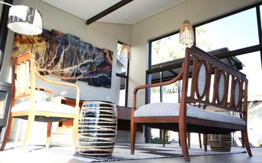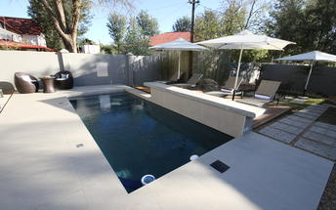

Meet and Greet
NTS Car Hire -Toyota Fortuner SUV Self-Drive
4x4 Toyota Fortuner Adventure and luxury combine in this comfortable 4-wheel drive vehicle. This is the way to do a self-drive if you ask us. A lifestyle vehicle with the same "off road" performance as other 4x4's without feeling all the bumps along the way. Travel in style. Includes: GPS, ZERO excess - maximum insurance, tyre & windscreen cover, unlimited mileage, 2nd spare tyre, additional driver, cell phone with local sim

Basis
Bed and Breakfast

Day 2-4: Desert Quiver Camp, Sossusvlei

Sossusvlei
Star dunes with up to five crests rise 300m into the air and rank among the biggest in the world; the dune valleys are marked by vast clay pans where the Tsauchab River gave up its fight to reach the sea more than 60,000 years ago.
Besides the dunes and pans of Sossusvlei and Sesriem Canyon, a sideshow of activities and sights has developed around the region and there are plenty of game lodges that provide additional desert-adapted activities.Plants and birds are the dominant life form in this dessicated realm and they support a tiny world of mammals, reptiles and insects that, in the absence of coastal fog, seldom wander far from the rivercourse and its pans.

Day Itinerary
Windhoek – Sossusvlei 350km - approximately 5 to 6 hours
- After breakfast, you can still pop into town for anything you might need and then depart heading south from Windhoek to your lodge for the next 2 nights
- The route will take you either via the beautiful Spreetshoogte or Remhoogte Pass, both showcasing the natural beauty of Namibia
- Wake up early for breakfast (Day 3) and then head to the entrance to Sossusvlei, the Sesriem Gate
- Spend the whole day in the beautiful Sossusvlei area, exploring the highlights: Sossusvlei, Dead Vlei, Dune 45, Big Daddy, Elim Dune and the Sesriem Canyon
- Return to the lodge for lunch or arrange a lunch pack to enjoy in the dunes and return late afternoon for a well-earned rest
- Optional extra activities: Guided Sossusvlei excursion; Hot air balloon safari; Nature drives

Overnight: Desert Quiver Camp View iBrochure
With its quirky yet somehow harmonious design Desert Quiver Camp, near the entrance to Sossusvlei, can be a luxury camping experience, a back-to-basics desert lodge or both. And the best part - it's entirely up to you.
The 24 units, built of poles and canvas and stone, look like A-frames adrift and subsiding into the desert. The natural construction and sympathetic choice of colours help these structures blend into the dramatic scenery and, after a short while, the striking asymmetry becomes rather pleasing.
Inside, the rooms are spacious, cool and spotless. An en suite bathroom with shower, toilet and wash basin lurks behind the dividing wall and while the doorless layout - oddly popular among the newer establishments in Namibia - may not be to everyone’s liking, the spacious shower and piping hot water is a sure thing.
The unit has a large shaded porch with a kitchenette cunningly tucked away behind a canvas roll-down; the picnic bench and barbecue set the scene for a classic campout under the stars beside a flickering fire. A nice feature is you can order in your fresh cooking supplies and have them delivered to your unit.
If you’re not up to the ordeal of ready-steady-cooking your own meal or you just fancy a treat the camp’s sister property, Sossusvlei Lodge - well known for excellent service and quality food - is a few km up the road. As a guest of Desert Quiver Camp, you have full access to their activity centre, wonderful buffet restaurant, bar and pool all overlooking a waterhole.
Back at camp, a huge and ever-sparkling pool and its companion lopsided A-frame bar provide an agreeable venue for a sunset cocktail and a refreshing dip - the ochre view across the plains towards the rocky mountains is pure Namibia.
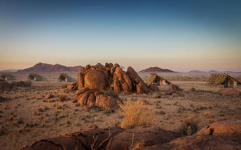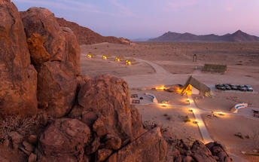

Basis
Dinner, Bed and Breakfast

Day 4-6: Swakopmund Luxury Suites, Swakopmund

Swakopmund
Surrounded by the ancient Namib desert and the inhospitable - but bounteous - Atlantic Ocean, Swakopmund is alive with activity and has a lot on offer for the adventure-seeker: quad-biking, sand-boarding, horse-riding, skydiving and more.
Swakopmund has many interesting German-influenced buildings from the early 1900s in a variety of styles and, for its size, Swakopmund has an astonishing array of restaurants that serve mainly seafood, steak and many German staples.

Walvis Bay
Walvis Bay is an industrial port which lies along the Atlantic Ocean, off Namibia's Skeleton Coast. The large bay and surrounding sand dunes help make Walvis Bay a tourist mecca with loads of activities on offer to explore it.
- Explore the Skeleton Coast where the dunes meet the sea at Sandwich Harbour‍
- Go on a dolphin boat cruise in the harbour. Enjoy champagne and oysters
- Kayak among the seals at Pelican Point
- Visit and climb the mighty Dune 7‍
- Visit the RAMSAR wetland birding site and the Walvis Bay Lagoon. Thousands of flamingos from October to April‍
- Explore the neighbouring town of Swakopmund. Activities abound and dining delights

Day Itinerary
Sossusvlei – Swakopmund 350km - approximately 5 to 6 hours
- Depart after breakfast and head north to Solitaire, then west crossing the Tropic of Capricorn, through the Gaub and Kuiseb Canyons via the Namib Gravel Plains to the coast
- Either via Walvis Bay to Swakopmund, or (recommended) detour via Ganab to the Welwitschia Plains and Moon Landscape
- The Namibian coastline is generally known as The Skeleton Coast due to the barren areas, ship wrecks and, in days gone by, whale skeletons left on the beach
- 1 full day is set aside for this lovely area where Swakopmund and Walvis Bay offer a wide range of activities such as: Dolphin cruise; Sandwich Harbour excursion (a real Skeleton Coast experience); Dune quad biking; Sand boarding; Sea kayaking; Lots more…
- Lunches and dinners can be enjoyed at a café or restaurant overlooking the sea

Overnight: Swakopmund Luxury Suites
Swakopmund Luxury Suites pack comfort and convenience into an elegant apartment-style accommodation option in the belly of Swakopmund's restaurant quarter.
Although “suites” is a bit of stretch size-wise, for comfort you can expect elegant, neutral décor that is easy on the senses and top quality linen with quite possibly the most comfortable bed you’ll encounter on your tour of Namibia. Attention to detail includes Nespresso machines with complimentary pods, bath robes, extra thick towels, wi-fi that actually works, climate control, mini-bar and that general air of purpose and cleanliness of a professional outfit.
For convenience you are a few minutes’ walk to the beach, restaurants, cafes and main attractions of central Swakopmund - a feature you will welcome after many hours’ in the car on Namibia’s long and dusty roads. And the day reception is staffed with the friendliest of friendly Namibians who add that personal touch and valuable insider’s information for making the most of your visit.
A secluded upper deck lined with comfortable recliners and deck chairs is a wonderful place to catch up with your digital life. Or escape it entirely with a good book and a glass of chardonnay. Parking out front is secure with 24-hour watch and CCTV and, occupying the first storey down a pedestrianised side street, the location is quiet and safe.
Considering the last thing Swakopmund needs is yet another mediocre eating venue, breakfast at the Swakopmund Suites is outsourced by way of vouchers and a helpful hint to one of three cafes within a couple of minutes’ walk: The Village Cafe is a bright and lively local institution; Cafe Anton, right next door to the Suites, is an old-school buffet good for an early or languid start to the day; and Bojo’s is half way between the two in every respect.
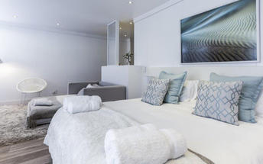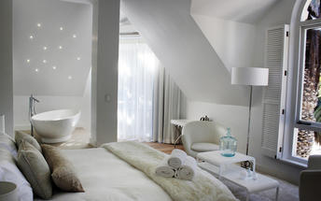

Basis
Bed and Breakfast

Day 6: Twyfelfontein Adventure Camp, Damaraland

Damaraland
Damaraland features vast khaki plains, sheer rocky mountains and incredible desert-adapted wildlife. Track rhino and desert elephant, explore the rugged land or sit back and enjoy the dramatic and endless scenery. Damaraland's hilly savannah supports a large number of species including lion, leopard, cheetah, hyena, eland, kudu, giraffe, klipspringer, steenbok, gemsbok and springbok. Birdlife is prolific with over 33 raptors recorded including cuckoo hawks, Egyptian vultures and peregrine falcons - the world's fastest animal.
Damaraland is divided into several enormous private game reserves, known as concessions, that support most species of Namibia's large game and provide some of the best birding and wildlife experiences in the country - and southern Africa for that matter.

Day Itinerary
Swakopmund – Damaraland 445km - approximately 7 to 8 hours
- Head north along the Skeleton Coast, via Henties Bay to visit the Cape Cross seal colony. Along the way, stop at the Lichen Fields as well as the ship wreck between the colourful small town of Wlotskasbaken and Henties Bay
- Backtrack to Henties Bay and head inland through wide open plains to Uis, then north to the Twyfelfontein area
- Visit to Namibia’s Open Air Museum, the Twyfelfontein Rock Engravings as well as the interesting Organ Pipes rock formations and Burnt Mountain
- Visit the Damara Living Museum for a hint of culture

Overnight: Twyfelfontein Adventure Camp View iBrochure
Against and among the granite boulders, Twyfelfontein Adventure Camp has prime location for visiting the highlights of the area. From here you can easily explore the heart of Damaraland, the sights of Twyfelfontein and track desert-adapted elephants.
Within walking distance of the Damara Living Museum, Twyfelfontein Adventure Camp (we'll call it TAC, shall we?) is a 10-minute drive from the Twyfelfontein Rock Engravings, Burnt Mountain and Organ Pipes. Situated in the Huab River Valley, there’s a chance the elephants could stroll past your tent at any moment or at the least, you won’t have to venture very far to find them.
Location is key and in that category TAC is a winner. It’s been a long day's drive from any direction to get here, so once you’ve arrived, it’s great knowing you won’t have to spend much time in the car to explore the area. Less time on the road means more time for adventure and to laze at the pool with a drink in hand. Of equal importance when on holiday.
The eco-friendly camp itself is basic, tasteful and really quite charming; add the view and the necessary comforts of a clean and decent stay and you’ll be delighted to call TAC your home for the next few nights. Two-night stays allow you to book a spectacular guided nature drive in an open safari vehicle.
Jumbled sandstone hills, platinum-blonde savannahs and olive-green shrublands make this landscape of incredible scale, colour and silence - so much silence - a marvel. See the many wildlife species that thrive here and learn how humans and wildlife including elephant, lion, rhino, antelope varieties and smaller predators have adapted to life in a land so hot and dry that it becomes ever more a wonder.
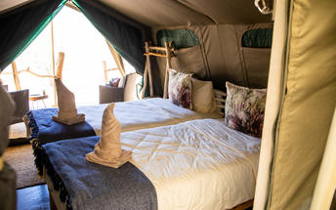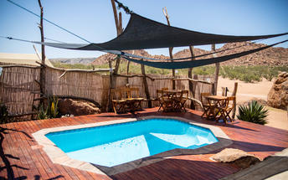

Basis
Dinner, Bed and Breakfast

Day 7: Etosha Village, Etosha South

Etosha South
Located just south of the boundary of Etosha National Park in northwestern Namibia, Etosha South makes up the southern region of this wild paradise. Ongava Private Game Reserve shares the southern boundary with Etosha National Park and offers an array of luxury lodges overlooking picturesque landscapes dotted with abundant wildlife. The national park can be accessed via the southern entrance at Andersson’s Gate. Visitors can catch a glimpse of a variety of wildlife including: lion, giraffe, elephant, white and black rhino, and a multitude of plains game. Popular activities include: game drives, tracking rhinos on foot, guided nature walks, or watching the sunset over the magnificent African landscape.

Day Itinerary
Damaraland – Etosha (south) 325km - approximately 4 to 5 hours
- After breakfast, drive east towards Khorixas stopping at the Petrified Forest en-route
- From Khorixas head further east along the tar road to Outjo and then north to your lodge which is situated very close to the southern entrance of Etosha, the Andersson Gate
- If time permits, enter Etosha for an afternoon game drive. Depending on how often you stop today, you should arrive at your lodge in time for lunch (optional extra)
- On entering the park, the first stop would be Okaukuejo where you pay your entry fee and I suggest you pop in at the local shop to purchase some drinks and snacks and most importantly, a map of Etosha which will show you all the waterholes along the way
- Etosha is one of Africa's great game parks. With 114 species of mammal and 340 species of birds you are sure to see a great variety of wildlife on your safari

Overnight: Etosha Village View iBrochure
Even before its hard refurb, Etosha Village was probably the best value safari lodge in Etosha. Replacing all tented accommodation with smart air-conditioned chalets, Etosha Village is now by far the best value safari lodge in Etosha.
Retaining its eco-conscious credentials - the bricks were salvaged from mining debris, grey water is filtered and re-used in the vegetable garden, water is solar heated and the kitchen produces a fair amount of high-quality composting material - Etosha Village had a major refurbishment in mid-2016 and what an upgrade.
Brick has replaced canvas, sleek tiles have replaced creaky wood decking and the en suite bathrooms are smart, shiny and functional. From the outside, the chalets are full of life and texture with gabion foundations, balustrades filled with pebbles, a gravelled forecourt and woven latte poles covering the roof. Inside, while a tad on the austere side, the rooms are spacious, practical and well-appointed with air conditioning, en suite bathroom, sofa bed good for two under-12s (the Village is one of a few child-friendly safari lodges in Etosha), fridge, tea/coffee, safe, balcony and a large gazebo to the side. Comfortable twin beds with soft cotton are a given.
The living areas have also retained their charm and casual comfort with a large swimming pool surrounded by loungers and parasols and a smaller pool adjacent to a third toddler-friendly pool. The food at Etosha Village is fresh and the staff here, recruited from the nearby village and trained in-house, are famous for their friendly and enthusiastic service.
Breakfast and dinner are sizeable buffet spreads and lunch is a small a la carte menu with local venison specialities. Tea, coffee, hot chocolate and juice are on the house all day and the open-air bar is a convivial spot to share a drink and a tale or just gaze into the night sky as is your want.
Being just minutes from the southern gate is ideal for daily access to Etosha National Park for guided game morning and evening drives in an open-sided safari vehicle. The vehicles accommodate up to 10 people and if that’s a bit crowded or constrained, Etosha is one of the easiest self-drive game reserves in Africa: arm yourself with a prepared breakfast and lunch or a picnic hamper from the well-stocked supply store and spend the day at any number of quiet waterholes. A good reference book, binoculars and of course your camera should be required equipment.
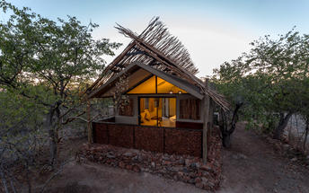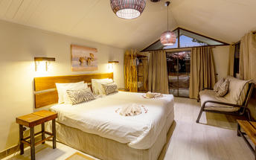

Basis
Dinner, Bed and Breakfast

Day 8-10: Onguma Bush Camp, Etosha East

Etosha East
On the eastern edge of Etosha National Park, the park itself is bordered by numerous private reserves and access into the park is via the Von Lindequist Gate, named after Dr. Friedrich von Lindequist who proclaimed it a game reserve in March 1907. This side of the park is characterised by flat endless plains, tree-savanna type of vegetation and fantastic waterholes, where you could easily spot any of the prolific wildlife Etosha is known for. There's an abundance of wildlife here.

Day Itinerary
Etosha (south) – Etosha (east) a full days game drive through the park
- From one side to the other side of the park is a full day game drive as you head slowly east stopping at numerous waterholes along the way
- Take a slow drive in the morning and then enjoy a packed lunch (optional extra) overlooking one of the waterholes before continuing on through the park to the eastern side
- 1 full day is set aside for game viewing, either all day or alternate with morning and afternoon drives. These are self-drive game drives but you can arrange at the lodge to go with their open safari vehicle and guide (optional extra)

Overnight: Onguma Bush Camp View iBrochure
Onguma Bush Camp is a comfortable, family-orientated lodge in a private reserve on the eastern edge of Etosha National Park. With 18 rooms including family suites as well as a small campsite, the atmosphere is tranquil and casual.
Onguma Bush Lodge is an alternative to staying inside Etosha National Park where your options are limited to three basic state-owned camps.
This comfortable lodge is located on the edge of the park near Fisher's Pan and the eastern entrance to Etosha. The rates are reasonable and the lodge is neat, small and an excellent base for families.
The en suite, air-conditioned rooms are built from local stone and have thatched roofs. The pool, open-air lapa and dining area provide the venues for some pleasant banter, spectacular sunsets and hearty meals. The lounge and dining area overlooks a waterhole for around-the-clock game viewing. The campsite has six sites with private ablutions and firewood; campers are welcome to make use of the bar, pool and restaurant.
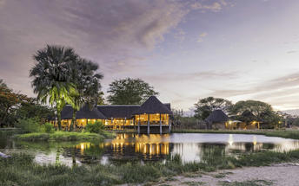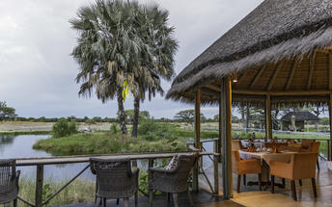

Basis
Dinner, Bed and Breakfast

Day 10-12: Shametu River Lodge, Caprivi West

Caprivi West
Caprivi West forms part of the Caprivi strip that protrudes from the northeastern corner of Namibia into Botswana and bordering on Angola. Here you're east of Rundu and on the western side of the Bwabwata National Park. The Caprivi is a lush, sub-tropical wetland offering a wealth of natural resources and serves as a haven for an abundance of wildlife, including the critically endangered African wild dog. This is the only spot in Namibia where one can spot the majestic Nile crocodile and the mighty hippo.
The Caprivi is a paradise for nature lovers with its free-roaming wildlife and postcard-perfect areas. Birdwatchers will be overjoyed as they keep an eye out for the 400 bird species that soar above. Visit the rapids of Popa Falls, go on game drives in the Mahango and Buffalo Core Areas of the greater Bwabwata National Park and enjoy the Okavango River.

Day Itinerary
Etosha (east) – West Caprivi 600km - approximately 7 to 8 hours
- Depart Etosha and drive east to Grootfontein, then north to Rundu before making your way east to Bagani, close to the Popa Falls
- A full day is set aside for a drive to the beautiful Mahango and Buffalo Game Parks, not very big but beautiful as you drive along the Okavango River
- Visit to Popa Falls
- Optional extra would be a sunset boat cruise or a Kavango Village visit in the area

Overnight: Shametu River Lodge
Picture yourself as The Mariner, Kevin Costner's anti hero, meandering through the water. Think mokoro rather than a trimaran, river rather than sea. This is for those of you that like the waterworld of Africa. But whereas the film's been described as a mess masquerading as a movie you'll exit this lodge feeling calm, chilled and chipper.
Louis and Amori fancied a retirement home in the Caprivi and this is it. Next to the Bwabwata National Park you're as close to the Kavango River you can get without actually sitting in it. The lodge literally peers out of the bushes like a lazy croc. It's an easy drive to access the small village of Divundu, which is approx 10km away - it's not much more than a petrol station and a shop of a place but it's rich in the culture of the Kavango people - locals fish with nothing more glamorous than a worm, children swim and Nguni cattle wander along. You'll also be close to the Popa Falls - more of a series of rapids running over the rocks than a waterfall but they're still stunning and popular.
Luxury chalets are big and bang on the banks of the river. You can see Popa Falls, you can hear hippos roaring. Brown leathery chairs, white bed linen. The standard chalets are not on the banks but you still get a view of the river. The luxury tents are permanent, sit on stilts and they're on the riverbanks. Definitely glamping you'll have the same ensuite, lounge area, coffee making facilities and mosquito nets as the two chalet options. The camping option's hardly slumming it either - you'll get your braai spruced up over night as well as your pots and pans washed up - when does that happen?! You'll also have your own ablution block and kitchen facilities. These have roofs so you're sheltered in the rainy season and shaded when it's hot. There's also a family style campsite if you want to share washing and cooking together. Each campsite also has access to electricity and running water.
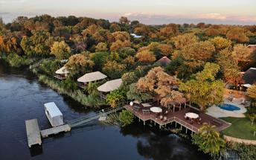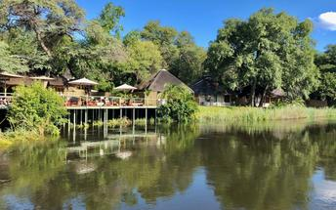

Basis
Dinner, Bed and Breakfast

Day 12-15: Chobe Safari Lodge, Chobe River Front

Chobe River Front
The Chobe River forms the northern boundary of the Chobe National Park which is renowned for its diverse and abundant game viewing opportunities. This section of the park is best known for its dense concentration of wildlife, including elephant and hippo populations, but the waters attract all manner of game including large herds of buffalo and the lions that prey on them - a visit to the Chobe River Front guarantees close encounters with an array of African wildlife. Visitors can look forward to a range of exciting activities such as game drives along the banks; motorboat cruises; and rare birdlife spotting. For a unique, luxury safari experience, hire a houseboat.

Day Itinerary
West Caprivi – Chobe 440km - approximately 6 to 7 hours
- Today you drive east through Katima Mulilo and then on to the Ngoma Border Post. Pass through customs and enter Botswana, Kasane, where you spend the next three nights close to the Chobe National Park
- Activities included:
1 x Game Drive
1 x Boat Cruise
1 x Private Boat Cruise
1 x Victoria Falls Day Trip (including return transfer to Victoria Falls (Zimbabwe) – Unguided
(Park fees for 2 days included)
(Note: The Victoria Falls Day Trip can also be exchanged for 2 other Chobe activities)

Overnight: Chobe Safari Lodge View iBrochure
Under One Botswana Sky comprises eight safari lodges and camps and one of the lucky winners is Chobe Safari Lodge, in Kasane, Botswana.
Chobe Safari Lodge sits on the edge of the Chobe River (as the name would suggest), but that also means that it borders four countries! Yup, that means you can quickly run off to Zambia is you feel like it. Clearly, this is going to be the easiest cross-country road trip yet...
This is quite a romantic spot, while you can see it is decorated in a traditional safari style; the pool, room service and private cruises tell a different, more luxurious story.
Here you can stay in a variety of accommodation such as suites, rooms, bungalows and even camping. The accommodation is a little less fabulous than the private cruise waiting for you, but we can let it slide. The rooms are very simple with double beds, a desk and an en-suite, but unfortunately no mini-fridge and water (something you expect if you don't want to run to the bar each time for a glass of water.) However there is a TV, Wifi and as we mentioned before, room service.
But let's be fair, if you come all this way you are not going to be spending much of your time in the room anyway. Outside you have a huge pool waiting for you, an open plan restaurant overlooking the pool and that gorgeous view of the river and a small island opposite that would make anyone back at home jealous. When you go have dinner, make sure to dive into a Kudu steak, it's the best one you will ever have.
There is also a little shop, a health and beauty salon and cocktail bar for your to indulge in with gifts, a new holiday (or honeymoon) look and a fancy drink on top of it all just because you deserve it.
With this picture-perfect view and never-ending river, we won't forgive you if you are just sitting at the pool all day. Make sure to tackle land and water with that private boat cruise or a game drive to spot the iconic Chobe elephants. If you are tempted by what's around the corner you can even book an overnight or day trip to go to the Victoria Falls.
It is worth the mention that Chobe Safari Lodge is the oldest one in the region, so while some things might be out of date (and style) other things have just been perfected. Here it's all about the safari experience and you're bound to have one of the most memorable safari experiences by far.
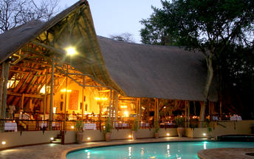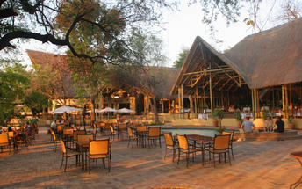

Basis
Half Board Plus - Dinner, Bed, Breakfast and Activities

Day 15: Planet Baobab, Makgadikgadi Salt Pans

Makgadikgadi Salt Pans
Makgadikgadi Pans. Something different. An amazing place that rewards the intrepid traveller willing to head off the beaten tourist track.
On the northern edge of the Central Kalahari Game Reserve, the Makgadikgadi, Sua, Ntwetwe and Nxai pans are remnants of a super-lake that once covered the area and supported life of a forgotten world.
Summer rains welcome hundreds of thousands of flamingos as well as endless herds of wildebeest and zebra form the second largest mammal migration in Africa. In winter the landscapes are of shimmering vast salt pans as far as the eye can see. Trek with authentic Bushman, sleep out under vast night skies, go see the giant baobabs and experience habituated meerkats. The uncharted wilderness of this part of the Kalahari makes it all the more exclusive.

Day Itinerary
Chobe – Makgadikgadi Pans 420km - approximately 5 to 6 hours
- From Kasane, drive south to Nata and then east to your lodge for the evening
- If time permits (leaving after breakfast you can reach your destination by lunch), an afternoon drive onto the pans … or a cattle post visit can be arranged with the lodge (optional extra)

Overnight: Planet Baobab View iBrochure
Planet Baobab is a quirky camp in a thicket of baobab trees on the edge of the Makgadikgadi. Comfortable and well-positioned, the camp is a good base from which to explore Botswana's other side - the Kalahari.
Planet Baobab is an exuberant oddity in the dramatic expanse of openness called the Makgadikgadi - once a country-sized lake and now an empty wilderness of adventure, beauty and total silence. Quirky décor decisions have followed sound practical ones like an enormous swimming pool, glorious showers, a bright and cheerful bar, a convivial central campfire and a variety of accommodation options to suit every need.
Accommodation options at Planet Baobab include traditional Bakalanga and Bushman huts enhanced with modern comforts - like an en suite bathroom, cotton linen and four-poster mosquito drapes. You can barbecue on your own or enjoy a meal at the restaurant. Activities include bush walks, quad bike trails, migration excursions, cultural interaction, bush dinners and sleep-outs.
People, places and ancient history converge at Planet Baobab, itself an eccentric convergence of modern and traditional styles. The Makgadikgadi Pans are littered with artefacts from the ancient hunter-gatherer people of the central Kalahari; an infusion of Bantu and Tswana add colour to the villages nearby and the whole region is a wonder of spectacular scenery, wildlife and the fragile desert ecosystem of the Kalahari. Set among ancient migration paths, Planet Baobab has formed a modern migration path of its own with visitors between the Kalahari and the Okavango Delta.
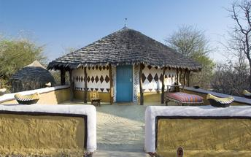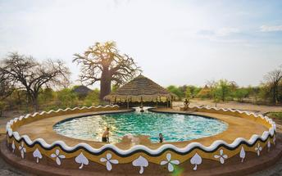

Basis
Bed and Breakfast

Day 16-18: Moremi Crossing, Okavango Delta

Okavango Delta
Crammed with every conceivable species of bird and beast, the delta is an Eden of excess. Amazing game viewing and birding in a scenic and tranquil African wilderness. If you’re looking for a true African safari. Look no further.
The quintessential delta experience: game drives in open safari vehicles and gliding in silence through the waterways on an African-style gondola carved from a single tree.
Access into the Okavango Delta is difficult, getting around is difficult, carting supplies in and waste out is difficult. These are all good things for this vast wildlife wilderness is utterly picturesque and devoid of human influence.
If constant close-ups of elephant, buffalo, lion, giraffe, hyena, jackal and plenty of large and small antelope start to grow old, there's always the chance encounter with cheetah, leopard, wild dog, and red lechwe to spice things up.

Day Itinerary
Makgadikgadi Pans - Maun 210km - approximately 2 to 3 hours
- This morning you will have breakfast and depart west to Maun Airport, where you will leave the vehicle and meet with your pilot for your shared charter flight into the Okavango Delta
(please take note of luggage restrictions)
- 2 nights makes this a 1.5 day stay and activities here focus on the water channels and the open floodplains of Chief’s Island. Enjoy mokoro activities, game walks and boat cruises as included

Overnight: Moremi Crossing View iBrochure
Moremi Crossing, built in 2009, is a modern and eco-friendly safari lodge in the Okavango Delta overlooking the Boro River and Chief's Island.
The transfer to Moremi Crossing is exciting enough: a scenic flight over the Okavango Delta lands at Chief's Island and a boat ride takes you to the doorstep of this apparently floating island lodge.
Built in the style of an exclusive and luxurious lodge, the camp manages to keep the price tag relatively low without compromising the essentials, these being: an beautiful and tranquil location, surrounded by the floodplains and channels of the Okavango Delta; amazing views from everywhere; exceptional game viewing and wilderness experience with elephant munching the trees nearby and hippos wallowing in front; exclusive access to first-rate game guides and activities including mokoro safaris, walking safaris and sunset river cruises; and of course comfortable accommodation, friendly service and good food.
The rooms are tented safari suites on wooden decks above the water level and connected by walkways. Each has an en suite bathroom with open-air showers - solar-heated water - flushing toilets with natural waste water filtration and large private balconies.
The living area at Moremi Crossing, buttressed by the dense riparian growth behind and the Boro River in front, is a multi-tiered wood and thatch construction above the water. Choose to laze in one of the private lounge areas, the bar, the dining area or the outdoor fireside deck.
Moremi Crossing has a small swimming pool shaded by wild fig, lined with loungers and surrounded by wild African bush.
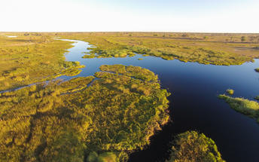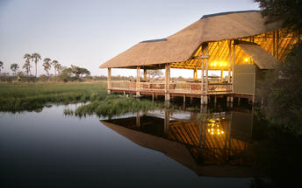

Basis
Fully Inclusive - Bed, All Meals, Fees and Activities

Day 18: Thakadu Bush Camp, Kalahari Botswana

Kalahari Botswana
Encompassing the vast majority of Botswana territory, the sprawling wilderness of the semi-arid Kalahari Desert is characterised by endless open plains, shimmering salt pans, picturesque orange sands and relics of ancient riverbeds. In the heart of the country lies the world's second-largest game reserve, the Central Kalahari Game Reserve.
Wilderness, wildlife and San hunter-gatherers. With such vast expanses of uninhabited land you're about as remote as you can be on planet Earth without putting your life at risk. Explorations barely scratch the perimeter of this savanna wilderness and wildlife roams far and free.

Day Itinerary
Maun – Kalahari Bushveld 265km - approximately 3 to 4 hours
- Fly back to Maun Airport, where you pick up your vehicle again and then drive south via Sehitwa to your lodge, which is close to Ghanzi
- The turnoff for Thakadu is 3km south of Ghanzi on the road to Gaborone and Namibia. A 3km rocky trail will bring you to Thakadu.
- Optional activities: San walks, San dances or enjoy walking trails and self game drives.

Overnight: Thakadu Bush Camp
Near the town of Ghanzi in Botswana, there are only a few places to stay. Thakadu Bush Camp is one of them. It’s 285km from Maun, 39km north of the Trans Kalahari Highway junction with Namibia and 526km from Windhoek. It’s the ideal stopover in the heart of the Central Kalahari if you’re travelling between Botswana and Namibia.
On the private Kabakae Game Reserve, Thakadu Bush Camp was a dream that became a reality in 1999 by Chris and Jeanette Woolcott. Now, more than 20 years later, this lodge is still in the family and they still love their special part of the Kalahari Bushveld. Better yet, they love sharing it with their guests and they’re good at it.
It’s rustic and down to earth (the brown dusty and sandy earth of the Kalahari Desert) which makes it all the more authentic. The last 3km to the lodge requires some ‘bundu bashing’ (a 4WD is ideal, but you’ll get there on these rough roads in a 2WD too). Thakadu overlooks a dry pan, which bar a few months of the year, after heavy rains, fills with water. Never mind though, there’s a waterhole there too and it draws out the plains game of the Kalahari year round.
Thakadu (tha-ka-du) in Setswana means a ‘long pig-like snout ant eating bear’, more commonly known to safari enthusiasts as the aardvark. A fitting description. You’ll see him in these parts. Be on the lookout. You could also see wildebeest, warthog, giraffe, springbok, mongoose, wildcat, aardwolf (not related to the aardvark although his dining preferences are similar), impala, porcupine, kudu, bat-eared fox, gemsbok and eland.
Accommodation options vary from brick walled rooms to thatched chalets and Meru-style tents. There’s a campsite too. Noku’s Nook is our favourite. An exclusive camp tucked away in the bush, 2,5km from the main lodge. It has a thatched lapa, swimming pool and its own private waterhole. It’s certainly not a luxury stay at Thakadu Bush Camp, but that’s not what they’re about. It’s more a comfort stop over, where it’s all about the bush experience, peaceful wilderness and beautiful night skies.
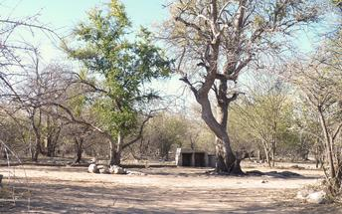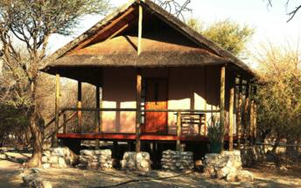

Basis
Dinner, Bed and Breakfast

Day 19: End of Itinerary

Day Itinerary
Kalahari Bushveld - Windhoek 570km - approximately 7 to 8 hours
- Depending on flight time or whether you will add a night in Windhoek, will depend on what time you depart the lodge
- The drive to Windhoek will go via the Mamuno Border Post, through Gobabis to Windhoek … about 6 hours … where this holiday will end
- An overnight stop in Windhoek is recommended before flying home otherwise you will drop the vehicle at the Windhoek International Airport on return and fly out

Basis
Bed and Breakfast

Transport

Flight Information
Date | Flight | Airline | Departure Airport | Time | Arrival Airport | Time | Class | Ref
 | Scheduled |  | Maun International Airport [MUB] |  | Moremi Crossing
 | Scheduled |  | Moremi Crossing |  | Maun International Airport [MUB]

Transfers
Date | Company | Pick Up | Drop Off | Time | Vehicle
 |  | Hosea Kutako International Airport [WDH] | Windhoek City |  | Transfer
 |  | Windhoek City | Hosea Kutako International Airport [WDH] |  | Transfer

Terms and Conditions

Namibia Tours & Safaris Terms and Conditions
Contract
1.1 The contract will become effective as from the date the invoice is completed and the deposit, referred to in Clause 2.1, is received by Africa Tours & Safaris CC (hereinafter known as the Company).
1.2 The contract is subject to the Namibian Law.
1.3 Any person making a reservation as per Clause 8.4 accepts the terms and conditions of this agreement set out hereunder.
How to Book
2.1 A 20% deposit of the full amount due is required to confirm any reservation and is to be done by the agent or client (see Clause 8.1) in writing or by e-mail.
2.2 The Company must receive the balance of the contract price no later than 42 days (6 weeks) prior to departure.
2.3 If the Company does not receive the full contract price 42 days (6 weeks) before the departure date, the Company may cancel the reservation and retain whatever deposit or other funds it has already received from the client or his agent.
How to Pay
3 The payment options will be provided upon confirmation of a booking.
Our Cancellation Policy
4.1 Any cancellation of a confirmed booking must be done in writing (email) to the Company whereupon cancellation charges as per Clause 4.2 will apply.
4.2 The following cancellation fees (as a percentage of the fully quoted price) are applicable to any cancelled travel:
Notice from date of travel:
Cancellation fee:
42 days or more 20% (deposit forfeited)
29 – 41 days 50%
15 – 28 days 75%
0 – 14 days 100%
Please note: the notice period is calculated from the date of cancellation to the start date of the tour/safari booking.
4.3 No refund will be made by the Company if, for any reason, inclusions or parts of the tour cannot be carried out / or utilised. These would include all facets such as meals, game drives, accommodation etc. This would also apply to any client who has booked a tour but fails to undertake the tour for any reason.
Our Changes Policy
5 If a booking is changed to an earlier date than originally reserved, the Company will endeavour to change it. If the booking is for a later date, charges as per Clause 4.2 could apply.
As things go, we've all had to adapt to changes during the Coronavirus pandemic and so too have we therefore amended our terms and conditions for travel during such times.
Price Changes
6.1 The Company reserves the right to increase the price of any tour prior to departure due to factors beyond the control of the Company, such as, without being limited to, and increase in fuel prices, new Government legislation, accommodation price increases, fluctuations in exchange rates, etc.
6.2 If the Company announces an in increase in the tour price in terms of this Clause, such addition amount must be paid to the Company before the departure of such tour or else the Company shall have the right to cancel the tour and the charges in Clause 4.2 will apply.
Changes to Itineraries
7 The Company shall at any time have the right, in its entire discretion, to alter the terms of the booking in relation to the route, timetable, itinerary and accommodation. The Company shall, however, make every effort to offer the client an alternative tour of a comparable standard.
Should the alternative be of a lesser standard, the client will be refunded the difference, but should there be an increase, the client shall have the right to either reject the alternative and obtain a refund of the relevant portion of the original contract sum, or to accept the alternative and pay the increased cost. In the event of the client rejecting the alternative tour and claiming a refund, such rejection will be treated as a cancellation and the refund will be calculated according to Clause 4.2 hereof. The client shall have no claim against the Company for any damages arising out of the alternative booking.
Responsibility and Liability
8.1 Neither the Company nor any person acting for through and on behalf of the Company shall be liable for any loss or damage whatsoever arising from any cause whatsoever and without restricting the generality of the aforegoing shall particularly not be responsible for the loss or damage arising from any errors or omissions contained in its brochure or other literature, late or non-confirmation or acceptance or bookings, loss or damage caused by delays, sickness, injury or death, whether occasioned by negligence or not.
8.2 The Company shall have the right at any time at is sole discretion, to cancel or the remainder thereof or to make an alteration in the route, accommodation price or other details. This would include any event of any tour being rendered impossible, illegal or inadvisable by weather, avalanches, strike, war, government or other interference or due to any other cause whatsoever. The extra expenses incurred as a result thereof shall be the responsibility of the client.
8.3 The Company may at its discretion and without liability or cost to itself at any time cancel, or terminate, a client's booking and in particular, without limiting the generality of the aforegoing, it shall be entitled to do so in the event of illness or the illegal or incompatible behaviour of any client undertaking the tour, who shall in such circumstances not be entitled to any refund.
8.4 Any person making a reservation with the Company (refer to Clause 1.1) warrants that her or she has the necessary authority to enter into this contract on behalf of the person or persons included in such a booking. The person making the reservation shall be liable for the total amount due to the Company.
Client's Obligations
9.1 It is the onus and responsibility of the client to obtain the necessary comprehensive insurance before departure for any possible cancellations, medical expenses, protection or personal property and money.
9.2 The onus is upon the client to ensure that passports and visas are valid for the duration of the safari. The Company cannot be held liable for any necessary visas or other travel documents not held by clients. In the event of a client not having the necessary documentation to enter any area or country the Company shall reserve the right to leave the client a the point of entry of such area or country. In such an event, the Company will not be held responsible to the client for further travel arrangements.
9.3 The onus is upon the client to ensure that the SARS-CoV-2 PCR tests are done prior to commencement of the safari and valid on arrival in accordance to the requirements of the country of intended travel and for the airline with which the client will travel. The same applies for any necessary testing for departure. The costs of any such COVID testing will be for the clients own account. While The Company can assist with arrangements for testing in-country, The Company will not be held responsible to the client for such arrangements and with regards to return time of test results.
9.4 Should the client need to undergo mandatory quarantine once in-country with regards to the SARS-CoV-2 virus, either on arrival as called for by the authorities or due to testing positive once in-country, this will be at the clients own expense.
Health and Personal Safety
10.1 The client shall be reasonably fit to undertake the tour.
10.2 Anti-malaria precautions should be commenced prior to tour departure. A medical doctor should be consulted for advice.
10.3 Tours offered by the Company cover a wide spectrum of the African wilds and neither the Company, its employees or agents can be held responsible for any injury or other related incidents whilst on the tour / safari.
10.4 The Company cannot be held responsible for any client who falls ill or contracts the SARS-CoV-2 virus while in-country. The client accepts that travel is at own risk.
Baggage
11.1 Clients are limited to one soft sports type bag per person with a maximum weight of 20 kilograms. This includes photographic equipment and hand luggage.
11.2 Due to the rugged terrain, the Company cannot be held responsible for damage or loss of any personal items including bags, contents of bags or photographic and related equipment. Due to extremely dusty conditions, please ensure all bags are dust proof.
Airline and Car Hire Clause
12.1 The Company will act as the agent of the client when booking the client with a car hire company, an airline or air charter service. The client therefore contracts with the car hire company, airline or charter service and not with the Company.
12.2 Charter flights are normally operated by smaller type aircraft such as Cessna 210. Luggage is strictly limited to 10-15 kgs (depending on terms of particular airline used) per person in soft hold all type bags. Due to the desert heat, it is not safe to overload aircraft thus this limit needs to be strictly controlled.

