MS Spitsbergen

* Year built - 2009
* Capacity - 180
* Year of refurbishment - 2016
* Ship yard - Estaleiro Navais de Viana do Castelo, Portugal
* Gross tonnage - 7344 T
* Speed - 14,5 knots
* Length - 100 m
* Beam - 18 m

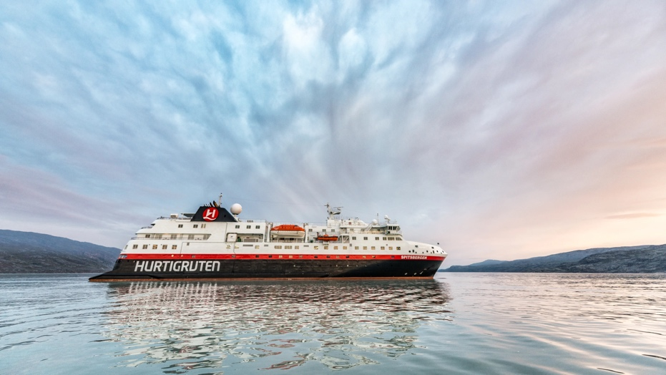

About the ship

MS Spitsbergen is named after the crown jewel of Arctic Norway – the Svalbard archipelago and its biggest island, Spitsbergen. Hurtigruten has a long history of travelling to Spitsbergen, beginning in 1896 with the 'Sports Route'. MS Spitsbergen cruises along the Norwegian coast from September to May and becomes part of our global expedition sailings during the rest of the year.

### Ship features

After a complete reconstruction, MS Spitsbergen joined the Hurtigruten fleet in 2016. The ship features high technical standards as well as comfortable, modern public areas and cabins. The vessel's fresh Scandinavian design reflects a colour palette derived from the sea. She is modern and environmentally progressive and will undergo further improvements that will reduce emissions and fuel consumption even more. The new ship’s maneuverability and optimal size make her quite suitable for exploring polar waters.

### Premium expedition comfort

MS Spitsbergen has her own onboard Expedition Team which serves as a university at sea. Interesting lectures inside the ship as well as out on the sun deck make cruising with her an exciting and educational journey. Topics depend on the season and the waters in which we sail. The Expedition Team hosts a lecture programme and evening gatherings daily. Out on deck, you can participate in live points of interest to learn more about the nature, culture and other phenomena we encounter along the coast. In addition, the Expedition Team will introduce you to the uniquely Norwegian notion of 'friluftsliv' (outdoor life), and encourage you take part in 'friluftsliv' hikes and activities throughout the cruise.

## **Polar Inside**

Our cozy Polar Inside cabins are located on all decks. All cabins include bathrooms with a shower/toilet. Most of the cabins have double beds, while some are equipped with separate beds where one doubles as a sofa, or upper and lower berths. All cabins have individual specifications.

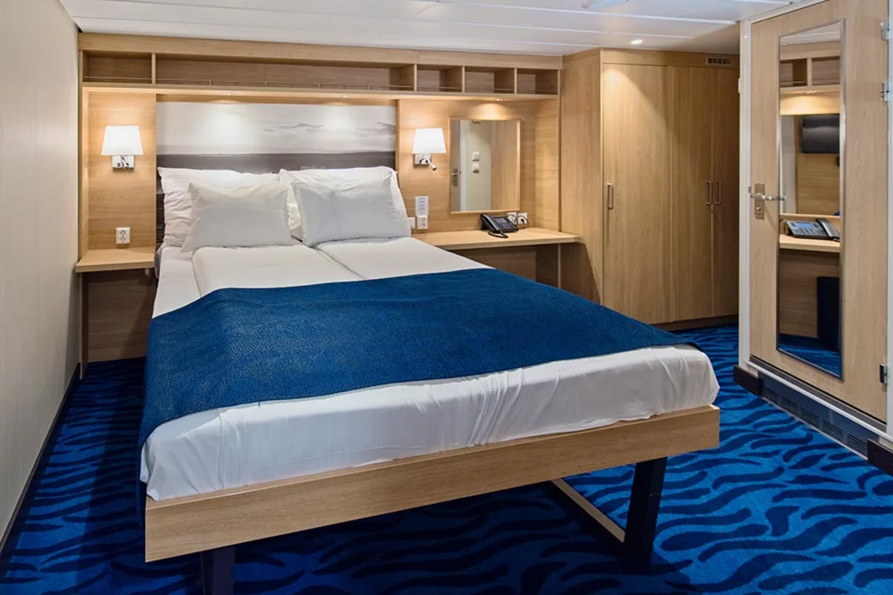

## **Polar Outside**

Our Polar Outside cabins are mostly situated on the middle or lower decks and all have bathrooms with a shower/toilet. Most have double beds, while others offer separate beds (where one is a sofa bed) or upper berths. All cabins have individual specifications.

