Discover Botswana
Chobe River Front - Savute - Chobe National Park - Okavango Delta - Makgadikgadi Pans National Park
11 Days / 10 Nights
Date of Issue: March 15, 2016

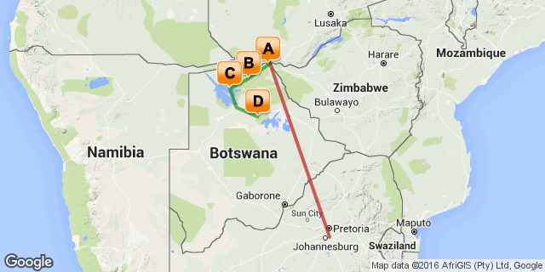

Click here to view your Digital Itinerary

Overview
Discover Botswana with Desert & Delta Safaris, experiencing spectacular locations and a diverse safari experience. From the iconic Chobe Game Lodge, to the predator renowned area of Savute Safari Lodge, Xugana Island Loge in the heart of the Okavango Delta and Leroo La Tau rising majestically above the Boteti River in the Makgadikgadi Pans National Park, this package will offer you an unrivaled safari experience throughout Botswana...

Destination | Accommodation | Nights | Basis | Room Type
Chobe River Front | Chobe Game Lodge | 2 | FB+
Savute - Chobe National Park | Savute Safari Lodge | 2 | FB+
Okavango Delta | Xugana Island Lodge | 2 | FB+
Makgadikgadi Pans National Park | Leroo La Tau | 2 | FB+

Key
RO: Room only
SC: Self Catering
HB: Half Board
B&B: Bed and breakfast
D, B&B: Dinner, bed and breakfast
FB: Dinner, bed, breakfast and lunch
FB+: Dinner, bed, breakfast, lunch and activities daily
FI: Fully inclusive

Included
Round trip coach air on South African Airways from New York (JFK) or Washington (IAD) Airport to South Africa OR Tambo International Airport
Regional coach air in South Africa as per the itinerary (Johannesburg - Kasane, Maun - Johannesburg)
Light aircraft flights (Kasane - Savute Safari - Camp Okavango - Leroo La Tau - Maun)
Accommodation as per the itinerary
Meals as per the itinerary (8 x breakfast, 8 x lunch, 8 x dinner)
All local drinks (South African wines & spirits)
All road transfers as per the itinerary
Scheduled safaris as per the itinerary
All game viewing and park fees while on safari in Botswana
laundry
Emergency medical evacuation insurance.

Excluded
Add on air from other US cities
Any meals or services not mentioned above
Any items of personal expense - i.e. premium brand beverages, telephone calls
Gratuities for rangers/guides/drivers

Day 1: Travelling

Depart from New York (JFK) for your South African Airways flight to South Africa.

Day 2-4
Chobe Game Lodge, Chobe River Front

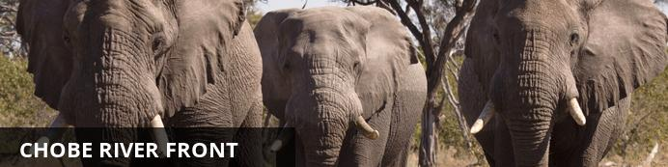
The Chobe River forms the northern boundary of the Chobe National Park, renowned for its reliable and diverse game viewing. Safaris are conducted both by boat and on land. This section of the park is best known for its elephant and hippo populations but the waters attract all manner of game including large herds of buffalo and the lions that prey on them.

Notes
On arrival in Johannesburg you will connect onwards for your flight to Kasane.
On arrival at Kasane Airport you will be met and transferred to the lodge.
Spend the next 2 nights on a full board basis at Chobe Game Lodge

Overnight: Chobe Game Lodge View iBrochure
Counter-balancing the wilderness are restful, air conditioned, en-suite lodgings. Graceful high arches, quarry tiled floors and barrel vaulted ceilings create an atmosphere of cool tranquillity.
Other facilities include a large swimming pool with terrace, a riverside boma area, a fully equipped conference room, a business centre for those guests needing to keep in touch, a stylish bar with an outside terrace overlooking the Chobe River and a cigar bar with a full sized billiard table. Meals are catered for at the terrace restaurant overlooking the Chobe River. Each of Chobe Game Lodge's 4 luxury suites has an individual plunge pool set on a private terrace with breathtaking panoramic views of the endless landscape and open plains. Graceful high arches, quarry tiled floors and barrel vaulted ceilings create an atmosphere of cool tranquillity. All 46 rooms are tastefully furnished, each room with hand crafted Rhodesian teak furniture and walls decorated with original African carvings and paintings.
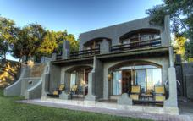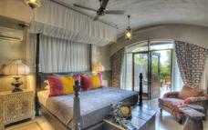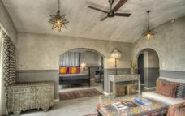

Included
Full Board and Activities

Day 4-6
Savute Safari Lodge, Savute - Chobe National Park

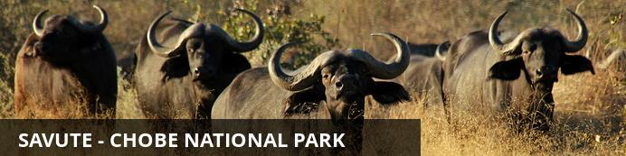
In the heart of Botswana’s Chobe National Park lies a dynamic wilderness, a sweeping expanse of savannah brooded over by several rocky outcrops which guard a relic marsh and the dry channel that was once its lifeline. This is Savute, where mysterious wet and dry cycles mould the landscape and dictate the nature of its wild inhabitants. Currently it is dry, and wild dogs hunt in the channel where crocodiles swam only twenty years ago.
The Gubatsa Hills shelter leopard and klipspringer and rock paintings of early man’s wildlife sightings. During the arid winter months game viewing concentrates on Savute’s resident bull elephants, antelope and lion prides, and black-backed jackal, bat-eared foxes, tsessebe, and kudu, abound.
The summer rains bring a feast for lion, hyena and cheetah as thousands of migrating zebra and wildebeest assemble in a chaotic pattern on the marsh. Cape buffalo herds arrive and migrant birds swell Savute’s 300 resident species, thrilling bird-watchers with their spectacular antics.

Notes
The morning is at leisure to enjoy the game viewing activities on offer. After breakfast a camp representative will transfer you to Kasane Airport. Depart on a Safari Air shared light aircraft charter flight to Savute Safari Lodge.
The afternoon is at leisure to enjoy the game viewing activity on offer.
Spend 2 nights on a full board basis at Savute Safari Lodge

Overnight: Savute Safari Lodge View iBrochure
Located on the banks of the Savute channel, Savute Safari Lodge is intimate, accommodating only 24 guests in cool thatched timber and glass suites.
The area is renowned for its population of bull elephant and for the unique interaction of the resident predator species. The close proximity of wildlife translates itself into the recently refurbished, modern African décor.
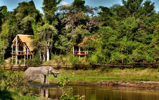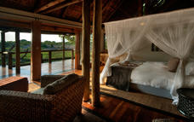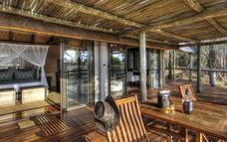

Included
Full Board and Activities

Day 6-8
Xugana Island Lodge, Okavango Delta

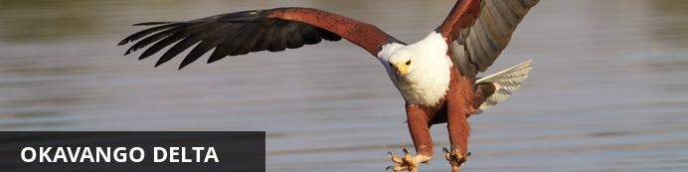
Lying in the middle of the largest expanse of sand on earth the Okavango Delta is one of Africa’s most amazing, sensitive and complex environments supporting a spectacle of wilderness and wildlife. Unique as one of the world’s few inland deltas, the placid waters and lush indigenous forests offer a safe haven for innumerable bird and wildlife species. The Okavango Delta offers a number of activities for the visitor; game viewing, birding and fishing are all on offer. One can experience this magical world of islands and waterways from land, air and water.
Highlights include the elusive Sitatunga antelope which has found refuge in this pristine wetland ecosystem, while birds such as the African fish eagle, Pel's fishing owl and many others provide a spectacular display.

Notes
The morning is at leisure to enjoy the game viewing activities on offer. After breakfast a camp representative will transfer you to the airstrip. Depart Savute Safari Lodge on a Safari Air shared light aircraft charter flight to Xugana Island Lodge.
The afternoon is at leisure to enjoy the game viewing activity on offer.
Spend 2 nights on a full board basis at Xugana Island Lodge

Overnight: Xugana Island Lodge View iBrochure
Xugana Lagoon is widely accepted as being the most spectacular permanent water site in the entire Okavango Delta. Xugana Island Lodge, situated on a wooded island abutting the lagoon, takes full advantage of this magnificent site. The thatched common area, comprising cocktail bar, lounge and curio shop, is still the original building put up in 1974, when Xugana became only the second tourist lodge ever built in the Okavango Delta. Meals, for which the lodge is justly famous, are taken alfresco on the edge of the lagoon, except on those rare occasions of rain when the lounge doubles as the dining-room. Tea is often served in the garden inside the island, where quiet, secluded reading benches can also be found.
Mokoro trips in eco-friendly dugout canoes built to the traditional design, boat safaris to lagoons and islands and wilderness walks give guests the chance to see the Delta denizens such as sitatunga and lechwe antelope, crocodile and hippo, as well as the other big game that frequents the islands and riverine fringes. Bird-watching opportunities are outstanding, and the bream and tiger fishing can be excellent at certain times of the year. The peaceful boat ride back across Xugana Lagoon during the spectacular African sunset provides a lifelong memory. All activities are conducted by our experienced naturalist guides, who, as well as ensuring that guests come to no harm, are keen to impart their vast knowledge and love of this unique area.
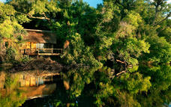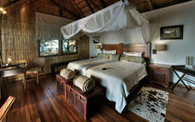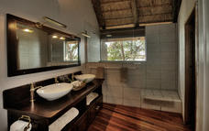

Included
Full Board and Activities

Day 8-10
Leroo La Tau, Makgadikgadi Pans National Park

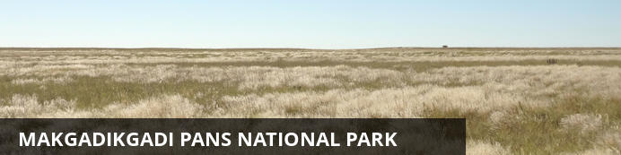
This ancient lake turned salt pan still manages to sustain life and awe visitors.

Notes
The morning is at leisure to enjoy the game viewing activities on offer. After breakfast a camp representative will transfer you to the airstrip. Depart Xugana Island Lodge on a Safari Air shared light aircraft charter flight to Leroo La Tau.
The afternoon is at leisure to enjoy the game viewing activity on offer.
Spend 2 nights on a full board basis at Leroo La Tau

Overnight: Leroo La Tau View iBrochure
Leroo La Tau rises majestically above the Boteti River which stretches across the western border of the Makgadikgadi Pans National Park.
The park, populated by up to 30,000 zebra and wildebeest closely accompanied by predators, offers guests the chance to experience the exhilaration of seeing large concentrations of game and the resultant predator interaction. The lodge offers a raised hide above the river where guests can enjoy the spectacular wildlife sightings that we’ve come to expect in this part of Botswana.
With just 12 thatched luxury chalets all overlooking the magnificent Makgadikgadi Pans National Park, each with en-suite bathrooms. There is a dining room, reading room and bar in the main lodge, expansive wooden decks and a plunge pool, where guests can immerse themselves seamlessly into the ultimate wildlife experience in Botswana.
Having explored the area and enjoyed a spectacular wildlife phenomenon on guided day and night game drives, guests can retire after dinner to a splendid fireplace overlooking the river.
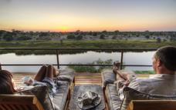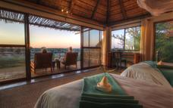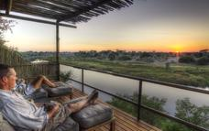

Included
Full Board and Activities

Day 10
Departure

Day Notes
Enjoy a morning game viewing activity followed by breakfast. You will depart on a shared light aircraft charter flight to Maun airport. Here you will depart on your flight to Johannesburg and connect onwards to the US.

Day 11: Travelling

Arrival in the United States at New York (JFK) airport.

Transport

Flight Information
Date | Flight | Departure Airport | Time | Arrival Airport | Time | Class | Ref
 |  | JFK International Airport [JFK] |  | OR Tambo International Airport [JNB]
 |  | OR Tambo International Airport [JNB] |  | Kasane Airport [BBK]
 |  | Kasane Airport [BBK] |  | Savute Safari Lodge
 |  | Savute Safari Lodge |  | Xugana Island Lodge
 |  | Xugana Island Lodge |  | Maun Airport [MUB]
 |  | Maun Airport [MUB] |  | Leroo La Tau
 |  | Leroo La Tau |  | Maun Airport [MUB]
 |  | Maun Airport [MUB] |  | OR Tambo International Airport [JNB]
 |  | OR Tambo International Airport [JNB] |  | JFK International Airport [JFK]

Transfers
Date | Pick Up | Drop Off | Time | Vehicle
 | Kasane Airport [BBK] | Chobe Game Lodge
 | Chobe Game Lodge | Kasane Airport [BBK]

Travel Information
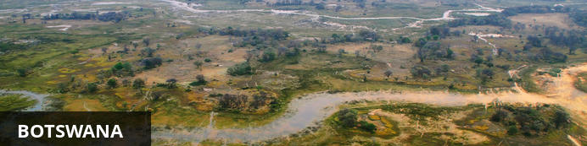
Despite recent and surprisingly rapid modernization, Botswana’s cities provide little in the way of tourist attractions. However, what the cities lack in excitement, the surrounding wilderness areas more than make up for in outstanding natural beauty. The country’s primary tourist draw card is undoubtedly the vast red expanse of the Kalahari desert and its remarkably beautiful Okavango Delta - the largest inland delta in the world - where a spectacular landscape of grassy plains and limpid lagoons provide sustenance to an extraordinary abundance of African wildlife. Other highlights include the impressive Makgadikgadi salt pans where visitors are privy to massive zebra migrations during the flood season; the Savuti plains which host large prides of lions; and the Tsodilo Hills where 4500 rock paintings form a unique record of human settlement over many millennia.

Banking and Currency
Currency
Botswana's currency is Pula (which means 'rain' in Setswana). It is divided into 100 thebe (which means 'shield' in Setswana). Travellers' cheques and foreign currency may be changed at banks, bureaux de change and authorised hotels.
The US dollar, Euros, British Pound and the South African Rand are the most easily convertible currencies (and accepted by some estabishments - but, generally, then an inflated rate of exchange will be applied).
Banking
Seven main commercial banks, as well as a number of foregin exchange bureaux, operate in Botswana. Operating hours are Monday to Friday 08h30 to 15h30 and Saturday 08h30 to 10h45.
Full banking services are available in major towns, although ATMs are sprouting up all over the country. Most credit cards are accepted at hotels and restaurants. Cultural sites and community art and craft outlets usually only accept cash.

Travel, Transport and Getting Around
Public transport in Botswana is geared towards the needs of the local populace and is confined to main roads between major population centres. Although cheap and reliable, it is of little use to the traveller as most of Botswana’s tourist attractions lie off the beaten track.
Driving off the main roads in Botswana is only recommended to expects in 4x4 vehicles, that are equipped correctly. Most lodges offer transfers or they can be arranged. If, however, you will be driving in Botswana: your home driving licence will be accepted (with an official English translation if necessary; driving is on the left side of the road; and the national speed limit is on tarred roads is 120km/h and 60km/h in towns and villages.
Be sure to watch out for wild animals on the roads!
There are major airports in Maun, Kasane and Gaborone, while smaller charter flights are used to get to the other top attractions and camps.

Food, Drink and Cuisine Advice
Tap water is considered safe to drink, although outside main cities and towns, visitors are advised to check first and sterilise water if in any doubt. Bottled water is available in most tourist centres. Filtered water is available at most camps and shops offer bottled water - it is advised to be well stocked of bottled water if you are travelling off the beaten track. Milk is pasteurised, and dairy products, local meat, poultry, seafood, fruit and vegetables are generally safe.
Safari lodges and camps serve international-style cuisine, generally of an extremely high standard, along with local beer and imported wine and spirits. Good restaurants and bars can be found in main towns, often within hotels. Beef and goat are very popular meats. Elsewhere, food is more basic: millet and sorghum porridge are the local staples.
A discretionary 5 to 10% tip is typical for restaurant bills. In many places, a service charge is automatically added. It is customary to tip the game guide and lodge staff while on safari.

Clothing / Dress Recommendations
In summer, lightweight, lightcoloured cottons are preferable. Avoid synthetic materials and black clothing, as they increase perspiration and discomfort. In winter, wear trousers, longsleeved shirts / blouses and jerseys. From May – August, night temperatures can fall below zero degrees celsius, so warm jerseys and jackets are vital, especially on morning and evening game drives. Garments of neutral colours that blend with the bush and forest are advisable for safaris and game viewing. Bring a lightweight jacket and/or jersey for unexpected temperature changes or rain. Closed, comfortable walking shoesor gym shoes are a must in all seasons. Special attention should be given to protection from the sun. Bring a sunhat, good quality sunscreen, sun lotion and polarised sunglasses. Wide brimmed sun hats are essential.

Electricity and Plug Standards
Electrical sockets (outlets) in Botswana are the "Type M " South African SABS1661 ("Large" 15 amp BS-546) sockets. This is actually an old British standard. The "Type M " South African plug and socket is not to be confused with the "Type D " Indian plug and socket. In pictures, they look very similar, but the South African type is much larger than the Indian type, and they are physically incompatible. If your appliance's plug doesn't match the shape of these sockets, you will need a travel plug adapter in order to plug in. Travel plug adapters simply change the shape of your appliance's plug to match whatever type of socket you need to plug into.
Electrical sockets (outlets) in Botswana usually supply electricity at between 220 and 240 volts AC. If you're plugging in an appliance that was built for 220-240 volt electrical input, or an appliance that is compatible with multiple voltages, then an adapter is all you need.
But travel plug adapters do not change the voltage, so the electricity coming through the adapter will still be the same 220-240 volts the socket is supplying. If you need to use appliances that are not compatible with 220-240 volt electrical input, you will need a voltage converter.

