15 day Grand Namibia & Skeleton Coast - Luxury Self-Drive & Fly-In 2022
Windhoek - Sossusvlei - Swakopmund & Coastal Strip - Ongava Private Game Reserve - Twyfelfontein - Hoanib River - Hartmann Valley
15 Days / 14 Nights
Group Size: 2-4
Reference: 15day GN&SC Fly & Drive 2022
Date of Issue: 16 February 2022

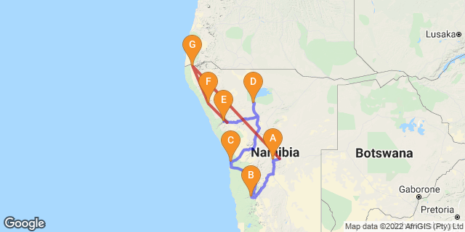

Click here to view your Digital Itinerary

Introduction
A luxury self-drive and fly-in safari in Namibia incorporating some of the best lodges and locations in the country. Explore the diverse landscapes from the dunes of Sossusvlei, drive to the coastal and quirky town of Swakopmund and onward to Etosha region for premier game viewing. You'll leave your vehicle in Damaraland to fly to the stunning and highly-recommended Hoanib Skeleton Coast Camp for a further 3nights with a further 2nights in the remote north overlooking Angola and where the river meets the desert. A varied trip covering the stunning and seemingly empty landscapes, superb game viewing and exclusive, high-quality destinations

Accommodation | Destination | Basis | Duration
The Olive Exclusive All-Suite Hotel | Windhoek | B&B | 1 Night
Little Kulala | Sossusvlei | FI | 2 Nights
Strand Hotel Swakopmund | Swakopmund & Coastal Strip | B&B | 2 Nights
Ongava Lodge | Ongava Private Game Reserve | FI | 2 Nights
Damaraland Camp | Twyfelfontein | FI | 2 Nights
Hoanib Skeleton Coast Camp | Hoanib River | FI | 3 Nights
Serra Cafema Camp | Hartmann Valley | FI | 2 Nights

Key
B&B: Bed and Breakfast
FI: Fully Inclusive - Bed, All Meals, Fees and Activities

Price
2022 Rates - manual vehicles unless indicated
Price per person to Chameleon with Car Rental
Based on 2 people sharing with a 4x4 Double Cab
Low Season (01/11/21- 31/05/22) N$188,365
High Season (01/06/22 - 31/10/22) N$255,385
Based on 4 people sharing with a 4x4 Double Cab
Low Season (01/11/21- 31/05/22) N$184,140
High Season (01/06/22 - 31/10/22) N$250,785
Single supplement N$58,715
Note rooms are on a twin share basis unless single supplement booked
Prices are guideline only due to variation in seasonal rates - contact us for price with client travel dates for accurate quote.
(Price valid until 31 October 2022)
Please note that the N$ is fixed to the South African Rand on a 1/1 basis

Included
Accommodation and activities as set out in itinerary; car rental as indicated for 10day rental; meals as stated in itinerary; vat; tourism levy; welcome pack; fully inclusive at Little Kulala, Damaraland & Ongava, Hoanib and Serra Cafema (fully inclusive includes twin share accommodation, meals, standard drinks and shared activities); seat rate flights between camps - Doro Nawas - Hoanib-Serra Cafema-Windhoek! Flight times as indicated -Should you want to fly when it suits please ask and we can arrange chartered flights at extra cost
Car Rental - Classic Plus - zero excess:
Includes: Unlimited kms, theft & collision damage waiver; Stamp duty, VAT; personal accident insurance; airport surcharge; tourism levy; carbon emissions tax; tyre, rim & hubcap damage; windscreen cover; sandblasting damage; & 1 spare wheel

Excluded
International and other flights; visas; fuel; additional meals and optional activities; personal insurance; tips/gratuities; items of a personal nature; curios; entry fees to parks and places of interest; ancillary charges for car hire as indicated below, etc
2022 park entry fees: N$150/person/day; Children under 16yrs N$100/day and N$30/vehicle day – subject to change & if you self-drive to park note that park gates open/close at sunrise/sunset and you must have exited the park prior to closure or risk a fine/refusal of departure - note as fully inclusive at lodges park fees are included in the activities - these only apply if you enter the park yourself
Car Rental: Ancillary charges
Excludes: Rental deposit; document admin fee N$115; fuel; refuelling fee N$40; additional driver per rental N$500; young driver surcharge N$150 per day (under 23 yrs & held licence min 3yrs); fine handling fee N$375; Assessor fee claim above N$5000 - N$820/per claim; assessor fee with claim below N$5000 N$330/claim; claim handling fee above N$1000 - N$975 or claim below N$1000 N$350/claim; baby seat/booster seat N$500/rental; GPS unit N$135/day (deposit N$1500); wifi router N$135/day (and security deposit of N$1500); second spare wheel N$1500/wheel; delivery of replacement tyres N$22 per km; delivery/collection fee during office hours – Within 25km N$590; Further than 25km N$590 + N$20/km; valet service (only if car excessively dirty) - renter account; roadside assistance call out (negligence) N$800; one way drop off fee if applicable
Prices quoted on ancillary charges for car rental are guideline and subject to amendment by car rental company and as per their terms and conditions
You are only charged for the extras you have - ie if you don't have a baby seat, you are not charged for one

Day 1: The Olive Exclusive All-Suite Hotel, Windhoek

Day Itinerary
Collect your vehicle and drive to Olive Exclusive, depending on the time of your arrival you may choose to wander into the city centre, relax by the pool or perhaps enjoy a massage and unwind from your flight. Overnight in a beautiful junior suite on a bed and breakfast basis; all other meals will be at client’s expense. Enjoy dinner at the lodge or in one of Windhoek's restaurants such as nearby Joe's Beer House. Comfort 4.5-5* Approx 40mins from airport plus time to collect vehicle/complete paperwork
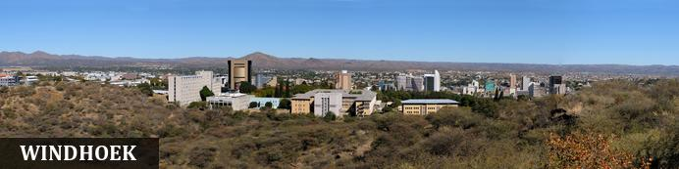
Windhoek is Namibia’s capital, home to an international airport and a plethora of restaurants, shops, entertainment venues and accommodation options. The city is clean, safe and well-organised, with a colonial legacy that is reflected in its many German eateries and shops, and the widespread use of the German language - though English is the official language. The city has an interesting mix of historical architecture and modern buildings, many of which are worth a look, including the Alte Feste (Old Fort), the 1896 Christuskirche (Christ Church), and the more contemporary Supreme Court. It's not a city to linger though - generally one or two nights is sufficient.

Overnight: The Olive Exclusive All-Suite Hotel
The Olive Exclusive is cool, contemporary and stylish but with a warm heart and authentic African soul. Its sleek, modern lines are complemented by organic textures, natural furnishings, an eco-friendly approach and dedicated personal service. Simple elegance is key, from the organic rough-hewn wooden benches and side tables, through the sculpted chunk of granite that serves as a coffee table in the guest lounge, to walls clad in abstract Namibian landscapes by well-known South African photographer Micky Hoyle. The seven suites are individually decorated so each reflects a different region in Namibia, and each has its own lounge area with fireplace and dining room, for private dining. Wide glass doors open onto spacious decks where you can relax on a shady daybed, enjoy al fresco lunches or, if yours is a premium suite, take a dip in your own private plunge pool. There are extra-length bed dressed in crisp, pure-cotton linen, or indulge in a bubble bath in a freestanding tub. Air-conditioning & satellite TV are standard, as is a computer with free WiFi access and a fully stocked mini bar. There's a quality restaurant featuring a seasonal menu, with inventive signature dishes and a fully stocked bar also features a classic selection of fine whisky.
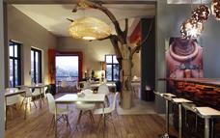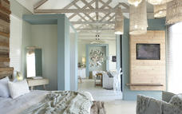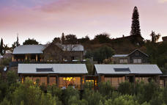

Basis
Bed and Breakfast

Day 2-3: Little Kulala, Sossusvlei

Day Itinerary
Drive via Rehoboth to Kulala Wilderness Reserve, where you are based for 2nights with ideal access to the towering red dunes of the Namib. This afternoon your activity will explore the private reserve and the following morning enter the Namib Naukluft via a private gate where your guide will escort you to the apricot dunes and ancient desert landscapes of Sossusvlei and surrounding areas - there’s the chance to climb a dune, take endless photos of Dead Vlei with its skeletal camel thorn trees, a testament to when water supported the region. Nowadays, the Tsauchab River only occasionally flows but when it does the desert comes to life with flowering desert plants and grasses and an oasis is created in the desert. You’ll return to Little Kulala later in the morning before the heat of the sun is too intense and after lunch perhaps have a massage (extra cost) or relax by your private plunge pool, to simply soak up the atmosphere. Later, head out for another activity to experience the stunning region or watch the world go by! Fully inclusive basis (includes accommodation, standard activities, meals and drinks (not imported)). There is a range of activities to choose from and we have indicated some of the options available. Comfort 5* Approx 5.5-6hours + from city to lodge; we have listed a range of activities on offer, when you arrive at the lodge you can discuss your preferences to match your own interests
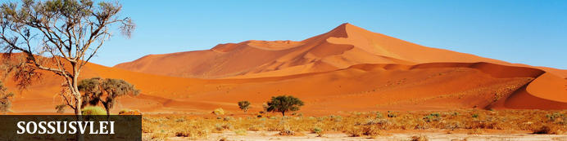
Sossusvlei is where you will find the iconic red sand dunes within the Namib Naukluft National Park. The clear blue skies contrast with the giant red sand dunes to make this one of the natural wonders of Africa and a photographers' heaven and set within the highest dunes in the world. It is at its most spectacular after a good rainy season and if the Tsauchab River has flowed filling the vlei and creating an oasis in the desert. The most iconic vlei is nearby Dead Vlei where the dazzling white clay pan is punctuated by skeletons of ancient camel-thorn trees, and set against the backdrop of the apricot dunes. Aside from the attractions at Sossusvlei - Dune 45, Hiddenvlei, Big Daddy and Elim's Dune - other attractions in the area include the Sesriem Canyon and Namib-Naukluft National Park, where the mountains of the Namib meet its plains and a great hiking destination.

Overnight: Little Kulala View iBrochure
This desert retreat is situated on the dry Auab riverbed in the Kulala Wilderness Reserve. The 11 climate-controlled, thatched “kulalas” merge seamlessly into the timeless desert landscape, with classical fittings and fixtures, and each with a private plunge pool. The extensive use of neutral colours, gorgeous textures and natural light reproduce the soothing pastel tones of the desert. Each villa has a rooftop “skybed” for romantic star gazing, with both indoor and outdoor showers. An elegant entertainment area includes al fresco fine dining as a highlight. Varied activities aim at acquainting guests with the splendour, solitude and stark beauty of the Namib Desert, with excursions to Sossusvlei (via a private gate), and nature drives and walks providing awe-inspiring views of desert-adapted wildlife and plants. A balloon safari (at extra cost) offers a unique experience soaring silently above the desert, while eco-sensitive quad biking explores this beautiful area on the ground. The main lodge is home to a large entrance, with wine cellar, indoor/outdoor dining area, lounge as well as an upstairs library room where there's also a selection of games. There's a large wooden deck and pool with loungers to sit and while away your time - or perhaps enjoy a massage (extra). Wifi available.
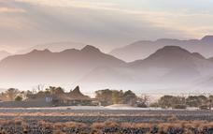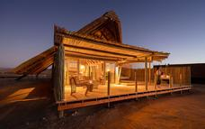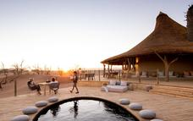

Little Kulala - Visit to Sossusvlei and Dead Vlei
World-famous Sossusvlei is the name of an enormous clay pan, flanked by the famous sand dunes that flush red in the early morning sun (as well as the name of the area in general). Close to the Sossusvlei pan is Dead Vlei, another pan where water once flowed. All that remains now are the skeletons of trees that reach up out of the cracked earth.
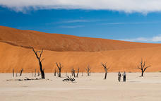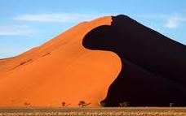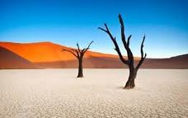

Little Kulala - Nature Drives
The 37 000-hectare private Kulala Wilderness Reserve offers visitors exclusive wildlife-viewing opportunities which include the likes of gemsbok (oryx), bat-eared fox, brown hyaena and birdlife. Sundowner stops in scenic parts of the reserve are a highlight.
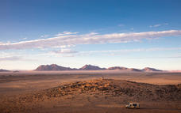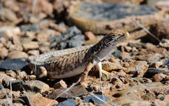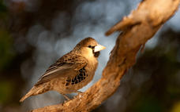

Little Kulala - Guided Nature Trails
Walking trails focus on becoming immersed in this remote area, as well as its scenic beauty and the fascinating, and surprisingly, diverse array of insects, reptiles and rodents which make this dry and harsh region their home. The Tsauchab River Trail takes a stroll along a fascinating dry riverbed.
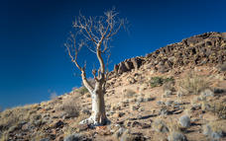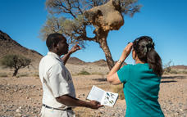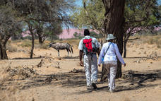

Little Kulala - Guided Quad Bike Excursions
Explore further into the private Kulala Wilderness Reserve, while enjoying the thrill of riding a quad bike. A guide leads these eco-sensitive excursions, allowing you to take in the incredible views and to catch a glimpse of the denizens of the desert.
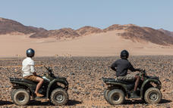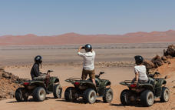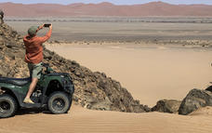

Little Kulala - Scenic Sundowner Excursion
Set out in the late afternoon for a nature drive and complete your excursion in a remote and dramatic spot on the reserve sipping a gin and tonic while watching the sunset.
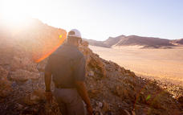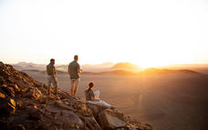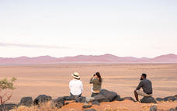

Little Kulala - Guided Scorpion Night Walks
After dark, another realm of the Namib awakes. Walks reveal some of these captivating critters such as dancing white lady spiders and scorpions which fluoresce under UV lights.
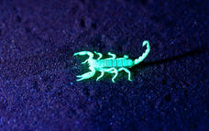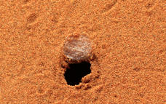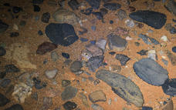

Little Kulala - Sleep-Out Experience
Delight in a sleep-out experience under the starry starry skies of the Namib and be lulled to sleep by the sounds of Africa on the bottom deck of your accommodation.
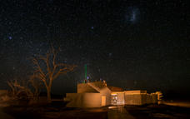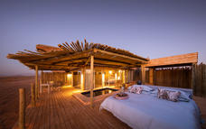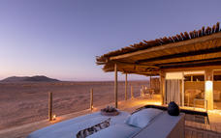

Little Kulala - Stargazing
The Namib is known for its clear night skies, and with no light pollution it is the ideal spot from which to learn about the incredible formations of the stars and planets. Our guides are also known to dabble in astronomy and will guide you through the constellations.
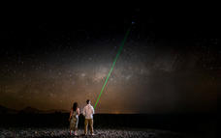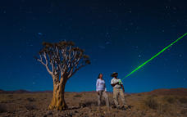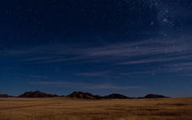

Basis
Fully Inclusive - Bed, All Meals, Fees and Activities
All Local Brands (Spirits, Wine and Beers) Included

Day 4-5: Strand Hotel Swakopmund, Swakopmund & Coastal Strip

Day Itinerary
This morning, drive to Swakopmund passing gravel plains and over Gaub and Kuiseb Passes through the desert to Walvis Bay, where you can stop at the lagoon, a RAMSAR protected wetland site, home to many different aquatic birds such as flamingo, pelicans, cormorant, avocets, and endemic Damara tern before continuing along the coastal road to Swakopmund. Should you arrive early enough you may have time to take part in one of the optional activities such as an afternoon scenic flight over the dunes of Sossusvlei, to the coast to see shipwrecks, old diamond mines, dunes falling into the ocean as well as seal colonies, flamingos etc. This flight really gives a different perspective of the area you have already seen from land. Alternatively, the following day is free to relax or join optional activities - this coastal town offers a huge range for all ages and interests. Accommodation in a 5* style hotel overlooking the ocean on a bed and breakfast basis with a choice of restaurant available. All other meals/activities in Swakopmund at client’s expense. Comfort 4.5-5* Approx 6-7hours
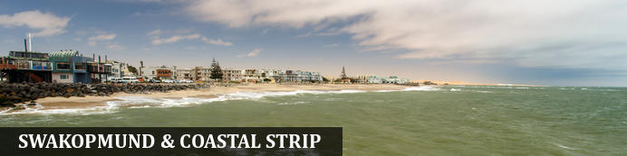
Founded in 1892 as the main harbour for German South West Africa, Swakopmund is often described as being more German than Germany. Now a seaside resort, Swakopmund is the capital of the Skeleton Coast tourism area and has plenty to keep visitors happy. The quirky mix of German and Namibian influences, colonial-era buildings and the cool sea breeze make it very popular and has a wide range of accommodation establishments, banks, restaurants/cafes and shops.
Along this stretch of coastline (Walvis Bay and Swakopmund) you can take part in a selection of activities sating the thirst of those seeking adrenaline adventures - sky diving, quad biking and sandboarding; or for the more leisurely a range of marine activities including kayaking and cruises. The coastal desert can also be explored with trips to Sandwich Harbour, or informative desert tours... There is a long list so just ask us!
Walvis Bay is Namibia's major harbour town and the lagoon has prolific bird life including flamingos, pelicans as well as the breeding area for the endemic Damara tern - any bird enthusiast should make a stop here.
Further north along this coastline - part of the Skeleton Coast, you'll find shipwrecks and the famous Cape Cross seal colony - one of the largest fur seal colonies in the area.

Overnight: Strand Hotel Swakopmund View iBrochure
The Strand Hotel Swakopmund is located directly on the Mole (promenade) in Swakopmund, surrounded on three sides by the Atlantic Ocean, with direct access to the main beach in town. On the fourth side it will back up to the town’s beautiful central park, through which it is a short five minute walk to the historic centre of this charming, German, Victorian era colonial seaside town, with all its shops, cafés, restaurants and bars. There are extensive, unique and creatively entertaining restaurants, bars, deli, lobby-lounge, sea facing terraces and shops. Its architectural inspiration finds its roots deep in Namibian German colonial history and reflects this in a tasteful contemporary manner.
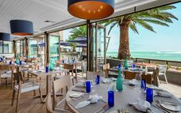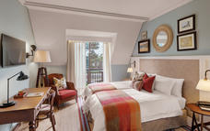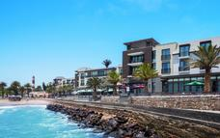

Walvis Bay Lagoon
Walvis Bay’s calm natural lagoon is a twitcher’s paradise, teeming with roughly 50 species of seabirds, including vivid flocks of flamingos, bulky-billed pelicans and glossy black cormorants. It’s also a popular spot for windsurfing, kitesurfing and kayaking, while the promenade stretching for three kilometres along the water’s edge is a great place for a scenic stroll.
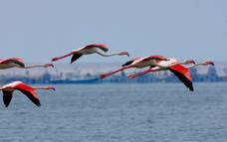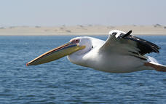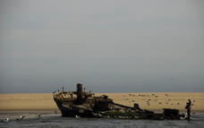

Basis
Bed and Breakfast

Day 6-7: Ongava Lodge, Ongava Private Game Reserve

Day Itinerary
Today’s drive takes you to 4.5* Ongava Lodge set on an incredible private game bordering the Etosha National Park and where you stay for two nights on a fully inclusive basis. Overnight in a twin bed chalet (lodge) with all meals, accommodation and standard/shared activities are included - join game drives in open vehicles with other guests on the reserve as well as into Etosha, night drives and game walks. Surprisingly the terrain on the reserve varies quite considerably from that of Etosha, with hills and plains, various woodlands and shrub areas – a highly recommended option. Comfort 4-4.5* We have listed some of the activities available at Ongava, these are subject to availability at the lodge and agreed upon arrival. Approx 6hours
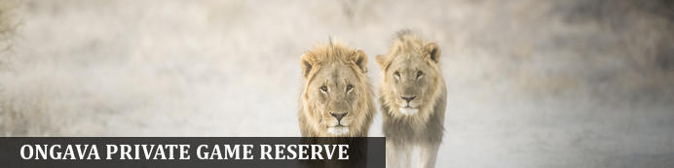
Sharing the southern boundary with Etosha National Park, the prolific 30 000-hectare private Ongava Game Reserve is considered one of the top private game reserves in the region, enjoying global recognition for exceptional conservation, groundbreaking research and exciting safari experiences. The landscape is characterised by vast open plains dotted with salt plans and abundant wildlife. Visitors can easily access Etosha through Andersson’s Gate in the south. Known for its luxury lodges made out of natural materials, Ongava is a popular destination for those looking to immerse themselves in nature. The reserve offers visitors the perfect combination of wildlife safari experiences within and around the Etosha National Park. One of Ongava’s top attractions is its rhino population and guests can experience the thrill of getting close to these majestic creatures. Popular activities include: night game drives, guided nature walks, bird watching and 4x4 guided game drives

Overnight: Ongava Lodge View iBrochure
The well-established Ongava Lodge is situated in the privately owned Ongava Game Reserve along the southern boundary of Etosha National Park. Placed close to the top of a hill in the foothills of the Ondundozonanandana range, the vantage point is beautiful and overlooks a well-frequented waterhole and the plains beyond. The lodge offers luxury accommodation (4*) in 14 rock-and-thatch en-suite chalets, all with large bedroom area, desk and chair, air-con and large doors to a private deck. The is a spacious bathroom with walk-in shower, twin basins along as well as an outdoor shower. In the room is a safe, tea/coffee station and all the standard facilities. There are impressive views over the camp’s waterhole from the main lounge and dining areas along with an inviting pool to cool off in the heat of the day. Meals are either served in the main dining area under thatch or on the dining deck under the stars. Activities include game drives into Etosha, spending time in the camp hide, and nature drives and walks on the reserve. Ongava has resident white and black rhino, giving guests staying at Ongava the opportunity to see both species.
Ongava Game Reserve Game drives normally leave in the early morning and late afternoon, ideal times for game viewing. Dusk and night drives offer an opportunity of experiencing nature after dark. You will be accompanied by an ecologically aware ranger who will guide you on an informative tour of the reserve, helping you discover some of the fascinating indigenous elements of the bushveld. A number of safe and secure hides are also available for guests wishing to spend time on close-up wildlife viewing or photography. Game on the reserve includes elephant, lion, rhino, various kinds of buck and a multitude of bird species
Ongava Game Reserve Reintroduction Project: Most general game has been reintroduced, including springbok, gemsbok (oryx), Hartmann's mountain zebra, red hartebeest, southern giraffe, eland, Damara dik-dik, and the largest population of the endemic black-faced impala (listed as Endangered) outside of Etosha.
White and Black Rhino Project: Another successful reintroduction project is the white and black rhino project – where Ongava holds one of the largest rhino custodianships for the Namibian government. These custodianships are set up in safe havens throughout the country in hopes of breeding rhino to more sustainable numbers and reintroducing them into areas where they previously flourished. Ongava Game Reserve is one of the few places in southern Africa where you will have a realistic chance of encountering both of these amazing creatures
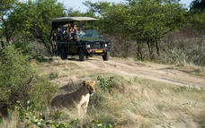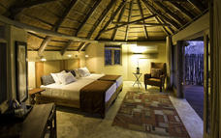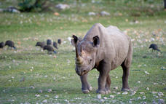

Activities
Ongava Lodge - Game drives on Ongava Game Reserve

Ongava Lodge - Excursions into Etosha National Park
Full- or half-day guided morning game drives in the Etosha National Park, Namibia’s prime savannah wilderness area (with a packed lunch on full day). See the massive saltpan as well as the perennial springs that provide the water required by the Park’s high-density big game population, including its elephant population. Private vehicles can be booked at an extra cost (subject to availability).
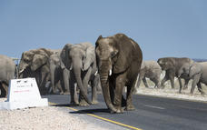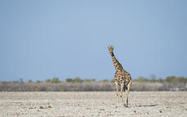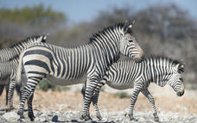

Ongava Lodge - Guided Nature Walks
Offered seasonally and subject to an available walking guide, nature walks through the area take in the abundant array of life, small and large; with a chance of potentially approaching white rhino.
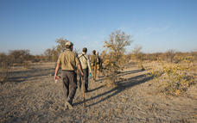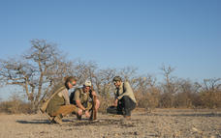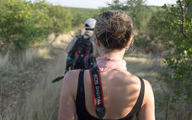

Ongava Lodge - Camp Hide
The hide is a fantastic place to relax and while the hours away up close and personal with wildlife slaking its thirst at the camp waterhole. This arid environment where little water occurs makes this a popular drinking spot for game.

Ongava Information System and Visitor Centre
Guests can interface with science and research across the Ongava Game Reserve and part of this experience is an immersion into the world of natural history and science at the new Ongava Visitor Centre. With dozens of in-depth displays that feature information on the geology, animals, plants and ecological functioning of this fascinating region, guests are encouraged to meander through the self-guided exhibition area.
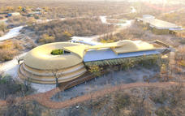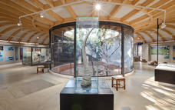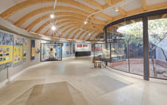

Ongava Lodge - Game drives on Ongava Game Reserve
Guided afternoon/evening game drives take place on the private Ongava Game Reserve. The reserve is famed for its population of rhino as well as lion and other game such as antelope, including endemic black-faced impala. Private vehicles can be booked at an extra cost (subject to availability).
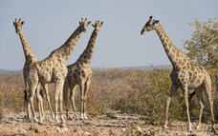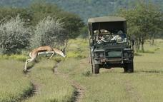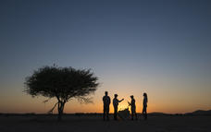

Basis
Fully Inclusive - Bed, All Meals, Fees and Activities
All Local Brands (Spirits, Wine and Beers) Included

Day 8-9: Damaraland Camp, Twyfelfontein

Day Itinerary
This morning perhaps join another activity before departing Ongava and driving west into Damaraland to overnight. Activities revolve around the rugged landscapes of this harsh but beautiful area and you can take a chance to relax or join activities from nature drives, to guided walks, cultural excursions and visits to nearby rock art. Fully inclusive basis. Comfort 4-4.5* Approx 4-4.5hours
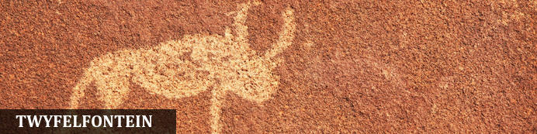
Twyfelfontein is a site of ancient rock engravings in Damaraland, and Namibia's first UNESCO World Heritage Site (2007). It has one of the largest collections in Africa as well as one of the most note-worthy with around 2,000+, some thought to be around 6,000 years old! It is believed that the creators of the rock art were the medicine people or shamans who incised their engravings as ameans of entering the supernatural world and recording the experiences, the process could prepare the shaman for a state of trance by the repetitive chipping and concentration of energy. Etched into the rock are thus stories within stories, eternalised as a legacy

Overnight: Damaraland Camp View iBrochure
Damaraland Camp is situated in the Huab River Valley in one of the best wilderness areas in Namibia, offering endless vistas across stark plains, ancient valleys and a stunning ochre-purple mountain backdrop. Ten large en-suite, adobe-style thatched units are raised off the ground, each with a walk-in dressing area and a large deck on which to sit and contemplate the desert. The units have tea/coffee station and safe in each room but note due to its remote location and eco policies there is no air con. The spacious living area comprises a dining area, and swimming pool. New technology combined with ancient knowledge has produced an eco-friendly yet high-performance design in this unique camp. An open campfire and outdoor “boma” are enjoyed during calm evenings and stargazing is superb, thanks to the crystal-clear night skies. Activities include nature drives and walks during which guests can see species such as desert-adapted elephant, gemsbok, kudu and springbok, as well as rare succulent plants. Further afield, ancient rock art and geological wonders dot the area. Damaraland Camp is the result of an award-winning partnership between Wilderness Safaris and the Torra Conservancy; visits to the local farmstead allow guests to see this relationship in action. No internet/wifi available so sit back and enjoy the peace and quiet
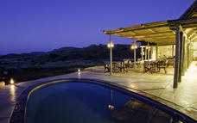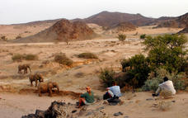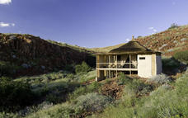

Damaraland Camp - Nature Drives
Morning and afternoon nature drives reveal the dramatic scenery and fascinating wildlife of the region. Desert-adapted elephant are the highlight of the area, although the natural cycle of rainfall dictates the seasonal movements of wildlife along the Huab River.
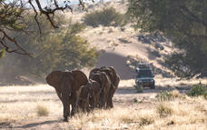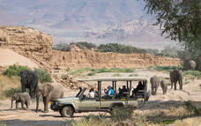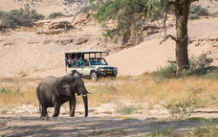

Damaraland Camp - Cultural Activities
Learn about the unique heritage of the local peoples, which include Nama-Damara, Herero, Owambo, and the displaced Riemvasmaakers of South Africa. This activity allows you to respectfully engage with these communities and it also includes a visit to the local Bergsig School.
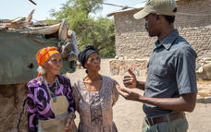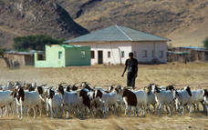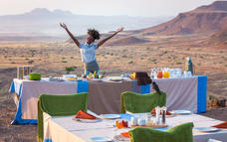

Damaraland Camp - Guided Nature Walks
Learn more about the ancient geological past and present of Damaraland; as well as about the unique plants, birds and reptiles that have superbly adapted to this arid area.
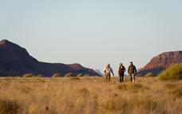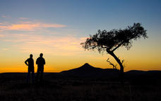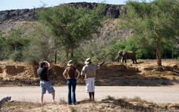

Damaraland Camp - Rock Art Excursions
Damaraland is world-famous for its ancient rock art; guests on stays of three nights or more can take a day drive to visit some of these remains and marvel at the artists of ages past.
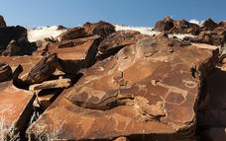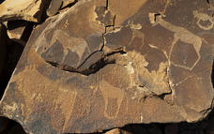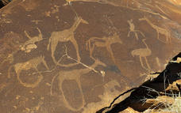

Basis
Fully Inclusive - Bed, All Meals, Fees and Activities
All Local Brands (Spirits, Wine and Beers) Included

Day 10-12: Hoanib Skeleton Coast Camp, Hoanib River

Day Itinerary
You can relax for a while (or perhaps join a further scheduled/shared activity), before making your way a short distance to Doro Nawas where you leave your vehicle and transferred to the airstrip taking a scheduled (seat-rate) flight at approx 12h45 arriving 13h25 at Hoanib Skeleton Coast, your base for 3nights on a fully inclusive basis.
Explore this diverse and fascinating part of the Palmwag Concession as well as the legendary Skeleton Coast National Park. Game drives and nature walks within this rugged landscape reveal wildlife such as desert-adapted elephant, desert-adapted lion, to Hartmann’s mountain zebra, and giraffe to name a few. A real highlight of your stay (weather permitting) is a visit to the iconic Skeleton Coast - travelling by air or by land, this fascinating journey takes you via the Hoanib River and floodplain, the dune fields and Klein Oasis, ending at the dramatic rocky coastline itself with its huge Cape fur seal colony. This is a beautiful luxury camp located in a highly restricted area so few visitors have the chance to explore it. Comfort 4.5- 5*.. Activities listed are subject to availability and discussed/arranged on arrival to suit your interests

Expert Tips
The seat rate flight will depart from Doro Nawas around 12h45 and fly to Hoanib arriving approx 13h25 where you are transferred from the airstrip to the lodge - note flight times are guidelines only
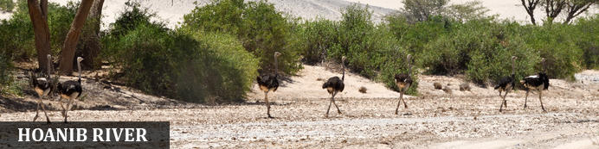
Where Kaokoland meets the Skeleton Coast, in western Namibia, the 270-kilometre-long Hoanib River is one of the last water oases in the country, providing a haven for numerous animals. Home to 75% of Namibia’s endemic species, including the largest numbers of desert-adapted, free-roaming elephants, lions, and rhinos in the world, as well as zebra, kudu, and giraffe, this is a truly exceptional and awe-inspiring place. Visitors can enjoy taking a wonderful four-wheel-drive route, going on adventurous hiking trails, running down enormous sand dunes, or climbing massive, strangely shaped rock formations as well as several guided nature walks.

Overnight: Hoanib Skeleton Coast Camp View iBrochure
In a remote area of the Kaokoveld, in a land of bare mountains, gravel-strewn plains and dry riverbeds that draw fascinating wildlife, lies Hoanib Skeleton Coast Camp. All eight large en-suite tents (including one family unit) with shaded outdoor lounges and the main area and swimming pool look out over rugged scenery: a wide valley slopes down to the almost-always dry Hoanib River. Explorations of this isolated yet diverse area take place via game drives along the riverbed’s narrow ribbon of vegetation, where a surprising wealth of desert-adapted wildlife can be found: elephant, giraffe, gemsbok and springbok, with glimpses of lion and brown hyaena. The Skeleton Coast with its desolate rocky coastline, noisy colonies of Cape fur seals and remains of shipwrecks is accessed either by a fascinating drive or scenic flight, depending on the weather. Hoanib is a hub for researchers studying predators such as desert-adapted lion and brown hyaena; guests can meet them (when they’re in camp) and view their work in the Research Centre. The camp is fully solar powered and a joint venture with the neighbouring Conservancies of Anabeb, Torra and Sesfontein but there is no air con so guests looking for creature comforts need to come with an open mind as the camp, location and experience is bound to leave its mark! A three night stay includes a 3/4 day trip to the Skeleton Coast itself. Note there is no wifi/internet due to remoteness of the camp
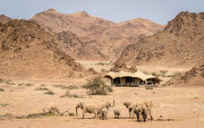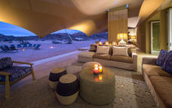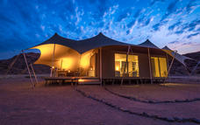

Hoanib Skeleton Coast - Nature drives
Nature drives showcase the magnitude of the landscape and offer the best possibilities of seeing desert-adapted wildlife. Morning or afternoon drives are available, as well as full-day excursions.

Hoanib Skeleton Coast - Guided nature walks
Guided nature walks from camp are an exciting way to get up close and personal with desert-wildlife. As well as the possibility of spotting big game, it is also a good opportunity to study the smaller creatures and the fascinating plant life of the concession.

Hoanib Skeleton Coast - Excursion to the Skeleton Coast
On a stay of three nights (or more) full-day excursions to the Skeleton Coast are offered. The fascinating 4x4 trip to the coast takes you via the wilderness and wildlife of the Hoanib River and floodplain, which include Klein Oases Spring and driving through a dune field - while the Skeleton Coast itself reveals a rocky coastline with its huge Cape fur seal colonies and shipwreck remains. Following a picnic lunch, the return flight back to camp offers a magnificent perspective of your journey from the air.

Hoanib Skeleton Coast - Day excursions
Operating within our concession area and on offer to all guests, these trips leave camp early in the morning, include a picnic lunch, and return to camp in the mid to late afternoon. It includes Mudorib Springs, exploring remote areas in the south of our allocated exclusive concession area, with the red basalt landscapes of the Damaraland. Amongst other general game species, guests have the chance of seeing Hartmann's mountain zebra and the desert-adapted rhino. In the northern and eastern area of the Hoanib, the valleys offer spectacular scenery.
Subject to private vehicle availability, to guarantee this excursion a private vehicle needs to be booked and paid for.

Hoanib Skeleton Coast - Interaction with wildlife researchers
Presentations and interaction with wildlife researchers are planned when researchers are in camp, or nearby. These include all current research, in particular the good work being done by Dr Flip Stander and his team on the unique desert-adapted lion.

Flight Information
Date | Flight | Airline | Departure Airport | Time | Arrival Airport | Time | Class | Ref
 | Scheduled |  | Doro Nawas Airstrip |  | Hoanib Skeleton Coast Camp

Basis
Fully Inclusive - Bed, All Meals, Fees and Activities
All Local Brands (Spirits, Wine and Beers) Included

Day 13-14: Serra Cafema Camp, Hartmann Valley

Day Itinerary
Fly by light aircraft to the vast Marienfluss Conservancy in the extreme north of Namibia for a three-night stay at Serra Cafema. The camp is poised along the lush banks of the Kunene River, a rejuvenating band of green, surrounded by the lunar-like landscape of the Namib Desert and the Cafema mountain range to the north. Informative nature drives and eco-friendly quad-bike excursions allow guests to experience this vast, fascinating area. Boating on the river reveals the resident crocodiles and waterbirds living in this riverside oasis. Walking in the remote mountain and river valleys is also a highlight, as is a visit to a Himba settlement. The intriguing fairy circle phenomenon is best viewed in the Hartmann Valley. Comfort 4.5-5* Flight Hoanib-Doro Nawas-Serra Cafema - departing Hoanib 10h50 and arriving Serra Cafema 13h40

Expert Tips
Your flight will leave (seat rate) at approx 12h45 and fly onto Serra Cafema arriving around 13h40 where you are transferred to the lodge - note flight times are guidelines only and other guests are likely to be on board
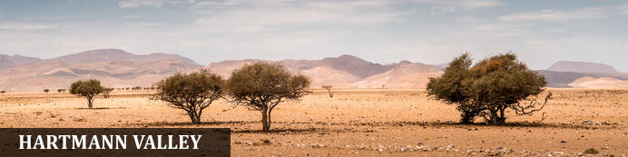
Stunningly remote, the Hartmann Valley is a desolate yet entrancing moonscape of sand and rock. Located in the extreme northwest of Namibia, the region offers a profound sense of wilderness and unusual juxtaposition of habitats, as the Kunene River nurtures a band of lush vegetation amidst one of the driest deserts on earth, while sea mists creep in from the coast, and waves upon waves of dunes beckon to be slid down. The valley is home to the Himba, one of the last true nomads in Africa.

Overnight: Serra Cafema Camp View iBrochure
Set among shady trees on the banks of the Kunene River, Serra Cafema has recently re-opened after extensive refurbishment is one of the most beautiful, yet remote camps in southern Africa, Its Portuguese name originates from the mountains that dominate the northern skyline. Guests fall asleep to the sound of rushing water, while by day they explore one of the driest deserts in the world. Activities here are varied, including boating (water levels permitting), walking, viewing breath-taking landscapes, as well as carefully guided quad-bike excursions that tread lightly on the dunes. In this isolated region, the Himba people continue their nomadic, traditional way of life and when in the area, guests have the opportunity to meet them and learn about their lifestyle and traditions.
INSIDER'S TIP: Most authentic Himba cultural experience in all of Namibia
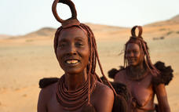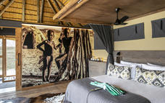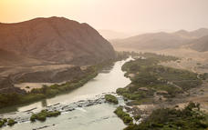

Recommended
Serra Cafema - Full-Day Outing To Marienfluss Valley With A Packed Picnic Lunch

Serra Cafema - Guided Quad Bike Excursions
One of our highlights, guided quad bike excursions through the fragile environs, is done with utmost care along specifically allocated pathways, so as to tread lightly on the dunes and preserve the unique and delicate habitats of this landscape.

Serra Cafema - Visits To A Himba Community
In this isolated area, the Himba people continue their traditional semi-nomadic way of life and, when they are in the area, guests have an opportunity to learn about their lifestyle and customs.

Serra Cafema - Boating Trips On The Kunene River
Boating on the Kunene River provides our guests with the opportunity to venture through the lush riverside oases. Crocodiles and waterbirds seem out of place in this surreal, lunar-like landscape.

Serra Cafema - Nature Drives & Walks In Hartmann's Valley
Informative nature drives in open Land Rovers allow guests to experience the true Namib in its unbridled glory, while walking provides unique opportunities to see the smaller denizens of the desert, from the famous fairy circles to the desert chameleon.

Serra Cafema - Full-Day Outing To Marienfluss Valley With A Packed Picnic Lunch
The vast expanse of the Marienfluss Valley offers a much-needed sense of space and enables new interpretation of the concept of beauty.

Flight Information
Date | Flight | Airline | Departure Airport | Time | Arrival Airport | Time | Class | Ref
 | Scheduled |  | Hoanib Skeleton Coast Camp |  | Serra Cafema Camp

Basis
Fully Inclusive - Bed, All Meals, Fees and Activities
All Local Brands (Spirits, Wine and Beers) Included

Day 15: End of Itinerary

Day Itinerary
Today, as your location is so remote (it is, after all, a lodge that borders Angola in the far north of the country!) leave Serra Cafema in the morning for around 10h45 flight and fly via Doro Nawas back to Windhoek arriving at 13h55 allowing time to catch a late afternoon flight.

Expert Tips
Note that no bookings have been made and subject to availability - should the indicated option not be available then the price/itinerary is subject to change
Comfort: we have tried to indicate throughout the itinerary a comfort rating to give you an idea of what to expect. Please note that Namibia does not have a set "star" system and the rating is based normally on the comfort of room/lodge, food, service as well as location and activities. Note these are guidelines only and do not always compare to European /city destinations who will have easy access to supplies - being in a remote location will mean limited menu choices etc. They are some of the best lodges in Namibia with unique experiences and locations.
International air connections leaving the safari: Please ensure that your departure flight is booked for after 17h00 from Windhoek. For earlier international departure flights, an additional transfer will be required to arrive for this connection, subject to extra cost.
Clothing and other items: Shorts; light trousers/jeans; T-shirts; warm clothes such as a fleece, sweater and even thermals during winter; (May – August); swimming costume; long-sleeved shirts; Camera; walking shoes; sandals; sun hat; windbreaker; towel on camping trips only; torch & spare batteries (even during accommodated trips walking between rooms/lodge etc it is useful to have); water bottle; mosquito protection UV protection
Car Rental: As with all car hire companies if you have an accident and they prove you were negligent– for example - speeding then the zero excess becomes void and you are liable for costs. When collecting the vehicle at car rental office, you’ll complete their contract and discuss any extras with them (such as further insurance/GPS hire etc). Check the vehicle carefully as you are responsible for it thereafter. If you have any problems with the car whilst you are on the road, please contact the car rental directly to help speed up the process (though we can assist if required).
All rentals require the following: passport, driving licence (written in English or an international licence), credit card (for refundable deposit/extras).
A GPS is often available by the car rental companies (at client’s own expense), however, we find that due to our road network system (and small population), it is not normally required, we realize this is a personal preference and are happy to pre-book for you.
Note that ancillary costs are a guideline and subject to change at suppliers discretion.
Outside of major towns/cities we do not suggest driving around/after sunset
Most vehicles have a tracking device, and should you damage your vehicle in any way and the route deemed unsuitable you will be held liable for the damage. More details regarding how to drive on gravel roads and in Namibia/surrounding countries is given with our “car rules and regulations” document issued with your self-drive confirmation
Note for flights: As safety and a quality air service is a strict focus for us, it is vital that we manage all weight and balance calculations ahead of time. We therefore require the weights of all guests prior to travel. Note that additional weight allowance on our aircraft does not need to be purchased for passengers weighing more than 100 kg (220 lb)
Maximum luggage weight 20kg including both check-in, camera and hand luggage. Excess luggage will either be charged for directly to the client or remain in Windhoek
Only soft bags will be accepted - no frames or rigid structures can be transported as they physically cannot fit into the aircraft. Wheels on a bag are only permissible if they are not part of a solid frame or rigid structure. A collapsible wheeled luggage frame / trolley (separate to the bag) is allowed, as long as the basic dimensions are similar to that of the bag. The maximum dimensions of the soft bags which can be accommodated are as follows: 25 cm (10 inches) wide x 30 cm (12 inches) high and 62 cm (24 inches) long. Should you require a bag, the air company offers a supply of soft canvas carry-all bags at a reasonable cost. Please note that the baggage compartments on light aircraft are only 25 cm high (10 inches), so pilots must be able to manipulate the bag into the compartment
On occasion, the times mentioned below will vary slightly as a result of unforeseen circumstances: late arrival/departure of scheduled airlines, delays with the customs & immigration process, aircraft technical and maintenance requirements or diversions due to adverse weather conditions or any other delays which are beyond the control of the agent or operator or in the interest of the safety of our passengers . The operator will always endeavour to rectify the situation to the best of their ability, however, they cannot held liable for any costs incurred as a result. There will be no refunds due in the event that alternative arrangements need to be made. The operator shall only be held liable for such costs in events where such delay was a direct consequence of the gross negligence or wilful misconduct
Conservation/Conservancies: Namibia was the first country in the world to include the protection of its environment in its constitution and today around 17% of its surface area is protected. The broader conservation network includes private and communal conservation areas covering over 44% of the country. Despite the milestones achieved in conservation with the collaboration of private and public sectors, and along with generous contributions and support from the traveller community; several stakeholders, including Chameleon Holidays are only expanding our services and operations to further sustain efforts towards conservation. On this safari alone, you are directly assisting Save the Rhino Trust, along with various freehold conservancies, all assisting in ensuring the local population/community, environment and wild animals benefit.
Money: The currency in Namibia is the Namibia Dollar, which is fixed to and equals the South African Rand on a 1-1 basis. The dollar and SA Rand are the only legal tender in Namibia, and both are used freely, however the Nam dollar is not legal tender in South Africa and we recommend that you exchange your money prior to departing Namibia
Credit Cards: Visa and MasterCard are generally accepted in shops and restaurants in towns and many lodges. Use of credit cards may incur an additional fee. Occasionally lines may be down and services not available particularly in remote destinations and payment will need to be in cash
Cash: South African rand can be purchased in advance. The Namibia dollar is not an international currency and therefore can only be obtained in country. Cash is available at ATM machines using credit card and pin number. There is FX bureau upon arrival at International Airport for those arriving by air and can be worth obtaining prior to arriving in city. It is customary to tip in Namibia, usually, around 10% at restaurants. A tip box is normally found in the reception in lodges
Safety: As with every destination safety tips needs to be adhered to; we strongly recommend you use a safe in a hotel/lodge or lock up your valuables when you are not in the room; when in a vehicle do not leave valuables on display but tucked away and out of sight. It is also better to have copies of passports, money; cards etc split between travellers so if anything, unexpected happens and a bag is lost or stolen then other funds/cards are available, you may also wish to consider using a money belt/neck wallet. We suggest you leave valuable jewellery at home – you won’t need it while travelling. A padlock for your luggage is also recommended
Booking & payment: When you have decided on a trip a booking form will need to be completed, signed and returned to us and we will enquire regarding availability and advise you. Once we have taken deposit, a confirmation is sent to you, advising you of the services agreed and booked. Payment is due approximately 6 weeks (sometimes 8 weeks depending on the supplier) prior to departure. Exchange 4 free, bank transfers and MasterCard/Visa are all accepted forms of payment but please ensure there are sufficient funds, and your bank is aware of the transaction about to take place (if you are paying via credit card), currently many banks will withhold money as a safeguard against fraud and this delay can be critical particularly if you are booking at short notice. Please also allow for payment to process and if paying via bank transfer to include all bank fees, note we are unable to confirm bookings/trip until funds have cleared into our account, any delay may see a cancellation in your trip and booking released.
Dietary: We can assist with booking of various dietary requirements or food allergies, but we appreciate your details when you book with us (or with your agent) and we will advise the appropriate lodges. Please be aware that the choice and options may not be as great as your home country.
Weather: Please note that in winter evenings and nights in particular can be very cold we recommend layered clothing – daytime temps can be 25°C so t-shirts and shorts is great for then, but thermals are very useful for evenings/night. Summer temperatures can exceed 40°C but also bring our rainy season so a lightweight rain jacket is handy, as with most places layering is the most recommended way of clothing – please ensure you pack your clothes in plastic bags and ensure cameras/electrical equipment is suitably protected
Climate: The African sun is very strong. Please use a factor 30 sunscreen and wear a hat. You should drink at least 3 litres of water per day to avoid dehydration. It can also get very cold during winter months on this route
Electrical: plugs are 220V and are 3pin (round pin as opposed to square pin). Adaptors can be purchased in Windhoek and most international airports; they are the same as South Africa if you are shopping in home country or at airport. Some lodges will also offer 2pin sockets or adaptors but please do not rely on this, it is much better to bring your own. It is possible to re-charge batteries at most lodges, but clients must be responsible for security of their possessions
Insurance: It is essential that you purchase comprehensive personal travel insurance before you embark on your holiday, medical insurance is insufficient. Travel insurance is for your own protection and should include evacuation; covid cover/cancellation for any reason; we also recommend full cover for baggage loss etc and consider it to be an essential part of modern international travel.
Health: Namibia is a low-risk malarial destination, but we recommend that seek professional medical advice to enable you to make decisions on personal malaria protection. Note that Etosha is an official malarial area (low risk) so please discuss with your doctor and obtain any necessary protection before departing your home country. No vaccinations are required by law for the countries being visited on this tour though we recommend clients are up to date with vaccinations of TB, hepatitis, polio etc
Covid: Please contact us for latest covid regulations. We recommend clients are fully vaccinated against covid when travelling
Water: All tap water in Namibia has been purified or comes directly from boreholes and is safe to drink. Tap drinking water is generally safe to drink but bottled mineral water is easily available at shops and rest camps should you prefer to drink this, at some lodges it is provided
Visas: The onus is on the client to organize all visas required for clients prior to departure. Please ensure that your passport is valid for at least six months after your scheduled departure date country of travel and has sufficient empty pages. If this is not the case, there is a danger of being turned away by the Immigration Service on arrival at the airport – assuming your airline has agreed to bring you and risk a fine in the first place. The Company cannot be held liable for any necessary visas or other travel documents not held by the clients. Please also note that if your passport requires a visa for the countries you visit and multiple entries if necessary, you will need to carry your passport with you during the trip
Responsible Tourism: When we put together an itinerary for you, our aim is to try to ensure you have the experience of a lifetime, we strongly believe in low impact or positive impact tourism. Furthermore, our responsibility to the country/ies you visit, and the environment is to try our best to ensure that all benefit – whether that is a small, local operator, local community or conservation programme. Your itinerary may include visits a “local community/village” which will enable you to directly assist and barter for a piece of jewellery; perhaps overnight at a locally owned campsite or lodge; maybe a local guide takes you to a place of interest or site; or visit an organization set up to protect endangered animals and species that occur naturally in the country. We will give you an insight into these initiatives but if you want more information please ask. Note that these initiatives vary according to the region travelled and what is available), remember your safety and enjoyment is also of paramount importance so we will not for example, use a camp site located in a place we consider unsuitable. Please also follow some of the notes we issue in our pre-departure information to minimise the effects of negative tourism on local cultures (respect for others and their beliefs etc). Generally, we prefer not to use large, international hotel chains as much of the revenue leaves the country but again, should you prefer this option we are happy to oblige.
If you have any questions, please do not hesitate to contact us.
Tel: +264 61 309387 Fax: + 264 61 220885
Email – info@chameleon-holidays.com Web - www.chameleonholidays.com
Skype- chameleon.holidays Facebook – Chameleon Holidays

