http://schemas.openxmlformats.org/drawingml/2006/picture

# 11 day Footprints in Namibia - Mid-Range Accommodation - Self-Drive 2024

*Windhoek - Namib - Namib-Naukluft National Park - Sossusvlei - Swakopmund & Coastal Strip - Erongo Mountains - Damaraland - Etosha South - Etosha National Park - Okonjima Nature Reserve*  
*11 Days / 10 Nights*  
*Group Size: 2-4*  
*Reference: 11day FiN MidAcc SD2024*  
*Date of Issue: 20 December 2023*

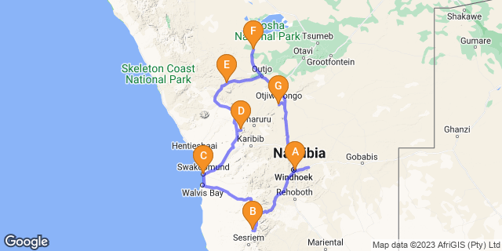

# [Click here to view your Digital Itinerary](https://wetu.com/Itinerary/Landing/913939E3-956B-04F9-3EFF-3FFCFDF63AFC)

## Introduction

This accommodated self-drive covers the major highlights of Namibia from the apricot dunes of Sossusvlei, the Skeleton Coast and colonial town of Swakopmund, through to the wonderful Erongo area where you'll have the chance to meet with local San community. From here it's into central Damaraland for ancient rock art, culture and history. Continue onto Etosha for fantastic game viewing with a final night at the AfriCat Foundation. Note this itinerary can also be offered as a camping option or upgrade to luxury accommodation. Ideal to experience landscapes, culture, wildlife and conservation, all can be tailored to suit your requirements

|  |  |  |  |  |  |
| --- | --- | --- | --- | --- | --- |
| **Start** | **Accommodation** | **Type** | **Destination** | **Basis** | **Duration** |
| Day 1 | [Naankuse @ Utopia](https://wetu.com/iBrochure/7357_31498) |  | Windhoek | B&B | **1 Night** |
| Day 2 | [Namib Desert Lodge Gondwana Collection Namibia](https://wetu.com/iBrochure/7357_32088) |  | Namib | B&B | **2 Nights** |
| Day 4 | [Cornerstone Guesthouse](https://wetu.com/iBrochure/7357_21613) |  | Swakopmund & Coastal Strip | B&B | **1 Night** |
| Day 5 | [Ai Aiba Rock Painting Lodge](https://wetu.com/iBrochure/7357_10519) |  | Erongo Mountains | B&B | **2 Nights** |
| Day 7 | [Damara Mopane Lodge Gondwana Collection Namibia](https://wetu.com/iBrochure/7357_24085) |  | Damaraland | B&B | **1 Night** |
| Day 8 | [Etosha Safari Camp Gondwana Collection Namibia](https://wetu.com/iBrochure/7357_10560) |  | Etosha South | B&B | **2 Nights** |
|  | → Okaukuejo Resort | alternate |  |  |  |
| Day 10 | [Okonjima Plains Camp](https://wetu.com/iBrochure/7357_8727) |  | Okonjima Nature Reserve | D,B&B | **1 Night** |

**Key**  
B&B: Bed and Breakfast  
D,B&B: Dinner, Bed and Breakfast

## Price

**2024 Rates - manual vehicles unless indicated**   
**Price per person based on 2 travellers including Car Rental**  
Low season (1 Nov 2023-30 June 2024)  
with Hyandai Grand Creta Group R vehicle - SUV 4x2 or similar  N$34,175  
with 4x4 Double cab  - Group W vehicle N$35,745

High season (1 July - 31 October 2024)  
with Hyandai Grand Creta Group R vehicle - SUV 4x2 or similar N$38,335  
with 4x4 Double cab Group W Vehicle N$39,680

**Price per person based on 4 travellers including Car Rental**  
Low season (1 Nov 2023-30 June 2024)  
with 4x4 Double cab  - Group W vehicle N$30,235

High season (1 July - 31 October 2024)  
with 4x4 Double cab Group W Vehicle N$33,685

Single supplement N$5625  
Twin share basis unless single supplement applied  
This is a guideline price-  please contact us for quote with travel dates  
(Price valid until 31 October 2024)  
Please note that the N$ is fixed to the South African Rand on a 1/1 basis

## Included

- Accommodation and activities as set out in itinerary;  
- Car rental as indicated  
- Meals as stated in itinerary  
- Ai Aiba - Walk to Bushman Living Museum  
- Okonjima- 1 x shared activity (leopard tracking or similar activity/same value) & conservation levy;  
- Welcome pack with detailed itinerary, driving directions, map, small guide book, vouchers & meet and greet service;  
- 24 hour personal support service  
- E-med evacuation insurance (medical evacuation);  
- VAT & tourism levy  
**Car Rental - Classic Plus cover zero excess:**  
Includes: Unlimited kms, theft & collision damage waiver; Stamp duty, VAT; personal accident insurance; airport surcharge; tourism levy; carbon emissions tax; tyre, rim & hubcap damage; windscreen cover; sandblasting damage; & 1 spare wheel; 24/7 breakdown/recovery assistance

## Excluded

- International and other flights  
- Visa/ visa applications, passport or immunisations  
- Additional meals and optional activities  
- Personal insurance and items of a personal nature including tips/curios etc  
- Entry fees to parks and places of interest  
- Ancillary car hire fees;  
*2024 Park entry fees:  on current rate N$150/person/day; Children under 16yrs N$100/day and N$30/vehicle day – subject to change* *& if you self-drive to park note that park gates open/close at sunrise/sunset and you must have exited the park prior to closure or risk a fine/refusal of departure*  
**Car Rental: Ancillary charges**   
Excludes: Rental deposit; document admin fee N$132; fuel; refuelling fee N$46; additional driver per rental N$572; young driver surcharge N$173 per day (under 23 yrs & held licence min 3yrs); fine handling fee N$432; Assessor fee;  claim handling fee above N$1000 -  N$1118 or claim below N$1000 N$400/claim;  baby seat/booster seat N$572/rental; GPS unit N$157/day (deposit N$1500); wifi router; second spare wheel N$2500/tyre - Group W only; After hours delivery/collection or drop off; valet service  - renter account; roadside assistance call out (negligence) N$880; cross border fee if applicable N$1588; one way drop off fee if applicable  
*Note: offices both in Windhoek City Centre and also at the International Airport – you are able to collect and drop your vehicle at either/both destinations*  
*Prices quoted on ancillary charges for car rental are guideline and subject to amendment by car rental company and as per their terms and conditions*  
*You are only charged for the extras you have  - ie if you don't have a baby seat, you are not charged for one*

## Day 1: Naankuse @ Utopia, Windhoek

### Day Itinerary

Upon arrival in Windhoek, collect your vehicle and drive to Utopia Boutique Hotel/Guesthouse, here you’ll meet one of our tour consultants’ who will go through your travel plans and answer any last-minute questions. Depending on your arrival time perhaps wander into the city centre, relax by the pool or join an optional township tour, horse ride, or even head out for a birding trip. Overnight in twin share room with en-suite facilities on a bed and breakfast basis, all other meals will be at client’s own expense. Comfort 3* *40mins from airport to city*

### Expert Tips

Located near to Joe's Beer House - this famous bar/restaurant is ideal for the first night

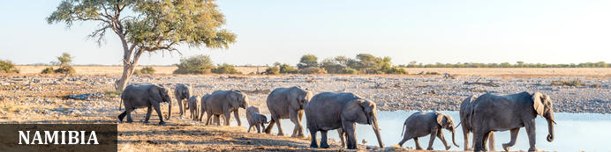

Namibia possesses some of the most stunning landscapes in Africa, and a trip through the country is one of the great road adventures. Natural wonders such as that mighty gash in the earth at Fish River Canyon and the wildlife utopia of Etosha National Park enthral, but it’s the lonely desert roads where mighty slabs of granite rise out of swirling desert sands that will sear themselves in your mind. It’s like a coffee-table book come to life as sand dunes in the world’s oldest desert meet the crashing rollers along the wild Atlantic coast. Among all this is a German legacy evident in the cuisine and art nouveau architecture, and in festivals such as Windhoek’s legendary Oktoberfest. Namibia is also the headquarters of adventure activities in the region, so whether you’re a dreamer or love hearing the crunch of earth under your boots, travel in Namibia will stay with you long after the desert vistas fade.

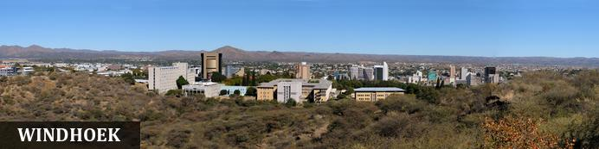

Windhoek is Namibia’s capital, home to an international airport and a plethora of restaurants, shops, entertainment venues and accommodation options. The city is clean, safe and well-organised, with a colonial legacy that is reflected in its many German eateries and shops, and the widespread use of the German language - though English is the official language. The city has an interesting mix of historical architecture and modern buildings, many of which are worth a look, including the Alte Feste (Old Fort), the 1896 Christuskirche (Christ Church), and the more contemporary Supreme Court. It's not a city to linger though - generally one or two nights is sufficient.

### Overnight: Naankuse @ Utopia [View iBrochure](https://wetu.com/iBrochure/7357_31498)

The modern Utopia Boutique establishment has allied with the neighbouring Pension Bougainvilla and offers serene rooms and luxurious suites situated amid beautiful, green lush gardens around a swimming pool. The hotel is conveniently located in the tranquil suburb of Klein Windhoek. There are just 12 standard rooms, 6 luxurious suites, and a self-catering unit. All rooms are equipped with a TV, DSTV, free wifi-access and air-conditioning along with a balcony or outside deck. The onsite Taste Academy, beautifully set in a restored German Manor built in 1912, offers a superb venue.

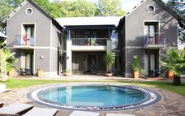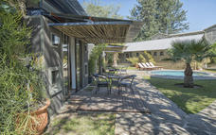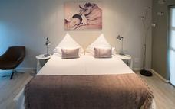

### Basis

Bed and Breakfast

## Day 2-3: Namib Desert Lodge Gondwana Collection Namibia, Namib

### Day Itinerary

After breakfast, set off on your self-drive to Namib Desert Lodge your base for 2nights.  There is time to relax this afternoon or head to the petrified sand dunes with a sundowner and glorious view located beside the lodge.  
Day 3: drive to the dunes located with the nearby Namib-Naukluft National Park. We recommend a pre-dawn departure to arrive at the Sesriem park gate for sunrise where you’ll collect the entry permit and from here drive through to the dune sea and the 2x4 car park. From here take a 4x4 shuttle to visit Sossusvlei, perhaps climb a dune to view the endless sand sea. Ensure you visit nearby Dead Vlei, where the ancient and skeletal camel thorn trees stand on the white pan with the backdrop of orange sand dunes and blue sky. There is the chance to explore the region on foot, climb a dune or wander around a vlei and taking in the magnitude of endless sand. There are a number of benches/tables to sit and relax before returning to Sesriem via Dune 45 and Sesriem Canyon, finally heading back to your lodge. The rest of the day is free for you to relax or for the energetic perhaps hire an e-bike to explore or head out on a walking trail.  The lodge also offers nature drives. Alternatively, you can join a guided excursion to the dunes with the lodge. All activities at own expense. 2nights in a twin room on a bed and breakfast basis*.  Comfort 3* Day 2: Approx 4.5-5hours from city; Day 3: lodge to gate approx. 45mins; 1hour from Sesriem gate to 2x4 car park. Please note the last 5kms section is 4x4 only and suggest you leave your vehicle here unless you are an experienced sand driver.*

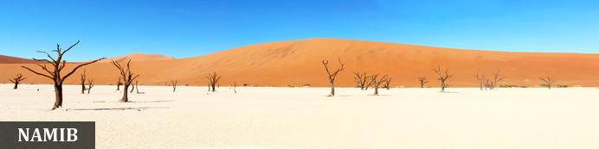

The Namib is the world’s oldest desert, and although it stretches along the entire length of Namibia’s coastline, the Namib commonly refers to the vast sea of sand from Luderitz to Swakopmund. For a big sandy desert the scenery is remarkably varied, with the giant red dunes of Sossusvlei being the most famous part. Because of how old it is the Namib is home to numerous species that don’t occur elsewhere and although no humans live in the desert an amazing array of flora and fauna manages to survive here. Famous species include the Welwitschia mirabilis – a living fossil plant, endemic chameleons, fur seals along the coast, brown hyenas, jackals and remarkably one of Africa’s largest antelope the Gemsbok. The name Namib is of Nama origin and means "vast place" and vast it certainly is.

### Overnight: Namib Desert Lodge Gondwana Collection Namibia [View iBrochure](https://wetu.com/iBrochure/7357_32088)

The main building and the chalets of Namib Desert Lodge are spread out along the foot of the fossilised dunes of the ancient Namib. A comfortable sojourn is guaranteed by 65 en suite rooms with air conditioning. A restaurant and bar, an inviting terrace with views of the fossilised dunes and two swimming pools beckon you to linger and relax. Oryx antelope and springbok make frequent appearances at this illuminated watering place. Internet and wifi available - though this is one of the largest lodges in the area, service and buffet meals are offered and ensure this is excellent value for money

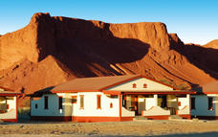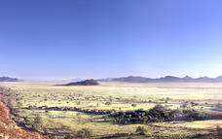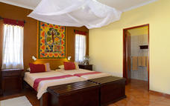

### Optional

|  |
| --- |
| Walking Trails |
| Morning or Sunset Drive |
| Sossusvlei Excursion |

### Recommended

|  |
| --- |
| Namib-Naukluft National Park |
| Dune 45 |
| Sesriem Canyon |

#### Walking Trails

Experience the Namib Desert on foot.

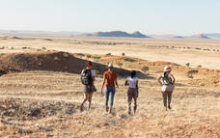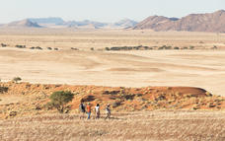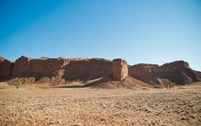

#### Morning or Sunset Drive

Discover the fossilised dunes, the red dunes above the plateau and the many wonders of the Namib Desert on this guides drive around Gondwana Namib Park.

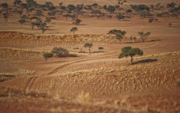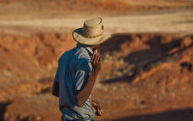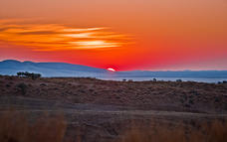

#### Sossusvlei Excursion

Enjoy a guided half-day excursion to highest dunes on Earth at Sossusvlei. They form part of the spectacular Namib Sand Sea, which was declared a World Heritage site in 2013. Including brunch, prebooking is essential.

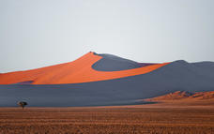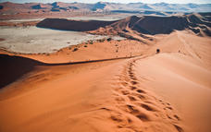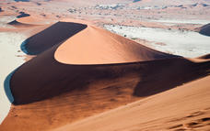

#### Namib-Naukluft National Park

Stretching almost 50000 square kilometres across the red-orange sands of the Namib Desert over the Naukluft Mountains to the east, the Namib-Naukluft National Park is Africa’s biggest wildlife reserve and the fourth largest in the world. Despite the unforgiving conditions, it is inhabited by a plethora of desert-adapted animals, including reptiles, buck, hyenas, jackals, insects and a variety of bird species. One of the main attractions of the park are the ancient dunes of Sossusvlei, home to some of the tallest dunes in the world rising over 300 metres from the desert floor. This magnificent landscape features rolling dunes, rugged moonscapes, lagoons, wetlands and mudflats. Visitors can look forward to a number of impressive sights including: the picture-perfect Dune 45, standing 170 metres high; the Welwitschia Plains, otherworldly lunar terrain dotted with the endemic plants; and the Dead Vlei, a photographer's dream.

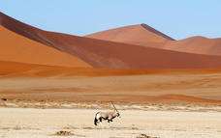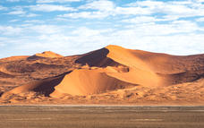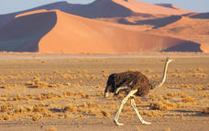

#### Dune 45

Dune 45 is located 45kms from the Sesriem gate, (and entrance to dunes), it is renowned for its elegant shape, which – along with its position close to the road – has earned it the distinction of ‘most photographed dune in the world’.  
Popular for sunrise, many people climb to gain a vantage point to watch the sun rise over the surrounding area and enjoy the changing colour of the dunes, at only 80 metres and featuring a much gentler gradient it is an easier climb than many of the other dunes found.

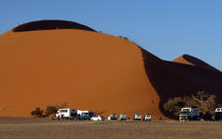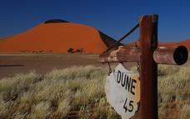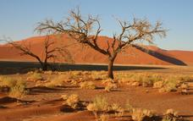

#### Sesriem Canyon

Sesriem Canyon is a captivating natural wonder located in the heart of the Namib Desert in Namibia. Carved over millions of years by the Tsauchab River, this narrow gorge is a testament to the power of erosion. The name Sesriem comes from the Afrikaans and Dutch words for six leather straps, which early pioneers used tied together to draw water from the deep pools within the canyon. Sesriem Canyon is not only a geological marvel but also a haven for unique desert flora and fauna, making it a popular stop for tourists exploring the surreal landscapes of the Namib Desert.

### Basis

Bed and Breakfast

## Day 4: Cornerstone Guesthouse, Swakopmund & Coastal Strip

### Day Itinerary

Leave after breakfast for your drive to Swakopmund, head across the Gaub and Kuiseb Passes towards Walvis Bay where it is worth a quick stop at the lagoon - it’s a RAMSAR protected wetland site, home to many different aquatic birds such as flamingos, pelicans, cormorant, avocets, the endemic Damara tern and many more species.   
From here, continue to Swakopmund and if you arrive early enough there may be time to take part in one of the optional activities such as an afternoon scenic flight over the dunes of Sossusvlei, to the coast to see shipwrecks, old diamond mines, dunes falling into the ocean as well as seal colonies, flamingos etc. This flight really gives a different perspective of the area you have already seen from land. Alternatively, take part in quad biking, tandem sky diving, afternoon excursion to Sandwich Harbour, or simply wander around the town and enjoy the architecture or perhaps some souvenir shopping. Overnight accommodation in a twin share room with en-suite bathroom, close to the centre of town. Bed and breakfast basis, all other meals will be at client’s expense. Comfort 3* *Approx 4.5-5hours*  
*Note if you wish to join any optional activities we recommend pre-booking.*

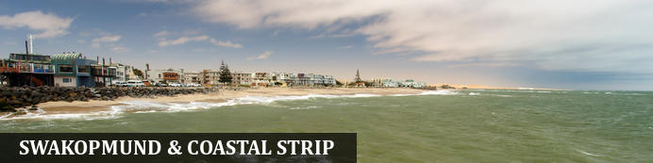

Founded in 1892 as the main harbour for German South West Africa, Swakopmund is often described as being more German than Germany. Now a seaside resort, Swakopmund is the capital of the Skeleton Coast tourism area and has plenty to keep visitors happy. The quirky mix of German and Namibian influences, colonial-era buildings and the cool sea breeze make it very popular and has a wide range of accommodation establishments, banks, restaurants/cafes and shops.  
Along this stretch of coastline (Walvis Bay and Swakopmund) you can take part in a selection of activities sating the thirst of those seeking adrenaline adventures - sky diving, quad biking and sandboarding; or for the more leisurely a range of marine activities including kayaking and cruises. The coastal desert can also be explored with trips to Sandwich Harbour, or informative desert tours... There is a long list so just ask us!  
Walvis Bay is Namibia's major harbour town and the lagoon has prolific bird life including flamingos, pelicans as well as the breeding area for the endemic Damara tern - any bird enthusiast should make a stop here.  
Further north along this coastline - part of the Skeleton Coast, you'll find shipwrecks and the famous Cape Cross seal colony - one of the largest fur seal colonies in the area.

### Overnight: Cornerstone Guesthouse [View iBrochure](https://wetu.com/iBrochure/7357_21613)

Cornerstone Guesthouse is a small, private and peaceful bed and breakfast an easy walk to the ocean and the town centre of Swakopmund on Namibia's fascinating Skeleton Coast. Occupying a quiet corner of Swakopmund's old town near the marine museum and the old brewery, it offers the charm and intimacy of a family-run B&B . Within a few minutes from the guest house you can walk to beaches, cafés, restaurants, lively pubs, Swakopmund tourist attractions and a variety of interesting shops and markets in the town.  
There are just 7 en-suite double rooms set around a lovely garden and 2 of the rooms can accommodate families of up to 4 people. Each room has TV, tea/coffee station, fridge, safe and wifi. Laundry facilities, along with off-street parking is available and makes this a good option for a 3* level of accommodation  
Self catering apartments are also available

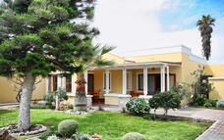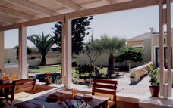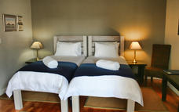

### Optional

|  |
| --- |
| Sun Sail Catamarans |
| Desert Explorers Quad Biking 90min Tour |

#### Walvis Bay Lagoon

Walvis Bay’s calm natural lagoon is a twitcher’s paradise, teeming with roughly 50 species of seabirds, including vivid flocks of flamingos, bulky-billed pelicans and glossy black cormorants. It’s also a popular spot for windsurfing, kitesurfing and kayaking, while the promenade stretching for three kilometres along the water’s edge is a great place for a scenic stroll.

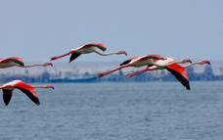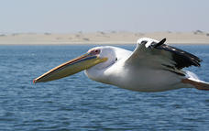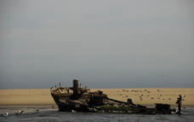

#### Sun Sail Catamarans

Sun Sail Catamarans operate three luxury catamarans for daily charters and a 1942 German war ship converted to a floating Guest house for visitors that would like to overnight on the Lagoon. Sun Sail Catamarans are environmentally friendly and believe in preserving the environment for future generations. Care is taken not to disturb the animals. Animals are approached up to 50m, but being curious creatures they usually come right up to the vessels. It is definitely ‘a magical experience to treasure.  
Activities include  
Marine Dolphin & Seal Cruise: sail along Walvis Bay Lagoon passing by the oyster farm to Pelican Point & Seal Colony. Informative yet adventurous tour on our comfortable catamarans.  Complimentary snacks platter and drinks  
Sandwich Harbour 4x4 Adventure: Experience adrenaline rush in our all terrain 4x4s with the most seasoned drivers in Namib Desert where massive sand dunes are engulfed by Atlantic waves. Take award-winning photographs on top of the endless rollings dunes and enjoy absolute peace. Paranomic views, interesting landscapes, sightings of desert animals, plants & bird life. Complimentary snacks platter, assorted beverages included.  Activity is either half day or full day.  
Marine Dune Combo: Combination of Marine cruise in the morning and half day Sandwich Harbour in the afternoon  
Kayak Tours/Combo tours can be offered on request

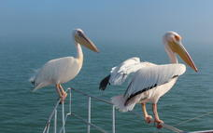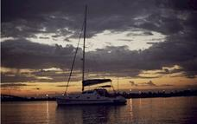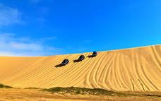

#### Desert Explorers Quad Biking 90min Tour

Located in Swakopmund, Namibia, Desert Explorers Quad Biking 90min Tour takes visitors on a pleasant guided quad bike tour. The 30-kilometre tour takes place in the Namib desert.

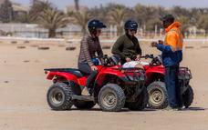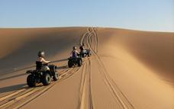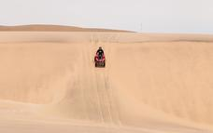

### Basis

Bed and Breakfast

## Day 5-6: Ai Aiba Rock Painting Lodge, Erongo Mountains

### Day Itinerary

Today, drive north along the Skeleton Coast stopping to view a shipwreck just south of Henties Bay and easily viewed by the shore; from here, continue a little further north to visit Cape Cross Seal Colony, where thousands of seals, and one of the largest colonies in southern Africa, congregate on the beach before retracing your steps to Henties Bay and turning inland. Drive to the beautiful Erongo region where you'll overnight at Ai Aiba Lodge.   
Included; Guided walk to Living Museum  
Free time to relax or join optional activity with lodge  
*Approx 3-4hours plus stops and additional time if driving via Cape Cross*  
*Alternatively you can join a morning marine cruise and drive straight through to Ai Aiba after activity.*

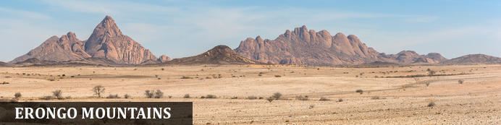

The Erongo Region is one of the largest of the 13 regions found in Namibia and received its name for the majestic Erongo Massif that dominates the area around Karibib, Omaruru and Usakos. The region reaches up to the Atlantic Ocean and includes the coastal towns of Swakopmund and Walvis Bay, its northern boundary ending at the Ugab River where the Skeleton Coast National Park begins its stretch to Angola. Spitzkoppe, Brandberg and Twyfelfontein are officially in this zone. The Erongo Mountains and western escarpment incorporates the Erongo Mountain Nature Conservancy which extends over 200,000ha, encompassing one of the most environmentally diverse areas including rock art and prehistoric settlements. The area is home to high densities of leopard and brown hyena along with hotspots of endemic plant, reptile, bird and mammal species.

### Overnight: Ai Aiba Rock Painting Lodge [View iBrochure](https://wetu.com/iBrochure/7357_10519)

Set afoot massive granite rock boulders, overlooking the magically beautiful Erongo mountain range, is Ai Aiba - The Rock Painting Lodge. The overwhelming panoramic view from the restaurant and bar is amazing. The crystal clear pool invites you to refresh and relax. Ai Aiba is an active member of the Erongo Mountain Nature Conservancy, an association of farmers dedicated to the protection and preservation of the unique fauna and flora, as well as the magnificent granite landscape of the Erongo.  
There are 20 thatched-roof twin-bedded rooms, each with en-suite and in a traditional African style and with air-con/heater. Credit card facilities available. Activities include game drives, birding, hiking, and of course, visiting the rock-art sites.

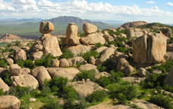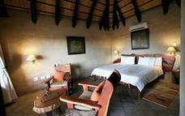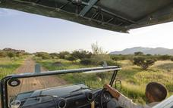

### Activities

|  |
| --- |
| Guided walks (Morning & Sundowner) |

### Optional

|  |
| --- |
| Cape Cross Seal Colony |
| Nature Drive / Bushman rock art |

#### Guided walks (Morning & Sundowner)

Walking the area surrounding the Lodge is highly encouraged and is an excellent way to experience the beauty of the Erongo Mountains. Our guides have been very well trained on the interesting Fauna and Flora of the area and are available to escort guests through the property.  
Guided Morning walks:  Breakfast is available in the restaurant from 07h00.  Your guide will take juice and snacks along for en-route. Please carry your own water.  Please ensure that you wear good walking shoes, and have adequate sun protection.  
1) Ai Aiba Walk: This walk is 2 – 3 hours in duration and can be of varying degrees of difficulty depending on your preference. It will include visits to certain rock art sites, and a focus on the smaller intricacies of nature. Morning walk departs at 07h30 (Summer and Winter), from the restaurant.  
2) Walk & Drive: This activity starts from the lodge with a 10min drive to Moringa valley. From there guests hike to a number of different rock art sites, including some fantastic viewpoints along the way. Then another short drive (10-15min), followed by another hike through majestic landscape to view some more rock art sites and fantastic rock formations. A short 20min drive will then take you back to the lodge. Total duration is approximately 3 hours.  
3) Walk with visit to the San Living Museum: This walk is approximately 3 hours. Our guides will walk with you to the San Living Museum, stopping at certain rock art sites en-route. Once at the Living Museum the bushman will take guests on a bushwalk, and then our guides will lead you back to the lodge again  
Sundowner walk: Very close to the lodge, you will be guided up a granite hill where you can relax and enjoy a cold ‘sun-downer’ drink while watching the sun set over spectacular views of the Erongo Mountains.

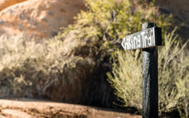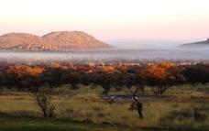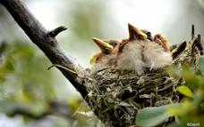

#### Cape Cross Seal Colony

This colony of Cape Fur Seals is one of the largest in the world, home to approximately 80 000 to 100 000 of these so-called 'seals', which are in fact a species of sea lion. Day trips to the colony are offered and the seals can be viewed from a walkway at a distance of roughly 200 metres.

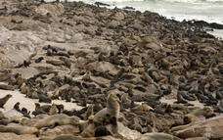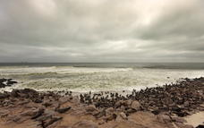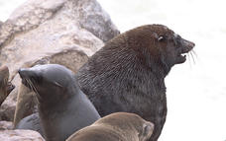

#### Nature Drive / Bushman rock art

This drive takes about 3 hours, through the scenically beautiful lodge property, with selected stops at sites to view and learn about bushman rock art. The drive will also include a stop for refreshments and snacks. A must-see for anyone visiting the area. This drive can be done both in the morning or the afternoon.

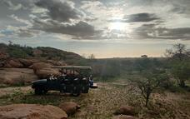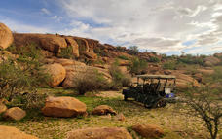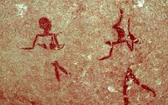

### Basis

Bed and Breakfast

## Day 7: Damara Mopane Lodge Gondwana Collection Namibia, Damaraland

### Day Itinerary

From Ai-Aiba, drive north - perhaps visit nearby Twyfelfontein rock etchings, the local Damara Living Museum, or Petrified Forest en route to Damara Mopane. It's also close to Vingerklip - a rock sitting rather precariously amongst the surrounding plains - you can enjoy short walks around here. *Approx 4-5 hours plus stops (depending on route taken)*

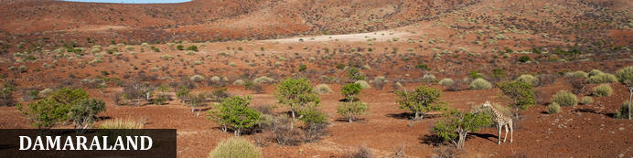

Huge, untamed and ruggedly beautiful Damaraland is an exceptionally scenic landscape of open plains and spectacular rock formations. Some regard the highlight of the region as Twyfelfontein - Namibia's first World Heritage Site and one of the largest collections of rock etchings in Africa. There are a number of sites worth exploring in the region and depending on how much time you have - Brandberg, Namibia's highest mountain, the Erongo Mountains with its granite formations and conservancy programmes, then Spitzkoppe offering incredible rock formations as well as rock paintings.  
Engage with local communities around the area including the Damara people and perhaps visit Damara Living Museum located close to Twyfelfontein  
Ultimately, this area is also home to free-roaming desert elephant, black rhino and desert-adapted lion (along with a number of other species including giraffe, mountain zebra etc), and some lodges offer superb activities enabling visitors to track these incredible animals

### Overnight: Damara Mopane Lodge Gondwana Collection Namibia [View iBrochure](https://wetu.com/iBrochure/7357_24085)

Built in the wattle and daub style under Mopane trees and connected by a labyrinth of paths, the main building and chalets of the lodge look like an African village. The walls are adorned by copies of the rock engravings at Twyfelfontein. Each of the 60 double-room chalets (with air conditioning) sits in a vegetable and herb garden surrounded by a low wall. The gardens supply fresh ingredients for supper, which consists of a starter followed by a delicious buffet. There is a swimming pool for chilling out and a viewing point for relishing sunsets. The lodge is at the gates of Damaraland is ideally suited for excursions to Twyfelfontein (130 km), the Petrified Forest (70 km) and the Vingerklip rock pillar (50 km).

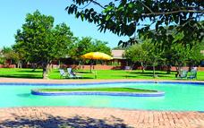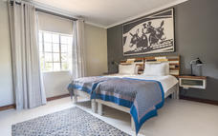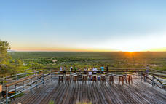

### Optional

|  |
| --- |
| Twyfelfontein Rock Art |
| Damara Living Museum |
| Sundowner Walk |
| Hiking Trails |

#### Twyfelfontein Rock Art

Twyfelfontein is a World Heritage Site boasting one of the richest rock art concentrations in Africa. Thousands of tourists come to this site each year to view some 2, 500 Stone Age rock engravings. The area is home to 17 rock art sites, which collectively encompass 212 engraved stone slabs. There are an additional 13 sites displaying rock paintings.

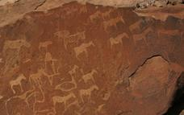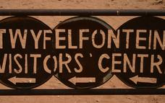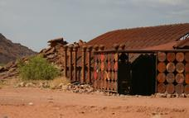

#### Damara Living Museum

Observe and experience the traditional Damara way of life right in the heart of their traditional homelands. A unique opportunity to see a way of life that is slowly dying out. Open daily.

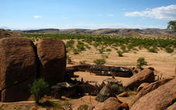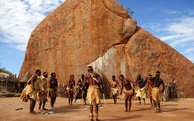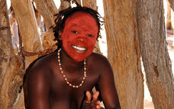

#### Sundowner Walk

A highlight at the end of the day is to ascend the hill to a viewing platform for a sweeping vista of the mopane woodland illuminated by the setting sun. Beverages are provided and charged to the room.

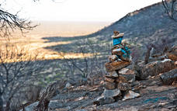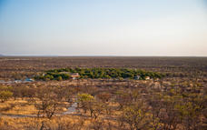

#### Hiking Trails

Explore the flora and fauna of the Damaraland on your own. You have two different self-guided hiking trails to choose from. They are well marked and take you through the wildly romantic scenery of the Damara Mopane Lodge house mountain. Duration: between 1 and 3 hours

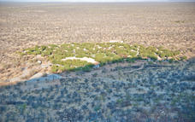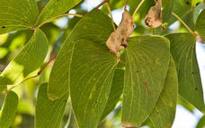

### Basis

Bed and Breakfast

## Day 8-9: Etosha Safari Camp Gondwana Collection Namibia, Etosha South

### Day Itinerary

Drive to the amazing Etosha National Park, enter via the Anderson’s Gate and game drive to the rest camp - perhaps visit Ombika waterhole en-route, and later this afternoon, if time permits, head out in search of some of the many species found here. Spend the next day game driving and enjoy watching the animals come in to quench their thirst at the waterholes and observe their individual behaviour; Okaukuejo and Halali often have busy waterholes and many species flock here after sunset including the black rhino, elephant, lion, and a plethora of plains game.  
Your two nights are based in twin bedded standard room on a bed and breakfast basis at Okaukuejo or outside the national park gate at Etosha Safari Camp; all other meals will be at client’s expense.  Comfort 2-2.5* *Okaukuejo; 3* Etosha Safari Camp Approx 3.5-4.5hours plus game drives* (vary)  
Note that the standards/service of resorts inside national park (government run) are not as good as those privately run outside the park.

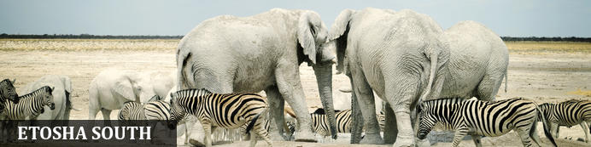

The national park can be accessed via the southern entrance at Andersson’s Gate and the central point is Okaukuejo Resort. Visitors can catch a glimpse of abundant wildlife including: lion, giraffe, elephant, white and black rhino, and a multitude of plains game. Popular activities include: game drives, tracking rhinos on foot, guided nature walks, or watch the sunset over this magnificent landscape. Just outside the national park is the upmarket Ongava Private Reserve, as well as a number of mid-level accommodation and camp sites.

### Overnight: Etosha Safari Camp Gondwana Collection Namibia [View iBrochure](https://wetu.com/iBrochure/7357_10560)

Etosha Safari Camp is situated just 10 km south of Andersson Gate and the quirky sister property to Etosha Safari Lodge. 50 twin-bedded simple styled bungalows nestle among mopani trees and impart a feeling of living in the lap of African nature, each of them is equipped with mosquito gauze, air con, and its own bathroom and small verandah. Special attractions are the Okambashu Restaurant and the Oshebeena Bar, styled like a typical little township bar and brimming with African joie de vivre. Etosha Safari Camp is the perfect base for safari excursions into Etosha - with an experienced guide on the daily game drive (24 seater vehicle) or by yourself in your own car.

Internet available in main area along with laundry facilities. This camp offers great value for money in an informal environment and ideal for budget travellers and families

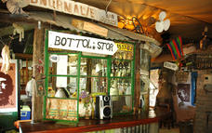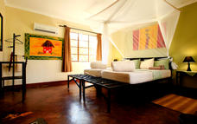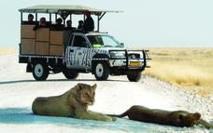

### Alternate: Okaukuejo Resort

Okaukuejo is located 17 km from the southern entrance of the park, and famous for its flood-lit waterhole, where visitors can observe at close quarters a spectacle of wildlife congregating and interacting - this is an incredible sight during the dry winter months and one of best places to see herds of elephant, black rhino and large herds of plains game. The spectacle starts at dawn, with animals coming in large numbers to quench their thirst and continues throughout the day until late at night. In the early evenings, it is not uncommon to have black rhino, elephant and lion all drinking at the same time. Wifi available (extra charge)

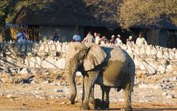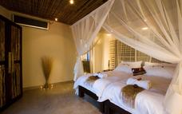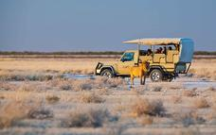

#### Etosha Pan

Aeons ago, Etosha Pan was the bed of a vast lake; today what remains is a glittering, silvery-green salt pan that stretches across roughly 5000 square kilometres. Etosha is protected by the Etosha Pan National Park surrounded by savannah plains and woodlands supporting large herds of elephants. When dry, the pan sustains little life except for the algae that gives it its distinctive colour, and migratory birds that use it as a pit stop, but with heavy rain it becomes a shallow lake (east side) where flamingos breed, pelicans wade and feed, and a variety of mammal species come to quench their thirst, including predators such as hyena, lion, cheetah, and leopards along with rhinos, and antelopes.

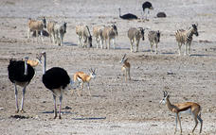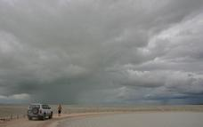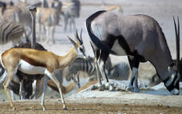

### Basis

Bed and Breakfast

## Day 10: Okonjima Plains Camp, Okonjima Nature Reserve

### Day Itinerary

After breakfast and a final game drive out of the park, drive south to Okonjima, home of the AfriCat Foundation, to overnight at Plains Camp in one of their lovely view rooms on dinner, bed and breakfast basis, one activity per person is included. When you check in, you’ll have the chance to discuss which activity best suits you and your interests - whether it’s tracking radio collared leopard from a vehicle, heading out on game drives or more.  We have indicated some of the options, but the lodge will give you more information.  Later in the afternoon you’ll enjoy your chosen activity before returning to the lodge for dinner.  
Included 1 x shared/lodge activity to value of leopard tracking*. Comfort 3.5-4* Approx 3-4hours drive plus game drive*

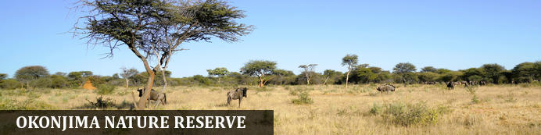

Halfway between Windhoek and Etosha lies the well-known Okonjima Nature Reserve. The 22 000 ha Nature Reserve is surrounded by 96 km of fence and was finally completed in 2010. Okonjima is home to AFRICAT, a Carnivore Conservation, which gives the captive carnivores a second chance to be released back into the wild and to take the time it needs, to become a completely independent hunter - in a protected area right in the middle of commercial farmland! Also in the Reserve is a 2000 ha 'safe' zone around Plains Camp, Bush Camp, Bush Suite, the Omboroko Campsite as well as the PAWS Environmental Education Centre.

### Overnight: Okonjima Plains Camp [View iBrochure](https://wetu.com/iBrochure/7357_8727)

Not only is Okonjima a luxury lodge, but is also home to The AfriCat Foundation, a non-profit organisation, committed to long-term conservation of Namibia's large carnivores, especially cheetahs and leopards and a visit will give you an opportunity to witness some of AfriCat's work. Plains Camp design honours the Okonjima cattle-farming history - in the early 1920’s, Okonjima became a cattle farm and was bought by Val (VJ) & Rose Hanssen in 1970. They were well-established Brahman breeders and continued to farm cattle until the need for solutions to increasing livestock losses became pertinent and post-independence interest in Namibia as a tourist destination, escalated. In 1993, the herds of Brahman and Jersey cattle were sold, changing the face of Okonjima as well as that of Carnivore Conservation! Nowadays, clients enjoy a selection of activities that include tracking rehabilitated carnivores on foot; visiting the AfriCat Carnivore Care & Information Centre; and/or tracking leopards from a game–viewing vehicle. Guided and self-guided birding/walking trails are also available. A superb first/last night destination and recommended. Facilities include swimming pool, curio shop, waterhole, free wifi.There is a choice of view rooms, standard rooms and the nearby garden rooms (these are a little further away from the lodge and part of old lodge - they are more traditional stone built). Note there is no air-conditioning.

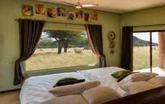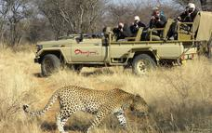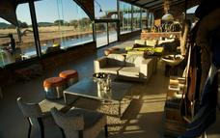

### Activities

|  |
| --- |
| LEOPARD TRACKING |
| ENDANGERED SPECIES NATURE DRIVE |

#### LEOPARD TRACKING

The Leopard ‘experience’ will take you out into the Okonjima Nature Reserve and will allow you to spend more time with our experienced guides and participate in the research data collection for our long-standing leopard project and newly introduced brown hyaena programme. Some of our adult leopards are radio collared which enables the guides to track them with a specialised telemetry device contributing to frequent viewing, giving visitors an opportunity to observe these magnificent predators in their natural habitat and experience the fascinating behaviour and interactions between these two species while they compete for food. Although this significantly increases the chance of an excellent sighting, it cannot ever be guaranteed as they are wild free-roaming predators.  
Morning activities (seasonal times): Departure 06:00 / 06:30 AM; Return 09:30 / 10:00 AM.  
Afternoon activities (seasonal times): Departure: 15:30 / 16:00 PM; Return 19:00 / 19:30 PM.

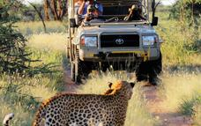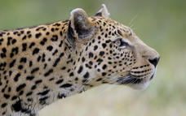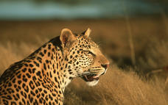

#### ENDANGERED SPECIES NATURE DRIVE

This game-drive allows more time to enjoy and understand the Okonjima Nature Reserve as a natural island bound ecosystem. As the private Nature Reserve was established primarily to conserve some of our more threatened mammal species, it provides an increased chance to encounter these relatively rare animals. This is once again assisted by the AfriCat Foundation’s research projects on the shy brown hyaena, bat-eared fox and rhino. There are more than 40 mammal species within the Okonjima Nature Reserve, both large and small as well as a good representation of the typical flora. At the discretion of your guide, there may be the chance to view some of these animals, large or small.  
Morning activities (seasonal times): Departure 06:00 / 06:30 AM; Return 09:30 / 10:00 AM.  
Afternoon activities (seasonal times): Departure: 15:30 / 16:00 PM; Return 19:00 / 19:30 PM.

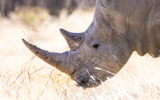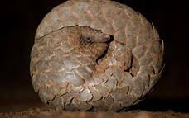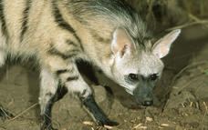

### Basis

Dinner, Bed and Breakfast

## Day 11: End of Itinerary

### Day Itinerary

If time permits, perhaps join a further activity (own expense), then return to Windhoek, you may wish to stop at Okahandja for some last-minute souvenir shopping at the craft markets where you can barter some gifts before returning to Windhoek International Airport and connect with your onward flight back home. *Drive time approx 2.45hours to Windhoek; drop off vehicle and another 40-45mins to airport – no flights prior to mid-afternoon and later if you wish to join Okonjima activity*. *End of services*

### Expert Tips

*Car Rental:* All car rentals will require you to provide your passport, driving licence (written in English or an international licence), as well as supply a credit card for the refundable deposit.   
If you have an accident and if the car rental company/insurance can prove you were negligent– for example - speeding - the zero excess becomes null and void and you are liable for costs.  
Upon collection of the vehicle you will complete the car rental suppliers’ contract and book any ancillary extras with them – these are for your own account.  
Please check the vehicle carefully as you are responsible for it thereafter.  
If you have any problems with the car whilst you are on the road please contact them directly.  
A GPS is often available by the car rental companies (at client’s own expense), however, due to our road network system (and small population), it is not normally required, we realize this is a personal preference and are happy to pre-book for you.  
Outside of major towns/cities do not drive around/after sunset.

*Availability & Comfort*: Please note that this quote is based on the availability of both accommodation/ vehicle and on the understanding that no bookings have been made. Should we need to use alternative options the price and itinerary is subject to change.  
Accommodation is in Government run camps such as Etosha - the waterholes are normally active but standards of service etc can vary. Note that Namibia does not have a fixed "star" rating and therefore the comfort rating is to be used as a guideline only and may vary a little to international standards. This itinerary uses accommodation outside the park.

*Travel times:* Travel times quoted are a guideline and only allow for one short stop and travelling at average speed – some clients will drive slower or stop multiple times enjoying longer breaks and therefore journeys will take longer. We recommend most days when travelling onto another destination to leave after breakfast to allow plenty of time to arrive in plenty of time and enjoy the location to arrive in afternoon.  
*Roads*:  Due to the location of destinations, some long days are inevitable - many Namibian roads are gravel which vary in quality depending on the season and maintenance work carried out by the Government, at times conditions can be poor. The conditions are also hard on vehicles and why we recommend 4x4 or similar (vehicles with higher ground clearance/larger tyres).  
Changing road conditions can have an impact on comfort and driving times.  
Do not deviate off public roads (or those into lodges/camps) and note the majority of rental vehicles have a tracking device, should you deviate and damage your vehicle in any way and the route deemed unsuitable you will be held liable for the damage.  
More details regarding how to drive on gravel roads and in Namibia/surrounding countries is given with our “car rules and regulations” document issued with your self-drive confirmation

*Is this destination right for you?*  Namibia is an incredible country to visit but remember we are in Africa and that not all standards are the same as you would get in Europe or other first world countries. To most of our clients, that is part of the appeal of travelling to destinations such as ours. If you are not comfortable with new challenges then you may wish to consider other companies or locations.  Ensure you read through the itinerary /route carefully and assess your ability to manage and enjoy this style of travel and destination.  
Infrastructure in the country is generally reliable but we cannot guarantee speedy wifi/internet services throughout your trip,  
Expect roads to be bumpy, dusty and outside of winter for it to be hot.  
Please manage your own expectations to what the country is really like rather than what you think it may be like, if you have questions about its suitability to you, then ask us. We think Namibia is fantastic and ideal for the adventurous minded but realize it's not ideal for everyone and most people need to have a degree of physical fitness to deal with lengthy travel times and conditions.

*Money:* The currency in Namibia is the Namibia Dollar, which is fixed to and equals the South African Rand on a 1-1 basis. The dollar and SA Rand are the only legal tender in Namibia and both are used freely, however the Nam dollar is not legal tender in South Africa and we recommend that you exchange your money prior to departing Namibia  
*Credit Card*s: Visa and MasterCard are generally accepted in shops and restaurants in towns and many lodges. Use of credit cards may incur an additional fee. Occasionally lines may be down and services not available particularly in remote destinations and payment will need to be in cash  
*Cash*: South African rand can be purchased in advance. The Namibia dollar is not an international currency and therefore can only be obtained in country. Cash is available at ATM machines using credit card and pin number. There is FX bureau upon arrival at International Airport for those arriving by air and can be worth obtaining prior to arriving in city. It is customary to tip in Namibia, usually, around 10% at restaurants. A tip box is normally found in the reception in lodges

*Safety:* As with every destination safety tips needs to be adhered to; we strongly recommend you use a safe in a hotel/lodge or lock up your valuables when you are not in the room; when in a vehicle do not leave valuables on display but tucked away and out of sight. It is also better to have copies of passports, money; cards etc split between travellers so if anything unexpected happens and a bag is lost or stolen then other funds/cards are available, you may also wish to consider using a money belt/neck wallet. We suggest you leave valuable jewellery at home – you won’t need it while travelling. A padlock for your luggage is also recommended  
  
*Luggage*: We recommend just 1 bag/suitcase and 1 hand luggage.  There are not always porters at your accommodation so be prepared to carry your luggage on occasions to keep it to around 15kg

*Booking & payment*: When you have decided on a trip a booking form needs to be completed, signed and returned to us and we will enquire regarding availability and advise you. Namibia has increased in popularity. Despite the influx of travellers, bed numbers are not being increased to match the demand. This intentional move is aimed at minimising the environmental impact of tourism, ensuring sufficient water levels in a desert country and keeping the destinations exclusive, many lodges also have limited room numbers. As such we may need to book an alternative option and will advise you in advance.  
Once we have taken deposit, a confirmation is sent to you, advising you of the services agreed and booked. Payment is due approximately 6 weeks (sometimes 8 weeks depending on the supplier) prior to departure.  
Bank transfers and MasterCard/Visa are accepted forms of payment but please ensure there are sufficient funds and your bank is aware of the transaction about to take place (if you are paying via credit card), as many banks will withhold money as a safeguard against fraud, this delay can be critical particularly if you are booking at short notice. Please also allow for payment to process and if paying via bank transfer to include all bank fees, note we are unable to confirm bookings/trip until funds have cleared into our account, any delay may see a cancellation in your trip and booking released. Card payments are subject to bank charges.

*Dietary*: We can assist with booking of various dietary requirements or food allergies but we appreciate your details when you book with us (or with your agent) and we will advise the appropriate lodges. Please be aware that the choice and options may not be as varied as your home country.

*Weather:* Namibia has around 300 days of sunshine each year and is a year-round destination, although some may prefer to avoid the heat of high summer.  
Coastal areas: The cold Benguela current keeps the Atlantic coast of the Namib Desert cool and rain-free for most of the year, with a thick coastal fog. January and February are the hottest and as such the coast is often much cooler than inland.  
Summer months (Nov-Feb) daytime temperatures can exceed 40°C (104°F) though generally around 30-38c, and nights outside of high summer are cooler. Namibia has summer rains (short rains Nov-Dec, main rainy season Jan-March) though it rarely rains for long, a rain jacket is useful and during this time the desert blooms. Many of the young animals are also born this time in game viewing areas. The rain may also affect road conditions.  
Winter nights can be cold and may be near freezing, but days are generally warm and pleasant. Layering of clothes during this time is recommended.  
Climate: The African sun is very strong. Please use a factor 30 sunscreen and wear a hat. You should drink  2-3 litres of water per day to avoid dehydration.

*Electrical*: plugs are 220V and are 3 pin (round pin as opposed to square pin). Adaptors can be purchased in Windhoek and most international airports; they are the same as South Africa if you are shopping in home country or at airport. Some lodges will also offer 2pin sockets or adaptors but please do not rely on this, it is much better to bring your own. It is possible to re-charge batteries at most lodges but clients must be responsible for security of their possessions

*Insurance:* It is essential that you purchase comprehensive personal travel insurance before you embark on your holiday, medical insurance is insufficient. Travel insurance is for your own protection and should include evacuation and cancel any reason/covid policy; we also recommend full cover for baggage loss etc and consider it to be an essential part of modern international travel.

*Health:* Namibia is a low-risk malarial destination, but we recommend that seek professional medical advice to enable you to make decisions on personal malaria protection. Note Etosha is officially a malarial area (low risk), please discuss with your doctor and obtain any necessary protection before departing your home country. No vaccinations are required by law for the countries being visited on this tour though we recommend clients are up to date with vaccinations of TB, hepatitis, polio etc  
Covid: no regulations are currently in place..

*Water*: All tap water in Namibia has been purified or comes directly from boreholes and is safe to drink. Tap drinking water is generally safe to drink but bottled mineral water is easily available at shops and rest camps should you prefer to drink this, at some lodges it is provided

*Visas*: The onus is on the client to organize all visas required for clients prior to departure. Please ensure that your passport is valid for at least six months after your scheduled departure date country of travel and has sufficient empty pages. If this is not the case, there is a danger of being turned away by the Immigration Service on arrival at the airport – assuming your airline has agreed to bring you and risk a fine in the first place. The Company cannot be held liable for any necessary visas or other travel documents not held by the clients. Please also note that if your passport requires a visa for the countries you visit and multiple entries if necessary, you will need to carry your passport with you during the trip. If travelling with children birth certificates will be required. Further details are on pre-departure information

*Responsible Tourism*: When we put together an itinerary for you, our aim is to try to ensure you have the experience of a lifetime, we strongly believe in low impact or positive impact tourism. Furthermore, our responsibility to the country/ies you visit and the environment is to try our best to ensure that all benefit – whether that is a small, local operator, local community or conservation programme. Your itinerary may include visits a “local community/village” which will enable you to directly assist and barter for a piece of jewellery; perhaps overnight at a locally-owned campsite or lodge; maybe a local guide takes you to a place of interest or site; or visit an organization set up to protect endangered animals and species that occur naturally in the country. We will give you an insight into these initiatives but if you want more information please ask. Note that these initiatives vary according to the region travelled and what is available), remember your safety and enjoyment is also of paramount importance so we will not for example, use a camp site located in a place we consider unsuitable. Please also follow some of the notes we issue in our pre-departure information to minimize the effects of negative tourism on local cultures (respect for others and their beliefs etc).  
Generally, we prefer not to use large, international hotel chains as much of the revenue leaves the country but again, should you prefer this option we are happy to oblige.

*Pre and Post Tour Accommodation*: If you require accommodation before or after your tour we can arrange

If you have any questions, please do not hesitate to contact us.  
Tel: +264 61 309387   After hours emergency cell phone: +26481 3784040 Fax: + 264 61 220885  
Email – info@chameleon-holidays.com    Web - www.chameleonholidays.com  
Skype- chameleon.holidays    Facebook – Chameleon Holidays