http://schemas.openxmlformats.org/drawingml/2006/picture

# 11 day Footprints in Namibia - Mid-Range Accommodation - Self-Drive 2023

*Windhoek - Namib - Namib-Naukluft National Park - Sossusvlei - Swakopmund & Coastal Strip - Erongo Mountains - Damaraland - Etosha South - Etosha National Park - Okonjima Nature Reserve*  
*11 Days / 10 Nights*  
*Group Size: 2-4*  
*Reference: 11day FiN MidAcc SD2023*  
*Date of Issue: 26 January 2023*

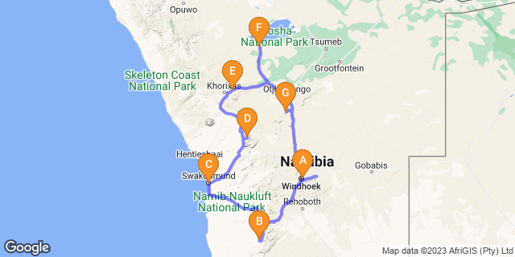

# [Click here to view your Digital Itinerary](https://wetu.com/Itinerary/Landing/913939E3-956B-04F9-3EFF-3FFCFDF63AFC)

## Introduction

This accommodated self-drive covers the major highlights of Namibia from the apricot dunes of Sossusvlei, the Skeleton Coast and colonial town of Swakopmund, through to the wonderful Erongo area where you'll have the chance to meet with local San community. From here it's into central Damaraland for ancient rock art, culture and history. Continue onto Etosha for fantastic game viewing with a final night at the AfriCat Foundation. Note this itinerary can also be offered as a camping option or upgrade to luxury accommodation. Ideal to experience landscapes, culture, wildlife and conservation, all can be tailored to suit your requirements

|  |  |  |  |  |  |
| --- | --- | --- | --- | --- | --- |
| **Start** | **Accommodation** | **Type** | **Destination** | **Basis** | **Duration** |
| Day 1 | [The Utopia Boutique Hotel](https://wetu.com/iBrochure/7357_31498) |  | Windhoek | B&B | **1 Night** |
| Day 2 | [Namib Desert Lodge Gondwana Collection Namibia](https://wetu.com/iBrochure/7357_32088) |  | Namib | B&B | **2 Nights** |
| Day 4 | [Cornerstone Guesthouse](https://wetu.com/iBrochure/7357_21613) |  | Swakopmund & Coastal Strip | B&B | **1 Night** |
| Day 5 | [Ai Aiba Rock Painting Lodge](https://wetu.com/iBrochure/7357_10519) |  | Erongo Mountains | B&B | **2 Nights** |
| Day 7 | [Damara Mopane Lodge Gondwana Collection Namibia](https://wetu.com/iBrochure/7357_24085) |  | Damaraland | B&B | **1 Night** |
| Day 8 | Okaukuejo Resort |  | Etosha South | B&B | **2 Nights** |
|  | → Halali Resort | alternate |  |  |  |
| Day 10 | [Okonjima Plains Camp](https://wetu.com/iBrochure/7357_8727) |  | Okonjima Nature Reserve | D,B&B | **1 Night** |

**Key**  
B&B: Bed and Breakfast  
D,B&B: Dinner, Bed and Breakfast

## Price

**2023 Rates - manual vehicles unless indicated**  
**Price per person to Chameleon with Car Rental**  
Based on 2 people sharing with a 2x4 Nissan XTrail /AWD Renault Duster or similar  
Low Season (01/11/22- 30/06/23) N$29,505  
High Season (01/07/23- 31/10/23) N$33,865

Based on 2 people sharing with a 4x4 Double Cab  
Low Season (01/11/22- 30/06/23) N$39,935  
High Season (01/07/23- 31/10/23) N$34,170

Based on 4 people sharing with a 4x4 Double Cab  
Low Season (01/11/22- 30/06/23) N$26,335  
High Season (01/07/23- 31/10/23) N$29,155  
Single supplement N$5,170  
Note rooms are on a twin share basis unless single supplement booked  
This is quote only and subject to various seasonal rates with lodges - please contact us with travel dates for accurate quote and note this is a guideline only

## Included

- Accommodation and activities as set out in itinerary;  
- Car rental as indicated  
- Meals as stated in itinerary  
- Ai Aiba 1 x San guided tour at Ai Aiba and guided walks (standard)  
- Okonjima- 1 x shared activity (leopard tracking)  
- Welcome pack with detailed itinerary, driving directions, map, small guide book, vouchers & meet and greet service;  
- 24 hour personal support service  
- E-med evacuation insurance (medical evacuation);  
- VAT & tourism levy  
**Car Rental - Classic Plus - zero excess:**  
Includes: Unlimited kms, theft & collision damage waiver; Stamp duty, VAT; personal accident insurance; airport surcharge; tourism levy; carbon emissions tax; tyre, rim & hubcap damage; windscreen cover; sandblasting damage; & 1 spare wheel

## Excluded

- International and other flights  
- Visa/ visa applications, passport or immunisations  
- Additional meals and optional activities  
- Personal insurance and items of a personal nature including tips/curios etc  
- Entry fees to parks and places of interest  
- Ancillary car hire fees;  
*2023 Estimated park entry fees:  N$150/person/day; Children under 16yrs N$100/day and N$30/vehicle day ;  subject to change*  
*Park gates open/close at sunrise/sunset and you must have exited the park prior to closure or risk a fine/refusal of departure*  
**Car Rental: Ancillary charges**  
Excludes: Rental /security deposit; document admin fee N$122; fuel; refuelling fee N$43; additional driver per rental N$530; young driver surcharge N$160 per day (under 23 yrs & held licence min 3yrs); fine handling fee N$400; Assessor fee claim above N$5000 - N$870/per claim; assessor fee with claim below N$5000 N$350/claim;  claim handling fee above N$1000 -  N$1035 or claim below N$1000 N$370/claim;  baby seat/booster seat N$530/rental; GPS unit N$145/day (deposit N$1500); wifi router N$145/day (and security deposit of N$1500); second spare wheel N$1850/tyre; delivery of replacement tyres N$22 per km; delivery/collection fee during office hours  N$650; Further than 25km + N$22/km; After hours delivery/collection N$1155; valet service  - renter account; roadside assistance call out (negligence) N$880; cross border fee if applicable N$1470; one way drop off fee if applicable  
*Note: offices both in Windhoek City Centre and also at the International Airport – you are able to collect and drop your vehicle at either/both destinations*  
*Prices quoted on ancillary charges for car rental are guideline and subject to amendment by car rental company and as per their terms and conditions*  
*You are only charged for the extras you have  - ie if you don't have a baby seat, you are not charged for one*

## Day 1: The Utopia Boutique Hotel, Windhoek

### Day Itinerary

Upon arrival in Windhoek, collect your vehicle and drive to Utopia Boutique Hotel/Guesthouse, here you’ll meet one of our tour consultants’ who will go through your travel plans and answer any last-minute questions. Depending on your arrival time perhaps wander into the city centre, relax by the pool or join an optional township tour, horse ride, or even head out for a birding trip. Overnight in twin share room with en-suite facilities on a bed and breakfast basis, all other meals will be at client’s own expense. Comfort 3* *40mins from airport to city*

### Expert Tips

Located near to Joe's Beer House - this famous bar/restaurant is ideal for the first night

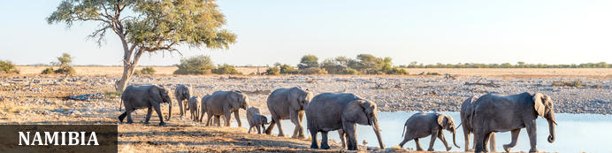

Namibia possesses some of the most stunning landscapes in Africa, and a trip through the country is one of the great road adventures. Natural wonders such as that mighty gash in the earth at Fish River Canyon and the wildlife utopia of Etosha National Park enthral, but it’s the lonely desert roads where mighty slabs of granite rise out of swirling desert sands that will sear themselves in your mind. It’s like a coffee-table book come to life as sand dunes in the world’s oldest desert meet the crashing rollers along the wild Atlantic coast. Among all this is a German legacy evident in the cuisine and art nouveau architecture, and in festivals such as Windhoek’s legendary Oktoberfest. Namibia is also the headquarters of adventure activities in the region, so whether you’re a dreamer or love hearing the crunch of earth under your boots, travel in Namibia will stay with you long after the desert vistas fade.

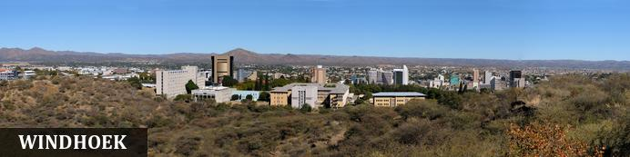

Windhoek is Namibia’s capital, home to an international airport and a plethora of restaurants, shops, entertainment venues and accommodation options. The city is clean, safe and well-organised, with a colonial legacy that is reflected in its many German eateries and shops, and the widespread use of the German language - though English is the official language. The city has an interesting mix of historical architecture and modern buildings, many of which are worth a look, including the Alte Feste (Old Fort), the 1896 Christuskirche (Christ Church), and the more contemporary Supreme Court. It's not a city to linger though - generally one or two nights is sufficient.

### Overnight: The Utopia Boutique Hotel [View iBrochure](https://wetu.com/iBrochure/7357_31498)

The modern Utopia Boutique establishment has allied with the neighbouring Pension Bougainvilla and offers serene rooms and luxurious suites situated amid beautiful, green lush gardens around a swimming pool. The hotel is conveniently located in the tranquil suburb of Klein Windhoek. There are just 12 standard rooms, 6 luxurious suites, and a self-catering unit. All rooms are equipped with a TV, DSTV, free wifi-access and air-conditioning along with a balcony or outside deck. The onsite Taste Academy, beautifully set in a restored German Manor built in 1912, offers a superb venue.

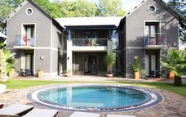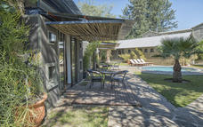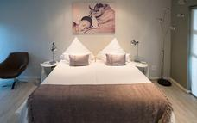

### Basis

Bed and Breakfast

## Day 2-3: Namib Desert Lodge Gondwana Collection Namibia, Namib

### Day Itinerary

After breakfast, set off on your self-drive to Namib Desert Lodge your base for 2nights.  There is time to relax this afternoon or head to the petrified sand dunes with a sundowner and glorious view located beside the lodge. The following morning, drive to the dunes located with the nearby Namib-Naukluft National Park. We recommend a pre-dawn departure to arrive at the Sesriem park gate for sunrise where you’ll collect the entry permit and from here drive through to the dune sea and the 2x4 car park. From here take a 4x4 shuttle to visit Sossusvlei, perhaps climb a dune to view the endless sand sea. Ensure you visit nearby Dead Vlei, where the ancient and skeletal camel thorn trees stand on the white pan with the backdrop of orange sand dunes and blue sky. There is the chance to explore the region on foot, climb a dune or wander around a vlei and taking in the magnitude of endless sand. There are a number of benches/tables to sit and relax before returning to Sesriem via Dune 45 and Sesriem Canyon, finally heading back to your lodge. The rest of the day is free for you to relax or for the energetic perhaps hire an e-bike to explore or head out on a walking trail.  The lodge also offers nature drives. Your two nights will be base in a twin room on a bed and breakfast basis*.  Comfort 3* Day 2: Approx 4.5-5hours from city; Day 3: lodge to gate approx. 45mins; 1hour from Sesriem gate to 2x4 car park. Please note the last 5kms section is 4x4 only and suggest you leave your vehicle here unless you are an experienced sand driver.*

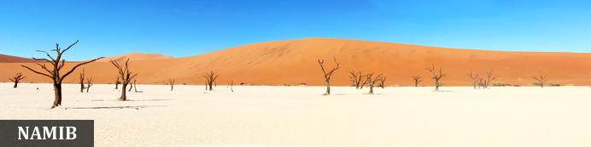

The Namib is the world’s oldest desert, and although it stretches along the entire length of Namibia’s coastline, the Namib commonly refers to the vast sea of sand from Luderitz to Swakopmund. For a big sandy desert the scenery is remarkably varied, with the giant red dunes of Sossusvlei being the most famous part. Because of how old it is the Namib is home to numerous species that don’t occur elsewhere and although no humans live in the desert an amazing array of flora and fauna manages to survive here. Famous species include the Welwitschia mirabilis – a living fossil plant, endemic chameleons, fur seals along the coast, brown hyenas, jackals and remarkably one of Africa’s largest antelope the Gemsbok. The name Namib is of Nama origin and means "vast place" and vast it certainly is.

### Overnight: Namib Desert Lodge Gondwana Collection Namibia [View iBrochure](https://wetu.com/iBrochure/7357_32088)

The main building and the chalets of Namib Desert Lodge are spread out along the foot of the fossilised dunes of the ancient Namib. A comfortable sojourn is guaranteed by 65 en suite rooms with air conditioning. A restaurant and bar, an inviting terrace with views of the fossilised dunes and two swimming pools beckon you to linger and relax. Oryx antelope and springbok make frequent appearances at this illuminated watering place. Internet and wifi available - though this is one of the largest lodges in the area, service and buffet meals are offered and ensure this is excellent value for money

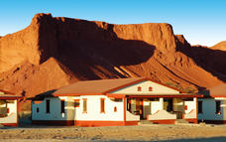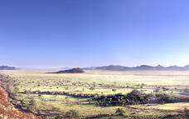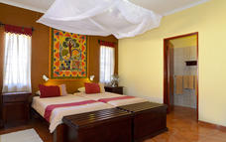

### Optional

|  |
| --- |
| E-Bike Tour |
| Walking Trails |
| Morning or Sunset Drive |

### Recommended

|  |
| --- |
| Namib-Naukluft National Park |
| Dune 45 |
| Sesriem Canyon |

#### E-Bike Tour

Explore the Namib Desert in your own time on an electrical bicycle, a trail map is available at the reception.

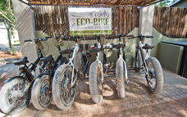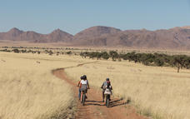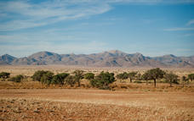

#### Walking Trails

Experience the Namib Desert on foot.

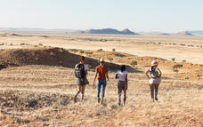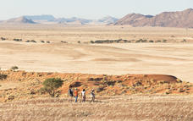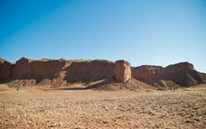

#### Morning or Sunset Drive

Discover the fossilised dunes, the red dunes above the plateau and the many wonders of the Namib Desert on this guides drive around Gondwana Namib Park.

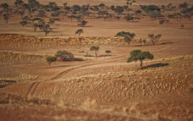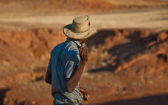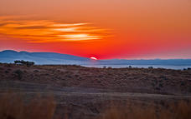

#### Namib-Naukluft National Park

Stretching almost 50000 square kilometres across the red-orange sands of the Namib Desert over the Naukluft Mountains to the east, the Namib-Naukluft National Park is Africa’s biggest wildlife reserve and the fourth largest in the world. Despite the unforgiving conditions, it is inhabited by a plethora of desert-adapted animals, including reptiles, buck, hyenas, jackals, insects and a variety of bird species. One of the main attractions of the park are the ancient dunes of Sossusvlei, home to some of the tallest dunes in the world rising over 300 metres from the desert floor. This magnificent landscape features, rolling dunes, rugged moonscapes, lagoons, wetlands and mudflats. Visitors can look forward to a number of impressive sights including: the picture-perfect Dune 45, standing 170 metres high; the Welwitschia Plains, otherworldly lunar terrain dotted with the endemic plants; and the Dead Vlei, a photographer's dream.

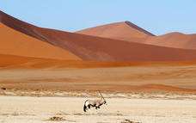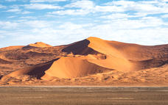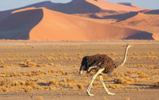

#### Dune 45

Dune 45 is located 45kms from the Sesriem gate, (and entrance to dunes), it is renowned for its elegant shape, which – along with its position close to the road – has earned it the distinction of ‘most photographed dune in the world’.  
Popular for sunrise, many people climb to gain a vantage point to watch the sun rise over the surrounding area and enjoy the changing colour of the dunes, at only 80 metres and featuring a much gentler gradient it is an easier climb than many of the other dunes found.

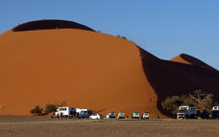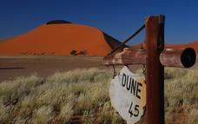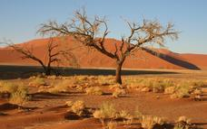

#### Sesriem Canyon

Sesriem Canyon, a deep chasm carved through the rocks by water, is a striking natural feature of the area that is best explored on foot. Stony walls rise up sharply on both sides of the canyon, while birds roost in its crags and lizards dart along the ledges. The canyon’s name was coined when early settlers used it as a water source, using six lengths of leather (‘ses riem – six thongs) tied together to lower buckets into the water at the base of canyon.

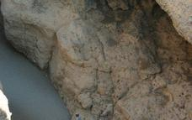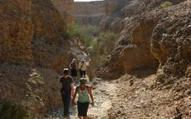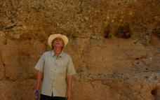

### Basis

Bed and Breakfast

## Day 4: Cornerstone Guesthouse, Swakopmund & Coastal Strip

### Day Itinerary

Leave after breakfast for your drive to Swakopmund, head across the Gaub and Kuiseb Passes towards Walvis Bay where it is worth a quick stop at the lagoon - it’s a RAMSAR protected wetland site, home to many different aquatic birds such as flamingos, pelicans, cormorant, avocets, the endemic Damara tern and many more species.  From here, continue to Swakopmund and if you arrive early enough there may be time to take part in one of the optional activities such as an afternoon scenic flight over the dunes of Sossusvlei, to the coast to see shipwrecks, old diamond mines, dunes falling into the ocean as well as seal colonies, flamingos etc. This flight really gives a different perspective of the area you have already seen from land. Alternatively, take part in quad biking, tandem sky diving or simply wander around the town and enjoy the architecture or perhaps some souvenir shopping. Overnight accommodation in a twin share room with en-suite bathroom, close to the centre of town. Bed and breakfast basis, all other meals will be at client’s expense. Comfort 3* *Approx 4.5-5hours*

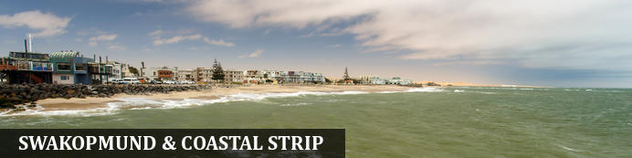

Founded in 1892 as the main harbour for German South West Africa, Swakopmund is often described as being more German than Germany. Now a seaside resort, Swakopmund is the capital of the Skeleton Coast tourism area and has plenty to keep visitors happy. The quirky mix of German and Namibian influences, colonial-era buildings and the cool sea breeze make it very popular and has a wide range of accommodation establishments, banks, restaurants/cafes and shops.  
Along this stretch of coastline (Walvis Bay and Swakopmund) you can take part in a selection of activities sating the thirst of those seeking adrenaline adventures - sky diving, quad biking and sandboarding; or for the more leisurely a range of marine activities including kayaking and cruises. The coastal desert can also be explored with trips to Sandwich Harbour, or informative desert tours... There is a long list so just ask us!  
Walvis Bay is Namibia's major harbour town and the lagoon has prolific bird life including flamingos, pelicans as well as the breeding area for the endemic Damara tern - any bird enthusiast should make a stop here.  
Further north along this coastline - part of the Skeleton Coast, you'll find shipwrecks and the famous Cape Cross seal colony - one of the largest fur seal colonies in the area.

### Overnight: Cornerstone Guesthouse [View iBrochure](https://wetu.com/iBrochure/7357_21613)

Cornerstone Guesthouse is a small, private and peaceful bed and breakfast an easy walk to the ocean and the town centre of Swakopmund on Namibia's fascinating Skeleton Coast. Occupying a quiet corner of Swakopmund's old town near the marine museum and the old brewery, it offers the charm and intimacy of a family-run B&B . Within a few minutes from the guest house you can walk to beaches, cafés, restaurants, lively pubs, Swakopmund tourist attractions and a variety of interesting shops and markets in the town.  
There are just 7 en-suite double rooms set around a lovely garden and 2 of the rooms can accommodate families of up to 4 people. Each room has TV, tea/coffee station, fridge, safe and wifi. Laundry facilities, along with off-street parking is available and makes this a good option for a 3* level of accommodation  
Self catering apartments are also available

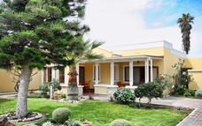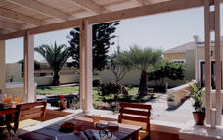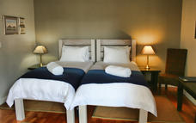

### Optional

|  |
| --- |
| Sossusfly Scenic Flight |
| Desert Explorers Quad Biking 90min Tour |
| Sandwich Harbour 4x4 |
| Mola Mola Marine Dolphin Cruise |

#### Walvis Bay Lagoon

Walvis Bay’s calm natural lagoon is a twitcher’s paradise, teeming with roughly 50 species of seabirds, including vivid flocks of flamingos, bulky-billed pelicans and glossy black cormorants. It’s also a popular spot for windsurfing, kitesurfing and kayaking, while the promenade stretching for three kilometres along the water’s edge is a great place for a scenic stroll.

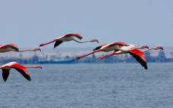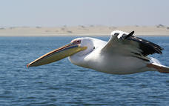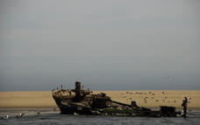

#### Sossusfly Scenic Flight

The Sossusfly Scenic Flight is a flight that gives visitors the opportunity to experience a birds-eye view of the most spectacular scenery of the Namib Desert. The flight covers the desert and the Southern Skeleton Coast from the air. The flight includes a low-level flight along the green Kuiseb to the Kuiseb Canyon, as well as the coastline. Highlights of the flight include Tsondablei, Sossusvlei area, diamond camps, shipwrecks, Sandwich Harbour, salt works, Walvis Bay, Longbeach, and Swakopmund.

#### Desert Explorers Quad Biking 90min Tour

Located in Swakopmund, Namibia, Desert Explorers Quad Biking 90min Tour takes visitors on a pleasant guided quad bike tour. The 30-kilometre tour takes place in the Namib desert.

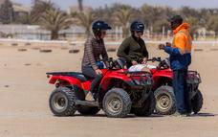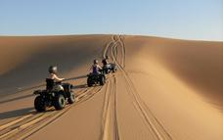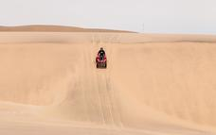

#### Sandwich Harbour 4x4

Join half-day or full day tours from Walvis Bay making our way between the crashing ocean and ancient dunes of the Namib, and when at the top, experience an endless view of sand and sky. Common sightings include bottlenose and heavy side/Benguela dolphins, cape fur seals, mola mola, penguins, southern right and humpback whales (August-November), springbok, and jackals. Note that due to tide conditions it may not always be possible to reach the harbour itself.

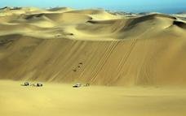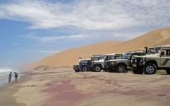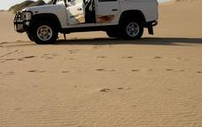

#### Mola Mola Marine Dolphin Cruise

Experience the beautiful Skeleton coast of Namibia and the amazing riches of the Atlantic Ocean with the Mola Mola Marine Dolphin Cruise. See an abundance of bird and mammal life up close and delight in the sea air, fresh oysters and bubbles – all in the morning. Frequent sightings include Bottlenose and Heavy Side dolphins, Cape Fur seals, Mola Mola's, penguins, Leatherback turtles, and whales (July-November). Lunch can also be arranged on the beach by special request. Tours are available in English, German and Afrikaans.

Request quotes for private tours and the Beach Braai (BBQ) lunch on Pelican Point Peninsula.

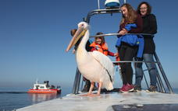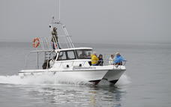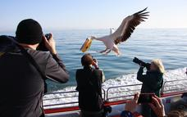

### Basis

Bed and Breakfast

## Day 5-6: Ai Aiba Rock Painting Lodge, Erongo Mountains

### Day Itinerary

Today, drive north along the Skeleton Coast stopping to view a shipwreck just south of Henties Bay and easily viewed by the shore; from here, continue a little further north to visit Cape Cross Seal Colony, where thousands of seals, and one of the largest colonies in southern Africa, congregate on the beach before retracing your steps to Henties Bay and turning inland. Drive to the beautiful Erongo region where you'll overnight at Ai Aiba Lodge.  During your stay a visit to a San Living Museum is included where you'll have the chance to learn about this remarkable tribe.  There is also time to join a self-guided walk, visit ancient rock art or simply relax with a book by the pool. *Guided walk for sunset is included in package. Approx 3-4hours plus stops and additional time if driving via Cape Cross*

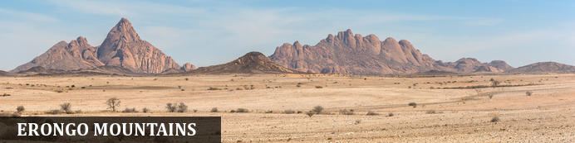

The Erongo Region is one of the largest of the 13 regions found in Namibia and received its name for the majestic Erongo Massif that dominates the area around Karibib, Omaruru and Usakos. The region reaches up to the Atlantic Ocean and includes the coastal towns of Swakopmund and Walvis Bay, its northern boundary ending at the Ugab River where the Skeleton Coast National Park begins its stretch to Angola. Spitzkoppe, Brandberg and Twyfelfontein are officially in this zone. The Erongo Mountains and western escarpment incorporates the Erongo Mountain Nature Conservancy which extends over 200,000ha, encompassing one of the most environmentally diverse areas including rock art and prehistoric settlements. The area is home to high densities of leopard and brown hyena along with hotspots of endemic plant, reptile, bird and mammal species.

### Overnight: Ai Aiba Rock Painting Lodge [View iBrochure](https://wetu.com/iBrochure/7357_10519)

Set afoot massive granite rock boulders, overlooking the magically beautiful Erongo mountain range, is Ai Aiba - The Rock Painting Lodge. The overwhelming panoramic view from the restaurant and bar is amazing. The crystal clear pool invites you to refresh and relax. Ai Aiba is an active member of the Erongo Mountain Nature Conservancy, an association of farmers dedicated to the protection and preservation of the unique fauna and flora, as well as the magnificent granite landscape of the Erongo.  
There are 20 thatched-roof twin-bedded rooms, each with en-suite and in a traditional African style and with air-con/heater. Credit card facilities available. Activities include game drives, birding, hiking, and of course, visiting the rock-art sites.

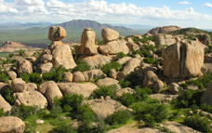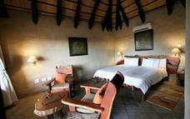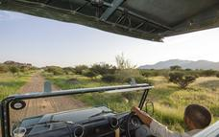

### Activities

|  |
| --- |
| San Living Museum Tours (available from 08h00 to 15h30) |

### Optional

|  |
| --- |
| Cape Cross Seal Colony |
| Nature Drive / Bushman rock art |
| Guided walks (Morning & Sundowner) |
| Self-Guided Walking Trail |

#### San Living Museum Tours (available from 08h00 to 15h30)

Various tours are available, and can all be booked directly at the lodge. Times are flexible, and bookings can usually be made according to your requirement. Please ask at reception for more information. -Bushwalk – approx. 2hours. Learn about hunting, snaring, tracking, lighting fire and collecting bush food.  
-Live in the village – approx. 2hours. Learn about singing and dancing, lighting a fire, making ropes and jewellery.  
-Combination (Action day) – approx. 4hours. A combination of the bushwalk and the “live in the village” tour.

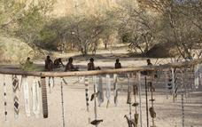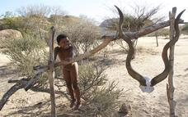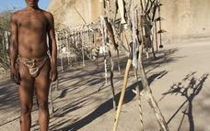

#### Cape Cross Seal Colony

This colony of Cape Fur Seals is one of the largest in the world, home to approximately 80 000 to 100 000 of these so-called 'seals', which are in fact a species of sea lion. Day trips to the colony are offered and the seals can be viewed from a walkway at a distance of roughly 200 metres.

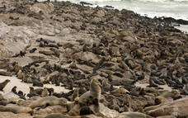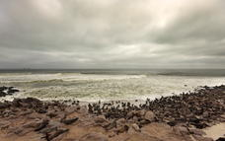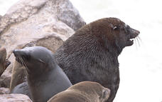

#### Nature Drive / Bushman rock art

This drive takes about 3 hours, through the scenically beautiful lodge property, with selected stops at sites to view and learn about bushman rock art. The drive will also include a stop for refreshments and snacks. A must-see for anyone visiting the area. This drive can be done both in the morning or the afternoon.

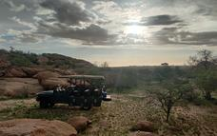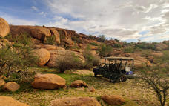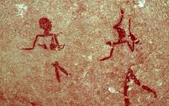

#### Guided walks (Morning & Sundowner)

Walking the area surrounding the Lodge is highly encouraged and is an excellent way to experience the beauty of the Erongo Mountains. Our guides have been very well trained on the interesting Fauna and Flora of the area and are available to escort guests through the property.  
Guided Morning walks:  Breakfast is available in the restaurant from 07h00.  Your guide will take juice and snacks along for en-route. Please carry your own water.  Please ensure that you wear good walking shoes, and have adequate sun protection.  
1) Ai Aiba Walk: This walk is 2 – 3 hours in duration and can be of varying degrees of difficulty depending on your preference. It will include visits to certain rock art sites, and a focus on the smaller intricacies of nature. Morning walk departs at 07h30 (Summer and Winter), from the restaurant.  
2) Walk & Drive: This activity starts from the lodge with a 10min drive to Moringa valley. From there guests hike to a number of different rock art sites, including some fantastic viewpoints along the way. Then another short drive (10-15min), followed by another hike through majestic landscape to view some more rock art sites and fantastic rock formations. A short 20min drive will then take you back to the lodge. Total duration is approximately 3 hours.  
3) Walk with visit to the San Living Museum: This walk is approximately 3 hours. Our guides will walk with you to the San Living Museum, stopping at certain rock art sites en-route. Once at the Living Museum the bushman will take guests on a bushwalk, and then our guides will lead you back to the lodge again  
Sundowner walk: Very close to the lodge, you will be guided up a granite hill where you can relax and enjoy a cold ‘sun-downer’ drink while watching the sun set over spectacular views of the Erongo Mountains.

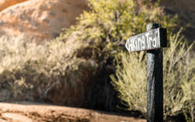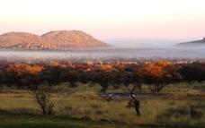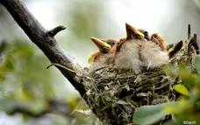

### Basis

Bed and Breakfast

### Included

San tour - Living Museum

## Day 7: Damara Mopane Lodge Gondwana Collection Namibia, Damaraland

### Day Itinerary

From Ai-Aiba, drive north - perhaps visit nearby Twyfelfontein rock etchings, the local Damara Living Museum, or Petrified Forest en route to Damara Mopane. It's also close to Vingerklip - a rock sitting rather precariously amongst the surrounding plains - you can enjoy short walks around here. *Approx 4-5 hours plus stops (depending on route taken)*

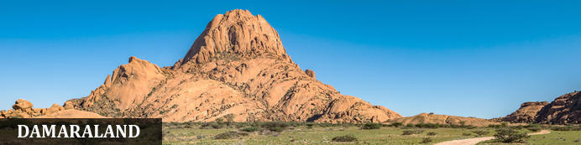

Huge, untamed and ruggedly beautiful Damaraland is an exceptionally scenic landscape of open plains and spectacular rock formations. Some regard the highlight of the region as Twyfelfontein - Namibia's first World Heritage Site and one of the largest collections of rock etchings in Africa. There are a number of sites worth exploring in the region and depending on how much time you have - Brandberg, Namibia's highest mountain, the Erongo Mountains with its granite formations and conservancy programmes, then Spitzkoppe offering incredible rock formations as well as rock paintings.  
Engage with local communities around the area including the Damara people and perhaps visit Damara Living Museum located close to Twyfelfontein  
Ultimately, this area is also home to free-roaming desert elephant, black rhino and desert-adapted lion (along with a number of other species including giraffe, mountain zebra etc), and some lodges offer superb activities enabling visitors to track these incredible animals

### Overnight: Damara Mopane Lodge Gondwana Collection Namibia [View iBrochure](https://wetu.com/iBrochure/7357_24085)

Built in the wattle and daub style under Mopane trees and connected by a labyrinth of paths, the main building and chalets of the lodge look like an African village. The walls are adorned by copies of the rock engravings at Twyfelfontein. Each of the 60 double-room chalets (with air conditioning) sits in a vegetable and herb garden surrounded by a low wall. The gardens supply fresh ingredients for supper, which consists of a starter followed by a delicious buffet. There is a swimming pool for chilling out and a viewing point for relishing sunsets. The lodge is at the gates of Damaraland is ideally suited for excursions to Twyfelfontein (130 km), the Petrified Forest (70 km) and the Vingerklip rock pillar (50 km).

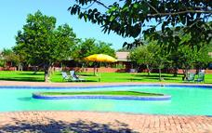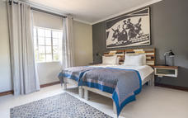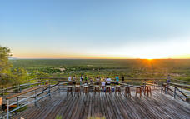

### Optional

|  |
| --- |
| Hiking Trails |
| Sundowner Walk |

#### Twyfelfontein Rock Art

Twyfelfontein is a World Heritage Site boasting one of the richest rock art concentrations in Africa. Thousands of tourists come to this site each year to view some 2, 500 Stone Age rock engravings. The area is home to 17 rock art sites, which collectively encompass 212 engraved stone slabs. There are an additional 13 sites displaying rock paintings.

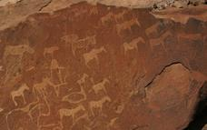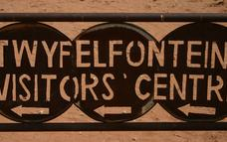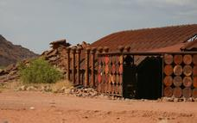

#### Damara Living Museum

Observe and experience the traditional Damara way of life right in the heart of their traditional homelands. A unique opportunity to see a way of life that is slowly dying out. Open daily.

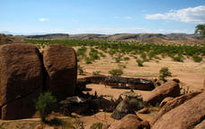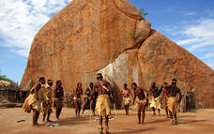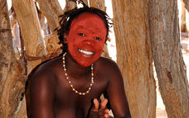

#### Petrified Forest

Situated approximately 50 kilometers west of the town of Khorixas, in an area of open veld, lies a large deposit of massive tree trunks that have "turned to stone" through a process of diagenesis. These petrified tree trunks are up to 34metres long, 6 metres in circumference and are approximately 260 million years old. Due to the lack of root or branch remains, it’s believed that the trees were washed down an ancient river to the site in a massive flood.

#### Hiking Trails

Explore the flora and fauna of the Damaraland on your own. You have two different self-guided hiking trails to choose from. They are well marked and take you through the wildly romantic scenery of the Damara Mopane Lodge house mountain. Duration: between 1 and 3 hours

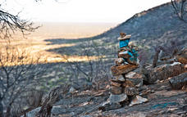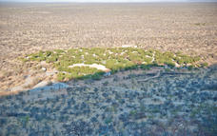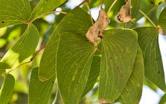

#### Sundowner Walk

A highlight at the end of the day is to ascend the hill to a viewing platform for a sweeping vista of the mopane woodland illuminated by the setting sun. Beverages are provided and charged to the room.

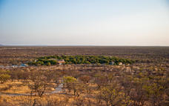

### Basis

Bed and Breakfast

## Day 8-9: Okaukuejo Resort, Etosha South

### Day Itinerary

Drive to the amazing Etosha National Park, enter via the Anderson’s Gate and game drive to the rest camp - perhaps visit Ombika waterhole en-route, and later this afternoon, if time permits, head out in search of some of the many species found here. Spend the next day game driving and enjoy watching the animals come in to quench their thirst at the waterholes and observe their individual behaviour; Okaukuejo and Halali often have busy waterholes and many species flock here after sunset including the black rhino, elephant, lion, and a plethora of plains game. Your two nights is based in twin bedded standard room on a bed and breakfast basis at Okaukuejo and/or Halali; all other meals will be at client’s expense.  Comfort 2-2.5* *Approx 3.5-4.5hours plus game drives* (vary)

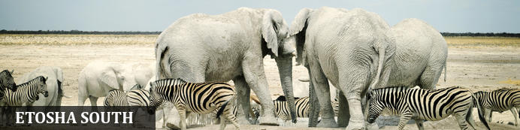

The national park can be accessed via the southern entrance at Andersson’s Gate and the central point is Okaukuejo Resort. Visitors can catch a glimpse of abundant wildlife including: lion, giraffe, elephant, white and black rhino, and a multitude of plains game. Popular activities include: game drives, tracking rhinos on foot, guided nature walks, or watch the sunset over this magnificent landscape. Just outside the national park is the upmarket Ongava Private Reserve, as well as a number of mid-level accommodation and camp sites.

### Overnight: Okaukuejo Resort

Okaukuejo is located 17 km from the southern entrance of the park, and famous for its flood-lit waterhole, where visitors can observe at close quarters a spectacle of wildlife congregating and interacting - this is an incredible sight during the dry winter months and one of best places to see herds of elephant, black rhino and large herds of plains game. The spectacle starts at dawn, with animals coming in large numbers to quench their thirst and continues throughout the day until late at night. In the early evenings, it is not uncommon to have black rhino, elephant and lion all drinking at the same time. Wifi available (extra charge)

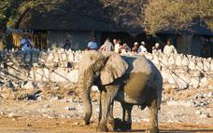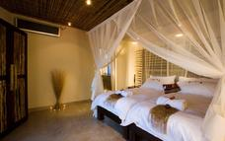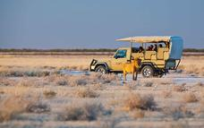

### Alternate: Halali Resort

Strategically located halfway between Okaukuejo and Namutoni inside Etosha National Park, Halali is situated at the base of a dolomite hill, amongst shady mopane trees and a Government run rest camp. A flood-lit waterhole is viewed from an elevated vantage point and during dry winter months provides exceptional wildlife viewing throughout the day and into the night and it's not unusual for elephant, rhino, hyena and various species of game to be seen. Accommodation is provided in family chalets, two and four bed bush chalets and standard rooms - all with en-suite facilities and overlook the natural surroundings of dry, pan like areas. Facilities include a restaurant, bar, small shop, swimming pool, kiosk and camping facilities. Watch out for honey badgers around the rooms and campsite - it's a great location for them.   
Standard rooms: Set in 2 long blocks of rooms, each with en-suite and small private verandah, furthest rooms from the waterhole. Fridge, tea/coffee station, air con  
Bush chalets: These are more spacious,with small lounge area and separate bedroom; fridge, tea/coffee station, air con and braai area (no cooking equipment)  
Family chalets: Larger than bush chalets and cooking equipment included

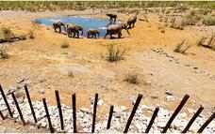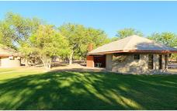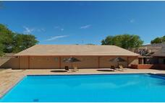

#### Etosha Pan

Aeons ago, Etosha Pan was the bed of a vast lake; today what remains is a glittering, silvery-green salt pan that stretches across roughly 5000 square kilometres. Etosha is protected by the Etosha Pan National Park surrounded by savannah plains and woodlands supporting large herds of elephants. When dry, the pan sustains little life except for the algae that gives it its distinctive colour, and migratory birds that use it as a pit stop, but with heavy rain it becomes a shallow lake (east side) where flamingos breed, pelicans wade and feed, and a variety of mammal species come to quench their thirst, including predators such as hyena, lion, cheetah, and leopards along with rhinos, and antelopes.

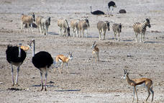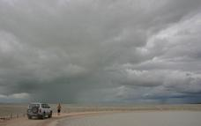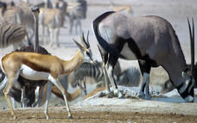

### Basis

Bed and Breakfast

## Day 10: Okonjima Plains Camp, Okonjima Nature Reserve

### Day Itinerary

After a final game drive and departure from Etosha, your journey takes you to Okonjima, home of the AfriCat Foundation, where you will overnight at Plains Camp, in twin view room on dinner, bed and breakfast basis, with one standard activity per person included, such as heading out on a game drive or tracking radio-collared leopard. Once here, you can choose which activity interests you most and later this afternoon head out on your chosen excursion before returning to the lodge in time for dinner. Comfort 3.5-4* *Approx 3.5hours*

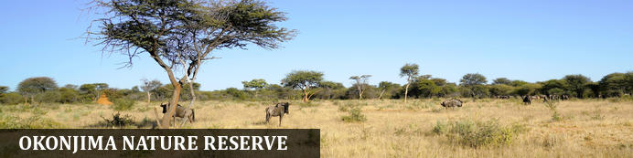

Halfway between Windhoek and Etosha lies the well-known Okonjima Nature Reserve. The 22 000 ha Nature Reserve is surrounded by 96 km of fence and was finally completed in 2010. Okonjima is home to AFRICAT, a Carnivore Conservation, which gives the captive carnivores a second chance to be released back into the wild and to take the time it needs, to become a completely independent hunter - in a protected area right in the middle of commercial farmland! Also in the Reserve is a 2000 ha 'safe' zone around Plains Camp, Bush Camp, Bush Suite, the Omboroko Campsite as well as the PAWS Environmental Education Centre.

### Overnight: Okonjima Plains Camp [View iBrochure](https://wetu.com/iBrochure/7357_8727)

Not only is Okonjima a luxury lodge, but is also home to The AfriCat Foundation, a non-profit organisation, committed to long-term conservation of Namibia's large carnivores, especially cheetahs and leopards and a visit will give you an opportunity to witness some of AfriCat's work. Plains Camp design honours the Okonjima cattle-farming history - in the early 1920’s, Okonjima became a cattle farm and was bought by Val (VJ) & Rose Hanssen in 1970. They were well-established Brahman breeders and continued to farm cattle until the need for solutions to increasing livestock losses became pertinent and post-independence interest in Namibia as a tourist destination, escalated. In 1993, the herds of Brahman and Jersey cattle were sold, changing the face of Okonjima as well as that of Carnivore Conservation! Nowadays, clients enjoy a selection of activities that include tracking rehabilitated carnivores on foot; visiting the AfriCat Carnivore Care & Information Centre; and/or tracking leopards from a game–viewing vehicle. Guided and self-guided birding/walking trails are also available. A superb first/last night destination and recommended. Facilities include swimming pool, curio shop, waterhole, free wifi.There is a choice of view rooms, standard rooms and the nearby garden rooms (these are a little further away from the lodge and part of old lodge - they are more traditional stone built). Note there is no air-conditioning.

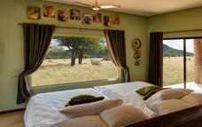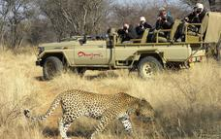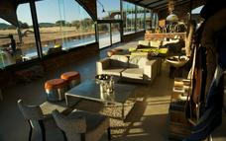

### Activities

|  |
| --- |
| The Okonjima Experience |

#### Okonjima - The AfriCat Foundation

Okonjima Nature Reserve in central Namibia is home to The AfriCat Foundation. It has grown significantly since it was established as a welfare organisation in the early 1990s and registered as a non-profit organisation in 1993. Today, AfriCat’s mission is the long-term conservation of some of Namibia’s large carnivores – such as brown hyaena, leopard and cheetah, all of which can be seen during an environmental education visit to Okonjima.

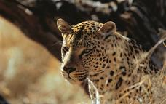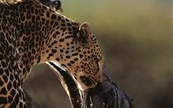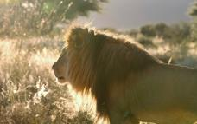

#### The Okonjima Experience

The Okonjima Nature Reserve sprawls over 200 square kilometres of undulating plains, mountainous outcrops, and riverine thickets, and it is here that leopard (Panthera pardus), the most adaptable of all the wild cats, thrive.  These intelligent, solitary predators occur in high density in the expanse of Okonjima Nature Reserve’s multi-faceted topography. The Reserve’s predator research programme has spanned three decades, and its findings have provided great insight to leopard behavioral patterns as well as offered an upbeat prognosis for a sustainable future for the species in today’s Africa.   Research programme leopard are actively tracked, and their collars are an invaluable resource for locating, and then returning to the Reserve, cats which have migrated to surrounding farmland where they are perceived as threats to livestock, guests can enjoy leopard tracking though sightings are not guaranteed they are very likely and the opportunity to see these beautiful cats close up are a highlight for many.  
Additional activities include finding out more on the protection of Namibia's predators including cheetah, leopard, hyena, lion and even wild dog and an insight is given to the human-wildlife conflict.  Visitors have the chance of seeing cheetah in a reserve (these individuals cannot be released to the wild) but makes for great photos.  
Perhaps join a Bushman walking trail, game drive on the reserve, or self-guided walks.  Night drives are also available to some lodge guests.

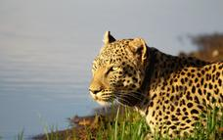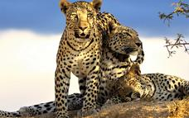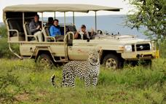

### Basis

Dinner, Bed and Breakfast

### Included

1 x standard activity

## Day 11: End of Itinerary

### Day Itinerary

If time permits, perhaps join a further activity (own expense), then return to Windhoek, you may wish to stop at Okahandja for some last-minute souvenir shopping at the craft markets where you can barter some gifts before returning to Windhoek International Airport and connect with your onward flight back home.  *Drive time approx 2.45hours to Windhoek; drop off vehicle and another 40-45mins to airport – no flights prior to mid-afternoon and later if you wish to join Okonjima activity*. *End of services*

### Expert Tips

Car Rental: As with all car hire companies if you have an accident and if they prove you were negligent– for example - speeding - then the zero excess becomes null and void and you are liable for costs.  
Upon collection of the vehicle you will complete the car rental suppliers contract and discuss any extras with them – these are for your own account – please check the vehicle carefully as you are responsible for it thereafter. If you have any problems with the car whilst you are on the road please contact them directly.  
All car rentals will require you to provide your passport, driving licence (written in English or an international licence), as well as supply a credit card for the refundable deposit.   
A GPS is often available by the car rental companies (at clients' own expense), however, due to our road network system (and small population), it is not normally required, we realize this is a personal preference and are happy to pre-book for you. Outside of major towns/cities please do not drive around/after sunset.

Please note that this quote is based on the availability of both accommodation/ vehicle and on the understanding that no bookings have been made. Should we need to use alternative options the price and itinerary is subject to change.  Please also be aware that standards of NWR/Government accommodation, food and service can vary and be very erratic but have selected these camps inside the park for the location /floodlit waterholes.  We have quoted for accommodation inside park this can be amended to suit you, comfort ratings are indicated but note there is no "star" system in Namibia so this should be used as a guideline only.

Travel times: When we give travel times in the itinerary please note these are a guideline and perhaps will only in one brief stop travelling at average speed – some clients will drive slower or stop multiple times enjoying longer breaks and therefore journeys will take longer. We recommend most days when travelling onto another destination to leave after breakfast to allow plenty of time to arrive in plenty of time and enjoy the location

Namibia is an incredible country to visit but please remember that we are in Africa and that not all standards are the same as you would get in Europe or other first world countries. To the majority of our clients, that is part of the appeal of travelling to destinations such as ours. If you are not comfortable with new challenges then you may wish to consider other companies or destinations. Please also note that due to the location of destinations, some long days are inevitable - you’ll travel on gravel roads which can vary in quality depending on the season and maintenance work carried out – please do not drive off road as the Namibian landscape is extremely fragile and follow only well-defined roads (we provide you with a map and suggested route to take once bookings are completed with us, and try to ensure the most suitable/direct/scenic route is taken). Deviating off existing roads not only spoils the scenery and enjoyment of others, but also destroys plants and small creatures, note that the majority of vehicles have a tracking device and should you damage your vehicle in any way and the route deemed unsuitable you will be held liable for the damage. More details regarding how to drive on gravel roads and in Namibia/surrounding countries is given with our “car rules and regulations” document issued with your self-drive confirmation

Money: The currency in Namibia is the Namibia Dollar, which is fixed to and equals the South African Rand on a 1-1 basis. The dollar and SA Rand are the only legal tender in Namibia and both are used freely, however the Nam dollar is not legal tender in South Africa and we recommend that you exchange your money prior to departing Namibia  
*Credit Cards*: Visa and MasterCard are generally accepted in shops and restaurants in towns and many lodges. Use of credit cards may incur an additional fee. Occasionally lines may be down and services not available particularly in remote destinations and payment will need to be in cash  
Cash: South African rand can be purchased in advance. The Namibia dollar is not an international currency and therefore can only be obtained in country. Cash is available at ATM machines using credit card and pin number. There is FX bureau upon arrival at International Airport for those arriving by air and can be worth obtaining prior to arriving in city. It is customary to tip in Namibia, usually, around 10% at restaurants. A tip box is normally found in the reception in lodges

Safety: As with every destination safety tips needs to be adhered to; we strongly recommend you use a safe in a hotel/lodge or lock up your valuables when you are not in the room; when in a vehicle do not leave valuables on display but tucked away and out of sight. It is also better to have copies of passports, money; cards etc split between travellers so if anything unexpected happens and a bag is lost or stolen then other funds/cards are available, you may also wish to consider using a money belt/neck wallet. We suggest you leave valuable jewellery at home – you won’t need it while travelling. A padlock for your luggage is also recommended

Booking & payment: When you have decided on a trip a booking form will need to be completed, signed and returned to us and we will enquire regarding availability and advise you. Once we have taken deposit, a confirmation is sent to you, advising you of the services agreed and booked. Payment is due approximately 6 weeks (sometimes 8 weeks depending on the supplier) prior to departure. Exchange 4 free, bank transfers and MasterCard/Visa are all accepted forms of payment but please ensure there are sufficient funds and your bank is aware of the transaction about to take place (if you are paying via credit card), in this day and age many banks will withhold money as a safeguard against fraud and this delay can be critical particularly if you are booking at short notice. Please also allow for payment to process and if paying via bank transfer to include all bank fees, note we are unable to confirm bookings/trip until funds have cleared into our account, any delay may see a cancellation in your trip and booking released.

Dietary: We can assist with booking of various dietary requirements or food allergies but we appreciate your details when you book with us (or with your agent) and we will advise the appropriate lodges. Please be aware that the choice and options may not be as great as your home country.

Weather: Please note that in winter evenings and nights in particular can be very cold we recommend layered clothing – day time temps can be 25°C so t-shirts and shorts is great for then but thermals are very useful for evenings/night. Summer temperatures can exceed 40°C but also bring our rainy season so a lightweight rain jacket is handy, as with most places layering is the most recommended way of clothing – please ensure you pack your clothes in plastic bags and ensure cameras/electrical equipment is suitably protected

Climate: The African sun is very strong. Please use a factor 30 sunscreen and wear a hat. You should drink at least 3 litres of water per day to avoid dehydration. It can also get very cold during winter months on this route

Electrical: plugs are 220V and are 3 pin (round pin as opposed to square pin). Adaptors can be purchased in Windhoek and most international airports; they are the same as South Africa if you are shopping in home country or at airport. Some lodges will also offer 2pin sockets or adaptors but please do not rely on this, it is much better to bring your own. It is possible to re-charge batteries at most lodges but clients must be responsible for security of their possessions

Insurance: It is essential that you purchase comprehensive personal travel insurance before you embark on your holiday, medical insurance is insufficient. Travel insurance is for your own protection and should include evacuation and cancel any reason/covid policy; we also recommend full cover for baggage loss etc and consider it to be an essential part of modern international travel.

Health: Namibia is a low risk malarial destination but we recommend that seek professional medical advice to enable you to make decisions on personal malaria protection. Note Etosha is officially a malarial area (low risk), please discuss with your doctor and obtain any necessary protection before departing your home country. No vaccinations are required by law for the countries being visited on this tour though we recommend clients are up to date with vaccinations of TB, hepatitis, polio etc  
Covid: contact us for latest regulations and note these can change at short notice. We recommend all visitors are fully vaccinated, no regulations are currently in place

Water: All tap water in Namibia has been purified or comes directly from boreholes and is safe to drink. Tap drinking water is generally safe to drink but bottled mineral water is easily available at shops and rest camps should you prefer to drink this, at some lodges it is provided

Visas: The onus is on the client to organize all visas required for clients prior to departure. Please ensure that your passport is valid for at least six months after your scheduled departure date country of travel and has sufficient empty pages. If this is not the case, there is a danger of being turned away by the Immigration Service on arrival at the airport – assuming your airline has agreed to bring you and risk a fine in the first place. The Company cannot be held liable for any necessary visas or other travel documents not held by the clients. Please also note that if your passport requires a visa for the countries you visit and multiple entries if necessary, you will need to carry your passport with you during the trip.  If travelling with children please note regulations regarding birth certificates etc, details are on pre-departure information you'll receive after booking.

Responsible Tourism: When we put together an itinerary for you, our aim is to try to ensure you have the experience of a lifetime, we strongly believe in low impact or positive impact tourism. Furthermore, our responsibility to the country/ies you visit and the environment is to try our best to ensure that all benefit – whether that is a small, local operator, local community or conservation programme. Your itinerary may include visits a “local community/village” which will enable you to directly assist and barter for a piece of jewellery; perhaps overnight at a locally-owned campsite or lodge; maybe a local guide takes you to a place of interest or site; or visit an organization set up to protect endangered animals and species that occur naturally in the country. We will give you an insight into these initiatives but if you want more information please ask. Note that these initiatives vary according to the region travelled and what is available), remember your safety and enjoyment is also of paramount importance so we will not for example, use a camp site located in a place we consider unsuitable. Please also follow some of the notes we issue in our pre-departure information to minimise the effects of negative tourism on local cultures (respect for others and their beliefs etc). Generally, we prefer not to use large, international hotel chains as much of the revenue leaves the country but again, should you prefer this option we are happy to oblige.

Pre and Post Tour Accommodation: If you require accommodation before or after your tour we can arrange

If you have any questions, please do not hesitate to contact us.  
Tel: +264 61 309387   After hours emergency cell phone: +26481 3784040 Fax: + 264 61 220885  
Email – info@chameleon-holidays.com    Web - www.chameleonholidays.com  
Skype- chameleon.holidays    Facebook