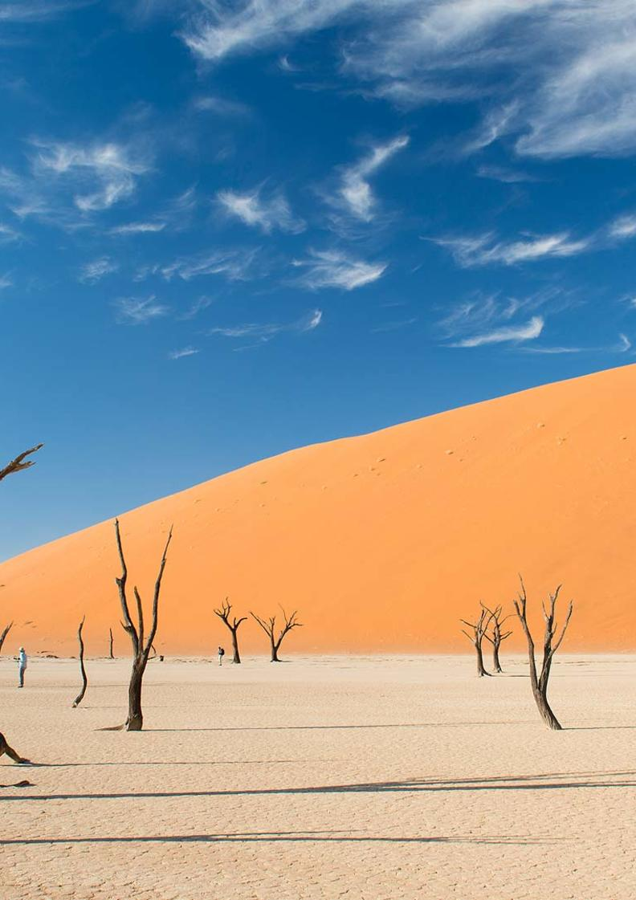

7-Day Namibia Highlights Fly-in Safari - Standard - NETT

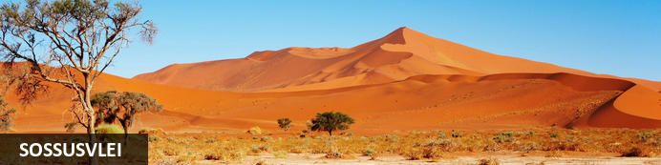
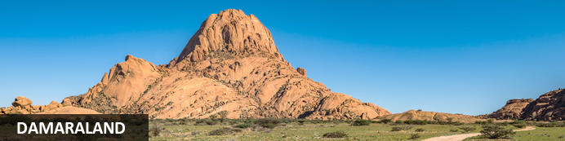
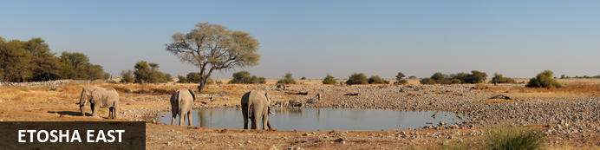

7-Day Namibia Highlights Fly-in Safari - Standard - NETT
Sossusvlei - Damaraland - Etosha East
7 Days / 6 Nights
Date of Issue: 13 March 2023

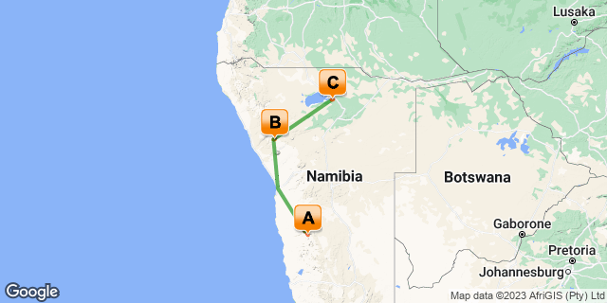

Click here to view your Digital Itinerary

Introduction
Starting and ending in Namibia's capital city, Windhoek, this sensational 7-day Namibia Highlights Fly-in Safari will fly over the great sand sea to Sossusvlei, then over the Skeleton Coast to the fascinating Damaraland, and finish off with a classic big game safari in Etosha National Park.
This fly-in tour is reversible and available in three levels of comfort: ultra-luxury, luxury and standard. You can also extend the itinerary by as many days as you wish to include some of Namibia's other major destinations like Swakopmund, Kaokoland and the Caprivi.

Accommodation | Destination | Basis | Duration
Desert Homestead Lodge | Sossusvlei | HB+ | 2 Nights
Camp Kipwe | Damaraland | FB+ | 2 Nights
Mushara Bush Camp | Etosha East | HB+ | 2 Nights

Key
B&B: Bed and Breakfast
HB+: Half Board Plus - Dinner, Bed, Breakfast and Activities
FB+: Full Board Plus - Dinner, Bed, Breakfast, Lunch and Activities

Price
NETT STO COSTS
1st January – 30th June 2023 – Low Season
2 guests - ZAR 70 510 per person sharing
4 guests - ZAR 49 035 per person sharing
Single supplement - ZAR 8 300
1st July – 31st December 2023 – High Season
2 guests - ZAR 74 230 per person sharing
4 guests - ZAR 52 320 per person sharing
Single supplement - ZAR 9 570
Flight costs are calculated on a private charter basis in a Cessna 210 aircraft.
Prices subject to change according to fuel price fluctuations.

Included
- Accommodation as indicated – can change depending on availability and request at time of booking
- Meals as indicated
- Meet and greet upon arrival
- Activities as indicated including park entry fees
- Private charter flights as indicated
- Airstrip transfers as necessary
- Tour file with detailed itinerary, map with route descriptions, vouchers etc.
- 24 hour personal and friendly support
- Fast and efficient response to service providers

Excluded
- Items of a personal nature
- Optional extra activities
- International flights
- Holiday or personal insurance
- Staff gratuities
- Visas and visa applications

Day 1-3: Desert Homestead Lodge, Sossusvlei

Sossusvlei
Star dunes with up to five crests rise 300m into the air and rank among the biggest in the world; the dune valleys are marked by vast clay pans where the Tsauchab River gave up its fight to reach the sea more than 60,000 years ago.
Besides the dunes and pans of Sossusvlei and Sesriem Canyon, a sideshow of activities and sights has developed around the region and there are plenty of game lodges that provide additional desert-adapted activities.Plants and birds are the dominant life form in this dessicated realm and they support a tiny world of mammals, reptiles and insects that, in the absence of coastal fog, seldom wander far from the rivercourse and its pans.

Day Itinerary
Flight: Windhoek – Sossusvlei 1 hour & 10 minutes
- You will be met on arrival by our representative to hand over your travel documents
- Meet your pilot and check in for your flight and briefing before taking to the Namibian skies
- Private charter flight from Windhoek to Sossusvlei over the Namib Naukluft Mountain Range
- Road transfer to the lodge on arrival
- Includes: Dinner, bed and breakfast; 1 x sundowner drive on day of arrival; 1 x Sossusvlei excursion
- Highlights: Sossusvlei, Dead Vlei, Dune 45, Big Daddy, Elim Dune and the Sesriem Canyon

Overnight: Desert Homestead Lodge View iBrochure
The Desert Homestead is a tranquil and unfussy lodge near Sossusvlei. Comfortable thatch chalets compliment the rich tapestry of the Namib Desert and the main living area is a serene salutation of the passing days.
While close to Sesriem and Sossusvlei, The Desert Homestead is more about a tranquil experience of the Namib Desert on horseback than the spectacle of the great sand dunes.
The lodge is made up of beautiful thatch-roofed pastel-walled chalets that lend themselves to the quiet charm of this magical region. Inside the 27 chalets (including a family room), the serenity continues: soft, white linens against dark furniture and whitewashed walls. Private verandahs look out over the plain that is framed by craggy mountains in every direction.
The main lodge is a light and airy mix of open relaxation and cosy retreat. Hearty homestead meals are enriched by the setting and with home-grown ingredients. The swimming pools provide languid refreshment after a hot day's riding.
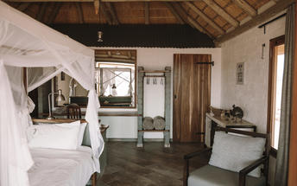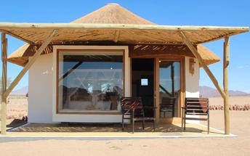

Basis
Half Board Plus - Dinner, Bed, Breakfast and Activities

Day 3-5: Camp Kipwe, Damaraland

Damaraland
Damaraland features vast khaki plains, sheer rocky mountains and incredible desert-adapted wildlife. Track rhino and desert elephant, explore the rugged land or sit back and enjoy the dramatic and endless scenery. Damaraland's hilly savannah supports a large number of species including lion, leopard, cheetah, hyena, eland, kudu, giraffe, klipspringer, steenbok, gemsbok and springbok. Birdlife is prolific with over 33 raptors recorded including cuckoo hawks, Egyptian vultures and peregrine falcons - the world's fastest animal.
Damaraland is divided into several enormous private game reserves, known as concessions, that support most species of Namibia's large game and provide some of the best birding and wildlife experiences in the country - and southern Africa for that matter.

Day Itinerary
Flight: Sossusvlei – Swakopmund 1 hour & 30 minutes (scenic) – refuel (30 minutes)
Swakopmund – Damaraland 50 minutes
- Road transfer to airstrip for departure flight
- Private charter scenic flight along the Skeleton Coast to Swakopmund to refuel
- Highlights: Sossusvlei, sand dunes, old diamond mines, shipwrecks & Sandwich Harbour
- Private charter flight from Swakopmund to Damaraland
- Road transfer to the lodge on arrival
- 2 night package includes: All meals; 1 x Nature drive to search for desert adapted elephants and other wildlife in the dry riverbed and surrounding areas; 1 x Guided Twyfelfontein excursion to view the Twyfelfontein Rock Engravings, Organ Pipes and Burnt Mountain

Overnight: Camp Kipwe View iBrochure
One of our favourites in the Damaraland area near Twyfelfontein, Camp Kipwe is intimate, stylish and quirky with an incredible view.
As unassuming as a Damara lean-to and as luxurious as a big-city hotel, Camp Kipwe is another iconic Namibian safari lodge from the ingenious creators of Onguma Tented Camp and Mowani Mountain Camp.
In design Camp Kipwe embraces the distinctive Damaraland scenery: massive red-purple granite boulders piled atop each other form inselbergs separated by carpets of blonde grass peppered with acacia trees.
While every item of furniture and every detail of the decor and construction at Camp Kipwe bears a striking resemblance to the striking scenery of the Aba Huab River Valley, the luxury offered within these wobbly walls raises the royal finger to the stark aridity of Damaraland's endless plains.
Built of stone, thatch and an impressive collection of slightly off-straight tree trunks and branches, Camp Kipwe is at once charming, authentic and something unique in this world of carbon-copied safari lodges.
Camp Kipwe is near Twyfelfontein in Damaraland, Namibia: a place of singular beauty and unimaginable tranquillity. The lodge has just nine dome-suites with polished floors, en suite bathrooms partially open and built into the enclosing boulders and a large deck that opens out to the glorious view across the valley. The Kipwe Suite is a step up from these with a private lounge and open-air bath tub. Take it up another notch and stay in one of two Luxury Suites with an even more spectacular view and a stocked minibar, heated splash pool and private sala. Stay for two nights in a Luxury Suite and they'll throw in your laundry service and a private dining option. The living area is a collection of larger domes, split level decks, a rock pool, lounge, dining area and curio shop.
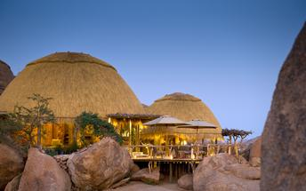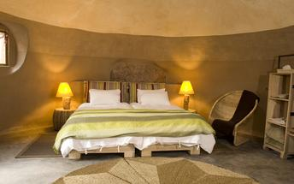

Basis
Full Board Plus - Dinner, Bed, Breakfast, Lunch and Activities

Day 5-7: Mushara Bush Camp, Etosha East

Etosha East
On the eastern edge of Etosha National Park, the park itself is bordered by numerous private reserves and access into the park is via the Von Lindequist Gate, named after Dr. Friedrich von Lindequist who proclaimed it a game reserve in March 1907. This side of the park is characterised by flat endless plains, tree-savanna type of vegetation and fantastic waterholes, where you could easily spot any of the prolific wildlife Etosha is known for. There's an abundance of wildlife here.

Day Itinerary
Flight: Damaraland – Etosha 1 hour & 15 minutes
- Road transfer to airstrip for departure flight
- Private charter flight from Damaraland to Etosha National Park (east)
- Road transfer to the lodge on arrival
- Includes: Dinner, bed and breakfast; 4 x game drives in Etosha National Park
- Etosha is one of Africa's great game parks. With 114 species of mammal and 340 species of birds you are sure to see a great variety of wildlife on your safari

Overnight: Mushara Bush Camp View iBrochure
Mushara Bush Camp is a luxury family-focused safari lodge in a private reserve on the eastern edge of Etosha National Park.
With an emphasis on family fun, Mushara Bush Camp is the newest addition to the impressive Mushara collection of safari lodges located in a private reserve 10km from the eastern gate of Etosha National Park.
Accommodation consists of 16 luxurious tented suites, four of which have additional beds to accommodate children. With plenty of privacy, large canvas doors and windows, en suite bathrooms and a private outside seating area, the chalets are pure bush luxury.
The main living area is a delightful thatch and wood structure with an inviting fire setting the mood from sunset onwards. A pool is an essential item in the hot African bush and the cool interior of the thatched house offers a memorable dining experience with the stars and sounds of the night all around you.
Children are especially well catered for with professional child minders, special meals, early dinner, a play area with a jungle gym, tractor and kiddie’s pool.
Game drives into Etosha Park are led by experienced guides in custom-built safari vehicles. Game viewing in Etosha is exceptional with waterholes surrounding the large shimmering pan and plenty of big game including rhino, elephants, lions, cheetahs and a host of large antelope, birds and smaller fascinating creatures.
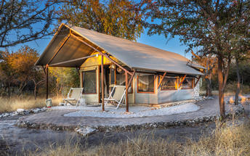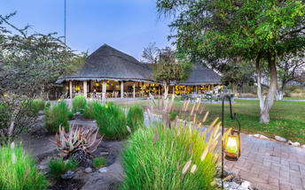

Basis
Half Board Plus - Dinner, Bed, Breakfast and Activities

Day 7: End of Itinerary

Day Itinerary
Flight: Etosha – Windhoek 1 hour & 40 minutes
- After your morning activity as included, you will road transfer to the airstrip for your departure flight.
- Private charter flight from Etosha to Windhoek International Airport. Keeping in mind that you need to be at the airport 2 hours prior to your international departure flight time.
- End of services

Basis
Bed and Breakfast

Transport

Flight Information
Date | Flight | Airline | Departure Airport | Time | Arrival Airport | Time | Class | Ref
 | Private Charter |  | Hosea Kutako International Airport [WDH] |  | Sossusvlei Airstrip
 | Private Charter |  | Sossusvlei Airstrip |  | Swakopmund Airport [SWP]
 | Private Charter |  | Swakopmund Airport [SWP] |  | Twyfelfontein Airstrip
 | Private Charter |  | Twyfelfontein Airstrip |  | Mokuti Lodge Airport [OKU]
 | Private Charter |  | Mokuti Lodge Airport [OKU] |  | Hosea Kutako International Airport [WDH]

Transfers
Date | Company | Pick Up | Drop Off | Time | Vehicle
 |  | Sossusvlei Airstrip | Desert Homestead Lodge |  | Transfer
 |  | Desert Homestead Lodge | Sossusvlei Airstrip |  | Transfer
 |  | Twyfelfontein Airstrip | Camp Kipwe |  | Transfer
 |  | Camp Kipwe | Twyfelfontein Airstrip |  | Transfer
 |  | Mokuti Lodge Airport [OKU] | Mushara Bush Camp |  | Transfer
 |  | Mushara Bush Camp | Mokuti Lodge Airport [OKU] |  | Transfer

Urgent Contact Numbers
Company Name | Telephone | Email Address | Contact Person
Namibia Tours & Safaris | +264 64 40 6038 | tanya@namibia-tours-safaris.com | Tanya Coetzee
Namibia Tours & Safaris - Emergency Contact | +264 81 784 4315

Service Provider Directory
Service Provider | Ref. Number | Telephone | Address
Camp Kipwe |  | +264 81 122 2072 | Camp KipweTwyfelfontein9000
Desert Homestead Lodge |  | +264-63-293-301 | C19, 3km to the crossing to D 854Farm WitwaterSesriem / Sossusvlei9000
Mushara Bush Camp |  | +264 61 24 1880 | Along C38, 8km infront of Von Lindequist GateP.O. Box 1814, Tsumeb, NamibiaEtosha National Park9000

Terms and Conditions

Namibia Tours & Safaris Terms and Conditions
Contract
1.1 The contract will become effective as from the date the invoice is completed and the deposit, referred to in Clause 2.1, is received by Africa Tours & Safaris CC (hereinafter known as the Company).
1.2 The contract is subject to the Namibian Law.
1.3 Any person making a reservation as per Clause 8.4 accepts the terms and conditions of this agreement set out hereunder.
How to Book
2.1 A 20% deposit of the full amount due is required to confirm any reservation and is to be done by the agent or client (see Clause 8.1) in writing or by e-mail.
2.2 The Company must receive the balance of the contract price no later than 42 days (6 weeks) prior to departure.
2.3 If the Company does not receive the full contract price 42 days (6 weeks) before the departure date, the Company may cancel the reservation and retain whatever deposit or other funds it has already received from the client or his agent.
How to Pay
3 The payment options will be provided upon confirmation of a booking.
Our Cancellation Policy
4.1 Any cancellation of a confirmed booking must be done in writing (email) to the Company whereupon cancellation charges as per Clause 4.2 will apply.
4.2 The following cancellation fees (as a percentage of the fully quoted price) are applicable to any cancelled travel:
Notice from date of travel: Cancellation fee:
42 days or more 20% (deposit forfeited)
29 – 41 days 50%
15 – 28 days 75%
0 – 14 days 100%
Please note: the notice period is calculated from the date of cancellation to the start date of the tour/safari booking.
4.3 No refund will be made by the Company if, for any reason, inclusions or parts of the tour cannot be carried out / or utilised. These would include all facets such as meals, game drives, accommodation etc. This would also apply to any client who has booked a tour but fails to undertake the tour for any reason.
Our Changes Policy
5 If a booking is changed to an earlier date than originally reserved, the Company will endeavour to change it. If the booking is for a later date, charges as per Clause 4.2 could apply.
As things go, we've all had to adapt to changes during the Coronavirus pandemic and so too have we therefore amended our terms and conditions for travel during such times. Check out the Updated COVID Terms and Conditions here.
Price Changes
6.1 The Company reserves the right to increase the price of any tour prior to departure due to factors beyond the control of the Company, such as, without being limited to, and increase in fuel prices, new Government legislation, accommodation price increases, fluctuations in exchange rates, etc.
6.2 If the Company announces an in increase in the tour price in terms of this Clause, such addition amount must be paid to the Company before the departure of such tour or else the Company shall have the right to cancel the tour and the charges in Clause 4.2 will apply.
Changes to Itineraries
7 The Company shall at any time have the right, in its entire discretion, to alter the terms of the booking in relation to the route, timetable, itinerary and accommodation. The Company shall, however, make every effort to offer the client an alternative tour of a comparable standard.
Should the alternative be of a lesser standard, the client will be refunded the difference, but should there be an increase, the client shall have the right to either reject the alternative and obtain a refund of the relevant portion of the original contract sum, or to accept the alternative and pay the increased cost. In the event of the client rejecting the alternative tour and claiming a refund, such rejection will be treated as a cancellation and the refund will be calculated according to Clause 4.2 hereof. The client shall have no claim against the Company for any damages arising out of the alternative booking.
Responsibility and Liability
8.1 Neither the Company nor any person acting for through and on behalf of the Company shall be liable for any loss or damage whatsoever arising from any cause whatsoever and without restricting the generality of the aforegoing shall particularly not be responsible for the loss or damage arising from any errors or omissions contained in its brochure or other literature, late or non-confirmation or acceptance or bookings, loss or damage caused by delays, sickness, injury or death, whether occasioned by negligence or not.
8.2 The Company shall have the right at any time at is sole discretion, to cancel or the remainder thereof or to make an alteration in the route, accommodation price or other details. This would include any event of any tour being rendered impossible, illegal or inadvisable by weather, avalanches, strike, war, government or other interference or due to any other cause whatsoever. The extra expenses incurred as a result thereof shall be the responsibility of the client.
8.3 The Company may at its discretion and without liability or cost to itself at any time cancel, or terminate, a client's booking and in particular, without limiting the generality of the aforegoing, it shall be entitled to do so in the event of illness or the illegal or incompatible behaviour of any client undertaking the tour, who shall in such circumstances not be entitled to any refund.
8.4 Any person making a reservation with the Company (refer to Clause 1.1) warrants that her or she has the necessary authority to enter into this contract on behalf of the person or persons included in such a booking. The person making the reservation shall be liable for the total amount due to the Company.
Client's Obligations
9.1 It is the onus and responsibility of the client to obtain the necessary comprehensive insurance before departure for any possible cancellations, medical expenses, protection or personal property and money.
9.2 The onus is upon the client to ensure that passports and visas are valid for the duration of the safari. The Company cannot be held liable for any necessary visas or other travel documents not held by clients. In the event of a client not having the necessary documentation to enter any area or country the Company shall reserve the right to leave the client a the point of entry of such area or country. In such an event, the Company will not be held responsible to the client for further travel arrangements.
9.3 The onus is upon the client to ensure that the SARS-CoV-2 PCR tests are done prior to commencement of the safari and valid on arrival in accordance to the requirements of the country of intended travel and for the airline with which the client will travel. The same applies for any necessary testing for departure. The costs of any such COVID testing will be for the clients own account. While The Company can assist with arrangements for testing in-country, The Company will not be held responsible to the client for such arrangements and with regards to return time of test results.
9.4 Should the client need to undergo mandatory quarantine once in-country with regards to the SARS-CoV-2 virus, either on arrival as called for by the authorities or due to testing positive once in-country, this will be at the clients own expense.
Health and Personal Safety
10.1 The client shall be reasonably fit to undertake the tour.
10.2 Anti-malaria precautions should be commenced prior to tour departure. A medical doctor should be consulted for advice.
10.3 Tours offered by the Company cover a wide spectrum of the African wilds and neither the Company, its employees or agents can be held responsible for any injury or other related incidents whilst on the tour / safari.
10.4 The Company cannot be held responsible for any client who falls ill or contracts the SARS-CoV-2 virus while in-country. The client accepts that travel is at own risk.
Baggage
11.1 Clients are limited to one soft sports type bag per person with a maximum weight of 20 kilograms. This includes photographic equipment and hand luggage.
11.2 Due to the rugged terrain, the Company cannot be held responsible for damage or loss of any personal items including bags, contents of bags or photographic and related equipment. Due to extremely dusty conditions, please ensure all bags are dust proof.
Airline and Car Hire Clause
12.1 The Company will act as the agent of the client when booking the client with a car hire company, an airline or air charter service. The client therefore contracts with the car hire company, airline or charter service and not with the Company.
12.2 Charter flights are normally operated by smaller type aircraft such as Cessna 210. Luggage is strictly limited to 10-15 kgs (depending on terms of particular airline used) per person in soft hold all type bags. Due to the desert heat, it is not safe to overload aircraft thus this limit needs to be strictly controlled.
Travelling or thinking of travelling during the COVID-19 pandemic? Take a look at our COVID Terms and Conditions for more information on how this will work and differ from our standard terms and conditions as listed above.

