

# Debbie Sawin - 2018

*Windhoek - Gochas - Green Kalahari - Augrabies Falls National Park - Orange River - Fish River Canyon - Aus - Luderitz - NamibRand Nature Reserve - Southern Namibia - Mariental*  
*27 Days / 26 Nights*  
*2 Persons*  
*Reference: Sawin 2018*  
*Date of Issue: 18 January 2018*  
**18 February 2018 - 16 March 2018**

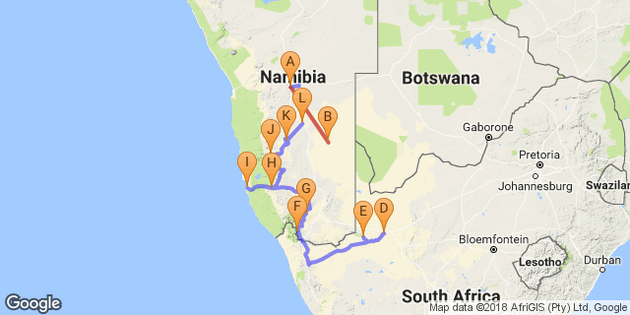

# [Click here to view your Digital Itinerary](http://wetu.com/Itinerary/Landing/90266A89-9786-D26B-C958-0FF9D00E9E9E)

## Overview

|  |  |  |  |  |  |  |
| --- | --- | --- | --- | --- | --- | --- |
| **Accommodation** | **Destination** | **Arr.** | **Dep.** | **Nights** | **Basis** | **Room Type** |
| [Hilltop Guest House](http://wetu.com/iBrochure/1617_21617) | Windhoek | 18 Feb | 19 Feb | 1 | B&B | 1x Deluxe Double |
| [Auob Country Lodge](http://wetu.com/iBrochure/1617_10514) | Gochas | 19 Feb | 20 Feb | 1 | D, B&B | 1x Double Room |
| Own Arrangement |  | 20 Feb | 2 Mar | 10 |  |  |
| River Place Manor | Green Kalahari | 2 Mar | 4 Mar | 2 | B&B | 1x Deluxe River Facing Room |
| Augrabies Falls Rest Camp | Augrabies Falls National Park | 4 Mar | 5 Mar | 1 |  |  |
| Norotshama River Resort | Orange River | 5 Mar | 7 Mar | 2 | B&B | 1x Rivers Edge Room |
| [Canyon Lodge Gondwana Collection Namibia](http://wetu.com/iBrochure/1617_1704) | Fish River Canyon | 7 Mar | 8 Mar | 1 | D, B&B | 1x Double Room |
| [Klein-Aus Vista Eagle's Nest Chalets Gondwana Collection Namibia](http://wetu.com/iBrochure/1617_34713) | Aus | 8 Mar | 10 Mar | 2 | B&B | 1x Eagles View Room |
| Kairos Cottage B&B and Coffee Shop | Luderitz | 10 Mar | 12 Mar | 2 | B&B | 1x Double Room |
| Greenfire Desert Lodge | NamibRand Nature Reserve | 12 Mar | 14 Mar | 2 | FB+ | 1x Double Room |
| Namseb Game Lodge | Southern Namibia | 14 Mar | 15 Mar | 1 | D, B&B | 1x Double Room |
| [Teufelskrallen Tented Lodge](http://wetu.com/iBrochure/1617_46547) | Mariental | 15 Mar | 16 Mar | 1 | D, B&B | 1x Double/Twin Tent |

**Key**  
SC: Self Catering  
B&B: Bed and breakfast  
D, B&B: Dinner, bed and breakfast  
FB+: Dinner, bed, breakfast, lunch and activities daily

## Price

ZAR 68,350  
(ZAR 34,175 per person)

## Day 1: Hilltop Guest House, Windhoek (Sun, 18 February)

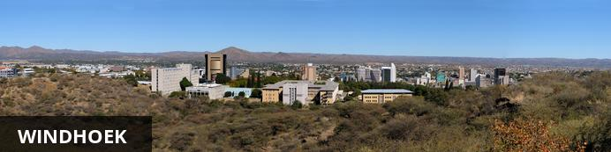

Situated in Central Namibia, the cosmopolitan city of Windhoek serves as the capital of the country. It is home to an international airport and a plethora of restaurants, shops, entertainment venues and accommodation options. The city is clean, safe and well-organised, with a colonial legacy that is reflected in its many German eateries and shops, and the widespread use of the German language. Windhoek has an interesting mix of historical architecture and modern buildings, many of which are worth a look, including the Alte Feste an old fort, the 1896 Christuskirche Christ Church, and the more contemporary Supreme Court.

### Day Itinerary

You will arrive at Windhoek Hosea Kutako International Airport where you will be met by our car hire representative.  
They will transfer you to the vehicle hire depot where the vehicle handover will take place. You will receive your Tracks 4 Africa highlighted route map and your information pack containing copies of your lodge and activity vouchers, directions from location to location with points of interest noted along the route, and other useful information.

You have the day at leisure in Windhoek.  
We can arrange guided sightseeing if required

### Overnight: Hilltop Guest House [View iBrochure](http://wetu.com/iBrochure/1617_21617)

Beautiful views abound, this 7 en suite bedroom guesthouse offer a modern rural feel with the African undertone. Secure on site parking available. Free wireless internet access available.   
he Hilltop Guest House in Windhoek, offers bed and breakfast accommodation within a warm and relaxed atmosphere where you will feel right at home.

We are centrally located in a quiet cul-de-sac on top of a hill in Klein Windhoek with a magnificent view of Windhoek and surrounding mountains. At night time this become a wonderland of light and color. We are also close to city center and some restaurants. Transfers to and from the airport can be arranged.

We can accommodate families with children.

We offer 7 elegant en-suite rooms consisting of 3 Luxury rooms and 4 Standard rooms. All rooms are air conditioned and have DSTV and free WiFi.

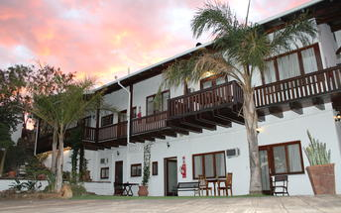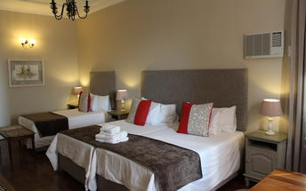

### Included

Bed & Breakfast

## Day 2: Auob Country Lodge, Gochas (Mon, 19 February)

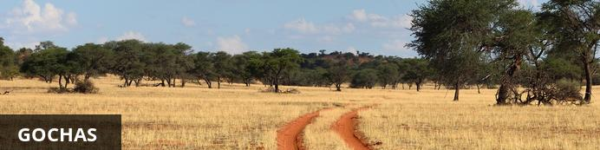

Located in the Hardap region of Namibia, Gochas is a secluded village known for its remarkable surrounding desert landscape. This picturesque retreat is set amidst the rolling red dunes of the Kalahari. It is said to be the smallest town in all of Namibia with just a few shops and limited accommodation options. Visitors can enjoy a variety of adventure activities including: thrilling 4x4 excursions, cycling, hiking and wildlife viewing.

### Overnight: Auob Country Lodge [View iBrochure](http://wetu.com/iBrochure/1617_10514)

Welcome to the magnificent and unspoiled Kalahari. Off the beaten track and away from crowded masses you will find the Kalahari being one of Namibia’s undiscovered jewels. An area so unique and diverse that words cannot describe it, only your own experience will let you grasp something of unique value-a memory, a story, a real treasure-its true value only known to you,… an indescribable moment in time you will cherish for life and will let you return for more.

Amid the iconic red sand dunes and dry river bed, Auob Country Lodge rewards your journey with a warm welcome and homely atmosphere. Relax the way you want, walk the dunes, watch the stars, breath the air, sing with the birds, feel the wind, dance in the rain and watch the sunset. You’ll arrive as guest and leave as family. Be prepared, a new chapter in life has just begun.

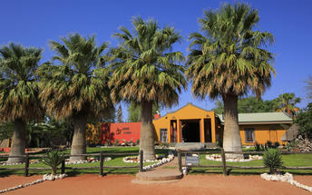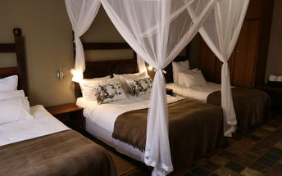

#### Double Room

The lodge offers 25 beautifully appointed rooms of various layout and sleeping arrangements. Whether travelling alone, as a group, or extended family, our Twin, Double and Family Rooms can accommodate your required sleeping needs. All rooms are air conditioned with en-suite bathrooms and mosquito nets.

Decorated with charming rustic furnishings, our double room boasts a lovely king-sized bed, sitting nook and make-up corner. The ideal hideout for those on a romantic journey…

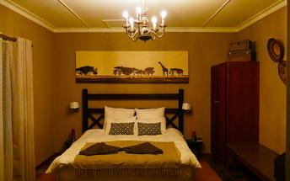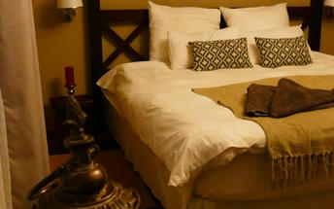

### Included

Dinner, Bed and Breakfast

## Day 3: Own Arrangement (Tue, 20 February)

### Overnight: Own Arrangement

## Day 4: Own Arrangement (Wed, 21 February)

## Day 5: Own Arrangement (Thu, 22 February)

## Day 6: Own Arrangement (Fri, 23 February)

## Day 7: Own Arrangement (Sat, 24 February)

## Day 8: Own Arrangement (Sun, 25 February)

## Day 9: Own Arrangement (Mon, 26 February)

## Day 10: Own Arrangement (Tue, 27 February)

## Day 11: Own Arrangement (Wed, 28 February)

## Day 12: Own Arrangement (Thu, 1 March)

## Day 13: River Place Manor, Green Kalahari (Fri, 2 March)

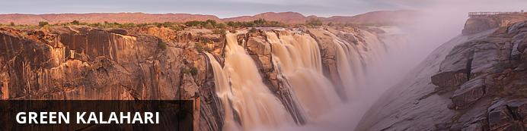

Dissected by the mighty Orange River, the Green Kalahari is a lush oasis in the larger Kalahari Desert. The river brings welcome water to this semi-arid region creating fertile valleys covered in thriving farmlands. Visitors can enjoy some wonderful attractions including: the popular wine route, the mighty Augrabies Falls in the Augrabies Falls National Park, and the massive Kgalagadi Transfrontier Park, home to an array of wildlife including springbok, gemsbok, wildebeest, red hartebeest, eland, leopard, cheetah and lion. Explore the ruins of an ancient San village on the Bitterputs farm in the Verneuk Pan, discover numerous fascinating cave drawings and engravings and enjoy a variety adventure activities including: camel safaris, white water rafting, hiking, bird watching, camping, canoeing, mountain biking, and game drives.

### Day Itinerary

Drive down from Kieliekrankie to River Place Manor.

I love this particular Guesthouse as it has a great spot on the river, the staff are amazing and also they can organise onsite some fab trips including canoeing on the River, wine tasting at local vineyards, river cruises and birdwatching, so I think you will like it here.

### Overnight: River Place Manor

Experience the true magnificence of the mighty Orange River right on your doorstep. Spectacular sunsets, whispers of flowing water and star-filled African skies offer an ambience of unequalled peace and tranquillity. River Place Manor is situated on one of Upington’s wine estates, yet it lies only three minutes from the Upington town centre.

This exclusive guest house offers luxury accommodation in Upington with individually-styled en-suite rooms which will meet a guest’s every need. The staff are friendly and always make every effort to please. There are 10 tastefully decorated rooms/family rooms and one family suite. All of which have kitchenettes that allow for self-catering. A bed and breakfast option is available for those who would prefer to enjoy the guest house’s sumptuous continental and English breakfast, served on the river facing patio or in the dining room.

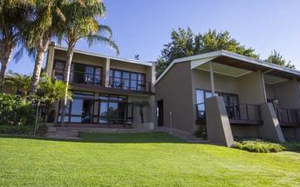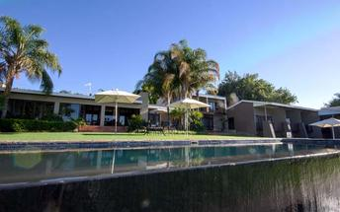

### Included

Bed & Breakfast

## Day 14: River Place Manor, Green Kalahari (Sat, 3 March)

### Included

Bed & Breakfast

## Day 15: Augrabies Falls Rest Camp, Augrabies Falls National Park (Sun, 4 March)

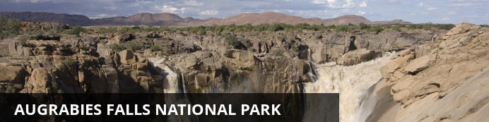

Located in South Africa’s Northern Cape Province, the Augrabies Falls National Park encircles the mighty Augrabies Falls. The Orange River plunges 60 metres and creates this cascading splendour which leads into the 18-kilometre ravine of the Orange River Gorge. The landscape of the park is characterised by rocky outcrops jutting from scrub-dotted plains scattered with clusters of kokerboom also known as quiver trees. This sanctuary provides a home for an array of wildlife such as springbok, gemsbok, klipspringer, various bird species and the endangered black rhino. Other commonly spotted wildlife include: giraffe, steenbok, kudu, eland, leopard, African wild cat, jackal, and caracal.

### Day Itinerary

Break the journey to Namibia at Augrabies National Park.

1 night is enough really.

### Overnight: Augrabies Falls Rest Camp

The Augrabies Falls Rest Camp is set in beautiful surroundings and offers warm hospitality. The rest camp is large and well organised, offering accommodations inside Augrabies Falls National Park. It provides an excellent base from which to explore the lovely northern Cape park.

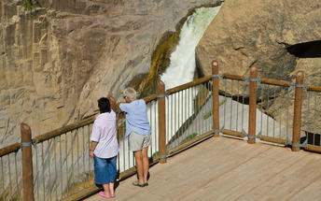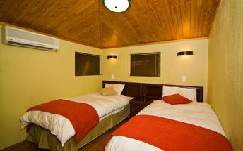

### Included

Self Catering

## Day 16: Norotshama River Resort, Orange River (Mon, 5 March)

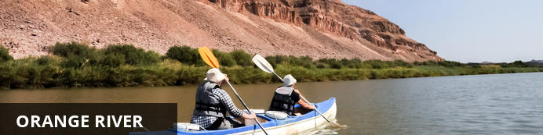

Rising from the beautiful Drakensberg Mountains in Lesotho, forming part of the international border between South Africa and Namibia, the Orange River is the longest river in South Africa. The Orange River Basin extends into Namibia and northern Botswana. The river snakes its way through one of Southern Africa’s harshest environments bringing life to an area of sheer rugged beauty. Aside from vineyards in the desert the river also creates a mobile playground from which to explore the area. This spectacular river created the diamond dune fields along Namibia's coast, by washing diamonds downstream from the Kimberly region over millions of years. Visitors can look forward to excellent whitewater rafting, canoeing, kayaking, and wonderful river cruises.

### Day Itinerary

drive through the Northern Cape and cross into Namibia at Noerdoewer.

You can do a full or half day canoe trip.

### Overnight: Norotshama River Resort

This malaria-free retreat is framed by Namibia's breathtaking natural landscape on the banks of the Orange River. Be sure to pack your camera as the route will expose you to stark contrasts of sky, water and sand unlike anything you have witnessed before. Not only will the landscape leave you breathless, but you may well come across the indigenous wild Namib horses that roam this untamed wilderness. To complete a truly memorable day, stop off at the A La Carte Restaurant and indulge in a candle-lit dinner while soaking in a larger-than-life sunset. At Norotshama River Resort there is a choice of luxury thatched chalets or floating bungalows. Riverside camping sites equipped with individual barbeques, electricity and ablution facilities are available. Norotshama Resort is located inside a private reserve, known as Aussenkehr Nature Park. You can experience the many unique features of the Park by making enquiries at Norotshama reception.  
Activities at Norotshama River Resort include:  
• Excursions to local canyons, wild Namib horses and Nature Park  
• Canoeing  
• Fishing and Fly Fishing  
• Bird Watching  
• Hiking  
• Sport Rock Climbing of various grades  
• Swimming.

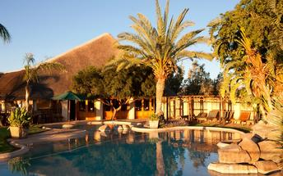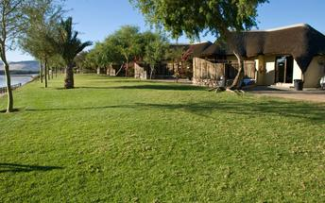

### Included

Bed & Breakfast

## Day 17: Norotshama River Resort, Orange River (Tue, 6 March)

### Included

Bed & Breakfast

## Day 18: Canyon Lodge Gondwana Collection Namibia, Fish River Canyon (Wed, 7 March)

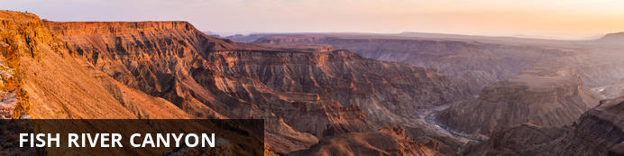

Carving out an epic rocky wonderland in the south of Namibia, the Fish River has created Africa’s largest and the world’s second largest canyon. Hot, dry and stony, the Fish River Canyon measures a whopping 160 kilometres in length, at times 27 kilometres in width and 550 metres in depth. The awe-inspiring natural beauty of this ancient geological marvel draws visitors from around the globe. For those looking for adventure, the intense 85 kilometre Fish River Hiking Trail through1.5 billion years of geological history will definitely thrill avid adventure enthusiasts, and for visitors looking to relax, head over to the canyon's southern end to enjoy a soak in the mineral waters of the renowned hot springs of Ai-Ais, or take in the spectacularly scenic views from Hobas Restcamp as well as numerous other viewpoints along its rim. Other popular activities include: scenic chartered flights, horse riding, nature drives and seasonal kayaking.

### Day Itinerary

Head over to the eastern side of the Canyon and overnight at Canyon Lodge.

### Overnight: Canyon Lodge Gondwana Collection Namibia [View iBrochure](http://wetu.com/iBrochure/1617_1704)

Canyon Lodge is located 20 km east of the Fish River Canyon on the C 37.  
A gem in the rugged environment, Canyon Lodge is a fusion of farmhouse flavour and natural splendour. Walkways lead to 30 natural stone chalets nestled amongst granite boulders. Celebrate dawn amongst the quiver trees and the aweinspiring adventure of life from the rim of the Fish River Canyon.

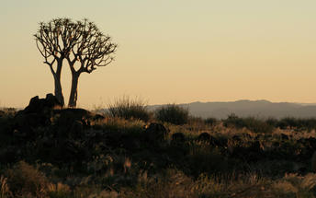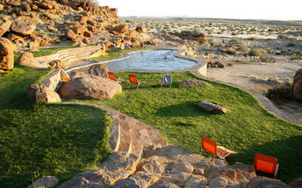

### Included

Dinner, Bed and Breakfast

## Day 19: Klein-Aus Vista Eagle's Nest Chalets Gondwana Collection Namibia, Aus (Thu, 8 March)

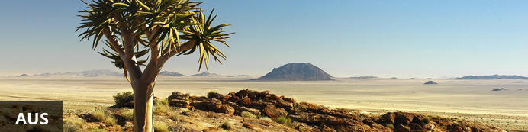

Perched above the plains of the Namib Desert and tucked away in the rocky Aus Mountains, the small village of Aus is located in the ǁKaras Region in southern Namibia. The arid surrounding landscape is known for its unique botanical diversity. Aus serves as an excellent base from which to explore the area and to view the main attraction: the feral horses of the Namib Desert, which run wild and free in the sparsely vegetated plains. Catch a glimpse of these wild desert-adapted creatures at the water trough at Garub just twenty kilometres away from the village. Visitors can explore the Succulent Karoo with a visit to the beautiful Gondwana Sperrgebiet Rand Park, home to the most biodiverse desert in the world, and take a scenic hike to discover fascinating indigenous fauna and flora. Don't miss the opportunity to camp under the clear Namibian night sky and view the vast desert landscape on horseback.

### Day Itinerary

2 nights at Eagle's Nest as requested :)

### Overnight: Klein-Aus Vista Eagle's Nest Chalets Gondwana Collection Namibia [View iBrochure](http://wetu.com/iBrochure/1617_34713)

Eagle's Nest Chalets are located 2 km west of Aus on the B 4 (Aus / Wild Horses).  
Forever landscapes, solitude, silence and sunsets. Klein Aus Vista’s Eagle Nest is a self-catering getaway with eight individually-built rock chalets. Keep to yourself or drive to Desert Horse Inn’s restaurant for delicious fare and congenial company. Return to dream of peace and wake to magnificent sunrise scenery.

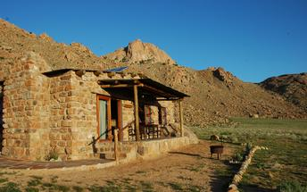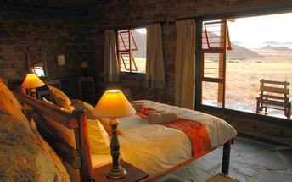

### Included

Bed & Breakfast

## Day 20: Klein-Aus Vista Eagle's Nest Chalets Gondwana Collection Namibia, Aus (Fri, 9 March)

### Included

Bed & Breakfast

## Day 21: Kairos Cottage B&B and Coffee Shop, Luderitz (Sat, 10 March)

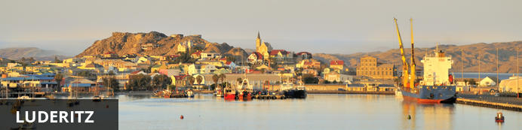

Sandwiched between the rugged and stark Atlantic Coast and the arid Namib Desert, the town of Luderitz is set in an incredibly unique geographical setting. This seaside town is something of an anomaly frozen in time – a piece of 19th-century Bavaria bordering the pinkish sand dunes of the Namib Desert. Lutheran churches, German bakeries, and colonial buildings boasting German art nouveau architecture are dotted about the settlement, while its windswept beaches are home to flamingos, ostriches, seals and penguins. The nearby ghost town of Kolmanskop, which has been taken over by the desert dunes, is one of the most fascinating area attractions, located approximately 10 kilometres from Luderitz central. Visitors can also take a trip to discover the wild desert-adapted horses located near the small town of Aus.

### Day Itinerary

This bed and breakfast is cheap as chips but really fabulous!!!

### Overnight: Kairos Cottage B&B and Coffee Shop

Kairos Cottage is a unique bed and breakfast accommodation boasting stunning sea views! Our guests can enjoy a lovely breakfast from our menu while being serenaded with a song or two. We offer five rooms, each with its own en-suite bathroom with a shower and spectacular sea views and sunsets. Good quality linen and towels are provided, and each room also has a television and coffee station with a bar fridge. At Kairos Cottage, you will experience a supreme moment that you will never forget!

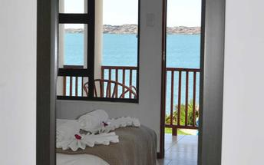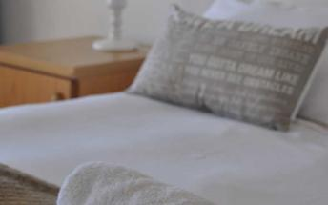

### Included

Bed & Breakfast

## Day 22: Kairos Cottage B&B and Coffee Shop, Luderitz (Sun, 11 March)

### Activities

Coastway Safaris Pomona/Bogenfels Tour

#### Coastway Safaris Pomona/Bogenfels Tour

Bogenfels is a famous rock arch that is about 60m high, standing with one foot in the sea and the other on land.   
The Pomona/Bogenfels Tour is a day tour in the Sperrgebiet area where De Beers are still mining. The tour includes the old ghost towns of Pomona and Bogenfels where visitors will see old mining equipment from the 1910-30's when the Germans discovered the first diamonds in the area.

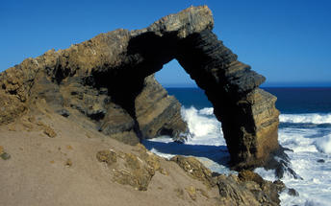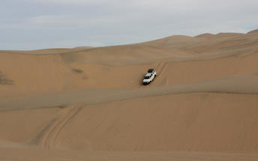

### Included

Bed & Breakfast

## Day 23: Greenfire Desert Lodge, NamibRand Nature Reserve (Mon, 12 March)

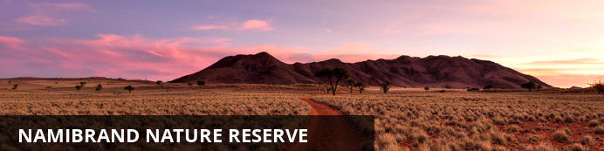

Spanning an area of 172,200 hectares and encompassing four distinct ecosystems, the Namib Rand Reserve is among the largest privately owned game parks in Southern Africa. Founded to conserve the unique environment and wildlife species of the south-western Namib Desert, the park’s mix of dunes, mountains, rocky outcrops, sandy flats and gravel plains provides habitats for a diversity of mammals – including hyenas, jackals, foxes, antelopes and various wild cats – as well as a plethora of bird species, reptiles, insects, frogs and flora. Visitors can discover the mysterious ‘fairy circles’, which dot the landscape and sip on sundowners while watching the sunset over this unspoilt ancient landscape. Having been named Africa’s first International Dark Sky Reserve, it is one of the least light-polluted areas in the world, so don't miss this excellent star gazing opportunity.

### Day Itinerary

Full board and activities included at Greenfire :)

### Overnight: Greenfire Desert Lodge

Greenfire Desert Lodge is situated on a private 20000 hectare wilderness reserve, within the Namibrand Nature Reserve. The lodge offers a game viewing experience as well as comfortable accommodations, while also providing a convenient stopover between the Sossusvlei Dunes and the attractions of Fish River Canyon and Luderitz.  
The lodge features six spacious, comfortably appointed en suite rooms, as well as a generous central lounge and dining area, all built of local stone to ensure warmth in winter and cool in summer. All rooms have a splendid west facing view of the surrounding desert. A terrace and sparkling swimming pool complete the package.

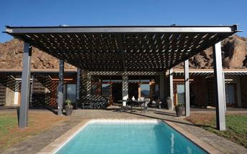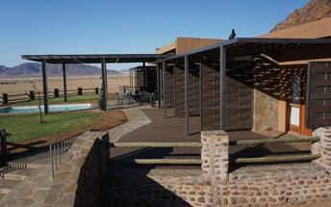

### Included

Full Board and Activities

## Day 24: Greenfire Desert Lodge, NamibRand Nature Reserve (Tue, 13 March)

### Included

Full Board and Activities

## Day 25: Namseb Game Lodge, Southern Namibia (Wed, 14 March)

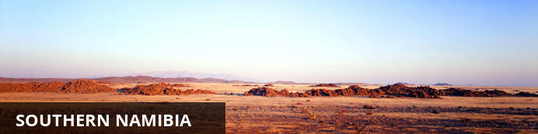

Southern Namibia offers a harsh but beautiful environment stretching from the Orange River up to the Central Namibian highlands, Southern Namibia is epitomised by vast, slowly changing landscapes. The breathtakingly beautiful landscape features the Naukluft mountains, Namib desert dunes, and the Fish River Canyon. Southern Namibia is dotted with quiver trees, covered in golden grasslands, and crowned with burnt red dunes fringed by blue sky-lines. A spectacular array of wildlife roams freely including klipspringer, oryx and kudu. Visitors can soak up the breathtaking views of the Fish River Canyon, discover the wild desert horses near Aus, and explore the famous ghost town of Kolmanskop. Don't miss the ancient ochre dunes of Sossusvlei.

### Day Itinerary

Never tried this spot so you would be my guinea pigs ;-)

### Overnight: Namseb Game Lodge

Situated at the top of the Namseb Plateau and nestled among the golden grass of the African savannah, Namseb Lodge offers guests a welcome retreat from the hustle and bustle of the city. It is perfect for nature lovers looking for a rural and undisturbed getaway.  
Guests can choose between bed and breakfast, and self-catering accommodation. The 16 en-suite guest rooms and the guest cottage are built completely of rock while the neutral colours and earth tones in the design add to the rustic charm of the lodge.  
A delicious buffet breakfast is served daily and the variety of dishes will cater to every palate. A light lunch and a three-course dinner is provided at an additional cost. Traditional braais and potjies are available on request and can be enjoyed on the grassy plains while appreciating the beautiful African sunset.  
Guests can spend lazy afternoons relaxing beside the swimming pool while enjoying nature. Sundowner game drives provide exclusive game-viewing opportunities, while hiking trails are ideal for a chance encounter with a kudu or a giraffe. The lodge is the perfect base to explore the area from with Fish River Canyon, the Sossusvlei and the Kalahari just a drive away.

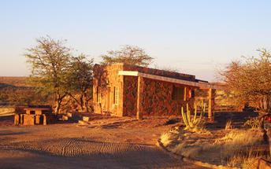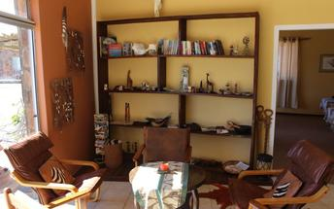

### Included

Dinner, Bed and Breakfast

## Day 26: Teufelskrallen Tented Lodge, Mariental (Thu, 15 March)

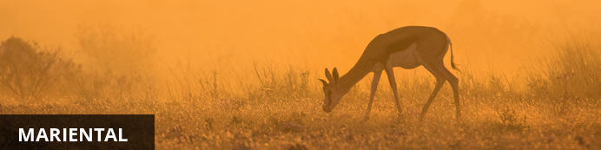

### Overnight: Teufelskrallen Tented Lodge [View iBrochure](http://wetu.com/iBrochure/1617_46547)

The large observation platforms of the 6 luxury tents on stilts offer a breathtaking view towards the impressive Kalahari scenery with its red dunes and camel thorn trees. The tents are large and comfortable, tastefully furnished and possess their own bathrooms that can be reached via a wooden boardwalk. Each tent is equipped with a fridge.  
The lodge has a swimming pool and a restaurant - “ALTES FARMHAUS”, as well as the lobby with free-of-charge internet access are located in an old farm house 3 km from the site, in the middle of an oasis-like garden with lots of shady spots. Enjoy breakfast and dinner in the old farm house. Relax at the pool in the tropical gardens or order a cool drink and find a shady spot underneath mighty trees.  
Enjoy almost 10,000 acres of pure Kalahari desert during a game drive. Climb red dunes that elevate up to 30 meters in an open off-road car and watch the spectacular animals and vegetation.

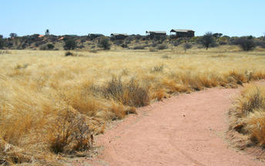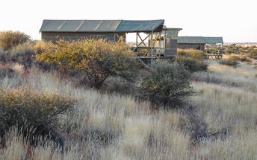

#### Double/Twin Tent

Double or twin beds.

### Included

Dinner, Bed and Breakfast

## Day 27: Departure (Fri, 16 March)

### Day Itinerary

Back to Windhoek.

# Transport

## Flight Information

|  |  |  |  |  |  |  |  |  |
| --- | --- | --- | --- | --- | --- | --- | --- | --- |
| **Date** | **Flight** | **Airline** | **Departure Airport** | **Time** | **Arrival Airport** | **Time** | **Class** | **Ref** |
| 19 Feb | Scheduled |  | Hilltop Guest House |  | Auob Country Lodge |  |  |  |

### Urgent Contact Numbers

|  |  |  |  |
| --- | --- | --- | --- |
| **Company Name** | **Telephone** | **Email Address** | **Contact Person** |
| Discover Namibia Safaris | +27 (0) 28 312 3133 | tours@discover-namibia-safari.net | Gemma Dry |

### Contact Details & Reference Numbers

|  |  |  |  |
| --- | --- | --- | --- |
| **Service Provider** | **Ref. Number** | **Telephone** | **Address** |
| Auob Country Lodge |  | +264 61 37 4750 | Situated only 6km north of Gochas on the C15 Road. |
| Canyon Lodge Gondwana Collection Namibia |  | +264 61 230066 | Canyon Lodge  Fish River Canyon  Keetmanshoop Region |
| Greenfire Desert Lodge |  | +27 11 888 1160 |  |
| Hilltop Guest House |  | +264 81 245 2750 | 12 Lessing Street,  Windhoek |
| Kairos Cottage B&B and Coffee Shop |  | +264 63 20 3080 |  |
| Klein-Aus Vista Eagle's Nest Chalets Gondwana Collection Namibia |  | +264 (0)63 258021 / 258116 | Gondwana Sperrgebiet Rand Park,  2km west of Aus,  on the B4 main road to Luderitz.  Namibia. |
| Namseb Game Lodge |  | +264 81 325 4790 | Farm Namseb  Maltahöhe |
| Norotshama River Resort |  | +264 63 297 215 |  |
| River Place Manor |  | +27 54 332 3102 |  |
| Teufelskrallen Tented Lodge |  | +264 63 26 4003 | P.O. Box 113,  Kalkrand,  Namibia |

## Travel Information

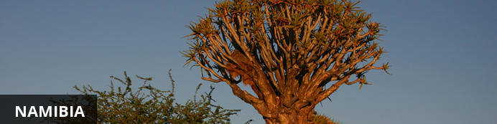

Located in southwestern Africa, Namibia boasts a well-developed infrastructure, some of the best tourist facilities in Africa, and an impressive list of breathtaking natural wonders. Visitors can explore the capital of Windhoek and discover the lovely coastal town of Swakopmund boasting remnants of the country’s German influence, reflected in the architecture, culture, cuisine and the annual Oktoberfest celebrations. To properly appreciate this extraordinary country, you will have to venture out of the cities to explore the remarkable natural landscapes Namibia has to offer. These include: the impressive Fish River Canyon; the vast Etosha National Park teeming with abundant wildlife, such as lions, desert-adapted elephants and the Hartmann's Mountain Zebra; the hauntingly beautiful Kalahari Desert; and of course the Namib Desert stretching for over 2000 km along the magnificent Atlantic Coast. Namibia is an ideal destination for travellers seeking an unforgettable African experience in a uniquely beautiful untamed wilderness.

#### Banking and Currency

**Currency**

Namibia uses the Namibian Dollar (N$) this is linked on a one to one exchange with the South African Rand. The Rand is legal tender in Namibia, but the N$ cannot be used in South Africa.

If you are wishing to purchase currency before arriving in Namibia, it is easiest to buy Rand as the Namibian Dollar is seldom available in banks outside of Namibia.

**Banking**

Banks are found in most towns, and are generally open from 09h00 to 15h30 on weekdays and 08h30 to 11h00 on Saturdays. Closed on Sundays and public holidays. Most of them offer foreign exchange services - with cash, bank and credit cards as well as travellers cheques.

You can also obtain cash from many of the ATMs. Several international banks have branches in main city centres. Always advise your bank that you are travelling outside of the country as they might block your purchases if they have not been informed.

#### Travel, Transport and Getting Around

Public transport in Namibia is geared towards the needs of the local populace, and is confined to main roads between major population centres. Although cheap and reliable, it is of little use to the traveller as most of Namibia’s tourist attractions lie off the beaten track.

It is easy to travel around Namibia by car, and a 2WD vehicle is perfectly adaquate for most journeys. However, long distances, poor mobile phone coverage outside of main towns and infrequent petrol stations that only accept cash mean that planning ahead is vital.

There are major airlines that fly into Windhoek and Swakopmund. Other destinations are reachable by car or charter flight.

Namibians drive on the left and all signposts are in English. Seat belts must be worn at all times and talking in a mobile phone while driving is prohibited. The general speed limit is 120km/h on tarred roads outside of towns and 100km/h on gravel roads. In built up areas, the speed limit is 60km/h.

#### Food, Drink and Cuisine Advice

Traditional Namibian cuisine is rarely served and so the food at restaurants tends to be European in style and is, generally, of a very high standard.

Namibia is very meat-orientated, and many menu options will feature steaks from various animals. However, there is usually a vegetarian and seafood section offered by most camps and restaurants.  
  
In the supermarkets you'll find pre-wrapped fresh fruit and vegetables (though the more remote the areas you visit, the smaller your choice), and plenty of canned foods, pasta, rice, bread, etc. Most of this is imported from South Africa.

The water in Namibia's main towns is generally safe to drink, though it may taste a little metallic if it has been piped for miles. Natural sources should usually be purified, though water from underground springs and dry riverbeds seldom causes any problems. However, filtered and bottled water are readily available in most towns and all camps, lodges and hotels.

#### Climate and Weather

Partially covered by the Namib Desert, one of the world's driest deserts, Namibia's climate is generally very dry and pleasant – it's fine to visit all year round. Namibia only receives a fraction of the rain experienced by countries further east. Between about **December to March** some days will be humid and rain may follow, often in localised, afternoon thunderstorms. These are more common in the centre and east of the country, and more unusual in the desert.  
  
**April** and especially **May** are often lovely months in Namibia. Increasingly dry, with a real freshness in the air, and much greenery in the landscape; at this time the air is clear and largely free from dust.  
  
From **June to August** Namibia cools down and dries out more; nights can become cold, dropping below freezing in some desert areas. As the landscape dries so the game in the north of the country gravitates more to waterholes, and is more easily seen by visitors. By **September and October** it warms up again; game-viewing in most areas is at its best, although there's often a lot of dust around and the vegetation has lost its vibrancy.  
  
**November** is a highly variable month. Sometimes the hot, dry weather will continue, at other times the sky will fill with clouds and threaten to rain – but if you're lucky enough to witness the first rains of the season, you'll never forget the drama.

#### Clothing and Dress Recommendations

Namibians have a somewhat relaxes attitude to dress codes. A jacket and tie is very unusual. In fact, long trousers and a shirt with buttons are often quite adequate for a formal occasion or work wear. A pair of sensible shoes, jeans and a t-shirt is recommended.

During the day it is generally hot, so pack light weight loose fitting clothes in natural fabrics, such linen or cotton, that will keep you cool and are easy to wash and dry.

Long sleeved shirts and long trousers will protect your against mosquitoes at night.

#### Electricity and Plug Standards

Current is 220/240 volts at 50 cycles per second. A three-point round-pin adapter plug should be brought for your electrical appliances. Such adapters are also available at major airports.

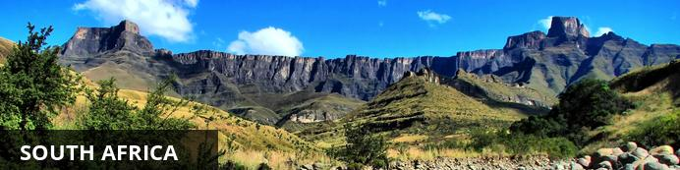

This vast country is undoubtedly one of the most culturally and geographically diverse places on earth. Fondly known by locals as the 'Rainbow Nation', South Africa has 11 official languages and its multicultural inhabitants are influenced by a fascinating mix of African, Asian and European cultures. Spend your days: discovering the gourmet restaurants, impressive art and nightlife scenes and fine beaches of Cape Town; enjoying a typical local braai (barbecue) in the Soweto township; browsing the bustling Indian markets in Durban; or sampling some of the world’s finest wines at the myriad wine estates dotted around the picturesque Cape Winelands. Due to its rich and turbulent history there are plenty of historical attractions to explore including the Zululand battlefields of KwaZulu-Natal, the Apartheid Museum in Johannesburg and Robben Island, just off the coast of Cape Town. Above all else, South Africa’s attraction lies in its remarkably untamed wilderness with its astonishing range of wildlife roaming freely across massive unfenced game reserves such as the world famous Kruger National Park. With all of this variety on offer, it is little wonder that South Africa has fast become Africa’s most popular tourist destination.

#### Banking and Currency

**Currency**

The currency is the Rand, which is divided into 100 cents. There are R200, R100, R50, R20 and R10 notes. Coins come in R5, R2, R1, 50c, 20c, 10c and 5c.

**Banking**

Banks are found in most towns, and are generally open from 09h00 to 15h30 on weekdays and 08h30 to 11h00 on Saturdays (Closed Sundays and Public Holidays). Most of them offer foreign exchange services - with cash, bank & credit cards as well as travellers cheques. You can also obtain cash from automatic teller machines (ATMs). Several international banks have branches in the main city centres. Always advise your bank that you are travelling outside of the country as they might block your purchases if they are not informed.

#### Travel, Transport and Getting Around

Travelling around South Africa is relatively easy by air, road and rail.   
  
Principal air routes are serviced by SAA and British Airways, operated by Comair. There are 2 low-cost carriers on main routes, namely Kulula.com and Mango.

Facilitating travel around South Africa are 10 airports managed by the Airports Company South Africa (Acsa). In addition, there are some 90 regional airports, including the Kruger Mpumalanga International Airport in Nelspruit and the Skukuza Airport, offering access to the Kruger National Park.

An extensive tarred road system makes travelling in South Africa by vehicle convenient and easy. You will find gravel roads in rural areas though. Note:

Another means of getting around South Africa are luxury inter-city bus services such as Greyhound and Trans-Lux. Metrobus buses are available for in-city transport. Metered taxis must be ordered by telephone. There is a hop-on-hop-off bus in Cape Town and Johannesburg.

Our rail system includes the long-haul, inexpensive Shosholoza Meyl Metrorail trains. More luxurious options are the Blue Train, Premier Classe and the steam train Rovos Rail. There is also the new Gautrain rapid transit railway system in Gauteng Province which links Johannesburg, Pretoria, Ekhuruleni and OR Tambo International Airport.

#### Food, Drink and Cuisine Advice

Standards of hygiene in relation to food health and safety in South Africa, are generally high in hotels, restaurants, pubs and nightspots. Tap water in South Africa is safe to drink and cook with when taken from taps in urban areas. Not all tap water in rural areas is safe for consumption, so take precautions if necessary.

It is safe to eat fresh fruit, vegetables and salads, and put ice in your drinks. South Africa's fish, meat and chicken are of excellent quality, so there is no need to limit yourself when enjoying the local cuisine.

Restaurants are subject to South Africa's food safety control legislation, which is implemented by local government. Regulations include certification and regular inspections by health inspectors to ensure hygienic standards are maintained.

Street food is not as common in South Africa as it is in other countries, although vendors selling traditional snacks and meals can be found in city centres and townships. Food safety in such instances cannot always be guaranteed.

#### Climate and Weather

South African temperatures, which are measured in centigrade, average at highs of 28°C to average lows of 8°C in the summer months while winter temperatures range from 1°C at night to around 18°C in the day. Average annual rainfall is on the low side at under 500mm a year, making the country somewhat dry. Much of the rain falls in the Western Cape in the winter, differing from the rest of the country, which experiences summer rainfall. On the plus side, the South African climate boasts more than its fair share of sunshine, recording an average of 8.5 hours a day.

#### Clothing and Dress Recommendations

**Summer**

Bring clothes that are cool, light and comfortable because summer temperatures can get well into the 30 - 40 degree Celsius range in some areas.Also bring an umbrella or raincoat during summer as this is when most of the country gets its rain, but don't forget a swimming costume (bathing suit).

**Winter**

The winters are generally mild, comparing favourably with European summers. But there are days when temperatures dive, especially in high-lying areas such as the Drakensberg, so be prepared with jerseys and jackets. Cape Town gets its rain during the winter season so it’s advisable to bring rain gear along.

**General**

Always bring a hat, sunglasses and sunblock as the sun can be strong even in the winter months.

Walking shoes are a good idea all year-round, with warm socks in the winter.

If you are doing business in the country, business attire (suit and tie) is generally called for in the corporate sector, but media for example generally dress more casually.

For game viewing, a couple of neutral-toned items will be useful, but there's no need to go overboard. A good pair of walking shoes is also advisable.

For the evening, if you are dining at an upmarket restaurant or seeing a show, smart-casual attire is recommended.

#### Electricity and Plug Standards

Current is 220/240 volts at 50 cycles per second. A three-point round-pin adapter plug should be brought for your electrical appliances - such adapters are also available at major airports.