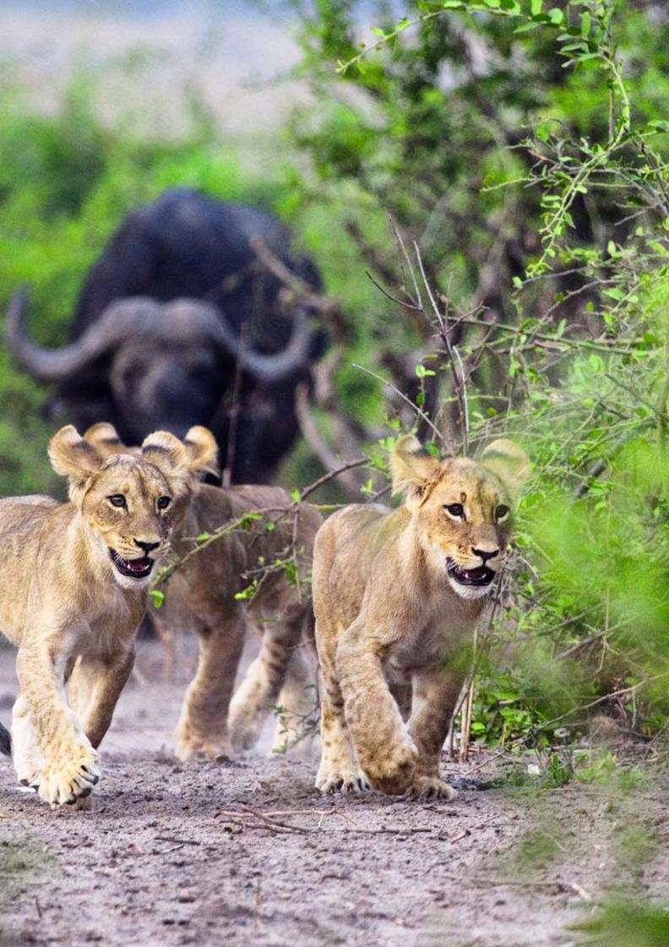

19-Day Namibia & Botswana Roundabout Self-drive Safari - Camping - RACK

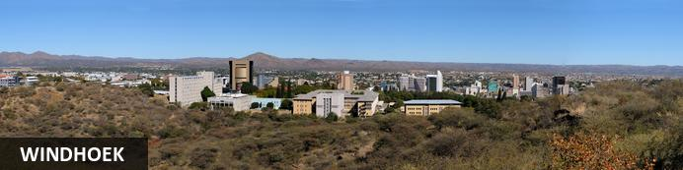
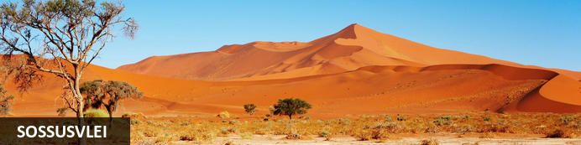
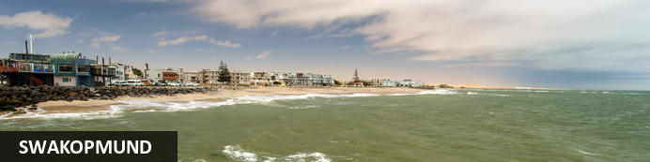
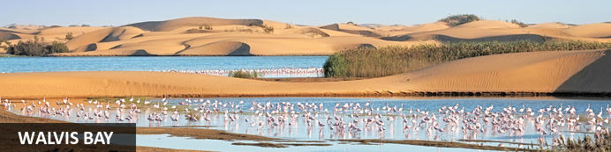
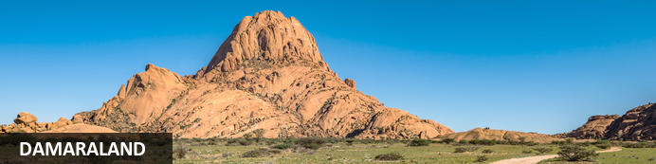
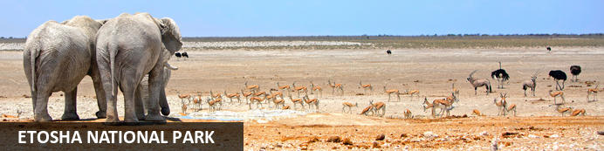
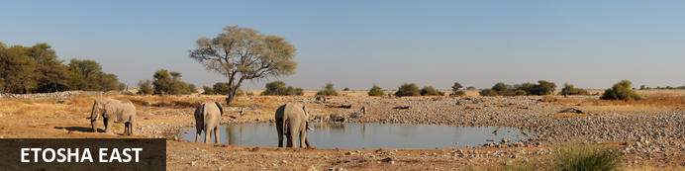
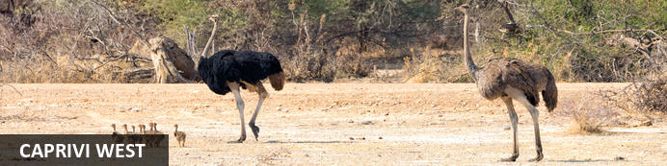
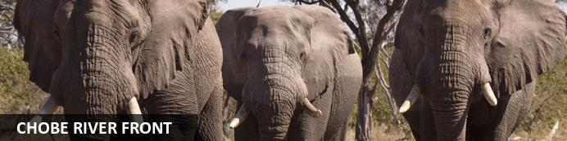
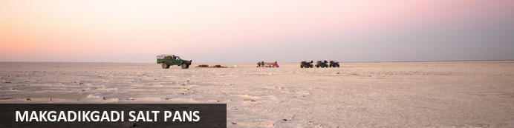
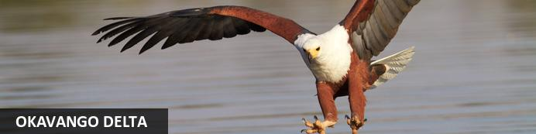
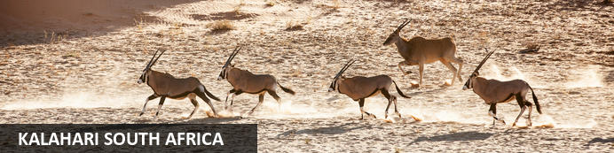

19-Day Namibia & Botswana Roundabout Self-drive Safari - Camping - RACK
Windhoek - Sossusvlei - Swakopmund - Walvis Bay - Damaraland - Etosha National Park - Etosha East - Caprivi West - Chobe River Front - Makgadikgadi Salt Pans - Okavango Delta - Kalahari South Africa
19 Days / 18 Nights
Date of Issue: 05 August 2022

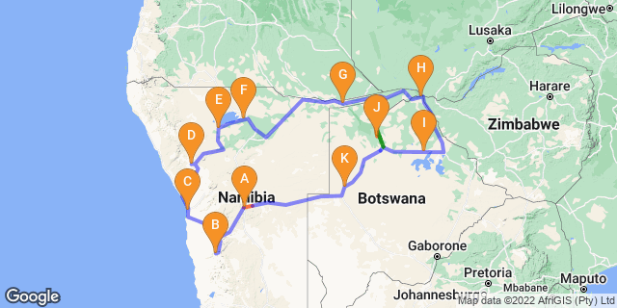

Click here to view your Digital Itinerary

Introduction
Showcasing diverse landscapes and incredible game viewing, this 19-day Namibia & Botswana Roundabout self-drive safari combines the best of Namibia with the best of Botswana as well as a visit to Victoria Falls.
Between the ancient desert, the wildlife of Damaraland and Etosha, the bounteous wetlands of the Caprivi, Chobe and the Okavango Delta and of course the wonder of Victoria Falls, it will be hard to pick a favourite. The tour starts and ends in Windhoek but you can start and end it in Chobe National Park or Victoria Falls.

Accommodation | Destination | Basis | Duration
The Elegant Guesthouse | Windhoek | B&B | 1 Night
Sesriem Oshana Campsite | Sossusvlei |  | 2 Nights
Swakopmund Luxury Suites | Swakopmund | B&B | 2 Nights
Madisa Campsite | Damaraland |  | 1 Night
Okaukuejo Campsite | Etosha National Park |  | 1 Night
Onguma Tamboti Campsite | Etosha East |  | 2 Nights
Shametu River Campsite | Caprivi West |  | 2 Nights
Chobe Safari Lodge Campsite | Chobe River Front |  | 3 Nights
Planet Baobab Campsite | Makgadikgadi Salt Pans |  | 1 Night
Moremi Crossing | Okavango Delta | FI | 2 Nights
Tautona Campsite | Kalahari South Africa |  | 1 Night

Key
B&B: Bed and Breakfast
FI: Fully Inclusive - Bed, All Meals, Fees and Activities

Price
1st January – 30th June 2023 – Low Season
Nam Section
2 guests - ZAR 36 980 per person sharing
4 guests - ZAR 22 970 per person sharing
Single supplement - ZAR 2 825
Bots/Zim Section
2 guests - USD 1 950 per person sharing
4 guests - USD 1 950 per person sharing
Single supplement - USD 550
1st July – 31st December 2023 – High Season
Nam Section
2 guests - ZAR 45 070 per person sharing
4 guests - ZAR 27 260 per person sharing
Single supplement - ZAR 3 020
Bots/Zim Section
2 guests - USD 2 160 per person sharing
4 guests - USD 2 160 per person sharing
Single supplement - USD 630

Included
- Accommodation as indicated – can change depending on availability and request at time of booking
- Meals as indicated
- Meet and greet upon arrival
- Car hire: Fully equipped camping vehicle - Zero Excess
- Airport transfers on arrival and for departure
- Charter flights as indicated – on a set seat rate basis
- Activities as indicated
- Tour file with detailed itinerary, map with route descriptions, vouchers etc.
- 24 hour personal and friendly support
- Fast and efficient response to service providers

Excluded
- Items of a personal nature
- Optional extra activities
- International flights
- Holiday or personal insurance
- Staff gratuities
- Park entry fees
- Fuel for vehicle rental
- Extras/ additional camping equipment on request
- Visas and visa applications

Day 1: The Elegant Guesthouse, Windhoek

Windhoek
Surrounded by the stubble-covered Auas Mountains and the endless Khomas Hochland, Windhoek lies in a long valley fed by ancient hot springs in the central highlands. Namibia’s capital and bustling city. More often than not, the start or end place of your Namibia safari.
In Windhoek there are many interesting historical buildings, museums, galleries and craft shops. The city has several good restaurants and modern shops and services making it an excellent base camp from which to launch your Namibian adventure.

Day Itinerary
- You will be met by the car rental company representative on arrival and transferred to their offices in Windhoek to complete all rental procedures
- You will then meet with our representative to hand over your travel documents
- The remainder of the day can be spent relaxing at your own leisure
- For dinner tonight, you can head into town for a bite to eat at one of Windhoek’s well known restaurants

Overnight: The Elegant Guesthouse View iBrochure
With easy access from Windhoek International and situated in Klein Windhoek - the Namibian capital's prototype leafy suburb - The Elegant Guesthouse makes for a comfortable overnight stop.
The Elegant, as she is known in these parts, is in a quiet neighbourhood, very secure and close to the shops, restaurants and attractions of northern Windhoek. Getting there from the airport requires two turns, getting to the rest of the country from here requires just three turns.
Modern design and fittings give The Elegant Guesthouse a sophisticated air. Once a small six-roomer, the Elegant has been upgraded and is ever more sophisticated now, offering 17 stylish and beautiful guest rooms. They didn't just add more rooms. They first acquired more space and then expanded, so the mood is still decidedly relaxed (if not more so than before): the perfect way to start or end your Namibia holiday.
All rooms have en suite bathrooms, twin beds (together making a king) and are fitted with air conditioners as well as fast WiFi, television and most open out onto a drought resistant garden or the swimming pool area surrounded by loungers and umbrellas.
Breakfast is served in the light and airy open-plan breakfast room or out in the garden on warm days, which is about 90% of the time in Namibia.
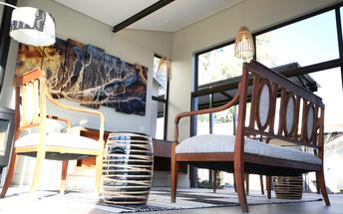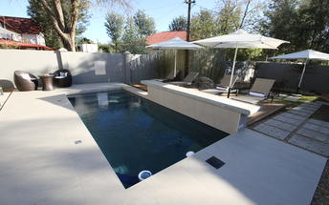

Basis
Bed and Breakfast

Day 2-4: Sesriem Oshana Campsite, Sossusvlei

Sossusvlei
Star dunes with up to five crests rise 300m into the air and rank among the biggest in the world; the dune valleys are marked by vast clay pans where the Tsauchab River gave up its fight to reach the sea more than 60,000 years ago.
Besides the dunes and pans of Sossusvlei and Sesriem Canyon, a sideshow of activities and sights has developed around the region and there are plenty of game lodges that provide additional desert-adapted activities.Plants and birds are the dominant life form in this dessicated realm and they support a tiny world of mammals, reptiles and insects that, in the absence of coastal fog, seldom wander far from the rivercourse and its pans.

Day Itinerary
Windhoek – Sossusvlei 350km - approximately 5 to 6 hours
- After breakfast, you can still pop into town for anything you might need and then depart heading south from Windhoek to your campsite for the next 2 nights
- The route will take you either via the beautiful Spreetshoogte or Remhoogte Pass, both showcasing the natural beauty of Namibia
- Wake up early for breakfast (Day 3) and then head to Sossusvlei
- Spend the whole day in the beautiful Sossusvlei area, exploring the highlights: Sossusvlei, Dead Vlei, Dune 45, Big Daddy, Elim Dune and the Sesriem Canyon
- Return to the campsite for lunch

Overnight: Sesriem Oshana Campsite
Sesriem Oshana Campsite brings you a step closer to Sossusvlei, since you're inside the park gates, but still far enough away to avoid all the other tourists trying to get in. Nowhere is closer to the dunes and you get an hour's drop on all but residents of the other campsite at Sesriem.
While Oshana Campsite prides itself for providing comfort, ease and luxury for campers, this is still very much a Campsite. While you have your own bathroom, parking, kitchenette and access to the bar and pool, you still need to bring all your own camping equipment and set up camp for yourself. That’s right: tent, sleeping bags and a fold-up chair to enjoy the view of Elim Dune. If you do need something though, there is a small shop where you can pick up a few basics and some souvenirs. Just don't forget the big ticket items like your tent or you'll be sleeping in the car.
You have power outlets, but don’t bargain on electronics since there is no WiFi (this is camping after all). Many choose this spot for its location. Inside the park and for its nothingness, it’s a chance to escape and head into the dunes before the sun rises. Win-win.
Although you are in the middle of nowhere, there is more to it. You can make use of the restaurant and the pool at Sesriem, which all sounds too perfect after a hot day of desert activities. As much as camping is an activity on its own, there's much more to do here. Guided walks and hiking trails through the beautiful landscapes that you wake up to every morning. If going by foot is not your thing you can go quad biking or in a hot air balloon. Now that sounds like an adventure.
It’s safe to say that if you want to do this right, you need to take a scenic drive to explore the highlights of Sossusvlei, Dead Vlei and Dune 45. Truth be told, there is a reason everyone wants to photograph it, but shh, don't tell everyone the secret is staying inside the park. That's your advantage.
The campsite itself is clean and the luxury of a hot shower after a long day is a blessing. The vast emptiness will give you the most beautiful night sky to admire and the morning sunrises will be so good you will forget that you slept in a tent.
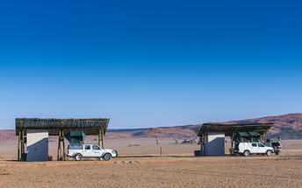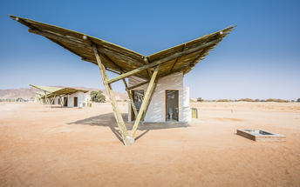

Day 4-6: Swakopmund Luxury Suites, Swakopmund

Swakopmund
Surrounded by the ancient Namib desert and the inhospitable - but bounteous - Atlantic Ocean, Swakopmund is alive with activity and has a lot on offer for the adventure-seeker: quad-biking, sand-boarding, horse-riding, skydiving and more.
Swakopmund has many interesting German-influenced buildings from the early 1900s in a variety of styles and, for its size, Swakopmund has an astonishing array of restaurants that serve mainly seafood, steak and many German staples.

Walvis Bay
Walvis Bay is an industrial port which lies along the Atlantic Ocean, off Namibia's Skeleton Coast. The large bay and surrounding sand dunes help make Walvis Bay a tourist mecca with loads of activities on offer to explore it.
- Explore the Skeleton Coast where the dunes meet the sea at Sandwich Harbour‍
- Go on a dolphin boat cruise in the harbour. Enjoy champagne and oysters
- Kayak among the seals at Pelican Point
- Visit and climb the mighty Dune 7‍
- Visit the RAMSAR wetland birding site and the Walvis Bay Lagoon. Thousands of flamingos from October to April‍
- Explore the neighbouring town of Swakopmund. Activities abound and dining delights

Day Itinerary
Sossusvlei – Swakopmund 350km - approximately 5 to 6 hours
- Depart after breakfast and head north to Solitaire, then west crossing the Tropic of Capricorn, through the Gaub and Kuiseb Canyons via the Namib Gravel Plains to the coast
- Either via Walvis Bay to Swakopmund, or (recommended) detour via Ganab to the Welwitschia Plains and Moon Landscape
- The Namibian coastline is generally known as The Skeleton Coast due to the barren areas, ship wrecks and, in days gone by, whale skeletons left on the beach
- 1 full day is set aside for this lovely area where Swakopmund and Walvis Bay offer a wide range of activities such as: Dolphin cruise; Sandwich Harbour excursion (a real Skeleton Coast experience); Dune quad biking; Sand boarding; Sea kayaking; Lots more…
- Lunches and dinners can be enjoyed at a café or restaurant overlooking the sea

Overnight: Swakopmund Luxury Suites
Swakopmund Luxury Suites pack comfort and convenience into an elegant apartment-style accommodation option in the belly of Swakopmund's restaurant quarter.
Although “suites” is a bit of stretch size-wise, for comfort you can expect elegant, neutral décor that is easy on the senses and top quality linen with quite possibly the most comfortable bed you’ll encounter on your tour of Namibia. Attention to detail includes Nespresso machines with complimentary pods, bath robes, extra thick towels, wi-fi that actually works, climate control, mini-bar and that general air of purpose and cleanliness of a professional outfit.
For convenience you are a few minutes’ walk to the beach, restaurants, cafes and main attractions of central Swakopmund - a feature you will welcome after many hours’ in the car on Namibia’s long and dusty roads. And the day reception is staffed with the friendliest of friendly Namibians who add that personal touch and valuable insider’s information for making the most of your visit.
A secluded upper deck lined with comfortable recliners and deck chairs is a wonderful place to catch up with your digital life. Or escape it entirely with a good book and a glass of chardonnay. Parking out front is secure with 24-hour watch and CCTV and, occupying the first storey down a pedestrianised side street, the location is quiet and safe.
Considering the last thing Swakopmund needs is yet another mediocre eating venue, breakfast at the Swakopmund Suites is outsourced by way of vouchers and a helpful hint to one of three cafes within a couple of minutes’ walk: The Village Cafe is a bright and lively local institution; Cafe Anton, right next door to the Suites, is an old-school buffet good for an early or languid start to the day; and Bojo’s is half way between the two in every respect.
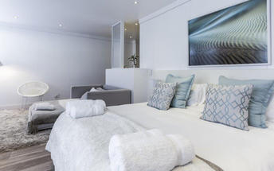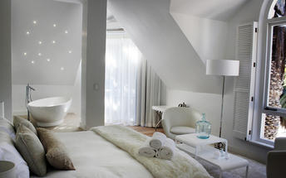

Basis
Bed and Breakfast

Day 6: Madisa Campsite, Damaraland

Damaraland
Damaraland features vast khaki plains, sheer rocky mountains and incredible desert-adapted wildlife. Track rhino and desert elephant, explore the rugged land or sit back and enjoy the dramatic and endless scenery. Damaraland's hilly savannah supports a large number of species including lion, leopard, cheetah, hyena, eland, kudu, giraffe, klipspringer, steenbok, gemsbok and springbok. Birdlife is prolific with over 33 raptors recorded including cuckoo hawks, Egyptian vultures and peregrine falcons - the world's fastest animal.
Damaraland is divided into several enormous private game reserves, known as concessions, that support most species of Namibia's large game and provide some of the best birding and wildlife experiences in the country - and southern Africa for that matter.

Day Itinerary
Swakopmund – Damaraland 445km - approximately 7 to 8 hours
- Head north along the Skeleton Coast, via Henties Bay to visit the Cape Cross seal colony. Along the way, stop at the Lichen Fields as well as the ship wreck between the colourful small town of Wlotskasbaken and Henties Bay
- Backtrack to Henties Bay and head inland through wide open plains to Uis, then north to the Twyfelfontein area
- Visit to Namibia’s Open Air Museum, the Twyfelfontein Rock Engravings as well as the interesting Organ Pipes rock formations and Burnt Mountain
- Visit the Damara Living Museum for a hint of culture

Overnight: Madisa Campsite
Madisa is a wonderful camp with meru-style tents and a campsite in Damaraland in prime desert-elephant country.
Perfect for your self-drive holiday or camping tour of Namibia, Madisa is an excellent choice for those looking for a basic tented camp or as a camping option with all the necessary facilities and delightful swimming pool built around an enormous rock.
Camping in Namibia is an obsession and in this country less is more when it comes to an enjoyable camping experience where, once the basics are covered, you're pretty much left to your own devices. Those basics are well covered at Madisa and they include a private elevated ablution facility for every campsite, with a fire-heated boiler, flushing toilets and a view of the riverbed.
The campsites at Madisa are spotless and well-spaced apart and demarcated with low walls beneath sprawling acacia trees. A barbecue area and table comprise your cooking and kitchen facilities and the stunning view, desert elephants ambling past if you're lucky, the serenity and the great open Namibian sky comprise your entertainment.
The safari tents as an alternative to the campsites, don’t offer a much different experience other than you don’t have to set up camp, it’s all ready for you to simply make yourself at home and enjoy the surrounds. It’s less of a lodge and more “glamping” if you must, but offers all that you need, nestled into the rock formations with an open air bathroom a chance to shower under the stars.
A short walk to the delightful, hand-made swimming pool that looks like a moat around a large rock. You can take a meander up the river bed to some spectacular rock formations or drive further afield in search of the desert elephants.
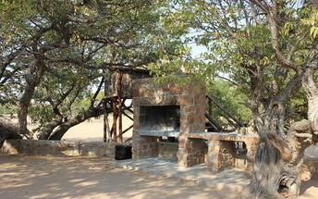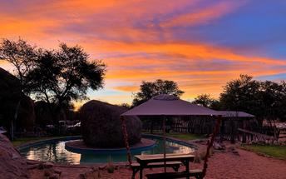

Day 7: Okaukuejo Campsite, Etosha National Park

Etosha National Park
Famous for its wildlife, Etosha Park supports 114 species of mammal and over 340 species of bird. At the heart of the park is a 4,800 square kilometre salt pan surrounded by sparse shrubs and grassy plains, the perfect haven for animals.
As vegetation in most areas is sparse, the animals have learnt to drink during the day when predators are inactive and it is the safest time to be out in the open. It is not uncommon to see up to 7 different species of game at any waterhole.Like everything in Namibia, the pan is ancient - 2 million years or so - and was formed when a great continental upheaval diverted the Kunene River towards the sea, leaving a massive inland lake that soon dried up. Usually a shimmering white horizon, the pan fills with water after a good rainy season and becomes a vast knee-deep lake.

Day Itinerary
Damaraland – Etosha (south) 325km - approximately 4 to 5 hours
- After breakfast, drive east towards Khorixas stopping at the Petrified Forest en-route
- From Khorixas head further east along the tar road to Outjo and then north to your campsite which is situated inside of the park
- If time permits, enjoy an afternoon game drive. Depending on how often you stop today, you should arrive at your lodge in time for lunch (optional extra)
- Pay your entry fee and I suggest you pop in at the local shop to purchase some drinks and snacks and most importantly, a map of Etosha which will show you all the waterholes along the way
- Etosha is one of Africa's great game parks. With 114 species of mammal and 340 species of birds you are sure to see a great variety of wildlife on your safari

Overnight: Okaukuejo Campsite
Okaukuejo Camp is inside Etosha National Park in Namibia. Consequently, you get to enjoy the nightlife. Those staying outside of the park do not, as the gates are closed. The oldest and most popular camp it’s a busy, bustling place and overlooks a floodlit waterhole.
You can get a site near the waterhole where there’s more privacy (and space) - although if you do pitch there, it’s more of a hike to the shower blocks. Get up early to avoid the ablution queues - there can be big groups waiting. By the way, don’t be surprised if you hear lions roaring close by. Just keep your sleeping bag zipped up tight. No giggling.
This is the wild, wild world of Namibia. Just face the bush and breathe. Feel free? Good. Enjoy the show.
But don’t come here to go glamping. This is the place to pitch up quickly, grab a beer and head to the waterhole as the sun sets. Nobody outside of the camp gets to do this - they close the gates when it gets dark - so this is a treat. And talking of gates, you’re 17km from the Andersson Gate which is Etosha’s southern entrance.
Okaukuejo is at the western end of the Etosha Pan. As well as being the oldest camp - it began life in 1957 - it’s also Etosha’s administrative centre and home to the Etosha Ecological Institute. They work to conserve the fauna and flora in this part of Namibia.
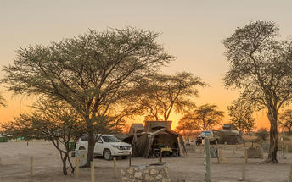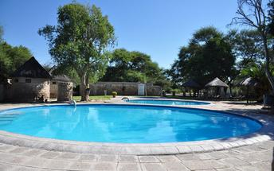

Day 8-10: Onguma Tamboti Campsite, Etosha East

Etosha East
On the eastern edge of Etosha National Park, the park itself is bordered by numerous private reserves and access into the park is via the Von Lindequist Gate, named after Dr. Friedrich von Lindequist who proclaimed it a game reserve in March 1907. This side of the park is characterised by flat endless plains, tree-savanna type of vegetation and fantastic waterholes, where you could easily spot any of the prolific wildlife Etosha is known for. There's an abundance of wildlife here.

Day Itinerary
Etosha (south) – Etosha (east) a full days game drive through the park
- From one side to the other side of the park is a full day game drive as you head slowly east stopping at numerous waterholes along the way
- Take a slow drive in the morning and then enjoy a packed lunch (optional extra) overlooking one of the waterholes before continuing on through the park to the eastern side
- 1 full day is set aside for game viewing, either all day or alternate with morning and afternoon self-drives

Overnight: Onguma Tamboti Campsite View iBrochure
Bridging the gap between safari lodge and camping, Onguma Tamboti Campsite has 15 shaded camping areas each with their own ablutions, washing-up facilities and electrical outlets.
Camping under the stars and preparing your meals over an open fire in the middle of nowhere, surrounded by acre after acre of bush is the quintessential African experience. Then again so is sitting on a shaded verandah overlooking a waterhole while a waiter refills your G n’ T and brings you dinner.
Whichever experience you’re after, Tamboti Campsite offers you the best of both. And being in a private game reserve, you won't be sharing this piece of wildlife paradise with more than handful of like-minded nature lovers. And what’s more the 34,000ha Onguma Game Reserve shares a fenceless boundary with Etosha National Park and so your wildlife experience is about as it gets.
To make the most of this wildlife-rich wilderness, pop over to Onguma Bush Camp and arrange a guided game drive into Etosha proper or join a small group on a sundowner game drive inside the private reserve. The early morning bush walk is a must for an intimate, all-senses experience of Africa as she has been for millions of years.
Or you can just laze away the afternoon by the pool after an early morning self-drive through the park, which, given the abundance of wildlife, the scarcity of water and the presence of waterholes can be every bit as rewarding as the guided safari.
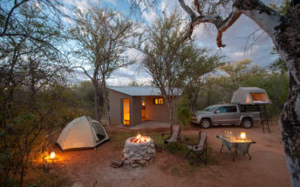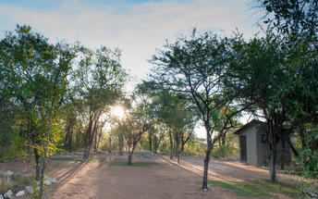

Day 10-12: Shametu River Campsite, Caprivi West

Caprivi West
Caprivi West forms part of the Caprivi strip that protrudes from the northeastern corner of Namibia into Botswana and bordering on Angola. Here you're east of Rundu and on the western side of the Bwabwata National Park. The Caprivi is a lush, sub-tropical wetland offering a wealth of natural resources and serves as a haven for an abundance of wildlife, including the critically endangered African wild dog. This is the only spot in Namibia where one can spot the majestic Nile crocodile and the mighty hippo.
The Caprivi is a paradise for nature lovers with its free-roaming wildlife and postcard-perfect areas. Birdwatchers will be overjoyed as they keep an eye out for the 400 bird species that soar above. Visit the rapids of Popa Falls, go on game drives in the Mahango and Buffalo Core Areas of the greater Bwabwata National Park and enjoy the Okavango River.

Day Itinerary
Etosha (east) – West Caprivi 600km - approximately 7 to 8 hours
- Depart Etosha and drive east to Grootfontein, then north to Rundu before making your way east to Bagani, close to the Popa Falls
- A full day is set aside for a drive to the beautiful Mahango and Buffalo Game Parks, not very big but beautiful as you drive along the Okavango River
- Visit to Popa Falls
- Optional extra would be a sunset boat cruise or a Kavango Village visit in the area

Overnight: Shametu River Campsite
Close to Popa Falls on the western side of the Caprivi Strip, Shametu River Campsite is easily one of the best spots to pitch your tent and from which to explore the river and surrounding game parks.
The Caprivi is a wetland and a green oasis of Namibia on the banks of the mighty Okavango. If you’re going to camp here, this is where you want to camp on the western side. Not only are you close to Popa Falls with great views, your campsite is all grass with your own ablutions and you can make use of the lodge facilities. Score.
The lure here is that your campsite is shaded, it’s neat and tidy, private and you have everything you need including electricity and your own private kitchenette which is thatched for extra coverage in rainy season (December through March) and to shelter you from the heat.
Explore the river. Go on game drives. There’s loads to do here and even just relaxing river side is an option. Take out your camp chair. There under a tree. Now for a cold drink. Splendid. If you’re heading to the nearby parks for game viewing, be on the lookout for Chobe bush buck, red lechwe, sitatunga, elephant, buffalo, hippo, crocodile, lion, leopard, cheetah, hyena and even African wild dog.
If you’re here for the birds. There are plenty of them. So many in fact, you’ll be bewildered by all of them. From wetland birds to seasonal rarities. Wattled cranes, African skimmer, western banded snake-eagle, narina trogon and so many more.
Check in. Set up camp. Explore and relax.
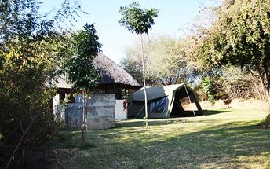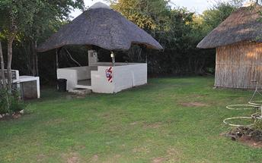

Day 12-15: Chobe Safari Lodge Campsite, Chobe River Front

Chobe River Front
The Chobe River forms the northern boundary of the Chobe National Park which is renowned for its diverse and abundant game viewing opportunities. This section of the park is best known for its dense concentration of wildlife, including elephant and hippo populations, but the waters attract all manner of game including large herds of buffalo and the lions that prey on them - a visit to the Chobe River Front guarantees close encounters with an array of African wildlife. Visitors can look forward to a range of exciting activities such as game drives along the banks; motorboat cruises; and rare birdlife spotting. For a unique, luxury safari experience, hire a houseboat.

Day Itinerary
West Caprivi – Chobe 440km - approximately 6 to 7 hours
- Today you drive east through Katima Mulilo and then on to the Ngoma Border Post. Pass through customs and enter Botswana, Kasane, where you spend the next three nights close to the Chobe National Park
- 2 full days are set aside to enjoy some optional extra activities such as game drives, boat cruises and a day trip to Vic Falls

Overnight: Chobe Safari Lodge Campsite
A top choice for a campsite if you are thinking to camp while exploring the game-rich Chobe National Park. From Chobe Safari Lodge, you’re only 10 minutes from the entrance into the park and the campsites are scattered beneath large trees on the banks of the Chobe River. This is arguably the best place in Kasane to take in the sunset.
Location is key and here you are best situated to explore the wildlife in the park and from the river. The Chobe is known for having the largest concentration of elephants in Africa.
‍
Overlooking the river and the Chobe floodplains, you’ll likely spot them from your tent and you’re only a short drive from the entrance gates to the park. Sounds pretty good. If you’re going to camp in Kasane, this is where you want to be.
Make a fire and cater for yourself or dine at the lodge. The Sedudu Bar is known for the finest sundowner in the area. Ask the locals they’ll say the same. Game drive yourself or join a safari with a lodge guide. Book a boat cruise to explore the Chobe River, you can even dine out on the waters. Let’s go.
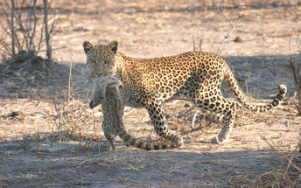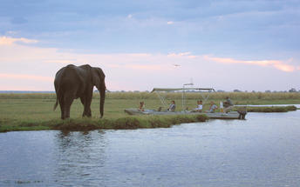

Day 15: Planet Baobab Campsite, Makgadikgadi Salt Pans

Makgadikgadi Salt Pans
Makgadikgadi Pans. Something different. An amazing place that rewards the intrepid traveller willing to head off the beaten tourist track.
On the northern edge of the Central Kalahari Game Reserve, the Makgadikgadi, Sua, Ntwetwe and Nxai pans are remnants of a super-lake that once covered the area and supported life of a forgotten world.
Summer rains welcome hundreds of thousands of flamingos as well as endless herds of wildebeest and zebra form the second largest mammal migration in Africa. In winter the landscapes are of shimmering vast salt pans as far as the eye can see. Trek with authentic Bushman, sleep out under vast night skies, go see the giant baobabs and experience habituated meerkats. The uncharted wilderness of this part of the Kalahari makes it all the more exclusive.

Day Itinerary
Chobe – Makgadikgadi Pans 420km - approximately 5 to 6 hours
- From Kasane, drive south to Nata and then east to your campsite for the evening
- If time permits (leaving after breakfast you can reach your destination by lunch), an afternoon drive onto the pans … or a cattle post visit can be arranged with the lodge (optional extra)

Overnight: Planet Baobab Campsite
Planet Baobab, like an authentic Kalanga style village, is one of few respites along a long stretch between Nata and Maun. African chic meets the simplicity of the Kalahari Desert. The campsites are shaded and the swimming pool is, by a long shot, the best in these parts.
Quirky and colourful, the clay painted walls and thatched lapas emulate the adjacent Gweta Village. Like a homestead, you are welcomed here by the friendly staff and an oversized aardvark, not a real one, a ginormous sculpture. You can’t miss it.
From the pans, you are 40 kilometres away, which makes this the ideal place to base yourself to explore the Makgadikgadi. One of the largest salt flats in the world. Amidst the middle of this dry savanna in north-eastern Botswana, Planet Baobab’s swimming pool has a reputation that precedes itself and for good reason. Its’ cool blue waters beckon from the arid Kalahari.
This is the land of the baobab, in fact there are 17 giant ones found in the area. Go see them. It’s a must, since they are after all, the world’s largest succulents. That’s right. They aren’t actually trees. Meet the habituated meerkats, taste traditional Batswana food (you can eat at the lodge if you don’t want to self-cater) and of course you should go see the pans. They’re vast and incredible. If you can do it by quad bike, great. If you can sleep out on the Ntwetwe Pan (in the dry season), even better.
Among the ant hills and red Kalahari sands, enjoy the starry skies, the immense white expanse of what used to be a lake some thousands of years ago and in the wet season, the masses of zebra and wildebeest as they migrate south.
This is a special place and Planet Baobab although rudimentary, with all its flair and African charm, is one you will remember for sure.
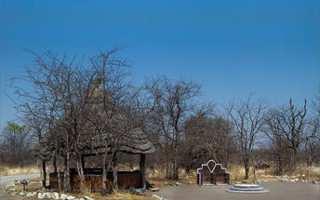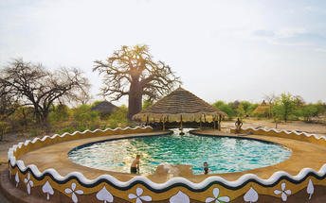

Day 16-18: Moremi Crossing, Okavango Delta

Okavango Delta
Crammed with every conceivable species of bird and beast, the delta is an Eden of excess. Amazing game viewing and birding in a scenic and tranquil African wilderness. If you’re looking for a true African safari. Look no further.
The quintessential delta experience: game drives in open safari vehicles and gliding in silence through the waterways on an African-style gondola carved from a single tree.
Access into the Okavango Delta is difficult, getting around is difficult, carting supplies in and waste out is difficult. These are all good things for this vast wildlife wilderness is utterly picturesque and devoid of human influence.
If constant close-ups of elephant, buffalo, lion, giraffe, hyena, jackal and plenty of large and small antelope start to grow old, there's always the chance encounter with cheetah, leopard, wild dog, and red lechwe to spice things up.

Day Itinerary
Makgadikgadi Pans - Maun 210km approximately 2 to 3 hours
- This morning you will have breakfast and depart west to Maun Airport, where you will leave the vehicle and meet with your pilot for your shared charter flight into the Okavango Delta
(please take note of luggage restrictions)
- 2 nights makes this a 1.5 day stay and activities here focus on the water channels and the open floodplains of Chief’s Island. Enjoy mokoro activities, game walks and boat cruises as included

Overnight: Moremi Crossing View iBrochure
Moremi Crossing, built in 2009, is a modern and eco-friendly safari lodge in the Okavango Delta overlooking the Boro River and Chief's Island.
The transfer to Moremi Crossing is exciting enough: a scenic flight over the Okavango Delta lands at Chief's Island and a boat ride takes you to the doorstep of this apparently floating island lodge.
Built in the style of an exclusive and luxurious lodge, the camp manages to keep the price tag relatively low without compromising the essentials, these being: an beautiful and tranquil location, surrounded by the floodplains and channels of the Okavango Delta; amazing views from everywhere; exceptional game viewing and wilderness experience with elephant munching the trees nearby and hippos wallowing in front; exclusive access to first-rate game guides and activities including mokoro safaris, walking safaris and sunset river cruises; and of course comfortable accommodation, friendly service and good food.
The rooms are tented safari suites on wooden decks above the water level and connected by walkways. Each has an en suite bathroom with open-air showers - solar-heated water - flushing toilets with natural waste water filtration and large private balconies.
The living area at Moremi Crossing, buttressed by the dense riparian growth behind and the Boro River in front, is a multi-tiered wood and thatch construction above the water. Choose to laze in one of the private lounge areas, the bar, the dining area or the outdoor fireside deck.
Moremi Crossing has a small swimming pool shaded by wild fig, lined with loungers and surrounded by wild African bush.
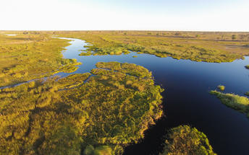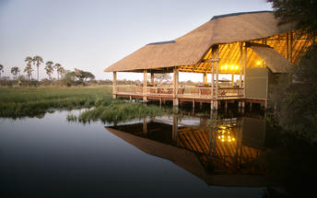

Basis
Fully Inclusive - Bed, All Meals, Fees and Activities

Day 18: Tautona Campsite, Kalahari South Africa

Kalahari South Africa
The Kalahari is an exceptionally beautiful living desert boasting expansive semi-arid sandy savannah draped over a gently rolling inland sea of sand covering most of Botswana and large parts of Namibia and South Africa. It is also the last bastion of the San people with the modern world having enveloped all the other areas they once roamed. The endless sand dunes of the Kalahari compose the largest continuous expanse of sand on earth. Visitors can enjoy the clear night skies for a spot of stargazing, excellent game viewing, nature walks, horse riding and thrilling 4x4 adventures through this magnificent desert. Commonly spotted wildlife include water buffalo, black-maned Kalahari lion, antelope, ostrich, meerkat and countless bird species.

Day Itinerary
Maun – Kalahari Bushveld 265km - approximately 3 to 4 hours
- Fly back to Maun Airport, where you pick up your vehicle again and then drive south via Sehitwa to your campsite, which is close to Ghanzi
- Enjoy your last night under the African stars

Overnight: Tautona Campsite
Tautona is an oasis in the bushveld of the Kalahari. The campsites are a mere kilometre from the lodge, the perfect spot to set up camp under the thorn trees. You’re just 5 minute drive from Ghanzi on a private reserve. It’s quiet and there’s wildlife.
Pitch your tent and set up camp. Welcome to the Kalahari on the western side of Botswana. Red sands beneath you and clear skies above.
You’re not far from the main lodge, a short walk or a five minute drive. Enjoy the swimming pool, dine at the restaurant or order an ice cold drink. In the desert, there’s something truly special about sitting pool-side in the heat with the sound of clinking ice against glass. This is an oasis and you can revel in all of it.
On a private reserve you can take a drive to explore the wildlife. There are numerous antelope to spot. Waterbuck, eland, impala, red hartebeest and oryx. Look out for giraffe and keep your eyes peeled for wild dog, lion and cheetah. They’re out there although scarce.
The waterhole is a great place to simply chill. There’s a view point and there’s game. Watch them come and go. Then return to camp and light the fire. Enjoy the stars. This is what camping is all about.
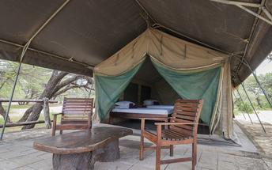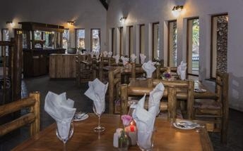

Day 19: End of Itinerary

Day Itinerary
Kalahari Bushveld - Windhoek 570km - approximately 7 to 8 hours
- Depending on flight time or whether you will add a night in Windhoek, will depend on what time you depart the lodge
- The drive to Windhoek will go via the Mamuno Border Post, through Gobabis to Windhoek … about 6 hours … where this holiday will end
- An overnight stop in Windhoek is recommended before flying home otherwise you will drop the vehicle at the Windhoek International Airport on return and fly out

Basis
Bed and Breakfast

Transport

Flight Information
Date | Flight | Airline | Departure Airport | Time | Arrival Airport | Time | Class | Ref
 | Charter Flight |  | Maun International Airport [MUB] |  | Camp Okavango Airstrip
 | Charter Flight |  | Camp Okavango Airstrip |  | Maun International Airport [MUB]

Transfers
Date | Company | Pick Up | Drop Off | Time | Vehicle
 |  | Hosea Kutako International Airport [WDH] | Windhoek City |  | Fully Guided Trip
 |  | Camp Okavango Airstrip | Moremi Crossing |  | Fully Guided Trip
 |  | Moremi Crossing | Camp Okavango Airstrip |  | Fully Guided Trip

Terms and Conditions

Namibia Tours & Safaris Terms and Conditions
Contract
1.1 The contract will become effective as from the date the invoice is completed and the deposit, referred to in Clause 2.1, is received by Africa Tours & Safaris CC (hereinafter known as the Company).
1.2 The contract is subject to the Namibian Law.
1.3 Any person making a reservation as per Clause 8.4 accepts the terms and conditions of this agreement set out hereunder.
How to Book
2.1 A 20% deposit of the full amount due is required to confirm any reservation and is to be done by the agent or client (see Clause 8.1) in writing or by e-mail.
2.2 The Company must receive the balance of the contract price no later than 42 days (6 weeks) prior to departure.
2.3 If the Company does not receive the full contract price 42 days (6 weeks) before the departure date, the Company may cancel the reservation and retain whatever deposit or other funds it has already received from the client or his agent.
How to Pay
3 The payment options will be provided upon confirmation of a booking.
Our Cancellation Policy
4.1 Any cancellation of a confirmed booking must be done in writing (email) to the Company whereupon cancellation charges as per Clause 4.2 will apply.
4.2 The following cancellation fees (as a percentage of the fully quoted price) are applicable to any cancelled travel:
Notice from date of travel:
Cancellation fee:
42 days or more 20% (deposit forfeited)
29 – 41 days 50%
15 – 28 days 75%
0 – 14 days 100%
Please note: the notice period is calculated from the date of cancellation to the start date of the tour/safari booking.
4.3 No refund will be made by the Company if, for any reason, inclusions or parts of the tour cannot be carried out / or utilised. These would include all facets such as meals, game drives, accommodation etc. This would also apply to any client who has booked a tour but fails to undertake the tour for any reason.
Our Changes Policy
5 If a booking is changed to an earlier date than originally reserved, the Company will endeavour to change it. If the booking is for a later date, charges as per Clause 4.2 could apply.
As things go, we've all had to adapt to changes during the Coronavirus pandemic and so too have we therefore amended our terms and conditions for travel during such times.
Price Changes
6.1 The Company reserves the right to increase the price of any tour prior to departure due to factors beyond the control of the Company, such as, without being limited to, and increase in fuel prices, new Government legislation, accommodation price increases, fluctuations in exchange rates, etc.
6.2 If the Company announces an in increase in the tour price in terms of this Clause, such addition amount must be paid to the Company before the departure of such tour or else the Company shall have the right to cancel the tour and the charges in Clause 4.2 will apply.
Changes to Itineraries
7 The Company shall at any time have the right, in its entire discretion, to alter the terms of the booking in relation to the route, timetable, itinerary and accommodation. The Company shall, however, make every effort to offer the client an alternative tour of a comparable standard.
Should the alternative be of a lesser standard, the client will be refunded the difference, but should there be an increase, the client shall have the right to either reject the alternative and obtain a refund of the relevant portion of the original contract sum, or to accept the alternative and pay the increased cost. In the event of the client rejecting the alternative tour and claiming a refund, such rejection will be treated as a cancellation and the refund will be calculated according to Clause 4.2 hereof. The client shall have no claim against the Company for any damages arising out of the alternative booking.
Responsibility and Liability
8.1 Neither the Company nor any person acting for through and on behalf of the Company shall be liable for any loss or damage whatsoever arising from any cause whatsoever and without restricting the generality of the aforegoing shall particularly not be responsible for the loss or damage arising from any errors or omissions contained in its brochure or other literature, late or non-confirmation or acceptance or bookings, loss or damage caused by delays, sickness, injury or death, whether occasioned by negligence or not.
8.2 The Company shall have the right at any time at is sole discretion, to cancel or the remainder thereof or to make an alteration in the route, accommodation price or other details. This would include any event of any tour being rendered impossible, illegal or inadvisable by weather, avalanches, strike, war, government or other interference or due to any other cause whatsoever. The extra expenses incurred as a result thereof shall be the responsibility of the client.
8.3 The Company may at its discretion and without liability or cost to itself at any time cancel, or terminate, a client's booking and in particular, without limiting the generality of the aforegoing, it shall be entitled to do so in the event of illness or the illegal or incompatible behaviour of any client undertaking the tour, who shall in such circumstances not be entitled to any refund.
8.4 Any person making a reservation with the Company (refer to Clause 1.1) warrants that her or she has the necessary authority to enter into this contract on behalf of the person or persons included in such a booking. The person making the reservation shall be liable for the total amount due to the Company.
Client's Obligations
9.1 It is the onus and responsibility of the client to obtain the necessary comprehensive insurance before departure for any possible cancellations, medical expenses, protection or personal property and money.
9.2 The onus is upon the client to ensure that passports and visas are valid for the duration of the safari. The Company cannot be held liable for any necessary visas or other travel documents not held by clients. In the event of a client not having the necessary documentation to enter any area or country the Company shall reserve the right to leave the client a the point of entry of such area or country. In such an event, the Company will not be held responsible to the client for further travel arrangements.
9.3 The onus is upon the client to ensure that the SARS-CoV-2 PCR tests are done prior to commencement of the safari and valid on arrival in accordance to the requirements of the country of intended travel and for the airline with which the client will travel. The same applies for any necessary testing for departure. The costs of any such COVID testing will be for the clients own account. While The Company can assist with arrangements for testing in-country, The Company will not be held responsible to the client for such arrangements and with regards to return time of test results.
9.4 Should the client need to undergo mandatory quarantine once in-country with regards to the SARS-CoV-2 virus, either on arrival as called for by the authorities or due to testing positive once in-country, this will be at the clients own expense.
Health and Personal Safety
10.1 The client shall be reasonably fit to undertake the tour.
10.2 Anti-malaria precautions should be commenced prior to tour departure. A medical doctor should be consulted for advice.
10.3 Tours offered by the Company cover a wide spectrum of the African wilds and neither the Company, its employees or agents can be held responsible for any injury or other related incidents whilst on the tour / safari.
10.4 The Company cannot be held responsible for any client who falls ill or contracts the SARS-CoV-2 virus while in-country. The client accepts that travel is at own risk.
Baggage
11.1 Clients are limited to one soft sports type bag per person with a maximum weight of 20 kilograms. This includes photographic equipment and hand luggage.
11.2 Due to the rugged terrain, the Company cannot be held responsible for damage or loss of any personal items including bags, contents of bags or photographic and related equipment. Due to extremely dusty conditions, please ensure all bags are dust proof.
Airline and Car Hire Clause
12.1 The Company will act as the agent of the client when booking the client with a car hire company, an airline or air charter service. The client therefore contracts with the car hire company, airline or charter service and not with the Company.
12.2 Charter flights are normally operated by smaller type aircraft such as Cessna 210. Luggage is strictly limited to 10-15 kgs (depending on terms of particular airline used) per person in soft hold all type bags. Due to the desert heat, it is not safe to overload aircraft thus this limit needs to be strictly controlled.

