CLASSIC PEARL OF AFRICA SAFARI

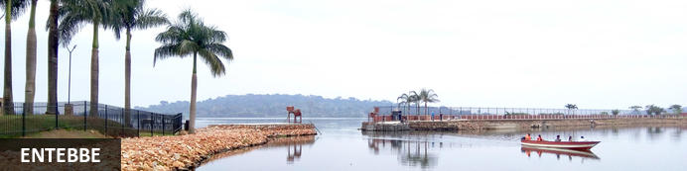
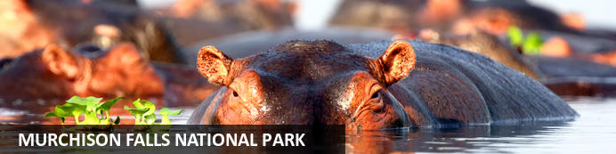
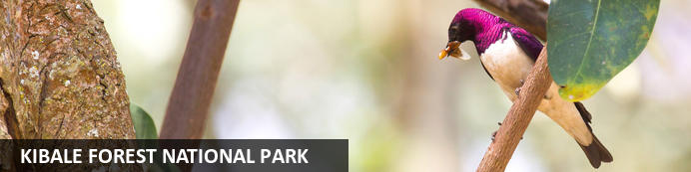
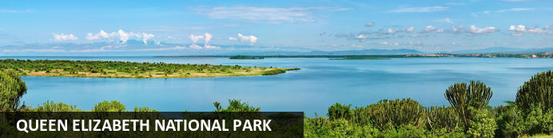
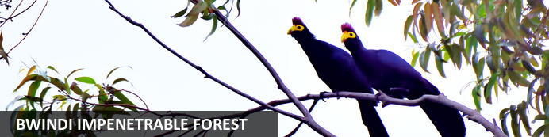
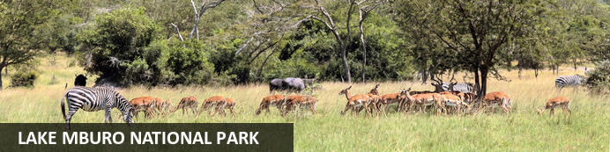

CLASSIC PEARL OF AFRICA SAFARI
Entebbe - Murchison Falls National Park - Kibale Forest National Park - Queen Elizabeth National Park - Bwindi Impenetrable Forest - Lake Mburo National Park
10 Days / 9 Nights
Reference: CSUG001
Date of Issue: October 13, 2022

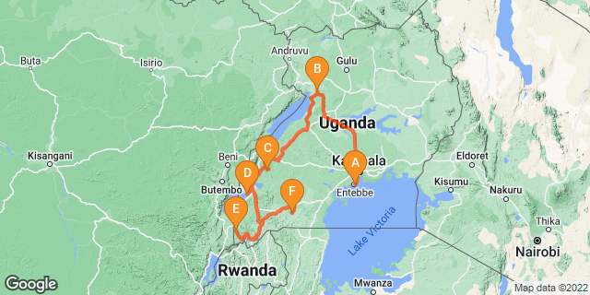

Click here to view your Digital Itinerary

Introduction

Start | Accommodation | Destination | Basis | Duration
Day 1 | The Boma Hotel Entebbe | Entebbe | B&B | 1 Night
Day 2 | Paraa Safari Lodge | Murchison Falls National Park | FB | 2 Nights
Day 4 | Turaco Treetops | Kibale Forest National Park | FB | 1 Night
Day 5 | Mweya Safari Lodge | Queen Elizabeth National Park | FB | 2 Nights
Day 7 | Silverback Lodge | Bwindi Impenetrable Forest | FB | 2 Nights
Day 9 | Mantana Tented Camp | Lake Mburo National Park | FB | 1 Night

Key
B&B: Bed and Breakfast
FB: Full Board - Dinner, Bed, Breakfast and Lunch

Price
*From US$ 4108.00 Per Person Sharing
*Terms and Conditions Apply.

Included
- Pick up and drop off in Kampala
- Ground transport in a private 4WD safari vehicle
- English speaking driver/guide
- Accommodation as described in the itinerary, based on a double room sharing
- Meals as described in the itinerary
- Bottled mineral water in the car
- Entrance and ranger fees for the national parks
- Activities mentioned in the program

Excluded
- International / Domestic flights
- Visa (USD $100)
- Meals and drinks not mentioned in the itinerary
- Items of personal nature
- Laundry service
- Tips and porterage
- Optional activities not included in the itinerary
- Gorilla Permit (USD 700 Per Person Per Permit))
- Chimps (USD 200 Per Person Per Permit)

Day 1: The Boma Hotel Entebbe, Entebbe

Entebbe
Situated on a peninsula in Lake Victoria, the former seat of Uganda’s government, Entebbe is just a short drive from the current capital and offers plenty to keep visitors amused. This charming town features tree-lined streets and serves as an excellent base from which to explore the surrounding area. Tourists can look forward to spending days on beautiful beaches along the banks of Lake Victoria, stroll through the fields and forests of the magnificent Botanical Gardens, or pay a visit to Ngamba Island Chimpanzee Sanctuary, a haven for country’s orphaned chimps.

Day Itinerary
Upon Arrival at the airport, you will meet and greet with a representative of Classic Safaris who will brief you on your safari and then transfer to your accommodation.
Dinner and overnight @ Boma guesthouse Or similar (BB).

Overnight: The Boma Hotel Entebbe
The Boma Hotel is Entebbe’s original and most exclusive hotel, set in tropical gardens in a leafy suburb, a few minutes drive from Entebbe International Airport. Our rooms combine the modern comforts one expects today with the charm and character of the original 1940’s home. The Boma is an ideal stopover for all travellers and airline passengers, and we will arrange all your airport transfers. Our staff and management team ensure guests receive a personable service and enjoy hospitality standards which are in keeping with the tradition of this charming lakeshore town.
The residents-only bar and dining area overlooks the pool area and provides a delightful and relaxed country house experience. The main house includes a private dining veranda and living room for overnight guests. Other hotel facilities include the swimming pool, Gym, Free WiFi, 24-hour security and car parking. We offer a laundry service for overnight guests and there is a small craft shop on site. We can organise local taxi hire and day trips to the nearby attractions.
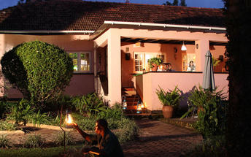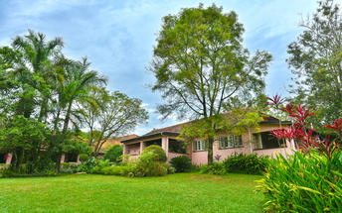

Basis
Bed and Breakfast

Day 2: Paraa Safari Lodge, Murchison Falls National Park

Murchison Falls National Park
Stretching from the shores of Lake Albert, Murchison Falls National Park is Uganda's largest National Park. The Nile River flows through the middle of the park creating the impressive Murchison Falls which is the park’s major attraction. The landscape features dense rainforest, undulating savannah and a diversity of abundant wildlife. Visitors can enjoy prime game-viewing along the Buligi Circuit. The forests are home to numerous primates, including Chimpanzees, and near the river, buffalo, elephants and Rothschild-Giraffes can be seen. Other commonly spotted wildlife include: lions, antelope, waterbucks, hippos and crocodiles.

Day Itinerary
After an early morning breakfast, depart Kampala for Murchison Falls National Park. That allows you a visit to Ziwa Rhino sanctuary (track the Rhinos here) proceeding later for lunch in Masindi town. On arrival at the park, you will encounter a variety of monkeys, baboons, among others as you proceed for a visit to the top of the falls. This will see you return to transfer to your lodge for a relaxed evening, dinner and overnight @ Paraa Safari Lodge (Standard Rooms) -FB.

Overnight: Paraa Safari Lodge
Paraa Safari Lodge is situated in Murchison Falls National Park, northwest Uganda. It overlooks nature's best-kept secrets, the River Nile, on its journey from its source at Lake Victoria. The lodge accommodation options include cottages, suites, double, twin and single rooms featuring fans, balconies and en-suite bathrooms. During their stay, guests can enjoy delicious local and international specialities at the on-site restaurant. Leisure facilities include a swimming pool, bar and a gift shop.
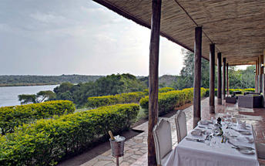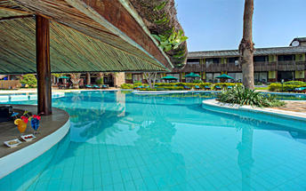

Basis
Full Board - Dinner, Bed, Breakfast and Lunch

Day 3: Paraa Safari Lodge, Murchison Falls National Park

Day Itinerary
After an early morning warm up tea/coffee, you will transfer for a game drive to the northern bank in search of animals like: lions, leopards, elephants, giraffes, hartebeests, oribis, Uganda kobs, buffaloes among other animal and bird species that your guide will help you spot. This will see you return for lunch at Paraa safari lodge. After lunch, transfer for a three hours boat ride on the Nile River to the bottom of falls where you will have the opportunity to view Animals like; hippos, crocodiles, waterbucks, buffaloes and elephants on the river banks. Return to your lodge for a relaxed evening, dinner and overnight @ Paraa Safari Lodge (Standard Rooms) -FB.

Basis
Full Board - Dinner, Bed, Breakfast and Lunch

Day 4: Turaco Treetops , Kibale Forest National Park

Kibale Forest National Park
Kibale Forest National Park, situated in Western Uganda, is famous for its high density of primates, breathtaking crater lakes, and thick, beautiful jungle. Thirteen primate species inhabit the beautiful tropical forest, including red-tailed monkey, L’Hoest's monkey, grey-cheeked mangabey, red colobus, and black and white colobus monkeys. Visitors may spot some of the 300 bird species and 250 butterfly species, and buffalo, forest elephants, leopards, bushbucks, and sitatungas also live in the park but are generally shy. The area is decorated by around 50 enthralling crater lakes and numerous pristine hiking trails. Several cultural tours are on offer which delve into the rich traditions of the Batoro people, giving travellers a chance to see Batoro dancing, singing and traditional healing up close.

Day Itinerary
After breakfast depart Murchison Falls with your parked lunch and drive Southwest via the Albertine Escarpment of the Western Rift Valley through Hoima, the town of the Bunyoro Kitara kingdom passing through verdant countryside tea plantations and traditional homesteads. You will arrive in Fort Portal town the capital of the Tooro kingdom late in the afternoon proceeding to your hotel. Dinner and overnight at Turacco Treetops Lodge -FB.

Overnight: Turaco Treetops
Turaco Treetops is ideally located just outside the lush Kibale National Park, Uganda, where many birds, monkeys and butterflies that inhabit the Kibale Forest can also be found. The accommodation is in the form of cottages and rooms equipped with practical furniture, mosquito nets, comfortable beds, a private bathroom and a balcony with fantastic views over the canopy. Guests can enjoy all their meals in the main lodge's dining room or sit in the bar with a refreshing drink. Additional amenities and services include a swimming pool, a lounge area with a fireplace, a first-floor lounge with spectacular views over the forest and the snow-capped Rwenzori mountains and Wi-Fi. Guests can enjoy going on day/night forest walks, mountain bike tours and experience chimpanzee trekking.
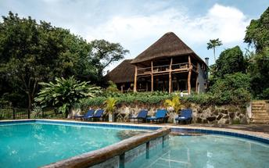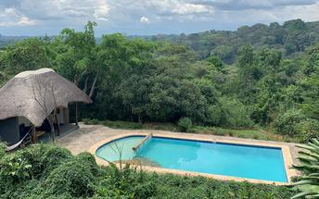

Basis
Full Board - Dinner, Bed, Breakfast and Lunch

Day 5: Mweya Safari Lodge, Queen Elizabeth National Park

Queen Elizabeth National Park
Located in southwestern Uganda, the Queen Elizabeth National Park is one of the county’s most popular parks. Volcanic craters, grassy plains, tropical forest and giant lakes connected by a channel inhabited by abundant hippos, are what you will see at the Queen Elizabeth National Park. The park has almost 100 types of mammal and 606 different bird species, including the peculiar shoebill. The 40-kilometre-long Kasinga Channel alone is said to contain the world's largest concentration of hippos, and a guided boat trip here is a popular way to see the wildlife. Other species to spot include buffalo, the rare aquatic sitatunga antelope, giant forest hog, Uganda kob, Defassa waterbuck and elephant. Don't miss the chance to explore the dramatic Kyambura Gorge, is home to habituated chimpanzees.

Day Itinerary
After an early morning breakfast, you will be transferred just a few meters to the chimpanzee tracking information office for a pre-briefing by your ranger guides who will then lead you into the rain forest tracking these primates (Chimpanzees). These primates are very mobile and viewing them is unpredictable but a forest walk is an enriching activity that starts at 8.00 am taking about 4 hours. This forest is home to a large number of chimpanzees and other primates including L’hoestes, Red-colobuses, Blues, Red-tailed, grey cheeked mangabeys, birds, and butterflies. The guide will provide detailed explanations on not only primates but also on all the forest’s fauna and flora. This will see you return to have your lunch at Primate lodge, after lunch, transfer to Queen Elizabeth National Park, following the mystical Rwenzori Mountain Range most of the journey. Dinner and overnight @ Mweya safari lodge (Standard Rooms) -FB.

Overnight: Mweya Safari Lodge
Mweya Safari Lodge offers visitors an unforgettable experience. Located on a peninsula within the heart of the Queen Elizabeth National Park, Mweya Safari Lodge is surrounded by the magical Rwenzori Mountains aptly described as the 'Mountains of the Moon' and overlooks the Kazinga Channel which links two of the Nile's great lakes – Lake George and Lake Edward. Mweya Safari Lodge offers visitors a spectacular experience of luxury in the wilderness. All of the rooms have wonderful views of the channel. The Lodge offers a range of activities and attractions: game drives, boat trips, wild life viewing and more.
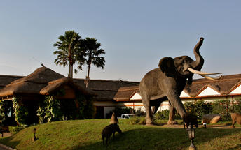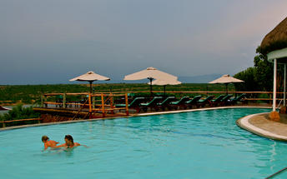

Basis
Full Board - Dinner, Bed, Breakfast and Lunch

Day 6: Mweya Safari Lodge, Queen Elizabeth National Park

Day Itinerary
After an early morning warm up tea or coffee, you will head for a game drive along Kasenyi tracks and Queens mile in search of animals like: lions, elephants, cape buffalos, warthogs, spotted hyenas, mangoose, waterbucks, kobs and, if you’re lucky, the leopard, and a great number of bird species, return for a full breakfast, relax into the lunch break and after lunch you will be transferred to enjoy a unique two hour boat cruise on the Kazinga Channel. This launch cruise gives you a great opportunity for photography, bird watching and game viewing at close range. The prolific bird life is colorful and stupendous with well over 550 resident species. Dinner and overnight @ Mweya safari lodge (Standard Rooms) -FB.

Basis
Full Board - Dinner, Bed, Breakfast and Lunch

Day 7: Silverback Lodge, Bwindi Impenetrable Forest

Bwindi Impenetrable Forest
Located in southwestern Uganda, the Bwindi Impenetrable Forest is said to be Africa’s oldest rainforest. It is world-renowned for its excellent gorilla-sighting opportunities - the forest is home to half of the remaining mountain gorillas on earth. This gorilla experience takes place among a rugged landscape of dense jungle, cascading waterfalls, sparkling mountain streams, deep valleys, and steep ridges. The untouched forest has been declared a UNESCO World Heritage Site for its breathtaking natural beauty and unique ecological significance, and aside from the amazing gorilla interactions, there are other drawcards such as a network of forest walks, over 340 species of bird to spot, and a variety of brightly-coloured butterflies to identify. Don’t miss the opportunity to explore the spectacular Virunga Volcanoes, three of which are still active.

Day Itinerary
On this day, after your breakfast, transfer to Bwindi impenetrable forest national park with your parked lunch via the Ishasha sector of the tree climbing lions. We will take an en-route game drive here in search of the tree climbing lions before proceeding to Bwindi through the Kigezi highlands in the beauties of the ‘‘Switzerland of Africa’’, arriving at your lodge for a relaxed evening, dinner and overnight @ Silverback gorilla lodge. (Standard Rooms) -FB.

Overnight: Silverback Lodge
Silverback Lodge is perched on high, atop the valley overlooking Bwindi Impenetrable National Park. The view is absolutely stunning and the best place to enjoy après-tracking cocktails. Bird watching and sometimes primate viewing is possible right from the front door of your room. With 12 rooms, we are the largest lodge in the area and will remain one of the best value properties in the region, whilst keeping the Marasa Africa standards of comfort and hospitality. The lodge is being completely re-furbished, we assure you that your stay will be of the highest comfort and standard.
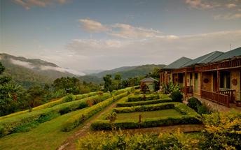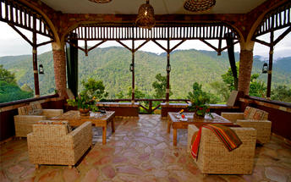

Basis
Full Board - Dinner, Bed, Breakfast and Lunch

Day 8: Silverback Lodge, Bwindi Impenetrable Forest

Day Itinerary
Today is your day for tracking the Gorilla’s. After an early but very powerful breakfast your driver/guide will bring you to the starting point of your gorilla track. (Packed lunch will be provided). Before you start the real tracking you will gather at the Uganda Wildlife Authority meeting area. Here you will find other people as well who will track with you in the same group. A clear briefing will be given to you on what you can expect during the day as well as safety rules and behavior when you are meeting the gentle giants. After the introduction it is time for you to start searching for the Gorilla’s. Depending on where the Gorilla’s are located we can never tell you how long it will take for you to see them. But please keep in mind that it can be active, adventurous, sometimes a bit difficult but definitely a worth it experience, that can last a full day. Return to the lodge in the afternoon. Dinner and overnight @ Silverback gorilla lodge. (Standard Rooms) -FB.

Basis
Full Board - Dinner, Bed, Breakfast and Lunch

Day 9: Mantana Tented Camp, Lake Mburo National Park

Lake Mburo National Park
Situated in the southwestern region of Uganda, Lake Mburo National Park is an easily accessible, compact little gem. Renowned for its impressive biodiversity, Lake Mburo National Park shelters almost seventy mammal species and over 300 avian species in its forests, swamps and grasslands. This spectacular landscape features open plains of savanna interrupted by rocky ridges, forested gorges and lush dense woodland. Crocodiles, hippos and a myriad of water birds are found in and around the five lakes, of which Lake Mburo is the largest. Other commonly spotted wildlife include: impala, oribi, eland, zebra, buffalo, Defassa waterbuck, leopard, hyena, hippo and reedbuck.

Day Itinerary
After breakfast, transfer to Lake Mburo national park arriving for your lunch at Arcadia Cottages. Relax for the rest of the day, dinner and overnight @ Mantana lodge Or Similar (FB)

Overnight: Mantana Tented Camp
Perched on a hill-top overlooking Lake Mburo, Mantana Tented Camp is a charming and simple camp, ideal for guests wanting to explore both the Lake Mburo National Park and Bwindi National Park. All 10 guest tents, as well as the restaurant and bar area, are set on raised wooden platforms that provide stunning views of the lake. Each tent features a comfortable bed and en suite bathroom.
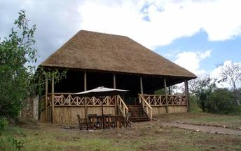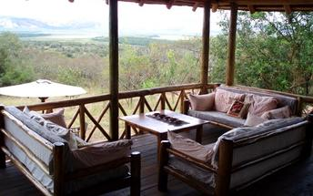

Basis
Full Board - Dinner, Bed, Breakfast and Lunch

Day 10: End of Itinerary

Day Itinerary
Early morning warm up tea, transfer for a game drive in search of the beautiful impalas, zebras, cape buffalos, elands, oribi, topis among other animal and bird species that your guide will help you spot. Return to your lodge for full breakfast and then proceed to Kampala. Arrive in time for lunch, if time allows go for souvenir shopping before airport transfer. (BB)

Basis
Full Board - Dinner, Bed, Breakfast and Lunch

Transport

Transfers
Date | Company | Pick Up | Drop Off | Time | Vehicle
 |  | The Boma Hotel Entebbe | The Boma Hotel Entebbe |  | Transfer
 |  | The Boma Hotel Entebbe | Paraa Safari Lodge |  | Transfer
 |  | Paraa Safari Lodge | Turaco Treetops |  | Transfer
 |  | Turaco Treetops | Mweya Safari Lodge |  | Transfer
 |  | Mweya Safari Lodge | Silverback Lodge |  | Transfer
 |  | Silverback Lodge | Mantana Tented Camp |  | Transfer

Urgent Contact Numbers
Company Name | Telephone | Email Address | Contact Person
CLASSIC SAFARIS LTD | +254 716 269009/255 | carol@classicsafaris.co.ke | Classic Reservations

Service Provider Directory
Service Provider | Ref. Number | Telephone | Address
Mweya Safari Lodge |  | +256 31 2260260
Paraa Safari Lodge |  | +256 200 414100 | 7HQF+X66, Paraa, Uganda
Silverback Lodge |  | +256 31 2260260
The Boma Hotel Entebbe |  | +256 39 3264810 | Plot 20A Gowers Road,  Entebbe,  Uganda
Turaco Treetops |  | +256 757 152323 | Kibale National Park, Uganda

Travel Information
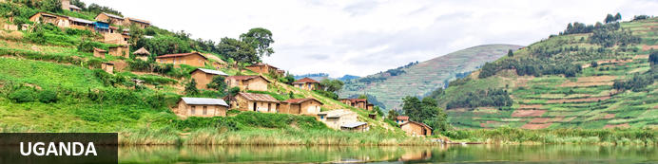
Uganda, or the ‘Pearl of Africa’, as it was famously dubbed by Winston Churchill, is characterised by relatively dry and flat savanna in the north, with verdant mountains in the West, and vast dense and remarkably lush forests in the central region. The nation is home to an astonishingly diverse range of African wildlife including the highly endangered mountain gorilla which can be found in the Bwindi Impenetrable Forest. A popular spot for wildlife watching is Queen Elizabeth National Park, which hosts four of the Big Five, a flock of flamboyant flamingos and the rare tree-climbing lions of Ishasha. Outdoor enthusiasts can get their adrenaline fix with plenty of whitewater rafting, kayaking, hiking, quad biking and horse riding facilities on offer. Add to this some friendly locals, a burgeoning cultural scene, and a capital city full of lively bars, clubs and restaurants, and it is easy to see why Uganda has gained itself a reputation as 'Africa's friendliest country'.

Entry Requirements
All visitors to Uganda require a visa and every visitor’s passport must be valid for at least six months from their departure date. Visas for Uganda can be obtained online if you want everything settled prior to arrival. There is also the East African Visa that allows you to move freely in between Kenya, Uganda, and Rwanda.
Visa Fees:
✓Single entry visa US$ 50
✓Multiple entry visa (6-12 months) US$ 100
Uganda Visa Requirements:
✓Passports : You need a valid passport, one that is expiring at least 6 months from the date you enter Uganda
✓Sufficient Funds: No amount is currently specified by the immigration but having a Credit Card and a return ticket are good evidence to convince the immigration officer that you have enough money with you.
✓Return / Onward Tickets: This is your evidence to prove that you have enough money on you, however, if you posses a one-way ticket, be ready to do some explaining to the immigration officer who might think you do not have enough funds to buy a flight out the country.
You will therefore need to present a visitor's pass for your next destination outside Uganda to avoid messing up your trip. You may actually have to buy a return ticket to your country before being allowed entry into Uganda, therefore, if you plan to leave the country overland, then organize your trip with an airline where a refund can be given for the unused ticket and at such dates and in search countries where you will be able to access the refund.
✓International Health Certificate: You will be requested to present this document to show that have received a yellow fever vaccine shot.

Banking and Currency
Uganda’s unit of currency is the Uganda Shilling and you’d be advised to get some on arrival as it is far easier to buy drinks, curios and meals in the local currency when travelling between destinations. You can exchange currency at any of the many forex bureaus OR banks in the country. US Dollars are widely accepted throughout the country though note that cash is best: traveler’s cheques and credit cards can be used at most lodges and in Kampala but attract hefty transaction fees. Euros, British Pounds, US Dollars, South African Rand and other major currencies can be exchanged locally or in advance of departure. Additionally, exchange facilities are available at various bureaus de change and banks in major towns have ATMs. It's advisable to request bank notes in smaller denominations, as it can sometimes be hard to get change from large notes and smaller notes are handy for smaller purchases and gratuities.

Travel, Transport and Getting Around
Fly Uganda (www.flyuganda.com), Eagle Air (www.flyeagleairuganda.com) and Aerolink (www.aerolinkuganda.com) offer scheduled and charter internal flights.
Domestic bus travel is cheap, but departures aren’t always on schedule. There are two classes of bus travel – matatu (minibus) or kigati (van) which travel fixed routes, and larger coaches or buses.
Self-drive and hiring a private car with a driver are other options. International hire companies are based near Entebbe International Airport and in the centre of Kampala. A four-wheel drive is recommended for rural areas. The speed limit is 80kph (50mph) or 100kph (62mph) on highways. Most car hire companies include breakdown cover. The Automobile Association of Uganda (www.aau.co.ug) can provide information and assistance.mAn International Driving Permit and adequate third-party insurance is required. UK driving licences are accepted. Drivers must carry their vehicle log books and must pay for a temporary road licence.
Whist some major roads are paved, the majority of minor and side roads are unpaved and can be bumpy and pot-holed, so drive with caution, especially in the rainy season.The roads are of variable quality and radiate from Kampala, although the network is sparse in the north. Whist some major roads are paved, the majority of minor and side roads are unpaved and can be bumpy and pot-holed, so drive with caution, especially in the rainy season. Note that there are still some army and police checkpoints on roads. Always keep vehicle doors locked and valuables out of sight.
Private taxis are identifiable by their black and white stripes. Boda-bodas (motorbike taxis) are often a cheaper option and, whilst fun, are not for the faint-hearted. Don’t be afraid to ask your driver to slow down if necessary as accidents are common.
Cycling in Uganda requires nerves of steel; many roads are dusty or under construction and motor vehicles rarely allow cyclists room. Always wear a helmet and use rear-view mirrors. Avoid cycling at night.
Uganda’s coach and bus services connect all major towns. The Post Office’s Post Bus Service (www.ugapost.co.ug) offers relatively comfortable buses and is more safety-aware than some other bus companies.
Most major routes are also covered by smaller white mini-buses. These are faster than coaches, but drivers wait until they are full before leaving and departure times are not fixed.
A passenger ferry links Nakiwogo Dock, south of Entebbe to Lutoboka on Buggala in the Ssese Islands on Lake Victoria. There is also a free vehicle ferry which runs from Bukakata, 40km (25 miles) east of Masaka, to Buggala. Lake taxis also link some of the other islands.
Passenger boats can be overloaded in Uganda and there have been several accidents, usually during the rainy season which can bring storms and high winds. Always makes sure boats have life jackets before you set off.

Health and Medical Information
You should seek medical advice from your local health practitioner before travelling to Uganda and ensure that you receive all of the appropriate vaccinations. As a guide Polio, Diphtheria, Hepatitis A & B and Tetanus are strongly recommended. Rabies and Meningitis are also recommended. There is a risk of malaria in Uganda so it is very important to check with your doctor before you go, to see whether malarial medication is required for the areas you are visiting. Generally, it is good practice to avoid mosquito bites by wearing long sleeved, light colored clothes and wearing a mosquito repellent that contains at least 50% DEET. It is strongly recommended that prophylactics (i.e., oral tablets) be taken as a preventative precaution. Following an outbreak of yellow fever in April 2016, the Ugandan Ministry of Health now requires all travelers provide proof of yellow fever vaccination.

Safety Notices
In general petty theft is common in Africa’s major cities and towns. Visitors should take the same care as they would normally take in any other destination worldwide. Keep a close watch on handbags, wallets, and cameras when walking in crowded places. Avoid walking at night and place your valuables in safe deposit boxes at hotels where they exist. Whereas at safari lodges and tented camps you are typically far from human settlement and crime is virtually nonexistent. We still advise that valuables be locked away in a room safe or kept under the supervision of the camp or lodge manager while on safari.

Food, Drink and Cuisine Advice
All water should be regarded as being a potential health risk. Water used for drinking, brushing teeth or making ice should be boiled or otherwise sterilised. Milk is unpasteurised and should be boiled. Powdered or tinned milk is available and is advised. Avoid dairy products which are likely to have been made from unboiled milk. Only eat well-cooked meat and fish, preferably served hot. Vegetables should be cooked and fruit should be peeled.
Ugandan cuisine draws on English, Arab and Asian – especially Indian – influences and uses home-grown local produce including plantains, sweet potatoes, corn, beans and cassava. It’s easy to eat cheaply almost anywhere in the country. International restaurants can be found in larger towns, with Indian, Chinese and Italian being the most popular.
Traditional foods include ugali (solidified maize meal porridge) served with a stew of groundnuts (peanuts), beans, chicken or meat such as beef, goat or mutton. Game can be found on menus in some restaurants and at safari lodges. Fish including the tiger fish, mukini, mputa and tilapia are popular.
Vegetarians may struggle outside of major towns, but Uganda’s Indian and Chinese restaurants generally offer a selection of vegetarian dishes. Traditional desserts include mandazi, a doughnut often served with cinnamon or sugar.
Although always appreciated, tipping is not standard practice. It is normal to tip 5 to 10% at tourist-orientated restaurants.

Climate and Weather
Uganda has a tropical climate, with temperatures ranging from 21-25°C (70- 77°F), apart from in the mountainous areas, which are much cooler; the top of Mount Elgon is often covered with snow. The hottest months are December to February. Evenings can feel chilly after the heat of the day with temperatures around 12- 16ºC (54-61°F).
Most regions of Uganda, apart from the dry area in the north, have an annual rainfall of between 1,000mm and 2,000mm. There is heavy rain between March and May and between October and November, when road travel can become difficult in parts of the country. The best time for trekking is during the dry seasons, between January and February and June to September. Wildlife viewing is best at the end of the dry seasons, when game is more concentrated around water sources.

Clothing and Dress Recommendations
During the day, temperatures in Uganda are generally warm so pack plenty of lightweight clothing. If you are going gorilla trekking, pack long trousers and long-sleeved tops, long socks to wear over your trousers as protection against ants, a pair of light gloves to protect against nettles, a hat and a raincoat.
A pair of sturdy, comfortable hiking boots is most important – try to break these in before your trip rather than wearing them brand new as you’re likely to get blisters. The mountains tend to be cold and damp so pack according to the altitude - a change of clothes and a warm fleece in your day pack, along with sunscreen and insect repellent are advised
Important: Gorilla trekking can be strenuous. Physical fitness is required
Gorilla trekking packing list:
- • - Sturdy walking boots or shoes (boots are better because they have better grip and support your ankles on hilly terrain)
- • - Breathable waterproof jacket and trousers. Even if it doesn’t rain, the ground and vegetation are generally wet. Wearing waterproof trousers means you can kneel to get gorilla photos or slide down slippery slopes.
- • - Long-sleeved shirt (to protect yourself from tree branches, the sun and insects)
- • - Gaiters (or long socks) to tuck long trousers into (to correct legs from scratches and keep insects out)
- • - A fleece or light wool sweater
- • - Sunglasses, sunscreen and sunhat
- • - Gloves to grip the vegetation (dime store or ‘pound shop’ gardening gloves are perfect!)
- • - Camera equipment (Extra batteries, Lenses, extra film, etc
- • - A walking pole. Will be provided. This is a big help for climbing up and easing yourself back down steep or muddy hills
- • - Plenty of water. Hydration is very important. Your lodge will provide you with a packed lunch and drinking water. (Don’t be afraid to ask for more than one bottle!)
- • - Tips (at your discretion) for your rangers and porter
- • - Lastly and most importantly: don’t forget to take your gorilla trekking permit and your passport (or the identification you used when reserving your permit). You will need to show your ID at the pre-trekking briefing.

IMPORTANT:
*Pack all of this in a small backpack.
• NOTE: Mornings in the mountains can be cool and nights can be cold. You will probably experience mist and quite possibly rain while you are trekking the gorillas. It can also get quite hot, from the sun and/ or the hiking uphill. Layered clothing is recommended, ideally the ‘wick-away’ moisture type.

EXTRA PACKING LIST:
Feel free to choose / add what you need;
• 1 – 2 pairs of light weight trousers / slacks – that can dry quickly if wearing on treks
• 1 Pair of shorts
• 1 – 2 long sleeved shirts – preferably quick drying
• 2 – 3 short sleeved shirts – preferably moisture wicking
Casual clothes for evenings:
• 1 – 2 pairs of light weight trousers / slacks
• 1 – 3 sports / long sleeved shirts and / or blouse
• 1 dress / skirt for ladies
*Exterior clothing:
• 1 Lightweight waterproof / windproof / breathable jacket, e.g. Gortex / Event type fabrics
• 1 Fleece, sweater or sweatshirt
• Sturdy / lightweight waterproof walking boots – trousers / pants should be tucked into socks and boots while trekking (heavy soled rain boots or gaiters also work well)
• 1 Pair of shoes for evening wear
• 1 Pair of sports sandals will be useful, e.g. TEVA
• Swimsuit (and a plastic bag for packing in)
• Bush hat with a brim for sun protection
• Underwear
• Lightweight wool socks
• Gloves – gardening or similar (for gorilla tracking only)
*Miscellaneous:
• Towel – many lodges provide these, but if needed we suggest taking trek towels. These are lightweight, pack to a small size and dry quickly. Best to get a large or extra-large.
• Gaiters.
• Sunscreen and moisturizing cream
• Sunglasses with neck strap
• Insect repellent with DEET, please note that DEET can effect man-made fibers and plastics.
• Daypack / small rucksack
• Binoculars
• Alarm clock – though our staff will wake you
• Ear plugs
• Spare / extra batteries
• Camera and extra lenses
• Camera charger / converter / adapter for 220 / 240 AC voltage, plus cigarette lighter adapter is useful
• Film – particularly fast film for the primates (400 – 1600ASA)
• Personal toiletries /Prescription medicines and the prescription itself
• Wet-wipes / tissues
• Back-up glasses especially if you wear contact lenses
• Wash cloth and plastic bag (if needed)
• Ziplocks / dry bags and other plastic bags for keeping valuables dry or storing wet clothes
• Torch / flashlight – LED models are light weight and have a good battery life
• Sewing kit (needle, thread, safety pins)
• Small notebook
• First Aid Kit – including anti-diarrhea medicine, rehydration sachets, aspirin, cold medication, antiseptic cream, band-aids (plasters), motion sickness pills, lip balm, eye drops and personal medication
• Photocopies of your passport, visas, credit cards and airline tickets (it is advisable to have 2 sets to keep in separate places)

Internet Availability
There are internet cafés in most large towns. Access in smaller towns and rural areas is limited.

Electricity and Plug Standards
Electrical sockets (outlets) in Uganda are the "Type G " British BS-1363 type. If your appliance's plug doesn't match the shape of these sockets, you will need a travel plug adapter in order to plug in. Travel plug adapters simply change the shape of your appliance's plug to match whatever type of socket you need to plug into.
Electrical sockets (outlets) in Uganda usually supply electricity at between 220 and 240 volts AC. If you're plugging in an appliance that was built for 220-240 volt electrical input, or an appliance that is compatible with multiple voltages, then an adapter is all you need.
But travel plug adapters do not change the voltage, so the electricity coming through the adapter will still be the same 220-240 volts the socket is supplying. North American sockets supply electricity at between 110 and 120 volts, far lower than in most of the rest of the world. Consequently, North American appliances are generally built for 110-120 volts.

General Guidance
Uganda Time Zone: -
Uganda is 3 hours ahead of GMT and does not observe daylight savings.
People & Culture:
Uganda is a conservative country and visitors would do well to adhere to local rules of behavior. That said, visitors often remark on the friendliness and politeness of the locals: greetings are an elaborate affair and may include inquiries as to the health of your family - perfunctory greetings and a demand for immediate action are somewhat frowned upon!
Tipping:
Tipping in Uganda is highly appreciated. It's just recognition of a good service offered, and it's completely to your own discretion. Tipping wholly depends on your personal budget and decision.
Tipping of around 10 - 15% is customary in Uganda for good service. Tips are usually given in Uganda Shillings or US Dollars. Safari guides should be tipped the equivalent of USD $10-15 per person per day and a few dollars should be put in a communal tip jar for the driver, cook and porters. If you eat in a restaurant then 10% on top of the bill is a suitable amount to leave.
If you are doing a gorilla trek, tipping is at your discretion - your porter (if you choose to take one) should usually receive the highest tip, with a second tip distributed between your guides, trackers and security personnel.
SOUVENIRS:
Traditional African handicrafts can be found throughout Uganda at very reasonable prices and make great souvenirs. Buying carved wooden masks and sculptures made by local artists is a good way to support the community and make sure you go home with something unique and authentic. There are plenty of other items on offer that will jazz up your home such as bowls, batik paintings and woven baskets.
Those looking to spice up their wardrobe needn’t look far whilst in Uganda. Bright fabrics with stunning African patterns can be easily purchased and either taken home as they are or turned into clothes by one of the local tailors. Once again, you will be providing valuable income for locals by getting your own custom-made clothes and you can be sure no-one will walk around wearing the same thing as you back home.
DUTY FREE ALLOWANCE:
Travelers over the age of 18 are permitted to bring the following into the country:
• 250g of tobacco products
• 1L of spirits or 2L of wine
• 500ml of perfume and eau de toilette, of which up to 250ml may be perfume
• Goods up to the value of US$500 (for returning residents)
The following are banned from being imported into Uganda: narcotics, pornography, counterfeit items, cultural artefacts and explosives are not permitted. Some medication may also be restricted - check before you travel. You must obtain a permit to import hunting weapons, live animals, fruit, flowers, cuttings or seeds
INTERNET/ WIFI:
You will be sure to find a WiFi connection in the majority of safari lodges & hotels. Note that you may have network difficulties outside the lodges / during safari activities
CELLPHONES:
Tri - band and quad-band cell phones work in most major African cities and towns however you must check to ensure your service provider has an agreement with the local provider. Also check rates as these can be up to US $3 per minute. Cell phones work at some safari lodges and camps where there are cell phone towers. Satellite phones are a great option for travelers who must stay connected. Keep in mind most lodges and camps require guests to keep satellite phones turned off and use them only for outgoing calls so as not to disturb other guests. Also keep in the high per minute call rates.

Terms and Conditions

CLASSIC SAFARIS LTD Terms and Conditions
CLASSIC SAFARIS LTD TERMS & CONDITIONS AGREEMENT
Classic Safaris Ltd Inclusions & Exclusions
Inclusions:
Accommodation in carefully selected properties in all East African countries as per the itineraries.
Transport in 4 X 4 Land cruisers or comfortable safari minibus, driven by a naturalist driver/guide.Multi lingual driver guides can also be provided.
Two ½ size bottles of mineral water each day for each guest while on safari.
All meals while on safari as per the itineraries.
All park entry fees as per itineraries.
All transfers as indicated in the itineraries.
Exclusions:
International flights
Things of personal nature and any other service not included in the itinerary
Passport and visa fees and service charges for obtaining visas.
Personal and baggage insurance.
Cost for anything not specifically mentioned in the listing above.
Laundry, beer and non luxurious spirits
How to Book:
Send a non-refundable deposit of 30% of the total tour cost. On receipt of your deposit, subject to availability terms, we will reserve a place on your selected safari.
Final Payment
Final payment is due one month prior to departure. Costs of gratuities to driver guides, lodge/hotel staff, as well as any excursion not related to the safari, and other items of personal nature are not included.
Cancellation & No Show
Reservations/Bookings that are cancelled, reduced in length of stay or reduced in numbers of participants (hereinafter collectively called CANCELLATION) are subject to cancellation and No Show fees. The scale of charges, expressed as a percentage of the tour prices, is as follows:
More than 8 week notice: - Deposit refunded less 5% handling fee
8 weeks – 4 week notice: - 50%
Less than 3 week notice: - 60%
Less than 2 week notice:- 90%
Less than 1 week notice:- 100%
Should you fail to join a tour or join it after departure or leave prior to its completion, no tour fare refund can be made. (Please note that if the reason for the cancellation falls within the terms of any holiday insurance policy, which you hold, then the insurance company, subject to the terms of your insurance will normally refund any such charges to you).
Accommodation Substitution:
Should the case arise whereby accommodation is not available at the quoted hotels/Lodges/Tented camps alternative accommodation will be provided at hotels/lodges/tented camps of similar caliber.
Refund:
Whilst the company uses its best endeavors to ensure that all anticipated accommodation is available as planned, there shall be no claim of any nature whatsoever against the company for a refund either in whole or part, if any accommodation or excursion is unavailable, or the passenger was unable to use this service.
Diet:
Guests with special dietary requirements are advised to warn us well in advance before your departure.
Luggage:
Please keep your luggage light – soft duffel bags are preferable. Luggage is limited to 15kg per person on internal local flights.
Passport and visas:
The onus is upon the client to ensure that passport and visas are valid for the countries listed. The company, its staff and its agents cannot be held liable for any visas etc. not held by the clients.
Photography:
The company reserves the right without further notice to make use of any photography or film taken on safari by our staff for general purposes without payment or permission.
Check-in and Check-out times:
Rooms are available for check in at 1200 Noon on the scheduled arrival date. Rooms should be vacated by 1000Hrs on the scheduled departure date. Special consideration may be extended on departure time subject to anticipated arrivals.
Changes to Schedule:
Although every effort is made to adhere to schedules it should be borne in mind that the Company reserves the right, and in fact is obliged, to occasionally change routes and accommodations on safaris as dictated by changing conditions. Such conditions may be brought by force majeure” or statutory directive, seasonal rainfall on bush tracks, airfields and game areas, or game migrations from region to another or reservation problems, etc. However, the company shall make all reasonable efforts in resolving the situation not limited to offering alternative
Airline Clause:
Flight fares, taxes and schedules are subject to change without prior notification by the airlines. The company will not be held liable for these changes and delays. The airlines cannot be held liable for
act, omission or event during the time the passengers are not on board their plane or conveyance. The passengers’ tickets in use by the airline or by other carriers concerned when issued, shall constitute a sole contract between the airline and the purchaser of these tickets and or passengers. Please note that the company subcontracts the flying services to independent charter operations, and they are responsible for the flying. The same will apply to train services.
Guide Substitution:
If one of our guides is unable to take a safari due to illness or other reasons, we reserve the right to substitute with another guide.
Prices:
We will do our outmost to keep the prices as quoted or published. Should fluctuation in statutory taxes, exchange rates, etc. force increases on us; we reserve the right to surcharge without notice, up to maximum of 10% of the tour rate.
Participant Incompatibilit:
The company may, at its discretion and without liability of its cost to itself, at any time cancel or terminate the passengers booking and in particular without limiting the generality of the forgoing, it shall be entitled to do in the event of illness or illegal or incompatible behaviour of the passenger, who shall in such circumstances not be entitled to any refund.
Publicity Materials:
The company reserves the right to use any photograph or film taken during the safari by any appointed representative of The Company, for the use in The Company’s advertising or publicity material, without obtaining further consent from the client prior to the departure of the client’s appointed safari
Fitness:
The client acknowledges that the safari can sometimes be demanding and it’s his/her responsibility to ensure that he/she is sufficiently fit and able to embark on the tour.
Authority of the Safari Leader:
Clients will accept the authority and decisions of the safari leader appointed by the Company. The final decision on the itinerary, accommodation and conduct on the safari will be taken by the safari leader appointed by the Company.
Liability:
The company is insured against legal liabilities arising from any injuries which might be received by passengers in its vehicles. The Company’s liability to passengers carried in its vehicles is governed by the laws of Kenya and no other Country, and all claims subject to the jurisdiction of the courts of Kenya.
The Company reserves the right to employ sub-contractors to carry out all or part of the Services agreed to be supplied and in the event of the exercise of such right the terms of clause relating to The Company is subject to the booking conditions and cancellation provisions of the Travel organizer or the airline concerned.
Neither the Company, nor any person acting for, through or on behalf of The Company shall be liable for any loss or damage whatsoever and without restricting the generality of errors or omission
contained in the brochure or other literature, late or non-confirmations or acceptance of bookings, loss or damage caused by delays, sickness or death whether occasioned by the negligence or not.
In addition, The Company shall have the right at any time at its discretion to cancel any tour or the reminder thereof or make alteration on route, accommodation, price or other details and in the event of any tour being rendered impossible, illegal or inadvisable by the weather, avalanches, strike, war, government or interference or any other cause whatsoever. The extra expense incurred as a result thereof shall be the responsibility of the passenger.
Please be aware that these safaris may take you into close contact with wild animals. Attacks by wild animals are rare, but no safari into the African Wilderness can guarantee that this will not occur. Neither the company, nor its employees, nor its agents can be held responsible for any injury or incident on the safari.
Governing Law:
All terms and conditions of this agreement shall be governed by and construed in accordance to the laws of Kenya, and any litigation necessary to resolve disputes between the parties shall be field in the courts located in Kenya where such a dispute cannot be solved through arbitration.

