7 day Classic Namibia Camping & Accommodated Self-Drive 2021
Sesriem - Swakopmund & Coastal Strip - Etosha South
7 Days / 6 Nights
Group Size: 2-4
Reference: 7day CN C&A SD2021
Date of Issue: 07 October 2020

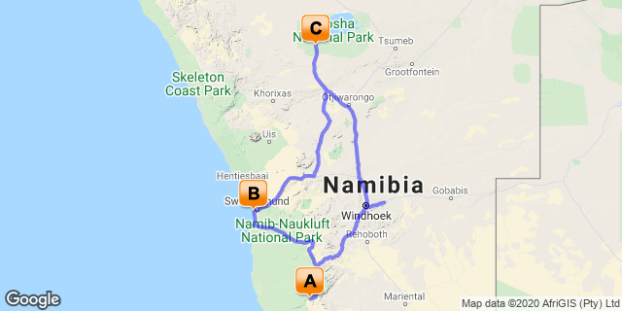

Click here to view your Digital Itinerary

Introduction
A short camping self-drive for those with limited time and wishing to see the two main destinations of Namibia - the recently declared UNESCO World Heritage Site of the Namib Naukluft Sand Sea and famous Sossusvlei dunes, and Etosha National Park for superb game viewing opportunities and regarded as one of the best places for animal sightings. Overnight in the coastal town of Swakopmund between the main destinations. A fully accommodated mid-range and luxury version of this self drive is also available

Accommodation | Type | Destination | Basis | Duration
Sesriem Oshana Campsite |  | Sesriem | SC | 2 Nights
Hotel Pension A La Mer |  | Swakopmund & Coastal Strip | B&B | 1 Night
Okaukuejo Campsite |  | Etosha South | SC | 3 Nights
→ Halali Campsite | alternate
→ Namutoni Camp | alternate

Key
SC: Self Catering
B&B: Bed and Breakfast

Price
2021 Rates manual vehicles
Price per person to Chameleon with Bidvest Car Rental
Based on 2 people sharing with a 4x4 Double Cab with camping equipment & 1 roof tent
Low Season (01/11/20- 30/06/21) N$9,420
High Season (01/07/21 - 31/10/21) N$12,645
Based on 4 people sharing with a 4x4 Double Cab with camping equipment & 2 roof tents
Low Season (01/11/20- 30/06/21) N$6,485
High Season (01/07/21 - 31/10/21) N$8,330
Single supplement N$330
(Price valid until 31 October 2021)
Please note that the N$ is fixed to the South African Rand on a 1/1 basis

Included
Campsites and accommodation as set out in itinerary; car rental as indicated; meals as stated in itinerary; vat; tourism levy; welcome pack; e-med evacuation insurance
Bidvest Car Rental - zero excess
Includes: Unlimited kms, Super CDW, Super theft loss waiver; stamp duty, third party liability; VAT; airport surcharge; map, inbound guide; full camping equipment for 2/4 people with 1 (for 2 people) roof tent or 2 (for 4 people) roof tents; 1 spare wheel; tyre & windscreen cover

Excluded
International and other flights; visas; fuel; additional meals and optional activities; personal insurance; tips/gratuities; items of a personal nature to include repatriation and cancel any reason policy; curios; entry fees to parks and places of interest; extras for car hire as indicated below, any other services not indicated etc
From 2021 proposed park entry fees: N$250/person/day; N$100/child under 16years and N$50/vehicle day – subject to change - please note that visitors must be in rest camps or outside the park - gates open/close at sunrise/sunset
Bidvest Car Rental:
Excludes: Rental deposit N$3768; contract fee N$105; fuel; tyre/rim/glass (all) waiver N$120/day combined; refuelling fee N$33(if more than N$50); additional driver per rental N$390; young driver surcharge N$412 per day (18-20 yrs); fine handling fee N$295; claim handling fee N$1331; Assessors fee in event damage is greater than N$5000 N$1270/incident; baby seat/booster seat N$484/rental; GPS unit N$120/day (deposit N$1000); jerry can N$502/rental (plus refundable deposit of N$110); second spare wheel N$165day and deposit of N$1100; delivery/collection fee during office hours – Within 25km N$530; Further than 25km N$530 + N$18/km; delivery collection after hours /weekends N$900 within 25km; further than 25km N$900 + N$18/km; Overdue rental admin fee N$880 per incident; water/sand/and undercarriage damage renters account; hail damage N$55/day; towing charges if not mechanical - renters account; no show fees/cancellation T&C; lost keys surcharge /call out N$693 + N$18per km & replacement of keys; valet service (only if car excessively dirty) - renter account; damage to equipment - renter account; towing - mechanical (Bidvest); towing - accident - renter account; carbon emission tax N$165/rental; cross border fee N$1997 when applicable; one way fee when applicable
Note: Bidvest Car Rental has offices both in Windhoek City Centre and also at the International Airport – you are able to collect and drop your vehicle at either/both destinations
Prices quoted for extras on car rental are guideline and subject to amendment by car rental company

Day 1-2: Sesriem Oshana Campsite, Sesriem

Day Itinerary
Collect your vehicle after breakfast, meet with a tour consultant who will go through your itinerary with you and answer any last-minute questions you may have, and leave the city behind. You'll drive southwest to Sesriem Oshana, a campsite inside the park for entry to the famous sand dunes of Sossusvlei. You’ll enjoy some of Namibia’s stunning landscapes along the way and once at Sesriem relax by the nearby swimming pool and suggest you visit nearby Elim’s Dune for sunset. This dune is the first in this famous sand sea as you enter the National Park and a wonderful spot to watch the sun dip behind the dunes and see mountains opposite change colour as they deepen from pale hues to deep purple.
The following day rise early to venture further into the dune field for sunrise, perhaps stop at Dune 45 first, or alternatively continue to the 2x4 car park and from here either hike or take the shuttle service to Sossusvlei and the dramatic desert and sand region. Ensure you visit Dead Vlei, a ghostly pan of cracked white clay featuring ancient skeletons of long dead camel-thorn trees, set against the backdrop of orange sand dunes and blue sky - a photographer’s delight. Return to camp at leisure once you have sated your appetite for this incredible desert landscape, and later this afternoon perhaps visit nearby Sesriem Canyon. Overnight camping only, all meals will be at client’s expense. (Please note that the last 5km from 2x4 car park is 4x4 driving with deep sand – we do not recommend clients drive this last section – the shuttle can be booked and paid for upon arrival). Day 1: Approx 5-5.5hours from city; Day 2: Approx 1hour from Sesriem to 2x car park

Expert Tips
Note: we recommend early morning flight arrival, the drive from the city is approx. 40mins, checking and collection of vehicle can take around 1hour, and the drive to the desert is approx. 5-5.5hours. Flights arriving later can mean arrival after dark (in winter), and we do not recommend driving in the dark; consider spending a night in Windhoek before your adventure if you arrive late morning or in the afternoon
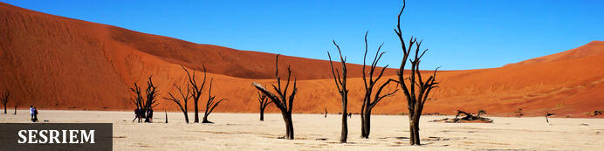
As there is no accommodation at Sossusvlei, visitors to this desert wilderness are likely to end up staying near to Sesriem, 65km away, where camps and lodges serve as a base from which to explore the dunes and where it serves as entry point to the national park. Sesriem Canyon, a deep chasm carved through the rocks by water, is a striking natural feature of the area that is best explored on foot. Stony walls rise up sharply on both sides of the canyon, while birds roost in its crags and lizards dart along the ledges. The canyon’s name was coined when early settlers used it as a water source, using six lengths of leather (‘ses riem – six thongs) tied together to lower buckets into the water at the base of canyon.)

Optional
Dead Vlei
Dune 45
Sesriem Canyon

Dead Vlei
This ancient clay pan was once an oasis, studded with acacias and fed by a river that suddenly changed course, leaving the earth to dry up along with the trees it previously supported. So dry were the climatic conditions that the trees never decomposed – instead they were entirely leached of moisture so that today, 900 years later, they remain as desiccated, blackened sentinels dotting the pan’s cracked surface. Surrounded by the red-pink dunes of the Namib Desert, blue skies, a white-clay pan, they create a surreal spectacle that is a photographer's dream.
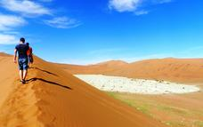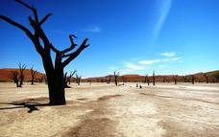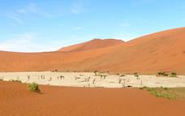

Dune 45
Dune 45 is located 45kms from the Sesriem gate, (and entrance to dunes), it is renowned for its elegant shape, which – along with its position close to the road – has earned it the distinction of ‘most photographed dune in the world’.
Popular for sunrise, many people climb to gain a vantage point to watch the sun rise over the surrounding area and enjoy the changing colour of the dunes, at only 80 metres and featuring a much gentler gradient it is an easier climb than many of the other dunes found.
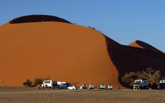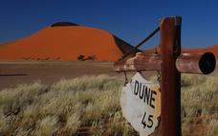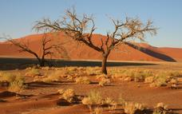

Sesriem Canyon
Sesriem Canyon, a deep chasm carved through the rocks by water, is a striking natural feature of the area that is best explored on foot. Stony walls rise up sharply on both sides of the canyon, while birds roost in its crags and lizards dart along the ledges. The canyon’s name was coined when early settlers used it as a water source, using six lengths of leather (‘ses riem – six thongs) tied together to lower buckets into the water at the base of canyon.
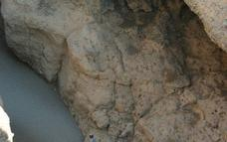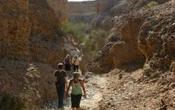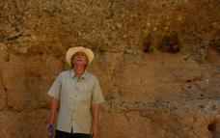

Overnight: Sesriem Oshana Campsite
Sesriem Oshana opened in 2020 and offers ten (10) self-catering campsites, each having its own private ablutions with toilet and shower, braai area, wash-up kitchenette with hot and cold water and 220V electricity points. Campers have full access to the shop, bar, restaurant and swimming pool at neighbouring Sesriem. It's located inside the national park, 600m from the permit office and 800m from Elim Dune.
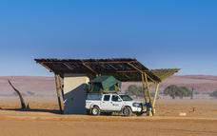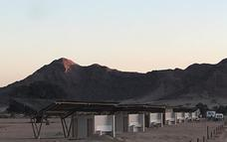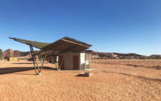

Basis
Self Catering

Day 3: Hotel Pension A La Mer, Swakopmund & Coastal Strip

Day Itinerary
Depart after breakfast and drive through the desert with its endless views across the pastel-coloured gravel plains to the port town of Walvis Bay, famous for the lagoon – a protected RAMSAR wetland site where you may see birds such as greater and lesser flamingos, pelicans, various water birds and perhaps the endemic Damara tern. The coastal drive north from Walvis Bay is where the dunes and ocean collides and takes you to the quaint town of Swakopmund - full of historic and ornate buildings. Once here and if time permits, you can join optional adventure activities such as quad biking or a scenic flight. Overnight bed and breakfast basis in twin room with en-suite facilities. Comfort 2.5-3*Approx 5-5.5hours
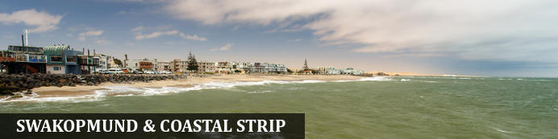
Founded in 1892 as the main harbour for German South West Africa, Swakopmund is often described as being more German than Germany. Now a seaside resort, Swakopmund is the capital of the Skeleton Coast tourism area and has plenty to keep visitors happy. The quirky mix of German and Namibian influences, colonial-era buildings and the cool sea breeze make it very popular and has a wide range of accommodation establishments, banks, restaurants/cafes and shops.
Along this stretch of coastline (Walvis Bay and Swakopmund) you can take part in a selection of activities sating the thirst of those seeking adrenaline adventures - sky diving, quad biking and sandboarding; or for the more leisurely a range of marine activities including kayaking and cruises. The coastal desert can also be explored with trips to Sandwich Harbour, or informative desert tours... There is a long list so just ask us!
Walvis Bay is Namibia's major harbour town and the lagoon has prolific bird life including flamingos, pelicans as well as the breeding area for the endemic Damara tern - any bird enthusiast should make a stop here.
Further north along this coastline - part of the Skeleton Coast, you'll find shipwrecks and the famous Cape Cross seal colony - one of the largest fur seal colonies in the area.

Optional
Walvis Bay Lagoon

Walvis Bay Lagoon
Walvis Bay’s calm natural lagoon is a twitcher’s paradise, teeming with roughly 50 species of seabirds, including vivid flocks of flamingos, bulky-billed pelicans and glossy black cormorants. It’s also a popular spot for windsurfing, kitesurfing and kayaking, while the promenade stretching for three kilometres along the water’s edge is a great place for a scenic stroll.
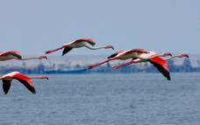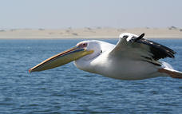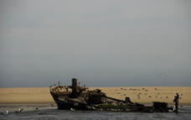

Overnight: Hotel Pension A La Mer
Hotel Pension A La Mer offers you charming accommodation with en-suite bathrooms just metres from the beach and the heart of the old town. There are 23 en-suite rooms ranging from simple standard, which are a little more traditional through to their luxury rooms - though these are quite sparse they offer good value for money. There's a bar, restaurant for breakfast and small curio shop. A warm and friendly atmosphere, 24 hour security and secured parking are all part of the service. Wifi available. Twin/double/triple and family rooms are available.
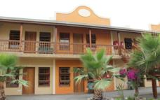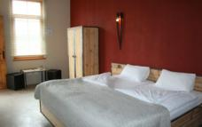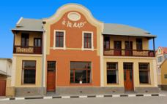

Basis
Bed and Breakfast

Day 4-6: Okaukuejo Campsite, Etosha South

Day Itinerary
Your destination today is the remarkable Etosha where you’ll spend the next three nights enjoying game drives in this premier park, one of the largest and best game reserves in Southern Africa recognised for the numbers and various species of game as well as interesting geology. Each of the traditional rest camps has a swimming pool, bar, restaurant and small shop, and a floodlit waterhole which during the dry winter months offer some amazing sights as animals come to drink, if you are lucky you may get to see black rhino, elephant, lion, hyena, as well as large numbers of plains game. During your stay it’s also worth stopping at the Etosha Pan viewpoint on the edge of the expansive white pan, the heart and essence of the park. Overnight camping only, all meals will be at client’s expense. Approx 5.5-6hours
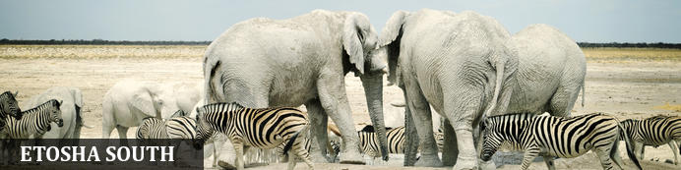
The national park can be accessed via the southern entrance at Andersson’s Gate and the central point is Okaukuejo Resort. Visitors can catch a glimpse of abundant wildlife including: lion, giraffe, elephant, white and black rhino, and a multitude of plains game. Popular activities include: game drives, tracking rhinos on foot, guided nature walks, or watch the sunset over this magnificent landscape. Just outside the national park is the upmarket Ongava Private Reserve, as well as a number of mid-level accommodation and camp sites.

Optional
Etosha Pan

Etosha Pan
Aeons ago, Etosha Pan was the bed of a vast lake; today what remains is a glittering, silvery-green salt pan that stretches across roughly 5000 square kilometres. Etosha is protected by the Etosha Pan National Park surrounded by savannah plains and woodlands supporting large herds of elephants. When dry, the pan sustains little life except for the algae that gives it its distinctive colour, and migratory birds that use it as a pit stop, but with heavy rain it becomes a shallow lake (east side) where flamingos breed, pelicans wade and feed, and a variety of mammal species come to quench their thirst, including predators such as hyena, lion, cheetah, and leopards along with rhinos, and antelopes.
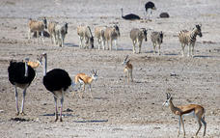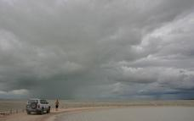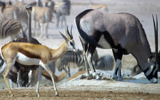

Overnight: Okaukuejo Campsite
Okaukuejo is located 17 km from the southern entrance of the park Anderson Gate, is the oldest tourist camp in Etosha and functions as the administrative centre of the park and home to the Etosha Ecological Institute. It is situated at the western end of the Etosha Pan in the south section, facilities include a restaurant, bar, shop, swimming pool, and kiosk. Wifi available (extra charge).The main attraction of this camp is the floodlit permanent waterhole where a wide diversity of wildlife congregate and interact from lion to rhino to elephant and antelope. The spectacle starts at dawn, with animals coming in large numbers to quench their thirst and continues throughout the day until late at night. In the early evenings, it is not uncommon to have black rhino, elephant and lion all drinking at the same time. The campsites are located near to the waterhole and along the boundary fence. Some smaller sites are set on a concrete base near the shared ablution and washing/kitchen facilities, with others a little further away. There is an electric point on most.
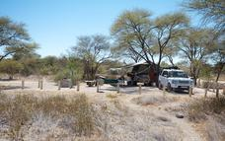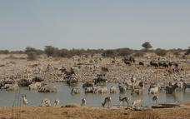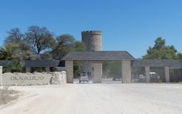

Alternate: Halali Campsite
In an otherwise flat area Halali Campsite is perched between a few hills and koppies. Thicker vegetation makes this popular with leopard, rhino and elephant. Situated halfway between Namutoni and Okaukuejo, the Halali Campsite is centrally located in close proximity of some of the most popular waterholes of the Etosha National Park. A short walk will take you to the camp’s floodlit waterhole with excellent day and night game viewing. ‘Halali’ is the German word for the traditional ending of a hunt. The campsite signifies the end of game hunting and the rise of eco-tourism in Namibia. Halali offers active guests the largest pool in the park and its strategic location between Namutoni and Okaukuejo makes it a great stopover for lunch, ice cream, a cool drink or just petrol. There are a number of campsites located around shared ablution blocks and most sites have an electric point and braai pit. Please note that there is little grass so it can get dusty here but the waterhole is generally good.
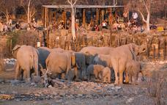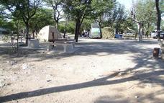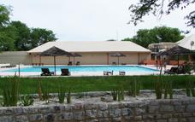

Alternate: Namutoni Camp
Built close to an old German Fort, Namutoni Campsite has a unique atmosphere. From the walls of the fort you can enjoy an elevated view of the King Nehale waterhole allowing for great game viewing without leaving the camp. Namutoni is situated in the eastern part of Etosha National Park and is accessible via the Von Lindequist Gate. Its close proximity to Fisher’s Pan makes it a hotspot for birders particularly during the rainy season when migrants such as blue crane visit. The camping area has generously spaced sites with plug point, light, braai facility and communal ablutions on either side of the campsite. Guests have access to the swimming pool, waterhole, restaurant, bar etc
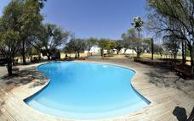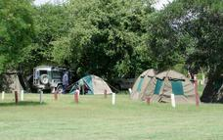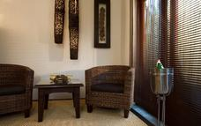

Basis
Self Catering

Day 7: End of Itinerary

Day Itinerary
After a final game drive, start your drive to Windhoek, en-route you may choose to stop in Okahandja, a small town that sells a wide variety of crafts and art and buy any last-minute gifts. Continue to Windhoek and drop off the rental vehicle in time to connect with your onward flight. No flights before late afternoon/evening, or recommend a night in/around Windhoek. End of services.
Approx 6-7hours from gate plus game drive to Windhoek, you will need to also allow time to drop off vehicle.

Expert Tips
As with all car hire companies if you have an accident and they prove you were negligent– for example - speeding then the zero excess becomes void and you are liable. You will complete the contract and discuss any extras with the car rental company upon collection of the vehicle – please check the vehicle carefully as you are responsible for it thereafter. If you have any problems with the car whilst you are on the road please contact them directly. All car rentals will require you to provide your passport, driving licence (written in English or an international licence), as well as supply a credit card for the refundable deposit. Fully equipped vehicles are provided with 1 or 2 roof tents (as indicated above, along with full camping equipment – essentially all you will need for day to day travelling including table/chairs; bed linen and general kitchen/cooking equipment including cool box, there is a list of full equipment should you wish. A GPS is often available by the car rental companies (at clients own expense), however, we do find that due to our road network system (and small population), it is not normally required, we realize this is a personal preference and are happy to pre-book for you. Outside of major towns/cities please do not drive on gravel road around/after sunset.
Travel times: When we give travel times in the itinerary please note these are a guideline and perhaps will only in one brief stop travelling at average speed – some clients will drive slower or stop multiple times enjoying longer breaks and therefore journeys will take longer. We recommend most days when travelling onto another destination to leave after breakfast to allow plenty of time to arrive in plenty of time and enjoy the location
Please note that this quote is based on the availability of both camping/ accommodation & vehicle and on the understanding that no bookings have been made. Should we need to use alternative options the price and itinerary is subject to change. . Note this option uses camps inside Etosha National Park, this is government run and as such service/food etc can be erratic and not always to the same standards as privately-run establishments but has the benefit of the floodlit waterholes. Most campsites have shared ablution facilities. For accommodation we try to indicate a comfort rating but note we do not have a set "star" system so this is to give you a guideline only.
Namibia is an incredible country to visit but please remember that we are in Africa and that not all standards are the same as you would get in Europe or other first world countries. To the majority of our clients, that is part of the appeal of travelling to destinations such as ours. If you are not comfortable with new challenges then you may wish to consider other companies or destinations.
Money: The currency in Namibia is the Namibia Dollar, which is fixed to and equals the South African Rand on a 1-1 basis. The dollar and SA Rand are the only legal tender in Namibia and both are used freely, however the Nam dollar is not legal tender in South Africa and we recommend that you exchange your money prior to departing Namibia
Credit Cards: Visa and MasterCard are generally accepted in shops and restaurants in towns and many lodges. Use of credit cards may incur an additional fee. Occasionally lines may be down and services not available particularly in remote destinations and payment will need to be in cash
Cash: South African rand can be purchased in advance. The Namibia dollar is not an international currency and therefore can only be obtained in country. Cash is available at ATM machines using credit card and pin number. There is FX bureau upon arrival at International Airport for those arriving by air and can be worth obtaining prior to arriving in city.
It is customary to tip in Namibia, usually, around 10% at restaurants.
Safety: As with every destination safety tips needs to be adhered to; we strongly recommend you use a safe in a hotel/lodge or lock up your valuables when you are not in the room; when in a vehicle do not leave valuables on display but tucked away and out of sight. It is also better to have copies of passports, money; cards etc split between travellers so if anything unexpected happens and a bag is lost or stolen then other funds/cards are available, you may also wish to consider using a money belt/neck wallet. We suggest you leave valuable jewellery at home – you won’t need it while travelling. A padlock for your luggage is also recommended.
Booking & payment: When you have decided on a trip a booking form will need to be completed, signed and returned to us and we will enquire regarding availability and advise you. Once we have taken deposit, a confirmation is sent to you, advising you of the services agreed and booked. Payment is due approximately 6 weeks (sometimes 8 weeks depending on the supplier) prior to departure. Exchange 4 free, bank transfers and MasterCard/Visa are all accepted forms of payment but please ensure there are sufficient funds and your bank is aware of the transaction about to take place (if you are paying via credit card), in this day and age many banks will withhold money as a safeguard against fraud and this delay can be critical particularly if you are booking at short notice. Please also allow for payment to process and if paying via bank transfer to include all bank fees, note we are unable to confirm bookings/trip until funds have cleared into our account, any delay may see a cancellation in your trip and booking released.
Weather: Please note that in winter evenings and nights in particular can be very cold we recommend layered clothing – day time temps can be 25°C so t-shirts and shorts is great for then but thermals are very useful for evenings/night. Summer temperatures can exceed 40°C but also bring our rainy season so a lightweight rain jacket is handy, as with most places layering is the most recommended way of clothing – please ensure you pack your clothes in plastic bags and ensure cameras/electrical equipment is suitably protected. More information is available in pre-departure information
Climate: The African sun is very strong. Please use a factor 30 sunscreen and wear a hat. You should drink at least 3 litres of water per day to avoid dehydration. It can also get very cold during winter months on this route
Electrical: plugs are 220V and are 3 pin (round pin as opposed to square pin). Adaptors can be purchased in Windhoek and most international airports; they are the same as South Africa if you are shopping in home country or at airport. Some lodges will also offer 2pin sockets or adaptors but please do not rely on this, it is much better to bring your own. It is possible to re-charge batteries at camps but clients must be responsible for security of their possessions and note that not all campsites will have electric points so consider bringing a charger for the vehicle
Insurance: It is essential that you purchase comprehensive personal travel insurance before you embark on your holiday, medical insurance is insufficient. Travel insurance is for your own protection and should include evacuation and cancel any reason/covid policy; we also recommend full cover for baggage loss etc and consider it to be an essential part of modern international travel. Some operators we work with will request seeing a copy of this documentation before the start of your trip so please ensure you have this on hand. If you have credit card insurance – please contact your bank for these details prior to arriving in-country. If you are uncertain whether this is enough please contact us when you book to ensure you have adequate cover
Health: Namibia is a low risk malarial destination but we recommend that seek professional medical advice to enable you to make decisions on personal malaria protection. Note that Etosha is considered a malaria region (low risk) particularly during rainy season though most areas further south (from Okonjima south are regarded malarial free). No vaccinations are required by law for the countries being visited on this tour though we recommend clients are up to date with vaccinations of TB, hepatitis, polio etc
Water: All tap water in Namibia has been purified or comes directly from boreholes and is safe to drink. Tap drinking water is generally safe to drink but bottled mineral water is easily available at shops and rest camps should you prefer to drink this, at some lodges it is provided
Visas: The onus is on the client to organize all visas required for clients prior to departure. Please ensure that your passport is valid for at least six months after your scheduled departure date country of travel and has sufficient empty pages. If this is not the case, there is a danger of being turned away by the Immigration Service on arrival at the airport – assuming your airline has agreed to bring you and risk a fine in the first place. The Company cannot be held liable for any necessary visas or other travel documents not held by the clients. Please also note that if your passport requires a visa for the countries you visit and multiple entries if necessary, you will need to carry your passport with you during the trip
Pre & Post Tour Accommodation: If you require accommodation after your tour we can arrange this for you
Responsible Tourism: When we put together an itinerary for you, our aim is to try to ensure you have the experience of a lifetime, we strongly believe in low impact or positive impact tourism. Furthermore, our responsibility to the country/ies you visit and the environment is to try our best to ensure that all benefit – whether that is a small, local operator, local community or conservation programme. Your itinerary may include visits a “local community/village” which will enable you to directly assist and barter for a piece of jewellery; perhaps overnight at a locally-owned campsite or lodge; maybe a local guide takes you to a place of interest or site; or visit an organization set up to protect endangered animals and species that occur naturally in the country. We will give you an insight into these initiatives but if you want more information please ask. Note that these initiatives vary according to the region travelled and what is available), remember your safety and enjoyment is also of paramount importance so we will not for example, use a camp site located in a place we consider unsuitable. Please also follow some of the notes we issue in our pre-departure information to minimize the effects of negative tourism on local cultures (respect for others and their beliefs etc). Generally, we prefer not to use large, international hotel chains as much of the revenue leaves the country but again, should you prefer this option we are happy to oblige.
If you have any questions, please do not hesitate to contact us.
Tel: +264 61 309387 After hours emergency: +264 81 378 4040 Fax: + 264 61 220885
Email – info@chameleon-holidays.com Web - www.chameleonholidays.com
Skype- chameleon.holidays Facebook – Chameleon Holidays

