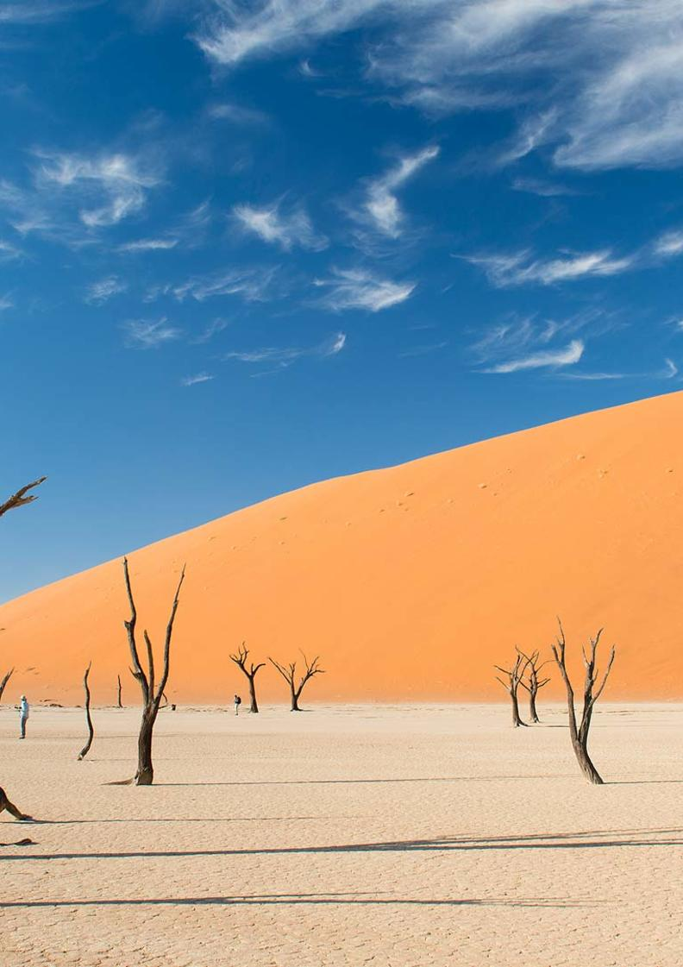

11-Day Namibia Highlights Private Guided Safari - Standard- RACK

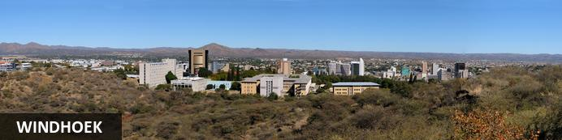
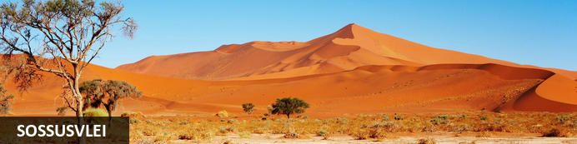
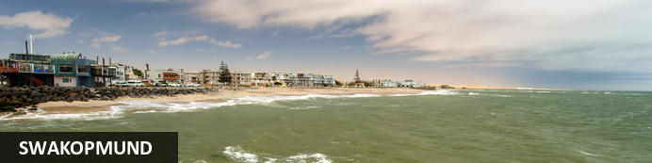
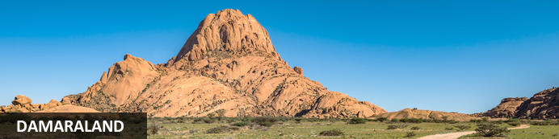
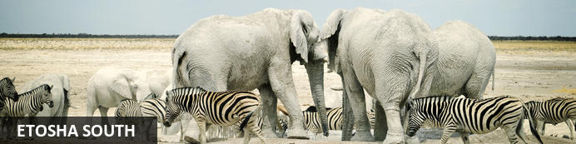
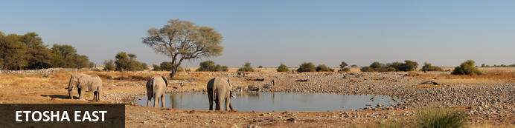

11-Day Namibia Highlights Private Guided Safari - Standard- RACK
Windhoek - Sossusvlei - Swakopmund - Damaraland - Etosha South - Etosha East
11 Days / 10 Nights
Date of Issue: 05 August 2022

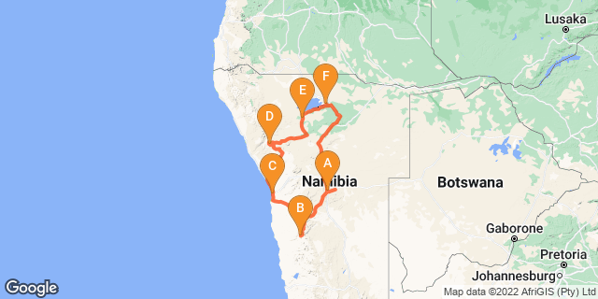

Click here to view your Digital Itinerary

Introduction
You could spend a lifetime exploring Namibia. Here we've assembled the highlights in the 11-day Namibia Highlights Safari – a journey of fascinating discovery that includes the Sossusvlei in the Namib-Naukluft Park, the Skeleton Coast, Damaraland and Etosha National Park.
The Namib Desert covers the entire Namibian coastline of over 1,500km and sweeps up to 200km inland. It is the planet's oldest desert and has an astonishing diversity of landscapes and habitats including the Great Sand Sea of Sossusvlei and the surreal Skeleton Coast north of Swakopmund.
Damaraland's scenic rocky outcrops and sandy riverbeds form a vast undulating landscape that shelters a variety of desert-adapted wildlife including elephant, rhino, lion and some rather hardy plains game.
Etosha National Park’s plains game come to drink during the middle of the day when predators are most lethargic; thus it's not uncommon to have a collage of several different species in the same frame. Lions, elephants and several endemic species of antelope and birds - including 46 raptors - add to the game viewing excitement

Accommodation | Destination | Basis | Duration
The Elegant Guesthouse | Windhoek | B&B | 1 Night
Desert Quiver Camp | Sossusvlei | D,B&B | 2 Nights
Swakopmund Luxury Suites | Swakopmund | B&B | 2 Nights
Twyfelfontein Adventure Camp | Damaraland | D,B&B | 2 Nights
Etosha Village | Etosha South | D,B&B | 1 Night
Onguma Bush Camp | Etosha East | D,B&B | 2 Nights

Key
B&B: Bed and Breakfast
D,B&B: Dinner, Bed and Breakfast

Price
1st January – 30th June 2023 – Low Season
2 guests - ZAR 73 330 per person sharing
4 guests - ZAR 47 715 per person sharing
6 guests - ZAR 39 930 per person sharing
Single supplement - ZAR 7 280
1st July – 31st December 2023 – High Season
2 guests - ZAR 77 400 per person sharing
4 guests - ZAR 50 110 per person sharing
6 guests - ZAR 41 850 per person sharing
Single supplement - ZAR 7 565

Included
- Accommodation as indicated - can change depending on availability and request at time of booking
- Meals as indicated
- Car hire for 2 & 4 pax - for 6 pax the vehicle is slightly larger
- All vehicle costs including fuel
- All park entry fees
- Guide and guide costs
- Water in the vehicle at all times
- Activities as shown in the itinerary … all activities that can be done with NTS guide and vehicle are included
- Tour file with detailed itinerary, map with route descriptions, vouchers etc.
- 24 hour personal and friendly support
- Fast and efficient response to service providers

Excluded
- Items of a personal nature
- Optional extra activities
- International flights
- Holiday or personal insurance
- Staff gratuities
- Visas and visa applications

Day 1: The Elegant Guesthouse, Windhoek

Windhoek
Surrounded by the stubble-covered Auas Mountains and the endless Khomas Hochland, Windhoek lies in a long valley fed by ancient hot springs in the central highlands. Namibia’s capital and bustling city. More often than not, the start or end place of your Namibia safari.
In Windhoek there are many interesting historical buildings, museums, galleries and craft shops. The city has several good restaurants and modern shops and services making it an excellent base camp from which to launch your Namibian adventure.

Day Itinerary
- You will be met by your guide on arrival in Windhoek and handed your travel documents
- City tour of Windhoek with your guide (if time permits)
- The remainder of the day can be spent relaxing at your own leisure
- For dinner tonight, you can head into town for a bite to eat at one of Windhoek's well-known restaurants

Overnight: The Elegant Guesthouse View iBrochure
With easy access from Windhoek International and situated in Klein Windhoek - the Namibian capital's prototype leafy suburb - The Elegant Guesthouse makes for a comfortable overnight stop.
The Elegant, as she is known in these parts, is in a quiet neighbourhood, very secure and close to the shops, restaurants and attractions of northern Windhoek. Getting there from the airport requires two turns, getting to the rest of the country from here requires just three turns.
Modern design and fittings give The Elegant Guesthouse a sophisticated air. Once a small six-roomer, the Elegant has been upgraded and is ever more sophisticated now, offering 17 stylish and beautiful guest rooms. They didn't just add more rooms. They first acquired more space and then expanded, so the mood is still decidedly relaxed (if not more so than before): the perfect way to start or end your Namibia holiday.
All rooms have en suite bathrooms, twin beds (together making a king) and are fitted with air conditioners as well as fast WiFi, television and most open out onto a drought resistant garden or the swimming pool area surrounded by loungers and umbrellas.
Breakfast is served in the light and airy open-plan breakfast room or out in the garden on warm days, which is about 90% of the time in Namibia.
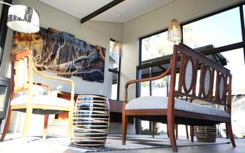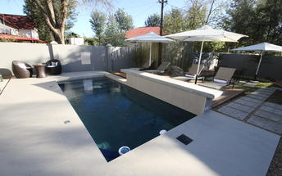

Meet and Greet
NTS Car Hire- Toyota Hilux Safari Private Guided
Toyota Hilux Safari
Travelling as a small group of friends or as a family and need a bit more space than you get with an SUV? Is your focus on photography and you want to get the best shots? This is how you travel in true safari style.

Basis
Bed and Breakfast

Day 2-4: Desert Quiver Camp, Sossusvlei

Sossusvlei
Star dunes with up to five crests rise 300m into the air and rank among the biggest in the world; the dune valleys are marked by vast clay pans where the Tsauchab River gave up its fight to reach the sea more than 60,000 years ago.
Besides the dunes and pans of Sossusvlei and Sesriem Canyon, a sideshow of activities and sights has developed around the region and there are plenty of game lodges that provide additional desert-adapted activities.Plants and birds are the dominant life form in this dessicated realm and they support a tiny world of mammals, reptiles and insects that, in the absence of coastal fog, seldom wander far from the rivercourse and its pans.

Day Itinerary
Windhoek – Sossusvlei 350km - approximately 5 to 6 hours
- After breakfast, you can still pop into town for anything you might need and then depart heading south from Windhoek to your lodge for the next 2 nights
- The route will take you either via the beautiful Spreetshoogte or Remhoogte Pass, both showcasing the natural beauty of Namibia
- Wake up early for breakfast (Day 3) and then head to the entrance to Sossusvlei, the Sesriem Gate
- Spend the whole day in the beautiful Sossusvlei area, exploring the highlights: Sossusvlei, Dead Vlei, Dune 45, Big Daddy, Elim Dune and the Sesriem Canyon
- Return to the lodge for lunch or arrange a lunch pack to enjoy in the dunes and return late afternoon for a well-earned rest
- Optional extra activities: Hot air balloon safari, Nature drives

Overnight: Desert Quiver Camp View iBrochure
With its quirky yet somehow harmonious design Desert Quiver Camp, near the entrance to Sossusvlei, can be a luxury camping experience, a back-to-basics desert lodge or both. And the best part - it's entirely up to you.
The 24 units, built of poles and canvas and stone, look like A-frames adrift and subsiding into the desert. The natural construction and sympathetic choice of colours help these structures blend into the dramatic scenery and, after a short while, the striking asymmetry becomes rather pleasing.
Inside, the rooms are spacious, cool and spotless. An en suite bathroom with shower, toilet and wash basin lurks behind the dividing wall and while the doorless layout - oddly popular among the newer establishments in Namibia - may not be to everyone’s liking, the spacious shower and piping hot water is a sure thing.
The unit has a large shaded porch with a kitchenette cunningly tucked away behind a canvas roll-down; the picnic bench and barbecue set the scene for a classic campout under the stars beside a flickering fire. A nice feature is you can order in your fresh cooking supplies and have them delivered to your unit.
If you’re not up to the ordeal of ready-steady-cooking your own meal or you just fancy a treat the camp’s sister property, Sossusvlei Lodge - well known for excellent service and quality food - is a few km up the road. As a guest of Desert Quiver Camp, you have full access to their activity centre, wonderful buffet restaurant, bar and pool all overlooking a waterhole.
Back at camp, a huge and ever-sparkling pool and its companion lopsided A-frame bar provide an agreeable venue for a sunset cocktail and a refreshing dip - the ochre view across the plains towards the rocky mountains is pure Namibia.
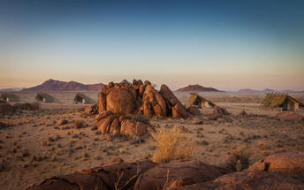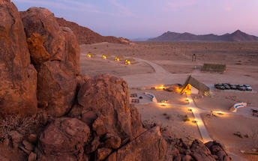

Basis
Dinner, Bed and Breakfast

Day 4-6: Swakopmund Luxury Suites, Swakopmund

Swakopmund
Surrounded by the ancient Namib desert and the inhospitable - but bounteous - Atlantic Ocean, Swakopmund is alive with activity and has a lot on offer for the adventure-seeker: quad-biking, sand-boarding, horse-riding, skydiving and more.
Swakopmund has many interesting German-influenced buildings from the early 1900s in a variety of styles and, for its size, Swakopmund has an astonishing array of restaurants that serve mainly seafood, steak and many German staples.

Day Itinerary
Sossusvlei - Swakopmund 350km - approximately 5 to 6 hours
- Depart after breakfast and head north to Solitaire, then west crossing the Tropic of Capricorn, through the Gaub and Kuiseb Canyons via the Namib Gravel Plains to the coast
- Either via Walvis Bay to Swakopmund, or (recommended) detour via Ganab to the Welwitschia Plains and Moon Landscape
- The Namibian coastline is generally known as The Skeleton Coast due to the barren areas, ship wrecks and, in days gone by, whale skeletons left on the beach
- 1 full day is set aside for this lovely area where Swakopmund and Walvis Bay offer a wide range of activities such as: Dolphin cruise, Sandwich Harbour excursion (a real Skeleton Coast experience), Dune quad biking, Sand boarding, Sea kayaking, Lots more…
- Lunches and dinners can be enjoyed at a cafe or restaurant overlooking the sea

Overnight: Swakopmund Luxury Suites
Swakopmund Luxury Suites pack comfort and convenience into an elegant apartment-style accommodation option in the belly of Swakopmund's restaurant quarter.
Although “suites” is a bit of stretch size-wise, for comfort you can expect elegant, neutral décor that is easy on the senses and top quality linen with quite possibly the most comfortable bed you’ll encounter on your tour of Namibia. Attention to detail includes Nespresso machines with complimentary pods, bath robes, extra thick towels, wi-fi that actually works, climate control, mini-bar and that general air of purpose and cleanliness of a professional outfit.
For convenience you are a few minutes’ walk to the beach, restaurants, cafes and main attractions of central Swakopmund - a feature you will welcome after many hours’ in the car on Namibia’s long and dusty roads. And the day reception is staffed with the friendliest of friendly Namibians who add that personal touch and valuable insider’s information for making the most of your visit.
A secluded upper deck lined with comfortable recliners and deck chairs is a wonderful place to catch up with your digital life. Or escape it entirely with a good book and a glass of chardonnay. Parking out front is secure with 24-hour watch and CCTV and, occupying the first storey down a pedestrianised side street, the location is quiet and safe.
Considering the last thing Swakopmund needs is yet another mediocre eating venue, breakfast at the Swakopmund Suites is outsourced by way of vouchers and a helpful hint to one of three cafes within a couple of minutes’ walk: The Village Cafe is a bright and lively local institution; Cafe Anton, right next door to the Suites, is an old-school buffet good for an early or languid start to the day; and Bojo’s is half way between the two in every respect.
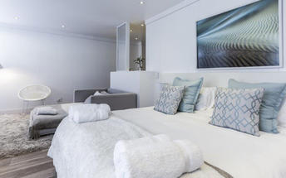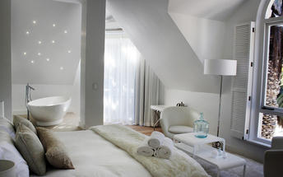

Basis
Bed and Breakfast

Day 6-8: Twyfelfontein Adventure Camp, Damaraland

Damaraland
Damaraland features vast khaki plains, sheer rocky mountains and incredible desert-adapted wildlife. Track rhino and desert elephant, explore the rugged land or sit back and enjoy the dramatic and endless scenery. Damaraland's hilly savannah supports a large number of species including lion, leopard, cheetah, hyena, eland, kudu, giraffe, klipspringer, steenbok, gemsbok and springbok. Birdlife is prolific with over 33 raptors recorded including cuckoo hawks, Egyptian vultures and peregrine falcons - the world's fastest animal.
Damaraland is divided into several enormous private game reserves, known as concessions, that support most species of Namibia's large game and provide some of the best birding and wildlife experiences in the country - and southern Africa for that matter.

Day Itinerary
Swakopmund – Damaraland 445km - approximately 7 to 8 hours
- Head north along the Skeleton Coast, via Henties Bay to visit the Cape Cross seal colony. Along the way, stop at the Lichen Fields as well as the ship wreck between the colourful small town of Wlotskasbaken and Henties Bay
- Backtrack to Henties Bay and head inland through wide open plains to Uis, then north to the Twyfelfontein area
- Visit to Namibia's Open Air Museum, the Twyfelfontein Rock Engravings as well as the interesting Organ Pipes rock formations and Burnt Mountain
- Take a drive with your guide, west (4x4 needed) to the Huab River to look for the desert adapted elephants as well as other game such as oryx, springbok, ostrich and lots more
- Visit the Damara Living Museum for a hint of culture

Overnight: Twyfelfontein Adventure Camp View iBrochure
Against and among the granite boulders, Twyfelfontein Adventure Camp has prime location for visiting the highlights of the area. From here you can easily explore the heart of Damaraland, the sights of Twyfelfontein and track desert-adapted elephants.
Within walking distance of the Damara Living Museum, Twyfelfontein Adventure Camp (we'll call it TAC, shall we?) is a 10-minute drive from the Twyfelfontein Rock Engravings, Burnt Mountain and Organ Pipes. Situated in the Huab River Valley, there’s a chance the elephants could stroll past your tent at any moment or at the least, you won’t have to venture very far to find them.
Location is key and in that category TAC is a winner. It’s been a long day's drive from any direction to get here, so once you’ve arrived, it’s great knowing you won’t have to spend much time in the car to explore the area. Less time on the road means more time for adventure and to laze at the pool with a drink in hand. Of equal importance when on holiday.
The eco-friendly camp itself is basic, tasteful and really quite charming; add the view and the necessary comforts of a clean and decent stay and you’ll be delighted to call TAC your home for the next few nights. Two-night stays allow you to book a spectacular guided nature drive in an open safari vehicle.
Jumbled sandstone hills, platinum-blonde savannahs and olive-green shrublands make this landscape of incredible scale, colour and silence - so much silence - a marvel. See the many wildlife species that thrive here and learn how humans and wildlife including elephant, lion, rhino, antelope varieties and smaller predators have adapted to life in a land so hot and dry that it becomes ever more a wonder.
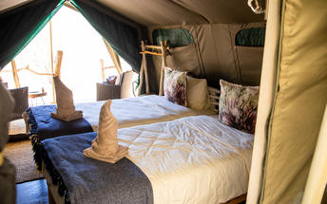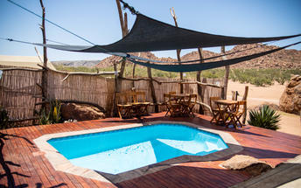

Basis
Dinner, Bed and Breakfast

Day 8: Etosha Village, Etosha South

Etosha South
Located just south of the boundary of Etosha National Park in northwestern Namibia, Etosha South makes up the southern region of this wild paradise. Ongava Private Game Reserve shares the southern boundary with Etosha National Park and offers an array of luxury lodges overlooking picturesque landscapes dotted with abundant wildlife. The national park can be accessed via the southern entrance at Andersson’s Gate. Visitors can catch a glimpse of a variety of wildlife including: lion, giraffe, elephant, white and black rhino, and a multitude of plains game. Popular activities include: game drives, tracking rhinos on foot, guided nature walks, or watching the sunset over the magnificent African landscape.

Day Itinerary
Damaraland – Etosha (south) 325km - approximately 4 to 5 hours
- After breakfast, drive east towards Khorixas stopping at the Petrified Forest en-route
- From Khorixas head further east along the tar road to Outjo and then north to your lodge which is situated very close to the southern entrance of Etosha, the Anderson Gate
- If time permits, enter Etosha for an afternoon game drive. Depending on how often you stop today, you should arrive at your lodge in time for lunch (optional extra)
- On entering the park, the first stop would be Okaukuejo where you pay your entry fee (included) and I suggest you pop in at the local shop to purchase some drinks and snacks and most importantly, a map of Etosha which will show you all the waterholes along the way
- Etosha is one of Africa's great game parks. With 114 species of mammal and 340 species of birds you are sure to see a great variety of wildlife on your safari

Overnight: Etosha Village View iBrochure
Even before its hard refurb, Etosha Village was probably the best value safari lodge in Etosha. Replacing all tented accommodation with smart air-conditioned chalets, Etosha Village is now by far the best value safari lodge in Etosha.
Retaining its eco-conscious credentials - the bricks were salvaged from mining debris, grey water is filtered and re-used in the vegetable garden, water is solar heated and the kitchen produces a fair amount of high-quality composting material - Etosha Village had a major refurbishment in mid-2016 and what an upgrade.
Brick has replaced canvas, sleek tiles have replaced creaky wood decking and the en suite bathrooms are smart, shiny and functional. From the outside, the chalets are full of life and texture with gabion foundations, balustrades filled with pebbles, a gravelled forecourt and woven latte poles covering the roof. Inside, while a tad on the austere side, the rooms are spacious, practical and well-appointed with air conditioning, en suite bathroom, sofa bed good for two under-12s (the Village is one of a few child-friendly safari lodges in Etosha), fridge, tea/coffee, safe, balcony and a large gazebo to the side. Comfortable twin beds with soft cotton are a given.
The living areas have also retained their charm and casual comfort with a large swimming pool surrounded by loungers and parasols and a smaller pool adjacent to a third toddler-friendly pool. The food at Etosha Village is fresh and the staff here, recruited from the nearby village and trained in-house, are famous for their friendly and enthusiastic service.
Breakfast and dinner are sizeable buffet spreads and lunch is a small a la carte menu with local venison specialities. Tea, coffee, hot chocolate and juice are on the house all day and the open-air bar is a convivial spot to share a drink and a tale or just gaze into the night sky as is your want.
Being just minutes from the southern gate is ideal for daily access to Etosha National Park for guided game morning and evening drives in an open-sided safari vehicle. The vehicles accommodate up to 10 people and if that’s a bit crowded or constrained, Etosha is one of the easiest self-drive game reserves in Africa: arm yourself with a prepared breakfast and lunch or a picnic hamper from the well-stocked supply store and spend the day at any number of quiet waterholes. A good reference book, binoculars and of course your camera should be required equipment.
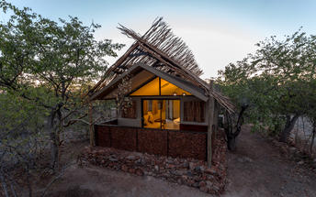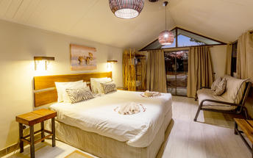

Basis
Dinner, Bed and Breakfast

Day 9-11: Onguma Bush Camp, Etosha East

Etosha East
On the eastern edge of Etosha National Park, the park itself is bordered by numerous private reserves and access into the park is via the Von Lindequist Gate, named after Dr. Friedrich von Lindequist who proclaimed it a game reserve in March 1907. This side of the park is characterised by flat endless plains, tree-savanna type of vegetation and fantastic waterholes, where you could easily spot any of the prolific wildlife Etosha is known for. There's an abundance of wildlife here.

Day Itinerary
Etosha (south) – Etosha (east) a full days game drive through the park
- From one side to the other side of the park is a full day game drive as you head slowly east stopping at numerous waterholes along the way
- Take a slow drive in the morning and then enjoy a packed lunch (optional extra) overlooking one of the waterholes before continuing on through the park to the eastern side
- 1 full day is set aside for game viewing, either all day or alternate with morning and afternoon guided drives

Overnight: Onguma Bush Camp View iBrochure
Onguma Bush Camp is a comfortable, family-orientated lodge in a private reserve on the eastern edge of Etosha National Park. With 18 rooms including family suites as well as a small campsite, the atmosphere is tranquil and casual.
Onguma Bush Lodge is an alternative to staying inside Etosha National Park where your options are limited to three basic state-owned camps.
This comfortable lodge is located on the edge of the park near Fisher's Pan and the eastern entrance to Etosha. The rates are reasonable and the lodge is neat, small and an excellent base for families.
The en suite, air-conditioned rooms are built from local stone and have thatched roofs. The pool, open-air lapa and dining area provide the venues for some pleasant banter, spectacular sunsets and hearty meals. The lounge and dining area overlooks a waterhole for around-the-clock game viewing. The campsite has six sites with private ablutions and firewood; campers are welcome to make use of the bar, pool and restaurant.
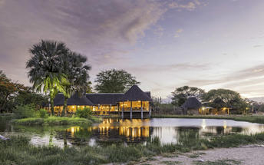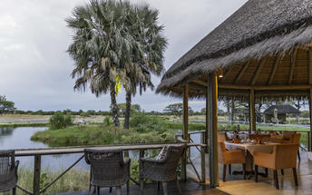

Basis
Dinner, Bed and Breakfast

Day 11: End of Itinerary

Day Itinerary
Etosha (east) – Windhoek 490km - approximately 6 hours
- Head back to Windhoek today, where your guide will drop you at the airport in time for your departure flight (Keep in mind that you need to be at the airport 2 hours prior and the airport is still a 45 minute to 1 hour drive from town)
- End of services

Basis
Bed and Breakfast

Transport

Transfers
Date | Company | Pick Up | Drop Off | Time | Vehicle
 |  | Hosea Kutako International Airport [WDH] | The Elegant Guesthouse |  | Fully Guided Trip
 |  | The Elegant Guesthouse | Desert Quiver Camp |  | Fully Guided Trip
 |  | Desert Quiver Camp | Swakopmund Luxury Suites |  | Fully Guided Trip
 |  | Swakopmund Luxury Suites | Twyfelfontein Adventure Camp |  | Fully Guided Trip
 |  | Twyfelfontein Adventure Camp | Etosha Village |  | Fully Guided Trip
 |  | Etosha Village | Onguma Bush Camp |  | Fully Guided Trip
 |  | Onguma Bush Camp | Hosea Kutako International Airport [WDH] |  | Fully Guided Trip

Terms and Conditions

Namibia Tours & Safaris Terms and Conditions
Contract
1.1 The contract will become effective as from the date the invoice is completed and the deposit, referred to in Clause 2.1, is received by Africa Tours & Safaris CC (hereinafter known as the Company).
1.2 The contract is subject to the Namibian Law.
1.3 Any person making a reservation as per Clause 8.4 accepts the terms and conditions of this agreement set out hereunder.
How to Book
2.1 A 20% deposit of the full amount due is required to confirm any reservation and is to be done by the agent or client (see Clause 8.1) in writing or by e-mail.
2.2 The Company must receive the balance of the contract price no later than 42 days (6 weeks) prior to departure.
2.3 If the Company does not receive the full contract price 42 days (6 weeks) before the departure date, the Company may cancel the reservation and retain whatever deposit or other funds it has already received from the client or his agent.
How to Pay
3 The payment options will be provided upon confirmation of a booking.
Our Cancellation Policy
4.1 Any cancellation of a confirmed booking must be done in writing (email) to the Company whereupon cancellation charges as per Clause 4.2 will apply.
4.2 The following cancellation fees (as a percentage of the fully quoted price) are applicable to any cancelled travel:
Notice from date of travel:
Cancellation fee:
42 days or more 20% (deposit forfeited)
29 – 41 days 50%
15 – 28 days 75%
0 – 14 days 100%
Please note: the notice period is calculated from the date of cancellation to the start date of the tour/safari booking.
4.3 No refund will be made by the Company if, for any reason, inclusions or parts of the tour cannot be carried out / or utilised. These would include all facets such as meals, game drives, accommodation etc. This would also apply to any client who has booked a tour but fails to undertake the tour for any reason.
Our Changes Policy
5 If a booking is changed to an earlier date than originally reserved, the Company will endeavour to change it. If the booking is for a later date, charges as per Clause 4.2 could apply.
As things go, we've all had to adapt to changes during the Coronavirus pandemic and so too have we therefore amended our terms and conditions for travel during such times.
Price Changes
6.1 The Company reserves the right to increase the price of any tour prior to departure due to factors beyond the control of the Company, such as, without being limited to, and increase in fuel prices, new Government legislation, accommodation price increases, fluctuations in exchange rates, etc.
6.2 If the Company announces an in increase in the tour price in terms of this Clause, such addition amount must be paid to the Company before the departure of such tour or else the Company shall have the right to cancel the tour and the charges in Clause 4.2 will apply.
Changes to Itineraries
7 The Company shall at any time have the right, in its entire discretion, to alter the terms of the booking in relation to the route, timetable, itinerary and accommodation. The Company shall, however, make every effort to offer the client an alternative tour of a comparable standard.
Should the alternative be of a lesser standard, the client will be refunded the difference, but should there be an increase, the client shall have the right to either reject the alternative and obtain a refund of the relevant portion of the original contract sum, or to accept the alternative and pay the increased cost. In the event of the client rejecting the alternative tour and claiming a refund, such rejection will be treated as a cancellation and the refund will be calculated according to Clause 4.2 hereof. The client shall have no claim against the Company for any damages arising out of the alternative booking.
Responsibility and Liability
8.1 Neither the Company nor any person acting for through and on behalf of the Company shall be liable for any loss or damage whatsoever arising from any cause whatsoever and without restricting the generality of the aforegoing shall particularly not be responsible for the loss or damage arising from any errors or omissions contained in its brochure or other literature, late or non-confirmation or acceptance or bookings, loss or damage caused by delays, sickness, injury or death, whether occasioned by negligence or not.
8.2 The Company shall have the right at any time at is sole discretion, to cancel or the remainder thereof or to make an alteration in the route, accommodation price or other details. This would include any event of any tour being rendered impossible, illegal or inadvisable by weather, avalanches, strike, war, government or other interference or due to any other cause whatsoever. The extra expenses incurred as a result thereof shall be the responsibility of the client.
8.3 The Company may at its discretion and without liability or cost to itself at any time cancel, or terminate, a client's booking and in particular, without limiting the generality of the aforegoing, it shall be entitled to do so in the event of illness or the illegal or incompatible behaviour of any client undertaking the tour, who shall in such circumstances not be entitled to any refund.
8.4 Any person making a reservation with the Company (refer to Clause 1.1) warrants that her or she has the necessary authority to enter into this contract on behalf of the person or persons included in such a booking. The person making the reservation shall be liable for the total amount due to the Company.
Client's Obligations
9.1 It is the onus and responsibility of the client to obtain the necessary comprehensive insurance before departure for any possible cancellations, medical expenses, protection or personal property and money.
9.2 The onus is upon the client to ensure that passports and visas are valid for the duration of the safari. The Company cannot be held liable for any necessary visas or other travel documents not held by clients. In the event of a client not having the necessary documentation to enter any area or country the Company shall reserve the right to leave the client a the point of entry of such area or country. In such an event, the Company will not be held responsible to the client for further travel arrangements.
9.3 The onus is upon the client to ensure that the SARS-CoV-2 PCR tests are done prior to commencement of the safari and valid on arrival in accordance to the requirements of the country of intended travel and for the airline with which the client will travel. The same applies for any necessary testing for departure. The costs of any such COVID testing will be for the clients own account. While The Company can assist with arrangements for testing in-country, The Company will not be held responsible to the client for such arrangements and with regards to return time of test results.
9.4 Should the client need to undergo mandatory quarantine once in-country with regards to the SARS-CoV-2 virus, either on arrival as called for by the authorities or due to testing positive once in-country, this will be at the clients own expense.
Health and Personal Safety
10.1 The client shall be reasonably fit to undertake the tour.
10.2 Anti-malaria precautions should be commenced prior to tour departure. A medical doctor should be consulted for advice.
10.3 Tours offered by the Company cover a wide spectrum of the African wilds and neither the Company, its employees or agents can be held responsible for any injury or other related incidents whilst on the tour / safari.
10.4 The Company cannot be held responsible for any client who falls ill or contracts the SARS-CoV-2 virus while in-country. The client accepts that travel is at own risk.
Baggage
11.1 Clients are limited to one soft sports type bag per person with a maximum weight of 20 kilograms. This includes photographic equipment and hand luggage.
11.2 Due to the rugged terrain, the Company cannot be held responsible for damage or loss of any personal items including bags, contents of bags or photographic and related equipment. Due to extremely dusty conditions, please ensure all bags are dust proof.
Airline and Car Hire Clause
12.1 The Company will act as the agent of the client when booking the client with a car hire company, an airline or air charter service. The client therefore contracts with the car hire company, airline or charter service and not with the Company.
12.2 Charter flights are normally operated by smaller type aircraft such as Cessna 210. Luggage is strictly limited to 10-15 kgs (depending on terms of particular airline used) per person in soft hold all type bags. Due to the desert heat, it is not safe to overload aircraft thus this limit needs to be strictly controlled.

