Highlights of Japan
Tokyo - Nagano - Takayama - Kanazawa - Kyoto - Hiroshima - Osaka
14 Days / 13 Nights
0 Persons
Date of Issue: 29 March 2017
01 November 2017 - 14 November 2017

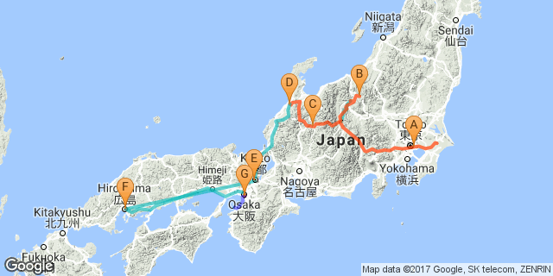

Click here to view your Digital Itinerary

Overview

Accommodation | Destination | Nights | Basis
Tobu Hotel Levant Tokyo | Tokyo | 4 | B&B
Yorozuya Ryokan | Nagano | 1 | B&B
Hotel Associa Takayama Resort | Takayama | 1 | B&B
Kanazawa Tokyu Hotel | Kanazawa | 2 | B&B
Mitsui Garden Hotel Kyoto Shijo | Kyoto | 2 | B&B
Hotel New Hiroden | Hiroshima | 1 | B&B
Cross Hotel Osaka | Osaka | 2 | B&B

Key
RO: Room only
SC: Self Catering
HB: Half Board
B&B: Bed and breakfast
B, B&L: Bed, breakfast and lunch
D, B&B: Dinner, bed and breakfast
FB: Dinner, bed, breakfast and lunch
FB+: Dinner, bed, breakfast, lunch and activities daily
FI: Fully inclusive

Included
13 Nights’ Accommodation13 Breakfasts & 1 Dinner8 Full Day Private Tours 5 Half Day Private ToursAdmission FeesAirport Transfers to and from Hotels

Day 1: Wednesday, 1 NovemberTobu Hotel Levant Tokyo, Tokyo

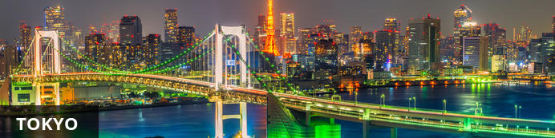
At over 13 million people in the official metropolitan area alone, Tokyo is the core of the most populated urban area in the world. This massive, wealthy and fascinating metropolis offers high-tech visions of the future alongside glimpses of traditional Japan. Huge and varied in its geography, Tokyo Metropolis spans not just the city but also spectacular, rugged mountains to the west and exquisite subtropical islands to the south. It's best thought of not as a single city, but a constellation of cities that have grown together. The various districts of this phenomenal city vary wildly in character, from the electronic blare of Akihabara to the magnificent Imperial gardens and shrines of Chiyoda, from the lively youth culture mecca of Shibuya to the splendid pottery shops and temple markets of Asakusa. If you don't like what you see, hop on the train and head to the next station, and you will find something entirely different. Tokyo truly has a little bit of everything for everyone.

Day Itinerary
Welcome! Upon arrival at the airport, transfer to accommodation by private coach.

Overnight: Tobu Hotel Levant Tokyo
Being one of the TOKYO SKYTREE official hotels, this hotel is in the middle of hot tourist area close to TOKYO SKYTREE, Asakusa, shopping centers along with nice eateries and convenience stores. They are only 300m walk from Kinshicho Station.
They boast their beautiful tower view from some of the rooms and in-house restaurants. Imagine yourself gazing quietly at the sparkling tower at the center of the night sky while resting on your bed or enjoying delicious dinner with your beloved person. It adds up to the romantic atmosphere.
They provide shuttle bus to TOKYO SKYTREE and Tokyo Disneyland. Direct airport limousines operate between their hotel and both Haneda and Narita International Airport.
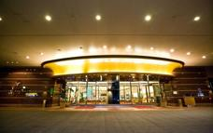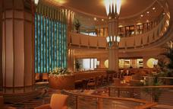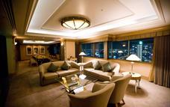

Included
Bed & Breakfast

Day 2: Thursday, 2 NovemberTobu Hotel Levant Tokyo, Tokyo

Day Itinerary
After breakfast, go on a full day Tokyo City Tour by private coach, visiting Tokyo Tower, Hamarikyu Garden, Sumida River Cruise, Asakusa and Ginza.

Activities
Tokyo Full Day City Tour by Private Coach
Tokyo Tower
Hamarikyu Gardens
Sumida River Cruise
Asakusa
Ginza

Tokyo Tower
At 332.9 metres, the Tokyo Tower is the second-tallest structure in Japan. The tower was built in 1958 and has been visited by over 150 million people to date. The tower’s main sources of revenue are tourism and antenna leasing. There are two observation platforms – one at 150 m and the other at 250 m. The tower is a lattice tower similar to the Eiffel Tower and is painted white and international orange to comply with air safety regulations. The lighting that illuminates the tower at night changes by season and for important events. Directly under the tower there is a 4-storey building called Foot Town that houses a wax museum, an aquariu, souvenir shops, and restaurants.
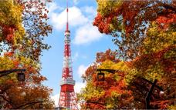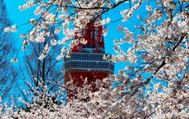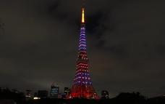

Hamarikyu Gardens
Surrounded by a seawater moat, the Hamarikyu Gardens in Tokyo are located at the mouth of the Sumida River near the famous Tsukiji Fishmarket. The gardens were created on the site of a 17th century villa of the Shogun Tokugawa family and were given to the Tokyo Metropolitan Government in 1945. The next year, on April 1, the gardens were opened to the public.The main attraction of the gardens is the beautiful Shiori Pond – a tidal pond that takes in seawater. There is a teahouse in the centre of the pond where visitors can enjoy matcha (ceremonial green tea) and Japanese sweets served in tea-ceremony style.It is possible to catch a water shuttle to Tokyo Bay via the Sumida River directly from within the gardens.

Sumida River
The Sumida River flows through Tokyo and is spanned by 26 bridges spaced about a kilometre apart over a distance of 27 km. Waterbuses provide transport along the river and are very popular even though they are a bit slower than the trains. The Asakusa to Hinode Pier route is a favourite with travellers who like to get off at Hamarikyu Garden to enjoy the beautiful Japanese garden. Those who do not wish to explore the river on their own can join one of the many cruises offered by tour operators in the area.

Asakusa District
The Asakusa District of Tokyo is situated along the west bank of the Sumida-gawa River. The town has an old, traditional feel to it and visitors can take a 30-minute rickshaw ride to the local attractions, or it can be easily explored on foot.The Sensoji, a 7th century Buddhist Temple with a fascinating history is the main attraction of the area as is the Nakamise, a shopping street that leads to the temple, where pilgrims and visitors have been buying traditional snacks, sweets and souvenirs for centuries. Asakusa also hosts many traditional events and festivals, the most popular of which is the fireworks display which is watched by over a million people every year.
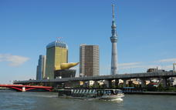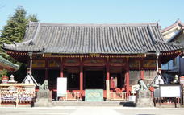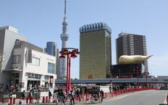

Ginza District
Ginza District is Tokyo’s best-known upmarket shopping, dining and entertainment district, and, at around 10 million Yen per square km of land, also some of the priciest real estate in Japan. Almost every leading brand name in fashion and cosmetics is represented here, and the classy beauty parlors, department stores, art galleries, boutiques, cafes, restaurants, and nightclubs offer pleasant and luxurious ways for visitors to spend their time.
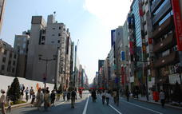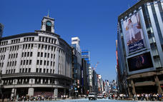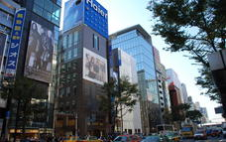

Included
Bed & Breakfast

Day 3: Friday, 3 NovemberTobu Hotel Levant Tokyo, Tokyo

Day Itinerary
After breakfast, go on a full day Kamakura Tour by private coach, visiting Kotokuin the Big Buddha Temple, Tsuruoka Shrine and Hokukuji Bambboo Temple.

Activities
Kamakura Full Day Tour by Private Coach

Included
Bed & Breakfast

Day 4: Saturday, 4 NovemberTobu Hotel Levant Tokyo, Tokyo

Day Itinerary
After breakfast, go on a full day Mt Fuji & Hakone Tour by private coach, visiting 5th Station Mt Fuji, Lake Akashi Cruise and Hakone Rope-Way.

Activities
Hakone and Mt Fuji Full Day Tour by Private Coach
Mount Fuji
Hakone

Mount Fuji
Mount Fuji is Japan’s highest mountain and most famous landmark, lying within the borders of the Fuji-Hakone-Izu National Park. It is known as one of the “Three Holy Mountains” and legend has it that Mount Fuji was a samurai training ground. Although the mountain can be seen from certain points in Tokyo, it is best viewed from Hakone, Kawaguchiko, Kamakura, Enoshima or Gotemba. The official climbing season starts early July to mid September for those who wish to hike the 3776 metres to the top. Sunrise from the summit is one of the most sought after views in Japan. Choose between the Yoshida Trail or the Subashiri, Gotemba and Fujinomiya Trails.
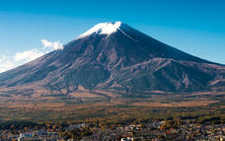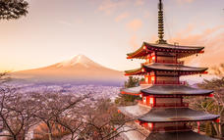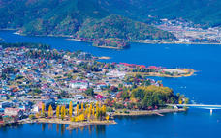

Hakone
Hakone is a city in Japan that lies within the borders of the Fuji-Hakone-Izu national park in the Ashigarashimo District of Kanagawa Prefecture. Tourists specifically travel here for the spectacular views of Mount Fuji. Other attractions in the area include walks to Hakone Shrine on the shore of Lake Ashi, day-trips through the Hakone Open-Air Museum and explorations to Mount Kintoki to view the ruins of old-Japan. No visit is complete without eating a black egg hard-boiled in the Great Boiling Valley of Owakudani. Legend has it that these eggs add some extra years to your lifespan.
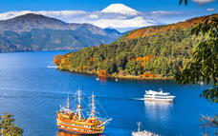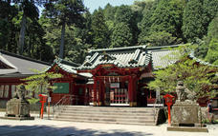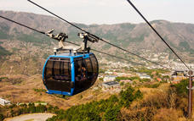

Included
Bed & Breakfast

Day 5: Sunday, 5 NovemberYorozuya Ryokan, Nagano

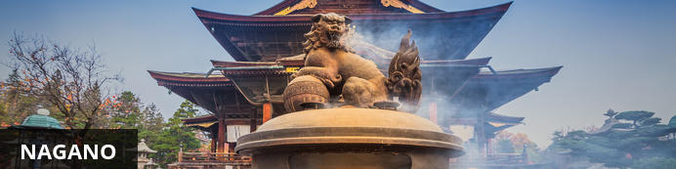
Nagano is the capital of Nagano Prefecture and it developed around Zenkoji, one of Japan’s most famous temples. The temple is an important pilgrims destination and remains an authentic centre of worship in Japan. The town is also known for their Togakure Ninja School and the Ninpo Museum where tourists can learn about the history of ninjas in Japan. Those seeking inner peace follow the footpaths and hiking trails that flow through the Togakushi Shrine in the mountains northwest of the city centre. It is at the Jigokudani Yaenkoen monkey park, just above Nagano where the wild snow macaques of the Japanese Alps soak in the steamy waters of natural hot springs during the cold winter season.

Day Itinerary
After breakfast, leave your main suitcase at the hotel reception as this will be transferred to Matsumoto (you will still need enough clothes for one day in Nagano) catch the bullet train to Nagano and go on a half day. Nagano Tour by private coach, visiting Zenko-ji Temple and Jigokudani Monkey Hot-Spring Park. Transfer to your next accommodation by private coach and enjoy dinner at Ryokan.

Overnight: Yorozuya Ryokan
Yorozuya Ryokan is located in Yamanouchi. The rooms offer a comfortable space for all guests as well as modern amenities. The on-site restaurant offers traditional Japanese cuisine with a unique interior. Facilities include the main dining lounge, gift shop, table tennis, salon, banquet hall and private bath.

Activities
Nagano Half Day City Tour by Private Coach
Zenkoji Temple
Jigokudani Monkey Park

Zenkoji Temple
Zenkoji Temple is located in Nagano, Japan. The Buddhist temple was built in in the 1700s, and contains various Buddhist statues. Visitors are required to pay a fee when entering the hall's inner chamber, enabling them to take a closer look at the main altar. There is also an underground passage, that visitors are able to walk through in absolute darkness, with the hopes of finding the "key to paradise". The key is attached to a wall along the passage and Buddhists believe that those who touch it, will be granted salvation.

Jigokudani Monkey Park
The Jigokudani Monkey Park is located in the Jigokudani Valley (Hell Valley) within the Joshinetsu-Kogen National Park in Japan. The valley was named so, because of the steep cliffs and the steam rising from the springs everywhere. The harsh environment of the valley is the natural habitat of the wild Japanese macaque, more popularly referred to as ‘snow monkeys’ which is why the park was established here.Visitors can observe the monkeys where they gather at a man-made pool a couple of minutes’ walk from the entrance of the park. Since visitors are not allowed to interact with or feed the monkeys, they have become quite accustomed to humans and usually ignore them allowing for excellent photographic opportunities.
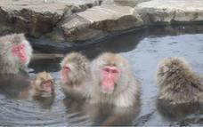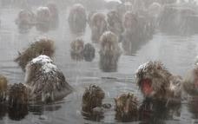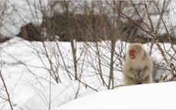

Included
Bed & Breakfast

Day 6: Monday, 6 NovemberHotel Associa Takayama Resort, Takayama

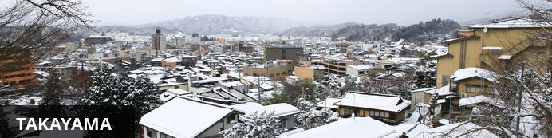
Takayama is a picturesque city situated in the Japanese Alps. The town prides itself on the inhabitant’s expertise in carpentry and the history of Tatayama is preserved in a number of small museums dotted throughout the city. Visit the historic district of San-machi Suji that is known for its sake breweries indicated by huge cedar balls hanging on the outside of shops. Visitors go inside for a tasting and a chat with sake makers. Don’t miss the Higashiyama Walking Course through a forest and past temples and cemeteries. East of the city is Japan’s highest snow cave known for its impressive stalactite and helictite formations.

Day Itinerary
After breakfast, go on a half-day Matsumoto City Tour by private coach visiting Matsumoto Castle and Wasabi Farm. Transfer to Takayama by private coach for a half-day Takayama tour, visiting, Old Town of Takayama and Float Museum.

Overnight: Hotel Associa Takayama Resort
Hotel Associa Takayama Resort is nestled in amongst the Hida Takayama Hot Spring Village offering a great selection of 10 different open-air hot springs in a two-storey tower, (Tenbo no Yu) that provides spectacular views of the Northern Alps. The Resort also features Spa Phyton, a spa facility offering total relaxation with a range of treatments including phytotherapy and touch therapy.
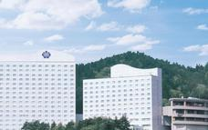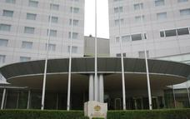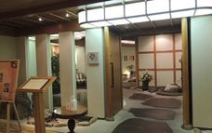

Activities
Matsumoto Half Day City Tour by Private Coach
Matsumoto Castle
Takayama Half Day Tour by Private Coach
Takayama

Matsumoto Castle
Matsumoto Castle is the oldest existing castle in Japan, it is also known as Crow Castle because of black exterior. Matsumoto is a hirajiro, or a flatland castle, because it was built on a plain and not on a hilltop or amid any rivers. The castle holds 400 years of history, and is a National Treasure in Japan.

Takayama
Takayama is a picturesque city situated in the Japanese Alps. The town prides itself on the inhabitant’s expertise in carpentry and the history of Tatayama is preserved in a number of small museums dotted throughout the city. Visit the historic district of San-machi Suji that is known for its sake breweries indicated by huge cedar balls hanging on the outside of shops. Visitors go inside for a tasting and a chat with sake makers. Don’t miss the Higashiyama Walking Course through a forest and past temples and cemeteries. East of the city is Japan’s highest snow cave known for its impressive stalactite and helictite formations.
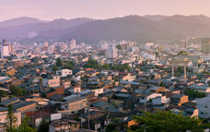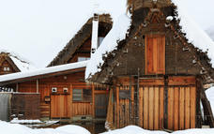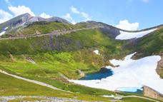

Included
Bed & Breakfast

Day 7: Tuesday, 7 NovemberKanazawa Tokyu Hotel, Kanazawa

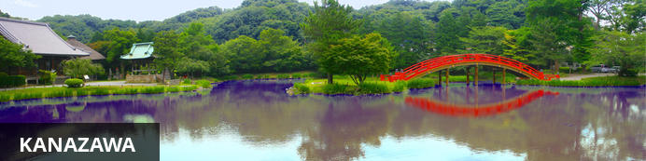
Kanazawa is the centre of culture and commerce in the Hokuriku region and is a favourite getaway for the Japanese. The whole town has been well preserved through the ages and it feels like a modern-day museum with all its castles, geishas and gardens. Visit Higashi Chaya where you will find kimono-clad geishas serving green tea in the courtyards of teahouses during the daytime. Kenrokuen garden gives weary travellers a space to rest or meditate under cherry blossoms and red azaleas. Most of Kanazawa has remained unchanged for centuries, and here you can see where and how Samurai warriors lived from the 16th to the 19th centuries.

Day Itinerary
After breakfast, go on a full-day Shirakawa-go/Gokayama tour by private coach, visiting Shirakawago Village, Gokayama Village and enjoy Japanese Washi Paper Making Experience. Then transfer to Kanazawa hotel by private coach.

Overnight: Kanazawa Tokyu Hotel
Adjacent to a bus stop, Kanazawa Tokyu Hotel is 7 minute walk from the 21st Century Museum of Contemporary Art and a 12 minute walk from the Kenroku-en gardens. The hotel's stylish rooms, have city views, free WiFi, flat screen TVs, mini fridges, as well as tea and coffee making facilities. The hotel features a high-end French restaurant and a Japanese eatery with panoramic city and garden views. Other amenities include a chic bar and a cozy guest lounge.
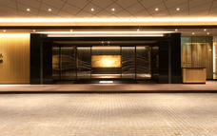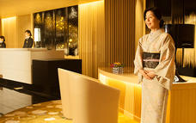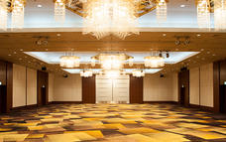

Activities
Shirakawago and Gokayama Full Day Tour by Private Coach
Shirakawa

Shirakawa
Located high on the peak of Mount Haku, the small, sleepy village of Shirakawa is a designated World Heritage Site known for its traditional Japanese Alpine architecture and old-world charm. In summer, the landscape is a riot of lush green forest, while the winter months bring vistas of snow-capped mountain peaks and excellent skiing opportunities.
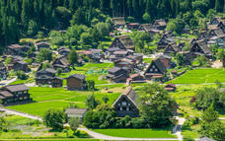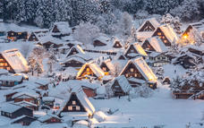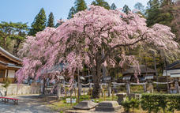

Included
Bed & Breakfast

Day 8: Wednesday, 8 NovemberKanazawa Tokyu Hotel, Kanazawa

Day Itinerary
After breakfast, leave your main suitcase for a next day transfer to Kyoto and enjoy a full day walking tour in Kanazawa, visiting Kenrokuen garden, Higashi Chaya station and the Samurai District.

Activities
Kanazawa Full Day Walking Tour
Kanazawa
Kenroku-en Garden
Higashiyama Higashi Chaya District

Kanazawa
Kanazawa is the centre of culture and commerce in the Hokuriku region and is a favourite getaway for the Japanese. The whole town has been well preserved through the ages and it feels like a modern-day museum with all its castles, geishas and gardens. Visit Higashi Chaya where you will find kimono-clad geishas serving green tea in the courtyards of teahouses during the daytime. Kenrokuen garden gives weary travellers a space to rest or meditate under cherry blossoms and red azaleas. Most of Kanazawa has remained unchanged for centuries, and here you can see where and how Samurai warriors lived from the 16th to the 19th centuries.
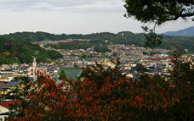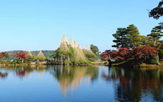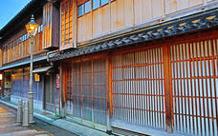

Kenroku-en Garden
Kenroku-en Garden is located in Kanazawa, Ishikawa, Japan. It is one of Japan's three most beautiful landscape gardens, featuring a variety of flowering trees which provide the garden with a different beauty each season. The spacious grounds used to be the outer garden of the Kanazawa Castle, constructed by the ruling Maeda family centuries ago, it opened to public in 1871.
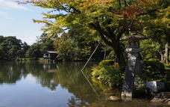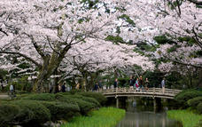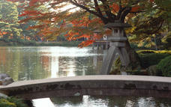

Higashiyama Higashi Chaya District
The Higashiyama Higashi Chaya District is the largest of three chaya districts just outside the city of Kanazawa and has been designated as one of Japan’s cultural assets. Literally translated, the word ‘chaya’ means teahouse, and in context, refers to traditional eating places where guests are entertained with songs and dances performed by geisha girls, a tradition dating back to the Edo period. The Shima Teahouse and Kaikaro Teahouse are open to the public while interesting shops and cafes populate the other buildings along the central street of the district. One of the highlights on the street is Hakuze, a shop that sells gold leaf products and displays a tea ceremony room that is completely covered in gold leaf. Geisha performances are held in the chaya districts every Saturday.

Included
Bed & Breakfast

Day 9: Thursday, 9 NovemberMitsui Garden Hotel Kyoto Shijo, Kyoto

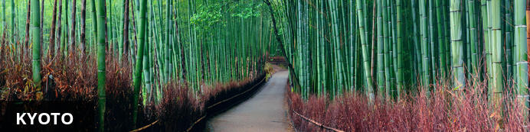
If you want to explore a city filled with shrines, temples and historical structures, Kyoto should be first on your list. This city has seventeen historic sites that has been proclaimed as World Heritage Sites. Visit Nijo Castle to see an example of Japanese architecture combined with beautiful interior decorating. While you’re there take a trip to the Gekkeikan Okura Show to experience the journey of sake-brewing history that include 6120 brewing tools through the ages and a space where you can listen to the recordings of brewing songs of the past. For a magnificent view of Koyoto city travellers stand on Kiyomizu Temple’s large wooden verandah that is built suspended over a deep valley.

Day Itinerary
After breakfast, transfer to Kyoto by bullet-train and go on a half-day Kyoto tour by public transport visiting Gion.

Overnight: Mitsui Garden Hotel Kyoto Shijo
Located in the center of Kyoto, the capital of one thousand years where you can enjoy the old imperial city ambiance. The modern atmosphere and the Kyoto sensibility make you long for another night’s stay in this hotel with amazing rooms.
Restaurant Otowa offers a Kyoto-style breakfast buffet called “obanzai”. Guests can enjoy a casual dinner with a variety of dishes, including “Ohmi Beef Gozen Platter”, “Healthy Kyoto Colors Gozen Set” and “Yuba (tofu skin) Ankake Don (starchy rice bowl)”and other mildly flavored dishes. To match the tastes of every customer, the restaurant also offers a Gozen (Dinner sets) Menu, a Shukou (sake and tapas) Menu and an Enkai (party banquet) Menu.

Activities
Kyoto Tour Half Day by Public Transport
Gion District

Gion District
The Gion District is one of the oldest districts of the city of Kyoto and was created to accommodate visitors to the Yasaka Shrine. This district is now one of the most exclusive geiko districts in Japan – geisha are referred to as geiko in Kyoto. Traditional establishments called machiya (townhouses) or ochaya (tea houses) where patrons have been entertained by geiko since the times of the samurai still exist in Gion. There are numerous modern restaurants, clubs, bars and tourist-orientated establishments that are also popular with the locals.

Included
Bed & Breakfast

Day 10: Friday, 10 NovemberMitsui Garden Hotel Kyoto Shijo, Kyoto

Day Itinerary
After breakfast, go on a full-day Kyoto tour by private coach, visiting Kinkakuji Temple, Ryuanjo Garden Temple,Fushimi-Inari Temple and Kiyomizu Temple.

Activities
Kyoto Full Day Tour by Private Coach
Kinkaku-ji Temple (Golden Pavillion)
Fushimi Inari Shrine
Kiyomizu-dera Temple

Kinkaku-ji Temple (Golden Pavillion)
Kinkaku-ji Temple also known as the Golden Pavillion, is a Zen temple situated in northern Kyoto. The temple was built as the retirement villa of the military dictator Ashikaga Yoshimitsu, it then became a Zen temple of the Rinzai sect after his death in 1408. Kinkakuji burnt down numerous times throughout its history, with the present structure rebuilt in 1955, overlooking a large pond. The beautiful temple was built to echo the extravagant Kitayama culture, with each floor representing a different style of architecture.

Fushimi Inari Shrine
Fushimi Inari Taisha is located in southern Kyoto and is a very important Shinto shrine. The shrine is renowned for its thousands of vermilion torii gates and its network of trails. The trails lead into the forest of Mount Inari, which is 233m high and belongs to the shrine grounds. Fushimi Inari Taisha is dedicated to the Shinto god of rice, Inari. Foxes are said to be Inari's messengers, and many statues of them can be seen all across the shrine grounds.

Kiyomizu-dera Temple
Kiyomizu-dera, is a significant independent Buddhist temple in eastern Kyoto. The temple forms part of the Historic Monuments of Ancient Kyoto UNESCO World Heritage site. The name of the temple translates in English to Pure Water Temple, because it was founded in 780 on the site of the Otowa Waterfall in the wooded hills east of Kyoto.
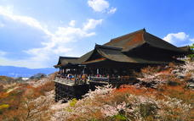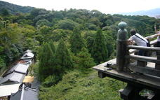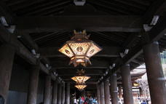

Included
Bed & Breakfast

Day 11: Saturday, 11 NovemberHotel New Hiroden, Hiroshima

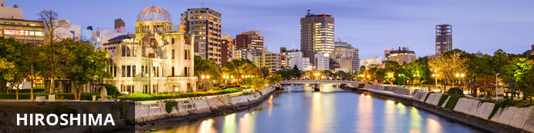
Hiroshima has a deep historical significance – it was the first city ever to suffer an atomic blast, which wreaked devastation across the urban hub on 6 August 1945. The only remaining building in the area was the Genbaku Dome, which is now known as the “City of Peace” and has become a worldwide symbol of hope for everlasting peace. Hiroshima-jo is a replica of the original castle where Japanese elders came together for centuries to discuss strategies and politics. Today Hiroshima is a thriving tourist destination with an interesting food scene and a very vibrant nightlife. Cultural experiences include the Hiroshima City Museum of Contemporary Art and the Mazda Museum.

Day Itinerary
After breakfast, leave your main suitcase for a next day transfer to Osaka. Transfer to Hiroshima by bullet-train and go on a full-day Hiroshima & Miyajima tour by local train and fast ferry, visiting Peace Memorial Park, Museum, A-Bomb Dome and see Itsukushima Shrine. Return to your hotel.

Overnight: Hotel New Hiroden
Hotel New Hiroden is conveniently located 3 minutes to the West of JR Hiroshima Station South Exit, within easy reach from the heart of the city. The hotel stands out elegantly beside the banks of Kyobashi River, one of the six rivers that flow through the city. Facilities include guest rooms, conference rooms, banquet halls, restaurants, and a bar as well. The hotel is perfectly suited for both business and tourist use.
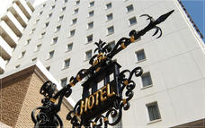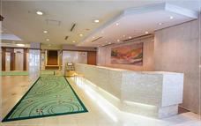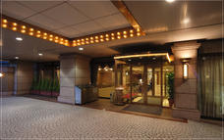

Activities
Hiroshima Full Day Tour by Private Coach
Hiroshima
Hiroshima Peace Memorial Park
Atomic Bomb Dome
Itsukushima Shrine

Hiroshima
Hiroshima has a deep historical significance – it was the first city ever to suffer an atomic blast, which wreaked devastation across the urban hub on 6 August 1945. The only remaining building in the area was the Genbaku Dome, which is now known as the “City of Peace” and has become a worldwide symbol of hope for everlasting peace. Hiroshima-jo is a replica of the original castle where Japanese elders came together for centuries to discuss strategies and politics. Today Hiroshima is a thriving tourist destination with an interesting food scene and a very vibrant nightlife. Cultural experiences include the Hiroshima City Museum of Contemporary Art and the Mazda Museum.
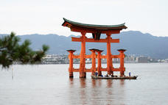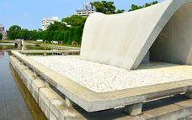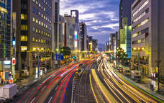

Hiroshima Peace Memorial Park
Hiroshima Peace Memorial Park is a huge park that measures over 120,000 square metres. The memorial park features trees, lawns, as well as walking paths, contrasting to the surrounding downtown area. On the fourth anniversary of the tragedy, the area was dedicated to peace memorial facilities, and become the Peace Park. Visitors to the area can see the A-Bomb Dome, which was one of the few buildings to remain standing after the explosion, and is a UNESCO World Heritage Site.

Atomic Bomb Dome
The Atomic Bomb Dome, also known as Genbaku Dōmu, is what remains of the former Prefectural Industrial Promotion Hall. It was one of the few buildings that was not completely destroyed after the explosion took place. The A-Bomb Dome is still present there today, and is a UNESCO World Heritage Site.

Itsukushima Shrine
Itsukushima Shrine is a Shinto shrine, located in the city of Hatsukaichi in Hiroshima Prefecture in Japan. The shrine and its torii gate were built over water, with the illusion that they are floating on the sea during high tide. The shrine complex is composed of many buildings, including a prayer hall, main hall, as well as a noh theatre stage, linked together by boardwalks and supported by pillars above the sea.
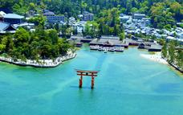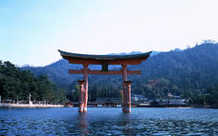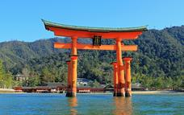

Included
Bed & Breakfast

Day 12: Sunday, 12 NovemberCross Hotel Osaka, Osaka

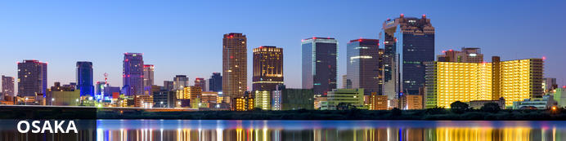
Osaka in West Japan is a well known economic hub with a variety of shopping areas each with their own restaurants, fashion hubs and general stores. Visit Shinsaibashi if you want to experience one of the best downtown areas. Those seeking a cultural experience should head to Minami with its many cinema and theatres. Osaka’s Castle is a favourite sightseeing spot and during cherry blossom season the castle’s lawn park puts on a beautiful show. Osaka has two airports. Itami Airport (ITM) handles most of the domestic flights while Kansai International Airport (KIX) is a man-made island that was built for all international traffic and some local routes.

Day Itinerary
After breakfast, transfer to Osaka by bullet-train and go on a half-day Osaka walking tour, visiting Shinsaibashi Street and Kuroman Market.

Overnight: Cross Hotel Osaka
Cross Hotel Osaka is conveniently located in Osaka's main shopping district close to the Dotonbori Area, America-mura Village and public transport hub. The stylish rooms include free WiFi internet, a complimentary bottle of water and private bathrooms. This hotel features 2 restaurants, a bar/lounge, and a coffee shop/café. WiFi in public areas is free. Other amenities include self parking, dry cleaning, and a 24-hour front desk.
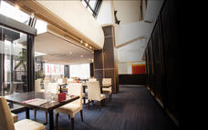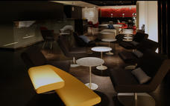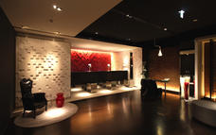

Activities
Osaka Half Day Walking Tour

Included
Bed & Breakfast

Day 13: Monday, 13 NovemberCross Hotel Osaka, Osaka

Day Itinerary
After breakfast, go on a full-day Osaka tour by private coach, visiting Keitakuen Garden, Shin-Sekai Street and Osaka Caste.

Activities
Osaka Full Day Tour by Private Coach
Osaka Castle

Osaka Castle
Situated within the Osaka Castle Park, Osaka Castle is the symbol of Osaka. The park is also home to sports facilities, the Osakajo Hall, and a shrine dedicated to Toyotomi Hideyoshi who commissioned the building of the castle.Building of the castle was completed in 1585 on the former site of the Ishiyama Honganji Temple. Major repairs to the castle tower were undertaken in 1997 and the inside has been modernised, even featuring an elevator. Within the tower is a museum where visitors can learn about the history of the castle and the life of Toyotomi Hideyoshi.There is a beautiful garden with 600 cherry trees and a tea house on the western side of the castle. An admission fee is charged to enter the garden while access to the rest of the grounds is free.
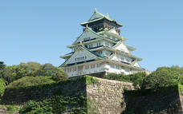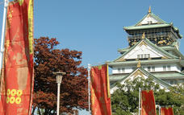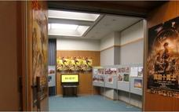

Included
Bed & Breakfast

Day 14: Tuesday, 14 NovemberDeparture

Day Itinerary
After breakfast, transfer to Kansai International Airport for your departing flight.

Transport

Transfers
Date | Pick Up | Drop Off | Time | Vehicle
01 Nov | Narita International Airport [NRT] | Tobu Hotel Levant Tokyo |  | Private Coach (Transfer)
05 Nov | Tobu Hotel Levant Tokyo | Matsumoto Station |  | Private Coach (Transfer)
05 Nov | Nagano Station | Yorozuya Ryokan |  | Private Coach (Transfer)
06 Nov | Yorozuya Ryokan | Hotel Associa Takayama Resort |  | Private Coach (Transfer)
07 Nov | Hotel Associa Takayama Resort | Kanazawa Tokyu Hotel |  | Private Coach (Transfer)
09 Nov | Kanazawa Tokyu Hotel | Kanazawa Station |  | Public Transport (Transfer)
09 Nov | Kyoto Station | Mitsui Garden Hotel Kyoto Shijo |  | Public Transport (Transfer)
11 Nov | Mitsui Garden Hotel Kyoto Shijo | Kyoto Station |  | Public Transport (Transfer)
11 Nov | Hiroshima Station | Hotel New Hiroden |  | Public Transport (Transfer)
12 Nov | Hotel New Hiroden | Hiroshima Station |  | Public Transport (Transfer)
12 Nov | Osaka Station | Cross Hotel Osaka |  | Public Transport (Transfer)

Journey Information
Date | Train | Departure Platform | Time | Arrival Platform | Time | Class | Ref
05 Nov | Bullet Train (Train) | Matsumoto Station |  | Nagano Station
09 Nov | Bullet Train (Train) | Kanazawa Station |  | Kyoto Station
11 Nov | Bullet Train (Train) | Kyoto Station |  | Hiroshima Station
12 Nov | Bullet Train (Train) | Hiroshima Station |  | Osaka Station

Urgent Contact Numbers
Company Name | Telephone | Email Address | Contact Person
ORBA TRAVEL BROKERS | +61 8 94741655 | richard@orba.com.au | Richard van Kempen

Contact Details & Reference Numbers
Service Provider | Ref. Number | Telephone | Address
Hotel Associa Takayama Resort |  | +81 577-36-0001
Hotel New Hiroden |  | +81 82-263-3456

Travel Information
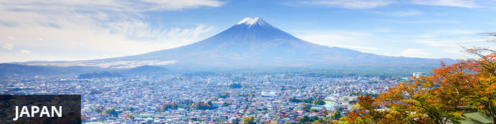
Japan is one of the most visited countries in the world and many tourists wax lyrical when they share their travel experiences. The landscape offers an interesting blend of beautiful nature, well kept religious shrines and temples, historical landmarks, modern cities and world heritage sites. The influence of Japan’s interesting cultures and unusual sub cultures have such an international impact that foreigners flock here to experience sumo wrestling, traditional tea drinking ceremonies, anime comic art, sumo wrestling, samurai legends and more. Japan is also known as the birthplace of sushi, aikido and calligraphy. A trip here would not be complete without experiencing the outwordly music scene and diverse night life.

Banking and Currency
Currency
The unit of Japanese currency is yen. Coins are available in denominations of 1, 5, 10, 50, 100 and 500 yen and bank notes in denominations of 1,000, 2,000, 5,000 and 10,000 yen. You can buy yen at foreign exchange banks and other authorized money exchangers. At the international airports, currency exchange counters are usually open during normal office hours. The exchange rate fluctuates daily depending on the money market.
Banking
Banking hours: Monday-Friday 09h00-15h00.
American Express, Diners Club, MasterCard, Visa and other major credit cards are widely accepted in major cities and towns. A pin number may be required to process the transaction. It is advisable to check with your bank to find out if your card will be recognised in Japan. The Japan Post Bank, Seven-Eleven convenience stores and international banks typically accept foreign credit cards.
ATMs at Seven-Eleven stores also accept foreign cards and are accessible 24 hours a day. International banks accept foreign credit or debit cards, and these are hard to find outside of major cities. Bank ATMs are generally open Monday-Friday 07h00-23h00, Saturday-Sunday 09h00-19h00, though some only operate during normal banking hours and on Saturday mornings. Citibank machines are the most likely to have ATMs, and also to accept foreign credit cards (and are usually open 24 hours).
Japan has a strong cash culture, and it is usual to see people carrying large amounts of cash with them because of the low crime rate. It is only recently that credit cards have begun to become more popular. However, travellers may still encounter difficulties with foreign credit cards.
Travellers cheques can be exchanged at most major banks, larger hotels and some duty-free shops. To avoid additional exchange rate charges, travellers are advised to take traveller's cheques in Japanese Yen or US Dollars.

Travel, Transport and Getting Around
Japan has an efficient public transportation network, especially within metropolitan areas and between the large cities. Japanese public transportation is characterized by its punctuality, its superb service, and the large crowds of people using it.
All Nippon Airways (ANA) and Japan Airlines (JAL) maintain an extensive network of flights covering all of Japan and its islands. There are a few budget airlines too, such as Skymark, Air Do, Solaseed Air, IBEX Airways and Starflyer. Tokyo is serviced by two airports; Haneda (HND) which has both domestic and international flights, and Narita (NRT) for international flights.
Japan has a network of well-connected expressways linking major regions. However, expressway tolls are very high and there is major congestion during peak holiday seasons. Driving is convenient if you are planning to travel outside the major cities to the more remote and scenic regions. It’s important to be aware of weather conditions – heavy rain and snow can force road closures. International visitors must have an international license in order to hire and drive a car in Japan. The minimum driving age is 18, and it is advisable to take out car insurance.
Taxis can be expensive, particularly in rush hour (07h30-09h30 and 17h00-18h00) when traffic can be very slow. There is a minimum charge of ¥660 for the first 2km (1.2 miles) followed by ¥80 per 274m (900ft) thereafter, plus a time charge when the taxi is moving at less than 10kph (6mph).
Taxi drivers are very professional, but tend not to speak English, so it is advisable for tourists to have their destination written out in Japanese, together with the name of some nearby landmark. A map may also help, as Japanese streets can be complicated and some taxi drivers will get confused. Hotels can provide this service.
Cycling is a pleasant way to enjoy exploring Japan, and is often faster than using public transport. Bicycle rental is available in all major cities, especially those with major sightseeing attractions such as Tokyo, Kamakura, Kyoto, Nara and Hiroshima.
There are regular long-distance bus services running between all the major regions and cities in Japan. Both daytime and overnight buses are available. It’s a cheap way to travel and sightseeing time during the day can be maximised by travelling at night.

Food, Drink and Cuisine Advice
If travelling to the area near the Fukushima nuclear accident it is advisable to take supplies of food and water. Produce from the area near the Fukushima nuclear accident, which is still being sold in some supermarkets nationwide, should be avoided due to the lack of a centralized testing system in Japan for radioactive contamination in food, and discrepancies between Japanese and international standards for safe levels of radioactive substances in food.
Tap water in Tokyo was declared not safe for consumption after the accident, although the government has since stated otherwise. Nevertheless, if travelling with children it is advisable to take precautions. The Ministry of Health, Labour and Welfare website (www.mhlw.go.jp) has updates on contamination levels in tested food. In other parts of Japan, food and drink are generally considered safe.
Only eat raw fish, seafood and meat from recognised establishments, and be aware that there is a risk of parasitic infection and toxins if these foods have not been prepared properly. E-coli food poisoning outbreaks tend to occur in Japan during the warmer months (June-September), and it is advisable to take precautions when consuming perishable foods at outdoor summer festivals, where refrigeration may be an issue.
Japanese cuisine involves fresh, delicate flavours based on seasonal ingredients. Rice, miso (fermented soy bean) soup, tofu (soy bean curd), pickled vegetables and fish are the traditional staples of daily Japanese cuisine. Traditionally, meat was not eaten because of Buddhist beliefs. However, beef, chicken are now also staple ingredients. Fresh seafood is highly valued and Japanese will travel far to eat crab in winter, for example, and unagi (eel) in summer. The variety of ingredients, the intensive preparation methods, and the meticulous presentation found in Japanese cuisine is highly impressive.
Sushi, pieces of raw fish on vinegared rice, has become synonymous with Japanese cuisine. The easiest place to try sushi is at a kaiten-zushi restaurant, where many varieties pass on a conveyor belt and diners can pick up what they fancy without any language difficulties, and at reasonable prices. More traditional sushi restaurants serve higher quality fish but also charge much higher prices.
The most luxurious dining in Japan is kaiseki cuisine – a multi-course banquet that was originally intended to accompany the tea ceremony. Kaiseki cuisine is exquisitely presented, reflecting the aesthetics of the seasons and traditional ceramics. A typical banquet will begin with light appetisers and soups before progressing to various steamed, grilled and fried dishes, and ending with a simple rice dish.
A variety of international restaurants are also available, catering for every taste and budget, from French and Italian to Chinese, Indian and Thai. Western dishes in expensive places are usually excellent, but cheaper diner-style restaurants may disappoint. While sake (rice wine) is still regularly served, beer is by far the most popular alcoholic beverage.
Tips are never expected. In some upmarket places, a 10 to 15% service charge will be added to the bill. In some bars, there may be a table or "charm" charge too, which can be quite steep; it's best to enquire in advance if you're in any doubt.

Climate and Weather
The climate varies widely from one region to region. Basically, Japan has four distinct seasons. Spring months are March, April, and May. Summer months are June, July, and August. Autumn months are September, October, and November. Winter months are December, January, and February. Summer is hot and humid in general. During the winter, it snows a lot on the Sea of Japan side, and it is dry on the Pacific Ocean side.

Clothing and Dress Recommendations
The Japanese dress as Westerners do and are quite conservative on the whole, but the youngsters are very daring and you'll see some mad outfits in Tokyo. Pack comfortable shoes for walking that can be slipped off easily when you need to. Holes in socks are not recommended, as you spend lots of time without shoes on - visiting temples, shrines and traditional restaurants etc. As the Japanese are very petite, finding clothes to fit in the popular stores can be difficult - so take everything you will need with you. In Japan tattoos are associated with the mafia, and are banned in many places - even a tiny mark may mean you are refused entry. So if you have any, keep them covered with clothing, plasters or special concealer products.

Electricity and Plug Standards
In Japan the standard voltage is 100 V. The standard frequency is 50/60 Hz. The power sockets that are used are of type A / B.
Japanese power outlets are identical to ungrounded (2-pin) North American outlets. While most Japanese outlets these days are polarized (one slot is slightly wider than the other), it is possible to encounter non-polarized outlets in some places.
The frequency of electric current is 50 Hertz in Eastern Japan (including Tokyo, Yokohama, Tohoku,Hokkaido) and 60 Hertz in Western Japan (including Nagoya, Osaka, Kyoto, Hiroshima, Shikoku,Kyushu); however, most equipment is not affected by this frequency difference. A possible exception are timing devices such as clocks.

Terms and Conditions
This is where you would put your standard terms and conditions. This is a sample account for Wetu so we do not have any T & Cs

