15 day Namibia Highlights - Camping & Accommodated Self-Drive v1
Windhoek - Kalahari Namibia - Sesriem - Sossusvlei - Swakopmund & Coastal Strip - Namib - Twyfelfontein - Damaraland - Etosha South - Etosha National Park - Onguma Game Reserve - Okonjima Nature Reserve
15 Days / 14 Nights
Group Size: 2
Reference: Safari Index - 2 clients March 2022
Date of Issue: 07 March 2022

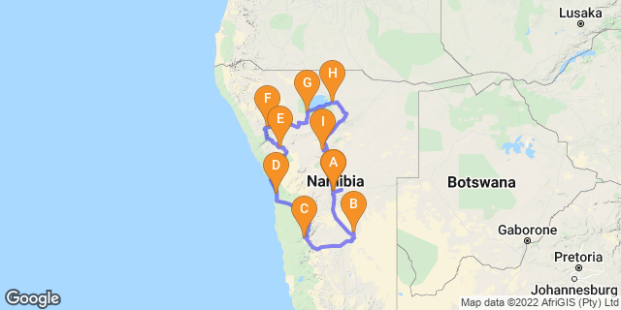

Click here to view your Digital Itinerary

Introduction

Accommodation | Type | Destination | Basis | Duration
The Utopia Boutique Hotel |  | Windhoek | B&B | 1 Night
Bagatelle Kalahari Game Ranch Campsite |  | Kalahari Namibia | SC | 1 Night
Sesriem Oshana Campsite |  | Sesriem | SC | 2 Nights
→ Sesriem Campsite | alternate
Swakopmund Sands Hotel |  | Swakopmund & Coastal Strip | B&B | 2 Nights
Madisa Camp |  | Twyfelfontein | SC | 1 Night
Grootberg Lodge |  | Damaraland | D,B&B | 2 Nights
Okaukuejo Camp |  | Etosha South | SC | 2 Nights
→ Halali Campsite | alternate
Onguma Tamboti Campsite |  | Onguma Game Reserve | SC | 1 Night
Okonjima's Omboroko Campsite |  | Okonjima Nature Reserve | SC | 1 Night
The Utopia Boutique Hotel |  | Windhoek | B&B | 1 Night

Key
SC: Self Catering
B&B: Bed and Breakfast
D,B&B: Dinner, Bed and Breakfast

Price
2022 Rates March
Nett Price per person to Chameleon with Car Rental
Based on 2 people sharing with a 4x4 Double Cab auto with camping equipment & 1 roof tent N$30,040

Included
Camping & accommodation as set out in itinerary; car rental as indicated; meals as stated in itinerary; Bagatelle - shared sundowner drive; Onguma - AM walk on reserve/shared; Okonjima for AfriCat Foundation - shared Africat (Carnivore Conservation) activity; vat; tourism levy; welcome pack;
Car Rental Company - super cover
Includes: Includes: 15% VAT, unlimited kms; collision damage waiver; standard tools, second driver; 2 x spare wheels; 1 x return airport transfer (HKIA-city- HKIA) ; tourism levy; stamp duty; tyre gauge and windshield cover; full camping equipment for 2 people and includes 1 roof tent
ALL OTHER EXTRAS TO BE PAID DIRECT BY CLIENT TO THE CAR RENTAL COMPANY

Excluded
International and other flights; visas; fuel; additional meals and optional activities; personal insurance; tips/gratuities; items of a personal nature; curios; entry fees to parks and places of interest; ancillary costs for car hire as indicated below, etc Covid-19 tests etc
2022 park entry fees: N$150/person/day; SADC rates - N$approx 80/person; Children under 16yrs N$100/day and N$30/vehicle day – subject to change & if you self-drive to park note that park gates open/close at sunrise/sunset and you must have exited the park prior to closure or risk a fine/refusal of departure.
Car Rental:
Excludes: Refundable vehicle deposit (N$4500); refundable camping equipment deposit (N$6,500); contract fee N$90/rental; Extra ground tent N$550; fuel/refuelling fee - cost of fuel & N$10; overdue rental admin fee N$550; claim admin fee; fines and fine handling fee N$250/incident; sand, water and undercarriage damage; tyre sidewall damage insurance N$95; cross border permits to Botswana, South Africa, Zambia and Zimbabwe - N$575; young driver (main driver should be 25 years) N$100/day; baby/booster seat N$450/rental; tow in /recovery service if not mechanical; lost key call out fee N$8/km & key replacement cost; GPS rental N$95/day; additional airport transfers (1 free of charge each way); unscheduled late/early delivery/collection fee within 25km and outside normal office hours N$350; delivery/collection fee for vehicle at Windhoek International Airport N$500; car cleaning fee for excessive dirt N$1200 or actual if more; 12v compressor N$400/rental; first aid kit N$350/rental; fuel canister N$70; water canister N$70; fire extinguisher N$350; sat phone (usage approx N$25/min- client account) N$140/day; damage to equipment - renter account; camping tool set (spade, axe etc) - N$450/rental; sand mats / tracks - N$650/rental
Note: The Car Rental has its office in Windhoek City Centre – they are able to provide airport transfers for you (inclusive of rates 1 x return transfer).
Prices quoted for extras on car rental are guideline and subject to amendment by car rental company

Day 1: The Utopia Boutique Hotel, Windhoek

Day Itinerary
Collect your vehicle upon arrival and drive to your guesthouse where you will have the chance to meet a Chameleon consultant who will go through your itinerary and answer any last-minute questions. Depending on your arrival time you may choose to wander into the city centre, relax by the pool or join an optional township tour, horse ride, or even head out for a birding trip. Overnight on bed and breakfast basis in en-suite room, all other meals will be at client’s expense. Comfort 3*. Approx 40mins to city from airport plus time to collect vehicle/complete paperwork.
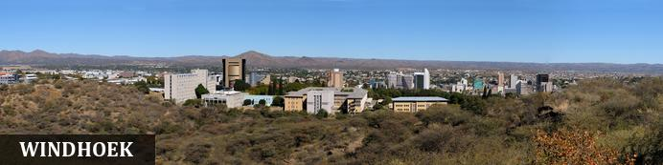
Windhoek is Namibia’s capital, home to an international airport and a plethora of restaurants, shops, entertainment venues and accommodation options. The city is clean, safe and well-organised, with a colonial legacy that is reflected in its many German eateries and shops, and the widespread use of the German language - though English is the official language. The city has an interesting mix of historical architecture and modern buildings, many of which are worth a look, including the Alte Feste (Old Fort), the 1896 Christuskirche (Christ Church), and the more contemporary Supreme Court. It's not a city to linger though - generally one or two nights is sufficient.

Overnight: The Utopia Boutique Hotel View iBrochure
The modern Utopia Boutique establishment has allied with the neighbouring Pension Bougainvilla and offers serene rooms and luxurious suites situated amid beautiful, green lush gardens around a swimming pool. The hotel is conveniently located in the tranquil suburb of Klein Windhoek. There are just 12 standard rooms, 6 luxurious suites, and a self-catering unit. All rooms are equipped with a TV, DSTV, free wifi-access and air-conditioning along with a balcony or outside deck. The onsite Taste Academy, beautifully set in a restored German Manor built in 1912, offers a superb venue.
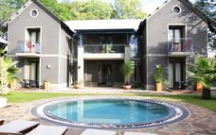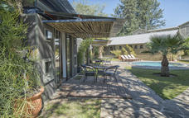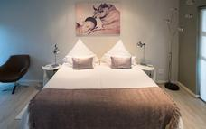

Basis
Bed and Breakfast

Day 2: Bagatelle Kalahari Game Ranch Campsite, Kalahari Namibia

Day Itinerary
This morning (after breakfast), head south onto the red dunes of the Kalahari Basin, where you’ll overnight in a campsite. Join a shared/guided sundowner activity on the reserve with the lodge later this afternoon. Overnight camping only, all meals and additional activities at own expense. Approx 3hours
Nature Drive and Sundowner
A game drive in the reserve with a variety of game such as giraffe, kudu, zebra, oryx, blue-wildebeest, eland and much more. The reserve has some of the highest dunes in this region, with views over the pans, characteristic to the Kalahari. Between the dunes, which are called streets, are the beautiful acacia trees. The Kalahari has more than 150 species of birds. The well-known suricate (meerkat) is also to be seen, although they are very scarce. As the day draws to an end, a sun-downer on the dune will await you, with refreshments and a Namibian snack, while enjoying a breath taking sunset in the Kalahari.

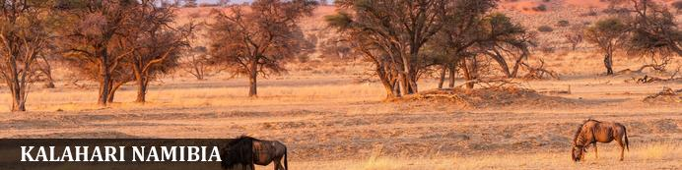
The Kalahari is an exceptionally beautiful living desert a large semi-arid sandy savannah draped over a gently rolling inland sea of sand covering most of Botswana and large parts of Namibia and South Africa. It is also the last bastion of the San people with the modern world having enveloped all the other areas they once roamed. Here in Namibia it is typically red sands covered in thin, wispy, mostly golden grass and dotted with camel-thorn acacia trees and wide ranging wildlife including gemsbok, giraffe, springbok, jackals and cheetah.

Overnight: Bagatelle Kalahari Game Ranch Campsite
Located on Bagatelle Game Ranch in the Kalahari Basin, there are five campsites, set between the red sand dunes, each campsite has it's own dedicated ablution block, toilet, shower, washbasin and mirror. It is fully tiled and hot water supplied by modern gas geysers and solar lights. Relax around a campfire and enjoy the Kalahari night. You can join the lodge for activities including sundowner drives, horse rides, Bushman walk, night sky star gazing and more. There's a swimming pool to relax around.
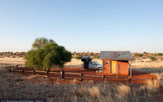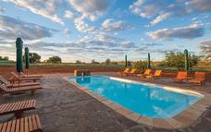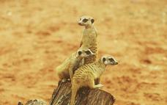

Basis
Self Catering

Day 3-4: Sesriem Oshana Campsite, Sesriem

Day Itinerary
Enjoy the stunning scenery on the drive to Sesriem, the main campsite area and entry to the famous sand dunes of Sossusvlei, once here you can relax by the nearby swimming pool and suggest a visit to nearby Elim’s Dune for sunset - watch the colours of the mountains change and listen to the call of the barking geckos. The following day rise early to venture into the dune fields (recommend leaving before sunrise to ensure you are in the dune sea for sunrise). One of the benefits of staying at Sesriem allows pre-dawn access to the dunes those outside the park are not afforded, and suggest you leave the vehicle at the 2x4 car park – from here walk the last section or take the shuttle service available from the car park. Climb Big Daddy sand dune adjoining the eerie Dead Vlei, where ancient skeletal camel thorn trees appear to stand guard over the shimmering white pan before continuing to Sossusvlei, renowned for its desiccated white pan surrounded by majestic star-shaped dunes. Relax under the shade of a huge tree and appreciate the beauty of the area before returning to camp (via famous Dune 45) and later this afternoon, explore nearby Sesriem Canyon. 2nights camping only; with all meals at clients’ expense. Day 3: Approx 5-5.5hours; Day 4: Approx 1hour Sesriem gate to 2x4 car park
note the last 5km is deep sand and 4x4 only so we do not recommend this unless you are an experienced sand driver. By staying at Sesriem you are based inside the national park and as such have access to leave camp for the dunes 1hour prior to sunrise - enabling you to see the sunrise in the dunes. Those staying outside the park are only able to enter at sunrise
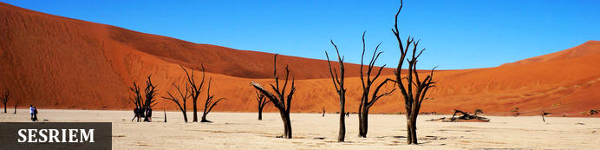
As there is no accommodation at Sossusvlei, visitors to this desert wilderness are likely to end up staying near to Sesriem, 65km away, where camps and lodges serve as a base from which to explore the dunes and where it serves as entry point to the national park. Sesriem Canyon, a deep chasm carved through the rocks by water, is a striking natural feature of the area that is best explored on foot. Stony walls rise up sharply on both sides of the canyon, while birds roost in its crags and lizards dart along the ledges. The canyon’s name was coined when early settlers used it as a water source, using six lengths of leather (‘ses riem – six thongs) tied together to lower buckets into the water at the base of canyon.)

Overnight: Sesriem Oshana Campsite
Sesriem Oshana opened in 2020 and offers ten (10) self-catering campsites, each having its own private ablutions with toilet and shower, braai area, wash-up kitchenette with hot and cold water and 220V electricity points. Campers have full access to the shop, bar, restaurant and swimming pool at neighbouring Sesriem. It's located inside the national park, 600m from the permit office and 800m from Elim Dune.
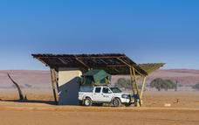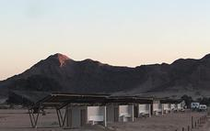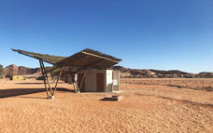

Alternate: Sesriem Campsite
Sesriem derives its name from the time when earlier pioneers tied six lengths of rawhide thongs (riem) together to draw water from the pools. There are 24 campsites with shared ablution blocks offering toilets/showers and washing up facilities there is also a fuel station, small store and restaurant/bar, along with a refreshing pool. Most of the campsites are set under the shade of a camel-thorn tree and have a low wall built around the site, there's a tap and some have electric point. Sesriem is the only campsite inside the national park and guests benefit from the park entrance gate opening 1hour prior to sunrise enabling guests to enter the park and drive to the dune sea for sunrise - those staying outside the park can only enter at sunrise.
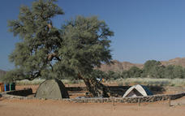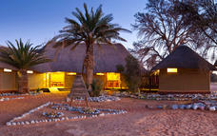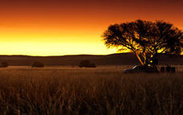

Optional
Dead Vlei
Dune 45
Sesriem Canyon

Dead Vlei
This ancient clay pan was once an oasis, studded with acacias and fed by a river that suddenly changed course, leaving the earth to dry up along with the trees it previously supported. So dry were the climatic conditions that the trees never decomposed – instead they were entirely leached of moisture so that today, 900 years later, they remain as desiccated, blackened sentinels dotting the pan’s cracked surface. Surrounded by the red-pink dunes of the Namib Desert, blue skies, a white-clay pan, they create a surreal spectacle that is a photographer's dream.
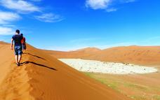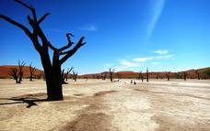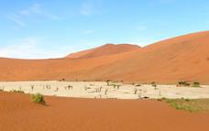

Dune 45
Dune 45 is located 45kms from the Sesriem gate, (and entrance to dunes), it is renowned for its elegant shape, which – along with its position close to the road – has earned it the distinction of ‘most photographed dune in the world’.
Popular for sunrise, many people climb to gain a vantage point to watch the sun rise over the surrounding area and enjoy the changing colour of the dunes, at only 80 metres and featuring a much gentler gradient it is an easier climb than many of the other dunes found.
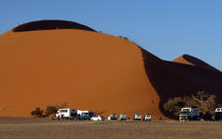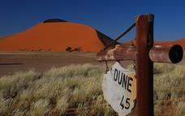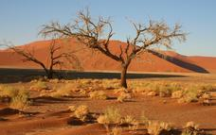

Sesriem Canyon
Sesriem Canyon, a deep chasm carved through the rocks by water, is a striking natural feature of the area that is best explored on foot. Stony walls rise up sharply on both sides of the canyon, while birds roost in its crags and lizards dart along the ledges. The canyon’s name was coined when early settlers used it as a water source, using six lengths of leather (‘ses riem – six thongs) tied together to lower buckets into the water at the base of canyon.
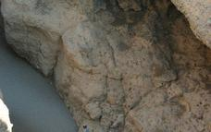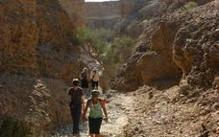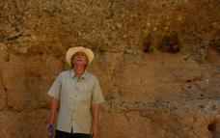

Basis
Self Catering

Day 5-6: Swakopmund Sands Hotel, Swakopmund & Coastal Strip

Day Itinerary
Drive through the desert to Swakopmund today, en-route stop at Walvis Bay to visit the lagoon, a protected RAMSAR wetland site, where you may see the many species of birds including greater and lesser flamingos, pelicans, avocets, plovers and the endemic Damara tern before a brief stop at the salt farm. From here, it is a short coastal drive to the historic and adventure seaside town of Swakopmund, where you can join optional activities on offer, perhaps take part in a marine cruise, kayak, sky dive or quad bike. Alternatively, a highly recommended option is a trip to Sandwich Harbour or perhaps a scenic flight over the dunes and coastline where you will see dunes falling into the ocean, a shipwreck 200m inland and of course, the dunes of Sossusvlei region. Activities can be booked in advance. There is a safe beach for swimming, an interesting aquarium and museum or you may want to sit back and relax with a coffee and cake and watch the world go by. Overnight in twin share room on a bed and breakfast basis, all other meals and activities will be at client’s expense (it can be really cold and foggy so we don’t recommend camping). Comfort 3* Approx 5-5.5hours
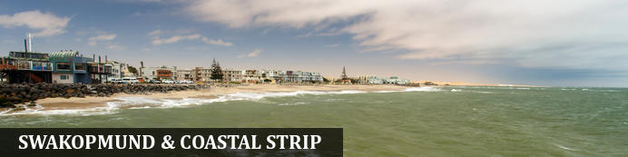
Founded in 1892 as the main harbour for German South West Africa, Swakopmund is often described as being more German than Germany. Now a seaside resort, Swakopmund is the capital of the Skeleton Coast tourism area and has plenty to keep visitors happy. The quirky mix of German and Namibian influences, colonial-era buildings and the cool sea breeze make it very popular and has a wide range of accommodation establishments, banks, restaurants/cafes and shops.
Along this stretch of coastline (Walvis Bay and Swakopmund) you can take part in a selection of activities sating the thirst of those seeking adrenaline adventures - sky diving, quad biking and sandboarding; or for the more leisurely a range of marine activities including kayaking and cruises. The coastal desert can also be explored with trips to Sandwich Harbour, or informative desert tours... There is a long list so just ask us!
Walvis Bay is Namibia's major harbour town and the lagoon has prolific bird life including flamingos, pelicans as well as the breeding area for the endemic Damara tern - any bird enthusiast should make a stop here.
Further north along this coastline - part of the Skeleton Coast, you'll find shipwrecks and the famous Cape Cross seal colony - one of the largest fur seal colonies in the area.

Overnight: Swakopmund Sands Hotel View iBrochure
The Swakopmund Sands is literary minutes’ walk away from the very popular Jetty and Tug restaurants as well as other tourist attractions and yet there is total privacy once on the premises. Each individually designed room is equipped with a flat screen TV, safe, under floor heating, fridge, as well as tea and coffee facilities. A laundry service is available for same day delivery. Each bathroom has a hairdryer and shaving facilities and all international power points can be used. Free wifi available. Note there is a breakfast room but additional meals are not available.
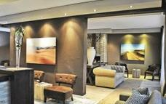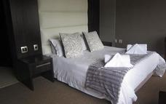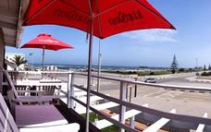

Optional
Walvis Bay Lagoon
Sandwich Harbour

Walvis Bay Lagoon
Walvis Bay’s calm natural lagoon is a twitcher’s paradise, teeming with roughly 50 species of seabirds, including vivid flocks of flamingos, bulky-billed pelicans and glossy black cormorants. It’s also a popular spot for windsurfing, kitesurfing and kayaking, while the promenade stretching for three kilometres along the water’s edge is a great place for a scenic stroll.
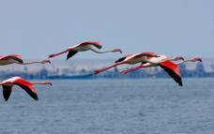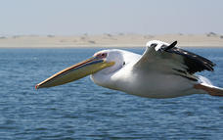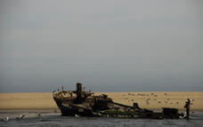

Sandwich Harbour
Located roughly 50 kilometres from Walvis Bay, Sandwich Harbour is a natural lagoon framed by sand dunes on one side and the Atlantic Ocean on the other. It is a prime angling and bird-watching site, with countless sea birds coming to feed on the rich fish population, including rare white pelican and vivid flocks of pink flamingos.
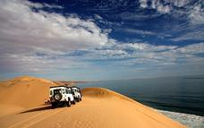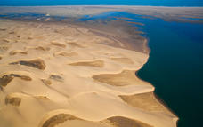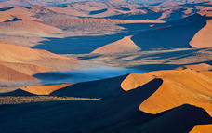

Basis
Bed and Breakfast

Day 7: Madisa Camp, Twyfelfontein

Day Itinerary
Depart from Swakopmund after breakfast and drive north along the Skeleton Coast, perhaps stop at a shipwreck south of Henties Bay before continuing along the coastline to visit Cape Cross seal colony – a huge colony of over 100,000 congregate here during breeding season. From Henties turn inland; your destination today is a campsite in the Twyfelfontein area, a vulnerable and delicate ecosystem renowned for some of the best rock engravings in Southern Africa. Interesting rock formations and the remainder of prehistoric volcanic action can be seen in the Organ Pipes and Burnt Mountain, some of the most prominent geographic features. The fauna and flora of Damaraland is as interesting as the landscape, with plants such as welwitschia, moringa and variety of commiphora species. The camp also offer optional activities such as village tours. Overnight camping only, all meals will be at client’s expense. Approx 5hours (plus Cape Cross diversion)
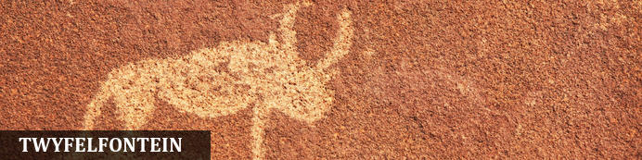
Twyfelfontein is a site of ancient rock engravings in Damaraland, and Namibia's first UNESCO World Heritage Site (2007). It has one of the largest collections in Africa as well as one of the most note-worthy with around 2,000+, some thought to be around 6,000 years old! It is believed that the creators of the rock art were the medicine people or shamans who incised their engravings as ameans of entering the supernatural world and recording the experiences, the process could prepare the shaman for a state of trance by the repetitive chipping and concentration of energy. Etched into the rock are thus stories within stories, eternalised as a legacy

Overnight: Madisa Camp
Madisa Camp is situated on the D2612 road to Twyfelfontein, a very popular route. The camp is hidden between amazing rock formations which are scattered with Bushman Paintings and has privy to an ancient Desert Elephant route that often gets visited by these beautiful giants. There are simple tented chalets with beds and basic en-suite facilities or stay at one of the spacious campsites with a view of the Gauntegab River bed and rock formations each with individual ablution facilities situated on stilts hidden in the tree tops. The braai facilities also double up as a heater (donkey system) for hot running water at each open air shower. There is also a simple restaurant facility available
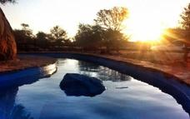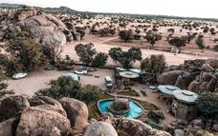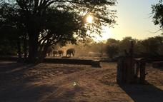

Optional
Cape Cross Seal Colony
Twyfelfontein Rock Art

Cape Cross Seal Colony
This colony of Cape Fur Seals is one of the largest in the world, home to approximately 80 000 to 100 000 of these so-called 'seals', which are in fact a species of sea lion. Day trips to the colony are offered and the seals can be viewed from a walkway at a distance of roughly 200 metres.
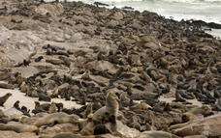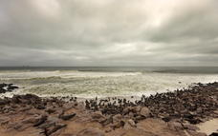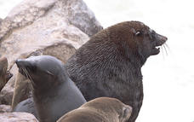

Twyfelfontein Rock Art
Twyfelfontein is a World Heritage Site boasting one of the richest rock art concentrations in Africa. Thousands of tourists come to this site each year to view some 2, 500 Stone Age rock engravings. The area is home to 17 rock art sites, which collectively encompass 212 engraved stone slabs. There are an additional 13 sites displaying rock paintings.
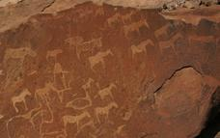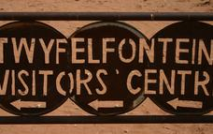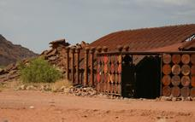

Basis
Self Catering

Day 8-9: Grootberg Lodge, Damaraland

Day Itinerary
Continue your drive to northern Damaraland, this is a community-based establishment, where plateaus reach high on skyline and strange plant life dominates the surrounds. 2nights are spent on a dinner, bed and breakfast basis and optional activities are at client’s own expense – we strongly recommend joining an excursion such as the rhino tracking, supporting the protection of one of the greatest animals known – the endangered black rhino. Alternatively, you can also track the elusive desert elephant found wandering through the ephemeral riverbeds (though during rainy season they may have wandered away) or visit one of the local Damara communities to get a better understanding of one of the tribes in Namibia. Comfort 3-3.5* Approx 3-4hours
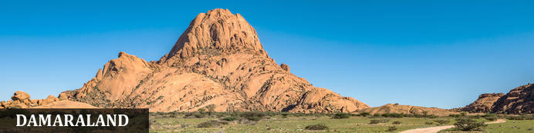
Huge, untamed and ruggedly beautiful Damaraland is an exceptionally scenic landscape of open plains and spectacular rock formations. Some regard the highlight of the region as Twyfelfontein - Namibia's first World Heritage Site and one of the largest collections of rock etchings in Africa. There are a number of sites worth exploring in the region and depending on how much time you have - Brandberg, Namibia's highest mountain, the Erongo Mountains with its granite formations and conservancy programmes, then Spitzkoppe offering incredible rock formations as well as rock paintings.
Engage with local communities around the area including the Damara people and perhaps visit Damara Living Museum located close to Twyfelfontein
Ultimately, this area is also home to free-roaming desert elephant, black rhino and desert-adapted lion (along with a number of other species including giraffe, mountain zebra etc), and some lodges offer superb activities enabling visitors to track these incredible animals

Overnight: Grootberg Lodge View iBrochure
Thanks to funds donated by the European Union, Grootberg Lodge was built. It was the first lodge to be wholly owned by the community and this in turn has brought employment and a more sustainable income to the members, as well as revenue to aide and promoted social initiatives and resources. With community members comprising of up to 98% of the employees, even former poachers became conservationists particularly for those with excellent bush and tracking skills, superb knowledge of the area, these people became the best candidates for the job. An environmental award-winning lodge, increasing wildlife numbers in the conservancy, superb location and game such as black rhino, desert-adapted lion and elephant and sustainable tourism makes this a truly worthwhile lodge to visit and is one of our favourites as a 3* destination. The lodge itself perches on the edge of the plateau with incredible vistas, and has an infinity pool, thatched bar, lounge and dining area, along with a small curio shop and internet facilities. There are 16 en-suite chalets in total - 14 twin/double, plus 2 family chalets, each with its own deck and view, and have tea/coffee station, and mossie nets.
Enjoy optional activities such as guided rhino tracking in the Klip River and is mixture of 4x4 game drive and tracking on foot, with the possibility of between 1-3 hours walk and at lunch time there will be a stop near the springs. It can be almost a full day activity travelling on bumpy roads and walking in rocky terrain and note that sightings are not guaranteed.
Alternatively, you may choose to enjoy searching for the famous desert elephant – a morning activity venturing to local communities and tracing the giants from here as they vend their way through the region and a real chance to see them in incredible habitats along with learning about the lifestyle of local people.
Other options include visiting a local Damara community, game drives, guided nature walks and sunset drives or simply relax by the infinity pool
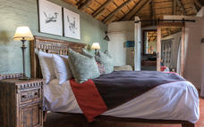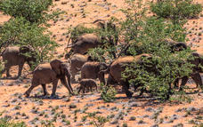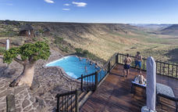

Optional
Desert Elephant Tracking
Rhino Tracking
Sundowner Drive
Damara Culture tour

Desert Elephant Tracking
This is one of our most popular activities. A guide with a tracker will take you out into the surrounding conservancy in search of the elusive desert elephants, giving one also the opportunity to appreciate the life style of the local Damara-Nama people. Lunch takes place in the shade of a tree in the remote wilderness of Damaraland. Damaraland is one of the few last places where the wildlife roams freely, sightings cannot be guaranteed.

Rhino Tracking
Your guide, along with the game trackers will take you in an open 4x4 game vehicle down to the Klip River Valley. Part of the tracking will take place on foot, with the possibility of between 1 to 3 hours walk at the most. At lunchtime there will be a stop near the springs where you can enjoy some refreshments. It's almost a full day activity going along bumpy roads and walking in rocky terrain, so not advisable for the faint-hearted. Sightings are not guaranteed. Note this activity is not available for children under 12yrs
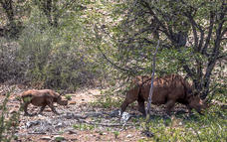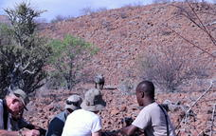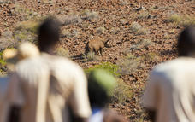

Sundowner Drive
The lodge offers scenic drives on top of the Etendeka Plateau with the possibility of seeing a variety of wildlife population of zebras, antelope, jackal and occasionally leopard and lion. Springbok, Kudu and Oryx are a permanent fixture and even the nervous and shy klipspringers are sometimes seen leaping from ledge to ledge on the steep cliffs of the mountain.
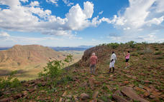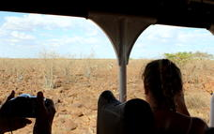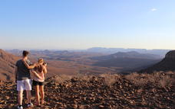

Damara Culture tour
Guests will be guided through surrounding conservancy farms visiting Damara people which allows them with the exclusive opportunity to spend time with their hosts understanding their origins, cultures, traditions and their approach to human wildlife conflict farming within the harsh desert conditions. Experience the modern life of the Damara people of the #Khoadi //Hoas community.
The tour includes a visit to the #Khoadi //Hoas Conservancy office to meet their staff and then on to the Erwee Primary School. This provides the guest with the unique experience of understanding and gaining insight into the positive impacts and benefits that the Conservancy enjoys directly as a result of its ownership of the Grootberg Lodge. The tour concludes with a cultural performance by the Erwee school pupils, followed by a lunch under the trees in a remote spot in the wilderness of Damaraland.
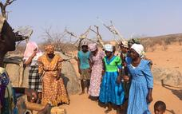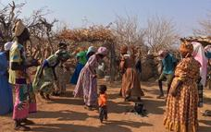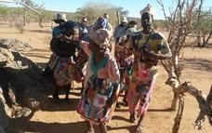

Basis
Dinner, Bed and Breakfast

Day 10-11: Okaukuejo Camp, Etosha South

Day Itinerary
Leave Grootberg and make your way to Etosha entering at Anderson Gate. Game drive to Okaukuejo - each of the main rest camps within Etosha has its own swimming pool, floodlit waterhole to enjoy day or night, a small shop, restaurant and bar. Enjoy game drive in your vehicle throughout the park exploring the areas and visiting some of the many waterholes that normally guarantee rewarding and often spectacular game viewing particularly during dry winter months. In good rain years the pan fills with draining southwards from Angola to create pools of water that attract huge flamingo numbers that come to breed. Overnight camping only
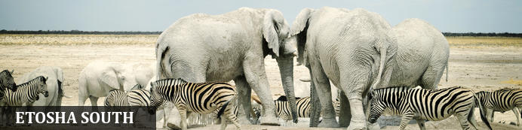
The national park can be accessed via the southern entrance at Andersson’s Gate and the central point is Okaukuejo Resort. Visitors can catch a glimpse of abundant wildlife including: lion, giraffe, elephant, white and black rhino, and a multitude of plains game. Popular activities include: game drives, tracking rhinos on foot, guided nature walks, or watch the sunset over this magnificent landscape. Just outside the national park is the upmarket Ongava Private Reserve, as well as a number of mid-level accommodation and camp sites.

Overnight: Okaukuejo Camp
Okaukuejo is located 17 km from the southern entrance of the park Anderson Gate, is the oldest tourist camp in Etosha and functions as the administrative centre of the park and home to the Etosha Ecological Institute. It is situated at the western end of the Etosha Pan in the south section, facilities include a restaurant, bar, shop, swimming pool, and kiosk. Wifi available (extra charge).The main attraction of this camp is the floodlit permanent waterhole where a wide diversity of wildlife congregate and interact from lion to rhino to elephant and antelope. The spectacle starts at dawn, with animals coming in large numbers to quench their thirst and continues throughout the day until late at night. In the early evenings, it is not uncommon to have black rhino, elephant and lion all drinking at the same time. The campsites are located near to the waterhole and along the boundary fence. Some smaller sites are set on a concrete base near the shared ablution and washing/kitchen facilities, with others a little further away. There is an electric point on most.
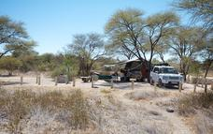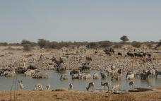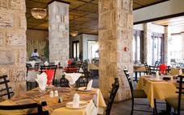

Alternate: Halali Campsite
In an otherwise flat area Halali Campsite is perched between a few hills and koppies. Thicker vegetation makes this popular with leopard, rhino and elephant. Situated halfway between Namutoni and Okaukuejo, the Halali Campsite is centrally located in close proximity of some of the most popular waterholes of the Etosha National Park. A short walk will take you to the camp’s floodlit waterhole with excellent day and night game viewing. ‘Halali’ is the German word for the traditional ending of a hunt. The campsite signifies the end of game hunting and the rise of eco-tourism in Namibia. Halali offers active guests the largest pool in the park and its strategic location between Namutoni and Okaukuejo makes it a great stopover for lunch, ice cream, a cool drink or just petrol. There are a number of campsites located around shared ablution blocks and most sites have an electric point and braai pit. Please note that there is little grass so it can get dusty here but the waterhole is generally good.
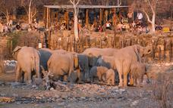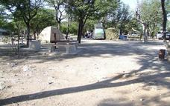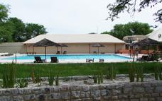

Optional
Etosha Pan

Etosha Pan
Aeons ago, Etosha Pan was the bed of a vast lake; today what remains is a glittering, silvery-green salt pan that stretches across roughly 5000 square kilometres. Etosha is protected by the Etosha Pan National Park surrounded by savannah plains and woodlands supporting large herds of elephants. When dry, the pan sustains little life except for the algae that gives it its distinctive colour, and migratory birds that use it as a pit stop, but with heavy rain it becomes a shallow lake (east side) where flamingos breed, pelicans wade and feed, and a variety of mammal species come to quench their thirst, including predators such as hyena, lion, cheetah, and leopards along with rhinos, and antelopes.
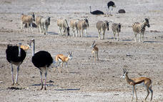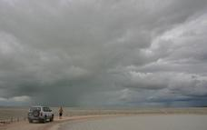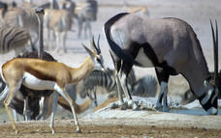

Basis
Self Catering

Day 12: Onguma Tamboti Campsite, Onguma Game Reserve

Day Itinerary
Game drive to the east of the park exploring waterholes such as Kalkauwel, Klein Namutoni, and Chudob as you go. Leave Etosha at the von Lindequist Gate and immediately turn into the Onguma Private Game Reserve, bordering Etosha Park and home to many animals. You can enjoy optional activities such as game drives in open vehicles offered by the lodge on the reserve or in Etosha, a sundowner or night drive, or even a nature walk to search for some of the smaller animals as well as the signs and indications of life which makes for a fascinating insight to understand the region. Overnight camping only
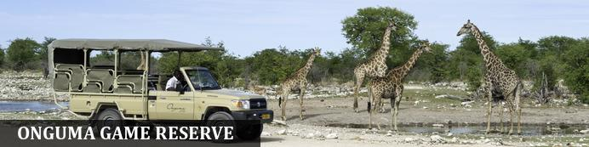
Situated east of Etosha, bordering Fisher's Pan, Onguma Game Reserve is one of Namibia's best-kept secrets. The reserve offers visitors the opportunity to experience Africa in all her beauty and diversity. Onguma Game Reserve features over 34000 hectares of protected land scattered with a variety of wildlife including plains game, black rhino, kudu, giraffe, zebra, lion, cheetah, leopard and more than 300 bird species. The seasonal rains attract thousands of migrating birds to the Fisher’s Pan wetland area. The neighbouring Etosha National Park is home to a rich array of wildlife, including four of the Big 5. Visitors can enjoy game drives, guided walks and rhino research drives within the private reserve as well as wildlife safaris into Etosha National Park to view abundant game in the largest national park in Namibia.

Overnight: Onguma Tamboti Campsite View iBrochure
Located on the private Onguma Reserve, Tamboti Campsite is fenced in allowing guests to wander freely around camp, there is still a bush feel with campsites set under the shade of trees and each site has its own ablutions, powerpoint, the site is serviced daily. Guests can join lodge restaurant but it is recommended meals booked in advance and there is a small kiosk for foodstuffs though it's probably best bringing their own supplies.
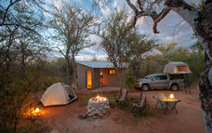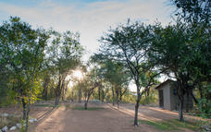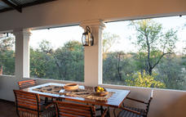

Activities
Bush Walks

Bush Walks
Africa takes on a new perspective when you experience it on foot as the first explorers did. A bush walk is a unique physical, mental and spiritual adventure through nature. Experience the sights, smells and sounds of the Namibian bush by conducting an early morning leisurely walk accompanied by one of our experienced armed rangers.
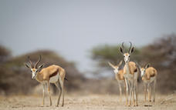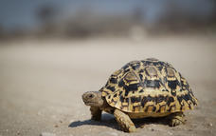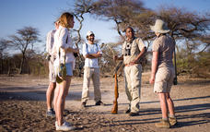

Basis
Self Catering

Included
Onguma - shared AM nature walk

Day 13: Okonjima's Omboroko Campsite, Okonjima Nature Reserve

Day Itinerary
This morning join a guided/shared nature walk with a lodge ranger on the reserve, during early morning light. A final game takes you out of the reserve, and head south to Okonjima, home of the AfriCat Foundation, where you will overnight at the campsite with 1x activity to the Africat Project - Carnivore Programme included, and learn about the protection of Namibia's predators including cheetah, lion, leopard, hyena and wild dog. Camping. Approx 4hours
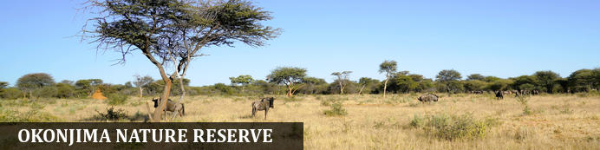
Halfway between Windhoek and Etosha lies the well-known Okonjima Nature Reserve. The 22 000 ha Nature Reserve is surrounded by 96 km of fence and was finally completed in 2010. Okonjima is home to AFRICAT, a Carnivore Conservation, which gives the captive carnivores a second chance to be released back into the wild and to take the time it needs, to become a completely independent hunter - in a protected area right in the middle of commercial farmland! Also in the Reserve is a 2000 ha 'safe' zone around Plains Camp, Bush Camp, Bush Suite, the Omboroko Campsite as well as the PAWS Environmental Education Centre.

Overnight: Okonjima's Omboroko Campsite View iBrochure
Camping in Okonjima Nature Reserve epitomises the African safari experience. Your small group or family can become one with nature as they visit the Carnivore Care Centre, track leopards and cheetahs, learn about the indigenous people during the Bushman trail, and grow attuned to the sights, sounds and ways of Namibia’s grassy plains. The four, partially-equipped, private campsites share a swimming pool at the foot of the Ombokoro Mountains and are located in the 2000ha non-rehabilitation area. All four sites boast spectacular sundowner viewpoints.
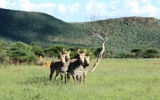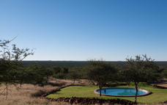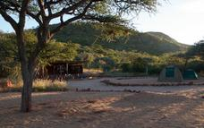

Activities
The AfriCat Foundation

Basis
Self Catering

Included
AfriCat Foundation - Carnivore Programme - shared activity with lodge

Day 14: The Utopia Boutique Hotel, Windhoek

Day Itinerary
Perhaps head out on a self-guided walking trail, enjoy a relaxing start, or take part in an optional activity. From here, return to Windhoek, you can choose to stop at Okahandja, for some last-minute souvenir shopping at the craft markets where you can barter some gifts before returning to the capital to overnight. Approx 3hours drive plus stops. Comfort 3*

Basis
Bed and Breakfast

Day 15: End of Itinerary

Day Itinerary
Drop off your vehicle and head to airport (road transfer). End of services Approx 40mins to city and time to drop off vehicle

Expert Tips
Please note that this quote is based on the availability and on the understanding that no bookings have been made. Should we need to use alternative options to those quoted the price and itinerary is subject to change
Standards/Comfort: Namibia is an incredible country to visit but please remember that we are in Africa and that not all standards are the same as you would get in Europe or other first world countries. To most of our clients, that is part of the appeal of travelling to destinations such as ours. If you are not comfortable with new challenges, then you may wish to consider other companies or destinations. Namibia does not have a fixed star rating and we have given a comfort indication as a guideline only. Please also be aware that standards of NWR/Government campsites/accommodation, food and service can vary and be very erratic but have selected these camps inside the park for the location /floodlit waterholes. Note that most campsites have shared ablution facilities and government run camps tend to be mixed in standards.
Car Rental: As with all car hire companies if you have an accident and they prove you were negligent– for example - speeding then the zero excess becomes void and you are liable for costs. When collecting the vehicle at car rental office, you’ll complete their contract and discuss any extras with them (such as further insurance/GPS hire etc). Check the vehicle carefully as you are responsible for it thereafter. If you have any problems with the car whilst you are on the road, please contact the car rental directly to help speed up the process (though we can assist if required).
Camping: vehicles are supplied with roof top tents, mattresses, bed linen, cooking equipment, table/chairs etc and all you need for your camping tour.
All rentals require the following: passport, driving licence (written in English or an international licence), credit card (for refundable deposit/extras).
A GPS is often available by the car rental companies (at client’s own expense), however, we find that due to our road network system (and small population), it is not normally required, we realize this is a personal preference and are happy to pre-book for you.
Note that ancillary costs are a guideline and subject to change.
Outside of major towns/cities we do not suggest driving around/after sunset
Most vehicles have a tracking device, and should you damage your vehicle in any way and the route deemed unsuitable you will be held liable for the damage. More details regarding how to drive on gravel roads and in Namibia/surrounding countries is given with our “car rules and regulations” document issued with your self-drive confirmation
IMPORTANT - Whilst visiting villages and local communities we cannot guarantee activities on offer, it often depends on how they feel on the day, however, it will give you the opportunity to meet and experience life in Namibia today
Additional information
Once you have booked your safari pre-departure information and a safari confirmation will be sent to you. The pre-departure information will assist you with what to bring, weather conditions and most other common questions we get asked.
Namibia is an incredible country to visit but please remember that we are in Africa and that not all standards are the same as you would get in Europe or other first world countries. To most of our clients, that is part of the appeal of travelling to destinations such as ours. If you are not comfortable with new challenges then you may wish to consider other companies or destinations. Please also note that due to the location of destinations, some long days are inevitable - you’ll travel on gravel roads which can vary in quality depending on the season and maintenance work carried out – we follow only well-defined roads. We also do not travel after sunset for safety reasons
Money: The Namibian dollar is tied permanently against the South African rand on a 1/1 basis so you can check the current exchange rate against your local currency but please note that Namibian dollars are not regarded as an international currency and cannot be purchased outside of the country, therefore if bringing money into the country then you’ll receive SA rand. Both Namibian dollars and South African rand are legal currencies in Namibia. Generally, credit card facilities are accepted in the lodges and ATMs are available in towns, however, we recommend you carry some cash with you in case a machine is out of order. Travellers’ cheques can only be exchanged in major towns and it is often a time consuming and costly process so we do not recommend carrying them with you. We recommend you bring South African rand with you or exchange at the airports prior to landing in Windhoek to avoid any unnecessary delays upon arrival or needing to carry large sums of money and passports around the city. It is customary to tip in Namibia, usually, around 10% at restaurants.
Safety: As with every destination safety tips needs to be adhered to; we strongly recommend you use a safe in a hotel/lodge or lock up your valuables when you are not in the room; when in a vehicle do not leave valuables on display but tucked away and out of sight. It is also better to have copies of passports, money; cards etc split between travellers so if anything unexpected happens and a bag is lost or stolen then other funds/cards are available, you may also wish to consider using a money belt/neck wallet. We suggest you leave valuable jewellery at home – you won’t need it while travelling. A padlock for your luggage is also recommended
Booking & payment: When you have decided on a trip a booking form will need to be completed, signed and returned to us and we will enquire regarding availability and advise you. Once we have taken deposit, a confirmation is sent to you, advising you of the services agreed and booked. Payment is due approximately 6 weeks (sometimes 8 weeks depending on the supplier) prior to departure. Exchange 4 free, bank transfers and MasterCard/Visa are all accepted forms of payment but please ensure there are sufficient funds, and your bank is aware of the transaction about to take place (if you are paying via credit card), in this day and age many banks will withhold money as a safeguard against fraud and this delay can be critical particularly if you are booking at short notice. Please also allow for payment to process and if paying via bank transfer to include all bank fees, note we are unable to confirm bookings/trip until funds have cleared into our account, any delay may see a cancellation in your trip and booking released.
Dietary: We can assist with booking of various dietary requirements or food allergies, but we appreciate your details when you book with us (or with your agent) and we will advise the appropriate lodges and so your guide can pre-plan meals. Please be aware that the choice and options may not be as great as your home country.
Weather: Please note that in winter evenings and nights in particular can be very cold we recommend layered clothing – day time temps can be 25°C so t-shirts and shorts is great for then but thermals are very useful for evenings/night. Summer temperatures can exceed 40°C but also bring our rainy season so a lightweight rain jacket is handy, as with most places layering is the most recommended way of clothing – please ensure you pack your clothes in plastic bags and ensure cameras/electrical equipment is suitably protected
Climate: The African sun is very strong. Please use a factor 30 sunscreen and wear a hat. You should drink at least 3 litres of water per day to avoid dehydration. It can also get very cold during winter months on this route
Electrical: plugs are 220V and are 3 pin (round pin as opposed to square pin). Adaptors can be purchased in Windhoek and most international airports; they are the same as South Africa if you are shopping in-home country or at airport. Some lodges will also offer 2pin sockets or adaptors but please do not rely on this, it is much better to bring your own. It is possible to re-charge batteries at most lodges but clients must be responsible for security of their possessions. At campsites most will have electrical points but this cannot be guaranteed so recommend you bring spare batteries with you
Insurance: It is essential that you purchase comprehensive personal travel insurance before embarking on your holiday - medical insurance is insufficient. Travel insurance is for your own protection and should include evacuation; we also recommend full cover for baggage loss etc and consider it to be an essential part of modern international travel. Recommend covid cover
Health: Namibia is a low-risk malarial destination but we recommend that seek professional medical advice to enable you to make decisions on personal malaria protection. Note that Etosha is an official malarial area (low risk) so please discuss with your doctor and obtain any necessary protection before departing your home country. No vaccinations are required by law for the countries being visited on this tour though we recommend clients are up to date with vaccinations of TB, hepatitis, polio etc
Covid: please contact us for the most recent covid requirements, we strongly recommend all visitors to be fully vaccinated
Water: All tap water in Namibia has been purified or comes directly from boreholes and is safe to drink. Tap drinking water is generally safe to drink but bottled mineral water is easily available at shops and rest camps should you prefer to drink this, at some lodges it is provided though may be at additional cost
Visas: The onus is on the client to organize all visas required for clients prior to departure. Please ensure that your passport is valid for at least six months after your scheduled departure date country of travel and has sufficient empty pages. If this is not the case, there is a danger of being turned away by the Immigration Service on arrival at the airport – assuming your airline has agreed to bring you and risk a fine in the first place. The Company cannot be held liable for any necessary visas or other travel documents not held by the clients. Please also note that if your passport requires a visa for the countries you visit and multiple entries if necessary, you will need to carry your passport with you during the trip
Responsible Tourism: When we put together an itinerary for you, our aim is to try to ensure you have the experience of a lifetime, we strongly believe in low impact or positive impact tourism. Furthermore, our responsibility to the country/ies you visit and the environment is to try our best to ensure that all benefit – whether that is a small, local operator, local community or conservation programme. Your itinerary may include visits a “local community/village” which will enable you to directly assist and barter for a piece of jewellery; perhaps overnight at a locally-owned campsite or lodge; maybe a local guide takes you to a place of interest or site; or visit an organization set up to protect endangered animals and species that occur naturally in the country. We will give you an insight into these initiatives but if you want more information please ask. Note that these initiatives vary according to the region travelled and what is available), remember your safety and enjoyment is also of paramount importance so we will not for example, use a camp site located in a place we consider unsuitable. Please also follow some of the notes we issue in our pre-departure information to minimise the effects of negative tourism on local cultures (respect for others and their beliefs etc). Generally, we prefer not to use large, international hotel chains as much of the revenue leaves the country but again, should you prefer this option we are happy to oblige.

