GARDEN ROUTE UNCOVERED

Uncover some of the best parts of the Garden Route. This exquisite stretch of coastline promises adventure and scenic beauty that will have you captivated by South Africa. The Garden Route is famous for its diverse offerings of activities, sights, and landmarks.

Your journey begins in Gqeberha (Port Elizabeth), and you will travel through Knysna, often called the heart of the Garden Route, and adored for its oysters. It is then on to Oudtshoorn, with a booming Ostrich industry, and a unique insight into these quirky creatures. The Cango Caves is a true highlight, a subterranean world that is a natural display of magnificence.

DATE | ROUTING
DAY 1 - Sunday | GQEBERHA (PORT ELIZABETH) – KNYSNA
DAY 2 - Monday | KNYSNA – TSITSIKAMMA - KNYSNA
DAY 3 - Tuesday | KNYSNA – OUDTSHOORN
DAY 4 - Wednesday | OUDTSHOORN – CAPE TOWN
 | END OF TOUR

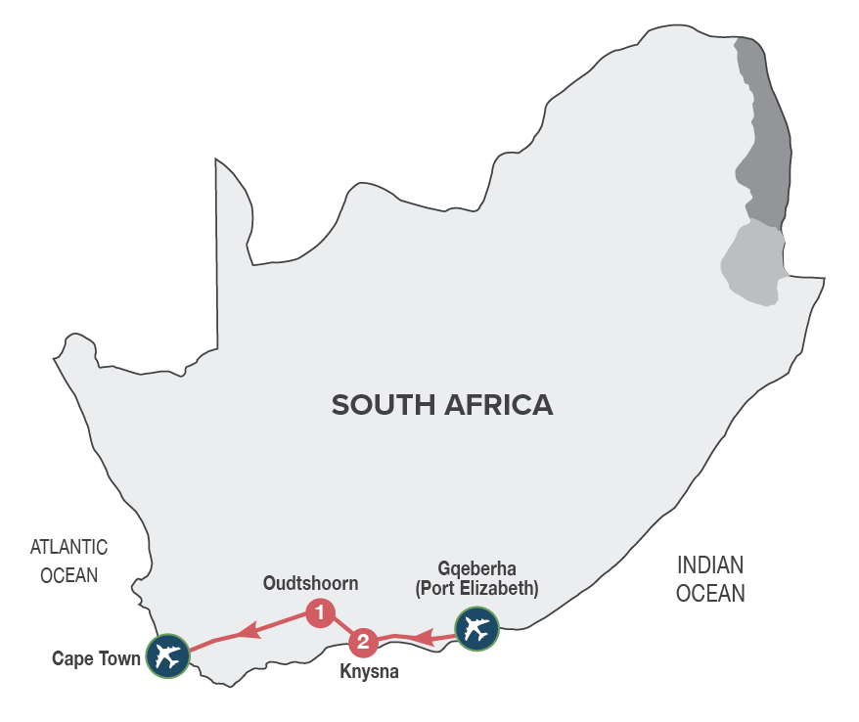

Small Group Tour
Minimum 2 guests / Maximum 10 guests

DURATION
4 days/3 nights

ROUTING
GQEBERHA (PORT ELIZABETH) - CAPE TOWN

INCLUDES
- 6 Meals: 3 breakfasts, 2 lunches, 1 dinner including gratuities
- 3 Nights’ accommodation including porterage
- Transportation including toll fees in air-conditioned vehicles
- Services of a professional English-speaking tour guide
- Entrance fees as specified in the itinerary
- Bottled water in eco-friendly packaging

TOUR HIGHLIGHTS
- Visit to Tsitsikamma National Park and scenic Storms River Mouth
- Enjoy a delicious dinner at a delightful lagoon side restaurant in Knysna
- Immersive journey into the mythical Knysna Forests, discovering the legends build around woodcutters, elephants, steam trains and gold miners
- Visit the ‘Dolphin Point’ lookout in Wilderness, with spectacular views of Wilderness beach and beyond
- Guided tour of the Cango Caves and a guided tour of a working ostrich farm in Oudtshoorn
- Visit a rural farm school in the Barrydale area with the opportunity to interact with the children. This visit supports our Barrydale Farm School Development Fund that encourages local education of underprivileged children in rural communities. School will be closed 01 – 16 Jan; 21 Mar - 02 April; 15 Jun.– 08 Jul; 21 – 30 Sep; 11 - 31 December 2024
- Explore the small towns along the well-known Route 62 between Oudtshoorn and Cape Town
- Meals included in this trip support sustainable food production with at least 30% of the food on the menu being sourced locally (within 50-80km) of where it’s prepared
- Enjoy carefully chosen optional MAKE TRAVEL MATTER® Experiences that positively impact our travellers and the communities we visit

SELECTED DEPARTURE DATES
 | Jan24 | Feb24 | Mar24 | Apr24 | May24 | Jun24 | Jul24 | Aug24 | Sep24 | Oct24 | Nov24 | Dec24
English | 14;21;28 | 4;11;18;25 | 3;10;17;24;31 | 7;14;21;28 | 5;12;19;26 | 2;9;16;23;30 | 7;14;21;28 | 4;11;18;25 | 1;8;15;22;29 | 6;13;20;27 | 3;10;17;24 | 1;8;15

RACK RATES valid 01/01/24-30/04/24 & 01/09/24-31/12/24
R 15 815.00 per person sharing twin/double accommodation
R 16 795.00 per single person

RACK RATES valid 01/05/24-31/08/24
R 15 540.00 per person sharing twin/double accommodation
R 16 490.00 per single person

Accommodation included:
4* Rex Hotel (standard room) or similar x 2 nights
4* Hlangana Lodge (standard room) or similar x 1 night

Transportation:
Transportation is in air-conditioned touring vehicles appropriate to the requirements of the tour
- 2 guests will travel in a sedan vehicle
- 3-10 guests will travel in a 13-seater vehicle

DAY 1 – SUNDAY GQEBERHA (PORT ELIZABETH) - KNYSNA
Meet your representative and fellow travellers and head westwards along the Garden Route, which follows the Indian Ocean coastline, and is bordered inland by soaring mountain ranges and indigenous forests. You’ll arrive at your hotel in Knysna, known as the oyster box of South Africa, nestling on the banks of a beautiful lagoon, in the heart of the Garden Route. Overnight in Knysna.
Distance travelled today: 360 kms

DAY 2 – MONDAY KNYSNA – TSITSIKAMMA - KNYSNA
After breakfast, visit the spectacular Tsitsikamma National Park, Storms River Mouth (weather permitting) and the magical Knysna Forests, the stamping ground of the elusive Knysna elephants. Discover the stories of the woodcutters who worked the forests, the elephants that were hunted to extinction and the discovery of gold. Our expedition into the forest starts with a visit to the Dalene Matthee Big Tree Memorial. The enormous Yellowwood tree of over 880 years was named after Matthee, best known author of four books on the Knysna Forest. Enjoy a delicious lunch en route of traditional cuisine and local treats. Overnight in Knysna with dinner at Drydock Restaurant, renowned for dishes with glorious aromas and flavours, using the finest local ingredients and freshly picked herbs from the region. [Breakfast, Lunch & Dinner]
Distance travelled today: 300 kms

DAY 3 – TUESDAY KNYSNA - OUDTSHOORN
Travel through the Outeniqua Pass to Oudtshoorn, known as the “ostrich capital” and the centre of the world’s Ostrich farming industry. Along the way, visit ‘Dolphin Point’, an extraordinary viewpoint in Wilderness. In Oudtshoorn, we’ll visit an Ostrich Farm for a fun filled interactive tour and light lunch that includes local specialities such as Ostrich Steak, before taking a tour of the spectacular limestone caverns of the Cango Caves, one of the world’s great natural wonders, sculpted by nature through the ages. We will arrive at our hotel in the late afternoon, in time to check in and relax before dinner (for own account).
Overnight in Oudtshoorn. [Breakfast & Lunch]
Distance travelled today: 210 kms

DAY 4 – WEDNESDAY OUDTSHOORN – CAPE TOWN
There is an option (for own account and subject to availability) to enjoy an early morning Meerkat Safari. Witness these incredible wild habituated creatures emerging out of their burrows, in time to soak up the sun before they head about their daily activities (weather permitting). A portion of the monies paid by guests for this MAKE TRAVEL MATTER® Experience go towards the Buffelsdrift Foundation, that focusses on Wildlife conservation in the Klein Karoo region, habitat conservation and the local community. The experience directly advances UN Global Goal 15: Life on Land. After breakfast, the journey continues through the ‘Little Karoo’ to Barrydale, where you will have the opportunity to visit a local farm school, to interact with the children and teachers, spending time with them in the classroom, learning more about this rural community. A portion of the trip monies go towards our Barrydale Farm School Development Fund, that support local education of underprivileged children in rural communities. (The school visit is subject to the school being open). Continue to Cape Town, spectacularly set at the foot of Table Mountain, where the tour ends on arrival. [Breakfast]
Distance travelled today: 468 kms

OPTIONAL EXCURSION
Enhance your journey with an optional excursion, available for pre-booking, subject to a minimum of 2 adults travelling:

Rack Rates valid 01/01/24 – 31/12/24:

** This MAKE TRAVEL MATTER® Experience seeks to encourage the greatest community benefit from travel and tourism, while also educating guests about The UN Global Sustainable Development Goals and the local community actions being taken to advance them.

** DAY 4 – WEDNESDAY - OUDTSHOORN – MAKE TRAVEL MATTER® Experience - EARLY MORNING MEERKAT SAFARI – R 850.00 per person
There is an option to enjoy an early morning Meerkat Safari. Witness these incredible wild habituated creatures emerging out of their burrows, in time to soak up the sun before they head about their daily activities (weather permitting & subject to availability at the time of booking). A portion of the monies paid by guests for this MAKE TRAVEL MATTER® Experience go towards the Buffelsdrift Foundation, that focusses on Wildlife conservation in the Klein Karoo region, habitat conservation and the local community. The experience directly advances UN Global Goal 15: Life on Land.

