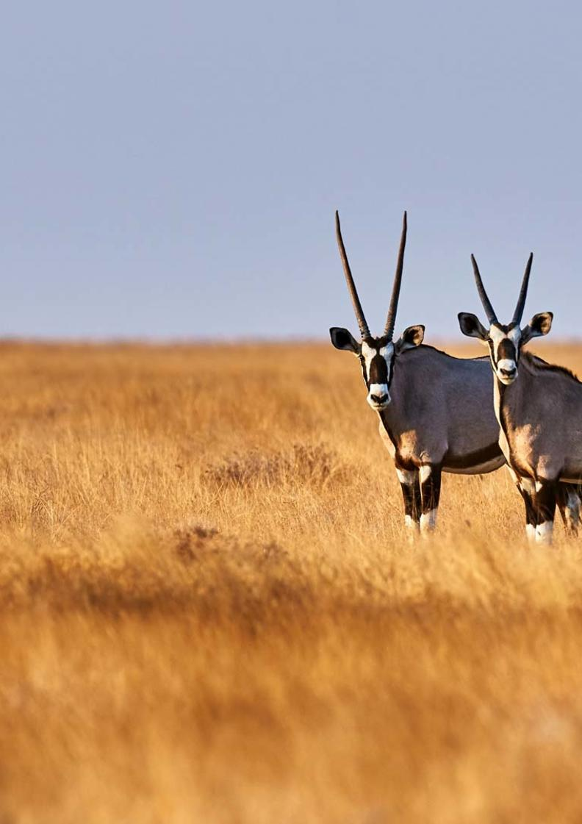


19-Day Ultimate Namibia Self-drive Safari - Camping Option - NETT

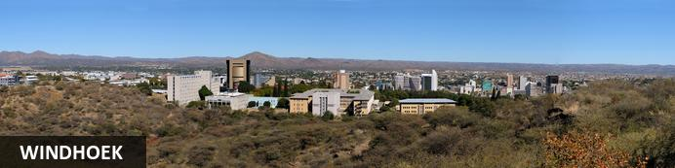
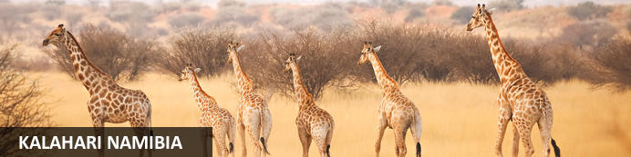
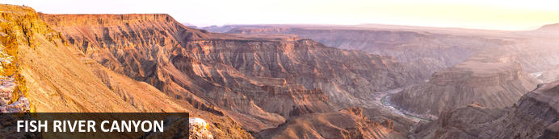
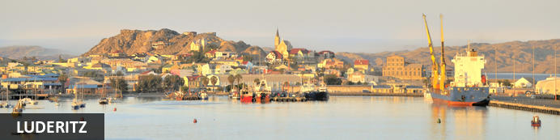
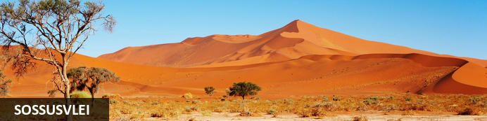
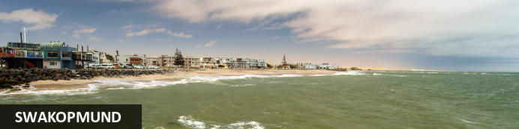
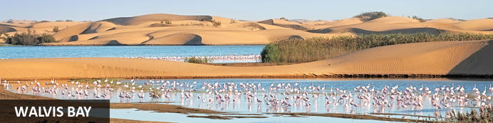
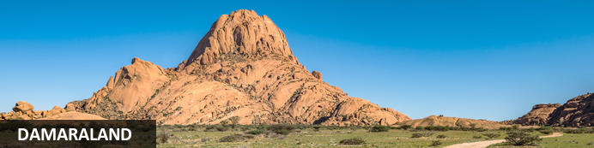
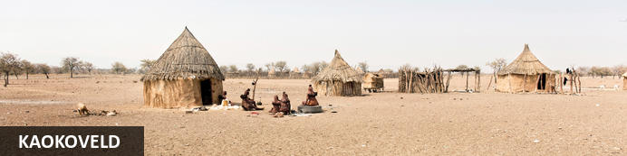
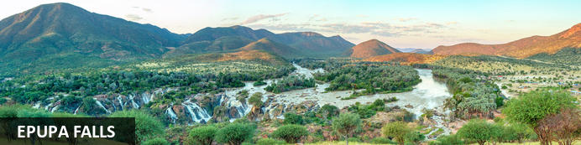
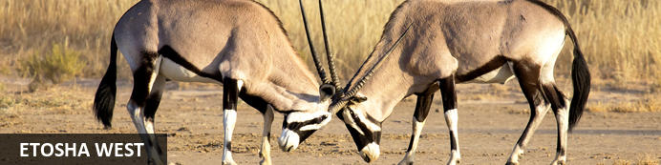
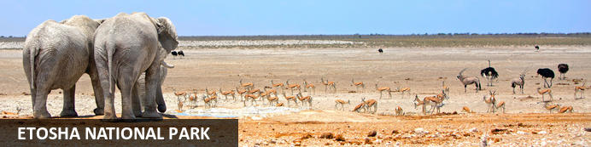
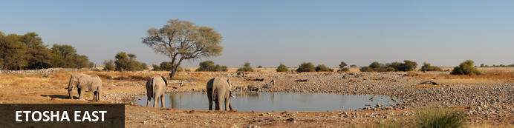
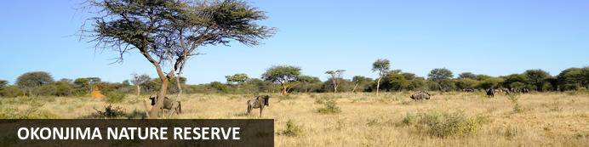

19-Day Ultimate Namibia Self-drive Safari - Camping Option - NETT
Windhoek - Kalahari Namibia - Fish River Canyon - Luderitz - Sossusvlei - Swakopmund - Walvis Bay - Damaraland - Kaokoveld - Epupa Falls - Etosha West - Etosha National Park - Etosha East - Okonjima Nature Reserve
19 Days / 18 Nights
Date of Issue: 13 March 2023

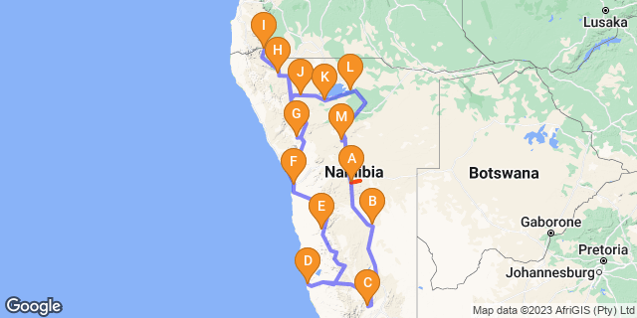

Click here to view your Digital Itinerary

Introduction
The best of Namibia in a 19-Day Ultimate Namibia Safari starting and ending in Windhoek that includes the highlights of Namibia: The Kalahari; Fish River Canyon; Lüderitz; Sossusvlei, with its great sand sea; the seaside towns of Swakopmund and the Skeleton Coast; Damaraland, with its fascinating rock formations, Bushman rock art and desert-adapted wildlife; Kaokoland, the last frontier of true wilderness and the realm of the nomadic Himba people; and Etosha National Park - one of Africa's great game parks.

Accommodation | Destination | Basis | Duration
The Elegant Guesthouse | Windhoek | B&B | 1 Night
Bagatelle Campsite | Kalahari Namibia |  | 1 Night
Canyon Roadhouse Campsite | Fish River Canyon |  | 1 Night
Alte Villa | Luderitz | B&B | 2 Nights
Sesriem Oshana Campsite | Sossusvlei |  | 2 Nights
Swakopmund Luxury Suites | Swakopmund | B&B | 2 Nights
Madisa Campsite | Damaraland |  | 1 Night
Opuwo Campsite | Kaokoveld |  | 1 Night
Omarunga Epupa-Falls Campsite | Epupa Falls |  | 2 Nights
Olifantsrus Camp | Etosha West |  | 1 Night
Okaukuejo Campsite | Etosha National Park |  | 1 Night
Onguma Tamboti Campsite | Etosha East |  | 2 Nights
Okonjima Omboroko Campsite | Okonjima Nature Reserve |  | 1 Night

Key
B&B: Bed and Breakfast

Price
NETT STO COSTS
1st January – 30th June 2023 – Low Season
2 guests - ZAR 37 935 per person sharing
4 guests - ZAR 25 550 per person sharing
Single supplement - ZAR 5 095
1st July – 31st December 2023 – High Season
2 guests - ZAR 45 260 per person sharing
4 guests - ZAR 29 455 per person sharing
Single supplement - ZAR 5 310

Included
- Accommodation as indicated – can change depending on availability and request at time of booking
- Meals as indicated
- Meet and greet upon arrival
- Car hire: Fully equipped camping vehicle - Zero Excess
- Airport transfers on arrival and for departure
- Tour file with detailed itinerary, map with route descriptions, vouchers etc.
- 24 hour personal and friendly support
- Fast and efficient response to service providers

Excluded
- Items of a personal nature
- Optional extra activities
- International flights
- Holiday or personal insurance
- Staff gratuities
- Park entry fees
- Fuel for vehicle rental
- Extras / additional camping equipment on request
- Visas and visa applications

Day 1: The Elegant Guesthouse, Windhoek

Windhoek
Surrounded by the stubble-covered Auas Mountains and the endless Khomas Hochland, Windhoek lies in a long valley fed by ancient hot springs in the central highlands. Namibia’s capital and bustling city. More often than not, the start or end place of your Namibia safari.
In Windhoek there are many interesting historical buildings, museums, galleries and craft shops. The city has several good restaurants and modern shops and services making it an excellent base camp from which to launch your Namibian adventure.

Day Itinerary
- You will be met by the car rental company representative on arrival and transferred to their offices in Windhoek to complete all rental procedures
- You will then meet with our representative to hand over your travel documents
- The remainder of the day can be spent relaxing at your own leisure
- For dinner tonight, you can head into town for a bite to eat at one of Windhoek’s well known restaurants

Overnight: The Elegant Guesthouse View iBrochure
With easy access from Windhoek International and situated in Klein Windhoek - the Namibian capital's prototype leafy suburb - The Elegant Guesthouse makes for a comfortable overnight stop.
The Elegant, as she is known in these parts, is in a quiet neighbourhood, very secure and close to the shops, restaurants and attractions of northern Windhoek. Getting there from the airport requires two turns, getting to the rest of the country from here requires just three turns.
Modern design and fittings give The Elegant Guesthouse a sophisticated air. Once a small six-roomer, the Elegant has been upgraded and is ever more sophisticated now, offering 17 stylish and beautiful guest rooms. They didn't just add more rooms. They first acquired more space and then expanded, so the mood is still decidedly relaxed (if not more so than before): the perfect way to start or end your Namibia holiday.
All rooms have en suite bathrooms, twin beds (together making a king) and are fitted with air conditioners as well as fast WiFi, television and most open out onto a drought resistant garden or the swimming pool area surrounded by loungers and umbrellas.
Breakfast is served in the light and airy open-plan breakfast room or out in the garden on warm days, which is about 90% of the time in Namibia.
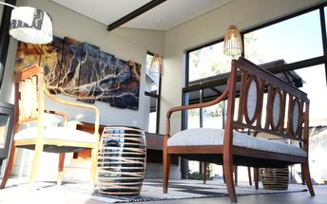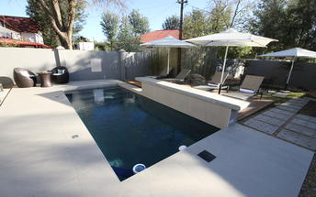

Basis
Bed and Breakfast

Day 2: Bagatelle Campsite, Kalahari Namibia

Kalahari Namibia
The Kalahari is a vast basin of semi-arid plains, dry savannah and moist woodland. Welcome to wide open spaces and ochre red sands.
In the southern Kalahari, attractions are few and very far between and that in itself is one of the major attractions of this endless land. Large camel-thorns and shepherd's trees dot the grassy plains and your field of vision may well cross a time zone with enormous skies and a chirrupy silence your only companions.
The semi-arid plains and dunes support diverse and fascinating plants, birds and animals that have adapted to life in a virtually water-free world. The gemsbok can go for months on end without water and have special blood-cooling systems at the base of their brains. The camel thorn is a large and hardy acacia tree that thrives in sandy soils thanks to a taproot that can extend to three times the tree's height.

Day Itinerary
Windhoek – Kalahari 245km - approximately 3 to 4 hours
- After breakfast, you can still pop into town for anything you might need and then depart heading south from Windhoek to the red sand dunes of the Kalahari
- Spend the remainder of the day at leisure in this beautiful setting
- Optional activities here include game and nature drives as well as a Bushman experience

Overnight: Bagatelle Campsite
An hour's drive from Mariental in the south of the Kalahari, you'll find the Bagatelle Kalahari Game Reserve. A place of iconic red sand dunes and an open shrub savannah dotted with Acacia trees.
On the reserve - springbok, gemsbok, zebras, ostrich, meerkats, cheetah, the Bagatelle Kalahari Game Lodge and the campsites (a hefty stroll from there).
Bagatelle has five individual campsites and there’s lots of space between them - great for groups who want privacy.
They’re all set between the red sand dunes with a large tree on each so you’ll get a touch of shade.
You’ll have your own ablution block as well - toilet, shower, washbasin. Nothing fancy, they’re little solar powered sheds which may require your patience. There is also a utility table and a sink for cooking.
Kids will love it. The insects in the long grass are impressive. It’s a proper “old school” return to nature experience. They can explore and play in the sand (bring their flip flops/thongs as that sand can get as red hot as those dunes) and you might get visited by cows at night.
Campsite 1 might be the one to go for if you have very young children as it’s only about a 1km walk back to the main lodge.
And you’ll want to head up there as all campers are allowed to use the main lodge and swimming pool.
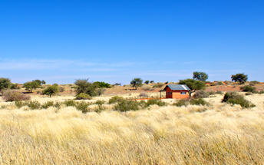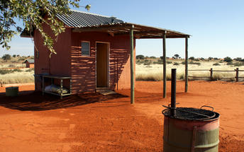

Day 3: Canyon Roadhouse Campsite, Fish River Canyon

Fish River Canyon
The major attraction in the southern-most reaches of Namibia is the Fish River Canyon. One of the largest in the world, the canyon proper is about 60km long, up to 8km wide, and 550m at its deepest.
The ephemeral Fish River - one of a handful that rise in Namibia - began its work creating the canyon in about 170 million years ago when tectonic rumblings increased the gradient of the river.All around the canyon, the land rises and falls in gentle undulations marked by dramatic inselbergs. Hardy wildlife thrives in the unspoilt wilderness of two adjacent nature reserves: Fish River Canyon National Park and the privately-owned Gondwana Cañon Park.

Day Itinerary
Kalahari – Fish River Canyon 440km - approximately 7 to 8 hours
- Head south via Mariental and Keetmanshoop to the Karas region, the Fish River Canyon area
- Detour en-route to Giant’s Playground and Quiver Tree Forest, a beautiful site where large aloes grow between rocks
- If time permits, visit the Fish River view point at sunset to end the day

Overnight: Canyon Roadhouse Campsite View iBrochure
Canyon Roadhouse Campsite is on a dry river bed. On the road to Fish River Canyon. Grab guitar. Cue music. After supper sit around the fire. Seriously, this camp is wild, rugged, dusty and just a darn authentic place to pitch the canvas.
This site is behind Canyon Roadhouse on the privately owned Gondwana Canyon Park. Alone with the eagles, listen to the call of the canyon. Only 14km away. Trek up the "local mountain" and watch the silent quiver trees. How clever they are standing out in the sands, surviving with no signs of water. But take a closer look. Their succulent leaves and bloated branches belie a secret. They're full of water. You can be too as the camp has plenty. Hot and cold. And fresh. There's shade around as well. Choose from 10 campsites with a maximum of 10 people in each.
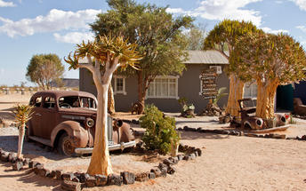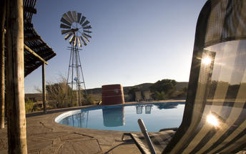

Day 4-6: Alte Villa , Luderitz

Luderitz
Luderitz is a harbour town on the Atlantic Coast in Namibia with 25,000 inhabitants. Born out of necessity in 1487 when Bartolomeu Diaz sailed his little flotilla into the natural bay it now boasts German history, excursions to Kolmanskop Ghost Town and off-shore activities.
Visit the abandoned Kolmanskop Ghost Town. An eerie feeling as you walk through deserted houses now filled with sand. Explore the old diamond mines and restricted areas of Pamona and Bogenfels rock arch. Be on the look out for crystallised stones known as the "Desert Rose". Go to Diaz Point. See the lighthouse or go on a boat cruise of the seas to explore the harbour. Search for the desert horses of Aus. The last true herd of feral horses in Africa.

Day Itinerary
Fish River Canyon – Lüderitz 385km - approximately 5 to 6 hours
- Enjoy a morning canyon view before heading west through harsh but beautiful terrain which changes to wide open desert plains as you make your way to the coast
- Your drive will take you via Aus, where you may be lucky to view the wild desert horses in the area
- 1 full day is set aside to enjoy the historic town of Lüderitz and visit the amazing Kolmanskop Ghost Town
- Lunches and dinners can be enjoyed at any of the local restaurants in town

Overnight: Alte Villa
Alte Villa Boutique Guesthouse is for all the gemologists out there, those of you interested in diamonds. Close to where that first precious little nub of carbon was stumbled upon. Steeped, no, imbibed in history, Alte Villa Guesthouse is a real home of a guest house bang in the heart of colonial relic, Lüderitz.
Put your shades on and get ready for the outside of this place. It's yellow. Very. Once you've settled in you can walk to Lüderitz town and marvel at all that architecture. Think German. Think art nouveau. Think surreal. You’re there.
Alte Villa Guesthouse is not some old dinosaur - sure, it was built in another century, it was Friedrich III’s spin of the wheel if you’re being pedantic. But in 2017 it got a whole new look when the current owners rolled up with their new fangled restoring and renovating ideas. All homemade bread, apple pie and coffee. With decent decking furniture and the civility of a reading area off the breakfast room. Marvellous.
Alte Villa Guesthouse has just 6 rooms each with their own name (in German naturally), decor and decadence:
Rotes Zimmer - queen sized bed, ensuite, red walls with a glass chandelier. Pretty glam this one.
Zimmer Garub - named after a train station nuzzled by wild horses. Big photo of two rearing stallions. No pressure. Twin beds. Ensuite. Here’s the money shot though - along with the room called Grazplatz, it shares exclusive access to a living room. A beauty with a balcony with views of Luderitz harbour.
Grazplatz - see above for adjoining joy. Twin beds. Ensuite. A Zacharias Lewala vibe. He being the guy who found the first diamond in Namibia in 1908. Got rich he did.
Ichaboe - large 2 room apartment, 65sqm, twin bed in one room, 2 singles in the other. Kitchen, shared bathroom.
Tsiras - This is a 60 sqm double with its own private garden - you can have your breakfast al fresco here which is rather superb. There's a TV, a built in fireplace and ensuite.
Bogenfels - This is a large double, 57 sqm. This room has a sunny disposition and stares out to sea. Little wonder it's such a cheery number. It's got it’s own entrance in the front garden, twin beds and an ensuite.
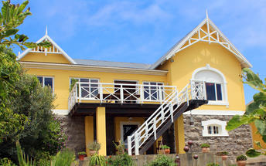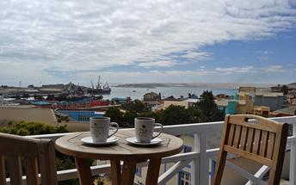

Basis
Bed and Breakfast

Day 6-8: Sesriem Oshana Campsite, Sossusvlei

Sossusvlei
Star dunes with up to five crests rise 300m into the air and rank among the biggest in the world; the dune valleys are marked by vast clay pans where the Tsauchab River gave up its fight to reach the sea more than 60,000 years ago.
Besides the dunes and pans of Sossusvlei and Sesriem Canyon, a sideshow of activities and sights has developed around the region and there are plenty of game lodges that provide additional desert-adapted activities.Plants and birds are the dominant life form in this dessicated realm and they support a tiny world of mammals, reptiles and insects that, in the absence of coastal fog, seldom wander far from the rivercourse and its pans.

Day Itinerary
Lüderitz – Sossusvlei 505km - approximately 7 to 8 hours
- After breakfast, you will depart to the “sea of sand” backtracking to Aus and then heading north via Helmeringhausen
- Wake up early to head into the park just before sunrise
- Spend the whole day in the beautiful Sossusvlei area, exploring the highlights: Sossusvlei, Dead Vlei, Dune 45, Big Daddy, Elim Dune and the Sesriem Canyon
- Return to camp for lunch or arrange to take some lunch along to enjoy in the dunes and return late afternoon for a well-earned rest
- Optional extra activities: Guided Sossusvlei excursion, Hot air balloon safari, Nature drives

Overnight: Sesriem Oshana Campsite
Sesriem Oshana Campsite brings you a step closer to Sossusvlei, since you're inside the park gates, but still far enough away to avoid all the other tourists trying to get in. Nowhere is closer to the dunes and you get an hour's drop on all but residents of the other campsite at Sesriem.
While Oshana Campsite prides itself for providing comfort, ease and luxury for campers, this is still very much a Campsite. While you have your own bathroom, parking, kitchenette and access to the bar and pool, you still need to bring all your own camping equipment and set up camp for yourself. That’s right: tent, sleeping bags and a fold-up chair to enjoy the view of Elim Dune. If you do need something though, there is a small shop where you can pick up a few basics and some souvenirs. Just don't forget the big ticket items like your tent or you'll be sleeping in the car.
You have power outlets, but don’t bargain on electronics since there is no WiFi (this is camping after all). Many choose this spot for its location. Inside the park and for its nothingness, it’s a chance to escape and head into the dunes before the sun rises. Win-win.
Although you are in the middle of nowhere, there is more to it. You can make use of the restaurant and the pool at Sesriem, which all sounds too perfect after a hot day of desert activities. As much as camping is an activity on its own, there's much more to do here. Guided walks and hiking trails through the beautiful landscapes that you wake up to every morning. If going by foot is not your thing you can go quad biking or in a hot air balloon. Now that sounds like an adventure.
It’s safe to say that if you want to do this right, you need to take a scenic drive to explore the highlights of Sossusvlei, Dead Vlei and Dune 45. Truth be told, there is a reason everyone wants to photograph it, but shh, don't tell everyone the secret is staying inside the park. That's your advantage.
The campsite itself is clean and the luxury of a hot shower after a long day is a blessing. The vast emptiness will give you the most beautiful night sky to admire and the morning sunrises will be so good you will forget that you slept in a tent.
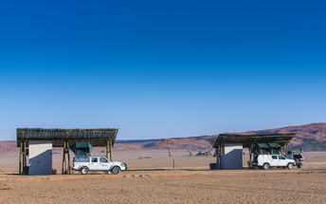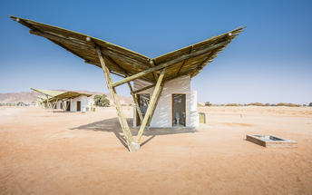

Day 8-10: Swakopmund Luxury Suites, Swakopmund

Swakopmund
Surrounded by the ancient Namib desert and the inhospitable - but bounteous - Atlantic Ocean, Swakopmund is alive with activity and has a lot on offer for the adventure-seeker: quad-biking, sand-boarding, horse-riding, skydiving and more.
Swakopmund has many interesting German-influenced buildings from the early 1900s in a variety of styles and, for its size, Swakopmund has an astonishing array of restaurants that serve mainly seafood, steak and many German staples.

Walvis Bay
Walvis Bay is an industrial port which lies along the Atlantic Ocean, off Namibia's Skeleton Coast. The large bay and surrounding sand dunes help make Walvis Bay a tourist mecca with loads of activities on offer to explore it.
- Explore the Skeleton Coast where the dunes meet the sea at Sandwich Harbour‍
- Go on a dolphin boat cruise in the harbour. Enjoy champagne and oysters
- Kayak among the seals at Pelican Point
- Visit and climb the mighty Dune 7‍
- Visit the RAMSAR wetland birding site and the Walvis Bay Lagoon. Thousands of flamingos from October to April‍
- Explore the neighbouring town of Swakopmund. Activities abound and dining delights

Day Itinerary
Sossusvlei – Swakopmund 350km - approximately 5 to 6 hours
- Depart after breakfast and head north to Solitaire, then west crossing the Tropic of Capricorn, through the Gaub and Kuiseb Canyons via the Namib Gravel Plains to the coast
- Either via Walvis Bay to Swakopmund, or (recommended) detour via Ganab to the Welwitschia Plains and Moon Landscape
- The Namibian coastline is generally known as The Skeleton Coast due to the barren areas, ship wrecks and, in days gone by, whale skeletons left on the beach
- 1 full day is set aside for this lovely area where Swakopmund and Walvis Bay offer a wide range of activities such as: Dolphin cruise, Sandwich Harbour excursion (a real Skeleton Coast experience), Dune quad biking, Sand boarding, Sea kayaking, Lots more…
- Lunches and dinners can be enjoyed at any of the many great cafés or restaurants overlooking the sea

Overnight: Swakopmund Luxury Suites
Swakopmund Luxury Suites pack comfort and convenience into an elegant apartment-style accommodation option in the belly of Swakopmund's restaurant quarter.
Although “suites” is a bit of stretch size-wise, for comfort you can expect elegant, neutral décor that is easy on the senses and top quality linen with quite possibly the most comfortable bed you’ll encounter on your tour of Namibia. Attention to detail includes Nespresso machines with complimentary pods, bath robes, extra thick towels, wi-fi that actually works, climate control, mini-bar and that general air of purpose and cleanliness of a professional outfit.
For convenience you are a few minutes’ walk to the beach, restaurants, cafes and main attractions of central Swakopmund - a feature you will welcome after many hours’ in the car on Namibia’s long and dusty roads. And the day reception is staffed with the friendliest of friendly Namibians who add that personal touch and valuable insider’s information for making the most of your visit.
A secluded upper deck lined with comfortable recliners and deck chairs is a wonderful place to catch up with your digital life. Or escape it entirely with a good book and a glass of chardonnay. Parking out front is secure with 24-hour watch and CCTV and, occupying the first storey down a pedestrianised side street, the location is quiet and safe.
Breakfast at the Swakopmund Luxury Suites is a delight. The breakfast room is stunning and the food is delicious. A great way to start your day before you head off to explore where the dunes meet the sea. You are just a short walk to the main beach and the main streets of town. Splendid.
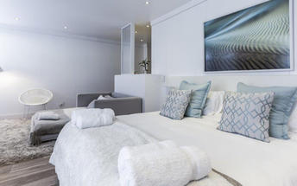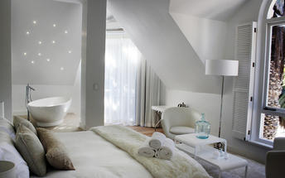

Basis
Bed and Breakfast

Day 10: Madisa Campsite, Damaraland

Damaraland
Damaraland features vast khaki plains, sheer rocky mountains and incredible desert-adapted wildlife. Track rhino and desert elephant, explore the rugged land or sit back and enjoy the dramatic and endless scenery. Damaraland's hilly savannah supports a large number of species including lion, leopard, cheetah, hyena, eland, kudu, giraffe, klipspringer, steenbok, gemsbok and springbok. Birdlife is prolific with over 33 raptors recorded including cuckoo hawks, Egyptian vultures and peregrine falcons - the world's fastest animal.
Damaraland is divided into several enormous private game reserves, known as concessions, that support most species of Namibia's large game and provide some of the best birding and wildlife experiences in the country - and southern Africa for that matter.

Day Itinerary
Swakopmund – Damaraland 445km - approximately 7 to 8 hours
- Head north along the Skeleton Coast, via Henties Bay to visit the Cape Cross seal colony. Along the way, stop at the Lichen Fields as well as the ship wreck between the colourful small town of Wlotskasbaken and Henties Bay
- Backtrack to Henties Bay and head inland through wide open plains to Uis, then north to the Twyfelfontein area
- Visit to Namibia’s Open Air Museum, the Twyfelfontein Rock Engravings as well as the interesting Organ Pipes rock formations and Burnt Mountain
- Visit the Damara Living Museum for a hint of culture

Overnight: Madisa Campsite
Madisa is a wonderful camp with meru-style tents and a campsite in Damaraland in prime desert-elephant country.
Perfect for your self-drive holiday or camping tour of Namibia, Madisa is an excellent choice for those looking for a basic tented camp or as a camping option with all the necessary facilities and delightful swimming pool built around an enormous rock.
Camping in Namibia is an obsession and in this country less is more when it comes to an enjoyable camping experience where, once the basics are covered, you're pretty much left to your own devices. Those basics are well covered at Madisa and they include a private elevated ablution facility for every campsite, with a fire-heated boiler, flushing toilets and a view of the riverbed.
The campsites at Madisa are spotless and well-spaced apart and demarcated with low walls beneath sprawling acacia trees. A barbecue area and table comprise your cooking and kitchen facilities and the stunning view, desert elephants ambling past if you're lucky, the serenity and the great open Namibian sky comprise your entertainment.
The safari tents as an alternative to the campsites, don’t offer a much different experience other than you don’t have to set up camp, it’s all ready for you to simply make yourself at home and enjoy the surrounds. It’s less of a lodge and more “glamping” if you must, but offers all that you need, nestled into the rock formations with an open air bathroom a chance to shower under the stars.
A short walk to the delightful, hand-made swimming pool that looks like a moat around a large rock. You can take a meander up the river bed to some spectacular rock formations or drive further afield in search of the desert elephants.
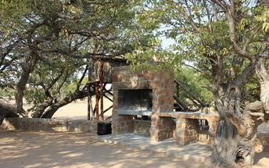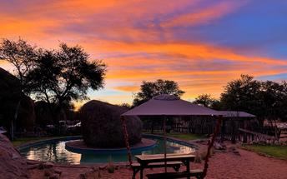

Day 11: Opuwo Campsite, Kaokoveld

Kaokoveld
The Kaokoveld, a vast and empty wilderness occupying the north-western quarter of Namibia, is roughly divided in two by the Hoanib River. It’s harsh, remote, unpopulated and makes for some of Namibia’s finest scenic landscapes.
Kaokoland is a succession of hills and mountains punctuated by endless plains. This isolated rugged region is home to the nomadic Himba pastoralists who have remained unchanged for many generations. The attraction of Kaokoland lies in its wild and uncharted valleys and mountains. It is the most isolated and undeveloped region of this mostly isolated and undeveloped country.

Day Itinerary
Damaraland – Opuwo 340km - approximately 5 to 6 hours
- Depart the Twyfelfontein area and head north via Palmwag, crossing the Hoanib River, up and over Joubert Pass to Opuwo, the centre of Kaokoland
- Opuwo is a small typical African town, where a range of different people live, from the traditional Himba tribes to Herero, Damara and Owambo cultures
- Along the way stop at various villages to interact and photograph the local people
- Depending on arrival time, enjoy a Himba village visit this afternoon. It is recommended to arrange a local guide to go with you (lodge reception can assist with this)

Overnight: Opuwo Campsite
The name Opuwo was given by the commissioner of Ondangwa when he came to build an office here. He asked local headmen to give him some land. They obliged by giving him a small plot. When they tried to give him more, Mr. Hahn said, "Opuwo", "it's enough for me". And that, dear friends, is how they say the story goes.
You'll be camping in the grounds of Opuwo Country Lodge. This hotel was opened by President Hifikepunye Pohamba in August 2005. It's just up the hill from Opuwo and close to Kaoko Otavi, Epupa Falls and Swartbooisdrift.
You're in the Kaokoveld, a huge, dry region of north east Namibia. Here, plants and animals have adapted to the arid conditions. Desert elephants wander the dry river beds. As do lions. Meanwhile, baobab trees grow.
There aren't really any tourist attractions in Opuwo town but seeing as it's the only settlement in the area, this is the place to buy petrol and stock up on groceries.
You'll get a good view of the town from the campsites. You'll be high up so watching the sun rise and set from your sleeping bag should be pretty special. Spin round and enjoy your 360 degree view. Not in your bag, you'll get into an awful twist. Come on, get out. Right. Ok? Good. By the way, you're facing northwest.
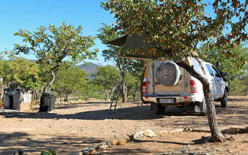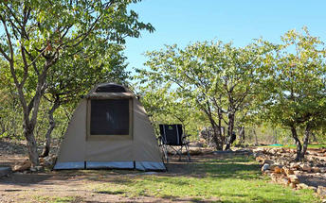

Day 12-14: Omarunga Epupa-Falls Campsite, Epupa Falls

Epupa Falls
Epupa Falls is on the Kunene River which forms the border between Namibia and Angola. Epupa means 'falling water' in the Herero language, its water cascading into a spectacular chute with a 60 metre drop and several natural rock pools where you can take a refreshing - and much needed - dip. Remote and wonderfully difficult to reach, is one of only a few waterfalls in Namibia.
If you’re visiting for a few days, you can pop off to the OvaHimba Village for a cultural experience. Don’t miss the opportunity to enjoy world-class birdwatching and spot an array of species including two of southern Africa's rarest birds: the Cinderella waxbill and the rufous-tailed palm thrush. Adventure-seekers can shoot the rapids in inflatable rafts on guided expeditions.

Day Itinerary
Opuwo – Epupa Falls 180km - approximately 3 hours
- Today takes you way north to the border with Angola, the beautiful Epupa Falls
- 2 nights, a full day is set aside here to visit some traditional Himba villages (not touristic … they live there permanently), view the falls and hike along the Kunene River
- Plan a morning visit to 1 or 2 authentic Himba villages as this is when there is the most “activity”

Overnight: Omarunga Epupa-Falls Campsite View iBrochure
Right there close to Epupa Falls, you can camp under the shade of the makalani palms, a pleasant spot despite the heat, well known when you're this far north in Namibia. Omarunga Campsite is easily one of the best spots in the area if you're opting to camp instead of lodge.
On the edge of the Kunene River, it's peaceful out here, except for the occasional incessant mosquito. There's spray for that, well hopefully you packed it, you are camping after all. You're roughly 200m upstream from the falls, so getting to the main attractions is easy and Omarunga makes for a great base.
When you aren't out and about exploring, sit long enough relaxing and you're likely to dose off to the distant hum of the falls, the constant rustle of tree branches above and the sweet song of hundreds of palm thrushes. It's something quite different from where you've been, no doubt you've seen much of Namibia if you've ventured this far. It's remote and since you did indeed travel far to get here, it's definitely time to unwind. An easy task here, where it’s slow going, both due to the heat and picturesque setting.
Barbecue with a view of the river or dine at Omarunga Epupa-Falls Camp. Explore the surrounds on your own, or book an activity with the lodge. There’s loads to do and much to see, but like we said, relaxation is a part of it too.
There are 10 Campsites with power points and shared ablution facilities. It’s sandy but this is camping. They’re basic but there’s not much more you need. You’re welcome to use the lodge facilities such as the pool, restaurant, bar and curio shop. There’s mobile connectivity in these parts and WIFI at the lodge too.

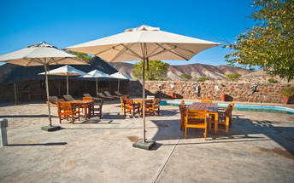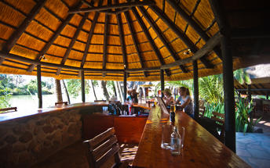

Day 14: Olifantsrus Camp, Etosha West

Etosha West
Situated in the western part of Etosha National park, a world-famous wildlife sanctuary in the northwestern part of Namibia, Etosha West is the wilder western region accessed through Galton Gate. Visitors to Etosha West can look forward to exploring the magnificent scenery of this remote north Namibian landscape characterised by lush undulating terrain and a reddish-brown soil, which is a stark contrast to the white dusty clay soil of Etosha East’s flat expansive plains. This area is home to several species not found in the rest of the park: baboons, Mountain Zebra, and Brown Hyena, as well as several unique plants. The area also boasts numerous waterholes attracting elephant, rhino, leopard, lion, a variety of buck, and around 300 bird species.

Day Itinerary
Epupa Falls - Etosha (west) 375km - approximately 5 hours
- Depart this morning after breakfast and backtrack to Opuwo before heading east and then south towards the west side of Etosha
- Enter the park at the Galton Gate
- Arrival here will be in the afternoon and if you wish, join an afternoon game drive with a lodge guide or enjoy the waterhole and hide at leisure to end the day

Overnight: Olifantsrus Camp
Olifantsrus Camp is a typically bare-boned NWR game viewing extravaganza in the remote and uncrowded western sector of Etosha National Park.
Being a state-owned Namibia Wildlife Resorts (NWR) property, Olifantsrus Camp will not win awards for its facilities or aesthetics but when it comes to the classic Etosha wildlife experience, this odd little place walks away with top honours. And that’s all to do with the game viewing hide.
At the end of an elevated wooden walkway, the hut-shaped hide juts into a small but oh-so-popular waterhole for some serious wildlife close-ups. From your elevated position the impossibly flat expanse of Etosha opens up all the way to the setting sun and special red floodlights keep the action going all through the night.
The western part of Etosha receives almost no traffic and with just 10 camping sites at Olifantsrus, you are assured of a front-row seat in that magnificent hide plus a whole lot more peace and quiet - even in peak season.
The wildlife here is prolific. Elephants, rhinos, lions, hyenas, jackals, antelopes galore along with the rest of Etosha’s wildlife and birdlife all seem quite partial to this particular water source negating the need for a game drive or even a game guide - a good reference book will do.
The price? Fend for yourself with a plug point, a water tap and a fire pit. Well not quite, the camp does have a small kiosk selling firewood, drinks and snacks, a basic communal kitchen and wash area and an ablution block with solar-heated water - take your shower in the evening; photovoltaic cells don’t work so well at night, even in Namibia.
The camping sites, while large enough, have been sited rather close together on account of the paucity of shady trees. Hopefully as the camp matures - it opened in October 2015 - so will the trees. And if the generator packs in it’s bye-bye water supply, electricity and the waterhole floodlights. All part of the adventure for the well-prepared.
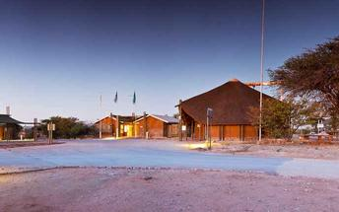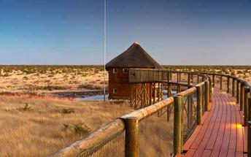

Day 15: Okaukuejo Campsite, Etosha National Park

Etosha National Park
Famous for its wildlife, Etosha Park supports 114 species of mammal and over 340 species of bird. At the heart of the park is a 4,800 square kilometre salt pan surrounded by sparse shrubs and grassy plains, the perfect haven for animals.
As vegetation in most areas is sparse, the animals have learnt to drink during the day when predators are inactive and it is the safest time to be out in the open. It is not uncommon to see up to 7 different species of game at any waterhole.Like everything in Namibia, the pan is ancient - 2 million years or so - and was formed when a great continental upheaval diverted the Kunene River towards the sea, leaving a massive inland lake that soon dried up. Usually a shimmering white horizon, the pan fills with water after a good rainy season and becomes a vast knee-deep lake.

Day Itinerary
Etosha (west) – Etosha (south) a full days game drive through the park
- After breakfast, a full morning game drive to Okaukuejo
- Set up camp and then you can return into the park for an afternoon drive or arrange with the lodge for a game drive (optional extra)
- At Okaukuejo, I suggest you pop in at the local shop to purchase some drinks and snacks and most importantly, a map of Etosha which will show you all the waterholes in the park
- Enjoy the waterhole inside the park which is floodlit at night
- Etosha is one of Africa's great game parks. With 114 species of mammal and 340 species of birds you are sure to see a great variety of wildlife on your safari

Overnight: Okaukuejo Campsite
Okaukuejo Camp is inside Etosha National Park in Namibia. Consequently, you get to enjoy the nightlife. Those staying outside of the park do not, as the gates are closed. The oldest and most popular camp it’s a busy, bustling place and overlooks a floodlit waterhole.
You can get a site near the waterhole where there’s more privacy (and space) - although if you do pitch there, it’s more of a hike to the shower blocks. Get up early to avoid the ablution queues - there can be big groups waiting. By the way, don’t be surprised if you hear lions roaring close by. Just keep your sleeping bag zipped up tight. No giggling.
This is the wild, wild world of Namibia. Just face the bush and breathe. Feel free? Good. Enjoy the show.
But don’t come here to go glamping. This is the place to pitch up quickly, grab a beer and head to the waterhole as the sun sets. Nobody outside of the camp gets to do this - they close the gates when it gets dark - so this is a treat. And talking of gates, you’re 17km from the Andersson Gate which is Etosha’s southern entrance.
Okaukuejo is at the western end of the Etosha Pan. As well as being the oldest camp - it began life in 1957 - it’s also Etosha’s administrative centre and home to the Etosha Ecological Institute. They work to conserve the fauna and flora in this part of Namibia.
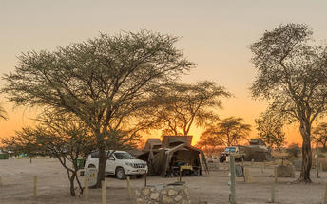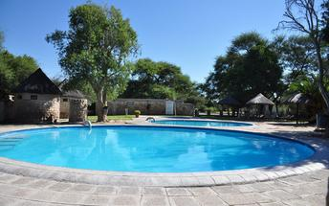

Day 16-18: Onguma Tamboti Campsite, Etosha East

Etosha East
On the eastern edge of Etosha National Park, the park itself is bordered by numerous private reserves and access into the park is via the Von Lindequist Gate, named after Dr. Friedrich von Lindequist who proclaimed it a game reserve in March 1907. This side of the park is characterised by flat endless plains, tree-savanna type of vegetation and fantastic waterholes, where you could easily spot any of the prolific wildlife Etosha is known for. There's an abundance of wildlife here.

Day Itinerary
Etosha (south) – Etosha (east) a full days game drive through the park
- From one side to the other side of the park is a full day game drive as you head slowly east stopping at numerous waterholes along the way
- Take a slow drive in the morning and then enjoy a snack or lunch overlooking one of the waterholes before continuing on through the park to the eastern side
- 1 full day is set aside for game viewing, either all day or alternate with morning and afternoon drives. These are self-drive game drives but you can arrange at the lodge to go with their open safari vehicle and guide (optional extra)

Overnight: Onguma Tamboti Campsite View iBrochure
Bridging the gap between safari lodge and camping, Onguma Tamboti Campsite has 15 shaded camping areas each with their own ablutions, washing-up facilities and electrical outlets.
Camping under the stars and preparing your meals over an open fire in the middle of nowhere, surrounded by acre after acre of bush is the quintessential African experience. Then again so is sitting on a shaded verandah overlooking a waterhole while a waiter refills your G n’ T and brings you dinner.
Whichever experience you’re after, Tamboti Campsite offers you the best of both. And being in a private game reserve, you won't be sharing this piece of wildlife paradise with more than handful of like-minded nature lovers. And what’s more the 34,000ha Onguma Game Reserve shares a fenceless boundary with Etosha National Park and so your wildlife experience is about as it gets.
To make the most of this wildlife-rich wilderness, pop over to Onguma Bush Camp and arrange a guided game drive into Etosha proper or join a small group on a sundowner game drive inside the private reserve. The early morning bush walk is a must for an intimate, all-senses experience of Africa as she has been for millions of years.
Or you can just laze away the afternoon by the pool after an early morning self-drive through the park, which, given the abundance of wildlife, the scarcity of water and the presence of waterholes can be every bit as rewarding as the guided safari.
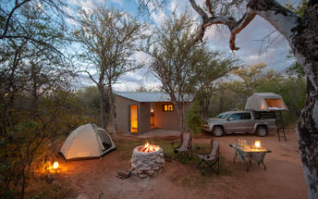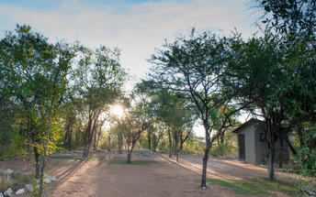

Day 18: Okonjima Omboroko Campsite, Okonjima Nature Reserve

Okonjima Nature Reserve
This 22,000-hectare private nature reserve is surrounded by the the Omboroko Mountains and the home of The AfriCat Foundation. AfriCat works to assist with the long term conservation and rehabilitation of carnivores like cheetah, leopard, brown hyena and that African icon, lion. Since 1993, over 1,000 predators have been saved with 86% released. Here you can see cheetah, wild dog and hyena in their natural home - leopards are radio tracked so you could get lucky and spot them too. 250 bird species think it’s an ideal spot and there’s a hide for watching nocturnal animals.

Day Itinerary
Etosha (east) – Okonjima 315km - approximately 4 to 5 hours
- Head south via Otavi and Otjiwarongo to Okonjima, which is home to the AfriCat Foundation.
- Enjoy some time relaxing or enjoy a walking trail in the area

Overnight: Okonjima Omboroko Campsite View iBrochure
This is cheetah land. Fierce, fast and furry. No loud, lazy lions. These cats can’t even roar but they do like a good purr. Pitch your tent. It's safe. Go check out the work of the AfriCat Foundation.
It’s not just cheetahs but leopards too - it’s all about looking out for wild carnivores. Literally and figuratively. Camping is in the 2000 hectare non-rehabilitation area at the foot of the Omboroko Mountains. Sandy, shaded, secluded.
4 campsites which share a swimming pool. A little circle of blue in a little patch of lawn. An incongruous touch reminiscent of the early days of Okonjima. In those days the first rescued cheetah would wander up for a fuss as afternoon tea was served.
Camp Koshi: the smallest site, it can take about eight people but there’s only really room for one vehicle. The shower is under roof and doesn’t have a view but the toilet does. Bonus. It’s a bit of a walk though so take your torch at night.
Camp Kendi: both the shower and toilet are under roof and this site can accommodate more than one vehicle.
Camp Chilala: open air shower and toilet with views. This site can accommodate more than one vehicle.
Camp Chimelo: open air shower and toilet with views. This site can also accommodate more than one vehicle.

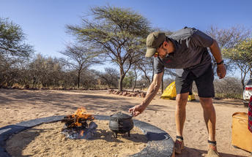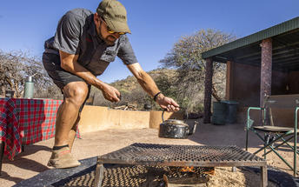

Day 19: End of Itinerary

Day Itinerary
Okonjima – Windhoek 225km - approximately 3 to 4 hours
- Head back to Windhoek today, where the vehicle is dropped off and your holiday comes to an end
- Transfer to the airport to catch your departure flight. (Keep in mind that you need to be at the airport 2 hours prior and the airport is still a 45 minute to 1 hour drive from town)

Basis
Bed and Breakfast

Transport

Transfers
Date | Company | Pick Up | Drop Off | Time | Vehicle
 |  | Hosea Kutako International Airport [WDH] | Windhoek City |  | Fully Guided Trip
 |  | Windhoek City | Hosea Kutako International Airport [WDH] |  | Fully Guided Trip

Urgent Contact Numbers
Company Name | Telephone | Email Address | Contact Person
Namibia Tours & Safaris | +264 64 40 6038 | tanya@namibia-tours-safaris.com | Tanya Coetzee
Namibia Tours & Safaris - Emergency Contact | +264 81 784 4315

Service Provider Directory
Service Provider | Ref. Number | Telephone | Address
Alte Villa |  |  | Mable Street  Lüderitz  Namibia
Bagatelle Kalahari Game Ranch Campsite |  |  | Kalahari Namibia  Mariental  Namibia
Camping at Opuwo Country Hotel |  | +264 65 27 3461 | Opuwo  Kaoko Otavi  Kunene  Namibia
Canyon Roadhouse Campsite Gondwana Collection Namibia |  | +264 61 42 7200 | Canyon RoadhouseHoloogKeetmanshoop9000
Okonjima's Omboroko Campsite |  | +264 67 31 4000 | Okonjima LodgeOtjiwarongo, Namibia9000
Olifantsrus Camp |  | +264 61 285 7200 | Okaukuejo  Outjo  Kunene  Namibia
Omarunga Epupa-Falls Campsite Gondwana Collection Namibia |  | +264 61 42 7200 | Omarunga Lodge and CampsiteKunene RegionNamibia9000
Onguma Tamboti Campsite |  | +264 67 22 9112 | Onguma Nature ReserveEtosha Namibia9000
Sesriem Oshana Campsite |  | +264-833-232393 | C27Sesriem9000
Swakopmund Luxury Suites |  | +264-64-463298 | A. Tobias Hainyeko & Am Zoll Street, 228cSwakopmund9000
The Elegant Guesthouse |  | +264 61 23 7294 | Von Eckenbrecher StrKlein Windhoek9000

Terms and Conditions

Namibia Tours & Safaris Terms and Conditions
Contract
1.1 The contract will become effective as from the date the invoice is completed and the deposit, referred to in Clause 2.1, is received by Africa Tours & Safaris CC (hereinafter known as the Company).
1.2 The contract is subject to the Namibian Law.
1.3 Any person making a reservation as per Clause 8.4 accepts the terms and conditions of this agreement set out hereunder.
How to Book
2.1 A 20% deposit of the full amount due is required to confirm any reservation and is to be done by the agent or client (see Clause 8.1) in writing or by e-mail.
2.2 The Company must receive the balance of the contract price no later than 42 days (6 weeks) prior to departure.
2.3 If the Company does not receive the full contract price 42 days (6 weeks) before the departure date, the Company may cancel the reservation and retain whatever deposit or other funds it has already received from the client or his agent.
How to Pay
3 The payment options will be provided upon confirmation of a booking.
Our Cancellation Policy
4.1 Any cancellation of a confirmed booking must be done in writing (email) to the Company whereupon cancellation charges as per Clause 4.2 will apply.
4.2 The following cancellation fees (as a percentage of the fully quoted price) are applicable to any cancelled travel:
Notice from date of travel: Cancellation fee:
42 days or more 20% (deposit forfeited)
29 – 41 days 50%
15 – 28 days 75%
0 – 14 days 100%
Please note: the notice period is calculated from the date of cancellation to the start date of the tour/safari booking.
4.3 No refund will be made by the Company if, for any reason, inclusions or parts of the tour cannot be carried out / or utilised. These would include all facets such as meals, game drives, accommodation etc. This would also apply to any client who has booked a tour but fails to undertake the tour for any reason.
Our Changes Policy
5 If a booking is changed to an earlier date than originally reserved, the Company will endeavour to change it. If the booking is for a later date, charges as per Clause 4.2 could apply.
As things go, we've all had to adapt to changes during the Coronavirus pandemic and so too have we therefore amended our terms and conditions for travel during such times. Check out the Updated COVID Terms and Conditions here.
Price Changes
6.1 The Company reserves the right to increase the price of any tour prior to departure due to factors beyond the control of the Company, such as, without being limited to, and increase in fuel prices, new Government legislation, accommodation price increases, fluctuations in exchange rates, etc.
6.2 If the Company announces an in increase in the tour price in terms of this Clause, such addition amount must be paid to the Company before the departure of such tour or else the Company shall have the right to cancel the tour and the charges in Clause 4.2 will apply.
Changes to Itineraries
7 The Company shall at any time have the right, in its entire discretion, to alter the terms of the booking in relation to the route, timetable, itinerary and accommodation. The Company shall, however, make every effort to offer the client an alternative tour of a comparable standard.
Should the alternative be of a lesser standard, the client will be refunded the difference, but should there be an increase, the client shall have the right to either reject the alternative and obtain a refund of the relevant portion of the original contract sum, or to accept the alternative and pay the increased cost. In the event of the client rejecting the alternative tour and claiming a refund, such rejection will be treated as a cancellation and the refund will be calculated according to Clause 4.2 hereof. The client shall have no claim against the Company for any damages arising out of the alternative booking.
Responsibility and Liability
8.1 Neither the Company nor any person acting for through and on behalf of the Company shall be liable for any loss or damage whatsoever arising from any cause whatsoever and without restricting the generality of the aforegoing shall particularly not be responsible for the loss or damage arising from any errors or omissions contained in its brochure or other literature, late or non-confirmation or acceptance or bookings, loss or damage caused by delays, sickness, injury or death, whether occasioned by negligence or not.
8.2 The Company shall have the right at any time at is sole discretion, to cancel or the remainder thereof or to make an alteration in the route, accommodation price or other details. This would include any event of any tour being rendered impossible, illegal or inadvisable by weather, avalanches, strike, war, government or other interference or due to any other cause whatsoever. The extra expenses incurred as a result thereof shall be the responsibility of the client.
8.3 The Company may at its discretion and without liability or cost to itself at any time cancel, or terminate, a client's booking and in particular, without limiting the generality of the aforegoing, it shall be entitled to do so in the event of illness or the illegal or incompatible behaviour of any client undertaking the tour, who shall in such circumstances not be entitled to any refund.
8.4 Any person making a reservation with the Company (refer to Clause 1.1) warrants that her or she has the necessary authority to enter into this contract on behalf of the person or persons included in such a booking. The person making the reservation shall be liable for the total amount due to the Company.
Client's Obligations
9.1 It is the onus and responsibility of the client to obtain the necessary comprehensive insurance before departure for any possible cancellations, medical expenses, protection or personal property and money.
9.2 The onus is upon the client to ensure that passports and visas are valid for the duration of the safari. The Company cannot be held liable for any necessary visas or other travel documents not held by clients. In the event of a client not having the necessary documentation to enter any area or country the Company shall reserve the right to leave the client a the point of entry of such area or country. In such an event, the Company will not be held responsible to the client for further travel arrangements.
9.3 The onus is upon the client to ensure that the SARS-CoV-2 PCR tests are done prior to commencement of the safari and valid on arrival in accordance to the requirements of the country of intended travel and for the airline with which the client will travel. The same applies for any necessary testing for departure. The costs of any such COVID testing will be for the clients own account. While The Company can assist with arrangements for testing in-country, The Company will not be held responsible to the client for such arrangements and with regards to return time of test results.
9.4 Should the client need to undergo mandatory quarantine once in-country with regards to the SARS-CoV-2 virus, either on arrival as called for by the authorities or due to testing positive once in-country, this will be at the clients own expense.
Health and Personal Safety
10.1 The client shall be reasonably fit to undertake the tour.
10.2 Anti-malaria precautions should be commenced prior to tour departure. A medical doctor should be consulted for advice.
10.3 Tours offered by the Company cover a wide spectrum of the African wilds and neither the Company, its employees or agents can be held responsible for any injury or other related incidents whilst on the tour / safari.
10.4 The Company cannot be held responsible for any client who falls ill or contracts the SARS-CoV-2 virus while in-country. The client accepts that travel is at own risk.
Baggage
11.1 Clients are limited to one soft sports type bag per person with a maximum weight of 20 kilograms. This includes photographic equipment and hand luggage.
11.2 Due to the rugged terrain, the Company cannot be held responsible for damage or loss of any personal items including bags, contents of bags or photographic and related equipment. Due to extremely dusty conditions, please ensure all bags are dust proof.
Airline and Car Hire Clause
12.1 The Company will act as the agent of the client when booking the client with a car hire company, an airline or air charter service. The client therefore contracts with the car hire company, airline or charter service and not with the Company.
12.2 Charter flights are normally operated by smaller type aircraft such as Cessna 210. Luggage is strictly limited to 10-15 kgs (depending on terms of particular airline used) per person in soft hold all type bags. Due to the desert heat, it is not safe to overload aircraft thus this limit needs to be strictly controlled.
Travelling or thinking of travelling during the COVID-19 pandemic? Take a look at our COVID Terms and Conditions for more information on how this will work and differ from our standard terms and conditions as listed above.

