Johnny Russell - Background
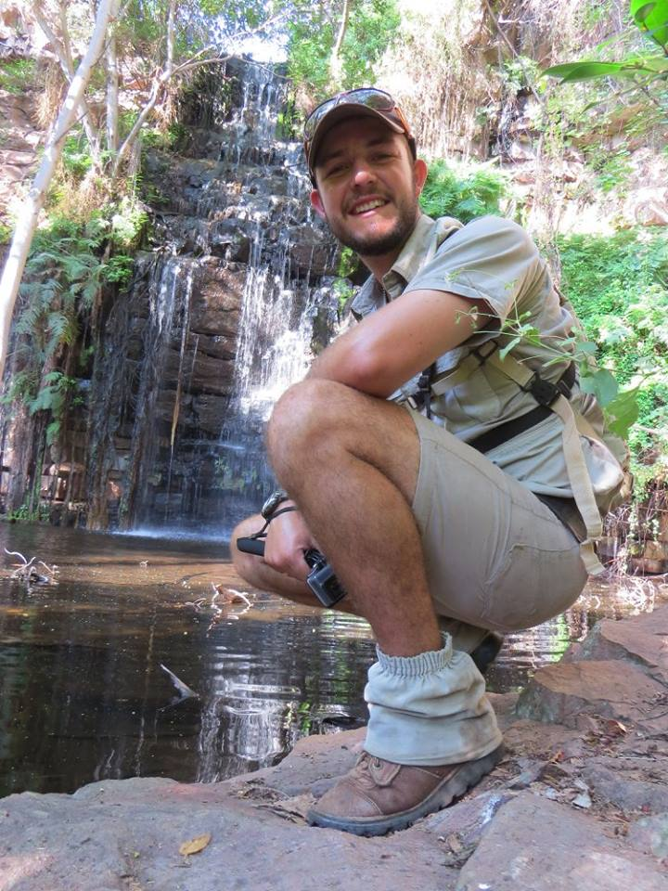
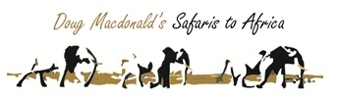
Johnny Russell was born in Zimbabwe in 1989 and was very fortunate to grow up spending holidays on his uncle’s farm in the North of Zimbabwe - Doma where he discovered all manner of animals, plants and creepy crawlies. His grandfather also loved the bush, birding and fishing, which also made an impression on Johnny as they explored together. Johnny took every opportunity to be outdoors and in school he excelled in sports, and represented Zimbabwe in rowing. He also had a keen interest in engines and mechanics and gained experience in this field after school at a car rally and auto electrics firm, and also a boat hire company – this all came in handy with his love of Land Rovers too!
It was not ironic that with his love of the bush and water, his first job in hospitality and the wilderness was working at a camp doing mobile safaris along the Zambezi River in Mana Pools. He made it a priority to quickly obtain his learner guide’s license which he passed in 2010, and from running the canoe trail safaris, he went into guiding for various camps. He was very good at sharing his enthusiasm and interest in the bush, and from guiding he then went on to managing camps. He has worked in Mana Pools, Hwange and Gonarezhou National Parks, as well as in Chewore and in the Save Valley. He is never happier than when he is in the bush exploring new areas with his camera and binoculars at hand, and reading the tracks, listening, watching, and seeing what different things the bush holds in store for that day.

