
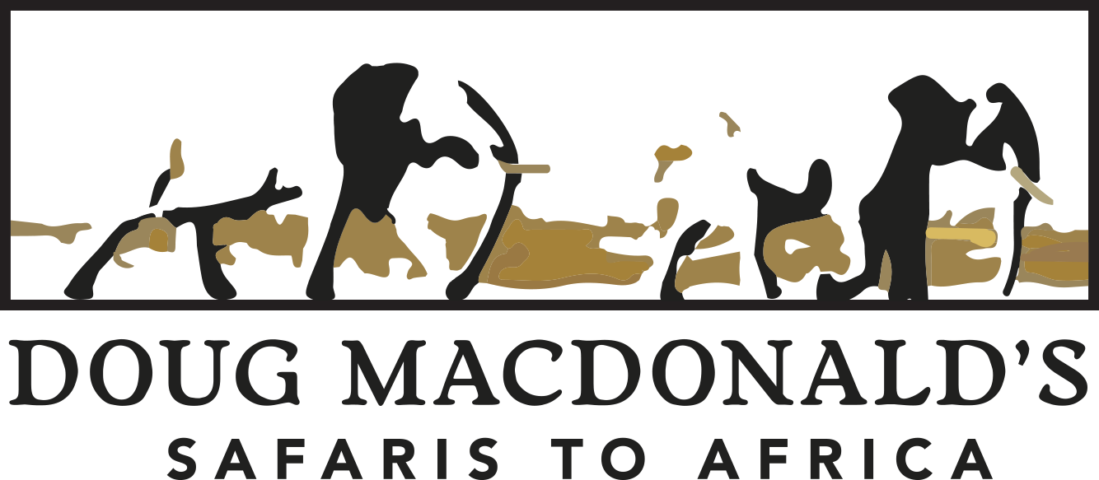
Terms and Conditions
- 20 % deposit to confirm booking
- Cancellation of booking after deposit being paid will result in deposit being forfeited
- Balance payable 60days before travel for final confirmation
- Cancellation of all or part of the safari after balance paid and within 60 days of travel will incur a penalty of 50% of the safari cost.
- Cancellation of all or part of the safari after balance paid and within 45 days of travel will incur a penalty of 75% of the safari cost.
- Cancellation of all or part of the safari after balance paid and within 30 days of travel will incur a penalty of 100% of the safari cost.
- If you cancel the safari as a result of testing positive for COVID and are unable to fly, or your government or host government stops you travelling for COVID related reasons we will endeavor to refund as much as possible of the safari or preferably reschedule the safari to a later date. There maybe some costs adjustments for new dates and we will advise you of all this at the time.
- If during the course of the safari you test positive for COVID and are unable to continue travelling and either need to quarantine or delay onward travel for retesting then the additional costs of tests, accommodation and flights will be for your account and we encourage you to have suitable insurance cover that will protect you in this case.
It is recommended for travel with Doug Macdonald Safaris that you take out comprehensive travel insurance that has clauses that are specific on the COVID situation prevailing when you pay your deposit or a cancellation “for whatever reason” clause to protect you and notify us of the details of that package.
It is important to please keep your belongings with you at all times especially those of a valuable nature and we cannot be responsible for them should they be misplaced, left in a camp or stolen. Should items be left behind in a camp we will try our best to get them returned to you timeously, but the cost of the communications and possible air charter costs or freight will be for your account.
Roads and the terrain in Africa and while on safari can be harsh and it is possible that injuries to you and equipment damage might occur so Doug Macdonald Safaris, its employees, camps and facilities used will not be liable for any accidents or damage that might occur. Most places booked for whilst on safari in Africa are in remote and wild places with dangerous animals, harsh terrain and harsh weather, as such you will be exposed to potentially dangerous situations and activities whilst in Africa

Terms and Conditions Contd.

and Doug Macdonald Safaris and Explore The Wilderness, it’s employees, camps and facilities used will not be liable for any injury, loss of life or damage whatsoever either during or after your travel arrangements.
Whilst we are committed to ensuring that your travel arrangements go to plan and as agreed, Doug Macdonald safaris or the camps and facilities that we use reserve the right to alter, cancel or change travel arrangements at anytime without your prior consent or approval should they feel it justified in the interests of safety, enjoyment and practical purposes for any of it’s guests or clients.
Doug Macdonald’s Safaris also reserve the right in the case of a privately guided safari to change the guide, if possible, should there be unforeseen circumstances such as sickness, injury or personal circumstances to the guide, making the guide un-fit to guide the safari. You will be notified of this situation and a suitable replacement or alternative arrangement will be made with you.
It is assumed the deposit payment and your final amount paid is because you have agreed to the terms and conditions set out by Doug Macdonald Safaris and the camps and facilities that we use and reserve on your behalf, and therefore will not hold liable any claim against any person or organization for any changes, cancellations, damage to one’s property, injury, death or any unforeseen occurrences whether it is due to negligence by one or more of our staff or any company. Therefore, you have indemnified the various organizations and individuals mentioned above in any such event.

Signed:__________________________________ Date :______________________________

The Core – No62 ICT Ave – Cybercity 72201 – Ebene Mauritius

