

9-Day Zimbabwe Highlights Safari - Standard - NETT

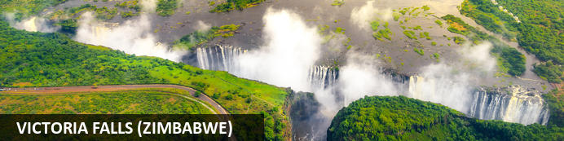
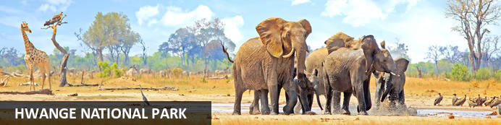
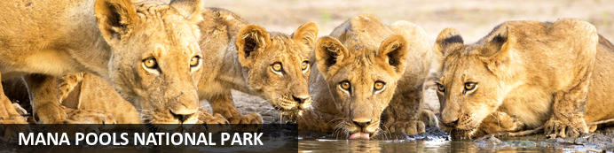

9-Day Zimbabwe Highlights Safari - Standard - NETT
Victoria Falls (Zimbabwe) - Hwange National Park - Mana Pools National Park
9 Days / 8 Nights
Date of Issue: 13 March 2023

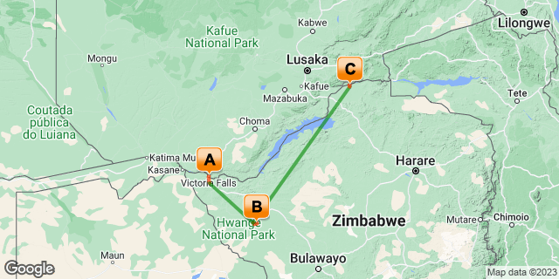

Click here to view your Digital Itinerary

Introduction
The perfect itinerary to visit some of the main highlights in Zimbabwe in just over a week. Including the magnificent Victoria Falls along with Zimbabwe’s most famous game park, Hwange National Park, and Mana Pools National Park, popular for walking safaris. A combination of the wonder of Victoria Falls with incredible wildlife viewing on a big game safari.

Accommodation | Destination | Basis | Duration
Ilala Lodge Hotel | Victoria Falls (Zimbabwe) | B&B | 2 Nights
African Bush Camps Somalisa Expeditions | Hwange National Park | FI | 3 Nights
Zambezi Expeditions | Mana Pools National Park | FI | 3 Nights

Key
B&B: Bed and Breakfast
FI: Fully Inclusive - Bed, All Meals, Fees and Activities

Price
NETT STO COSTS
1st April 2023 – 31st May 2023
2 or more guests - USD 5550 per person sharing
Single supplement - USD 1880
1st June 2023 – 31st October 2023
2 or more guests - USD 6975 per person sharing
Single supplement - USD 1880
Note:
Mana Pools Season - April through October.
** Rates are subject to change
Includes shared road & air transfers starting VFA & ending HRE on a seat rate basis
Tip: From 1st January 2023 - 31st March 2023 at Ilala: Book a sunset cruise on the Ra-ikane & get a 3 course dinner at The Palm free of charge.

Included
- Accommodation as indicated – can change depending on availability and request at time of booking
- Meals as indicated
- Activities as indicated
- Shared road transfers as necessary
- Seat on internal flights as indicated
- Tour file with detailed itinerary, map with route descriptions, vouchers etc.
- 24 hour personal and friendly support
- Fast and efficient response to service providers

Excluded
- Items of a personal nature
- Optional extra activities
- International flights
- Holiday or personal insurance
- Staff gratuities
- Park entry fees (for optional extra activities in Victoria Falls)
- Victoria Falls Airport departure tax
- Visas and visa applications

Day 1-3: Ilala Lodge Hotel, Victoria Falls (Zimbabwe)

Victoria Falls (Zimbabwe)
A gazillion tonnes of water thundering over a sheer cliff drowns all other sounds. The swirling mist hides all sign of human activity. Beyond your rain forest sanctuary people are hurling themselves off bridges, across gorges, into walls of raging water and out of aircraft.
Victoria Falls is a paradox of tranquil beauty and exciting adventure.
Mosi-oa-Tunya, 'The Smoke that Thunders' is undoubtedly Zimbabwe's finest and most well-known attraction. It is or rather was (if you're keeping up with the latest list) one of the Seven World Wonders. We still believe it deserves the title. It truly is spectacular and not considered to be one of the world's largest waterfalls without good reason. It's not the widest or the highest , yet it is considered to the largest based on it's combined width, at 1,708 metres wide and height, at 108 metres. Impressively it takes the title for the largest sheet of falling water.

Day Itinerary
- On arrival at Victoria Falls Airport you will be met and transferred to your lodge in town for the next two nights
Airport Transfer Time: 30 minutes from Victoria Falls Airport
- The remainder of the day can be spent relaxing at your own leisure on arrival. Wild animals are often seen grazing the hotel lawns as the National Park borders the front of the property
- Enjoy any of the many activities on offer. Ask at lodge reception to make activity and dining bookings for you. A full day is set aside to explore the falls, adventure into town and go wild on activities
- Dine at the lodge restaurant or head into town. We recommend a Zambezi dinner cruise or dinner at the Boma Restaurant for local cuisine and culture

Overnight: Ilala Lodge Hotel View iBrochure
Ilala Lodge is an elegant, intimate and comfortable hotel on the edge of the Zambezi National Park a short safe walk from Victoria Falls on the Zimbabwean side.
Ilala Lodge is a charming hotel, just minutes from Victoria Falls on the Zimbabwean side adjoining the Zambezi National Park.
This privately owned and managed hotel guarantees the service is personal and the atmosphere intimate. All the rooms are air conditioned and have patio doors opening onto a balcony or large front lawn - mowed by a regular troupe of warthog and occasional visits from waterbuck, baboons, monkeys and even elephant from time to time. The Deluxe and Pool Wing assure a view of the distant spray of the Falls and the Garden Wing, a view onto the peacefully luxuriant gardens.
Good travel advice is to eat where the locals eat and they eat at Ilala's Palm Restaurant. With tables set under the stars on clear nights or in the high-thatched dining room, the food is unfussy and the atmosphere is relaxed. The croc-pie and ostrich steak are local delicacies worth trying.
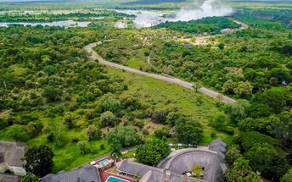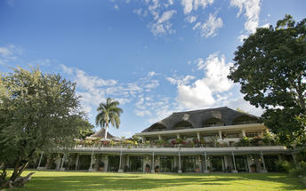

Basis
Bed and Breakfast

Included
- Bed & Breakfast

Excluded
- Drinks, additional meals, activities, additional transfers & laundry

Day 3-6: African Bush Camps Somalisa Expeditions, Hwange National Park

Hwange National Park
About an hour's drive from Victoria Falls, Hwange National Park is Zimbabwe's most famous game reserve and with good reason. The Kalahari biome reaches from central Botswana into the south and west regions characterised by level plains and sparse scrub land with great wildlife.
Hwange has many waterholes to ensure varied and reliable game viewing; it is home to great herds of elephant and buffalo; the largest population of the extremely rare African dog thrives here; and the birdlife is prolific.
Wildlife highlights in Hwange National Park include: elephant, wild dog, lion, leopard, cheetah, rhino, buffalo, spotted hyena, brown hyena, jackal, zebra, giraffe, waterbuck, gemsbok, eland, roan, sable, kudu and many smaller antelope and nocturnal mammals.

Day Itinerary
- After breakfast, enjoy a last activity in Victoria Falls (if time allows). You will be transferred to the airport for your onward internal flight from the Victoria Falls Airport to the Manga Airstrip in Hwange National Park
Airport Transfer Time: 30 minutes to Victoria Falls Airport and 30 minutes from Manga Airstrip to camp
- Enjoy the scheduled activities with your lodge guide as included. Activities include guided walks lead by qualified and passionate guides who will share their knowledge and love of the bush with you, game drives and night drives. Wildlife sightings include elephant, kudu, sable antelope, zebra, wildebeest, gemsbok, the rare and endangered roan antelope, buffalo, giraffe, lion, leopard, hyena and many other wildlife species
Activities: day & night game drives, walking, bird watching and evening spot lighting

Overnight: African Bush Camps Somalisa Expeditions View iBrochure
Somalisa Expeditions is a classic safari camp of old world charm. The essence of a mobile camp with all the additional comforts of a luxurious permanent lodge. In the heart of the Hwange National Park. In a private concession. A real safari adventure that immerses you in the bush and gets you up close with wildlife. Elephants are everywhere.
A sincere Serengeti-style tented camp with a vintage feel. The camp is spectacular, the people even more so and the wildlife continues to raise the bar. There’s more than just something special about this place. It’s everything that makes it what it is.
The way it’s designed to allow you to truly explore the bush. The elephants that come to quench their thirst daily at ‘elephant’s pool’. The service-minded staff and the finer details that make this camp authentic without compromising on comfort. You’ll be left in awe. It’s both humble and proud.
Wood, canvas with touches of copper and gold are a reminder of a bygone era. Perfectly transformed to the modern world without losing the essence of a classic safari camp. You’re in the African bush here and it’s incredible. From your private deck look out onto the dry grass and acacia savannah. You’re likely to spot the elephants and lions have been known to come close too.
This camp is for the wildlife enthusiast. The adventurer who wants it as real as it gets and real it is out here. It’s all about the raw Zimbabwean wilderness along the Kennedy Vlei Line. The seasonal Somalisa pans in a pristine private concession. A game rich area where the highlight is a guided walking safari. That says it all.
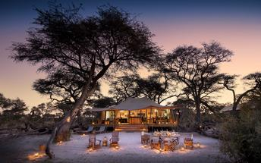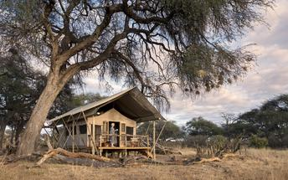

Basis
Fully Inclusive - Bed, All Meals, Fees and Activities
All Drinks (excl Premium Brands) Included

Included
- All meals, local drinks, activities, park fees and laundry

Excluded
- Premium drinks

Day 6-9: Zambezi Expeditions, Mana Pools National Park

Mana Pools National Park
Mana Pools is famous for its walking safaris, canoeing safaris as well as night and day game drives made all the more exciting by the ever-present thrill of getting close to elephants, lions, buffalos, rhinos,cheetahs, leopards, hippos, crocs and much more.
Your guide will be on the lookout for massive elephants following ancient migration paths, lion prides on the hunt, territorial rhinos and grumpy hippos. Birdlife along the river and around the pools is prolific with a low-season count of about 450 birds increasing to 640 in the the dry winter season between March and September - when game viewing is also at its best.

Day Itinerary
- Today you depart Hwange National Park and make your way to your next destination in Mana Pools, flying from one airstrip to another
Airstrip Transfer Times: 30 minutes to Manga Airstrip and 30 minutes from Mana Pools Airstrip to your mobile safari camp
- 2 full days are set aside to enjoy the scheduled activities with your lodge guide as included
- Some of the wildlife you can expect to see is eland antelope, elephant, African wild dogs, water buck, and big herds of buffalo, kudu antelopes, lion and leopard. You will explore a rich abundance of life on the Zambezi River under a sky inhabited by fantastic bird species. Game drives along the flood plain in open 4 x 4 Land cruisers are one of the main highlights, taking you into the core of the wildlife scene that is abounding with a diversity of wildlife. The camp is designed to give you access to the Zambezi river affording you canoeing excursions on the river, fishing either from the banks or off an island in the middle of the Zambezi river. Don’t forget to do a walking safari – a must in these parts
Activities: game drives, walking safaris, canoeing, fishing and bird watching

Overnight: Zambezi Expeditions View iBrochure
From April through November, Zambezi Expeditions, on the banks of the Zambezi River becomes the most enviable location within the Mana Pools National Park. A mobile camp and an authentic safari experience.
Mana Pools National Park is a UNESCO World Heritage Site based on its untouched wilderness and pure beauty. Zambezi Expeditions is right in the thick of it. On the banks of the river along the shoreline under the winter thorn and ebony trees. For only eight months of the year (in the dry season), this is the place you want to be. In the wild. Among nature.
With only six Meru-style canvas tents. All sides rolled up, you’re in the bush and it’s exclusive. It’s a classic tented camp with bucket showers. Don’t think rudimentary though, it’s rather more civilised with everything you’d need and some additional comforts. Yet it still stays true to being a ‘real deal’ mobile camp in the heart of the African wilderness.
From Mana Main Airstrip it’s a 40 minute game drive to camp. It’s civilised but nowhere near civilisation. It’s a hefty five to six hours drive from Harare and that’s not for the faint hearted. You have got to know how to drive a 4x4 and be comfortable heading off road. This is big-game country and you’re smack bang in the middle of it.
Known for some of the best wild dog encounters. Even better on foot. This area is surreal. The wildlife is amazing and the sunrises and sunsets rival some of the finest. You’re in for an absolute treat here. Not so much in terms of luxury but if you’re happy the basics are well covered and it’s all about the destination for you. Then Zambezi Expeditions is a sure-fire win.
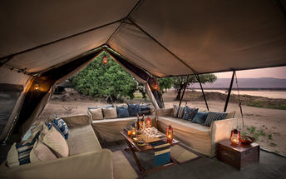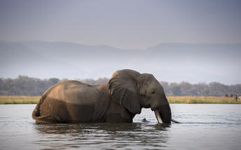

Basis
Fully Inclusive - Bed, All Meals, Fees and Activities
All Drinks (excl Premium Brands) Included

Included
- All meals, local drinks, activities, park fees, conservation & community levy and laundry

Excluded
- Premium drinks

Day 9: End of Itinerary

Day Itinerary
- After breakfast and a morning activity (if time allows depending on your departure flight), you will depart back to the Mana Pools Airstrip and take your onward flight ending in Harare
Airstrip Transfer Time: 30 minutes from camp to Mana Pools Airstrip
- Fly out directly from Harare (Robert Gabriel Mugabe International Airport) or spend a night in Harare before catching your onward flight the next day
- End of services

Basis
Bed and Breakfast

Transport

Flight Information
Date | Flight | Airline | Departure Airport | Time | Arrival Airport | Time | Class | Ref
 | Charter Flight |  | Victoria Falls International Airport [VFA] |  | Manga Airstrip
 | Charter Flight |  | Manga Airstrip |  | Mana Pools Airstrip
 | Charter Flight |  | Mana Pools Airstrip |  | Robert Gabriel Mugabe International Airport [HRE]

Transfers
Date | Company | Pick Up | Drop Off | Time | Vehicle
 |  | Victoria Falls International Airport [VFA] | Ilala Lodge Hotel |  | Transfer
 |  | Ilala Lodge Hotel | Victoria Falls International Airport [VFA] |  | Transfer
 |  | Manga Airstrip | African Bush Camps Somalisa Expeditions |  | Transfer
 |  | African Bush Camps Somalisa Expeditions | Manga Airstrip |  | Transfer
 |  | Mana Pools Airstrip | Zambezi Expeditions |  | Transfer
 |  | Zambezi Expeditions | Mana Pools Airstrip |  | Transfer

Urgent Contact Numbers
Company Name | Telephone | Email Address | Contact Person
Namibia Tours & Safaris | +264 64 40 6038 | tanya@namibia-tours-safaris.com | Tanya Coetzee
Namibia Tours & Safaris - Emergency Contact | +264 81 784 4315

Service Provider Directory
Service Provider | Ref. Number | Telephone | Address
African Bush Camps Zambezi Expeditions |  | +27 21 701 0270
Ilala Lodge Hotel |  | +263832844737 | Ilala Lodge Hotel  411 Livingstone Way  Victoria Falls  Zimbabwe

Terms and Conditions

Namibia Tours & Safaris Terms and Conditions
Contract
1.1 The contract will become effective as from the date the invoice is completed and the deposit, referred to in Clause 2.1, is received by Africa Tours & Safaris CC (hereinafter known as the Company).
1.2 The contract is subject to the Namibian Law.
1.3 Any person making a reservation as per Clause 8.4 accepts the terms and conditions of this agreement set out hereunder.
How to Book
2.1 A 20% deposit of the full amount due is required to confirm any reservation and is to be done by the agent or client (see Clause 8.1) in writing or by e-mail.
2.2 The Company must receive the balance of the contract price no later than 42 days (6 weeks) prior to departure.
2.3 If the Company does not receive the full contract price 42 days (6 weeks) before the departure date, the Company may cancel the reservation and retain whatever deposit or other funds it has already received from the client or his agent.
How to Pay
3 The payment options will be provided upon confirmation of a booking.
Our Cancellation Policy
4.1 Any cancellation of a confirmed booking must be done in writing (email) to the Company whereupon cancellation charges as per Clause 4.2 will apply.
4.2 The following cancellation fees (as a percentage of the fully quoted price) are applicable to any cancelled travel:
Notice from date of travel: Cancellation fee:
42 days or more 20% (deposit forfeited)
29 – 41 days 50%
15 – 28 days 75%
0 – 14 days 100%
Please note: the notice period is calculated from the date of cancellation to the start date of the tour/safari booking.
4.3 No refund will be made by the Company if, for any reason, inclusions or parts of the tour cannot be carried out / or utilised. These would include all facets such as meals, game drives, accommodation etc. This would also apply to any client who has booked a tour but fails to undertake the tour for any reason.
Our Changes Policy
5 If a booking is changed to an earlier date than originally reserved, the Company will endeavour to change it. If the booking is for a later date, charges as per Clause 4.2 could apply.
As things go, we've all had to adapt to changes during the Coronavirus pandemic and so too have we therefore amended our terms and conditions for travel during such times. Check out the Updated COVID Terms and Conditions here.
Price Changes
6.1 The Company reserves the right to increase the price of any tour prior to departure due to factors beyond the control of the Company, such as, without being limited to, and increase in fuel prices, new Government legislation, accommodation price increases, fluctuations in exchange rates, etc.
6.2 If the Company announces an in increase in the tour price in terms of this Clause, such addition amount must be paid to the Company before the departure of such tour or else the Company shall have the right to cancel the tour and the charges in Clause 4.2 will apply.
Changes to Itineraries
7 The Company shall at any time have the right, in its entire discretion, to alter the terms of the booking in relation to the route, timetable, itinerary and accommodation. The Company shall, however, make every effort to offer the client an alternative tour of a comparable standard.
Should the alternative be of a lesser standard, the client will be refunded the difference, but should there be an increase, the client shall have the right to either reject the alternative and obtain a refund of the relevant portion of the original contract sum, or to accept the alternative and pay the increased cost. In the event of the client rejecting the alternative tour and claiming a refund, such rejection will be treated as a cancellation and the refund will be calculated according to Clause 4.2 hereof. The client shall have no claim against the Company for any damages arising out of the alternative booking.
Responsibility and Liability
8.1 Neither the Company nor any person acting for through and on behalf of the Company shall be liable for any loss or damage whatsoever arising from any cause whatsoever and without restricting the generality of the aforegoing shall particularly not be responsible for the loss or damage arising from any errors or omissions contained in its brochure or other literature, late or non-confirmation or acceptance or bookings, loss or damage caused by delays, sickness, injury or death, whether occasioned by negligence or not.
8.2 The Company shall have the right at any time at is sole discretion, to cancel or the remainder thereof or to make an alteration in the route, accommodation price or other details. This would include any event of any tour being rendered impossible, illegal or inadvisable by weather, avalanches, strike, war, government or other interference or due to any other cause whatsoever. The extra expenses incurred as a result thereof shall be the responsibility of the client.
8.3 The Company may at its discretion and without liability or cost to itself at any time cancel, or terminate, a client's booking and in particular, without limiting the generality of the aforegoing, it shall be entitled to do so in the event of illness or the illegal or incompatible behaviour of any client undertaking the tour, who shall in such circumstances not be entitled to any refund.
8.4 Any person making a reservation with the Company (refer to Clause 1.1) warrants that her or she has the necessary authority to enter into this contract on behalf of the person or persons included in such a booking. The person making the reservation shall be liable for the total amount due to the Company.
Client's Obligations
9.1 It is the onus and responsibility of the client to obtain the necessary comprehensive insurance before departure for any possible cancellations, medical expenses, protection or personal property and money.
9.2 The onus is upon the client to ensure that passports and visas are valid for the duration of the safari. The Company cannot be held liable for any necessary visas or other travel documents not held by clients. In the event of a client not having the necessary documentation to enter any area or country the Company shall reserve the right to leave the client a the point of entry of such area or country. In such an event, the Company will not be held responsible to the client for further travel arrangements.
9.3 The onus is upon the client to ensure that the SARS-CoV-2 PCR tests are done prior to commencement of the safari and valid on arrival in accordance to the requirements of the country of intended travel and for the airline with which the client will travel. The same applies for any necessary testing for departure. The costs of any such COVID testing will be for the clients own account. While The Company can assist with arrangements for testing in-country, The Company will not be held responsible to the client for such arrangements and with regards to return time of test results.
9.4 Should the client need to undergo mandatory quarantine once in-country with regards to the SARS-CoV-2 virus, either on arrival as called for by the authorities or due to testing positive once in-country, this will be at the clients own expense.
Health and Personal Safety
10.1 The client shall be reasonably fit to undertake the tour.
10.2 Anti-malaria precautions should be commenced prior to tour departure. A medical doctor should be consulted for advice.
10.3 Tours offered by the Company cover a wide spectrum of the African wilds and neither the Company, its employees or agents can be held responsible for any injury or other related incidents whilst on the tour / safari.
10.4 The Company cannot be held responsible for any client who falls ill or contracts the SARS-CoV-2 virus while in-country. The client accepts that travel is at own risk.
Baggage
11.1 Clients are limited to one soft sports type bag per person with a maximum weight of 20 kilograms. This includes photographic equipment and hand luggage.
11.2 Due to the rugged terrain, the Company cannot be held responsible for damage or loss of any personal items including bags, contents of bags or photographic and related equipment. Due to extremely dusty conditions, please ensure all bags are dust proof.
Airline and Car Hire Clause
12.1 The Company will act as the agent of the client when booking the client with a car hire company, an airline or air charter service. The client therefore contracts with the car hire company, airline or charter service and not with the Company.
12.2 Charter flights are normally operated by smaller type aircraft such as Cessna 210. Luggage is strictly limited to 10-15 kgs (depending on terms of particular airline used) per person in soft hold all type bags. Due to the desert heat, it is not safe to overload aircraft thus this limit needs to be strictly controlled.
Travelling or thinking of travelling during the COVID-19 pandemic? Take a look at our COVID Terms and Conditions for more information on how this will work and differ from our standard terms and conditions as listed above.

