South Africa Country Basics

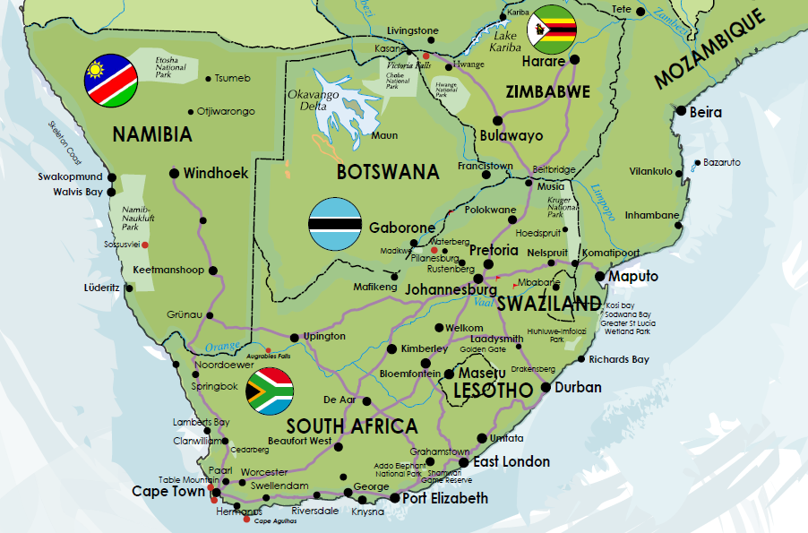

Official Name | Republic of South Africa
Total Area | 1,221,037 sq kms
Total Population | 44.6 million
Capital Cities | Cape Town (legislative)  Pretoria (administrative)  Bloemfontein (judicial)
National Symbols | Flower – Protea  Animal – Springbok  Tree – Yellowwood  Bird – Blue Crane
11 Official Languages | Afrikaans Tswana Venda  English Tsonga Swati  Zulu Sepedi Ndebele  Xhosa Sesotho
Religion | Predominantly Christian
Public Holidays | 1st January 21st March  27th April 1st May  16th June 9th August  24th September 16th December  25 & 26 December Good Friday (variable)  Easter Monday (variable)
The Nine Provinces | Western Cape  Eastern Cape  Northern Cape  North West  Free State  Kwa Zulu Natal  Gauteng  Mpumalanga  Limpopo
Time | Local time is GMT +2.
Electricity | Electrical current is 230 volts, 50Hz. Round, three-pin plugs are standard.
Money | South Africa's currency is the Rand (ZAR), which is divided into 100 cents. Money can be exchanged at banks, bureaux de change and the larger hotels. ATMs are widely available (there is a daily limit for cash withdrawals) and major international credit cards are widely accepted, except in petrol stations where cash is required. Travellers cheques and some foreign currencies are accepted at larger hotels and shops, but commission is charged, otherwise all commercial banks will exchange them.
Tipping | On safari it is customary to tip your ranger – this varies between ZAR 120 per person per day depending on your satisfaction. General lodge staff is approximately ZAR 50 per person per day. Tips are normally given at the end of your stay. Porters are usually about ZAR 20 per movement. A minimum of 10% of the bill is customary in city restaurants and bars.

Entry Requirements | Americans:  United States nationals need a valid passport, but no visa is needed for stays of up to 90 days.  Canadians:  Canadian nationals need a valid passport, but no visa is needed for stays of up to 90 days.  UK nationals:  British Nationals need a valid passport, but no visa is needed for stays of up to 90 days if passport holder is an endorsed British Citizen including Guernsey, Jersey and Isle of Man, British Dependent Territories Citizen, or British Overseas Territories Citizen (Virgin Islands). Those whose passports state British National (Overseas) may stay up to 30 days without a visa. All others require a visa.  European Union:  European Union nationals need a valid passport, but no visa is needed for stays of up to 90 days.  Australians:  Australian nationals need a valid passport, but no visa is needed for stays of up to 90 days.  New Zealanders:  New Zealand nationals require a valid passport, but no visa is necessary for stays of up to 90 days.  Irish nationals:  Irish nationals require a valid passport, but no visa is necessary for a stay of up to 90 days.  South America Countries:  Most South American countries require a valid passport, but no visa is necessary for a stay of up to 90 days.  - Countries exempt from South African visas  http://www.home-affairs.gov.za  - Countries subject to South African visa fees  http://www.home-affairs.gov.za
Passport / Visa Note: | Passports must be valid for at least 30 days beyond the period of intended stay. An onward or return ticket is required, as well as sufficient funds and documents needed for further travel. Note that visitors to South Africa must have at least three blank (unstamped) pages in their passport, each time entry is sought; these pages are in addition to the endorsement/amendment pages at the back of the passport.
Health | Travellers arriving in South Africa from infected areas require a yellow fever vaccination certificate; otherwise no vaccination is required. (NB if travelling from foreign language countries the Yellow Fever Certificate needs to be translated into English). There is a malaria risk in the following areas; low-lying areas of the Northern Province and Mpumalanga (including the Kruger National Park) and northeastern KwaZulu-Natal, and precautions are advised when travelling to these areas. Tap water is safe in urban areas but bottled water is advisable elsewhere. Medical facilities in South Africa are very good, but medical insurance is strongly advised as private hospitals expect payment up front and public hospitals are best avoided.
Safety | Although crime does occur in South Africa, this tends to be concentrated in pockets throughout the country, for example in the township areas and opportunistic crime can be encountered. Travelers should always be aware of these risks and exercise the necessary precautions. Doors should be locked when driving and one should not walk alone at night in city streets, isolated beaches or remote areas. Be vigilant when using ATMs and do not display signs of wealth (e.g. mobile phones, money, expensive jewellery) on the streets. It is worthwhile noting that the South African authorities do give high priority to the protection of tourists.

Business | South Africa's multicultural status means that business etiquette may vary with different people, and according to individual sectors, though it is most often similar to dealings in Europe and the United States. Although there are 11 official languages, English is the primary language of business.  It is best to dress formally for initial meetings. Generally South Africans are regarded as relaxed and informal with regards to introductions and the handling of business cards. Shaking hands is common for both men and women. The giving of gifts is uncommon and unnecessary. Business hours are generally 9am to 5pm Monday to Friday with an hour taken over lunch.
Communications | The international access code for South Africa is +27. The outgoing code is 00 followed by the relevant country code (e.g. 0044 for the United Kingdom). GSM mobile phone networks providing 900 and 1800 frequencies serve the country. Mobile service providers offer very cheap 'pay-as-you-go' Sim cards, which are a good option for visitors staying for some time. Internet cafes are widespread. Card and coin operated pay phones are also widespread.
Duty Free | Travellers to South Africa do not have to pay duty on 200 cigarettes, 50 cigars and 250g of tobacco; 2 litres wine and 1 litre spirits; perfume up to 50ml and 250ml eau de toilette; and other goods to the value of R3,000. All other goods brought in from abroad by South African residents must be declared on arrival. These will be subject to import duties. For goods to be re-imported, travellers must complete a DA65 or NEP-form that is issued on departure. Prohibited items include meat and dairy products, all medication except for personal consumption, flick knives, ammunition, explosives
Useful Contacts | Tourism  South African Tourism, Johannesburg: +27 (0)11 895 3000 or www.southafrica.net  South Africa Embassies  South African Embassy, Washington, United States: +1 202 232 4400  South African Embassy, London, United Kingdom: +44 (0)20 7451 7299  South African High Commission, Ottawa, Canada: +1 613 744 0330  South African High Commission, Canberra, Australia (also responsible for New Zealand): +61 (0)2 6272 7300  South African Embassy, Dublin, Ireland: +353 (0)1 661 5553  South African Embassy, Moscow, Russian Federation: +7 495926 1177  South African Embassy, Brussels, Belgium:+322 285 4400  South African Embassy, Paris, France: 09331 535-92323  South African Embassy, Munich, Germany: +49 89 23 1630  South African Embassy, Brasilia, Brazil: +5 561 3312 9500  South African Embassy, Santiago, Chile: +56 2 2312860-3  South African Embassy, Buenos Aires, Argentina: +5411 4317 2900  Foreign Embassies in South Africa  United States Embassy, Pretoria: +27 (0)12 431 4000  British High Commission, Pretoria: +27 (0)12 421 7733  Canadian High Commission, Pretoria: +27 (0)12 422 3000  Australian High Commission, Pretoria: +27 (0)12 423 6000  Irish Embassy, Pretoria: +27 (0)12 342 5062  New Zealand High Commission, Pretoria: +27 (0)12 342 8656/7/8/9.  Argentina Consulate General, Johannesburg: +27 (0)11 783 9032  Brazilian Embassy, Pretoria: +27 (0)12 366 5200  The Embassy of Chile, Pretoria: +27 (0)12 460 8090  The Embassy of Russian Federation, Pretoria: +27 (0)12 362 1337  Belgian Consulate General, Pretoria: +27 (0) 12 440 3201  French Consulate-General, Johannesburg: +27 (0) 11 7785600  German Embassy, Pretoria: +27 (0) 12 427 8974

South African Airports  www.airports.co.za | Cape Town  Cape Town International Airport (CPT)  Location: The airport is situated 13 miles (20km) east of Cape Town.  Time: GMT +2.  Contacts: Tel: +27 (0)21 937 1200  Transfer to the city: Pre arranged transfers are recommended.  Car rental: Car rental companies represented at the airport include Hertz, Avis, National Alamo, Budget, Imperial and Tempest.  Facilities: ATMs, bars, restaurants and currency exchange facilities are available throughout the airport. There are several shops, including duty-free in the International Departures' section. A VAT refund service is available by the International check in desk. Hotels reservations and tourist information are available in the International Terminal. There is a Vodacom shop in International Arrivals where visitors can buy local SIM cards for their mobile phones.  Parking: Short- and long-term parking, as well as valet parking, is available.  Departure Tax: Tax included in ticket  Johannesburg  O R Tambo International Airport (ORTIA) (JNB)  Location: The airport is 14 miles (22km) east of Johannesburg.  Time: GMT +2.  Contacts: Tel: +27 (0)11 921 6262  Transfer to the city: Pre arranged transfers are recommended. The new Gautrain now also offers a wonderful, direct link to Sandton. Journey time is only 15 minutes.  Car rental: Car rental companies represented at the airport include Sizwe, Avis, Budget, Imperial, Tempest, Europcar and Khaya.  Facilities: Facilities at the airport include bureaux de change, banks, a post office, shops, restaurants and bars, Internet access, mobile phone rental, viewing decks, a medical clinic and a prayer room.  Parking: Short- and long-term parking is available.  Departure Tax: Tax included in ticket  King Shaka International Airport – KSIA (DUR)  Location: The airport is 22 miles (35km) North of Durban.  Time: GMT +2.  Contacts: Tel: +27 (0)32 436 6758  Transfer to the city: Pre arranged transfers are recommended.  Car rental: Numerous car rental companies are represented at the airport, including Europcar, Hertz, Avis, Budget, Capital Car Hire, Dollar Thrifty Car Rental, Easy Hire, First Car Rental / Sixt, Tempest Car Hire, Woodford.  Facilities: Facilities at the airport include ATM’s, a bank, lounges, a post office, restaurants and bars, and shops. Disabled facilities are good; those with special needs should contact their airline in advance.  Parking: Parking is available (over 4500 parking bays)  Departure Tax: Tax included in ticket

Climate | The South Africa summer season runs from October through to March and the central winter period falls between May and July. Although South Africa’s climate is affected by regional differences, the climate is generally mild throughout the year with predominantly summer rainfall. On the whole, South Africa ranks high on the sunshine index.  The Western Cape region (including Cape Town) is the only area that has a mild, Mediterranean climate with dry summers and winter rainfall. In summer the weather in Cape Town is warm and dry, but the idyllic sunny weather can be punctuated by strong south easterly winds. Winters (June, July & August) are characterised by heavy rain, particularly on the mountain slopes, strong north-westerly winds, and low temperatures.  The main game viewing areas of Mpumalanga, Limpopo and KwaZulu Natal, experience predominantly summer rain fall periods with hot, sometimes humid weather. Winter days are mild with evenings and early mornings being chilly. Due to high summer temperatures, spring and autumn are usually the best times to plan a comfortable safari experience.
What to Pack | As a general guide, comfortable, casual wash and wear clothes are recommended. Please note that muted colours are recommended for game-viewing. Game-drives are conducted in the early morning and late afternoon, which can be very cold, especially in winter. Layered clothing is advisable.  The most practical items to pack for safari are:  • Khaki, green, beige and neutral colours  • Shirts with long sleeves (even in summer, as protection from the sun and  mosquitoes)  • T shirts  • Shorts or a light skirt  • Jeans or safari trousers for evenings and cooler days  • A jacket and sweater are recommended for early morning and evening  game drives  • Lightweight water-proof jacket  • Swim and beachwear  • Comfortable walking shoes  • Sun block, sunglasses, hat, insect repellent, moisturizer and  lip-salve are all essentials  • Binoculars and camera equipment  Rovos Rail  During the day, the dress is smart casual. Attire that is more formal is worn in the evening on the “Pride of Africa”. A jacket & tie is a minimum requirement, please. Please include warm clothing for cold mornings and evenings.

South African “Lingo” | Babalas - Pronounced “Bubba-luss”  There is simply no word in the English language to adequately describe the feeling – so we’ve created one. Your tongue feels like sandpaper, someone is driving a nine-inch nail through the back of you skull and foggy images from the night before are crawling into memory. You slurred your life story to some degenerate at a bar, you sang “It’s Raining Men” several dozen times, and somehow, somewhere, you acquired a traffic cone. That’s right, you have a “babalas”. A nice big hangover.  Braai - Pronounced “Brye”  After soccer, rugby and cricket, our top sport is the “braai” – otherwise known as the barbeque. It’s our favourite pastime and a huge source of merriment for the boykies (a slang name for the men). South Africans abroad have even been known to brave the blizzard and “braai” in London’s below-freezing conditions. Mad? Not as mad as missing a good “braai”.  Crash  Why appoint a designated driver when you can just crash? No, it’s not as bad as it sounds. To “crash” means to spend the night at someone’s house. It beats a head-on collision any day of the week.  Drive Alive, do not drink and drive!  Dwaal  Spend enough time in Cape Town or Durban and you may find yourself in a state of sleepy hypnosis brought on by fresh sea air or magnificent mountain vistas. If this happens, don’t be concerned. It is a common garden variety “dwaal”. Some call it a daydream; others: The Thousand Yard Stare. Whatever you call it, when you are caught staring at a total stranger; the safest response is: “Sorry, I was just in a dwaal”.  Kief  They say that Eskimos have sixty-four words for snow, which makes perfect sense. Their countries boast vast expanses of frozen water and lots of polar bears. In South Africa we have a similar phenomenon. We have countless words to express that which is good, or cool, or exciting, or beautiful; among them, “kief”. Sunny weather; sandy beaches; exotic wildlife; beautiful people - we’ve got more positives than a 12 volt battery. And we can’t help talking about it.  Madiba  Pronounced “Muh-deeba”  More serene than the Dalai Llama, more forgiving than Ghandi, more eloquent than Churchill . . . To us he is our history’s miracle; our national treasure; our most bankable export. You may call him Nelson Mandela, but he is our grandfather: “Madiba”  Mission  No, this has nothing to do with charity work. That’s “missionary”. Being on a “mission” could be as important as delivering high-level documents to Government or as menial as grabbing a cup of coffee.  Platteland  Pronounced “Pluh-te-lund”  The Afrikaans translation of the “flat land” is what we call parts of South Africa that are, you guessed it, flat.  Skollie  Pronounced “Skoh-lee”  A good-for-nothing. Ne’er-do-well, slob, slacker or loser. In other words, your average Mr. Wrong.
Latest News:

From 1 June 2015, children travelling in and out of South Africa will be required to carry an unabridged birth certificate as well as a valid passport, under new regulations aimed at improving the safety of children.

The rules are aimed at improving the safety of children, including "their protection from child trafficking, abduction and kidnapping."

The department has urged citizens and foreign nationals to apply for unabridged birth certificates, which reflect the particulars of both parents, in good time in order to avoid possible delays to their travel plans. It can take up to six to eight weeks for an unabridged birth certificate application to be processed.

Update: From April 2016

The term Unabridged Birth Certificate has been changed to Birth Certificate.

Non-South African Citizens travelling to SA:
- Will still be required to submit an original birth certificates and, as necessary, parental consent or certified copies during the visa application process.
- For visa-exempt countries a strong advisory has been issued, with travellers advised to have proof of relationship and consent from the absent parent/s or guardian/s, in case they are asked to provide such on arrival. It has been recommended by the US Embassy that US citizens (and other visa-free travellers) should carry an authorisation letter that is notarised. You may not be asked for this but in the meantime it seems like the best possible insurance against complications at the border When a child is travelling alone to South Africa the child must carry a letter from the person that will be receiving them in South Africa, containing the person’s address and contact details, as well as a copy of the host’s identity document or passport (in this case it is probable that no birth certificate will be required).

We recommend carrying an unabridged birth certificate with you to cover all eventualities.

For more detailed information please contact us.

