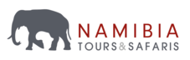

9-Day Zimbabwe Highlights Safari - Luxury - NETT

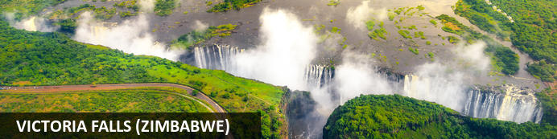
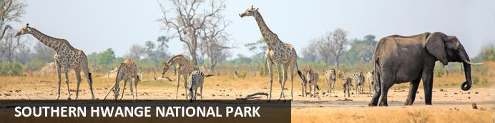
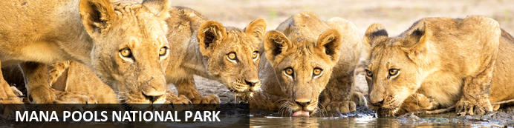

9-Day Zimbabwe Highlights Safari - Luxury - NETT
Victoria Falls (Zimbabwe) - Southern Hwange National Park - Mana Pools National Park
9 Days / 8 Nights
Date of Issue: 13 March 2023

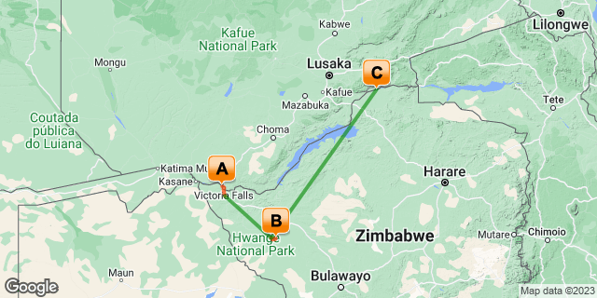

Click here to view your Digital Itinerary

Introduction
The perfect itinerary to visit some of the main highlights in Zimbabwe in just over a week. Including the magnificent Victoria Falls along with Zimbabwe’s most famous game park, Hwange National Park, and Mana Pools National Park, popular for walking safaris. A combination of the wonder of Victoria Falls with incredible wildlife viewing on a big game safari.

Accommodation | Destination | Basis | Duration
Old Drift Lodge | Victoria Falls (Zimbabwe) | FI | 2 Nights
African Bush Camps Somalisa Camp | Southern Hwange National Park | FI | 3 Nights
Nyamatusi Camp | Mana Pools National Park | FI | 3 Nights

Key
B&B: Bed and Breakfast
FI: Fully Inclusive - Bed, All Meals, Fees and Activities

Price
NETT STO COSTS
1st April 2023 – 31st May 2023
2 or more guests - USD 7480 per person sharing
Single supplement - USD 2385
1st June 2023 – 31st October 2023
2 or more guests - USD 9915 per person sharing
Single supplement - USD 2385
Note:
Mana Pools Season - April through October.
** Rates are subject to change
Includes shared road & air transfers starting VFA & ending HRE on a seat rate basis

Included
- Accommodation as indicated – can change depending on availability and request at time of booking
- Meals as indicated
- Activities as indicated
- Shared road transfers as necessary
- Seat on internal flights as indicated
- Tour file with detailed itinerary, map with route descriptions, vouchers etc.
- 24 hour personal and friendly support
- Fast and efficient response to service providers

Excluded
- Items of a personal nature
- Optional extra activities
- International flights
- Holiday or personal insurance
- Staff gratuities
- Park entry fees (for optional extra activities in Victoria Falls)
- Victoria Falls Airport departure tax
- Visas and visa applications

Day 1-3: Old Drift Lodge, Victoria Falls (Zimbabwe)

Victoria Falls (Zimbabwe)
A gazillion tonnes of water thundering over a sheer cliff drowns all other sounds. The swirling mist hides all sign of human activity. Beyond your rain forest sanctuary people are hurling themselves off bridges, across gorges, into walls of raging water and out of aircraft.
Victoria Falls is a paradox of tranquil beauty and exciting adventure.
Mosi-oa-Tunya, 'The Smoke that Thunders' is undoubtedly Zimbabwe's finest and most well-known attraction. It is or rather was (if you're keeping up with the latest list) one of the Seven World Wonders. We still believe it deserves the title. It truly is spectacular and not considered to be one of the world's largest waterfalls without good reason. It's not the widest or the highest , yet it is considered to the largest based on it's combined width, at 1,708 metres wide and height, at 108 metres. Impressively it takes the title for the largest sheet of falling water.

Day Itinerary
- On arrival at Victoria Falls Airport you will be met and transferred to your lodge for the next two nights in the untouched, beautiful surrounds of the Zambezi National Park, only 4.5km upstream from Victoria Falls
Airport Transfer Time: 40 minutes from Victoria Falls Airport
- The remainder of the day can be spent relaxing at your own leisure on arrival or join in for an afternoon activity (if time allows)
- The Zambezi National Park plays host to a wide variety of larger mammals including African elephant, lion, Cape buffalo and leopard. In addition to these charismatic members of the "big 5" there are herds of sable antelope, common eland, common zebra, southern giraffe, greater kudu, waterbuck and impala. In addition, many species of smaller wildlife can be seen here and over 400 species of birds.
- Enjoy any of the many activities on offer. You can discuss your activity schedule with the lodge reception on arrival. You have a full day to explore and enjoy the wonder of the falls and the surrounding National Park
Activites: Morning and afternoon game drives and river safaris, bush walks, guided Tour of the Falls (excluding Entry Fee)

Overnight: Old Drift Lodge View iBrochure
On the banks of the Zambezi River, Old Drift Lodge is an upmarket and luxury safari lodge with spacious elegant tented suites spaced out beneath the bush. Frequented by elephants and other wildlife, here you’re immersed in nature and you’re only 7km from the majestic Victoria Falls.
Old Drift is easily one of the most luxurious options for accommodation on the Zimbabwean side of the falls and since you aren’t in town itself, you will feel as though you are on safari from the moment you arrive. You get here by boat transfer by the way. Great news: at Old Drift you are the closest lodge with the Zambezi National Park to Victoria Falls. You’re just a short way away and your activities are included in your stay.
You have the chance to see elephants, buffalo, sable, eland, giraffe, zebra, waterbuck and impala. Either around your tent, along the river or at the waterhole. It’s serene, beautiful and quiet.
Your tented suite is stylish and modern including all the necessities and the added extras which takes this safari lodge up a notch from the guesthouse or hotel you could have opted for in town. As if the wildlife wasn’t enough of a drawing card? You have an indoor and outdoor shower, an open-air bath with a view and your very own private plunge pool.
With only 10 double suites and 4 family suites it is a small safari lodge and the ideal getaway just down the drag from the bustling town of Victoria Falls. Listen to the river as you soak in your bath on the deck. Enjoy the tranquility and calmness. Revel in the night skies from your star bed. This is the pinnacle of relaxation.
The large wooden deck at the main lodge area is terrific for sundowners, further relaxation and stories around the campfire after a dining experience you won’t forget. Expect fine dining of traditional African flavours. Here the food reflects and celebrates a sense of place, and well, there really is no place like Old Drift.
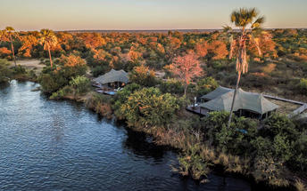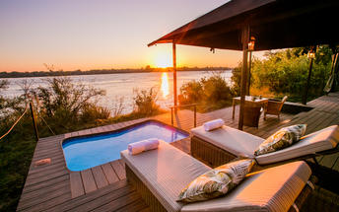

Basis
Fully Inclusive - Bed, All Meals, Fees and Activities
All Drinks (excl Premium Brands) Included

Included
- All meals, selected activities, local drinks, return Victoria Falls/Livingstone airport transfers, conservation levy park fees, town shuttle & laundry

Excluded
- Premium drinks, additional activities, rain forest entry fee

Day 3-6: African Bush Camps Somalisa Camp, Southern Hwange National Park

Southern Hwange National Park
Located in western Zimbabwe, Hwange National Park (formerly Wankie Game Reserve) is the largest natural reserve in the country and is famous for its rich diversity of wildlife. Home to one of the biggest elephant populations in the world, as well as around 100 mammal species, the park is popular among animal lovers. Several protected species inhabit the awe-inspiring open landscapes, including the endangered wild dog, critically endangered black rhino, and rare roan and sable - along with lion, cheetah, and around 500 bird species. Adventurers can look forward to guided bush hikes, game drives, and horse riding safaris, all of which offer excellent photographic opportunities.

Day Itinerary
- After breakfast, enjoy a last activity in Victoria Falls (if time allows). You will be transferred to the airport for your onward internal flight from the Victoria Falls Airport to the Manga Airstrip in Hwange National Park.
Airport Transfer Time: 40 minutes to Victoria Falls Airport
Airstrip Transfer Time: 30 minutes transfer from Manga Airstrip to the camp
- On arrival at the airstrip make your way to your camp in its stunning location tucked away on an acacia island along the edge of an ancient seasonal flood plain, which gives it breathtaking views of the savannah plains of the Kennedy Vlei line. Your transfer from the airstrip is a game drive
- Enjoy the scheduled activities with your lodge guide as included. Activities consist of guided walks, game drives and spot lighting as well as game viewing from hides. Wildlife includes elephant, kudu, sable antelope, zebra, wildebeest, gemsbok, the rare and endangered roan antelope, buffalo, giraffe, white rhino, lion, leopard and hyena amongst others. During the rainy season, the Kennedy Vlei is littered with flamboyant colours from the seasonal wild flowers that emerge as the first rains begin and, as the grass dries out, large herds of buffalo, zebra and elephant are in abundance
Activities: Day & night game drives, walking, bird watching and game viewing from hides

Overnight: African Bush Camps Somalisa Camp View iBrochure
Somalisa Camp, in the heart of Hwange National Park has twice been named Zimbabwe’s Leading Tented Safari Camp in the World Travel Awards (in 2019 and 2020) and it’s no secret why. It’s also the first lodge in Zimbabwe to receive the GOLD Green Tourism Certification.
Elegant in style, organic and natural to emulate the incredible African bush of the surrounds. A mere seven sailcloth tents are found on this private concession in the Hwange National Park, making it intimate, quiet and exclusive. The camp is completely run on solar power and uses a water purity system allowing the camp to recycle up to 80% of its water. It’s an eco-friendly safari stay.
Built by the owner Beks Ndlovu, the camp sits under the dappled shade of the Acacia grove. Right there on a seasonal floodplain. Old world charm meets modern contemporary style. It’s a classic bush camp with an African take on present-time features which give it a unique feel and welcoming atmosphere.
Terra cotta, shades of brown and nudes draw you into the seemingly simple yet entirely understated interior where gold features round it all off. It’s luxurious, spacious and the views are amazing, whether on your private balcony enjoying a drink or relaxing in your copper bath tub after a day out in the bush. It’s spectacular.
From dense teak to acacia forest and open savannah. You can expect a raw and diverse adventure of nature and wildlife. On guided walks and game drives you’ll get to experience it all. Elephant, kudu, sable antelope, zebra, wildebeest, gemsbok, roan antelope, buffalo, giraffe, lion, leopard, hyena and there's more.
From the viewing deck and swimming pool, relax and enjoy as the elephants frequent the waterhole in front of the lodge. A highlight when in camp and that’s on top of the excellent service, delicious cocktails and fine foods.
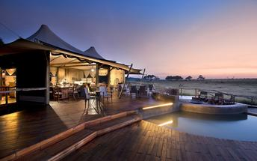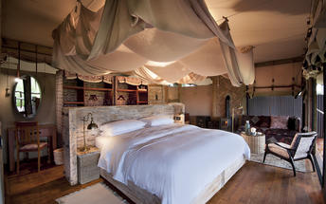

Basis
Fully Inclusive - Bed, All Meals, Fees and Activities
All Drinks (excl Premium Brands) Included

Included
- All meals, local drinks, activities, park fees and laundry

Excluded
- Premium drinks

Day 6-9: Nyamatusi Camp, Mana Pools National Park

Mana Pools National Park
Mana Pools is famous for its walking safaris, canoeing safaris as well as night and day game drives made all the more exciting by the ever-present thrill of getting close to elephants, lions, buffalos, rhinos,cheetahs, leopards, hippos, crocs and much more.
Your guide will be on the lookout for massive elephants following ancient migration paths, lion prides on the hunt, territorial rhinos and grumpy hippos. Birdlife along the river and around the pools is prolific with a low-season count of about 450 birds increasing to 640 in the the dry winter season between March and September - when game viewing is also at its best.

Day Itinerary
- Today you depart Hwange National Park and make your way to your next destination in Mana Pools, flying from one airstrip to another
Airstrip Transfer Times: 30 minutes transfer to Manga Airstrip and 30 minutes from Mana Pools Airstrip to your mobile safari camp
- 2 full days are set aside to enjoy the scheduled activities with your lodge guide as included
- Some of the wildlife you can expect to see is eland antelope, elephant, African wild dogs, water buck, and big herds of buffalo, kudu antelopes, lion and leopard. You will explore a rich abundance of life on the Zambezi River under a sky inhabited by fantastic bird species. Game drives along the flood plain in open 4 x 4 Land cruisers are one of the main highlights, taking you into the core of the wildlife scene that is abounding with a diversity of wildlife. The camp is designed to give you access to the Zambezi river affording you canoeing excursions on the river, fishing either from the banks or off an island in the middle of the Zambezi river. Don’t forget to do a walking safari – a must in these parts
Activities: Morning & afternoon game drives, guided walks (over 16 years of age), canoeing (water level dependent), bird watching and shore fishing on a catch and release basis

Overnight: Nyamatusi Camp View iBrochure
Nyamatusi means “wild game”. A fitting name since this place is about as wild as it gets with an abundance of game. On the banks of the mighty Zambezi River, one of the world’s oldest river systems and set in Mana Pools National Park, a UNESCO World Heritage Site. It doesn’t take much to see that this place is spectacular.
Nyamatusi Camp is an eco-conscious and exclusive camp. It embodies a sustainable design with solar power, all natural materials and blends into the surrounds. It’s low impact on the environment and high impact on awe factor. It’s stunning, both the lodge itself and the surrounds. A never ending green escarpment in the background and the river in all her glory, right there in front of you.
A turquoise door invites you in to your own secluded and private abode. A large viewing deck and plunge pool under the shade of winter thorn trees. The soft drapery not only looks luxurious but aids in keeping your tent cool echoed in the neutral palette and pale shades of grey and green. It’s lush and romantic. Crisp, modern and sleek. Classic with light wooden finishes and elegance in every respect.
The service is impeccable. The food is delicious and the staff are welcoming and ever professional hosts. Is this place even real? I guess you’ll just have to go find out for yourself. Pssst. It is real by the way, even though it’s seemingly unbelievable. We know!

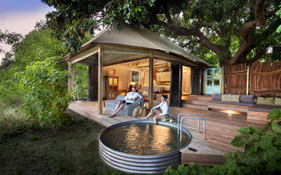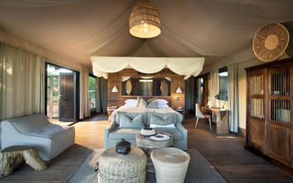

Basis
Fully Inclusive - Bed, All Meals, Fees and Activities
All Drinks (excl Premium Brands) Included

Included
- All meals, local drinks, activities, park fees, conservation levy and laundry

Excluded
- Premium drinks

Day 9: End of Itinerary

Day Itinerary
- After breakfast and a last morning activity (depending on your departure flight time), you will depart back to the Mana Pools Airstrip and take your onward flight ending in Harare
Airstrip Transfer Time: 30 minutes from camp to Mana Pools Airstrip
- Fly out directly from Harare (Robert Gabriel Mugabe International Airport) or spend a night in Harare before catching your onward flight the next day
- End of services

Basis
Bed and Breakfast

Transport

Flight Information
Date | Flight | Airline | Departure Airport | Time | Arrival Airport | Time | Class | Ref
 | Charter Flight |  | Victoria Falls International Airport [VFA] |  | Manga Airstrip
 | Charter Flight |  | Manga Airstrip |  | African Bush Camps Nyamatusi Camp
 | Charter Flight |  | African Bush Camps Nyamatusi Camp |  | Robert Gabriel Mugabe International Airport [HRE]

Transfers
Date | Company | Pick Up | Drop Off | Time | Vehicle
 |  | Victoria Falls International Airport [VFA] | Old Drift Lodge |  | Transfer
 |  | Old Drift Lodge | Victoria Falls International Airport [VFA] |  | Transfer
 |  | Manga Airstrip | African Bush Camps Somalisa Camp |  | Transfer
 |  | African Bush Camps Somalisa Camp | Manga Airstrip |  | Transfer

Urgent Contact Numbers
Company Name | Telephone | Email Address | Contact Person
Namibia Tours & Safaris | +264 64 40 6038 | tanya@namibia-tours-safaris.com | Tanya Coetzee
Namibia Tours & Safaris - Emergency Contact | +264 81 784 4315

Service Provider Directory
Service Provider | Ref. Number | Telephone | Address
African Bush Camps Nyamatusi Camp |  | +27 21 701 0270
African Bush Camps Somalisa Camp |  | +27 21 701 0270
Old Drift Lodge |  | +263832844571

Terms and Conditions

Namibia Tours & Safaris Terms and Conditions
Contract
1.1 The contract will become effective as from the date the invoice is completed and the deposit, referred to in Clause 2.1, is received by Africa Tours & Safaris CC (hereinafter known as the Company).
1.2 The contract is subject to the Namibian Law.
1.3 Any person making a reservation as per Clause 8.4 accepts the terms and conditions of this agreement set out hereunder.
How to Book
2.1 A 20% deposit of the full amount due is required to confirm any reservation and is to be done by the agent or client (see Clause 8.1) in writing or by e-mail.
2.2 The Company must receive the balance of the contract price no later than 42 days (6 weeks) prior to departure.
2.3 If the Company does not receive the full contract price 42 days (6 weeks) before the departure date, the Company may cancel the reservation and retain whatever deposit or other funds it has already received from the client or his agent.
How to Pay
3 The payment options will be provided upon confirmation of a booking.
Our Cancellation Policy
4.1 Any cancellation of a confirmed booking must be done in writing (email) to the Company whereupon cancellation charges as per Clause 4.2 will apply.
4.2 The following cancellation fees (as a percentage of the fully quoted price) are applicable to any cancelled travel:
Notice from date of travel: Cancellation fee:
42 days or more 20% (deposit forfeited)
29 – 41 days 50%
15 – 28 days 75%
0 – 14 days 100%
Please note: the notice period is calculated from the date of cancellation to the start date of the tour/safari booking.
4.3 No refund will be made by the Company if, for any reason, inclusions or parts of the tour cannot be carried out / or utilised. These would include all facets such as meals, game drives, accommodation etc. This would also apply to any client who has booked a tour but fails to undertake the tour for any reason.
Our Changes Policy
5 If a booking is changed to an earlier date than originally reserved, the Company will endeavour to change it. If the booking is for a later date, charges as per Clause 4.2 could apply.
As things go, we've all had to adapt to changes during the Coronavirus pandemic and so too have we therefore amended our terms and conditions for travel during such times. Check out the Updated COVID Terms and Conditions here.
Price Changes
6.1 The Company reserves the right to increase the price of any tour prior to departure due to factors beyond the control of the Company, such as, without being limited to, and increase in fuel prices, new Government legislation, accommodation price increases, fluctuations in exchange rates, etc.
6.2 If the Company announces an in increase in the tour price in terms of this Clause, such addition amount must be paid to the Company before the departure of such tour or else the Company shall have the right to cancel the tour and the charges in Clause 4.2 will apply.
Changes to Itineraries
7 The Company shall at any time have the right, in its entire discretion, to alter the terms of the booking in relation to the route, timetable, itinerary and accommodation. The Company shall, however, make every effort to offer the client an alternative tour of a comparable standard.
Should the alternative be of a lesser standard, the client will be refunded the difference, but should there be an increase, the client shall have the right to either reject the alternative and obtain a refund of the relevant portion of the original contract sum, or to accept the alternative and pay the increased cost. In the event of the client rejecting the alternative tour and claiming a refund, such rejection will be treated as a cancellation and the refund will be calculated according to Clause 4.2 hereof. The client shall have no claim against the Company for any damages arising out of the alternative booking.
Responsibility and Liability
8.1 Neither the Company nor any person acting for through and on behalf of the Company shall be liable for any loss or damage whatsoever arising from any cause whatsoever and without restricting the generality of the aforegoing shall particularly not be responsible for the loss or damage arising from any errors or omissions contained in its brochure or other literature, late or non-confirmation or acceptance or bookings, loss or damage caused by delays, sickness, injury or death, whether occasioned by negligence or not.
8.2 The Company shall have the right at any time at is sole discretion, to cancel or the remainder thereof or to make an alteration in the route, accommodation price or other details. This would include any event of any tour being rendered impossible, illegal or inadvisable by weather, avalanches, strike, war, government or other interference or due to any other cause whatsoever. The extra expenses incurred as a result thereof shall be the responsibility of the client.
8.3 The Company may at its discretion and without liability or cost to itself at any time cancel, or terminate, a client's booking and in particular, without limiting the generality of the aforegoing, it shall be entitled to do so in the event of illness or the illegal or incompatible behaviour of any client undertaking the tour, who shall in such circumstances not be entitled to any refund.
8.4 Any person making a reservation with the Company (refer to Clause 1.1) warrants that her or she has the necessary authority to enter into this contract on behalf of the person or persons included in such a booking. The person making the reservation shall be liable for the total amount due to the Company.
Client's Obligations
9.1 It is the onus and responsibility of the client to obtain the necessary comprehensive insurance before departure for any possible cancellations, medical expenses, protection or personal property and money.
9.2 The onus is upon the client to ensure that passports and visas are valid for the duration of the safari. The Company cannot be held liable for any necessary visas or other travel documents not held by clients. In the event of a client not having the necessary documentation to enter any area or country the Company shall reserve the right to leave the client a the point of entry of such area or country. In such an event, the Company will not be held responsible to the client for further travel arrangements.
9.3 The onus is upon the client to ensure that the SARS-CoV-2 PCR tests are done prior to commencement of the safari and valid on arrival in accordance to the requirements of the country of intended travel and for the airline with which the client will travel. The same applies for any necessary testing for departure. The costs of any such COVID testing will be for the clients own account. While The Company can assist with arrangements for testing in-country, The Company will not be held responsible to the client for such arrangements and with regards to return time of test results.
9.4 Should the client need to undergo mandatory quarantine once in-country with regards to the SARS-CoV-2 virus, either on arrival as called for by the authorities or due to testing positive once in-country, this will be at the clients own expense.
Health and Personal Safety
10.1 The client shall be reasonably fit to undertake the tour.
10.2 Anti-malaria precautions should be commenced prior to tour departure. A medical doctor should be consulted for advice.
10.3 Tours offered by the Company cover a wide spectrum of the African wilds and neither the Company, its employees or agents can be held responsible for any injury or other related incidents whilst on the tour / safari.
10.4 The Company cannot be held responsible for any client who falls ill or contracts the SARS-CoV-2 virus while in-country. The client accepts that travel is at own risk.
Baggage
11.1 Clients are limited to one soft sports type bag per person with a maximum weight of 20 kilograms. This includes photographic equipment and hand luggage.
11.2 Due to the rugged terrain, the Company cannot be held responsible for damage or loss of any personal items including bags, contents of bags or photographic and related equipment. Due to extremely dusty conditions, please ensure all bags are dust proof.
Airline and Car Hire Clause
12.1 The Company will act as the agent of the client when booking the client with a car hire company, an airline or air charter service. The client therefore contracts with the car hire company, airline or charter service and not with the Company.
12.2 Charter flights are normally operated by smaller type aircraft such as Cessna 210. Luggage is strictly limited to 10-15 kgs (depending on terms of particular airline used) per person in soft hold all type bags. Due to the desert heat, it is not safe to overload aircraft thus this limit needs to be strictly controlled.
Travelling or thinking of travelling during the COVID-19 pandemic? Take a look at our COVID Terms and Conditions for more information on how this will work and differ from our standard terms and conditions as listed above.

