**Mount Meru - Advanced**

At 14,980ft (4566m), Mount Meru is the second-highest peak in Tanzania. It’s a fine trekking experience in its own right, as well as a good way to acclimatize before conquering [Mount Kilimanjaro](https://www.worldnomads.com/explore/africa/tanzania/climbing-mt-kilimanjaro-or-attempting-to).

Located in Arusha National Park, around 50 miles (80km) west of Kili, Mt Meru is a challenging ascent that’s best completed over three to four days. Lower down, on the surrounding slopes, you have a good chance of seeing giraffes, elephants, buffalo, and warthogs, with the volcanic landscapes becoming more dramatic as you climb higher. Accommodation comes in the form of mountain huts along the trail.

Hitting the summit for sunrise is rewarded with unforgettable views of Mount Kilimanjaro and the Mount Meru Crater

*Only a Mt Meru trek allows you to experience Arusha National Park in such an immersive way: trekking a volcano; capturing breathtaking scenery; and interacting with Africa’s incredible wildlife. You stay in rustic huts and can do this in 4 days instead of 8 days doing Kilimanjaro, camping!*

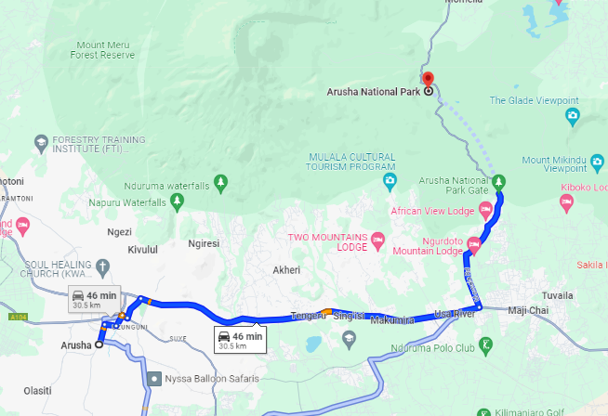

<https://www.climbkilimanjaroguide.com/climb-mount-meru/>

<https://www.tranquilkilimanjaro.com/places/miriakamba-huts-camp/>

**8 day Lemosho Kilimanjaro** trek:https://www.tranquilkilimanjaro.com/lemosho-route/