# [BARAZA RESORT & SPA](https://wetu.com/iBrochure/en/Home/30789_20454/baraza_resort_spa)

# **Zanzibar's all-inclusive luxury resort**

Discover a sense of wonder at the Baraza Resort and Spa, a 5 star all-inclusive boutique resort in Zanzibar. The resort  
was voted as one of the 60 best new hotels in the world by Condé Nast Traveller, a prestigious world wide travel magazine.

The resort is located along the Bwejuu-Paje beach in Zanzibar with spectacular views of the Indian Ocean. With just 30 villas, this stunning resort  
evokes the heritage of Zanzibar dating back to the era of the Omani Sultans. A fusion of Arabic, Swahili and Indian design, with Swahili arches,  
intricate hand carved décor, beautiful antiques, handmade furniture and intricate brass lanterns; Baraza offers unparalleled  
standards of luxury on the Island of Zanzibar.

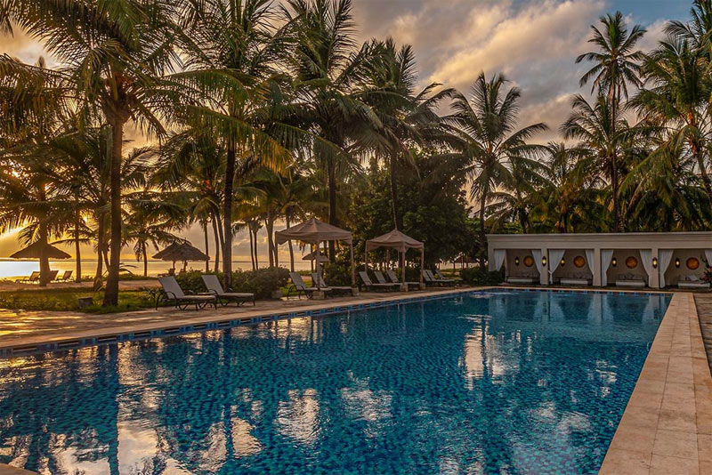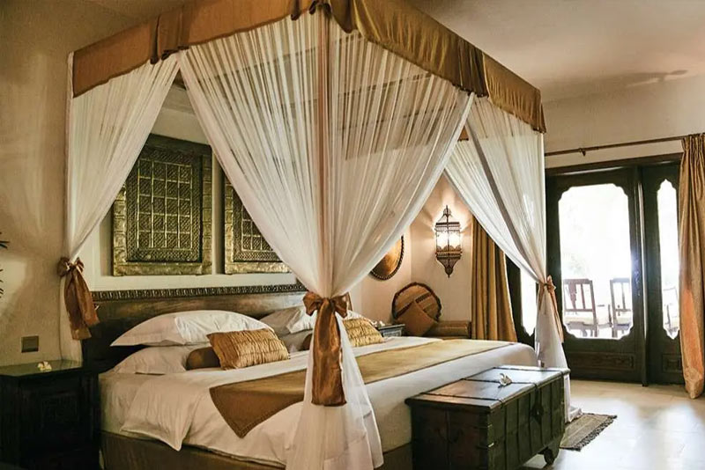Simply drift away to sleep lulled by the sounds of the ocean and wake up each morning reinvigorated by the gentle breeze.

Alternatively, if you are on more of a budget and don’t want an all-inclusive, there are some very nice beach hotels in Zanzibar!