GARDEN ROUTE SPLENDOUR

The Garden Route begins a few hours outside of Cape Town and is one of the most beautiful stretches of coastline. It is a wildly popular route, that consists of a series of towns that each offer diverse and unique experiences, some favorited and others, off-the-beaten track.

The Garden Route Splendour package is a collection of all the experiences that make this region celebrated. You will follow the path from Cape Town, through the ostrich capital of the world, Oudtshoorn, also home to the Cango Caves, and then enjoy the splendour of Knysna and the Tsitsikamma. A world of natural wonder beckons.

DATE | ROUTING
DAY 1 - Monday | CAPE TOWN – OUDTSHOORN
DAY 2 - Tuesday | OUDTSHOORN
DAY 3 - Wednesday | OUDTSHOORN - KNYSNA
DAY 4 - Thursday | KNYSNA
DAY 5 - Friday | KNYSNA - TSITSIKAMMA
DAY 6 - Saturday | TSITSIKAMMA – GQEBERHA (PORT ELIZABETH)
 | END OF TOUR

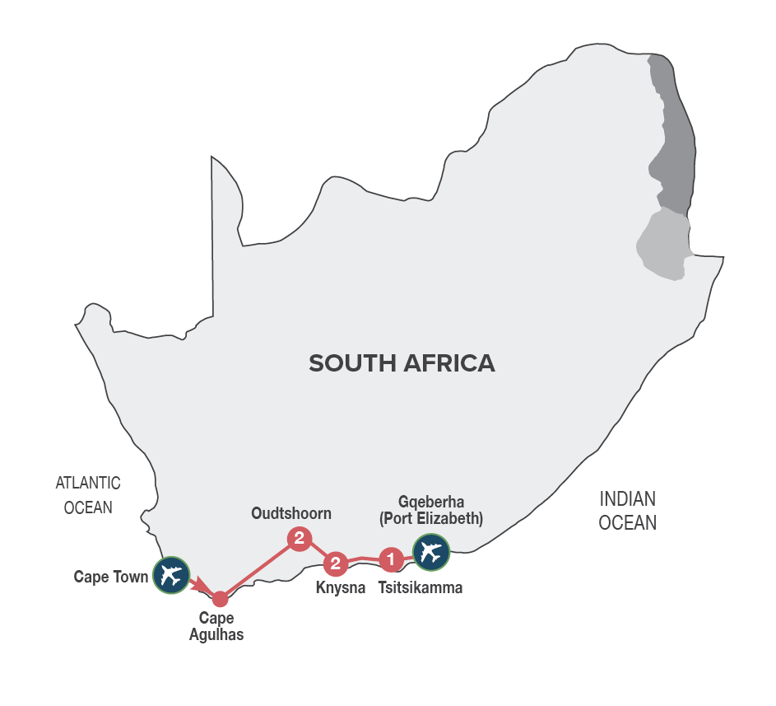
Small Group Tour
Minimum 2 guests / Maximum 10 guests

DURATION
6 days/5 nights

ROUTING
CAPE TOWN – GQEBERHA (PORT ELIZABETH)

INCLUDES
- 7 Meals: 5 breakfasts, 1 lunch, 1 dinner including gratuities
- 5 Nights’ accommodation including porterage
- Transportation including toll fees in air-conditioned vehicles
- Services of a professional English-speaking tour guide
- Entrance fees as specified in the itinerary
- Bottled water in eco-friendly packaging
TOUR HIGHLIGHTS
- Visit Dassiesfontein, a farmstall packed with locally produced products from the Overberg region
- Visit to Cape Agulhas (the southernmost tip of Africa)
- Travel via the scenic Tradouw Pass
- Sample top quality Port style wines in Calitzdorp, a town well known for its fortified wines
- Guided tour of the Cango Caves, a wine tasting in the scenic Schoemanshoek Valley, guided tour of a working ostrich farm in Oudtshoorn
- Immersive journey into the mythical Knysna Forests, discovering the legends build around woodcutters, elephants, steam trains and gold miners
- Visit to Monkeyland Primate Sanctuary & Birds of Eden Sanctuary in Plettenberg Bay
- Visit to Tsitsikamma National Park and scenic Storms River Mouth
- Enjoy carefully chosen MAKE TRAVEL MATTER® Experiences that positively impact our travellers and the communities we visit
- Meals included in this trip support sustainable food production with at least 30% of the food on the menu being sourced locally (within 50-80km) of where it’s prepared

SELECTED DEPARTURE DATES
 | Jan24 | Feb24 | Mar24 | Apr24 | May24 | Jun24 | Jul24 | Aug24 | Sep24 | Oct24 | Nov24 | Dec24
English | 1;15;29 | 5;12;19;26 | 4;11;18;25 | 1;8 | 6;20 | 10 | 1;15 | 5;19;26 | 2;16;23 | 7;14;21;28 | 4;11;18;25 | 2

RACK RATES valid 01/01/24-30/04/24 & 01/10/24-31/12/24
R 20 530.00 per person sharing twin/double accommodation
R 22 990.00 per single person

RACK RATES valid 01/05/24-30/09/24
R 19 975.00 per person sharing twin/double accommodation
R 22 335.00 per single person

Accommodation included:
4* La Plume Guest House or similar x 2 nights
4* Rex Hotel or similar x 2 nights
3* Tsitsikamma Village Inn or similar x 1 night

Transportation:
Transportation is in air-conditioned touring vehicles appropriate to the requirements of the tour
- 2 guests will travel in a sedan vehicle
- 3-10 guests will travel in a 13-seater vehicle

DAY 1 – MONDAY CAPE TOWN – CAPE AGULHAS - OUDTSHOORN
This morning you will be met by your local tour guide and depart for the scenic Garden Route. Travel along Sir Lowry’s Pass, with its magnificent views, to Grabouw and Elgin, a lush landscape surrounded by majestic mountains. Stop en route at a farmstall packed with locally produced products from the area. Our journey continues to Cape Agulhas, the southernmost tip of Africa, where the Atlantic and Indian Oceans meet. The area has largely been untouched and unexplored with its rugged coastline being the graveyard for many a ship. The historic Cape Agulhas Lighthouse is considered the icon that signifies the tip of Africa. After this thrilling experience, we continue via historic Swellendam and the Tradouw Pass to Barrydale and the famous Route 62. Sample top quality port style wines in Calitzdorp, before continuing to Oudtshoorn, the ‘ostrich feather capital’ and centre of the world’s Ostrich farming industry. Overnight in Oudtshoorn. Enjoy dinner at an Ostrich Farm, dining on local specialities such as Ostrich Steak. [Dinner]
Distance travelled today: 550 kms

DAY 2 – TUESDAY OUDTSHOORN
After a leisurely breakfast take a tour of the spectacular limestone caverns of the Cango Caves, one of the world’s great natural wonders, sculpted by nature through the ages. Afterwards enjoy a wine tasting at a local wine estate in the scenic Schoemanshoek Valley. Return to Oudtshoorn for a fun filled interactive guided tour at a working Ostrich Farm.
Overnight in Oudtshoorn. [Breakfast]
Distance travelled today: 90 kms

DAY 3 – WEDNESDAY OUDTSHOORN - KNYSNA
After breakfast, travel over the Outeniqua Pass to George, the sixth oldest town in South Africa, with many historical landmarks like the Slave Tree and King Edward VII Library building; said to be the best example of Edwardian architecture in the town. The tour travels via Wilderness, an attractive holiday resort, to Knysna, known as the oyster box of South Africa, nestling on the banks of a beautiful lagoon in the heart of the Garden Route. Journey into the magical Knysna Forests (weather & road conditions dependent), the stamping ground of the elusive Knysna elephants. Discover the stories of the woodcutters who worked the forests, the elephants that were hunted to extinction and the discovery of gold. Visit the Dalene Matthee Big Tree Memorial. The enormous Yellowwood tree of over 880 years was named after Matthee, best known author of four books on the Knysna Forest. Enjoy a delicious lunch en route of traditional cuisine and local treats. Overnight in Knysna. [Breakfast & Lunch]
Distance travelled today: 170 kms

DAY 4 – THURSDAY KNYSNA
Today you’ll have the opportunity to further explore the natural beauty of the Garden Route. Visit Monkeyland Primate Sanctuary, where you will be able to see a variety of primates, roaming free in the forest. This award-winning sanctuary is well known for its efforts to rehabilitate and free previously caged primates. A portion of the trip price of this MAKE TRAVEL MATTER® Experience, goes towards ensuring that these already endangered species can survive and reproduce for a future reintroduction into the wild. The experience directly advances UN Global Goal 15: Life on Land. The tour continues to the famous Eastern Head, where you will enjoy spectacular views of the Knysna Heads (weather permitting). Afterwards you’ll travel to Brenton on Sea, a breath-taking holiday location and a nature lover’s paradise with its unspoilt beaches and peaceful surroundings. The remainder of the afternoon will be at leisure. Overnight in Knysna. [Breakfast]
Distance travelled today: 110 kms

DAY 5 – FRIDAY KNYSNA - TSITSIKAMMA
Travel to Plettenberg Bay, considered the jewel of the Garden Route, for a visit to the Birds of Eden sanctuary, the biggest single free flight aviary in the world. The sanctuary was developed to create a safe environment in which to release a large collection of free-flight African birds. A portion of the trip price of this MAKE TRAVEL MATTER® Experience goes towards protecting genetically pure species of various Taxa in a semi-wild state and to hold the seeds of these Taxa for future reintroduction into the wild. The experience directly advances UN Global Goal 15: Life on Land. Our journey continues to Bloukrans Bridge, currently offering the highest commercially operated Bungy Jump in the world. Visit the Tsitsikamma National Park and Storms River Mouth (weather permitting). The Tsitsikamma National Park incorporates 80 km of rocky coastline with spectacular sea and landscapes, a remote mountainous region with secluded valleys covered in mountain Fynbos and temperate high forests with deep river gorges leading down to the sea. Overnight in the Tsitsikamma area. [Breakfast]
Distance travelled today: 100 kms

DAY 6 – SATURDAY TSITSIKAMMA – GQEBERHA (PORT ELIZABETH)
Head eastwards along the Tsitsikamma Forest to Gqeberha (Port Elizabeth), affectionately known as the “friendly city”. Enjoy a city orientation tour of Gqeberha (Port Elizabeth), where the tour ends on arrival.
Guests may disembark, on request, at Chief Dawid Stuurman Airport. [Breakfast]
Distance travelled today: 185 kms

