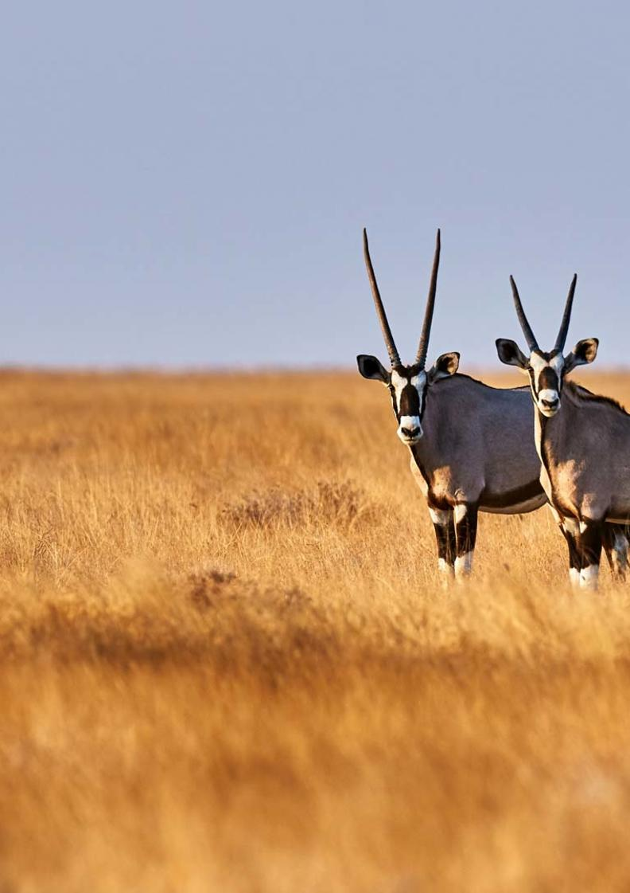


19-Day Ultimate Namibia Self-drive Safari - Luxury - RACK

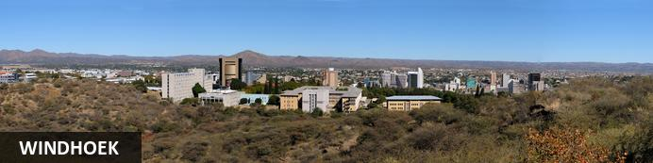
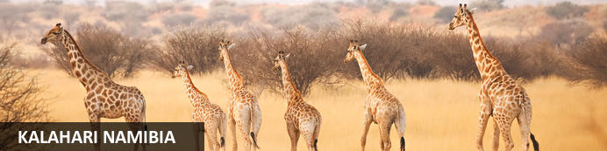
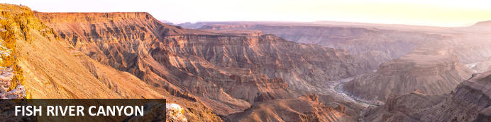
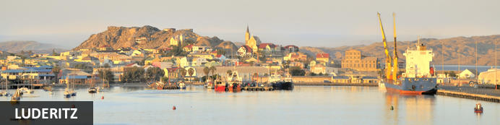
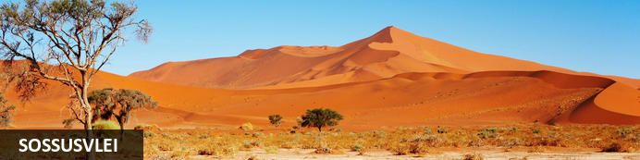
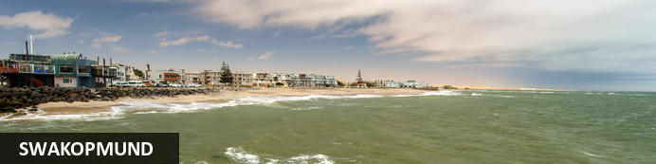
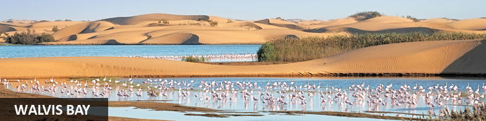
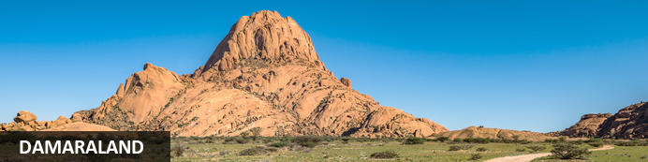
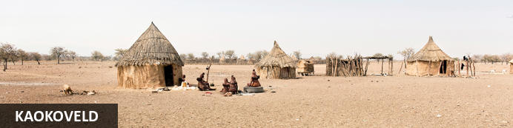
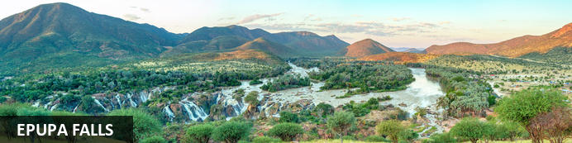
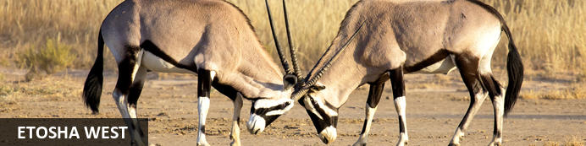
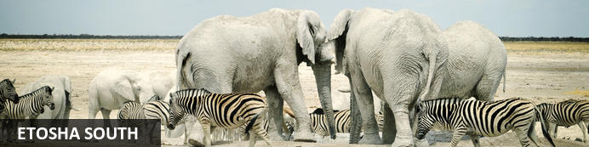
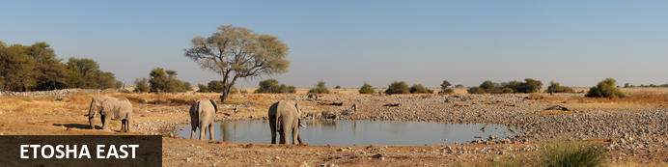
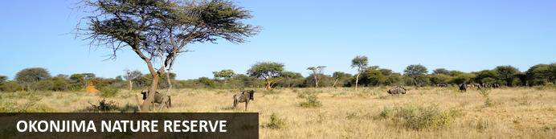

19-Day Ultimate Namibia Self-drive Safari - Luxury - RACK
Windhoek - Kalahari Namibia - Fish River Canyon - Luderitz - Sossusvlei - Swakopmund - Walvis Bay - Damaraland - Kaokoveld - Epupa Falls - Etosha West - Etosha South - Etosha East - Okonjima Nature Reserve
19 Days / 18 Nights
Date of Issue: 05 August 2022

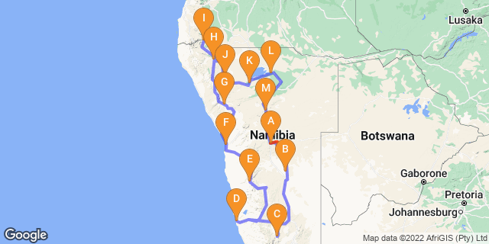

Click here to view your Digital Itinerary

Introduction
The best of Namibia in a 19-Day Ultimate Namibia Safari starting and ending in Windhoek that includes the highlights of Namibia: The Kalahari; Fish River Canyon; Lüderitz; Sossusvlei, with its great sand sea; the seaside towns of Swakopmund and the Skeleton Coast; Damaraland, with its fascinating rock formations, Bushman rock art and desert-adapted wildlife; Kaokoland, the last frontier of true wilderness and the realm of the nomadic Himba people; and Etosha National Park - one of Africa's great game parks.

Accommodation | Destination | Basis | Duration
The Weinberg Windhoek | Windhoek | B&B | 1 Night
Zebra Kalahari Lodge | Kalahari Namibia | D,B&B | 1 Night
Fish River Lodge | Fish River Canyon | D,B&B | 1 Night
Luderitz Nest Hotel | Luderitz | B&B | 2 Nights
Namib Outpost | Sossusvlei | D,B&B | 2 Nights
Strand Hotel Swakopmund | Swakopmund | B&B | 2 Nights
Mowani Mountain Camp | Damaraland | D,B&B | 1 Night
Opuwo Country Lodge | Kaokoveld | D,B&B | 1 Night
Omarunga Epupa-Falls Camp | Epupa Falls | D,B&B | 2 Nights
Dolomite Camp | Etosha West | B&B | 1 Night
Ongava Lodge | Etosha South | D,B&B | 1 Night
Mushara Outpost | Etosha East | D,B&B | 2 Nights
Okonjima Luxury Bush Camp | Okonjima Nature Reserve | FI | 1 Night

Key
B&B: Bed and Breakfast
D,B&B: Dinner, Bed and Breakfast
FI: Fully Inclusive - Bed, All Meals, Fees and Activities

Price
1st January – 30th June 2023 – Low Season
2 guests - ZAR 95 640 per person sharing
4 guests - ZAR 83 885 per person sharing
Single supplement - ZAR 28 095
1st July – 31st December 2023 – High Season
2 guests - ZAR 105 925 per person sharing
4 guests - ZAR 92 890 per person sharing
Single supplement - ZAR 31 185

Included
- Accommodation as indicated - can change depending on availability and request at time of booking
- Meals as indicated
- Meet and greet upon arrival
- Car hire: 4X4 Toyota Fortuner – Zero Excess
- Airport transfers on arrival and for departure
- Activities as indicated
- Tour file with detailed itinerary, map with route descriptions, vouchers etc.
- 24 hour personal and friendly support
- Fast and efficient response to service providers

Excluded
- Items of a personal nature
- Optional extra activities
- International flights
- Holiday or personal insurance
- Staff gratuities
- Park entry fees
- Fuel for vehicle rental
- Visas and visa applications

Day 1: The Weinberg Windhoek, Windhoek

Windhoek
Surrounded by the stubble-covered Auas Mountains and the endless Khomas Hochland, Windhoek lies in a long valley fed by ancient hot springs in the central highlands. Namibia’s capital and bustling city. More often than not, the start or end place of your Namibia safari.
In Windhoek there are many interesting historical buildings, museums, galleries and craft shops. The city has several good restaurants and modern shops and services making it an excellent base camp from which to launch your Namibian adventure.

Day Itinerary
- You will be met by the car rental company representative on arrival and transferred to their offices in Windhoek to complete all rental procedures
- You will then meet with our representative to hand over your travel documents
- The remainder of the day can be spent relaxing at your own leisure
- For dinner tonight, you can head into town for a bite to eat at one of Windhoek's well known restaurants

Overnight: The Weinberg Windhoek View iBrochure
If you can imagine yourself in a fine countryside manor house overlooking orchards and then at the same time imagine you are in an urban chic, modern hotel, then you could see yourself at The Weinberg Windhoek for sure. Cape Town meets Stellenbosch in central residential Windhoek.
Previously named, Am Weinberg Boutique Hotel, this elegant 41-room hotel is built around a heritage building. It offers contemporary amenities with a touch of class and sophistication without being presumptuous. They've perfected the balance between lavish and homely, unpretentious, yet certainly gives you a feeling of being in the presence of the upper elite.
From colours, textures and materials used, the well thought out décor makes you feel right at home, if the home is that of your wealthy, but down to earth aunt and uncle perhaps. Nothing is out of place and be assured every fine detail has been thought out to ensure a top class stay.
Colonial meets modern, fine country living and 21st century all in one, in harmony. Add great service, multiple dining options, roof–top terrace and world class spa and you find yourself in one of the best up and coming places to stay in Windhoek, without actually feeling as though you are in the capital city at all.
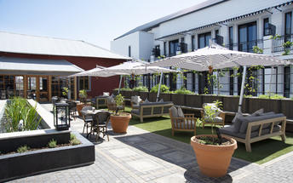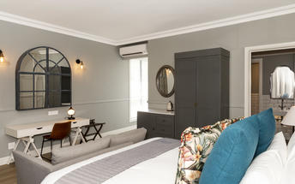

Meet and Greet
NTS Car Hire -Toyota Fortuner SUV Self-Drive
4x4 Toyota Fortuner
Adventure and luxury combine in this comfortable 4-wheel drive vehicle. This is the way to do a self-drive if you ask us. A lifestyle vehicle with the same "off road" performance as other 4x4's without feeling all the bumps along the way. Travel in style.
Includes:
GPS, ZERO excess - maximum insurance, tyre & windscreen cover, unlimited mileage, 2nd spare tyre, additional driver, cell phone with local sim

Basis
Bed and Breakfast

Day 2: Zebra Kalahari Lodge, Kalahari Namibia

Kalahari Namibia
The Kalahari is a vast basin of semi-arid plains, dry savannah and moist woodland. Welcome to wide open spaces and ochre red sands.
In the southern Kalahari, attractions are few and very far between and that in itself is one of the major attractions of this endless land. Large camel-thorns and shepherd's trees dot the grassy plains and your field of vision may well cross a time zone with enormous skies and a chirrupy silence your only companions.
The semi-arid plains and dunes support diverse and fascinating plants, birds and animals that have adapted to life in a virtually water-free world. The gemsbok can go for months on end without water and have special blood-cooling systems at the base of their brains. The camel thorn is a large and hardy acacia tree that thrives in sandy soils thanks to a taproot that can extend to three times the tree's height.

Day Itinerary
Windhoek – Kalahari 245km - approximately 3 to 4 hours
- After breakfast, you can still pop into town for anything you might need and then depart heading south from Windhoek to the red sand dunes of the Kalahari
- Spend the remainder of the day at leisure in this beautiful setting
- Optional activities here include game and nature drives as well as a Bushman experience

Overnight: Zebra Kalahari Lodge
Experience the aching beauty and serenity of the Kalahari at the Zebra Kalahari Lodge in southern Namibia.
The neutral tones of the lodge and chalet buildings contrast quite spectacularly with the deep red sand of the Kalahari. Tucked away in the Intu Afrika Game Reserve in southern Namibia, each room at the Zebra Kalahari Lodge is spacious and has a seating area inside the room as well as outside on the porch which, on a clear day, you can see for miles from in all directions.
The main lodge and dining area overlooks a waterhole, a popular stop for antelope like springbok, gnu and giraffe, not to mention all the birds. A pool and massage room add a little something extra to this lodge although if you plan on treating yourself to a massage, you should make this clear when you make a reservation so that you are assured that the massage therapist is there.
The walks into the wilderness with San bushman get rave reviews from guests especially because this area, although classified as a semi-dessert, has a beauty which leaves a mark on your mind which is difficult to erase.
If you don't have a 4-wheel drive vehicle, getting to the lodge can be quite tricky with deep sand between the gate and the lodge.
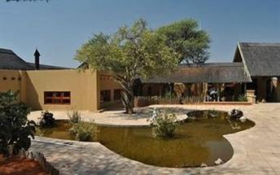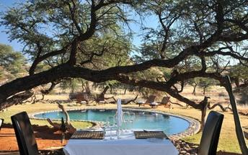

Basis
Dinner, Bed and Breakfast

Day 3: Fish River Lodge, Fish River Canyon

Fish River Canyon
The major attraction in the southern-most reaches of Namibia is the Fish River Canyon. One of the largest in the world, the canyon proper is about 60km long, up to 8km wide, and 550m at its deepest.
The ephemeral Fish River - one of a handful that rise in Namibia - began its work creating the canyon in about 170 million years ago when tectonic rumblings increased the gradient of the river.All around the canyon, the land rises and falls in gentle undulations marked by dramatic inselbergs. Hardy wildlife thrives in the unspoilt wilderness of two adjacent nature reserves: Fish River Canyon National Park and the privately-owned Gondwana Cañon Park.

Day Itinerary
Kalahari – Fish River Canyon 480km - approximately 7 to 8 hours
- Head south via Mariental and Keetmanshoop to the Karas region, the Fish River Canyon area
- Detour en-route to Giant’s Playground and Quiver Tree Forest, a beautiful site where large aloes grow between rocks
- Enjoy the view from the lodge at sunset to end the day

Overnight: Fish River Lodge View iBrochure
Quite literally on the edge of the world, the Fish River Lodge is perched on the edge of the Fish River Canyon in southern Namibia, west of Keetmanshoop and far, far away from anything you've ever seen before.
The buildings are contemporary in design using glass, wood and stone in order to blend in to the surroundings, making sure that the canyon stays the centre of attention. Each chalet has uninterrupted views over the landscape through floor to ceiling windows, so that you can enjoy the view right from your bed.
En-suite bathrooms facilities include an outdoor shower and for warm evenings you can take in the night sky as it should be, free of light and air pollution, blanketed with stars - from an outdoor lounger or on cooler nights, from inside through the windows in the roof.
This is the place you come to if you want to relax and reconnect with nature. There isn't much to do other than marvel at the view or for those who are a bit more energetic, walks into the canyon will open your eyes to the unique plant and animal life which have adapted to these harsh conditions. Scenic drives are offered by the lodge in the late afternoon so that you can watch the sunset over the canyon, marvelling at the colours which this time of day brings.
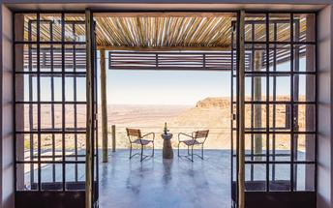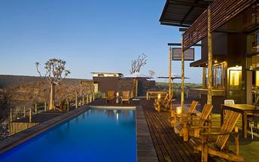

Basis
Dinner, Bed and Breakfast

Day 4-6: Luderitz Nest Hotel, Luderitz

Luderitz
Luderitz is a harbour town on the Atlantic Coast in Namibia with 25,000 inhabitants. Born out of necessity in 1487 when Bartolomeu Diaz sailed his little flotilla into the natural bay it now boasts German history, excursions to Kolmanskop Ghost Town and off-shore activities.
Visit the abandoned Kolmanskop Ghost Town. An eerie feeling as you walk through deserted houses now filled with sand. Explore the old diamond mines and restricted areas of Pamona and Bogenfels rock arch. Be on the look out for crystallised stones known as the "Desert Rose". Go to Diaz Point. See the lighthouse or go on a boat cruise of the seas to explore the harbour. Search for the desert horses of Aus. The last true herd of feral horses in Africa.

Day Itinerary
Fish River Canyon – Lüderitz 385km - approximately 5 to 6 hours
- Enjoy a morning canyon view before heading west through harsh but beautiful terrain which changes to wide open desert plains as you make your way to the coast
- Your drive will take you via Aus, where you may be lucky to view the wild desert horses in the area
- 1 full day is set aside to enjoy the historic town of Lüderitz and visit the amazing Kolmanskop Ghost Town
- Lunches and dinners can be enjoyed at any of the local restaurants in town

Overnight: Luderitz Nest Hotel View iBrochure
With the best seat in the house, Lüderitz Nest is the town's best hotel to boot. It sits on a peninsula that juts into the bay and every room has a spectacular sea view.
The rooms are comfortable and modern with custom-made fittings, en suite bathrooms, air conditioning, heated towel rails, satellite TV and the usual hotel extras like tea and coffee, direct dial telephones. The decor is basic but as they say "less is more" and here, since the refurb, we'll tell you that less definitely is more indeed. Simple and unsophisticated, which really is fine, since you could not be better located or have better views.
The restaurant, quite rightly, places an emphasis on fresh seafood, plucked from the shores beneath your very room. The terrace outside has an oyster bar beside a large pool and lush garden - all facing the sea of course. A sauna - with sea view - provides complete respite from the chilled wind that blows in from the Antarctic.
In front of the hotel is a private beach that is safe for swimming, if you don't mind the cold water and the town and surrounds of Lüderitz provide plenty of daytime interest. A pleasant diversion while you work up an appetite for your next dinner.
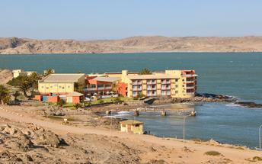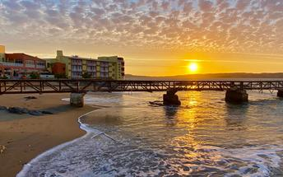

Basis
Bed and Breakfast

Day 6-8: Namib Outpost, Sossusvlei

Sossusvlei
Star dunes with up to five crests rise 300m into the air and rank among the biggest in the world; the dune valleys are marked by vast clay pans where the Tsauchab River gave up its fight to reach the sea more than 60,000 years ago.
Besides the dunes and pans of Sossusvlei and Sesriem Canyon, a sideshow of activities and sights has developed around the region and there are plenty of game lodges that provide additional desert-adapted activities.Plants and birds are the dominant life form in this dessicated realm and they support a tiny world of mammals, reptiles and insects that, in the absence of coastal fog, seldom wander far from the rivercourse and its pans.

Day Itinerary
Lüderitz – Sossusvlei 505km - approximately 7 to 8 hours
- After breakfast, you will depart to the "sea of sand" backtracking to Aus and then heading north via Helmeringhausen
- Wake up early for breakfast (Day 7) and then head to the entrance to Sossusvlei, the Sesriem Gate
- Spend the whole day in the beautiful Sossusvlei area, exploring the highlights: Sossusvlei, Dead Vlei, Dune 45, Big Daddy, Elim Dune and the Sesriem Canyon
- Return to the lodge for lunch or arrange a lunch pack to enjoy in the dunes and return late afternoon for a well-earned rest
- Optional extra activities: Guided Sossusvlei excursion, Hot air balloon safari, Nature drives

Overnight: Namib Outpost View iBrochure
Namib Outpost, once Desert Homestead Outpost, is an upmarket, upscale, up-everything version of the Desert Homestead Lodge in the Namib Desert 30km from the entrance to Sossusvlei.
The main lodge appears to be have been carved out of the desert rather than built atop it so natural are the materials and so sensitive the architecture. At the base of a rocky mountain, Namib Outpost looks out across what must be one of the most spellbinding views on Earth: an uninterrupted panorama so vast it beggars belief, no hint of human habitation and an ever-shifting spectrum of blondes, browns, yellows and reds framed by a mountain range of Marsian hues topped with a deep blue sky only the world’s oldest desert can produce. Words are an insult; we suggest you witness it yourself.
Twelve huge stone-walled, thatch-roofed, canvas-sided suites line the mountain base, spaced far apart and angled just right for you to enjoy the view as if it were yours and yours alone through the floor-to-ceiling windows or your shaded balcony. The décor is understated and elegant, the en suite bathroom is huge with a double-volume shower and twin basins. An outside stairway leads you to a flat-topped portion of roof where you can watch the night sky - with zero light pollution - doing its level best to top the daytime viewing.
The main lodge serves a set menu dinner under those same stars, or indoors beside a towering chiminea on wintry desert nights. A swimming pool, bar, viewing deck and cool lounge cover all the de-stressing bases. Perhaps the most amazing feature of this wonderful desert outpost is the solar power. Topped with panels the shaded carports form a rather sizeable solar farm that powers your air con, charges your gadgets, and cools your drinks; even your hot water is solar heated.
Despite the arid conditions, you will likely see oryx - the national animal of Namibia - ostrich, mountain zebra and springbok dotting the plains below. Keep a pair of binoculars at hand and you might be lucky enough to see cheetah or leopard - a good excuse for another cold drink thank you very much. High above the lodge is an unmissable sunset viewing deck and the Outpost has a well-marked 10km running trail for the mentally unstable (although even the most lethargic among us might be tempted to experience a car-free trundle through this haunting landscape). Another activity you should seriously consider is an overnight hike between the Desert Homestead and the Outpost - in that order we suggest. The hike is fully portered and doesn’t require extraordinary levels of fitness. And of course the Desert Homestead is most famous for its desert rides either short outrides or multi-day treks - could there be a better way to experience this magnificent place? A hot-air balloon at sunrise might come close. And did we mention a day trip to Sossusvlei? Don’t forget about Sossusvlei.
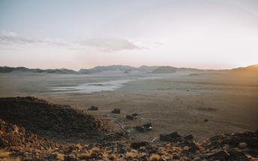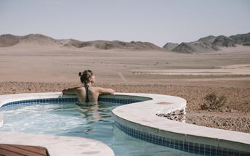

Basis
Dinner, Bed and Breakfast

Day 8-10: Strand Hotel Swakopmund, Swakopmund

Swakopmund
Surrounded by the ancient Namib desert and the inhospitable - but bounteous - Atlantic Ocean, Swakopmund is alive with activity and has a lot on offer for the adventure-seeker: quad-biking, sand-boarding, horse-riding, skydiving and more.
Swakopmund has many interesting German-influenced buildings from the early 1900s in a variety of styles and, for its size, Swakopmund has an astonishing array of restaurants that serve mainly seafood, steak and many German staples.

Walvis Bay
Walvis Bay is an industrial port which lies along the Atlantic Ocean, off Namibia's Skeleton Coast. The large bay and surrounding sand dunes help make Walvis Bay a tourist mecca with loads of activities on offer to explore it.
- Explore the Skeleton Coast where the dunes meet the sea at Sandwich Harbour‍
- Go on a dolphin boat cruise in the harbour. Enjoy champagne and oysters
- Kayak among the seals at Pelican Point
- Visit and climb the mighty Dune 7‍
- Visit the RAMSAR wetland birding site and the Walvis Bay Lagoon. Thousands of flamingos from October to April‍
- Explore the neighbouring town of Swakopmund. Activities abound and dining delights

Day Itinerary
Sossusvlei – Swakopmund 350km - approximately 5 to 6 hours
- Depart after breakfast and head north to Solitaire, then west crossing the Tropic of Capricorn, through the Gaub and Kuiseb Canyons via the Namib Gravel Plains to the coast
- Either via Walvis Bay to Swakopmund, or (recommended) detour via Ganab to the Welwitschia Plains and Moon Landscape
- The Namibian coastline is generally known as The Skeleton Coast due to the barren areas, ship wrecks and, in days gone by, whale skeletons left on the beach
- 1 full day is set aside for this lovely area where Swakopmund and Walvis Bay offer a wide range of activities such as: Dolphin cruise, Sandwich Harbour excursion (a real Skeleton Coast experience), Dune quad biking, Sand boarding, Sea kayaking, Lots more…
- Lunches and dinners can be enjoyed at a café or restaurant overlooking the sea

Overnight: Strand Hotel Swakopmund View iBrochure
Occupying most of the breakwater responsible for the calm bay, the Strand Hotel is inches from the roaring Atlantic. Rooms, spotless and tasteful, come in a variety of sizes and configurations, most of them sea-facing, and are equipped with the modern hotel's in-house conveniences like wi-fi, flat-screen telly, international plug points, air conditioning and, to be on the safe side you've got a mini-bar and room service. You get the impression they really want you to eat, drink and sleep well at the Strand Hotel. And so you shall.
The Strand includes three dining options not to mention room service.
The Brewer & Butcher is clearly building on the Brauhaus and Kucki's success stories. A lively place to enjoy traditional Namibian food which is, by turn, influenced by German food so expect jolly portions of Eisbein sidestepping trays of cascading bierkröge held aloft. The Farmhouse Deli is where the buffet breakfast is served offers a more informal cafe feel. The Ocean Cellar is The Strand's signature restaurant and presents an exciting and much-needed quality seafood restaurant to balance out Swakopmund's meat-heavy palate. The sushi is excellent as are the oysters and, like all the eating options, you can see, hear, smell and even taste the sea. Or you can turn and face the show kitchen and enjoy that oh-so-soothing experience of watching a team of experts at work.
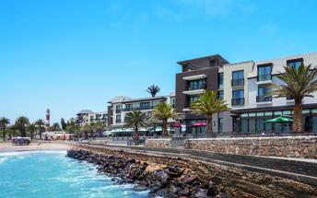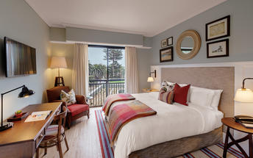

Basis
Bed and Breakfast

Day 10: Mowani Mountain Camp, Damaraland

Damaraland
Damaraland features vast khaki plains, sheer rocky mountains and incredible desert-adapted wildlife. Track rhino and desert elephant, explore the rugged land or sit back and enjoy the dramatic and endless scenery. Damaraland's hilly savannah supports a large number of species including lion, leopard, cheetah, hyena, eland, kudu, giraffe, klipspringer, steenbok, gemsbok and springbok. Birdlife is prolific with over 33 raptors recorded including cuckoo hawks, Egyptian vultures and peregrine falcons - the world's fastest animal.
Damaraland is divided into several enormous private game reserves, known as concessions, that support most species of Namibia's large game and provide some of the best birding and wildlife experiences in the country - and southern Africa for that matter.

Day Itinerary
Swakopmund – Damaraland 445km - approximately 7 to 8 hours
- Head north along the Skeleton Coast, via Henties Bay to visit the Cape Cross seal colony. Along the way, stop at the Lichen Fields as well as the ship wreck between the colourful small town of Wlotskasbaken and Henties Bay
- Backtrack to Henties Bay and head inland through wide open plains to Uis, then north to the Twyfelfontein area
- Visit to Namibia’s Open Air Museum, the Twyfelfontein Rock Engravings as well as the interesting Organ Pipes rock formations and Burnt Mountain
- Visit the Damara Living Museum for a hint of culture

Overnight: Mowani Mountain Camp View iBrochure
Mowani Mountain Camp offers luxury accommodation, a relaxed atmosphere and what could be one of the best views in Namibia. The vast landscape of true Damaraland as far as the eye can see.
Just short of 20 kilometres from the sights that make the area of Twyfelfontein famous, on an outcrop, above the desert landscape below, you'll find Mowani Mountain Camp built on wooden platforms, hidden amongst granite boulders.
The camp's 12 tented rooms (4 Superior View, 3 View and 5 Standard), are fit for a queen with plush beds, luxurious en suite bathrooms with an exhilarating roofless section, and a private balcony with superb views of the Abu Huab River valley and Damaraland all around. If you're upping the ante and staying in the Luxury Room, Mini Suite or Mountain Suite, enjoy that view from your very own splash pool.
A refined mix of luxury and comfort, chic modern accents with touches of Africa and a stillness that brings inner peace. The perfect place to unwind and take in all the "nothingness" that surrounds you.
The private suite stops at nothing in the luxury department with a sublime setting high on a granite outcrop. A private butler will tend to your every need and the lounge, bedroom and open-air bathroom all share the same fantastic view.
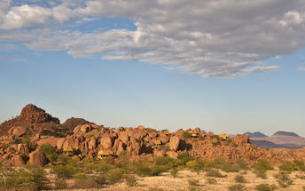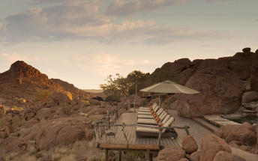

Basis
Dinner, Bed and Breakfast

Day 11: Opuwo Country Lodge, Kaokoveld

Kaokoveld
The Kaokoveld, a vast and empty wilderness occupying the north-western quarter of Namibia, is roughly divided in two by the Hoanib River. It’s harsh, remote, unpopulated and makes for some of Namibia’s finest scenic landscapes.
Kaokoland is a succession of hills and mountains punctuated by endless plains. This isolated rugged region is home to the nomadic Himba pastoralists who have remained unchanged for many generations. The attraction of Kaokoland lies in its wild and uncharted valleys and mountains. It is the most isolated and undeveloped region of this mostly isolated and undeveloped country.

Day Itinerary
Damaraland – Opuwo 340km - approximately 5 to 6 hours
- Depart the Twyfelfontein area and head north via Palmwag, crossing the Hoanib River, up and over Joubert Pass to Opuwo, the centre of Kaokoland
- Opuwo is a small typical African town, where a range of different people live, from the traditional Himba tribes to Herero, Damara and Owambo cultures
- Along the way stop at various villages to interact and photograph the local people
- Depending on arrival time, enjoy a Himba village visit this afternoon. It is recommended to arrange a local guide to go with you (lodge reception can assist with this)

Overnight: Opuwo Country Lodge View iBrochure
The Masai-like Himba people of Kaokoland have retained their traditional semi-nomadic lifestyle. Their land is harsh, inhospitable and fascinating, creating a delicate balance between survival and obliteration.
The Opuwo Country Hotel (also known as Opuwo Country Lodge) overlooking the untouched wilderness, provides a comfortable base from which to explore this beguiling region and to discover the secrets of its proud inhabitants. The lodge is also an excellent base for exploring the Kunene River and the far flung moonscape of valleys, mountains and ravines.
The luxury hotel opened late in 2005, and the rooms are all air conditioned and have en suite bathrooms. It's certainly not luxury compared to other high-end lodges throughout Namibia, but in these parts it's the most luxurious option there is and given the setting it's more than suitable. The air-conditioning alone takes the win.
The main living area houses the bar, restaurant, lounge, wine cellar, curio shop and a large verandah with a view that starts at the pool, sweeps over a mopane-covered valley, and ends in a haze of mountains.
Opuwo means "finished" or "up to here and no further" but really you can continue to the more northern reaches of Namibia from here and if you are heading in that direction, then you are almost certainly guaranteed to stay here along the way.
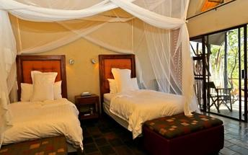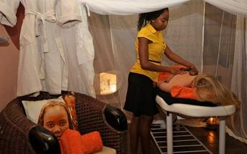

Basis
Dinner, Bed and Breakfast

Day 12-14: Omarunga Epupa-Falls Camp, Epupa Falls

Epupa Falls
Epupa Falls is on the Kunene River which forms the border between Namibia and Angola. Epupa means 'falling water' in the Herero language, its water cascading into a spectacular chute with a 60 metre drop and several natural rock pools where you can take a refreshing - and much needed - dip. Remote and wonderfully difficult to reach, is one of only a few waterfalls in Namibia.
If you’re visiting for a few days, you can pop off to the OvaHimba Village for a cultural experience. Don’t miss the opportunity to enjoy world-class birdwatching and spot an array of species including two of southern Africa's rarest birds: the Cinderella waxbill and the rufous-tailed palm thrush. Adventure-seekers can shoot the rapids in inflatable rafts on guided expeditions.

Day Itinerary
Opuwo – Epupa Falls 180km - approximately 3 hours
- Today takes you way north to the border with Angola, the beautiful Epupa Falls
- 2 nights, a full day is set aside here to visit some authentic traditional Himba villages, view the falls and hike along the Kunene River
- Plan a morning visit to 1 or 2 authentic Himba villages as this is when there is the most activity

Overnight: Omarunga Epupa-Falls Camp View iBrochure
Shaded by the Makalani Palm Tree forest, fourteen thatched chalets look out on the river with a small veranda – the perfect place for you, a cooling drink and the setting sun to complete the day. If you would prefer to self-cater then there is also a small campsite with ten stands, an ablution with hot water and cooking facilities.
The lodge is situated only 200 metres upstream from the Epupa Falls and along the Kunene River. An oasis of peace and quiet - the perfect place to relax in the sweltering heat, when you aren't exploring all the area has to offer.
The restaurant, although simple, offers a 3-course dinner which has the potential to far exceed your expectations – especially given that the closest shop is quite far away. Breakfast is served buffet-style in the morning, where you can watch the early traffic on the river as animals prepare for the day ahead.
The lodge swimming pool is probably a wise choice to cool off in; unfortunately the resident crocodiles and hippos wallowing in the river make it impossible to swim in, although a river cruise allows you to view these animals in safety as well as other animals which come to the river for water.
If you’re visiting for a few days, you can pop off to the OvaHimba Village for a cultural experience, or take a 10min guided walk to the Epupa Falls. Sunsets from the nearby hilltop are also not to be missed.
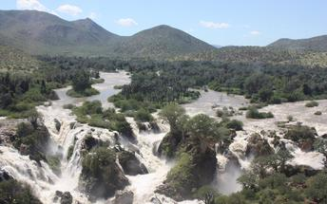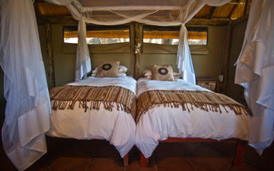

Basis
Dinner, Bed and Breakfast

Day 14: Dolomite Camp, Etosha West

Etosha West
Situated in the western part of Etosha National park, a world-famous wildlife sanctuary in the northwestern part of Namibia, Etosha West is the wilder western region accessed through Galton Gate. Visitors to Etosha West can look forward to exploring the magnificent scenery of this remote north Namibian landscape characterised by lush undulating terrain and a reddish-brown soil, which is a stark contrast to the white dusty clay soil of Etosha East’s flat expansive plains. This area is home to several species not found in the rest of the park: baboons, Mountain Zebra, and Brown Hyena, as well as several unique plants. The area also boasts numerous waterholes attracting elephant, rhino, leopard, lion, a variety of buck, and around 300 bird species.

Day Itinerary
Epupa Falls - Etosha (west) 375km - approximately 5 hours
- Depart this morning after breakfast and backtrack to Opuwo before heading east and then south towards the west side of Etosha
- Arrival here will be in the afternoon and if you wish, join an afternoon or evening game drive (optional extra)

Overnight: Dolomite Camp
Dolomite Camp is a Namibia Wildlife Resorts luxury safari lodge in the newly opened western section of Etosha National Park.
Looking out over a horizon of endless silence, Dolomite Camp is far - very far - from anyone or anything in the hitherto restricted western sector of Etosha National Park. In October 2011 the western gate opened to the public, allowing access to the game reserve from Damaraland and Kaokoland, and Dolomite Camp sits in the middle of a vast expanse of Namibia’s largest game reserve.
Atop a small outcrop of rock from which the safari lodge gets its name, Dolomite Camp has a 360-degree view of the grass-covered plains below punctuated by the occasional copycat outcrop. Accommodation is luxurious and the game viewing is exceptional and unique.
Combine two or three nights in Dolomite Camp with another stay in Etosha National Park - Okuaukuejo, Halali or Namutoni for a complete Etosha experience that takes in the variety of habitats, from the grassy plains to the shimmering pans, that make this enormous Namibian park one of the great game reserves of Africa. Keep in mind though that the other camps inside the park are not nearly as luxurious. It's about staying inside the park, which is why you're choosing these accommodations over those on private reserves just outside the park gates.
Wildlife and game viewing opportunities in Etosha are exceptional including: elephants, lions, rhino, cheetah, leopard, giraffe, Hartmann's mountain zebra, Burchell's plains zebra, springbok and many other species of plains game, a great variety of birds including many raptors.
Game drives at Dolomite Camp traverse the exclusive western sector and visit natural waterholes where a great variety of wildlife passes through to quench their thirst in these parched lands. Your thirst for excellent game viewing, quality accommodation and a unique African safari will also be quenched.
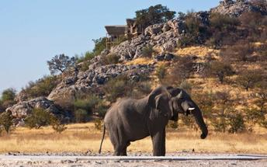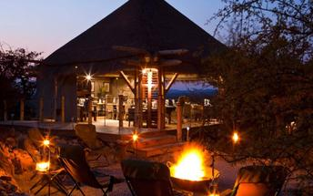

Basis
Bed and Breakfast

Day 15: Ongava Lodge, Etosha South

Etosha South
Located just south of the boundary of Etosha National Park in northwestern Namibia, Etosha South makes up the southern region of this wild paradise. Ongava Private Game Reserve shares the southern boundary with Etosha National Park and offers an array of luxury lodges overlooking picturesque landscapes dotted with abundant wildlife. The national park can be accessed via the southern entrance at Andersson’s Gate. Visitors can catch a glimpse of a variety of wildlife including: lion, giraffe, elephant, white and black rhino, and a multitude of plains game. Popular activities include: game drives, tracking rhinos on foot, guided nature walks, or watching the sunset over the magnificent African landscape.

Day Itinerary
Etosha (west) – Etosha (south) a full days game drive through the park
- After breakfast, enjoy a full morning game drive to Okaukuejo and exit Etosha at the southern gate, Andersson gate
- Return into Etosha for an afternoon drive or arrange with the lodge for a game drive (optional extra)
- At Okaukuejo, I suggest you pop in at the local shop to purchase some drinks and snacks and most importantly, a map of Etosha which will show you all the waterholes in the park
- Etosha is one of Africa's great game parks. With 114 species of mammal and 340 species of birds you are sure to see a great variety of wildlife on your safari

Overnight: Ongava Lodge View iBrochure
Ongava Game Lodge has a rustic overcoat that fails to conceal its underbelly of luxury and elegance. The 14 enormous thatched chalets each have an en suite bathroom - with a view - and a large verandah looking out over the reserve.
You are perched on top of a hill here, so the views out from the main deck are well grand but this also means it's a trundle down to your room and back up again. The main lodge is open-sided under a canopy of timber and thatch and has a split-level living area, a dining room and a bar. The swimming pool looks out over a floodlit waterhole. There's a hide at the waterhole too. Splendid.
Ongava is a 30,000ha private game reserve on the southern edge of Etosha. There are three other lodges in the reserve - Little Ongava Lodge and Anderssons @ Ongava, for complete luxury and Ongava Tented Camp for an elegant sufficiency. The reserve has all of Namibia's wildlife except elephant, which you will no doubt find on your safaris in Etosha. A highlight of the private reserve is a walking safari in which you track both black and white rhino - with an armed ranger of course.
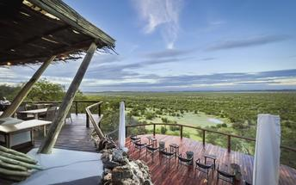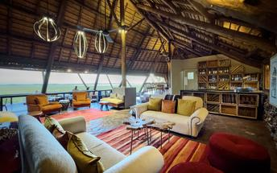

Basis
Dinner, Bed and Breakfast

Day 16-18: Mushara Outpost, Etosha East

Etosha East
On the eastern edge of Etosha National Park, the park itself is bordered by numerous private reserves and access into the park is via the Von Lindequist Gate, named after Dr. Friedrich von Lindequist who proclaimed it a game reserve in March 1907. This side of the park is characterised by flat endless plains, tree-savanna type of vegetation and fantastic waterholes, where you could easily spot any of the prolific wildlife Etosha is known for. There's an abundance of wildlife here.

Day Itinerary
Etosha (south) – Etosha (east) a full days game drive through the park
- From one side to the other side of the park is a full day game drive as you head slowly east stopping at numerous waterholes along the way
- Take a slow drive in the morning and then enjoy a packed lunch (optional extra) overlooking one of the waterholes before continuing on through the park to the eastern side
- 1 full day is set aside for game viewing, either all day or alternate with morning and afternoon drives. These are self-drive game drives but you can arrange at the lodge to go with their open safari vehicle and guide (optional extra)

Overnight: Mushara Outpost View iBrochure
Sophisticated and elegant, Mushara Outpost is a luxury addition to the Mushara collection of lodges on the eastern side of Etosha National Park.
Accommodation at Mushara Outpost is paired down luxury with eight chalets built on elevated decks with canvas roofing, floor-to-ceiling glass doors, en suite bathrooms with enclosed toilet and an open-plan shower with a cheeky private view of the Namibian bush.
The main living area is a charming farmstead house with a massive wrap-around verandah providing cool shade from the blazing sun and cooling the airy interior even further.
A large swimming pool invites an afternoon doze and the evening campfire, wine cellar and fancy food complete the picture of delightful relaxation.
The lodge is in a private game reserve with several small antelope and hundreds of birds setting the stage for your safari proper into Etosha, which is just 10km from your piece of paradise.
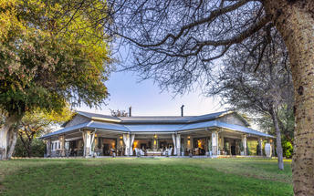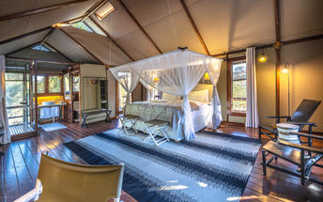

Basis
Dinner, Bed and Breakfast

Day 18: Okonjima Luxury Bush Camp, Okonjima Nature Reserve

Okonjima Nature Reserve
This 22,000-hectare private nature reserve is surrounded by the the Omboroko Mountains and the home of The AfriCat Foundation. AfriCat works to assist with the long term conservation and rehabilitation of carnivores like cheetah, leopard, brown hyena and that African icon, lion. Since 1993, over 1,000 predators have been saved with 86% released. Here you can see cheetah, wild dog and hyena in their natural home - leopards are radio tracked so you could get lucky and spot them too. 250 bird species think it’s an ideal spot and there’s a hide for watching nocturnal animals.

Day Itinerary
Etosha (east) – Okonjima 315km - approximately 4 to 5 hours
- Head south via Otavi and Otjiwarongo to Okonjima, which is home to the AfriCat Foundation. Aim to arrive here by 14h00 latest in order to enjoy the afternoon tea/coffee and cakes before heading off on your afternoon excursion
- After dinner, an optional visit to the night hide to view some nocturnal animals

Overnight: Okonjima Luxury Bush Camp View iBrochure
Okonjima Luxury Bush Camp is the luxury option at Okonjima - a family-owned portfolio of lodges on a private reserve between Etosha and Windhoek.
Bright versions of earthy tones and an open-plan design give the place a relaxed and informal atmosphere. The eight chalets and junior suite are spaced well apart from each other and are built like an African hut - with some essential modifications. The front half of the chalets roll up to reveal nothing but the African bush; each has an en suite bathroom, mini-bar, telephone, ceiling fan and a safe. You'll also have your own private open-air sala for ultimate relaxation.
The living area, or lapa if you want to get into the swing of things, is an enormous open-sided thatch construction that looks out over a waterhole and the wilderness. Inside its earthen-coloured walls is the dining area, a large lounge with a raised fireplace, and a sunken bar area; next to it is the swimming pool.
Okonjima Bush Camp is the luxury option and the Main Camp is the original lodge that offers home-grown comfort; Okonjima Villa and Okonjima Bush Suite are the pinnacle of luxury and seclusion.
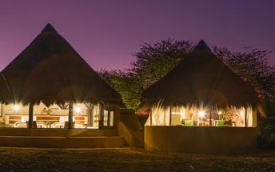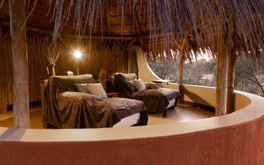

Basis
Fully Inclusive - Bed, All Meals, Fees and Activities

Day 19: End of Itinerary

Day Itinerary
Okonjima – Windhoek 225km - approximately 3 to 4 hours
- Early morning rise for a quick snack before joining the morning activity, which will be to visit the AfriCat Foundation or for a drive in the animal enclosure, which is more a game reserve
- Back to the lodge for a hearty Namibian breakfast before departure
- Head back to Windhoek today, where the vehicle is dropped off and your holiday comes to an end
- Transfer to the airport to catch your departure flight. (Keep in mind that you need to be at the airport 2 hours prior and the airport is still a 45 minute to 1 hour drive from town)

Basis
Bed and Breakfast

Transport

Transfers
Date | Company | Pick Up | Drop Off | Time | Vehicle
 |  | Hosea Kutako International Airport [WDH] | Windhoek City |  | Transfer
 |  | Windhoek City | Hosea Kutako International Airport [WDH] |  | Transfer

Terms and Conditions

Namibia Tours & Safaris Terms and Conditions
Contract
1.1 The contract will become effective as from the date the invoice is completed and the deposit, referred to in Clause 2.1, is received by Africa Tours & Safaris CC (hereinafter known as the Company).
1.2 The contract is subject to the Namibian Law.
1.3 Any person making a reservation as per Clause 8.4 accepts the terms and conditions of this agreement set out hereunder.
How to Book
2.1 A 20% deposit of the full amount due is required to confirm any reservation and is to be done by the agent or client (see Clause 8.1) in writing or by e-mail.
2.2 The Company must receive the balance of the contract price no later than 42 days (6 weeks) prior to departure.
2.3 If the Company does not receive the full contract price 42 days (6 weeks) before the departure date, the Company may cancel the reservation and retain whatever deposit or other funds it has already received from the client or his agent.
How to Pay
3 The payment options will be provided upon confirmation of a booking.
Our Cancellation Policy
4.1 Any cancellation of a confirmed booking must be done in writing (email) to the Company whereupon cancellation charges as per Clause 4.2 will apply.
4.2 The following cancellation fees (as a percentage of the fully quoted price) are applicable to any cancelled travel:
Notice from date of travel:
Cancellation fee:
42 days or more 20% (deposit forfeited)
29 – 41 days 50%
15 – 28 days 75%
0 – 14 days 100%
Please note: the notice period is calculated from the date of cancellation to the start date of the tour/safari booking.
4.3 No refund will be made by the Company if, for any reason, inclusions or parts of the tour cannot be carried out / or utilised. These would include all facets such as meals, game drives, accommodation etc. This would also apply to any client who has booked a tour but fails to undertake the tour for any reason.
Our Changes Policy
5 If a booking is changed to an earlier date than originally reserved, the Company will endeavour to change it. If the booking is for a later date, charges as per Clause 4.2 could apply.
As things go, we've all had to adapt to changes during the Coronavirus pandemic and so too have we therefore amended our terms and conditions for travel during such times.
Price Changes
6.1 The Company reserves the right to increase the price of any tour prior to departure due to factors beyond the control of the Company, such as, without being limited to, and increase in fuel prices, new Government legislation, accommodation price increases, fluctuations in exchange rates, etc.
6.2 If the Company announces an in increase in the tour price in terms of this Clause, such addition amount must be paid to the Company before the departure of such tour or else the Company shall have the right to cancel the tour and the charges in Clause 4.2 will apply.
Changes to Itineraries
7 The Company shall at any time have the right, in its entire discretion, to alter the terms of the booking in relation to the route, timetable, itinerary and accommodation. The Company shall, however, make every effort to offer the client an alternative tour of a comparable standard.
Should the alternative be of a lesser standard, the client will be refunded the difference, but should there be an increase, the client shall have the right to either reject the alternative and obtain a refund of the relevant portion of the original contract sum, or to accept the alternative and pay the increased cost. In the event of the client rejecting the alternative tour and claiming a refund, such rejection will be treated as a cancellation and the refund will be calculated according to Clause 4.2 hereof. The client shall have no claim against the Company for any damages arising out of the alternative booking.
Responsibility and Liability
8.1 Neither the Company nor any person acting for through and on behalf of the Company shall be liable for any loss or damage whatsoever arising from any cause whatsoever and without restricting the generality of the aforegoing shall particularly not be responsible for the loss or damage arising from any errors or omissions contained in its brochure or other literature, late or non-confirmation or acceptance or bookings, loss or damage caused by delays, sickness, injury or death, whether occasioned by negligence or not.
8.2 The Company shall have the right at any time at is sole discretion, to cancel or the remainder thereof or to make an alteration in the route, accommodation price or other details. This would include any event of any tour being rendered impossible, illegal or inadvisable by weather, avalanches, strike, war, government or other interference or due to any other cause whatsoever. The extra expenses incurred as a result thereof shall be the responsibility of the client.
8.3 The Company may at its discretion and without liability or cost to itself at any time cancel, or terminate, a client's booking and in particular, without limiting the generality of the aforegoing, it shall be entitled to do so in the event of illness or the illegal or incompatible behaviour of any client undertaking the tour, who shall in such circumstances not be entitled to any refund.
8.4 Any person making a reservation with the Company (refer to Clause 1.1) warrants that her or she has the necessary authority to enter into this contract on behalf of the person or persons included in such a booking. The person making the reservation shall be liable for the total amount due to the Company.
Client's Obligations
9.1 It is the onus and responsibility of the client to obtain the necessary comprehensive insurance before departure for any possible cancellations, medical expenses, protection or personal property and money.
9.2 The onus is upon the client to ensure that passports and visas are valid for the duration of the safari. The Company cannot be held liable for any necessary visas or other travel documents not held by clients. In the event of a client not having the necessary documentation to enter any area or country the Company shall reserve the right to leave the client a the point of entry of such area or country. In such an event, the Company will not be held responsible to the client for further travel arrangements.
9.3 The onus is upon the client to ensure that the SARS-CoV-2 PCR tests are done prior to commencement of the safari and valid on arrival in accordance to the requirements of the country of intended travel and for the airline with which the client will travel. The same applies for any necessary testing for departure. The costs of any such COVID testing will be for the clients own account. While The Company can assist with arrangements for testing in-country, The Company will not be held responsible to the client for such arrangements and with regards to return time of test results.
9.4 Should the client need to undergo mandatory quarantine once in-country with regards to the SARS-CoV-2 virus, either on arrival as called for by the authorities or due to testing positive once in-country, this will be at the clients own expense.
Health and Personal Safety
10.1 The client shall be reasonably fit to undertake the tour.
10.2 Anti-malaria precautions should be commenced prior to tour departure. A medical doctor should be consulted for advice.
10.3 Tours offered by the Company cover a wide spectrum of the African wilds and neither the Company, its employees or agents can be held responsible for any injury or other related incidents whilst on the tour / safari.
10.4 The Company cannot be held responsible for any client who falls ill or contracts the SARS-CoV-2 virus while in-country. The client accepts that travel is at own risk.
Baggage
11.1 Clients are limited to one soft sports type bag per person with a maximum weight of 20 kilograms. This includes photographic equipment and hand luggage.
11.2 Due to the rugged terrain, the Company cannot be held responsible for damage or loss of any personal items including bags, contents of bags or photographic and related equipment. Due to extremely dusty conditions, please ensure all bags are dust proof.
Airline and Car Hire Clause
12.1 The Company will act as the agent of the client when booking the client with a car hire company, an airline or air charter service. The client therefore contracts with the car hire company, airline or charter service and not with the Company.
12.2 Charter flights are normally operated by smaller type aircraft such as Cessna 210. Luggage is strictly limited to 10-15 kgs (depending on terms of particular airline used) per person in soft hold all type bags. Due to the desert heat, it is not safe to overload aircraft thus this limit needs to be strictly controlled.

